MODELING FUTURE CLIMATE IMPACTS ON BRAZIL’S OPERATIONAL WIND AND SOLAR ENERGY CAPACITY
Felipe Husadel Poyer^{a*}, Francisco Lopes Limaª, Rodrigo Santos Costaª, André Rodrigues Gonçalvesª, Fernando R. Martins^{b}, André F. Lucena^{c}, Enio Bueno Pereiraª
ªLaboratory for Modeling and Studies of Renewable Energy Resources - http://labren.ccst.inpe.br/, National Institute for Space Research (INPE), Av.
Astronautas, 1758, São José dos Campos, 12227010, São Paulo, Brazil
^{b}Institute of Marine Science (IMar), Federal University of São Paulo (UNIFESP): Rua Carvalho de Mendonça, 144, CEP: 11030-100, Santos, São Paulo, Brazil.
^{c}Center for Energy and Environmental Economics (Cenergia), Energy Planning Program (PPE), Coppe, Federal University of Rio de Janeiro, Centro Tecnológico, Sala C-211, C.P. 68565, Cidade Universitária, Ilha do Fundão, 21941-972, Rio de Janeiro, Brazil

* Corresponding author: felipe.poyer@inpe.br

Supplementary Material

1 – Results: Regions of analysis
Table 1 presents the number of power plants, municipalities, and total installed capacity for wind and solar PV energy resources as of the end of 2024.
Table 1 – Region of analysis
Source | n° of Power Plants | N° of municipalities | Installed Capacity
Wind | 1023 | 116 | 31.778 MW
PV Solar | 439 | 48 | 16.536 MW
Source: Based on wind and PV power plant databases [40; 41]

2- Results: Clustering Analyses

As explained in Sections 3.2 of the main article, the clustering information is presented in Table 2 and Table 3, and the complete list of wind and solar municipalities and their respective clusters is presented in Tables 4 and Table 5.
Table 2 – Wind Clusters
Cluster | n° of Power Plants | N° of municipalities | Installed Capacity
NE | 459 | 64 | 14.364 MW
BA_PI | 477 | 43 | 15.212 MW
S | 87 | 9 | 2.201 MW

Table 3 – Solar Clusters
Cluster | n° of Power Plants | N° of municipalities | Installed Capacity
NE | 187 | 27 | 6.520 MW
BA_MG | 218 | 13 | 8.848 MW
SP | 34 | 8 | 1.167 MW

Table 4 – Wind municipalities and clusters
 | State | Municipality | Cluster |  | State | Municipality | Cluster |  | State | Municipality | Cluster
1 | CE | Acaraú | NE | 40 | BA | Gentio do Ouro | BA_PI | 79 | PI | Queimada Nova | BA_PI
2 | RN | Afonso Bezerra | NE | 41 | RN | Guamaré | NE | 80 | BA | Riacho de Santana | BA_PI
3 | SC | Água Doce | S | 42 | BA | Guanambi | BA_PI | 81 | RN | Riachuelo | NE
4 | CE | Amontada | NE | 43 | CE | Ibiapina | NE | 82 | RS | Rio Grande | S
5 | RN | Angicos | NE | 44 | BA | Ibipeba | BA_PI | 83 | RN | Ruy Barbosa | NE
6 | CE | Aracati | NE | 45 | BA | Ibitiara | BA_PI | 84 | PE | Saloá | NE
7 | BA | Araci | NE | 46 | CE | Icapuí | NE | 85 | PB | Santa Luzia | NE
8 | PE | Araripina | BA_PI | 47 | BA | Igaporã | BA_PI | 86 | RS | Santa Vitória do Palmar | S
9 | RN | Areia Branca | NE | 48 | BA | Iraquara | BA_PI | 87 | RS | Santana do Livramento | S
10 | PB | Areia de Baraúnas | NE | 49 | BA | Itaguaçu da Bahia | BA_PI | 88 | RN | Santana do Matos | NE
11 | MA | Barreirinhas | NE | 50 | CE | Itarema | NE | 89 | RN | São Bento do Norte | NE
12 | RN | Bento Fernandes | NE | 51 | RN | Jandaíra | NE | 90 | CE | São Gonçalo do Amarante | NE
13 | PI | Betânia do Piauí | BA_PI | 52 | RN | Jardim de Angicos | NE | 91 | RN | São José do Campestre | NE
14 | BA | Biritinga | NE | 53 | RN | João Câmara | NE | 92 | PB | São José do Sabugi | NE
15 | RN | Bodó | NE | 54 | PB | Junco do Seridó | NE | 93 | PB | São Mamede | NE
16 | SC | Bom Jardim da Serra | S | 55 | PI | Lagoa do Barro do Piauí | BA_PI | 94 | RN | São Miguel do Gostoso | NE
17 | BA | Boninal | BA_PI | 56 | RN | Lagoa Nova | NE | 95 | RN | São Tomé | NE
18 | BA | Bonito | BA_PI | 57 | RN | Lajes | NE | 96 | RN | São Vicente | NE
19 | BA | Brotas de Macaúbas | BA_PI | 58 | BA | Licínio de Almeida | BA_PI | 97 | BA | Sento Sé | BA_PI
20 | BA | Brumado | BA_PI | 59 | RN | Macau | NE | 98 | RN | Serra de São Bento | NE
21 | PE | Caetés | NE | 60 | PI | Marcolândia | BA_PI | 99 | RN | Serra do Mel | NE
22 | BA | Caetité | BA_PI | 61 | RN | Monte das Gameleiras | NE | 100 | PI | Simões | BA_PI
23 | BA | Cafarnaum | BA_PI | 62 | BA | Morro do Chapéu | BA_PI | 101 | BA | Souto Soares | BA_PI
24 | RN | Caiçara do Norte | NE | 63 | BA | Mulungu do Morro | BA_PI | 102 | PE | Tacaratu | NE
25 | RN | Caiçara do Rio do Vento | NE | 64 | BA | Novo Horizonte | BA_PI | 103 | BA | Tanque Novo | BA_PI
26 | PI | Caldeirão Grande do Piauí | BA_PI | 65 | RS | Osório | S | 104 | RN | Tenente Laurentino Cruz | NE
27 | BA | Campo Formoso | BA_PI | 66 | PE | Ouricuri | BA_PI | 105 | CE | Tianguá | NE
28 | BA | Canudos | BA_PI | 67 | BA | Ourolândia | BA_PI | 106 | RN | Touros | NE
29 | BA | Casa Nova | BA_PI | 68 | RS | Palmares do Sul | S | 107 | CE | Trairi | NE
30 | RN | Ceará-Mirim | NE | 69 | PE | Paranatama | NE | 108 | BA | Tucano | NE
31 | RN | Cerro Corá | NE | 70 | RN | Parazinho | NE | 109 | CE | Ubajara | NE
32 | RS | Chuí | S | 71 | RN | Parelhas | NE | 110 | BA | Uibaí | BA_PI
33 | RN | Currais Novos | NE | 72 | MA | Paulino Neves | NE | 111 | BA | Umburanas | BA_PI
34 | PI | Curral Novo do Piauí | BA_PI | 73 | PI | Paulistana | BA_PI | 112 | BA | Urandi | BA_PI
35 | BA | Dom Basílio | BA_PI | 74 | PE | Pedra | NE | 113 | BA | Várzea Nova | BA_PI
36 | PI | Dom Inocêncio | BA_PI | 75 | RN | Pedra Grande | NE | 114 | PE | Venturosa | NE
37 | RN | Equador | NE | 76 | RN | Pedra Preta | NE | 115 | RS | Viamão | S
38 | RN | Fernando Pedroza | NE | 77 | RN | Pedro Avelino | NE | 116 | BA | Xique-Xique | BA_PI
39 | CE | Fortim | NE | 78 | BA | Pindaí | BA_PI
Table 5 – Solar municipalities and clusters
 | State | Municipality | Cluster |  | State | Municipality | Cluster |  | State | Municipality | Cluster
1 | CE | Abaiara | NE | 17 | SP | Guaimbê | SP | 33 | PB | Pombal | NE
2 | CE | Aquiraz | NE | 18 | SP | Ilha Solteira | SP | 34 | CE | Quixeré | NE
3 | MG | Araxá | SP | 19 | CE | Jaguaretama | NE | 35 | PI | Ribeira do Piauí | NE
4 | RN | Areia Branca | NE | 20 | MG | Jaíba | BA_MG | 36 | PI | Ribeiro Gonçalves | NE
5 | MG | Arinos | BA_MG | 21 | MG | Janaúba | BA_MG | 37 | PB | Santa Luzia | NE
6 | RN | Açu | NE | 22 | RN | Jandaíra | NE | 38 | RN | Santana do Matos | NE
7 | BA | Barreiras | BA_MG | 23 | BA | Juazeiro | NE | 39 | MG | São Gonçalo do Abaeté | BA_MG
8 | BA | Bom Jesus da Lapa | BA_MG | 24 | RN | Lajes | NE | 40 | PI | São Gonçalo do Gurguéia | BA_MG
9 | PI | Brasileira | NE | 25 | CE | Limoeiro do Norte | NE | 41 | PI | São João do Piauí | NE
10 | PI | Caldeirão Grande do Piauí | NE | 26 | BA | Oliveira dos Brejinhos | BA_MG | 42 | PE | São José do Belmonte | NE
11 | SP | Castilho | SP | 27 | SP | Ouroeste | SP | 43 | RN | Serra do Mel | NE
12 | CE | Caucaia | NE | 28 | MG | Paracatu | BA_MG | 44 | BA | Tabocas do Brejo Velho | BA_MG
13 | PB | Coremas | NE | 29 | SP | Pedranópolis | SP | 45 | CE | Tabuleiro do Norte | NE
14 | SP | Dracena | SP | 30 | RN | Pedro Avelino | NE | 46 | PE | Tacaratu | NE
15 | PE | Flores | NE | 31 | SP | Pereira Barreto | SP | 47 | CE | Trairi | NE
16 | MG | Francisco Sá | BA_MG | 32 | MG | Pirapora | BA_MG | 48 | MG | Várzea da Palma | BA_MG

3 – Results: Wind Ensemble

Table 6 - 8 and Figures 1 - 3, present the wind results for each cluster, scenario, and time slice. The values correspond to the ensemble of the selected GCMs.

Table 6a - Wind power density change factor (∆wPD) representing the relative difference between the mean wPD at the mid-century (2040-2069) and the historical period (1985-2014).
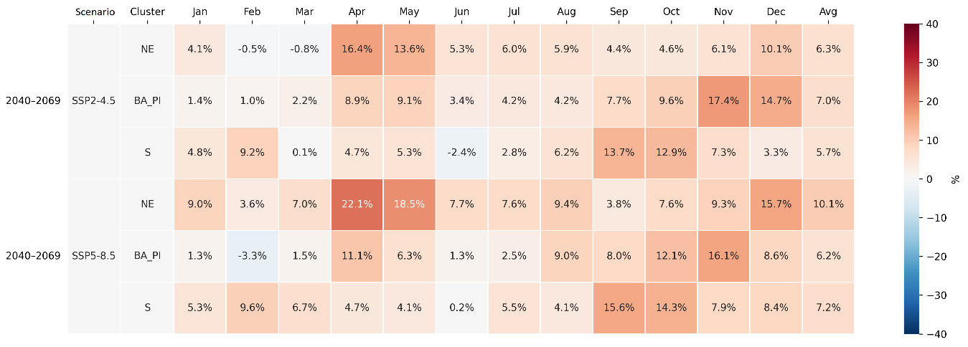
Table 6b - Wind power density change factor (∆wPD) representing the relative difference between the mean wPD at the end of the century (2070-2099) and the historical period (1985-2014).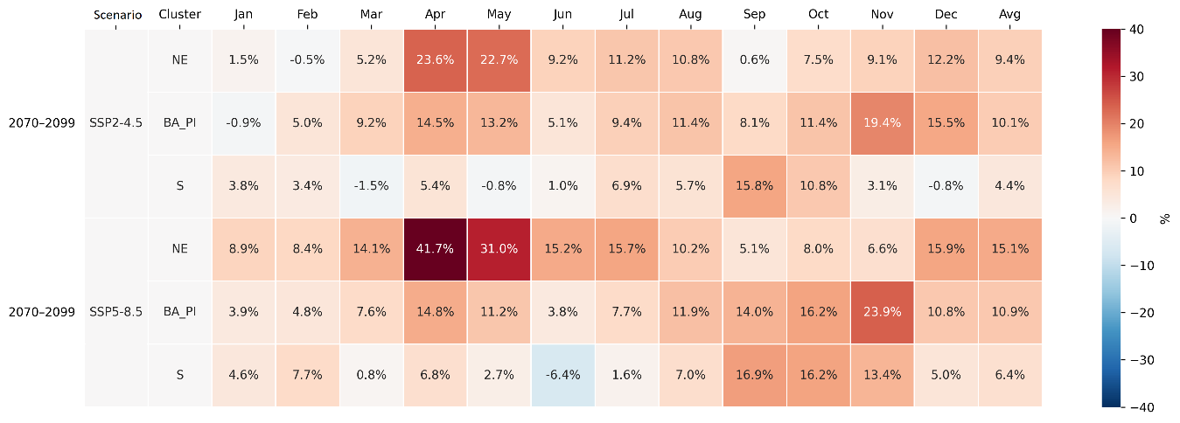

Table 7 - Historical wind capacity factor (hwCF).
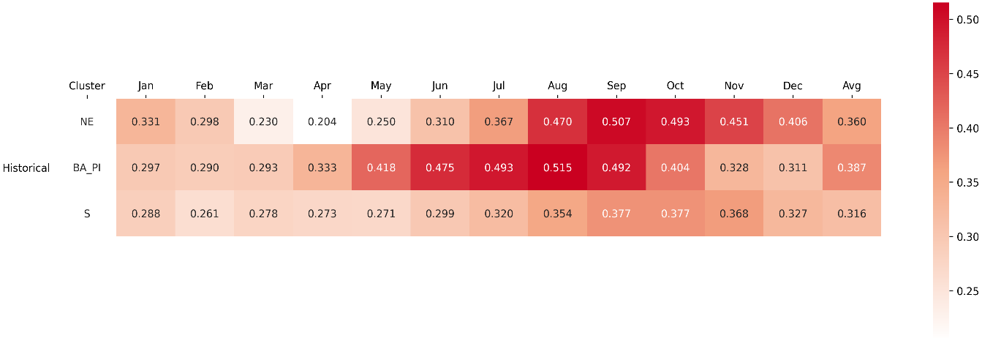
Table 8a - Future wind capacity factor (fwCF) at the mid-century (2040-2069). 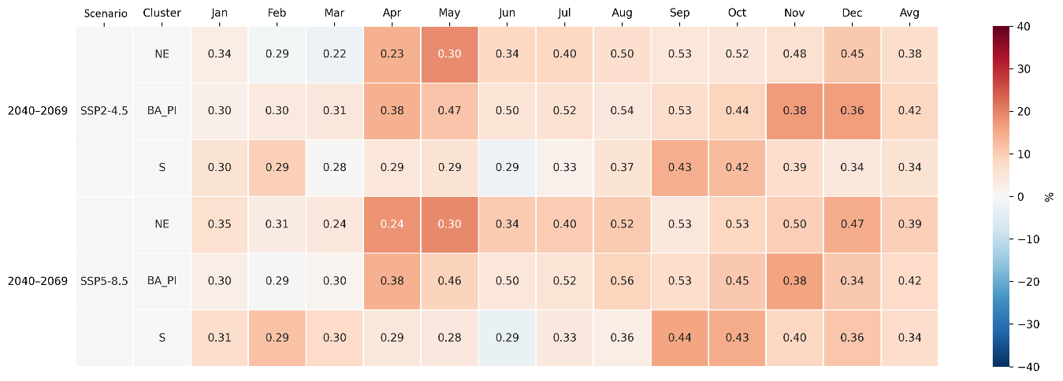Notes: The heatmap indicates variations in fwCF in comparison with hwCF.

Table 8b - Future wind capacity factor (fwCF) at the end of the century (2070-2099). 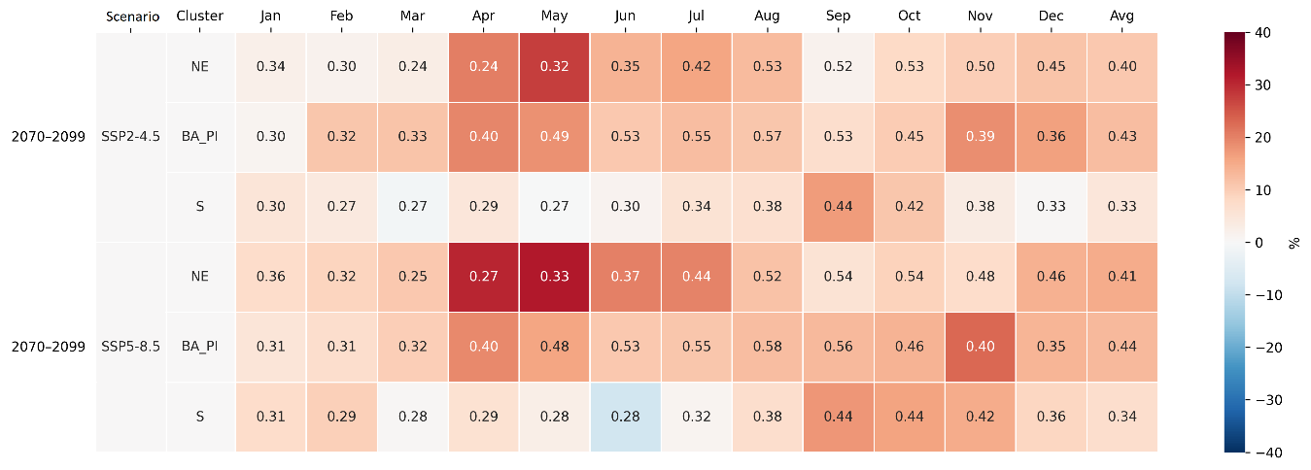Notes: The heatmap indicates variations in fwCF in comparison with hwCF.

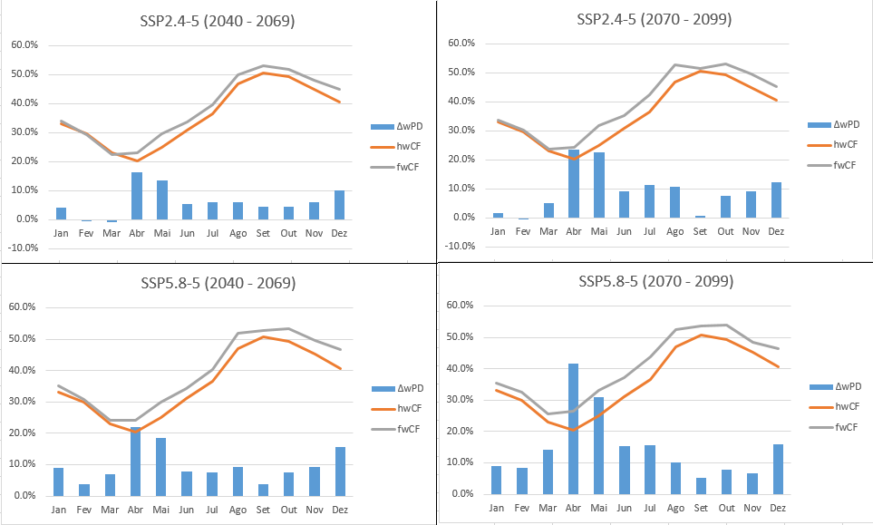Figure 1 - Cluster NE monthly future wind capacity factor (fwCF), historical wind capacity factor (hwCF) and wind power density change factor (∆wPD)

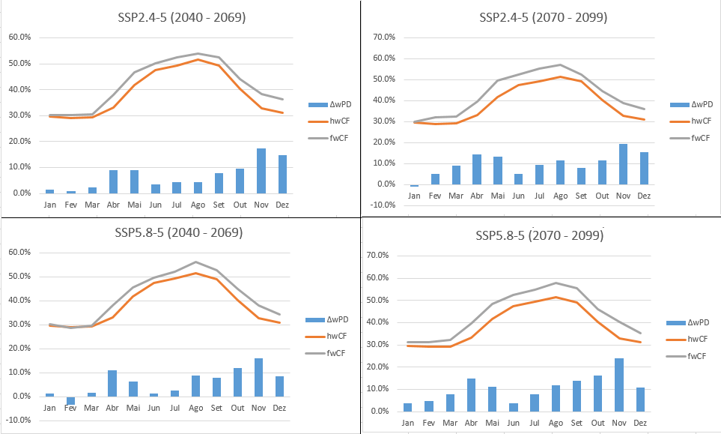
Figure 2 - Cluster BA_PI monthly future wind capacity factor (fwCF), historical wind capacity factor (hwCF) and wind power density change factor (∆wPD)

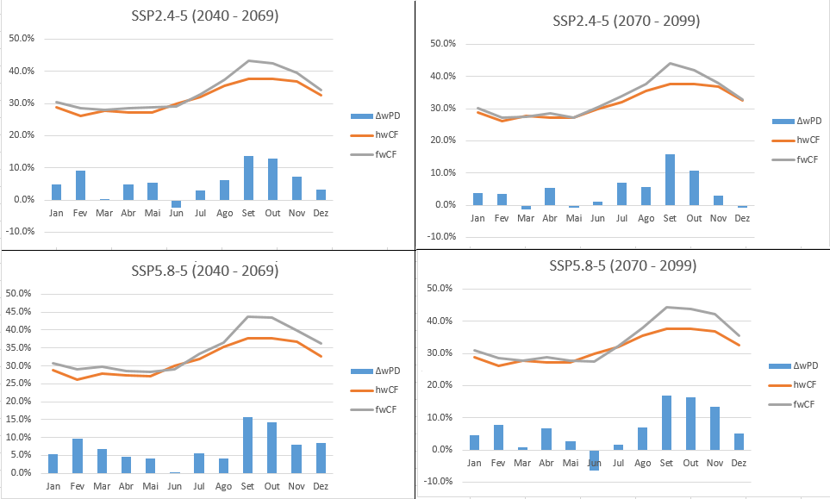
Figure 3 - Cluster S monthly future wind capacity factor (fwCF), historical wind capacity factor (hwCF) and wind power density change factor (∆wPD)

3.2 – Results: Wind by GCM

Tables 3 - 5 and Figure 4 display the fwCF for each cluster, displaying all GCMs utilized in the analysis. In addition to the monthly values, the tables also report the corresponding monthly means and standard deviations.

Table 3 - Cluster NE future wind capacity factor (fwCF)

Table 4 - Cluster BA_PI future wind capacity factor (fwCF)

Table 5 - Cluster S future wind capacity factor (fwCF)
Figure 4 displays the fwCF annual mean variability among GCM using boxplots for each cluster, scenario and time-slice.
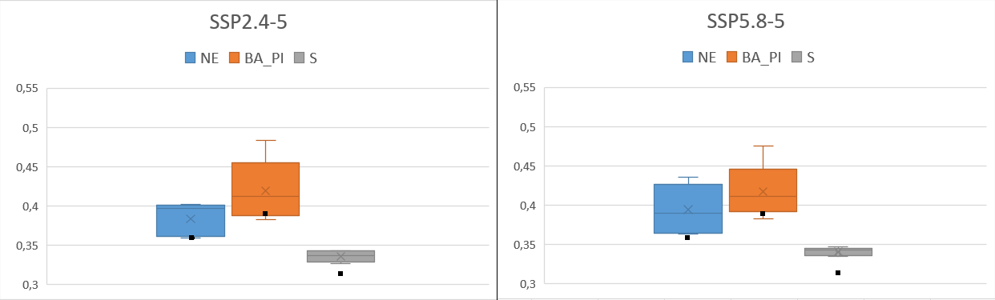
Figure 4a – fwCF annual mean variability by clusters between the GCMs in the mid- century for SSP2-4.5 and SSP5-8.5. Black dots represent hwCF.

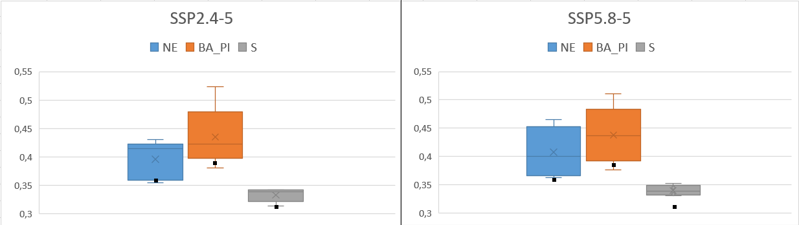
Figure 4b – fwCF annual mean variability by cluster between the GCMs at the end of the century for SSP2-4.5 and SSP5-8.5. Black dots represent hwCF.

3 – Results: Solar PV Ensemble

Table 9 - 12 and Figures 5 - 7, present the solar PV results for each cluster, scenario, and time slice. The values correspond to the ensemble of the selected GCMs

Table 9a - Surface solar irradiance change factor (∆sR) representing the relative difference between the mean sR at the mid-century (2040-2069) and the historical period (1985-2014).
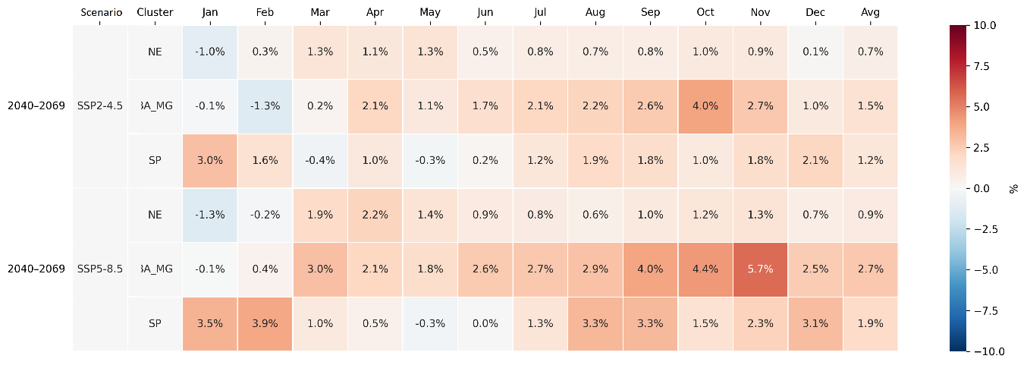
Table 9b - Surface solar irradiance change factor (∆sR) representing the relative difference between the mean sR at the end of the century (2070-2099) and the historical period (1985-2014).
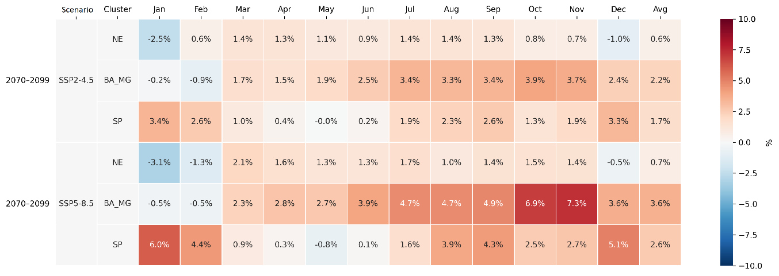
Table 10a - Solar panel efficiency change factor (∆ sPE) representing the relative difference between the mean sPE at the mid-century (2040-2069) and the historical period (1985-2014).
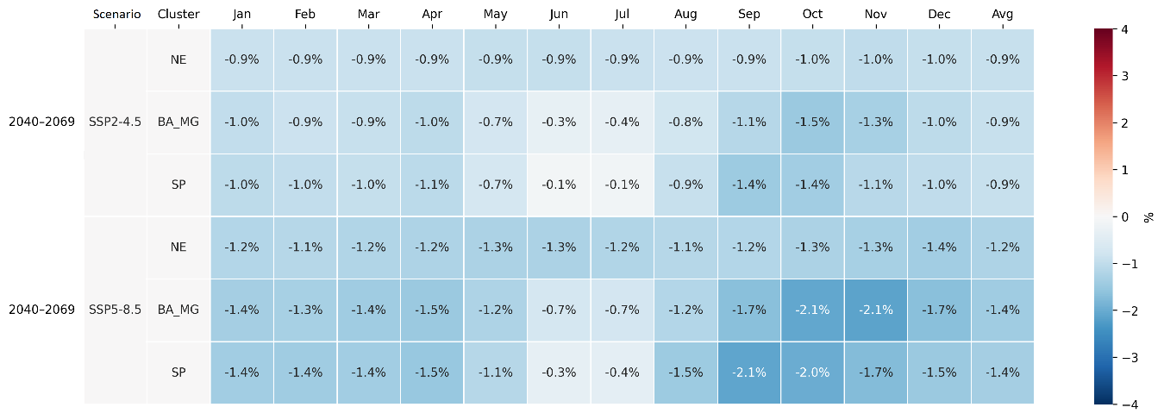
Table 10b - Solar panel efficiency change factor (∆ sPE) representing the relative difference between the mean sPE at the end of the century (2070-2099) and the historical period (1985-2014). 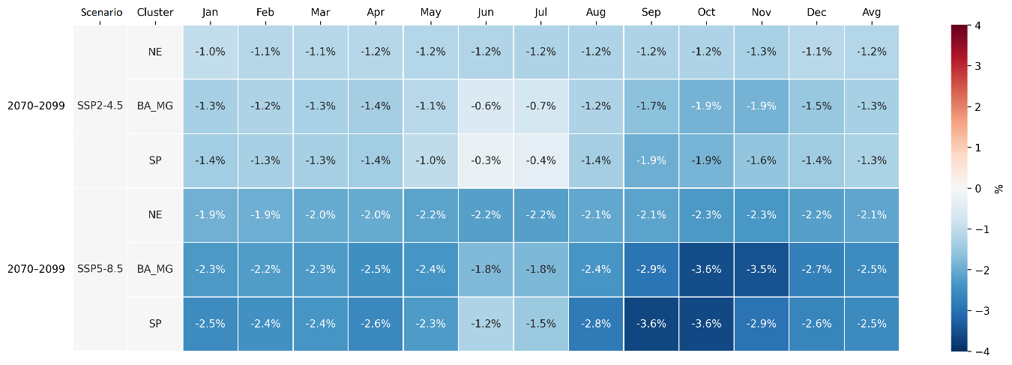
Table 11 - Historical solar capacity factor (hsCF).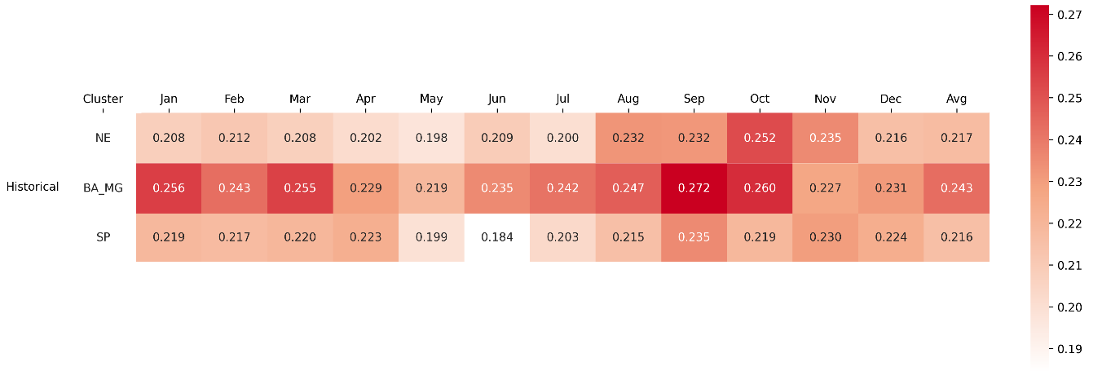
Table 12a - Future solar capacity factor (fsCF) at the mid-century (2040-2069).
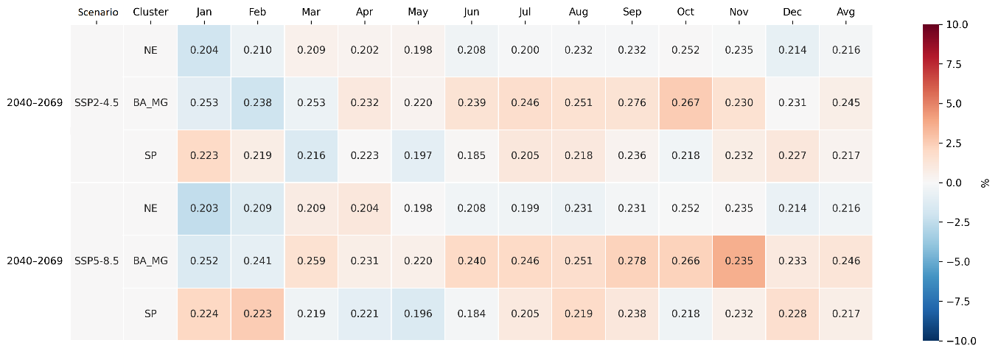
Notes: The heatmap indicates variations in fsCF in comparison with hsCF.

Table 12b - Future solar capacity factor (fsCF) at the end of the century (2070-2099).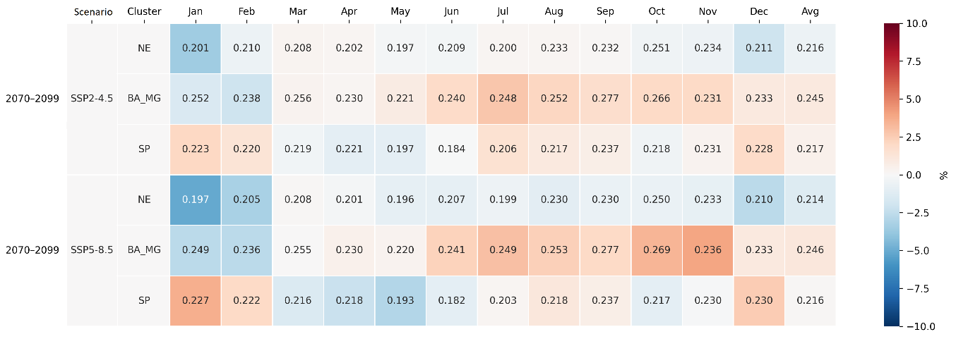Notes: The heatmap indicates variations in fsCF in comparison with hsCF.
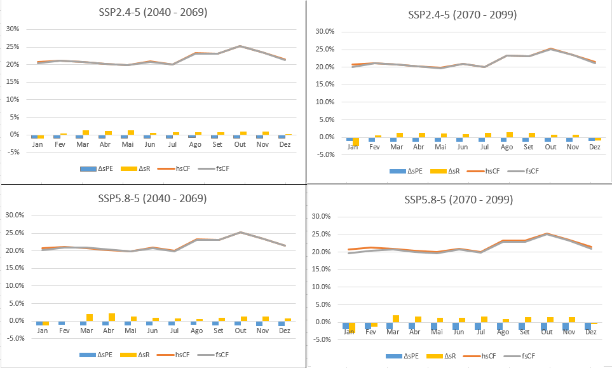
Figure 5 - Cluster NE monthly future solar capacity factor (fsCF), historical solar capacity factor (hsCF), solar radiation change factor (∆sR) and solar PV panel efficiency change factor (∆SPE)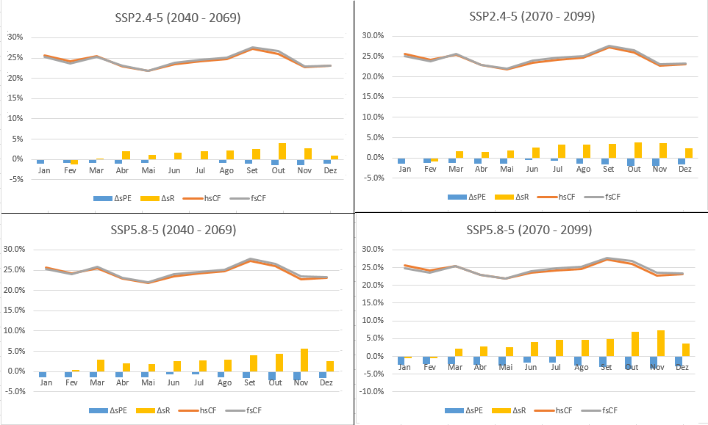
Figure 6 - Cluster BA_MG monthly future solar capacity factor (fsCF), historical solar capacity factor (hsCF), solar radiation change factor (∆sR) and solar PV panel efficiency change factor (∆SPE)
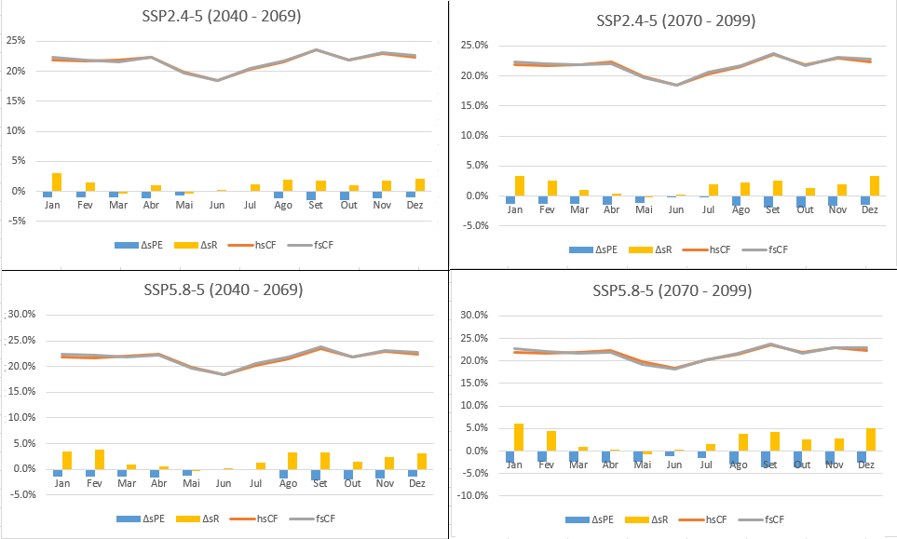
Figure 7 - Cluster SP monthly future solar capacity factor (fsCF), historical solar capacity factor (hsCF), solar radiation change factor (∆sR) and solar PV panel efficiency change factor (∆SPE)

3 - Future solar PV capacity factor variability by GCM

Tables 6, 7, and 8 display the fsCF for each cluster, displaying all GCMs utilized in the analysis. In addition to the monthly values, the tables also report the corresponding monthly means and standard deviations.

Table 6 - Cluster NE future solar capacity factor (fsCF)

Table 7 - Cluster BA_MG future solar capacity factor (fsCF)

Table 8 - Cluster SP future solar capacity factor (fsCF)
Figure 8 displays the fsCF annual mean variability among GCM using boxplots for each cluster, scenario and time-slice.
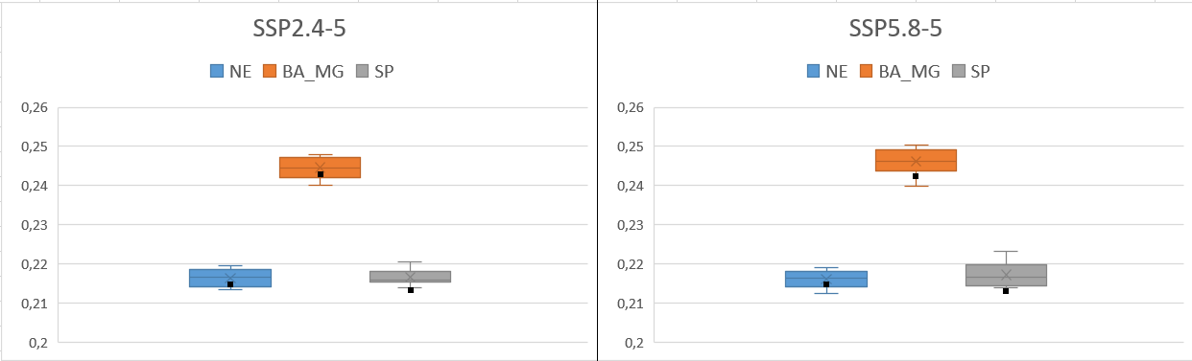Figure 8a – fsCF annual mean variability by cluster between the GCMs in the mid-century for SSP2-4.5 and SSP5-8.5. Black dots represent hsCF.
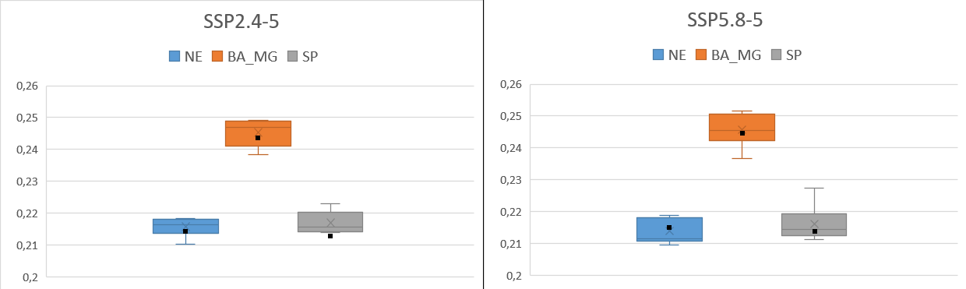
Figure 8b – fsCF annual mean variability by cluster between the GCMs at the end of the century for SSP2-4.5 and SSP5-8.5. Black dots represent hsCF.

