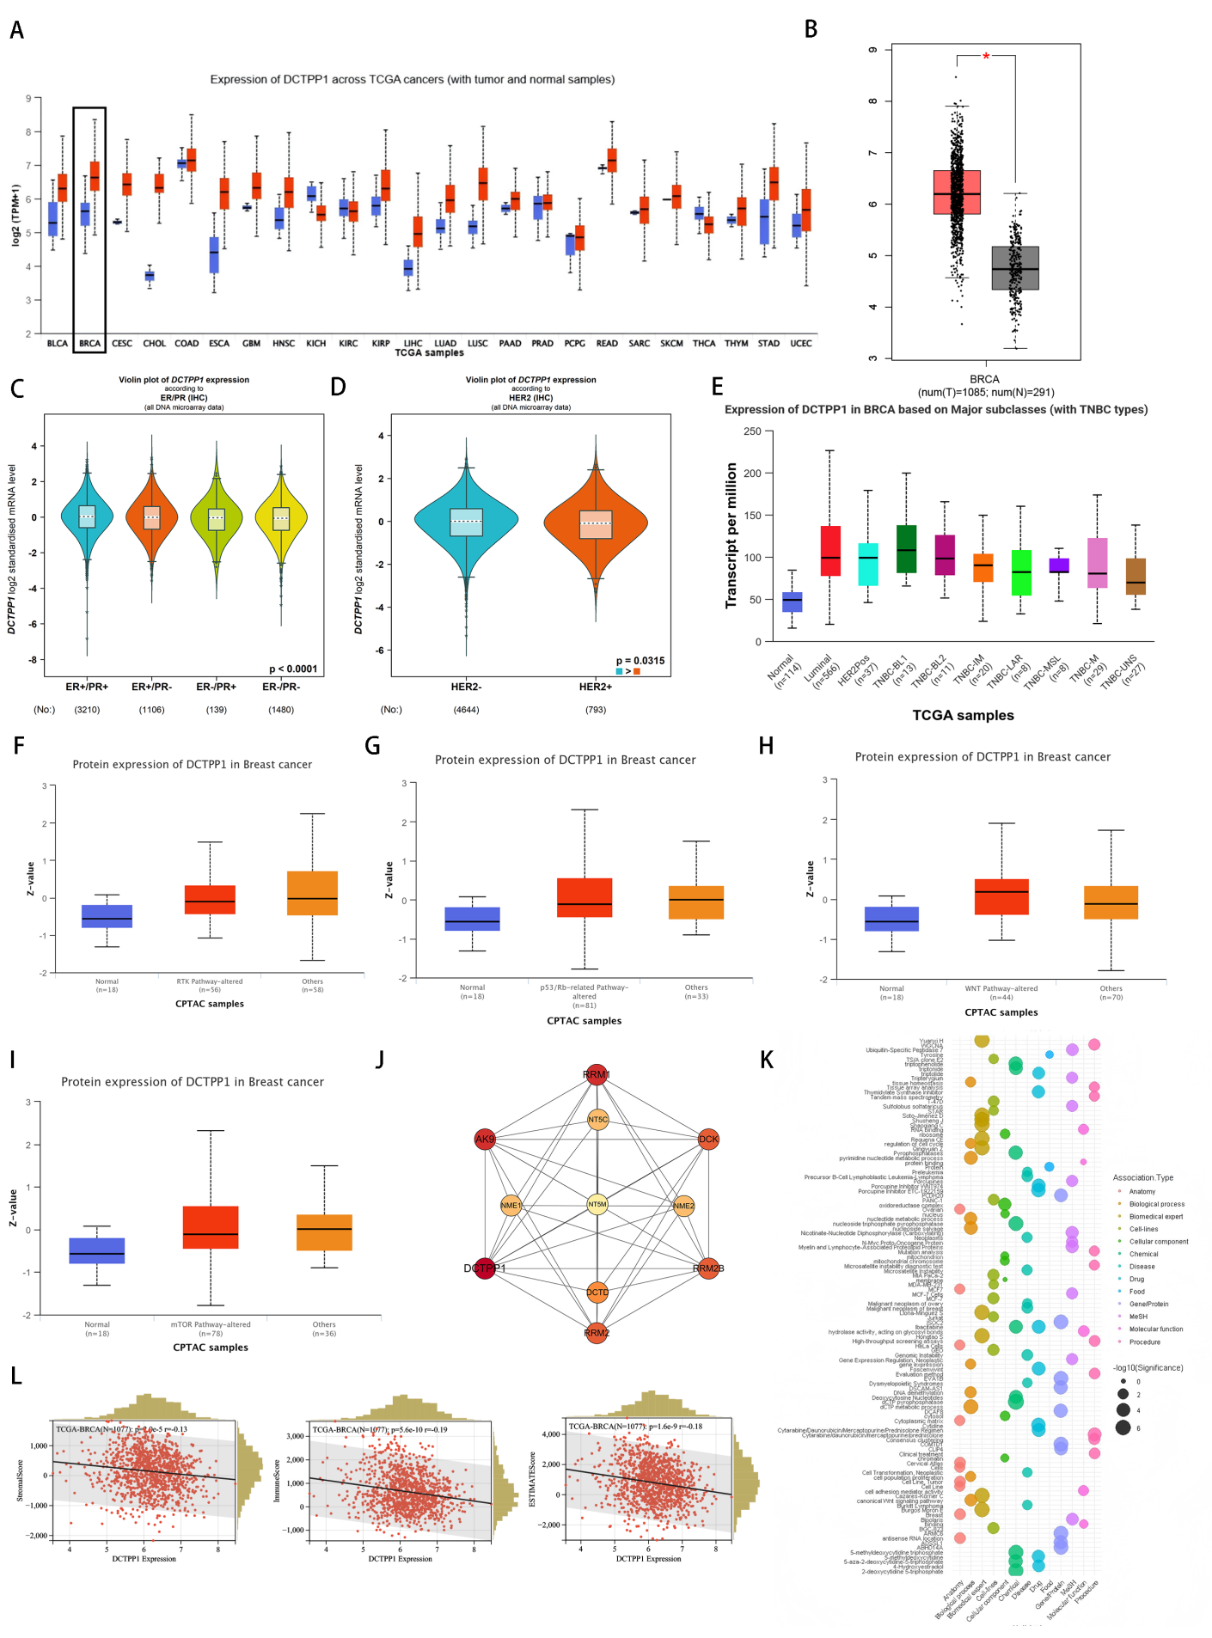
Supplementary Fig.1 Pan-cancer analysis of DCTPP1 and its bioinformatics analysis in breast cancer

Note: (A) Pan-cancer analysis of DCTPP1 transcriptional level differences between normal tissues and breast cancer tissues. (B) Expression differences of DCTPP1 in normal breast tissue and breast cancer tissue. (C-E) Expression differences of DCTPP1 in different molecular phenotype breast cancers. Violin plots showing expression differences in ER/PR (C), HER2-negative and HER+ breast cancers (D), and clinical phenotype-specific expression differences of DCTPP1 (E). (F-I) Expression differences of DCTPP1 protein in samples with altered pathways. Significant expression differences were observed in RTK pathway-altered samples (F), p53/Rb pathway-altered samples (G), WNT pathway-altered samples (H), mTOR pathway-altered samples (I), and others (pathway-unchanged breast cancer samples) (J). Cytoscape-based mapping of DCTPP1 protein interaction network (K). Bubble plot based on Coremine database illustrating the significance intensity of DCTPP1 association with various biological concepts (e.g., anatomy, biological processes, etc.) (L). Correlation maps showing associations between matrix scores, immune scores, and ESTIMATE scores and DCTPP1 expression.

