Supplementary Information

Thick single-crystal rhombohedral boron nitride as a substrate platform enabling high-performance III-V electronics
Pengfei Yang^{1,2#}, Haidi Wu^{3,4,5#}, Quan Xie^{6,7}, Fangyuan Zheng², Ni Yang², Qi Jiang⁸, Junbo Yang¹, Haoran Zhang^{3,4,5}, Shiyu Li^{3,4,5}, Maoyang Xia^{3,4,5}, Yu-Ming Chang¹, Chenyang Li¹, Jincheng Zhang^{3, 4, 5}, Yue Hao^{3, 4, 5}, Yi Wan², Qinghong Yuan^{6,7}, Feng Ding^{7*}, Jing Ning^{3, 4, 5*}, and Lain-Jong Li^{1*}

¹ Department of Materials Science and Engineering, National University of Singapore, Singapore
² Department of Mechanical Engineering, The University of Hong Kong, Hong Kong, China
³ The State Key Laboratory of Wide-Bandgap Semiconductor Devices and Integrated Technology, Xi’an 710071, China
⁴ Shaanxi Joint Key Laboratory of Graphene, Xidian University, Xi’an 710071, China
⁵ Xidian-Wuhu Research Institute, Wuhu 241000, China
⁶ State Key Laboratory of Precision Spectroscopy, School of Physics and Electronic Science, East China Normal University, Shanghai, China
⁷ Suzhou Laboratory, Suzhou, China
⁸ Shanghai Synchrotron Radiation Facility, Shanghai Advanced Research Institute, Chinese Academy of Sciences, Shanghai, China

*Address correspondence: lance.li@nus.edu.sg; ningj@xidian.edu.cn; f.ding@siat.ac.cn
#These authors contributed equally to this work.

Contents
Supplementary Note 1: A summary of CVD grown thick-layer BN.
Supplementary Note 2: MD simulations.

Supplementary Note 1: A summary of CVD grown thick-layer BN.
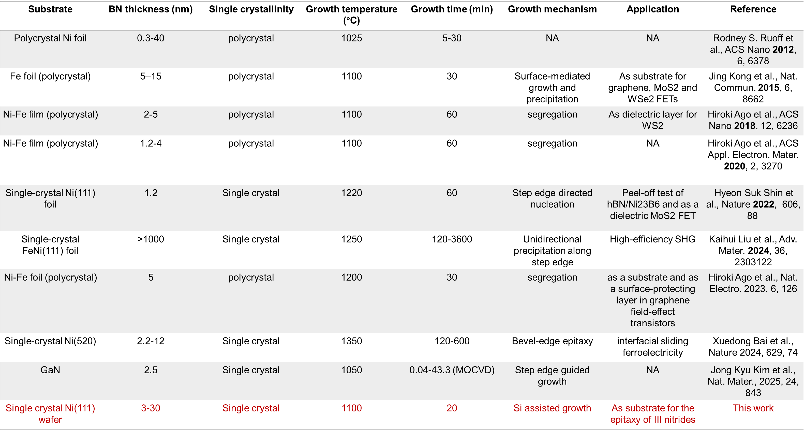
Supplementary Table. 1 | A summary of growth parameters and results for thick-layer BN synthesized via CVD methods.

Supplementary Note 2: MD simulations

To elucidate the underlying mechanism of silicon-assisted growth of high-quality thick-layer rBN, we conducted molecular dynamics (MD) simulations based on machine learning force fields (MLFFs). A high-precision neuroevolution potential (NEP) was developed for the quaternary Ni–Si–B–N system using an extensive first-principles dataset (accuracy metrics in Supplementary Figs. 1–4). This potential function enables reliable large-scale, long-timescale MD simulations.

Using the well-trained potential function, we first examined the effect of substrate phase state on the dissolution behavior of B and N atoms. A 60-layer Ni(111) substrate model was constructed and heated it to 1400 K and 2000 K to represent solid and liquid substrate environments, respectively. During the simulation, B and N atoms were continuously introduced to the surface to mimic the chemical vapor deposition (CVD) process. After 20 nanoseconds of evolution, distinct atomic distributions emerged (Extended Data Fig. 3a). While both substrates exhibited near-surface enrichment of B and N atoms, their penetration depths differed markedly (Extended Data Fig. 3b). B and N atoms showed negligible solubility in solid Ni, but high solubility in liquid Ni, maintaining substantial concentrations deep into the substrate. These results demonstrate that substrate liquefaction is the key factor enabling enhanced solubility of B and N atoms, thereby providing sufficient atomic reservoirs for subsequent thick-layer rBN growth.

We further investigated how Si incorporation regulates substrate melting behavior. MD simulations with varying Si layer thicknesses revealed rapid interdiffusion of Si into Ni at 1400 K, forming a liquid Ni–Si alloy layer (Extended Data Fig. 3c, left panel), consistent with experimental observations. The equilibrium Si concentration profiles at 300 K show a confined high-Si region near the surface, and drops sharply to background levels (Extended Data Fig. 3c, right panel), matching our SIMS analysis (Extended Data Fig. 6). The computed Ni–Si phase diagram (Extended Data Fig. 3d) indicates that Si incorporation substantially lowers the melting point: at 20–25 at.% Si, the alloy melts at 1100–1300 K, far below the 1728 K of pure Ni. Hence, at the experimental growth temperature (1400 K), the Ni–Si surface is actually a molten state rather than a solid state. This phase transition explains the enhanced solubility of B and N and establishes a liquid atomic reservoir that sustains thick-layer rBN growth.

To visualize the distinct growth kinetics, we simulated the complete rBN growth process on solid and liquid Ni substrates (Extended Data Fig. 3e,f). On solid Ni, limited solubility leads to surface segregation and nucleation at ~23 ns, followed by slow lateral epitaxy to form a monolayer hBN within ~69.3 ns. In contrast, the liquid substrate delays nucleation (~84.5 ns) but accumulates abundant dissolved B and N atoms. Once nucleation occurs, the supersaturated liquid drives rapid atomic incorporation, completing monolayer formation within ~1.7 ns and multilayer rBN growth by ~123 ns, an overall rate enhancement of nearly 27 compared to solid-state epitaxy.

These results demonstrate that Si incorporation enables substrate liquefaction by reducing the Ni melting point from 1728 K to ~1200 K, maintaining a liquid surface at the growth temperature. The liquid state enhances atomic solubility and diffusion, provides a continuous atomic reservoir, and promotes rapid, defect-suppressed epitaxy. This Si-assisted liquid-phase mechanism fundamentally overcomes the kinetic limitations of solid-state epitaxy, offering an effective pathway for the controlled synthesis of high-quality thick-layer 2D materials.

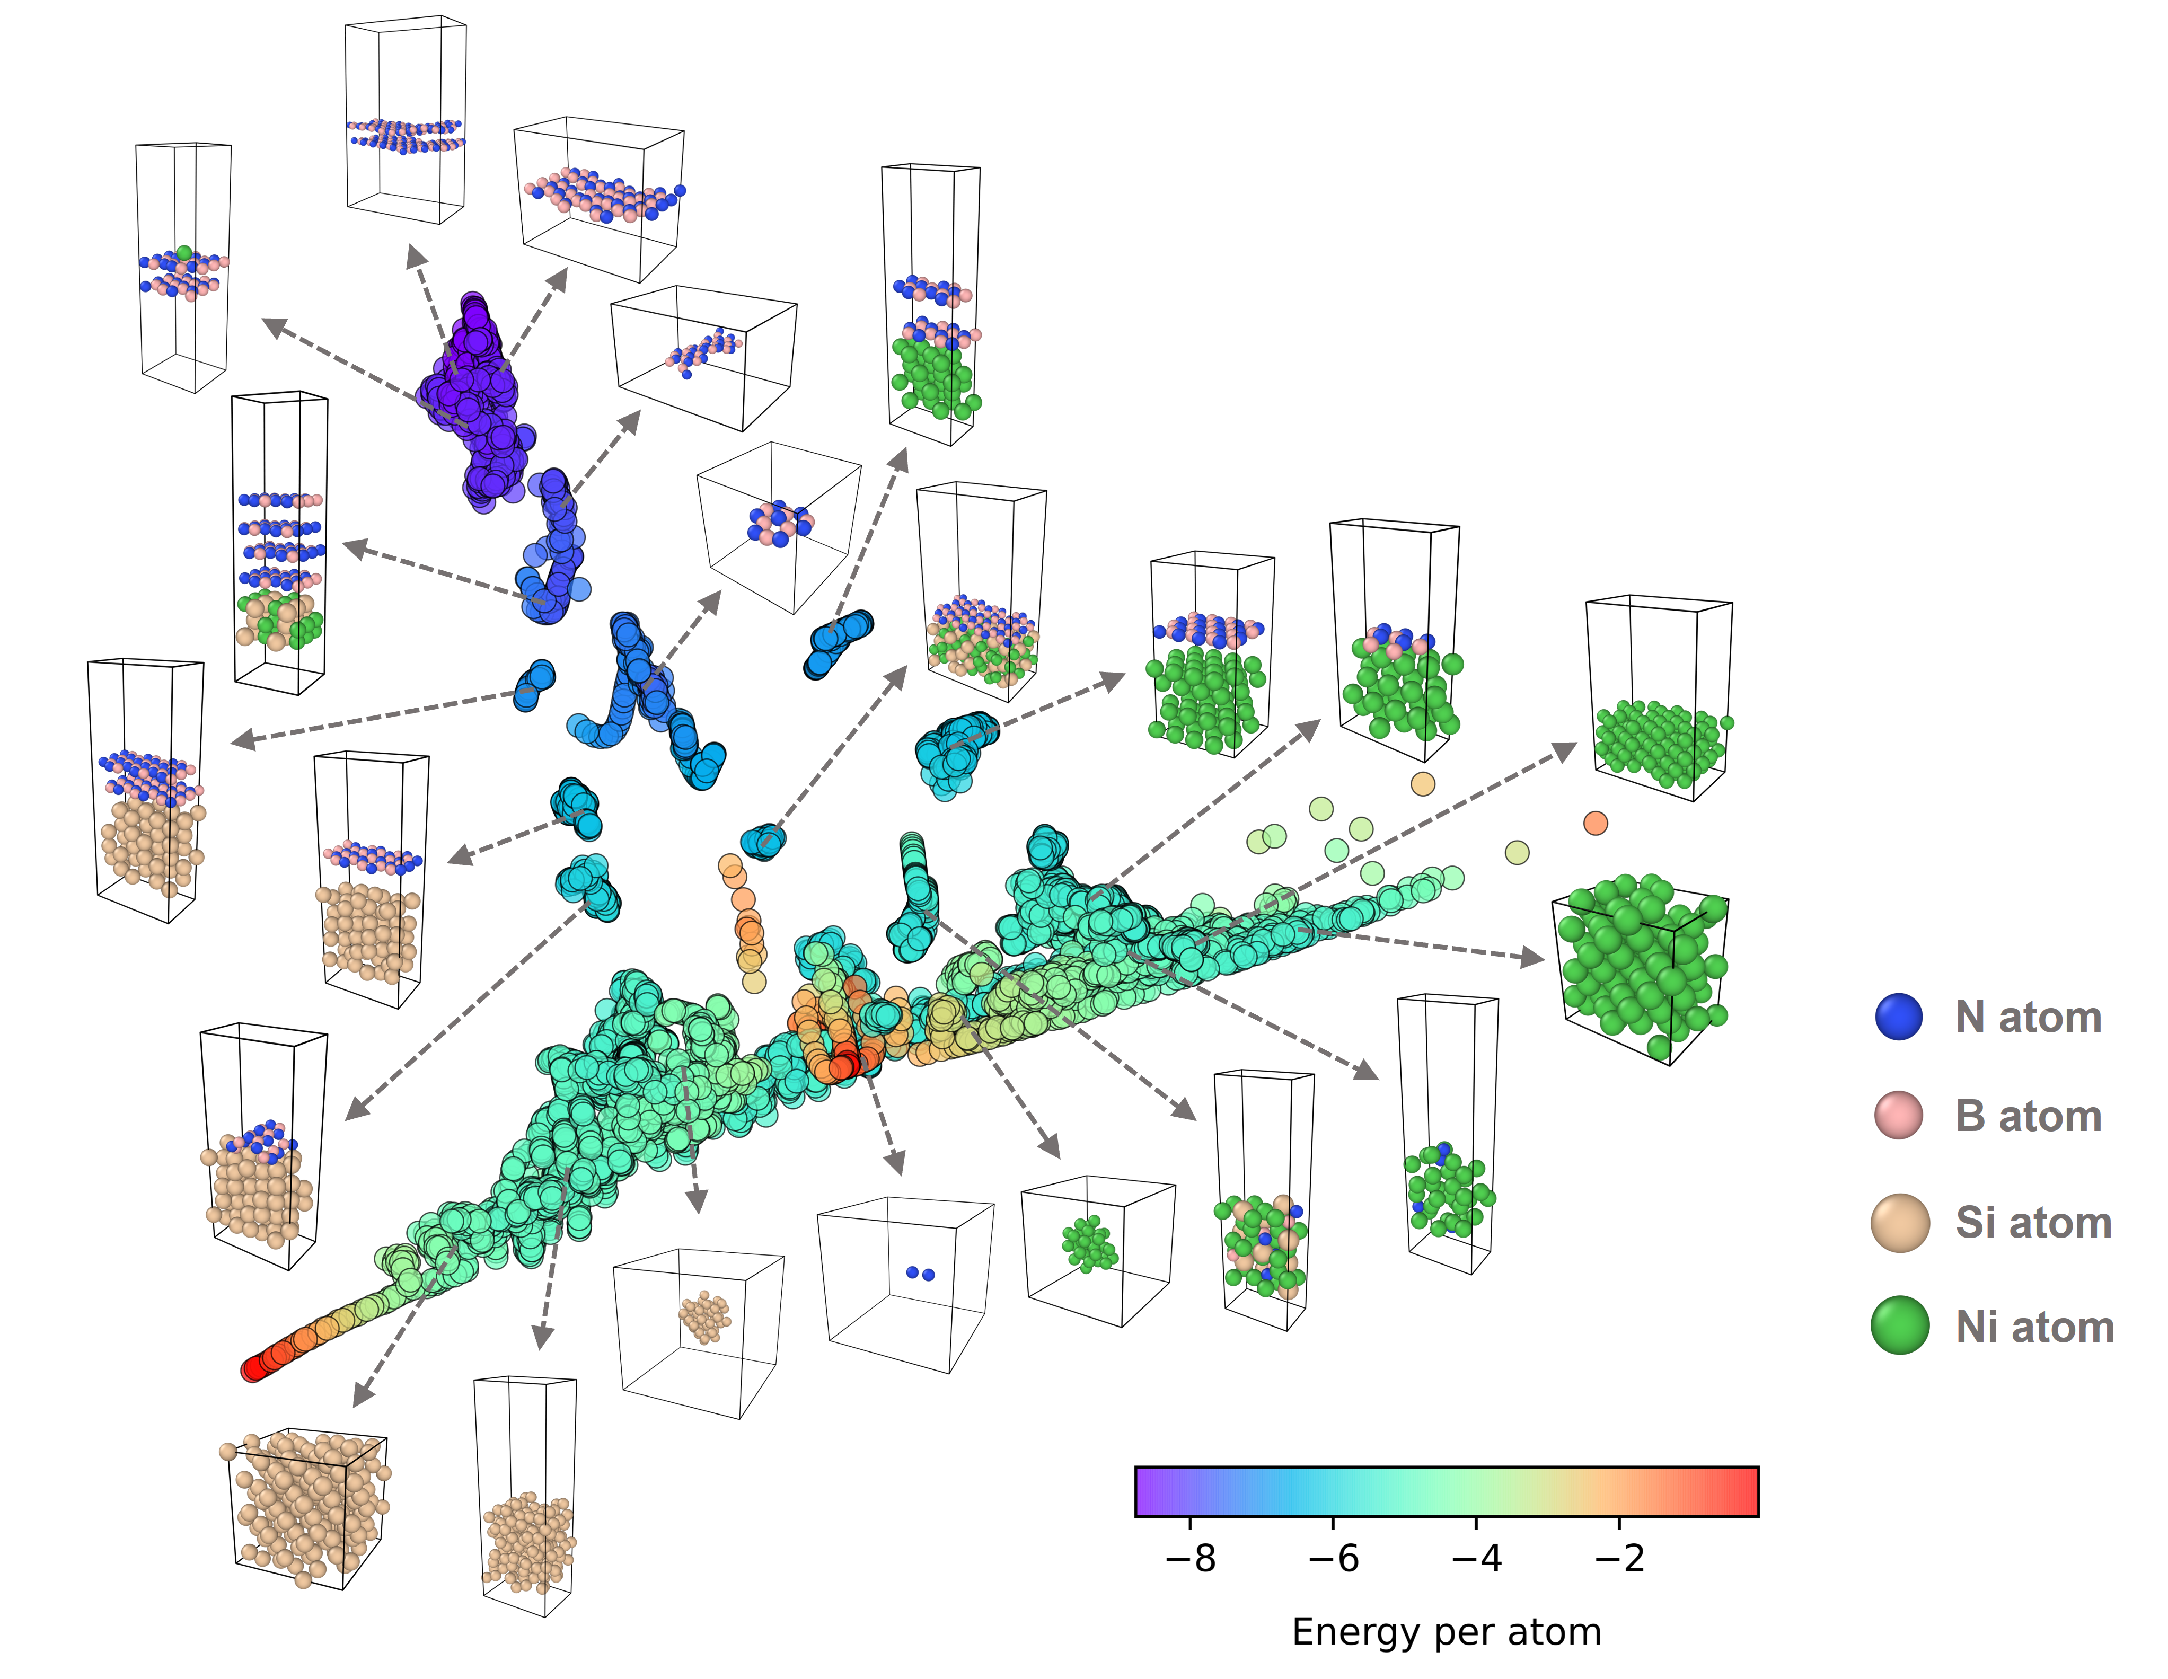
Supplementary Fig. 1 | Configuration space distribution of the training dataset. Each point represents a distinct atomic configuration projected onto the first two principal components, with colors indicating the corresponding DFT energy per atom.

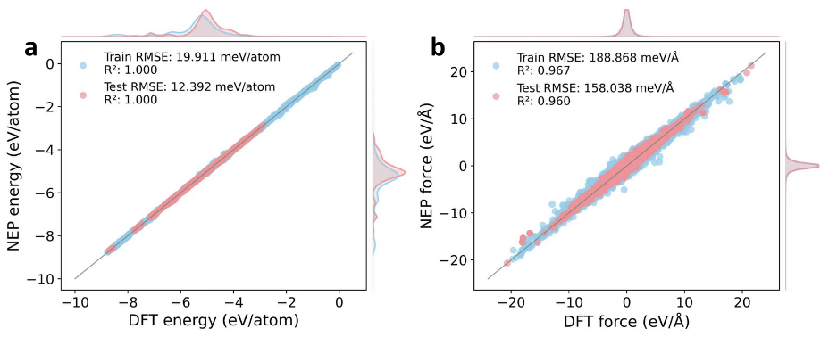

Supplementary Fig. 2 | Parity plots for NEP model performance. Comparison between DFT-calculated and NEP-predicted (a) energies and (b) forces for the training and test datasets. The grey diagonal line represents perfect agreement. Marginal density distributions show the data distribution for DFT (top/right) and NEP (left/bottom) predictions, with peak intensities indicating the frequency of occurrence. RMSE and R² values quantify the prediction accuracy.

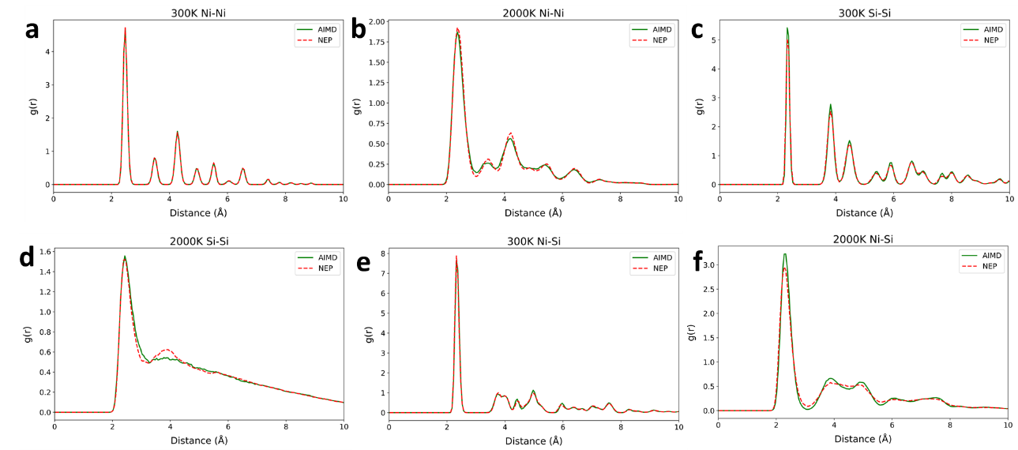
Supplementary Fig. 3 | Radial distribution functions for bulk metallic systems. Comparison of RDFs calculated by DFT (symbols) and NEP (lines) for Cu (a, b), Ni (c, d), and Ni-Si (e, f) systems at 300 K (a, c, e) and 2000 K (b, d, f). The excellent agreement with DFT calculations validates the NEP’s accuracy in reproducing structural correlations across different temperatures and compositions.
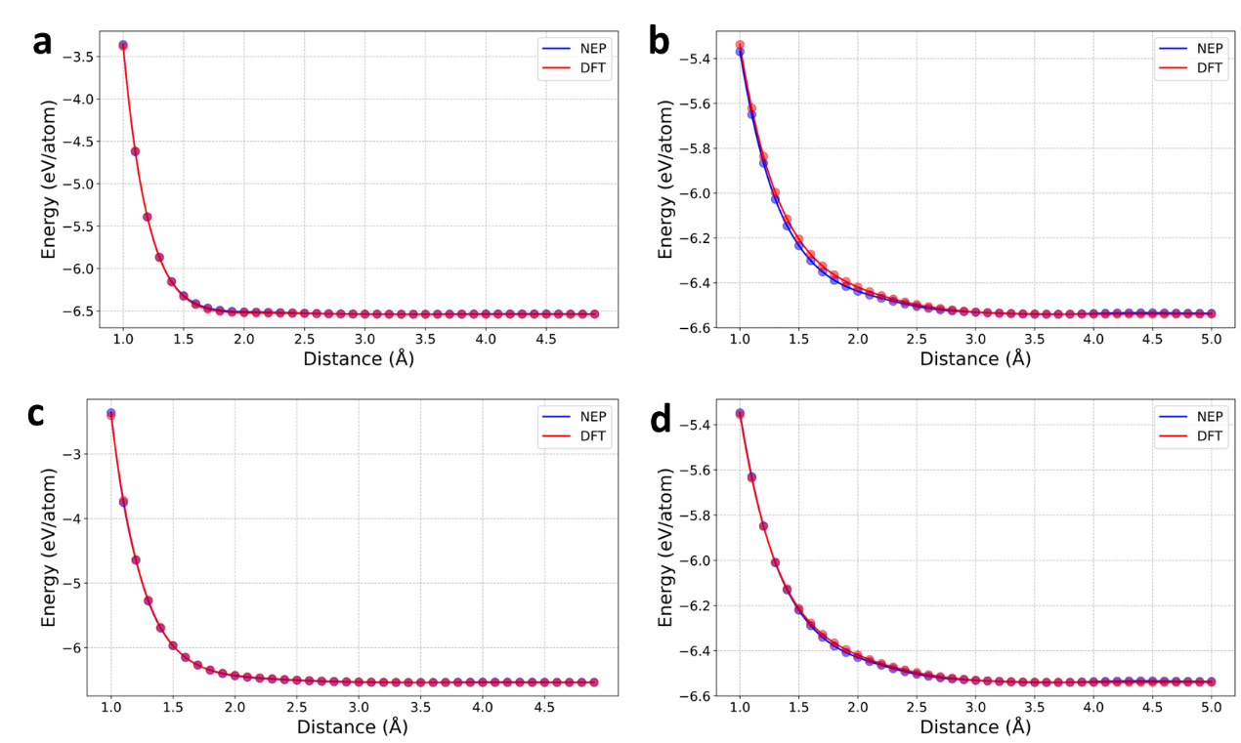

Supplementary Fig. 4 | Validation of van der Waals interactions for hBN/Ni(111) interface. (a-d) Adsorption energy comparison between DFT and NEP for four distinct configurations: (a) N-top, (b) N-hollow, (c) B-top, and (d) B-hollow sites. The excellent agreement demonstrates NEP’s capability to accurately capture weak van der Waals interactions at the 2D/metal interface.

