Appendix 1. Selection of SoyMGI diversity panel

The objective of this method was to select the most diverse (genetically) set of accessions (for a fixed sample size) from a large collection of genotypes using their whole-genome marker profiles alone.
For this, we aimed to find out of the universe $\left(X_{1271,20K}\right)$of $n=1271$ accessions in maturity group MG I held in the USDA Soybean Germplasm Collection, a reduced set of genotypes of size $n_{0}=400$ that minimize the $E\left(S^{2}\right)$, with $S=X_{0}^{'}X_{0}$ where $X_{0}$ is a marker incidence matrix of 400 x 20,000. The number of polymorphic SNPs used for this analysis was 20,000.
The $E\left(S^{2}\right)$ is defined as the sum of the squared values of the off-diagonal elements of $S^{2}$; $S_{20K,20K}$ is a matrix of genetic similarities between pairs of marker SNPs for a given set of 400 accessions.
The idea is to find the set of accessions that produces (on average) the least correlated (in absolute values) genetic similarities between pairs of markers by minimizing $E\left(S^{2}\right)$.
To accomplish this, we developed an iterative procedure that sequentially evaluates candidate accessions to compose the reduced set. In what follows we describe this method.
We first define $X_{1271,20K}=\left[\begin{matrix}X_{1}^{(1)} \\ X_{0}^{(1)}\end{matrix}\right]$ where the accessions in $X_{1}^{(1)}$ and $X_{0}^{(1)}$are initially randomly selected. In this case, $X_{0}^{(1)}$ corresponds to the initial reduced set of accessions while $X_{1}^{(1)}$ contains the remaining accessions. This last set of 871 = 1271-400 accessions contains the candidate genotypes to compose the reduced set.
In the first step, we compute the $E\left(S^{2\left(1\right)}\right)$ for the initial set of candidate accessions $X_{0}^{(1)}$. Then, we substitute the first genotype from $X_{1}^{(1)}$ $\left(i.e., X_{1[1,]}^{(1)}\right)$ on each one of the 400 positions from the target set $X_{0[i,]}^{(1)}$ $\left(i=1,2,…,400\right)$ and assess the $E\left(S_{i,1}^{2(1)}\right)$. This will produce a vector with the $E\left(S^{2}\right)$ derived from substituting the candidate genotype $\left(j = 1\right)$ from $X_{1}^{(1)}$ $\left(X_{1[j,]}^{(1)}\right)$.
We repeat the same procedure for the second genotype $\left(j = 2\right)$ in the set of candidate accessions $\left(X_{1[2,]}^{(1)}\right).$ This will result in a second vector with the corresponding $E\left(S^{2}\right)$ derived from substitute the second genotype from $X_{1}^{(1)}$ on each one of the 400 positions of $X_{0}^{(1)}$. Sequentially, we repeat the same procedure for all the genotypes in the set of 871 candidate accessions ($j=1,2,…,871$).

The previous procedure produces a matrix of order 400 × 871 whose entries contain the obtained $E\left(S_{i,j}^{2(1)}\right)$ for all ${\left(i,j\right)}^{th}$ combinations.

$S_{1,1}^{2\left(1\right)}$ | $S_{2,1}^{2\left(1\right)}$ | . | . | . | $S_{400,1}^{2\left(1\right)}$
$S_{2,1}^{2\left(1\right)}$ | $S_{2,2}^{2\left(1\right)}$ |  |  |  | $S_{400,2}^{2\left(1\right)}$
. | . | . |  |  | .
. | . |  | . |  | .
. | . |  |  | . | .
$S_{400,1}^{2\left(1\right)}$ | $S_{400,2}^{2\left(1\right)}$ | . | . | . | $S_{400,871}^{2\left(1\right)}$

The next step consists of identifying the ${\left(i,j\right)}^{th}$ exchange of genotypes that returned the smallest $E\left(S^{2}\right)$ $\left[i.e, E_{min}\left(S_{i,j}^{2\left(1\right)}\right)\right]$ for the first iteration.
Next, we exchange the j^{th} genotype from the matrix of candidates $X_{1}^{(1)}$ (i.e., $X_{1[j,]}^{(1)}$) with the i^{th} genotype from the $X_{0}^{(1)}$ reduced matrix (i.e., $X_{0[i,]}^{(1)}$). With this we finalize the steps of the first iteration.
Thus, the total number of combinations for a single iteration is 348,400 = 400 × 871.
After exchanging both genotypes between these two matrices, the new partitions become $\left[\begin{matrix}X_{1}^{(2)} \\ X_{0}^{(2)}\end{matrix}\right]$. Then, the next iteration starts (second).
The same procedure is repeated for all iterations until $E_{min}\left(S_{i,j}^{2\left(k\right)}\right)≤E_{min}\left(S_{i,j}^{2\left(k+1\right)}\right)$ for the k^{th} iteration $\left(k=1,2,…\right)$.
In this study, a total of 246 iterations were necessary to reach convergence (Method Figure 1).
The selected samples are highlighted with blue color in the population structure plot derived from using the first two principal components derived from $G=XX^{'}=$ (Method Figure 2).
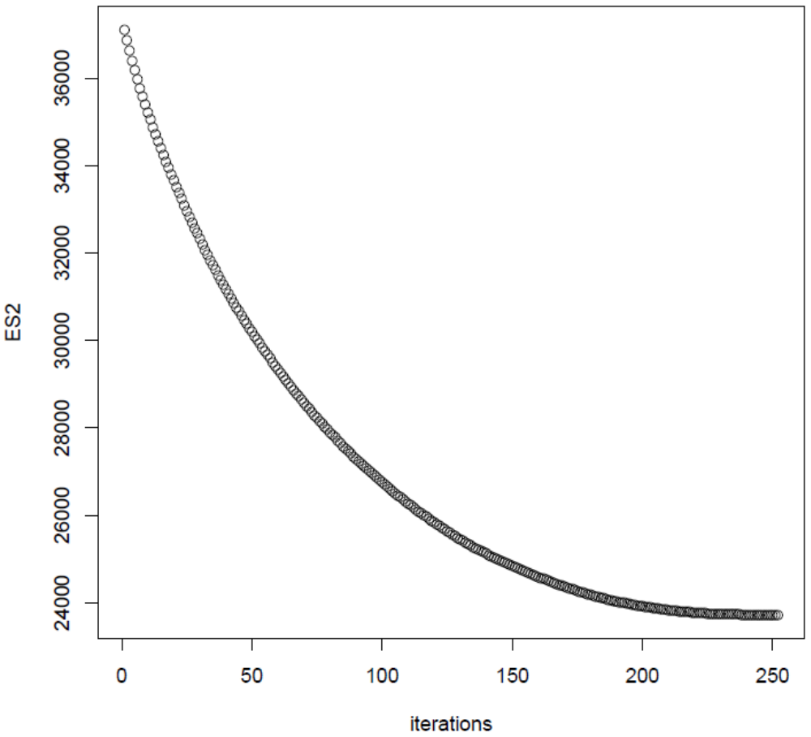
Method Figure 1. Progression of the $E_{min}\left(S_{k}^{2}\right)$ ($k=1,2,…, 246$) until convergence is reached
$\left[i.e., E_{min}\left(S_{i,j}^{2\left(k\right)}\right)≤E_{min}\left(S_{i,j}^{2\left(k+1\right)}\right) \right]$.

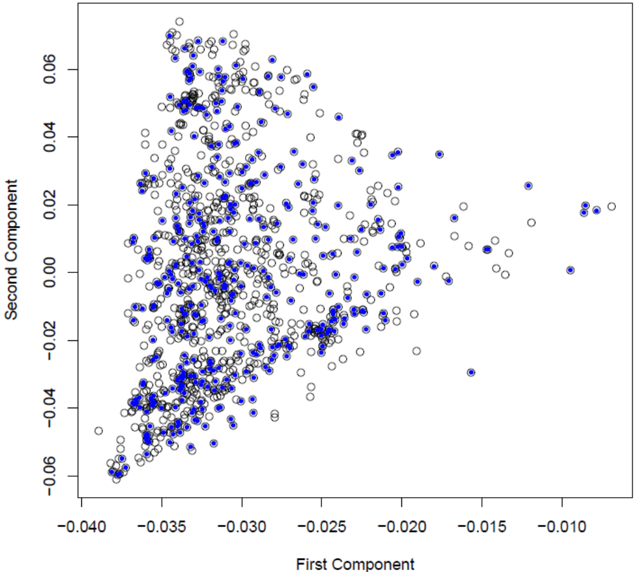
Method Figure 2. Population structure of the complete set of genotypes in maturity group 1 using the first two components derived from $G=XX^{'}$. The blue dots represent the final set of genotypes selected for the reduced set.

