SUPPLEMTARY MATERIALS – 2 – the procedure to calculate the RD and K parameters using the publicly available service: hphob.sano.science
ROLE OF Zn2+ IN PROTEIN STRUCTURALIZATION
Irena Roterman, Katarzyna Stapor, Dawid Dułak, Leszek Konieczny

PROCEDURE TO CALCULATE THE RD AND K PARAMETERS AS DEFINED IN FOD-M MODEL (FUZZY OIL DROP MODEL)
- The service is publicly available: hphob.sano.science
- The screen appearing is as follows
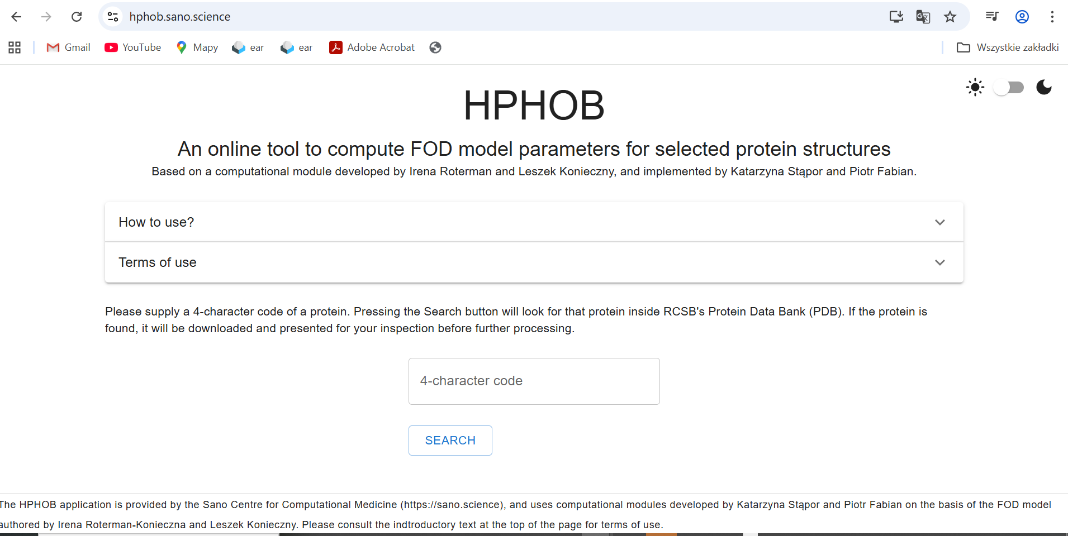
- The instruction of usage is given in the position How to use it ?
- The option: Terms of use introduces the potential user with the theoretical background of the FOD-M model
- The window : 4 character code – put here the PDB code of selected protein
- After introducing the PDB code and pushing the SEARCH option the dialog window is as follows after selecting the protein with 1LZ1 PDB code: 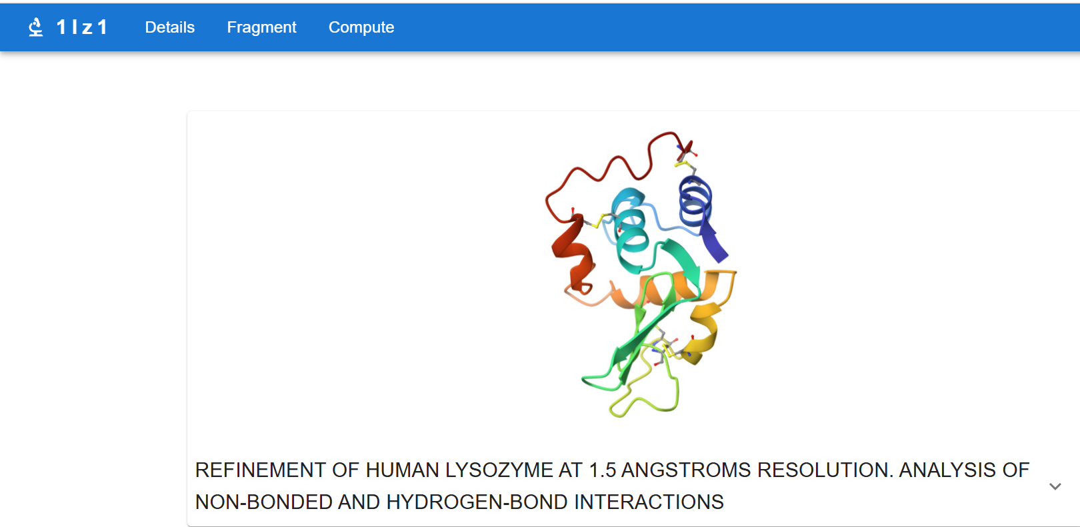
- After selection „COMPUTE” the short version of results appears as it is shown below
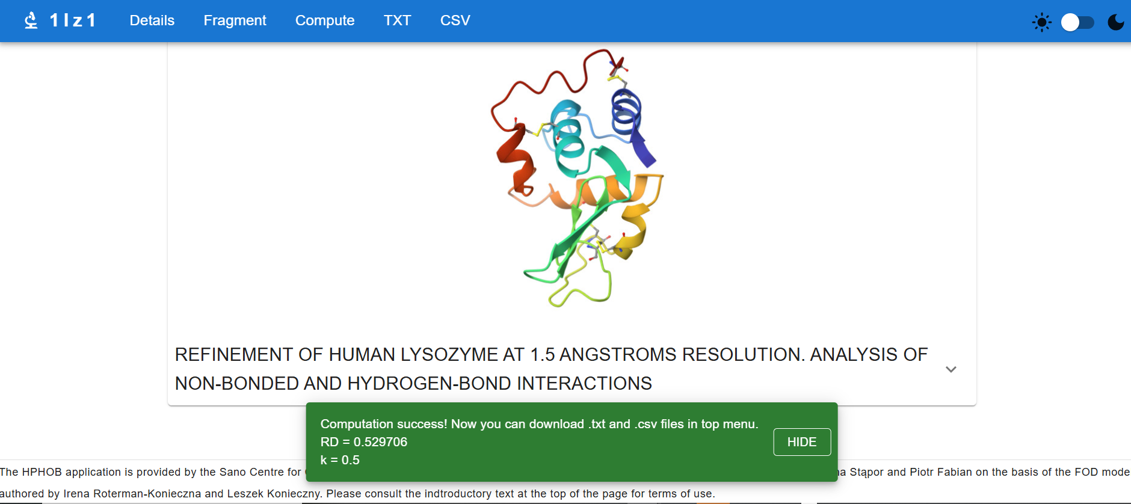
- The detailed results are available after selection of TXT 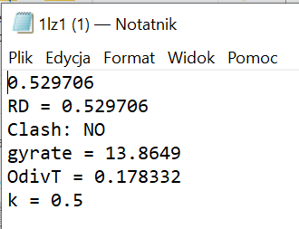
RD value as well K value are given in the file of .txt format – the opening of which gives the results as shown above.
- Selection of CSV option makes available the results in . csv format.
- The columns in this file as follows:
Column A – numer of residue according the numbering system as applied in PDB file
B – sequence – 3 letter codes
C – chain identification as appeared in PDB file
D – hydrophobicity scale applied
E – T values calculated according to 3D Gauss function
F – O values calculated according to Micehal Levitt function
G – values of Kullback-Leibler entropy for O|T relations
H – valued of Kullback-Leibler entropy for O|R relations
I, J, K – x, y, z positions for effective atoms
L, M, N – steps for M profile calculation
O – M distribution
- To draw the set of profiles columns A, E, F and O selected separately allows the graphic presentation of results in form of T, O and M profiles as shown below:

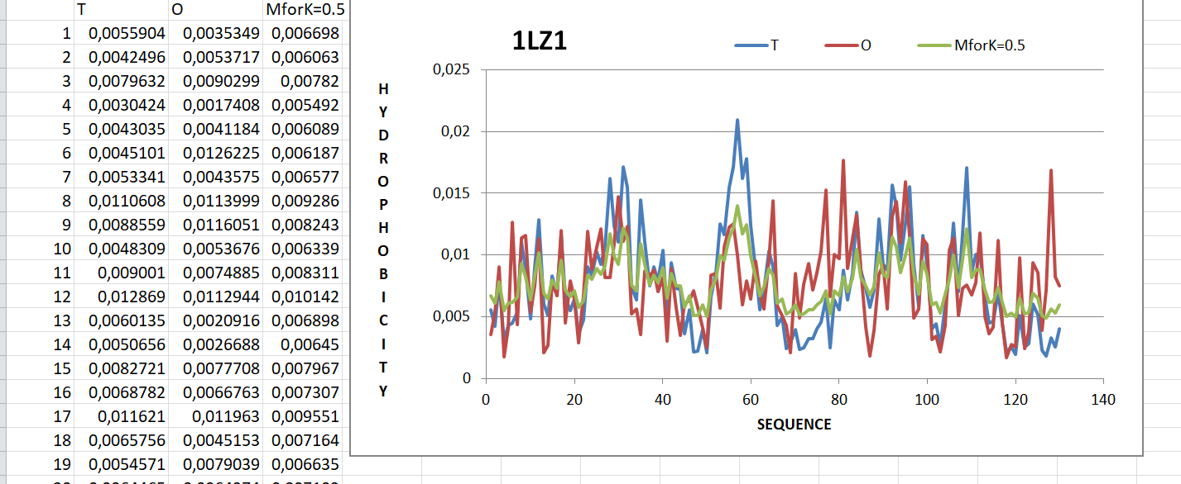
- The option FRAGMENT allows extraction of the part under condireation like : chain, domain of selected secondary fragment (PDB – 1A6P – two chains protein):
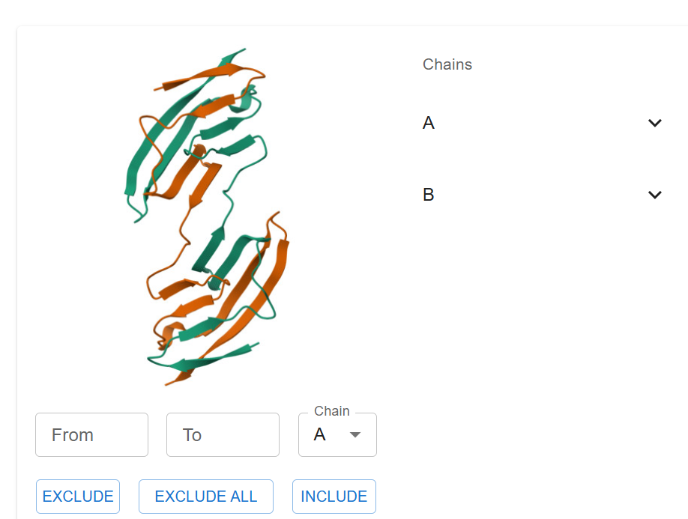

- To select chain A : click EXCLUDE ALL, than click INCLUDE and the chain in the window above will be treated for calculation after clicking on selected chain on the list on right.
- Selection of defined chain fragment – clicking on slected chain the list of fragments with defined secondary structure gets opened. Clicking on selected fragments makes tchem included in calculation. Only sheet fragment 5-9 got selected in the example below.
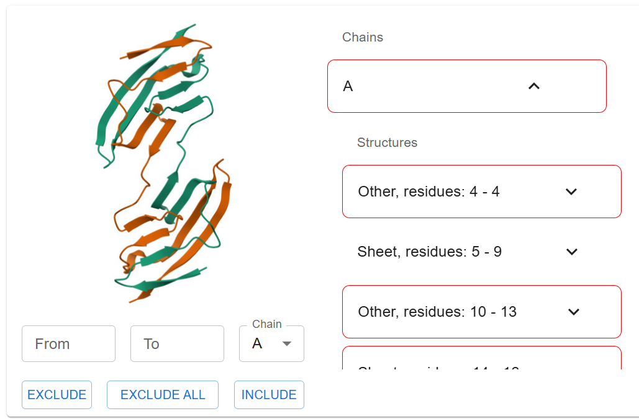
- The results files appeare after clicking the option CALCULATE.

In case of unsuccessful use please contact the Author :
Irena Roterman email:myroterm@cyf-kr.edu.pl

