Supplements
(5 pages, 136 words)

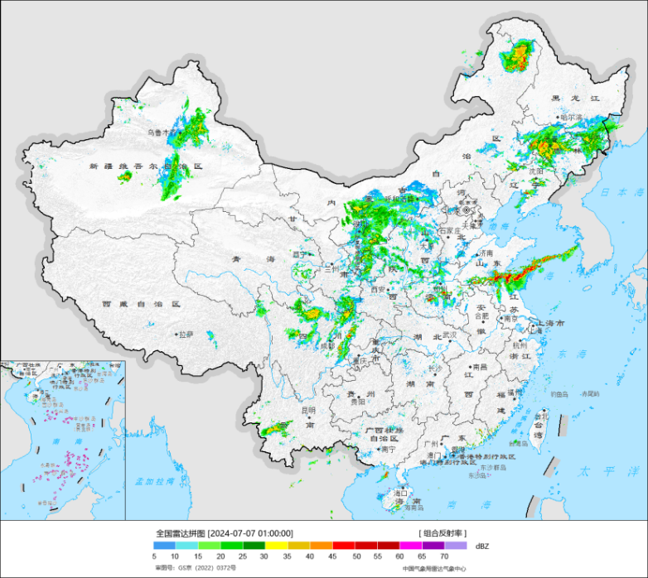
Fig. S1. Map of radar echoes for 7 July by the CMB showing a linear band of convective rain clouds extending from the Yellow Sea to Korea.

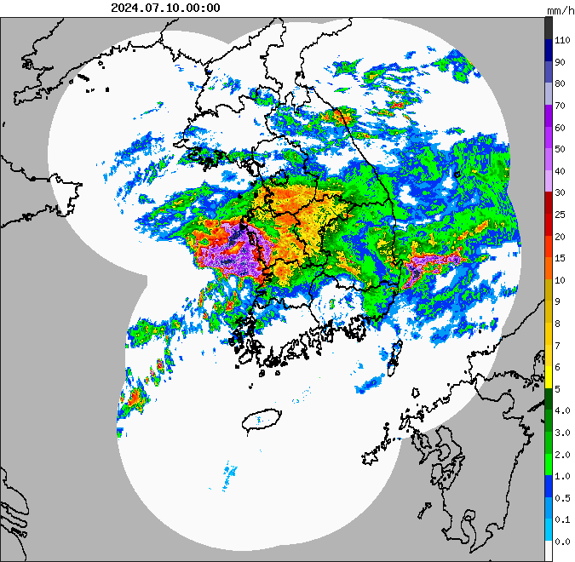
Fig. S2. Radar echoes from the KMA showing an image of intensive rainfall
occurring in western Korea on 10 July 2024.

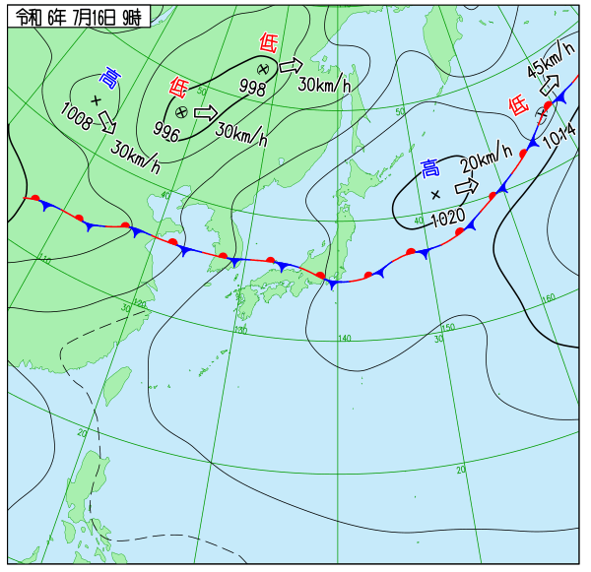
Fig. S3. Meteorological chart for 16 July given by the JMA.

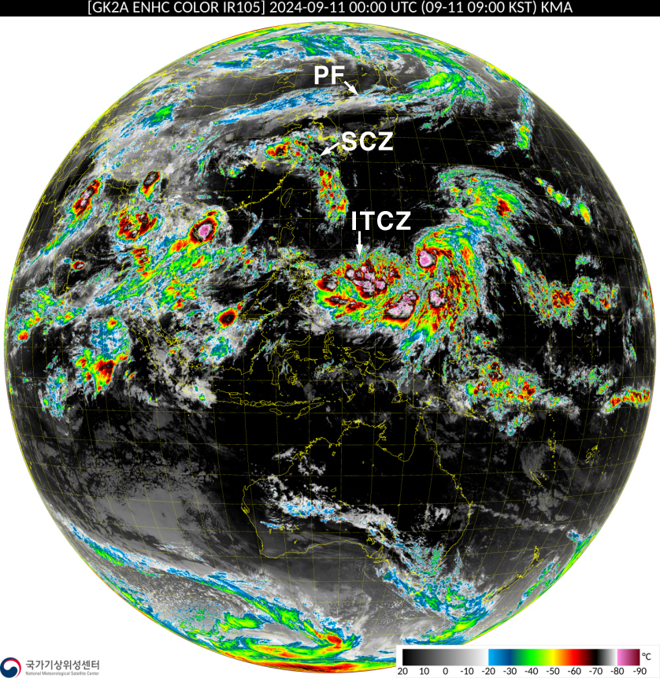
Fig. S4. Global satellite image from the KMA for 11 September showing the SCZ.

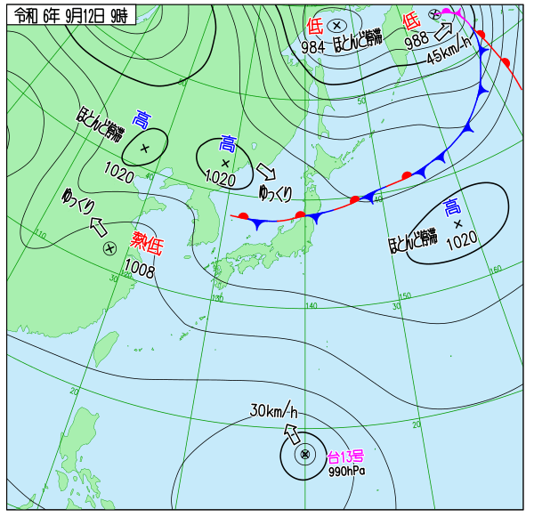
Fig. S5. Meteorological map for 12 September from the JMA.

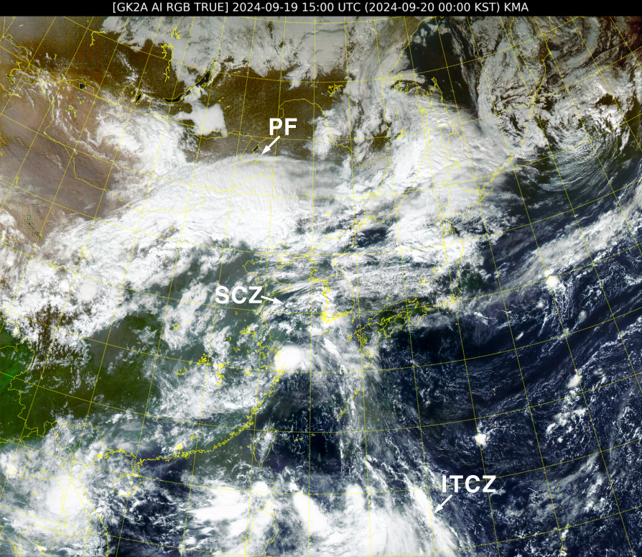
Fig. S6. Satellite image for 19 September from the KMA.

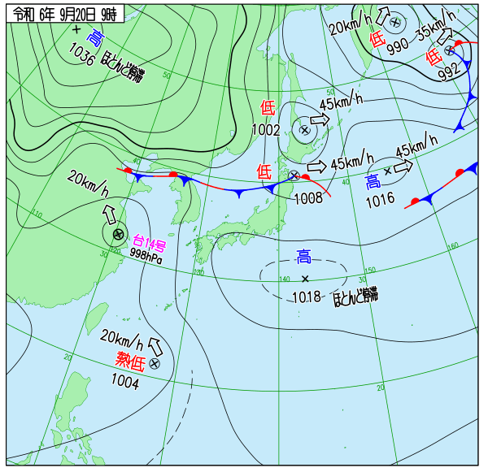
Fig. S7. Meteorological map for 20 September from the JMA.

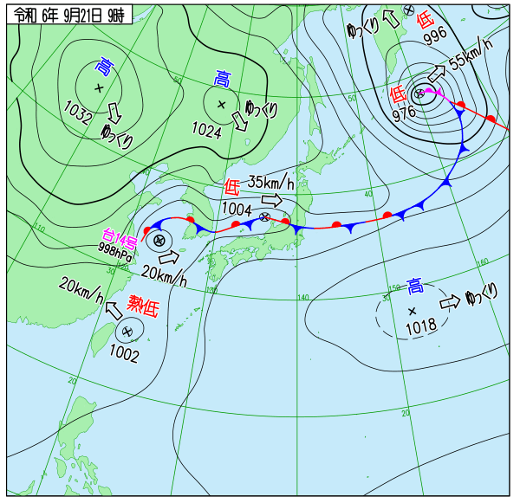
Fig. S8. Meteorological map for 21 September from the JMA.

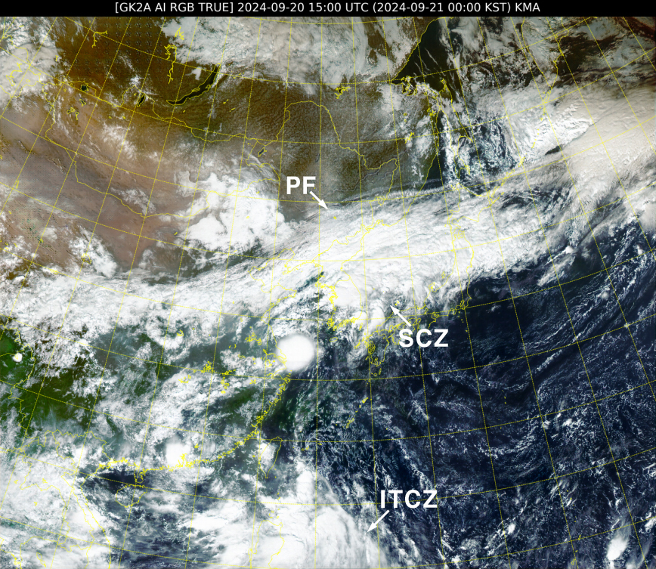
Fig. S9. Rgional satellite image for 20 September from the KMA.

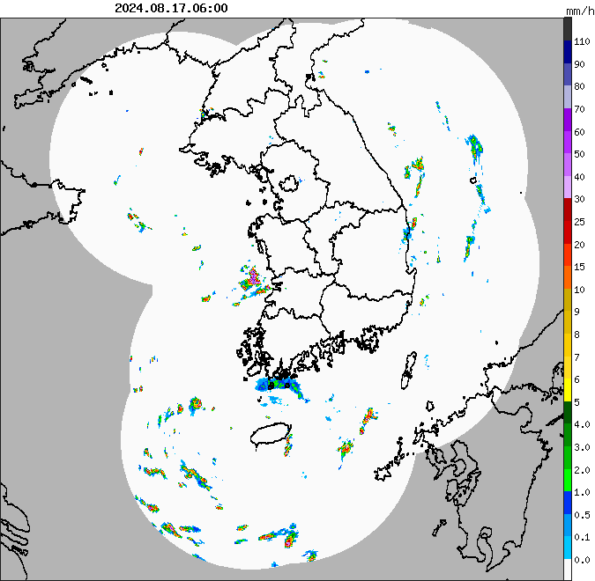
Fig. S10. Radar echoes for 17 August from the KMA.

