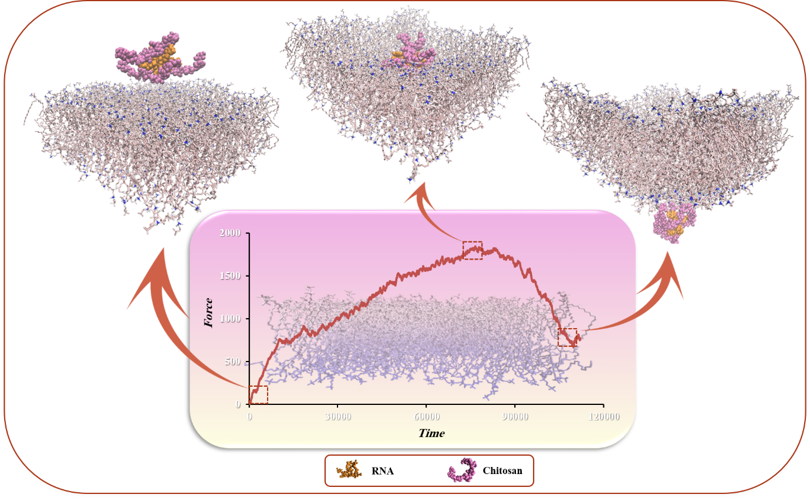
Graphical abstract Atomistic simulations demonstrate chitosan-mediated siRNA transport across the lipid bilayer revealed by atomistic steered molecular dynamics simulations

