Supplementary information
Supplementary Table 1. Subgroup analysis of the impact of SGLT-2is versus active-control arms on metabolic and hormonal parameters of importance.
Outcome parameter | SMD | 95% CI | P-value
FPG | -0.28 | -0.47 to -0.07 | 0.01
HOMA-IR | -0.14 | -0.33 to 0.07 | 0.19
DHEAS | -0.27 | -0.46 to -0.05 | 0.02

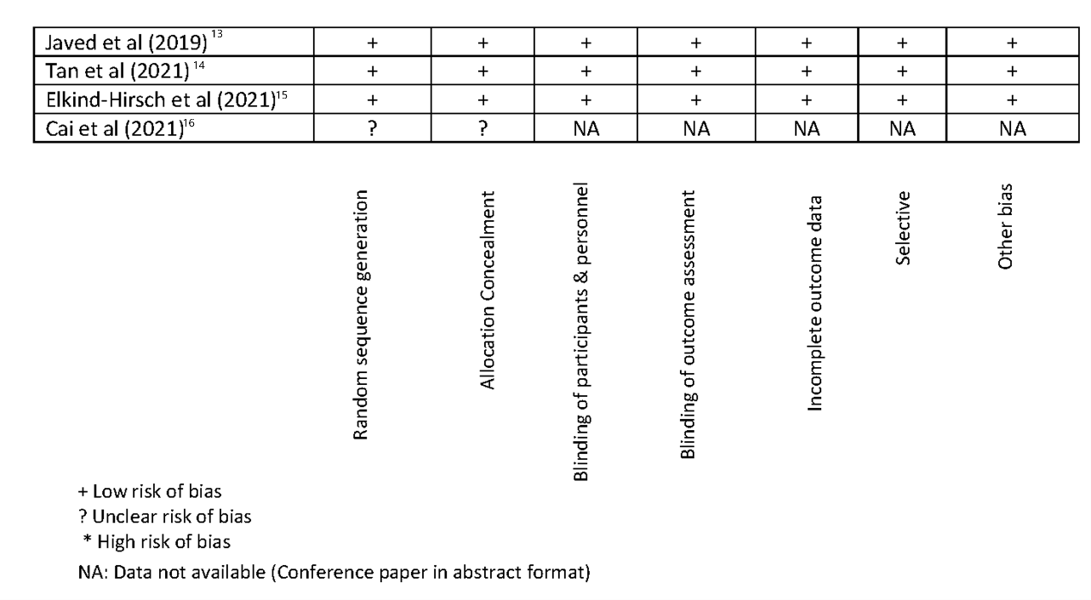
Supplementary Figure 1. Quality of studies

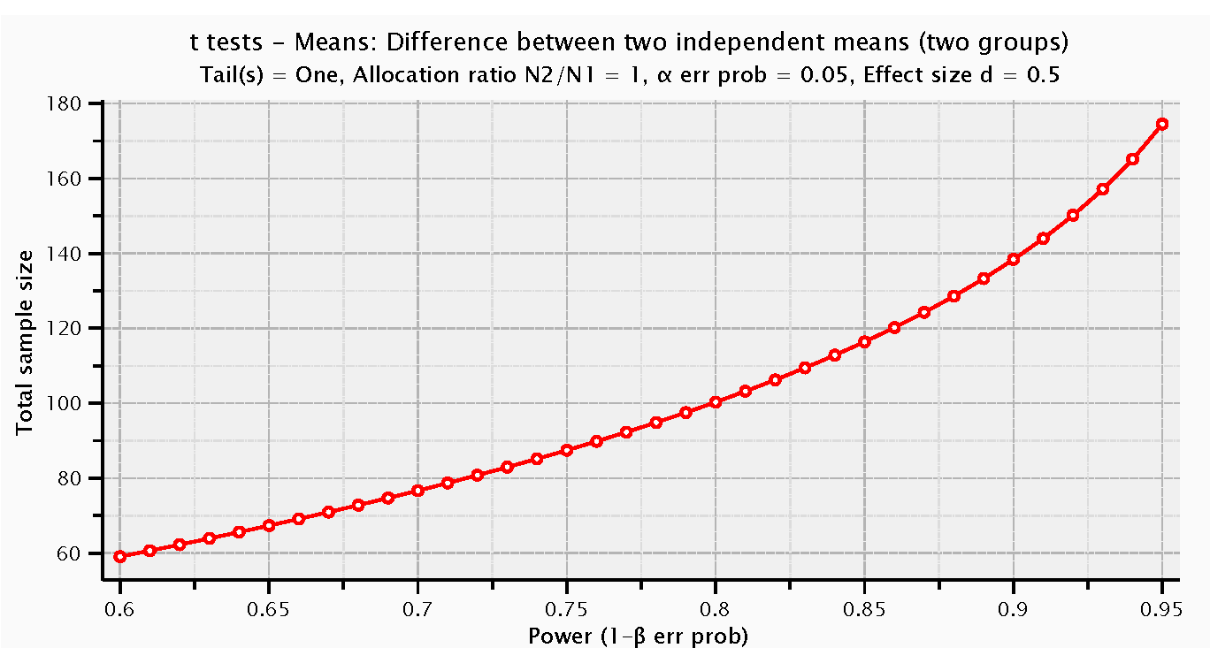
Supplementary Figure 2. A priori power calculation for sample size estimation

