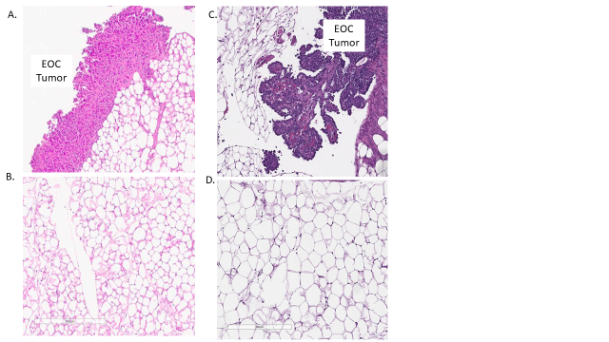
Supplemental Figure 1. Representative image of confirmed EOC through H&E staining of omental tumor tissue and survival curve comparison between groups. (A) BL/6 EOC tumor, (B) BL/6 benign adjacent omentum, (C) NSG EOC tumor, (D) NSG benign adjacent omentum, (E) BL/6 cohorts, (F) NSG cohorts.

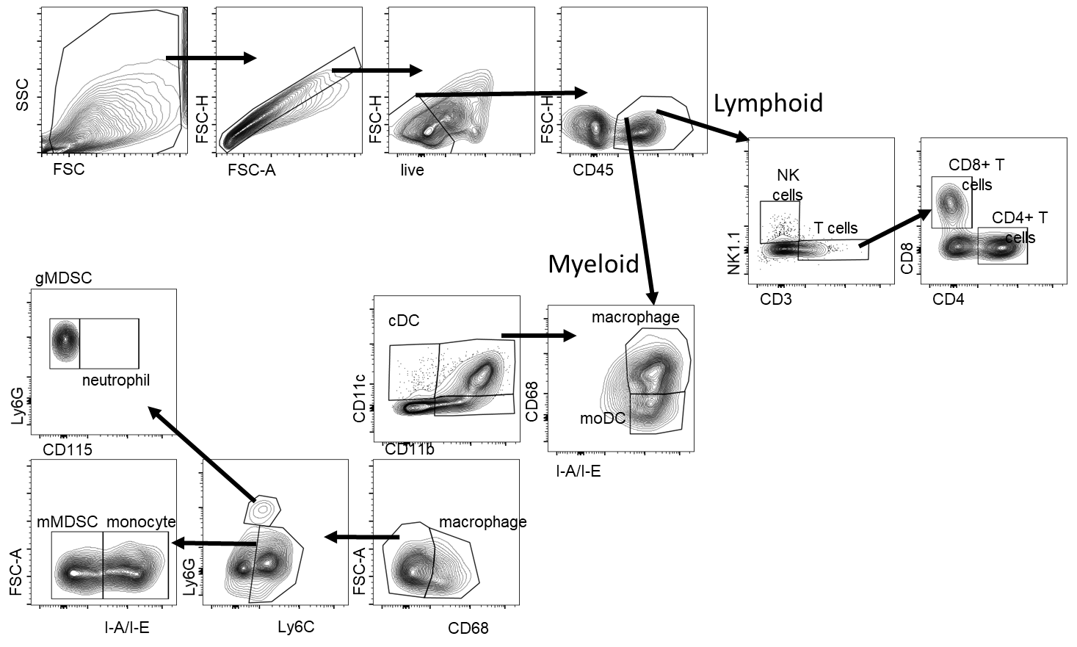
Supplemental Figure 2. Representative multi –parameter gating strategy for myeloid and lymphoid cell populations.

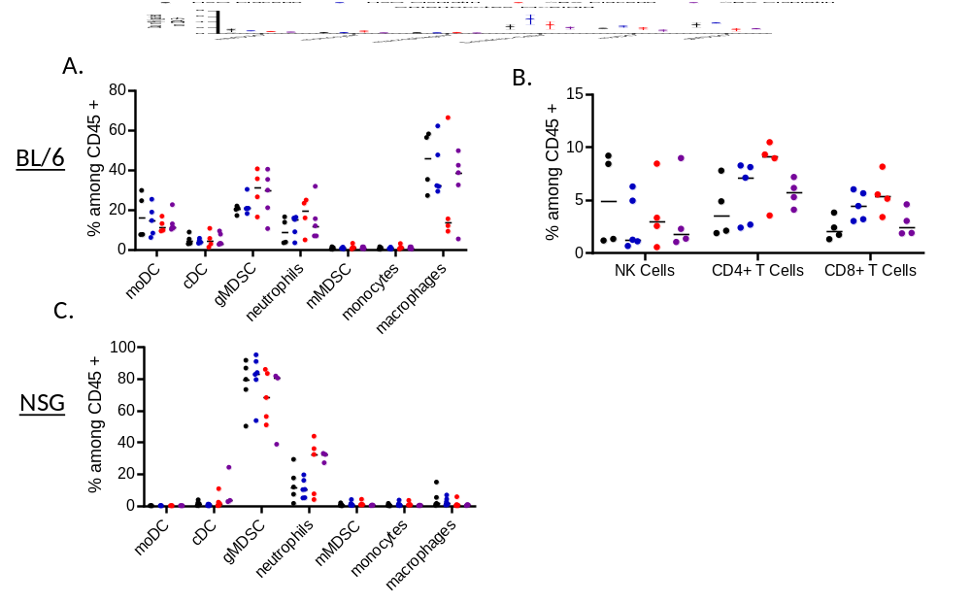Supplemental Figure 3. Myeloid and lymphoid immune cell population analysis from ascites of BL/6 and NSG ID8 VEGF tumor bearing mice at endpoint. Following ABX therapy, BL/6 ID8 VEGF ascites did not exhibit significant alterations in myeloid (A) or lymphoid populations (B) by flow cytometry analysis. NSG ID8 VEGF ascites did not exhibit significant alterations in myeloid (C) populations. Values are represented as percent (%) among CD45+ staining. BL/6 n=4 mice per group, NSG n=5 mice per group Statistical analysis: non-linear multiple t tests.

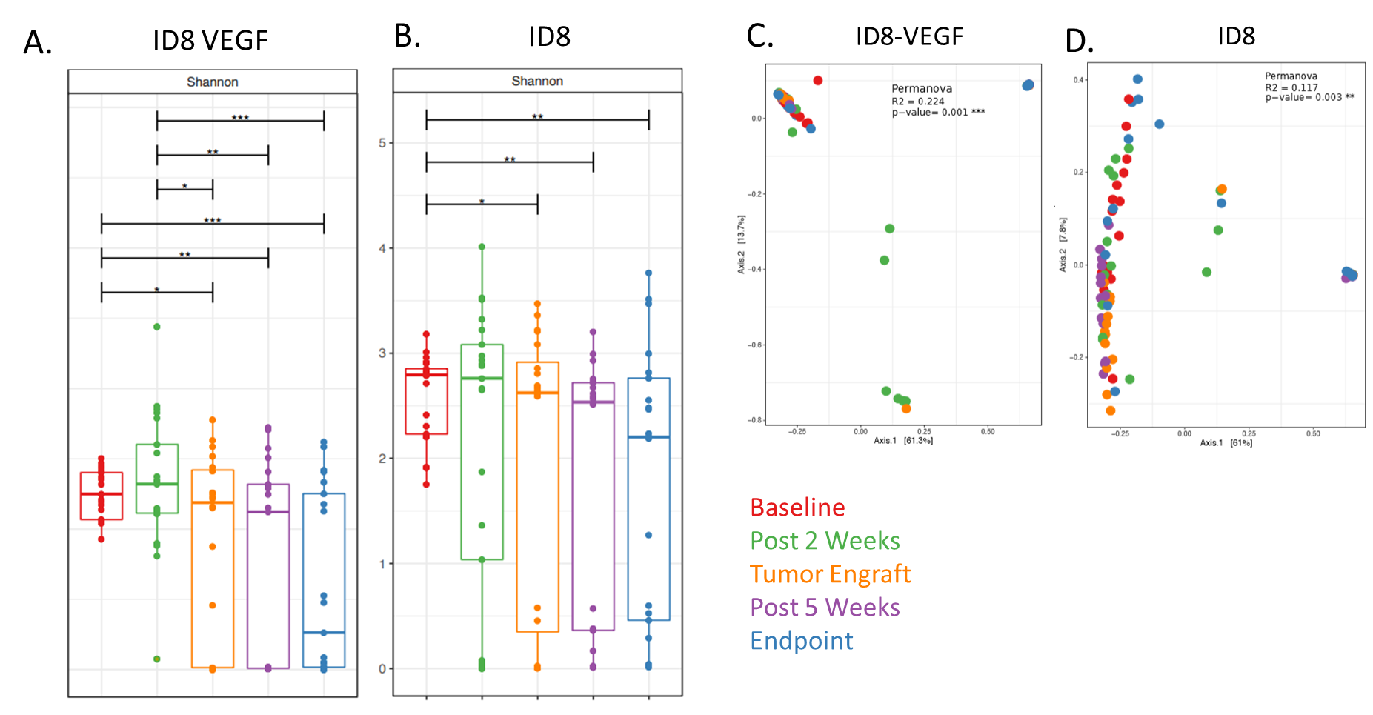
Supplemental Figure 4. BL/6 16S Alpha and Beta Diversity. A. BL/6 ID8 VEGF alpha diversity, B. BL/6 ID8 alpha diversity, C. BL/6 ID8 VEGF beta diversity, D. BL/6 ID8 beta diversity. Two-way ANOVA *p<0.05, **p<0.01, ***p<0.001 n= 8 mice per group

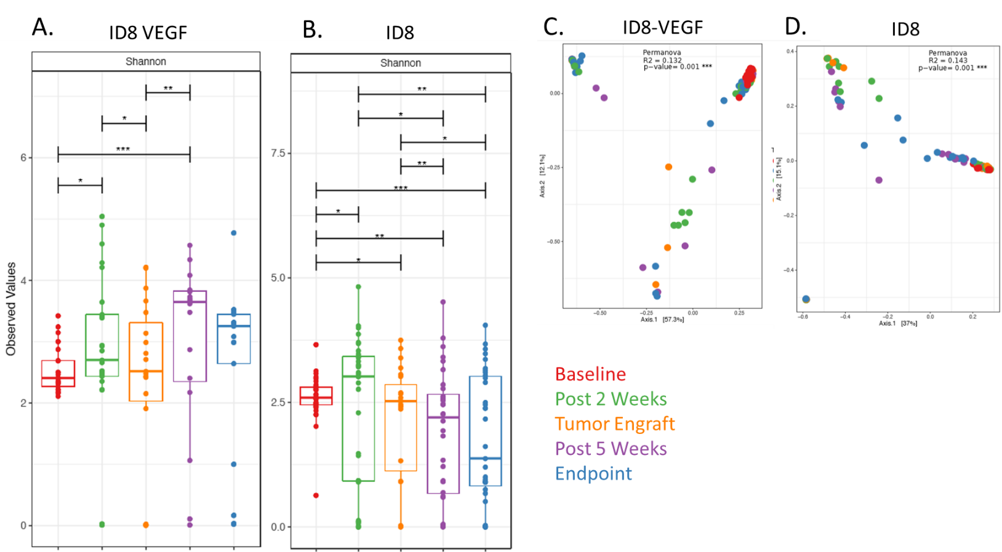
Supplemental Figure 5. NSG 16S Alpha and Beta Diversity. A. NSG ID8 VEGF alpha diversity, B. NSG ID8 alpha diversity, C. NSG ID8 VEGF beta diversity, D. NSG ID8 beta diversity. Two-way ANOVA *p<0.05, **p<0.01, ***p<0.001 n= 8 mice per group

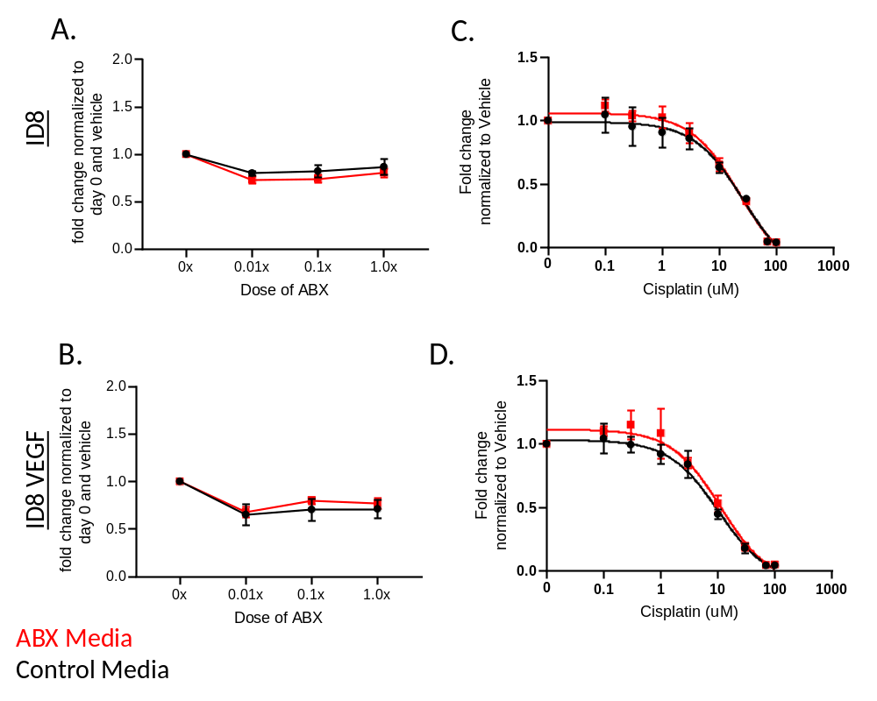
Supplemental Figure 6. ABX treatment does not significantly alter tumor cell proliferation or cisplatin sensitivity in vitro. Following 4 days co-culture of ID8 (A) and ID8 VEGF (B) with ABX at vary concentrations, no significant change in proliferation was observed compared to cells cultured with media alone. The IC50 of Cisplatin was not significantly altered when co cultured with ABX compared to control media in ID8 (C) or ID8 VEGF (D) cells in vitro. Two stage T test, n= 3 replicates per data point.

Supplemental Table 1. Myeloid and lymphoid antibody lists utilized for ascites analysis.

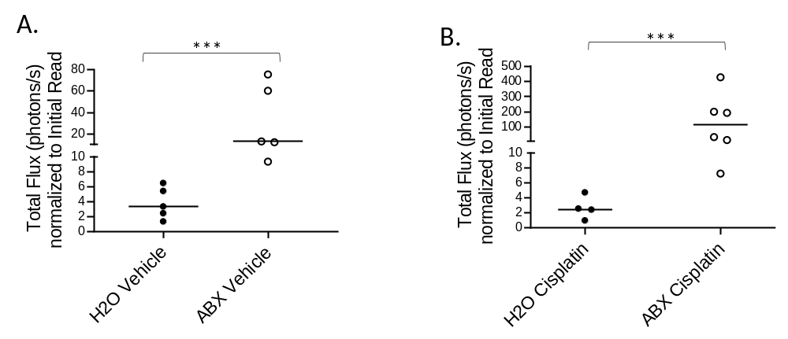
Supplemental Figure 7. ABX treatment decreases sensitivity of OV81 cells to cisplatin therapy, resulting in increased tumor growth. Mice treated with antibiotics exhibited increased overall OV81 tumor growth in both the presence and absence of cisplatin therapy compared to the H₂O treated control. ANOVA F test ***p<0.001

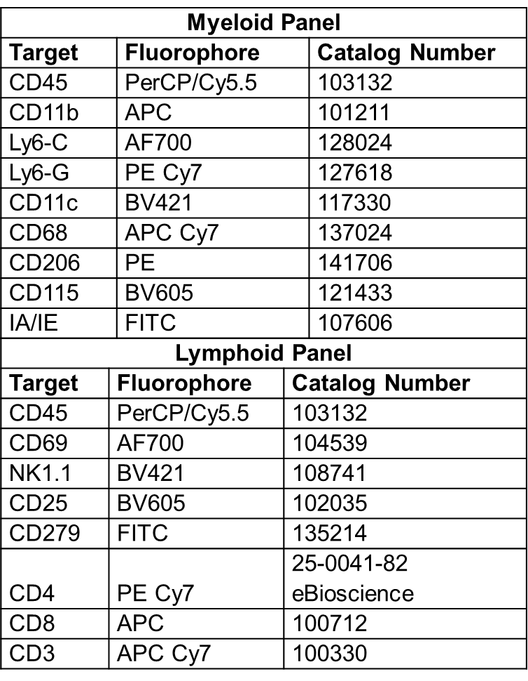
Supplemental Table 1. Myeloid and lymphoid antibody lists utilized for ascites analysis.

