Supplementary Information

Membrane depolarization kills dormant Bacillus subtilis cells by generating a lethal dose of ROS

Declan A. Gray, Biwen Wang, Pamela Gamba, Henrik Strahl, Leendert W. Hamoen

Table of content
- Table S1. Strains used in this study
- Table S2. Plasmids used in this study
- Table S3. Primers used in this study
- Table S4. Minimum inhibitory concentration of B subtilis PG344 for 4 antibiotics
- Fig. S1. Membrane depolarization of B. subtilis cells in the exponential or stationary phase
- Fig. S2. Large field fluorescence images of stationary phase cells expression cytochrome bc1 and cytochrome-c oxidase subunits and cytochrome c550 fused to GFP
- Fig. S3. Large field fluorescence images of exponential phase cells expression cytochrome bc1 and cytochrome-c oxidase subunits and cytochrome c550 fused to GFP
- Fig. S4. Killing of stationary phase S. aureus cells by valinomycin
- References

Table S1. Strains used in this study
Strain | Genotype | Source or reference
2682 | recA::tet | Lab strain
1A1299 | Δskin, Δprophage1, Δprophage3, ΔSPbeta, ΔPBSX, pks::Cm, ICEBs1(0) | BGSC
BKE01830 | ndhF::erm | BGSC
BKE08820 | katA::erm | BGSC
BKE09300 | glpD::erm | BGSC
BKE14590 | pdhB::erm | BGSC
BKE14890 | ctaC::erm | BGSC
BKE14900 | ctaD::erm | BGSC
BKE14910 | ctaE::erm | BGSC
BKE14920 | ctaF::erm | BGSC
BKE17930 | ccdA::erm | BGSC
BKE19330 | sodF::erm | BGSC
BKE19400 | sodC::erm | BGSC
BKE22540 | qcrC::erm | BGSC
BKE22550 | qcrB::erm | BGSC
BKE22560 | qcrA::erm | BGSC
BKE23150 | resA::erm | BGSC
BKE25020 | sodA::erm | BGSC
BKE25190 | cccA::erm | BGSC
BKE28450 | sdhC::erm | BGSC
BKE35270 | cccB::erm | BGSC
BKE38760 | cydA::erm | BGSC
BSB1 | trp+ | Lab strain
BWB03 | spoIIE::spec, cccA::erm | This work
BWB04 | spoIIE::spec, cccB::erm | This work
BWB76 | spoIIE::erm, amyE::Pxyl-gfp-qcrA-spec | This work
BWB77 | spoIIE::erm, amyE::Pxyl-gfp-qcrB-spec | This work
BWB78 | spoIIE::erm, amyE::Pxyl-gfp-qcrC-spec | This work
BWB79 | spoIIE::erm, amyE::Pxyl-gfp-cccA-spec | This work
BWB80 | spoIIE::erm, amyE::Pxyl-gfp-ctaC-spec | This work
BWB81 | spoIIE::erm, amyE::Pxyl-gfp- ctaD-spec | This work
BWB92 | spoIIE::erm, qcrBC::kan | This work
BWB93 | spoIIE::erm, qcrABC::kan | This work
BWB96 | ΔspoIIE, recA::erm, qcrA::kan | This work
DG001 | spoIIE::erm, divIVA-gfp | ¹
DG003 | Δskin, Δprophage1, Δprophage3, ΔSPbeta, ΔPBSX, pks::Cm, ICEBs1(0), spoIIE::erm | This work
DG010 | spoIIE::erm, recA::tet | This work
DG022 | lytABC::neo, lytD::tet, lytE::chl, lytF::spc, spoIIE::erm | This work
DG025 | spoIIE::erm, spx::kan | This work
DG037 | spoIIE::erm, ΔsodA | This work
DG038 | spoIIE::erm, ΔsodC | This work
DG042 | spoIIE::erm, ΔsodF | This work
DG051 | spoIIE::erm, ΔkatA | This work
DG082 | spoIIE::spec, glpD::erm | This work
DG102 | spoIIE::spec, pdhB::erm | This work
DG103 | spoIIE::spec, sdhC::erm | This work
DG106 | spoIIE::spec, qcrA::erm | This work
DG110 | spoIIE::spec, qcrB::erm | This work
DG111 | spoIIE::spec, cydA::erm | This work
DG112 | spoIIE::spec, ctaE::erm | This work
DG113 | spoIIE::spec, ccdA::erm | This work
DG115 | spoIIE::spec, resA::erm | This work
DG116 | spoIIE::spec, ctaC::erm | This work
DG117 | spoIIE::spec, ctaF::erm | This work
DG118 | spoIIE::spec, ctaD::erm | This work
DG119 | spoIIE::spec, qcrC::erm | This work
DG120 | ndh::erm, spoIIE::spec | This work
DGYK1460 | spoIIE::erm, divIVA-gfp, ctaB::tn-kan | This work
DGYK1461 | spoIIE::erm, divIVA-gfp::chl, yjlD(ndh)::tn-kan | This work
DGYK1462 | spoIIE::erm, divIVA-gfp::chl, qoxB::tn-kan | This work
PG344 | spoIIE::erm | ¹
PG344_2 | spoIIE::spec | ¹
SH1000 | Staphylococcus aureus wildtype Newman | ²
SH1000 ∆sodA | S. aureus, sodA::erm | ²
SH1000 ∆sodAM | S. aureus, sodA::erm, sodM::tet | ²
SH1000 ∆sodM | S. aureus, sodM::tet | ²
YK1461 | yjlD(ndh)::tn-kan | ³
YK1462 | qoxB::tn-kan | ³
Δspx | spx::kan | Lab strain

Table S2. Plasmids used in this study.
Plasmid | Genotype | Source or reference
pBW6 | amyE::(Pxyl-msfgfp-qcrC-spec) | This work
pDR244 | cre, spec, amp | BGSC
pErm::Spec | erm::spec | ⁴
pHJS105 | amyE::(Pxyl-mSFgfpV206K spec) | ⁵
pLB2 | amyE::(Pxyl-msfgfp-qcrA-spec) | This work
pLB4 | amyE::(Pxyl-msfgfp-ctaD-spec) | This work
pLB6 | amyE::(Pxyl-msfgfp-ctaC-spec) | This work
pLB8 | amyE::(Pxyl-msfgfp-qcrB-spec) | This work

Table S3. Primers used in this study.
Primer | Sequence 5’—3’ | Gene
BW_100 | TTAACAAAATTCTCCAGTCTTCA | Rv-amyE5'
BW_104 | TCACATTTATATTGTGCAACACTTCACAAA | Fw-amyE3'
BW_105 | TGACCCTCCAGAGCCACCTTTGTAGAGCTCATCCATGCCATGT | Fw-sfGFP3
BW_106 | GGTGGCTCTGGAGGGTCAAAATCAAAGTTATCGATACTAATGAT | Fw-cccB
BW_107 | TGGATCCGAAGTCTGGACATTTTttaCTTTTTTTCTGACAGCCATTT | Rv-cccB
BW_241 | CTAAAACAATTCATCCAGTAAAATAT | Rv-Km
BW_242 | TAAAGAGAATGTCATGACTACC | Fw-qcrAupstream
BW_245 | TTTTGTGTGTCTGATGTATCAG | Rv-qcrBCdownstream
BW_247 | TCCGGTGATATTCTCATTTTAGCCATCTCTTCTCCCCCCTCTAA | Rv-qcrAupstream
BW_299 | TAAAATATTATATTTTACTGGATGAATTGTTTTAGCGTATTGTGAATTGTCAAATGG | Fw-qcrBCdownstream
BW_303 | ACATAGTATCGACGGAGCCGATTGTCACCCTTCCCCCTTAG | Rv-qcrAupstream2
BW_313 | CTTTGCTTTTCCAAGATACAG | Rv-qcrAinternal
BW_314 | CAATTTTTGAATTATACGCTCAC | Fw-qcrAinternal
BW_61 | AAAATGTCCAGACTTCGGA | Fw-amyE5'
BW_64 | AAAATGTCCAGACTTCGGATCCACatgCACCGGGGCAAAGGGAT | Fw-qcrC
BW_65 | ATCAAGCTTATCGATACCGTCGACttaTTTTGCGGTTGTTTCAGAAAT | Rv-qcrC
BW_66 | TGTCCAGACTTCGGATCCACATGGGCGGAAAACATGATAT | Fw-qcrA
BW_67 | ATCAAGCTTATCGATACCGTCGACTCACCCTTCCCCCTTAGGCT | Rv-qcrA
BW_72 | AAAATGTCCAGACTTCGGATCCACATGTTGAATGCGCTTACAGA | Fw-ctaD
BW_73 | ATCAAGCTTATCGATACCGTCGACTTATGCCTTCACCCCTTTAT | Rv-ctaD
BW_86 | ATGTCCAGACTTCGGATCCACATGGTAAAGCATTGGCGTC | Fw-ctaC
BW_87 | GATCCGAAGTCTGGACATTTTCTACTTGCTTTCCGC | Rv-ctaC
BW_90 | GGCTCCGGAAGTGGCTCTCTGAACAAAATTTATGAC | Fw-qcrB
BW_91 | CGAAGTCTGGACATTTTTTTAAAGCGGTCCTGAAATCCC | Rv-qcrB
BW_92 | ACTTCCGGAGCCGCTACCTTTGTAGAGCTCATCCAT | Rv-sfGFP2
BW_97 | TGACCCTCCAGAGCCACCTTTGTAGAGCTCATCCATGC | Rv-sfGFP3
BW_98 | GGTGGCTCTGGAGGGTCAAAATGGAACCCGCTTATTCC | Fw-cccA
BW_99 | TGGATCCGAAGTCTGGACATTTTttaTTTAATTTTTGACACCCACT | Rv-cccA
EKP22 | GTCGACGGTATCGATAAGCTTGAT | Fw-sfGFP
EKP30 | GTGGATCCGAAGTCTGGACATTTT | Rv-sfGFP
MW245 | AAAATGTCCAGACTTCGGATC | Fw-sfGFP2
Ters158 | TCACATTTATATTGTGCAACACT | Rv-amyE3'
Ters350 | CACCGCCGACATTCGCGTGGCTCCA | Rv-amyEDown
Ters351 | GCATCAGGGCTGCGGCATCCGGA | Fw-amyEUp
ZT202 | AATCGGCTCCGTCGATACTATG | Fw-Km

Table S4. Minimum inhibitory concentration (MIC) of B. subtilis PG344 for 4 antibiotics.
Antibiotics | MIC | Funtional Target
Vancomycin | 2 µg/mL | cell wall synthesis
Ciprofloxacin | 0.2 µg/mL | DNA synthesis
Kanamycin | 1 µg/mL | protein synthesis
Valinomycin | 10 µM | membrane potential dissipation

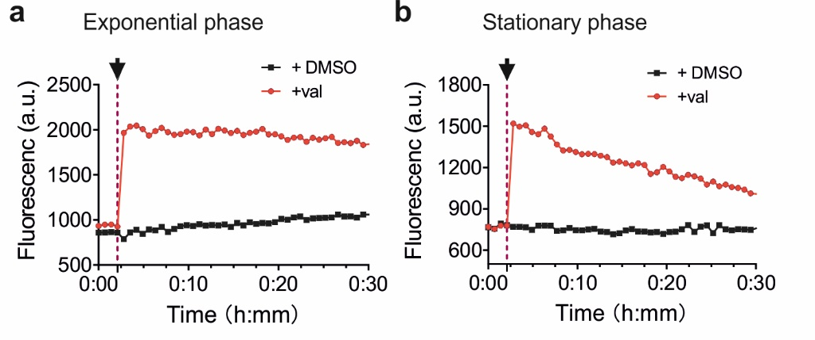
Fig. S1. Membrane depolarization of B. subtilis cells in the exponential or stationary phase.
The membrane potential was measured using the membrane potential-sensitive fluorescent probe DiSC₃(5). Cells from either an exponentially growing (a) or stationary phase culture (b) were incubated in microtiter plates and when the baseline was stable either 10 µM valinomycin (val) or 1 % DMSO was added to the cells. The arrow indicates the time point of valinomycin or DMSO addition. Of note, we used a ten-times lower valinomycin concentration in this assay compared with the concentration used in the experiments because at high concentrations valinomycin affects the fluorescence of DiSC₃(5).

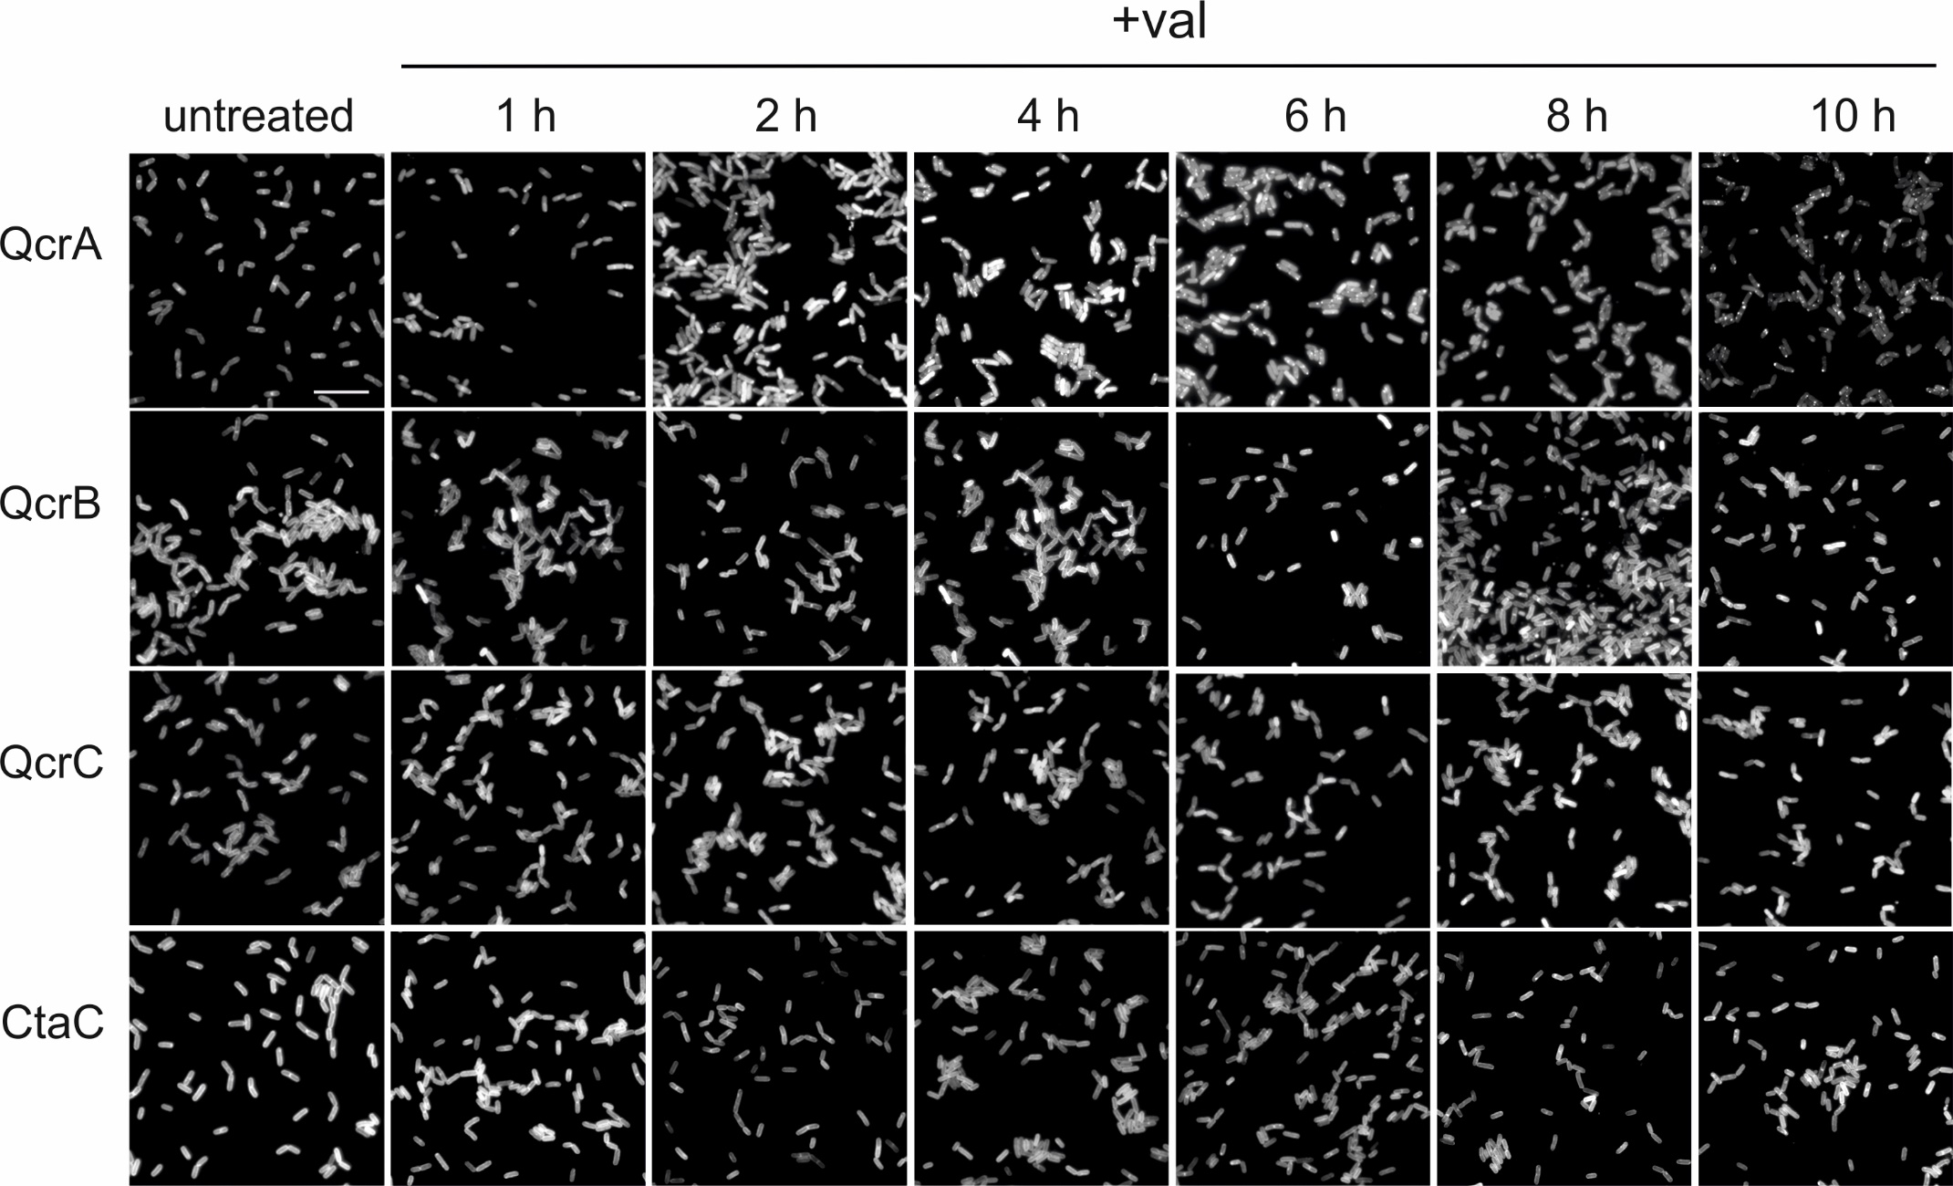
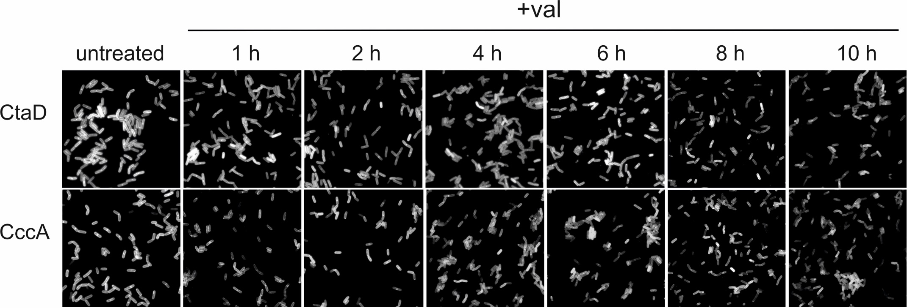
Fig. S2. Large field fluorescence images of stationary phase cells expression cytochrome bc1 and cytochrome-c oxidase subunits and cytochrome c550 fused to GFP.
Cellular localization of GFP tagged cytochrome bc1 subunits QcrA (Rieske protein), QcrB and QcrC, cytochrome-c oxidase subunits CtaC and CtaD, and cytochrome c550 in stationary phase cells incubated with 100 μM valinomycin (+ val) for up to 10 h. Scale bar represents 10 μm. This figure is related to Fig. 6A in the main text.

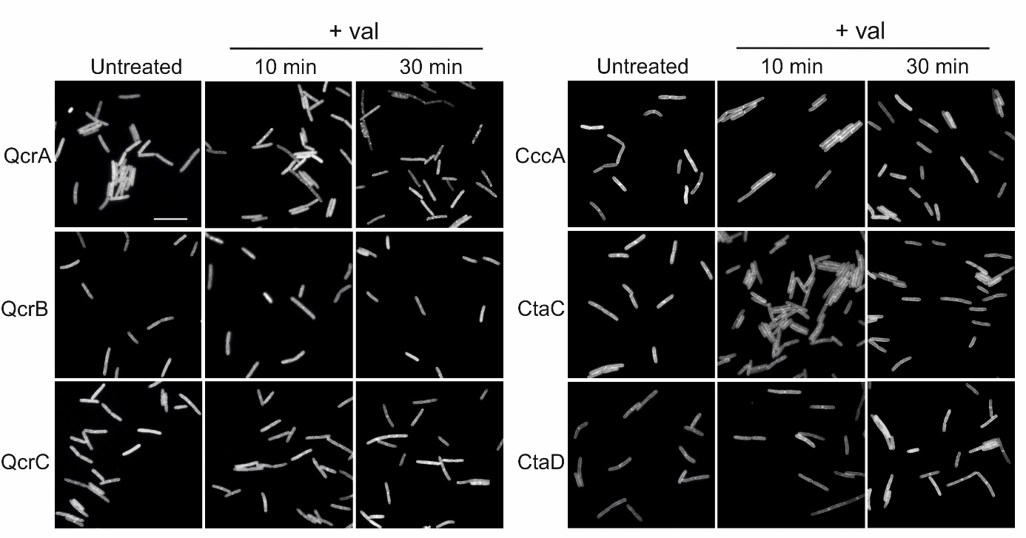
Fig. S3. Large field fluorescence images of exponential phase cells expression cytochrome bc1 and cytochrome-c oxidase subunits and cytochrome c550 fused to GFP.
Cellular localization of GFP-tagged cytochrome bc1 subunits QcrA (Rieske protein), QcrB and QcrC, cytochrome-c oxidase subunits CtaC and CtaD, and cytochrome c550 in exponentially growing cells incubated with 100 μM valinomycin (+ val) for up to 30 min. Scale bar represents 10 μm. This figure is related to Fig. 6B in the main text.
Fig. S4. Killing of stationary phase S. aureus cells by valinomycin.
Survival curves of stationary phase S. aureus wild type cells (wt) and the S. aureus superoxide dismutase mutants ΔsodA, ΔsodM and double mutant ΔsodAM when incubated with 100 µM valinomycin (val). 1 % DMSO was used as negative control. The survival curves of the superoxide dismutase mutants with DMSO were similar to that of the wild type strain and not shown here. Data shown reflect mean ± SD of three biological replicates.
Reference
1. Gray, D. A. et al. Extreme slow growth as alternative strategy to survive deep starvation in bacteria. Nat. Commun. 10, (2019).
2. Tarrant, E. et al. Copper stress in Staphylococcus aureus leads to adaptive changes in central carbon metabolism. Metallomics 11, 183–200 (2019).
3. Kawai, Y. et al. Cell Growth of Wall-Free L-Form Bacteria Is Limited by Oxidative Damage. Curr. Biol. (2015).
4. Steinmetz, M. & Richter, R. Plasmids designed to alter the antibiotic resistance expressed by insertion mutations in Bacillus subtilis, through in vivo recombination. Gene 142, 79–83 (1994).
5. Gamba, P., Jonker, M. J. & Hamoen, L. W. A Novel Feedback Loop That Controls Bimodal Expression of Genetic Competence. PLoS Genet. (2015).

