Uncropped and unprocessed images of the complete gel and blot in Figure 3C
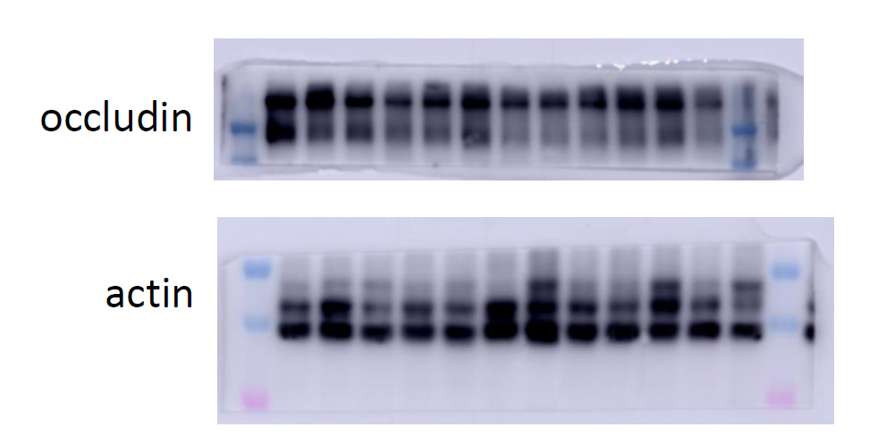

Uncropped and unprocessed images of the complete gel and blot in Figure 5G
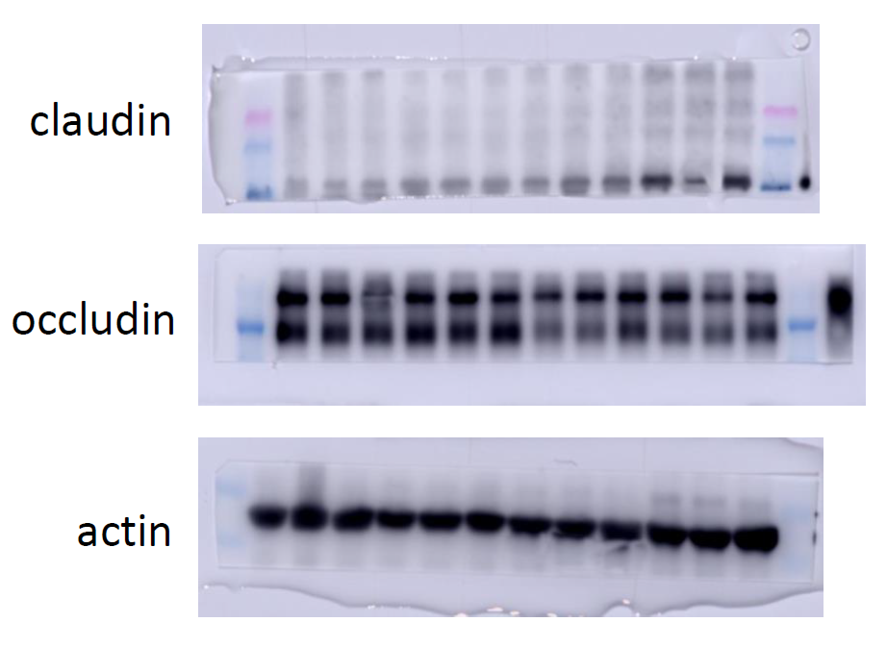

Uncropped and unprocessed images of the complete gel and blot in Figure 7A
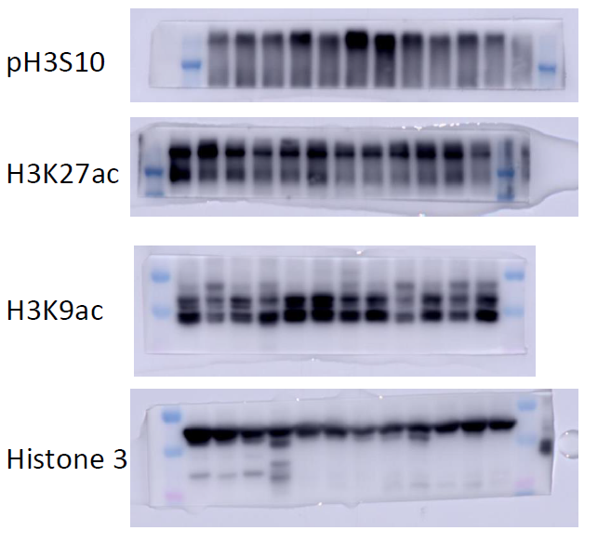
Uncropped and unprocessed images of the complete gel and blot in Figure 7B
