Table S1 Benefit of N emission mitigation ($/kg N) to air, land, and water.
 | Effect | Type | Subject | Low | Median | High
NO_{x} | Increased incidence of respiratory disease | human health | air/climate | 12.88 | 23.1 | 38.63
NO_{x} | Declining visibility—loss of aesthetics | human health | air/climate | 0.31 | 0.31 | 0.31
NO_{x} | Increased effects of airborne particulates/increased carbon sequestration in forests (includes benefits) | climate | air/climate | -11.59 | -4.51 | 2.58
NO_{x} | Increased damages to buildings from acid | ecosystem | land | 0.09 | 0.09 | 0.09
NO_{x} | Increased ozone exposure to crops | ecosystem | land | 1.29 | 1.51 | 2.58
NO_{x} | Increased ozone exposure to forests | ecosystem | land | 0.89 | 0.89 | 0.89
NO_{x} | Increased loss of plant biodiversity from N enrichment | ecosystem | land | 2.58 | 7.73 | 12.88
NH₃ | Increased incidence of respiratory disease | human health | air/climate | 2.58 | 4.93 | 25.75
NH₃ | Declining visibility—loss of aesthetics | human health | air/climate | 0.31 | 0.31 | 0.31
NH₃ | Increased effects of airborne particulates/increased carbon sequestration in forests (includes benefits) | human health | air/climate | -3.86 | -1.93 | -1.93
NH₃ | Increased damages to buildings from particulates | ecosystem | land | 0.09 | 0.09 | 0.09
NH₃ | Increased loss of plant biodiversity | ecosystem | land | 2.58 | 7.73 | 12.88
N₂O | Increased ultra-violet light exposure from ozone—humans | human health | air/climate | 1.29 | 1.33 | 3.86
N₂O | Increased emission of a greenhouse gas | climate | air/climate | 5.2 | 13.5 | 21.9
N₂O | Increased ultra-violet light exposure from ozone-crops | ecosystem | air/climate | 1.33 | 1.33 | 1.33
runoff | Declining waterfront property value | ecosystem | freshwater | 0.21 | 0.21 | 0.21
runoff | Loss of recreational use | ecosystem | freshwater | 0.17 | 0.17 | 0.17
runoff | Loss of endangered species | ecosystem | freshwater | 0.01 | 0.01 | 0.01
runoff | Increased eutrophication | ecosystem | freshwater | 6.44 | 16.1 | 25.75
runoff | Undesirable odor and taste | human health | drinking water | 0.14 | 0.14 | 0.14
runoff | Nitrate contamination | human health | drinking water | 0.54 | 0.54 | 0.54
runoff | Increased colon cancer risk | human health | drinking water | 1.76 | 1.76 | 5.15
leaching | Undesirable odor and taste | human health | drinking water | 0.14 | 0.14 | 0.14
leaching | Nitrate contamination | human health | drinking water | 0.54 | 0.54 | 0.54
leaching | Increased colon cancer risk | human health | drinking water | 1.76 | 1.76 | 5.15
coastal N loading | Loss of recreational use | ecosystem | coastal zone | 6.38 | 6.38 | 6.38
coastal N loading | Declines in fisheries and estuarine/marine habitat | ecosystem | coastal zone | 6 | 15.84 | 26
Note: Figures are the original values applicable to the EU and US. Negative values indicate an economic benefit.

Table 2 Unit mitigation benefit of improved N management via the NCS by nation
 |  |  | Ecosystem ($/kg N) |  |  |  | Health ($/kg N) |  | Climate ($/kg N)
Countries | Population density  (person/km²) | PGDP ($) | NH₃ | N₂O | NO_{x} | runoff | NH₃ | NO_{x} | NH₃ | N₂O | NO_{x}
Afghanistan | 53 | 2213 | 6.3 | 1.1 | 8.1 | 13.2 | 13.9 | 14.9 | -1.5 | 11.9 | -3.6
Albania | 105 | 12085 | 7.0 | 1.2 | 9.1 | 14.8 | 27.5 | 15.6 | -1.7 | 13.4 | -4.1
Algeria | 17 | 11511 | 7.0 | 1.2 | 9.1 | 14.8 | 1.4 | 3.0 | -1.7 | 13.4 | -4.1
Angola | 22 | 8036 | 7.0 | 1.2 | 9.1 | 14.8 | 1.4 | 3.0 | -1.7 | 13.4 | -4.1
Antigua and Barbuda | 213 | 18595 | 7.0 | 1.2 | 9.1 | 14.8 | 3.8 | 2.6 | -1.7 | 13.4 | -4.1
Argentina | 16 | 23966 | 7.0 | 1.2 | 9.1 | 14.8 | 3.8 | 2.6 | -1.7 | 13.4 | -4.1
Armenia | 103 | 11321 | 6.6 | 1.1 | 8.6 | 14.0 | 13.9 | 14.9 | -1.6 | 12.6 | -3.8
Australia | 3 | 47786 | 7.8 | 1.3 | 10.1 | 16.5 | 0.4 | 0.3 | -1.9 | 14.9 | -4.5
Austria | 105 | 52945 | 7.8 | 1.3 | 10.1 | 16.5 | 27.5 | 15.6 | -1.9 | 14.9 | -4.5
Azerbaijan | 117 | 14895 | 7.0 | 1.2 | 9.1 | 14.8 | 13.9 | 14.9 | -1.7 | 13.4 | -4.1
Bahamas | 37 | 35837 | 7.8 | 1.3 | 10.1 | 16.5 | 3.8 | 2.6 | -1.9 | 14.9 | -4.5
Bahrain | 1763 | 48304 | 7.8 | 1.3 | 10.1 | 16.5 | 13.9 | 14.9 | -1.9 | 14.9 | -4.5
Bangladesh | 1200 | 3700 | 6.3 | 1.1 | 8.1 | 13.2 | 13.9 | 14.9 | -1.5 | 11.9 | -3.6
Barbados | 664 | 15383 | 7.8 | 1.3 | 10.1 | 16.5 | 3.8 | 2.6 | -1.9 | 14.9 | -4.5
Belarus | 47 | 18405 | 7.0 | 1.2 | 9.1 | 14.8 | 27.5 | 15.6 | -1.7 | 13.4 | -4.1
Belgium | 372 | 49431 | 7.8 | 1.3 | 10.1 | 16.5 | 27.5 | 15.6 | -1.9 | 14.9 | -4.5
Belize | 16 | 7259 | 6.6 | 1.1 | 8.6 | 14.0 | 3.8 | 2.6 | -1.6 | 12.6 | -3.8
Benin | 94 | 2946 | 6.3 | 1.1 | 8.1 | 13.2 | 1.4 | 3.0 | -1.5 | 11.9 | -3.6
Bhutan | 19 | 10086 | 6.6 | 1.1 | 8.6 | 14.0 | 13.9 | 14.9 | -1.6 | 12.6 | -3.8
Bolivia | 10 | 7984 | 6.6 | 1.1 | 8.6 | 14.0 | 3.8 | 2.6 | -1.6 | 12.6 | -3.8
Botswana | 4 | 16714 | 7.0 | 1.2 | 9.1 | 14.8 | 1.4 | 3.0 | -1.7 | 13.4 | -4.1
Brazil | 24 | 15059 | 7.0 | 1.2 | 9.1 | 14.8 | 3.8 | 2.6 | -1.7 | 13.4 | -4.1
Brunei Darussalam | 79 | 63149 | 7.8 | 1.3 | 10.1 | 16.5 | 13.9 | 14.9 | -1.9 | 14.9 | -4.5
Bulgaria | 66 | 19540 | 7.0 | 1.2 | 9.1 | 14.8 | 27.5 | 15.6 | -1.7 | 13.4 | -4.1
Burkina Faso | 66 | 1935 | 6.3 | 1.1 | 8.1 | 13.2 | 1.4 | 3.0 | -1.5 | 11.9 | -3.6
Burundi | 396 | 825 | 6.3 | 1.1 | 8.1 | 13.2 | 1.4 | 3.0 | -1.5 | 11.9 | -3.6
Cabo Verde | 130 | 6267 | 6.6 | 1.1 | 8.6 | 14.0 | 1.4 | 3.0 | -1.6 | 12.6 | -3.8
Cambodia | 88 | 3544 | 6.3 | 1.1 | 8.1 | 13.2 | 13.9 | 14.9 | -1.5 | 11.9 | -3.6
Cameroon | 49 | 3459 | 6.6 | 1.1 | 8.6 | 14.0 | 1.4 | 3.0 | -1.6 | 12.6 | -3.8
Canada | 4 | 47341 | 7.8 | 1.3 | 10.1 | 16.5 | 3.8 | 2.6 | -1.9 | 14.9 | -4.5
Central African Republic | 7 | 853 | 6.3 | 1.1 | 8.1 | 13.2 | 1.4 | 3.0 | -1.5 | 11.9 | -3.6
Chad | 11 | 1857 | 6.3 | 1.1 | 8.1 | 13.2 | 1.4 | 3.0 | -1.5 | 11.9 | -3.6
Chile | 24 | 23634 | 7.0 | 1.2 | 9.1 | 14.8 | 3.8 | 2.6 | -1.7 | 13.4 | -4.1
China | 146 | 12101 | 7.0 | 1.2 | 9.1 | 14.8 | 13.9 | 14.9 | -1.7 | 13.4 | -4.1
Colombia | 43 | 14238 | 7.0 | 1.2 | 9.1 | 14.8 | 3.8 | 2.6 | -1.7 | 13.4 | -4.1
Comoros | 418 | 2960 | 6.3 | 1.1 | 8.1 | 13.2 | 1.4 | 3.0 | -1.5 | 11.9 | -3.6
Congo | 14 | 3802 | 6.6 | 1.1 | 8.6 | 14.0 | 1.4 | 3.0 | -1.6 | 12.6 | -3.8
Costa Rica | 95 | 18024 | 7.0 | 1.2 | 9.1 | 14.8 | 3.8 | 2.6 | -1.7 | 13.4 | -4.1
Côte d'Ivoire | 73 | 4417 | 6.6 | 1.1 | 8.6 | 14.0 | 1.4 | 3.0 | -1.6 | 12.6 | -3.8
Cuba | 109 | 7694 | 7.0 | 1.2 | 9.1 | 14.8 | 3.8 | 2.6 | -1.7 | 13.4 | -4.1
Cyprus | 126 | 25098 | 7.8 | 1.3 | 10.1 | 16.5 | 13.9 | 14.9 | -1.9 | 14.9 | -4.5
Czechia | 137 | 35978 | 7.8 | 1.3 | 10.1 | 16.5 | 27.5 | 15.6 | -1.9 | 14.9 | -4.5
North Korea | 209 | 1588 | 6.3 | 1.1 | 8.1 | 13.2 | 13.9 | 14.9 | -1.5 | 11.9 | -3.6
Democratic Republic of the Congo | 34 | 1065 | 6.3 | 1.1 | 8.1 | 13.2 | 1.4 | 3.0 | -1.5 | 11.9 | -3.6
Denmark | 135 | 52970 | 7.8 | 1.3 | 10.1 | 16.5 | 27.5 | 15.6 | -1.9 | 14.9 | -4.5
Djibouti | 39 | 4489 | 6.6 | 1.1 | 8.6 | 14.0 | 1.4 | 3.0 | -1.6 | 12.6 | -3.8
Dominican Republic | 213 | 15328 | 7.0 | 1.2 | 9.1 | 14.8 | 3.8 | 2.6 | -1.7 | 13.4 | -4.1
Ecuador | 65 | 11896 | 7.0 | 1.2 | 9.1 | 14.8 | 3.8 | 2.6 | -1.7 | 13.4 | -4.1
Egypt | 93 | 10570 | 6.6 | 1.1 | 8.6 | 14.0 | 1.4 | 3.0 | -1.6 | 12.6 | -3.8
El Salvador | 305 | 8143 | 6.6 | 1.1 | 8.6 | 14.0 | 3.8 | 2.6 | -1.6 | 12.6 | -3.8
Eritrea | 0 | 598 | 6.3 | 1.1 | 8.1 | 13.2 | 1.4 | 3.0 | -1.5 | 11.9 | -3.6
Estonia | 30 | 31211 | 7.8 | 1.3 | 10.1 | 16.5 | 27.5 | 15.6 | -1.9 | 14.9 | -4.5
Ethiopia | 101 | 1779 | 6.3 | 1.1 | 8.1 | 13.2 | 1.4 | 3.0 | -1.5 | 11.9 | -3.6
Fiji | 48 | 12553 | 6.6 | 1.1 | 8.6 | 14.0 | 0.4 | 0.3 | -1.6 | 12.6 | -3.8
Finland | 18 | 45060 | 7.8 | 1.3 | 10.1 | 16.5 | 27.5 | 15.6 | -1.9 | 14.9 | -4.5
France | 122 | 44969 | 7.8 | 1.3 | 10.1 | 16.5 | 27.5 | 15.6 | -1.9 | 14.9 | -4.5
Gabon | 8 | 15509 | 7.0 | 1.2 | 9.1 | 14.8 | 1.4 | 3.0 | -1.7 | 13.4 | -4.1
Gambia | 206 | 2059 | 6.3 | 1.1 | 8.1 | 13.2 | 1.4 | 3.0 | -1.5 | 11.9 | -3.6
Georgia | 65 | 11669 | 6.6 | 1.1 | 8.6 | 14.0 | 13.9 | 14.9 | -1.6 | 12.6 | -3.8
Germany | 234 | 51146 | 7.8 | 1.3 | 10.1 | 16.5 | 27.5 | 15.6 | -1.9 | 14.9 | -4.5
Ghana | 122 | 4670 | 6.6 | 1.1 | 8.6 | 14.0 | 1.4 | 3.0 | -1.6 | 12.6 | -3.8
Greece | 84 | 28968 | 7.8 | 1.3 | 10.1 | 16.5 | 27.5 | 15.6 | -1.9 | 14.9 | -4.5
Guatemala | 145 | 7783 | 6.6 | 1.1 | 8.6 | 14.0 | 3.8 | 2.6 | -1.6 | 12.6 | -3.8
Guinea | 47 | 2090 | 6.3 | 1.1 | 8.1 | 13.2 | 1.4 | 3.0 | -1.5 | 11.9 | -3.6
Guinea-Bissau | 62 | 1800 | 6.3 | 1.1 | 8.1 | 13.2 | 1.4 | 3.0 | -1.5 | 11.9 | -3.6
Guyana | 4 | 8604 | 6.6 | 1.1 | 8.6 | 14.0 | 3.8 | 2.6 | -1.6 | 12.6 | -3.8
Haiti | 388 | 1764 | 6.3 | 1.1 | 8.1 | 13.2 | 3.8 | 2.6 | -1.5 | 11.9 | -3.6
Honduras | 81 | 5283 | 6.6 | 1.1 | 8.6 | 14.0 | 3.8 | 2.6 | -1.6 | 12.6 | -3.8
Hungary | 109 | 27725 | 7.8 | 1.3 | 10.1 | 16.5 | 27.5 | 15.6 | -1.9 | 14.9 | -4.5
Iceland | 3 | 51829 | 7.8 | 1.3 | 10.1 | 16.5 | 27.5 | 15.6 | -1.9 | 14.9 | -4.5
India | 441 | 5454 | 6.6 | 1.1 | 8.6 | 14.0 | 13.9 | 14.9 | -1.6 | 12.6 | -3.8
Indonesia | 143 | 10150 | 6.6 | 1.1 | 8.6 | 14.0 | 13.9 | 14.9 | -1.6 | 12.6 | -3.8
Iran | 48 | 47140 | 7.0 | 1.2 | 9.1 | 14.8 | 13.9 | 14.9 | -1.7 | 13.4 | -4.1
Iraq | 82 | 10311 | 6.6 | 1.1 | 8.6 | 14.0 | 13.9 | 14.9 | -1.6 | 12.6 | -3.8
Ireland | 68 | 72002 | 7.8 | 1.3 | 10.1 | 16.5 | 27.5 | 15.6 | -1.9 | 14.9 | -4.5
Israel | 387 | 39528 | 7.8 | 1.3 | 10.1 | 16.5 | 13.9 | 14.9 | -1.9 | 14.9 | -4.5
Italy | 206 | 40546 | 7.8 | 1.3 | 10.1 | 16.5 | 27.5 | 15.6 | -1.9 | 14.9 | -4.5
Jamaica | 267 | 9471 | 7.0 | 1.2 | 9.1 | 14.8 | 3.8 | 2.6 | -1.7 | 13.4 | -4.1
Japan | 349 | 39411 | 7.8 | 1.3 | 10.1 | 16.5 | 13.9 | 14.9 | -1.9 | 14.9 | -4.5
Jordan | 104 | 9971 | 7.0 | 1.2 | 9.1 | 14.8 | 13.9 | 14.9 | -1.7 | 13.4 | -4.1
Kazakhstan | 6 | 24250 | 7.0 | 1.2 | 9.1 | 14.8 | 13.9 | 14.9 | -1.7 | 13.4 | -4.1
Kenya | 84 | 3825 | 6.3 | 1.1 | 8.1 | 13.2 | 1.4 | 3.0 | -1.5 | 11.9 | -3.6
Kuwait | 215 | 54834 | 7.8 | 1.3 | 10.1 | 16.5 | 13.9 | 14.9 | -1.9 | 14.9 | -4.5
Kyrgyzstan | 31 | 4803 | 6.3 | 1.1 | 8.1 | 13.2 | 13.9 | 14.9 | -1.5 | 11.9 | -3.6
Laos | 29 | 6544 | 6.6 | 1.1 | 8.6 | 14.0 | 13.9 | 14.9 | -1.6 | 12.6 | -3.8
Latvia | 32 | 26223 | 7.0 | 1.2 | 9.1 | 14.8 | 27.5 | 15.6 | -1.7 | 13.4 | -4.1
Lebanon | 639 | 16299 | 7.0 | 1.2 | 9.1 | 14.8 | 13.9 | 14.9 | -1.7 | 13.4 | -4.1
Lesotho | 68 | 2727 | 6.6 | 1.1 | 8.6 | 14.0 | 1.4 | 3.0 | -1.6 | 12.6 | -3.8
Liberia | 46 | 1580 | 6.3 | 1.1 | 8.1 | 13.2 | 1.4 | 3.0 | -1.5 | 11.9 | -3.6
Libya | 4 | 11022 | 7.0 | 1.2 | 9.1 | 14.8 | 1.4 | 3.0 | -1.7 | 13.4 | -4.1
Lithuania | 46 | 30518 | 7.0 | 1.2 | 9.1 | 14.8 | 27.5 | 15.6 | -1.7 | 13.4 | -4.1
Luxembourg | 234 | 111512 | 7.8 | 1.3 | 10.1 | 16.5 | 27.5 | 15.6 | -1.9 | 14.9 | -4.5
Madagascar | 42 | 1547 | 6.3 | 1.1 | 8.1 | 13.2 | 1.4 | 3.0 | -1.5 | 11.9 | -3.6
Malawi | 178 | 1027 | 6.3 | 1.1 | 8.1 | 13.2 | 1.4 | 3.0 | -1.5 | 11.9 | -3.6
Malaysia | 92 | 24792 | 7.0 | 1.2 | 9.1 | 14.8 | 13.9 | 14.9 | -1.7 | 13.4 | -4.1
Mali | 14 | 2141 | 6.3 | 1.1 | 8.1 | 13.2 | 1.4 | 3.0 | -1.5 | 11.9 | -3.6
Mauritania | 4 | 5127 | 6.3 | 1.1 | 8.1 | 13.2 | 1.4 | 3.0 | -1.5 | 11.9 | -3.6
Mexico | 63 | 19288 | 7.0 | 1.2 | 9.1 | 14.8 | 3.8 | 2.6 | -1.7 | 13.4 | -4.1
Mongolia | 2 | 11023 | 6.6 | 1.1 | 8.6 | 14.0 | 13.9 | 14.9 | -1.6 | 12.6 | -3.8
Morocco | 78 | 7238 | 6.6 | 1.1 | 8.6 | 14.0 | 1.4 | 3.0 | -1.6 | 12.6 | -3.8
Mozambique | 34 | 1263 | 6.3 | 1.1 | 8.1 | 13.2 | 1.4 | 3.0 | -1.5 | 11.9 | -3.6
Myanmar | 81 | 4269 | 6.3 | 1.1 | 8.1 | 13.2 | 13.9 | 14.9 | -1.5 | 11.9 | -3.6
Namibia | 3 | 10488 | 7.0 | 1.2 | 9.1 | 14.8 | 1.4 | 3.0 | -1.7 | 13.4 | -4.1
Nepal | 188 | 2912 | 6.3 | 1.1 | 8.1 | 13.2 | 13.9 | 14.9 | -1.5 | 11.9 | -3.6
Netherlands | 503 | 53228 | 7.8 | 1.3 | 10.1 | 16.5 | 27.5 | 15.6 | -1.9 | 14.9 | -4.5
New Zealand | 17 | 40302 | 7.8 | 1.3 | 10.1 | 16.5 | 0.4 | 0.3 | -1.9 | 14.9 | -4.5
Nicaragua | 52 | 5630 | 6.6 | 1.1 | 8.6 | 14.0 | 3.8 | 2.6 | -1.6 | 12.6 | -3.8
Niger | 16 | 1131 | 6.3 | 1.1 | 8.1 | 13.2 | 1.4 | 3.0 | -1.5 | 11.9 | -3.6
Nigeria | 199 | 5515 | 6.6 | 1.1 | 8.6 | 14.0 | 1.4 | 3.0 | -1.6 | 12.6 | -3.8
Norway | 14 | 61762 | 7.8 | 1.3 | 10.1 | 16.5 | 27.5 | 15.6 | -1.9 | 14.9 | -4.5
Oman | 14 | 30193 | 7.8 | 1.3 | 10.1 | 16.5 | 13.9 | 14.9 | -1.9 | 14.9 | -4.5
Pakistan | 259 | 4278 | 6.6 | 1.1 | 8.6 | 14.0 | 13.9 | 14.9 | -1.6 | 12.6 | -3.8
Panama | 53 | 28436 | 7.0 | 1.2 | 9.1 | 14.8 | 3.8 | 2.6 | -1.7 | 13.4 | -4.1
Papua New Guinea | 18 | 4204 | 6.6 | 1.1 | 8.6 | 14.0 | 0.4 | 0.3 | -1.6 | 12.6 | -3.8
Paraguay | 17 | 11810 | 6.6 | 1.1 | 8.6 | 14.0 | 3.8 | 2.6 | -1.6 | 12.6 | -3.8
Peru | 24 | 12110 | 7.0 | 1.2 | 9.1 | 14.8 | 3.8 | 2.6 | -1.7 | 13.4 | -4.1
Philippines | 342 | 7300 | 6.6 | 1.1 | 8.6 | 14.0 | 13.9 | 14.9 | -1.6 | 12.6 | -3.8
Poland | 124 | 27836 | 7.8 | 1.3 | 10.1 | 16.5 | 27.5 | 15.6 | -1.9 | 14.9 | -4.5
Portugal | 113 | 31127 | 7.8 | 1.3 | 10.1 | 16.5 | 27.5 | 15.6 | -1.9 | 14.9 | -4.5
Puerto Rico | 392 | 35242 | 7.8 | 1.3 | 10.1 | 16.5 | 3.8 | 2.6 | -1.9 | 14.9 | -4.5
Qatar | 221 | 97306 | 7.8 | 1.3 | 10.1 | 16.5 | 13.9 | 14.9 | -1.9 | 14.9 | -4.5
South Korea | 524 | 39017 | 7.8 | 1.3 | 10.1 | 16.5 | 13.9 | 14.9 | -1.9 | 14.9 | -4.5
Moldova | 99 | 7215 | 6.6 | 1.1 | 8.6 | 14.0 | 27.5 | 15.6 | -1.6 | 12.6 | -3.8
Reunion | 355 | 104 | 7.8 | 1.3 | 10.1 | 16.5 | 1.4 | 3.0 | -1.9 | 14.9 | -4.5
Romania | 86 | 23813 | 7.0 | 1.2 | 9.1 | 14.8 | 27.5 | 15.6 | -1.7 | 13.4 | -4.1
Russian Federation | 9 | 25817 | 7.0 | 1.2 | 9.1 | 14.8 | 27.5 | 15.6 | -1.7 | 13.4 | -4.1
Rwanda | 461 | 1889 | 6.3 | 1.1 | 8.1 | 13.2 | 1.4 | 3.0 | -1.5 | 11.9 | -3.6
Saint Kitts and Nevis | 197 | 25569 | 7.8 | 1.3 | 10.1 | 16.5 | 3.8 | 2.6 | -1.9 | 14.9 | -4.5
Saint Lucia | 301 | 14030 | 7.0 | 1.2 | 9.1 | 14.8 | 3.8 | 2.6 | -1.7 | 13.4 | -4.1
Saint Vincent and the Grenadines | 280 | 6917 | 7.0 | 1.2 | 9.1 | 14.8 | 3.8 | 2.6 | -1.7 | 13.4 | -4.1
Samoa | 68 | 6007 | 6.6 | 1.1 | 8.6 | 14.0 | 0.4 | 0.3 | -1.6 | 12.6 | -3.8
Sao Tome and Principe | 208 | 3758 | 6.6 | 1.1 | 8.6 | 14.0 | 1.4 | 3.0 | -1.6 | 12.6 | -3.8
Saudi Arabia | 15 | 48921 | 7.8 | 1.3 | 10.1 | 16.5 | 13.9 | 14.9 | -1.9 | 14.9 | -4.5
Senegal | 76 | 2966 | 6.6 | 1.1 | 8.6 | 14.0 | 1.4 | 3.0 | -1.6 | 12.6 | -3.8
Seychelles | 203 | 25189 | 7.0 | 1.2 | 9.1 | 14.8 | 1.4 | 3.0 | -1.7 | 13.4 | -4.1
Sierra Leone | 99 | 1552 | 6.3 | 1.1 | 8.1 | 13.2 | 1.4 | 3.0 | -1.5 | 11.9 | -3.6
Singapore | 7807 | 88453 | 7.8 | 1.3 | 10.1 | 16.5 | 13.9 | 14.9 | -1.9 | 14.9 | -4.5
Slovakia | 113 | 12888 | 7.8 | 1.3 | 10.1 | 16.5 | 27.5 | 15.6 | -1.9 | 14.9 | -4.5
Somalia | 22 | 293 | 6.3 | 1.1 | 8.1 | 13.2 | 1.4 | 3.0 | -1.5 | 11.9 | -3.6
South Africa | 46 | 12840 | 7.0 | 1.2 | 9.1 | 14.8 | 1.4 | 3.0 | -1.7 | 13.4 | -4.1
Spain | 93 | 37269 | 7.8 | 1.3 | 10.1 | 16.5 | 27.5 | 15.6 | -1.9 | 14.9 | -4.5
Sri Lanka | 334 | 11926 | 6.6 | 1.1 | 8.6 | 14.0 | 13.9 | 14.9 | -1.6 | 12.6 | -3.8
Sudan | 0 | 4192 | 6.6 | 1.1 | 8.6 | 14.0 | 1.4 | 3.0 | -1.6 | 12.6 | -3.8
Suriname | 4 | 17349 | 7.0 | 1.2 | 9.1 | 14.8 | 3.8 | 2.6 | -1.7 | 13.4 | -4.1
Sweden | 24 | 51886 | 7.8 | 1.3 | 10.1 | 16.5 | 27.5 | 15.6 | -1.9 | 14.9 | -4.5
Switzerland | 210 | 66047 | 7.8 | 1.3 | 10.1 | 16.5 | 27.5 | 15.6 | -1.9 | 14.9 | -4.5
Syrian Arab Republic | 98 | 2794 | 6.6 | 1.1 | 8.6 | 14.0 | 13.9 | 14.9 | -1.6 | 12.6 | -3.8
Tajikistan | 61 | 2822 | 6.3 | 1.1 | 8.1 | 13.2 | 13.9 | 14.9 | -1.5 | 11.9 | -3.6
Thailand | 134 | 16302 | 7.0 | 1.2 | 9.1 | 14.8 | 13.9 | 14.9 | -1.7 | 13.4 | -4.1
Timor-Leste | 80 | 3303 | 6.6 | 1.1 | 8.6 | 14.0 | 13.9 | 14.9 | -1.6 | 12.6 | -3.8
Togo | 135 | 1447 | 6.3 | 1.1 | 8.1 | 13.2 | 1.4 | 3.0 | -1.5 | 11.9 | -3.6
Tokelau | 125 | 6275 | 6.3 | 1.1 | 8.1 | 13.2 | 0.4 | 0.3 | -1.5 | 11.9 | -3.6
Tonga | 140 | 6026 | 6.6 | 1.1 | 8.6 | 14.0 | 0.4 | 0.3 | -1.6 | 12.6 | -3.8
Trinidad and Tobago | 267 | 29183 | 7.8 | 1.3 | 10.1 | 16.5 | 3.8 | 2.6 | -1.9 | 14.9 | -4.5
Tunisia | 72 | 10520 | 7.0 | 1.2 | 9.1 | 14.8 | 1.4 | 3.0 | -1.7 | 13.4 | -4.1
Turkey | 102 | 26015 | 7.0 | 1.2 | 9.1 | 14.8 | 13.9 | 14.9 | -1.7 | 13.4 | -4.1
Turkmenistan | 12 | 12994 | 6.6 | 1.1 | 8.6 | 14.0 | 13.9 | 14.9 | -1.6 | 12.6 | -3.8
Tuvalu | 370 | 3619 | 7.0 | 1.2 | 9.1 | 14.8 | 0.4 | 0.3 | -1.7 | 13.4 | -4.1
Uganda | 191 | 2052 | 6.3 | 1.1 | 8.1 | 13.2 | 1.4 | 3.0 | -1.5 | 11.9 | -3.6
Ukraine | 78 | 10718 | 6.6 | 1.1 | 8.6 | 14.0 | 27.5 | 15.6 | -1.6 | 12.6 | -3.8
United Arab Emirates | 130 | 65219 | 7.8 | 1.3 | 10.1 | 16.5 | 13.9 | 14.9 | -1.9 | 14.9 | -4.5
United Kingdom | 269 | 44406 | 7.8 | 1.3 | 10.1 | 16.5 | 27.5 | 15.6 | -1.9 | 14.9 | -4.5
Tanzania | 58 | 2285 | 6.6 | 1.1 | 8.6 | 14.0 | 1.4 | 3.0 | -1.6 | 12.6 | -3.8
United States of America | 35 | 58491 | 7.8 | 1.3 | 10.1 | 16.5 | 3.8 | 2.6 | -1.9 | 14.9 | -4.5
Uruguay | 19 | 20588 | 7.0 | 1.2 | 9.1 | 14.8 | 3.8 | 2.6 | -1.7 | 13.4 | -4.1
Uzbekistan | 74 | 6159 | 6.6 | 1.1 | 8.6 | 14.0 | 13.9 | 14.9 | -1.6 | 12.6 | -3.8
Vanuatu | 22 | 3042 | 6.6 | 1.1 | 8.6 | 14.0 | 0.4 | 0.3 | -1.6 | 12.6 | -3.8
Venezuela | 34 | 10737 | 6.6 | 1.1 | 8.6 | 14.0 | 3.8 | 2.6 | -1.6 | 12.6 | -3.8
Viet Nam | 299 | 6438 | 6.6 | 1.1 | 8.6 | 14.0 | 13.9 | 14.9 | -1.6 | 12.6 | -3.8
Yemen | 50 | 1623 | 6.6 | 1.1 | 8.6 | 14.0 | 13.9 | 14.9 | -1.6 | 12.6 | -3.8
Zambia | 21 | 3444 | 6.6 | 1.1 | 8.6 | 14.0 | 1.4 | 3.0 | -1.6 | 12.6 | -3.8
Zimbabwe | 36 | 2958 | 6.3 | 1.1 | 8.1 | 13.2 | 1.4 | 3.0 | -1.5 | 11.9 | -3.6

Table S3 Characteristics of different nitrogen mitigation measures.
Measures | Description | Reduction | Implementation cost | Benefit | Viable regions | Challenges | Tier
Rate | Optimizing N fertilizer rate based on needs. | -43% | Advanced soil testing with variable rate technology (VRT) map building was assumed at $8/acre based on industry information. | Increase NUE. | Regions with excessive use of N fertilizer like China India, EU and USA. | Soil test, knowledge, negative economic impacts of N management policies on the fertilizer industry. | 2
Type | Shift from urea to ammonium sulfate/nitrate | -23% | Urea average price at $596/tonne. Ammonium Sulphate recent price at $425/tonne; Ammonium Phosphate average price at $723/tonne | yield Increase 5–11% | Areas that rely heavily on urea fertilization, like China, India | farmers may have to learn new practices or purchase new technologies to maintain their yield level when significant reduction in N application rate and change in fertilizer type | 2
EEF | purchase and application of these new fertilizer: enhanced efficiency fertilizers (EEFs), which we define here to include slow/controlled release fertilizers and nitrification and urease inhibitors | -47% | Price for slow/controlled release fertilizers range from a 50% to a 1200% premium over the price of a traditional N fertilizer, Prices for nitrification and urease inhibitors are 8 to 100% premium above the price of traditional N fertilizer | The net benefit to farmers using this practice is estimated to range from $9–$87 per acre | Areas that rely heavily on urea fertilization, like China, India | farmers poor access to information, lack of business concept in agriculture, and cost involved in the technology (for smallholder farmers) | 1
Irrigation | (drip) fertigation, where mineral fertilizer is supplied via a drip system, provides more appropriate amounts of nutrients (e.g., N) and water to the active plant root zone than does broadcast fertilization | -37% | A drip irrigation system costs $2,150 per acre on average, with a typical range of $1,800 to $2,500. Costs associated with installing and maintaining drip irrigation. | water conservation as well as saving time, money and hassles | Drip irrigation can be applied to the irrigation of fruit trees, vegetables, cash crops and greenhouses. It can also be used for the irrigation of field crops in places with drought and water shortage | the lower profit from crops cultivated using fertigation systems is the main factor restricting their use. Financial aid is a win–win solution to solve the problems of high production costs. Policies and financial programs are required to support the installation of fertigation technology. | 3
Amendment | the use of soil amendments generally is a cost-effective practice. A variety of products are available bagged or bulk for soil amendments. Organic amendments include sphagnum peat, wood chips, grass clippings, straw, compost, manure, biosolids, sawdust and wood ash. Manure-based compost and plant-based composts may be applied at higher application rates, more effectively improving the soil. | -9% | The costs associated with soil amendments can be determined by several factors. This includes • Type and quality of the material • Water content of the material • Freight costs based on distance • Spreading/incorporation costs, which depend on: • application rates • type of compost • machinery required – travelling time • scale of the work.  It is important to also consider labor and financial costs associated with other practices that may need to change in conjunction with amendment application, such as tillage, nutrition, irrigation and crop protection  requirements. | Organic amendments increase soil organic matter content and offer many benefits. Over time, organic matter improves soil aeration, water infiltration, and both water- and nutrient-holding capacity. Many organic amendments contain plant nutrients and act as organic fertilizers, therefore could reduce chemical fertilizer input | countries in Africa (sub-Saharan Africa), Asia, and Latin America | commercially available amendment may higher in price. public acceptance, Not consistently regulated; Variable quality; Not routinely treated for pathogen reduction; High nutrient loadings in some settings; | 1
Time | splitting fertilizer application into smaller applications throughout the growing season that coincide with the times that the crops most need fertilizer or using GPS technology to identify more precisely where the N requirements are in a particular field | 17% | Additional applications, especially late season work, take additional equipment, manpower and time. | By postponing a portion of the N treatment until the crop is better able to utilize the nutrient, plants take up the nitrogen more quickly and efficiently. That means growers get more from their fertilizer investment and fertilizer losses that can contribute to environmental concerns are lessened. | applicable to both smallholder farmers and larger-scale operations. | roadblocks that stand in the way of wider adoption of split programs: (1) Resources. Additional applications, especially late season work, take additional equipment, manpower and time. (2) Convenience. (3) weather condition | 2
Placement | the minimum depth of the deep placement of fertilizer N was 5 cm below the soil surface, usually supplied at 20cm depth from soil surface below plants. | -5% | Mechanized deep placement of fertilizer could save some expensive labor because of high-efficiency. | deep placement significantly decreased floodwater NH4+-N concentration and NH3 volatilization compared to surface application | The placement technology is best suited to conditions where the predominant N loss mechanism is ammonia volatilization rather than leaching or denitrification, for example, the rainfed lowland areas, | Small farm size; strongly influenced by weather conditions, and have a high degree of uncertainty | 2
Tillage | No tillage farming is an agricultural technique for growing crops or pasture without disturbing the soil through tillage. | 11% | No-till farming requires some different skills than conventional farming. A combination of technique, equipment, pesticides, crop rotation, fertilization, and irrigation have to be used for local conditions. Generally, it reduces annual 2/3 fuel and labor investments compared to conventional tillage. | Saving time and improving soil health lead to additional economic benefits. | applicable mainly in sandy and dry soils on sloping terrain |  | 3
New Cultivar | adoption of improved crop varieties is an important agronomic tool. Cultivars not only need to be adapted to such agronomic strategies supporting sustainable N management but also must allow such strategies to work optimally. | 2% | using improved crop varieties is one of the most effective economical means to improve NUE and stabilize yield | help boost productivity of staple crops through genetic improvement | developing countries where a large yield gap exists, such as Sub-Saharan Africa | The major bottlenecks of New Cultivar is the time it takes to develop an improved crop variety. Traditionally, it can take one or two decades because of the many steps of crossing, selection and testing required. Besides, ongoing investment from the public and private sectors is necessary to maintain the development of high NUE cultivar | 3
Legume | legume–cereal rotation is the practice of using the legume to provide complementary inorganic nitrogen in the soil for the succeeding crops. | -32% | negative cost | reduce the demand for labor for weed control in subsequent cereal crops (Vereijken and Kloen 1994). In addition, legumes reduce soil erosion (Lawson et al. 2007) and enhance stability and resilience | can remain economically viable options for farmers, particularly in the dry areas where soil N is limiting, such as Sub-Saharan Africa | farmers poor access to information, lack of business concept in agriculture | 1
Buffer Zone | a buffer zone is an area located between a certified production operation or portion of a production operation and an adjacent land area that is not maintained under organic management. A buffer zone must be sufficient in size or other features (e.g., windbreaks or a diversion ditch) to prevent contact by prohibited substances applied to adjacent land areas. | -14% | 219-1578 €/kg or 291 €/ha/yr | could also reduce GHG emission and create a favorable environment for return of the C sink function, which is characteristic of well-functioning organic soils; avoiding the cost of deposited sediment removal yields annual benefits at the sub-catchments’ scale | Buffer zones are important components of a farm’s organic system plan. Buffer zones are put in place to make sure that prohibited substances do not contaminate organic crops. | Land Use Conflict, farmers poor access to information, lack of business concept in agriculture, | 4
References
Zhang, X., et al. Mitigation of greenhouse gas emissions through optimized irrigation and nitrogen fertilization in intensively managed wheat–maize production. Sci Rep-Uk 10 (2020).
Benefits and costs of nitrogen fertilizer management for climate change mitigation: Focus on India and Mexico.
Kanter, D.R., Zhang, X. & Mauzerall, D.L. Reducing Nitrogen Pollution while Decreasing Farmers’ Costs and Increasing Fertilizer Industry Profits. J Environ Qual 44, 325-335 (2015).
Laurén A, Koivusalo H, Ahtikoski A, et al. Water protection and buffer zones: how much does it cost to reduce nitrogen load in a forest cutting?[J]. Scandinavian Journal of Forest Research, 2007, 22(6): 537-544.
Franke, A.C., van den Brand, G.J., Vanlauwe, B. & Giller, K.E. Sustainable intensification through rotations with grain legumes in Sub-Saharan Africa: A review. Agriculture, Ecosystems & Environment 261, 172-185 (2018).
Pingali, P.L. Green Revolution: Impacts, limits, and the path ahead. Proceedings of the National Academy of Sciences 109, 12302-12308 (2012).
Yigezu, Y.A., et al. Legume-based rotations have clear economic advantages over cereal monocropping in dry areas. Agron Sustain Dev 39 (2019).
Mohanty, S.K., Singh, U., Balasubramanian, V. & Jha, K.P. Nitrogen deep-placement technologies for productivity, profitability, and environmental quality of rainfed lowland rice systems. Nutr Cycl Agroecosys 53, 43-57 (1998).
Tröster, M.F., Pahl, H. & Sauer, J. Effects of application costs on fertilizer application strategy. Comput Electron Agr 167, 105033 (2019).
Jabłońska, E., et al. Catchment-Scale Analysis Reveals High Cost-Effectiveness of Wetland Buffer Zones as a Remedy to Non-Point Nutrient Pollution in North-Eastern Poland. Water-Sui 12, 629 (2020).

Table S4 Adoption rate of different options integrated in tier approach by nation
 |  | Tier 1 |  |  | Tier 2 | Tier 3 |  |  | Tier 4
 |  | EEF | Amendment | Legume | 4 R | Tillage | New cultivar | Irrigation | Buffer zone
area | Income group | option 1 | option 2 | option 3 | option 4-7 | option 8 | option 9 | option 10 | option 11
Afghanistan | Low-income | 30% | 50% | 45% | 40% | 20% | 40% | 40% | 75%
Albania | Upper-middle-income | 40% | 15% | 50% | 60% | 20% | 30% | 30% | 90%
Algeria | Upper-middle-income | 0% | 50% | 40% | 60% | 20% | 50% | 40% | 90%
Angola | Upper-middle-income | 0% | 50% | 40% | 60% | 20% | 60% | 40% | 90%
Antigua and Barbuda | Upper-middle-income | 0% | 20% | 50% | 60% | 20% | 60% | 55% | 90%
Argentina | Upper-middle-income | 0% | 40% | 30% | 60% | 50% | 10% | 10% | 90%
Armenia | Lower-middle-income | 30% | 50% | 50% | 40% | 20% | 60% | 55% | 80%
Australia | High-income | 30% | 50% | 38% | 60% | 50% | 30% | 20% | 100%
Austria | High-income | 40% | 30% | 30% | 70% | 30% | 20% | 20% | 100%
Azerbaijan | Upper-middle-income | 0% | 50% | 50% | 60% | 20% | 40% | 40% | 90%
Bahamas | High-income | 30% | 20% | 50% | 70% | 20% | 60% | 55% | 100%
Bahrain | High-income | 80% | 50% | 50% | 70% | 20% | 60% | 55% | 100%
Bangladesh | Low-income | 40% | 50% | 38% | 40% | 30% | 30% | 30% | 75%
Barbados | High-income | 30% | 10% | 40% | 70% | 30% | 60% | 55% | 100%
Belarus | Upper-middle-income | 30% | 30% | 25% | 60% | 20% | 40% | 40% | 90%
Belgium | High-income | 60% | 15% | 35% | 70% | 20% | 10% | 10% | 100%
Belize | Lower-middle-income | 40% | 50% | 40% | 40% | 30% | 50% | 50% | 80%
Benin | Low-income | 0% | 50% | 40% | 40% | 30% | 60% | 55% | 75%
Bhutan | Lower-middle-income | 40% | 50% | 50% | 40% | 20% | 10% | 10% | 80%
Bolivia | Lower-middle-income | 0% | 30% | 30% | 40% | 50% | 20% | 20% | 80%
Botswana | Upper-middle-income | 30% | 40% | 50% | 60% | 20% | 60% | 55% | 90%
Brazil | Upper-middle-income | 20% | 30% | 23% | 50% | 50% | 20% | 18% | 90%
Brunei Darussalam | High-income | 60% | 10% | 50% | 70% | 20% | 60% | 55% | 100%
Bulgaria | Upper-middle-income | 30% | 50% | 50% | 60% | 20% | 40% | 40% | 90%
Burkina Faso | Low-income | 0% | 50% | 40% | 40% | 30% | 60% | 50% | 75%
Burundi | Low-income | 0% | 50% | 50% | 40% | 20% | 50% | 50% | 75%
Cabo Verde | Lower-middle-income | 0% | 50% | 50% | 40% | 20% | 60% | 55% | 80%
Cambodia | Low-income | 0% | 30% | 25% | 40% | 40% | 40% | 40% | 75%
Cameroon | Lower-middle-income | 0% | 50% | 40% | 40% | 20% | 60% | 50% | 80%
Canada | High-income | 40% | 50% | 40% | 70% | 30% | 10% | 10% | 100%
Central African Republic | Low-income | 0% | 40% | 40% | 40% | 30% | 60% | 55% | 75%
Chad | Low-income | 0% | 50% | 40% | 40% | 30% | 60% | 55% | 75%
Chile | Upper-middle-income | 40% | 20% | 40% | 60% | 20% | 30% | 30% | 90%
China | Upper-middle-income | 40% | 35% | 28% | 60% | 30% | 30% | 40% | 90%
Colombia | Upper-middle-income | 30% | 15% | 50% | 60% | 20% | 60% | 60% | 90%
Comoros | Low-income | 0% | 50% | 50% | 40% | 20% | 60% | 60% | 75%
Congo | Lower-middle-income | 0% | 50% | 40% | 40% | 30% | 60% | 60% | 80%
Costa Rica | Upper-middle-income | 60% | 20% | 50% | 60% | 20% | 50% | 50% | 90%
Côte d'Ivoire | Lower-middle-income | 0% | 50% | 50% | 40% | 20% | 60% | 50% | 80%
Cuba | Upper-middle-income | 30% | 50% | 50% | 60% | 20% | 60% | 60% | 90%
Cyprus | High-income | 40% | 30% | 50% | 70% | 20% | 50% | 50% | 100%
Czechia | High-income | 40% | 50% | 50% | 70% | 20% | 30% | 30% | 100%
Democratic People's North Korea | Low-income | 20% | 30% | 30% | 40% | 40% | 40% | 40% | 75%
Democratic Republic of the Congo | Low-income | 10% | 50% | 50% | 40% | 20% | 60% | 40% | 75%
Denmark | High-income | 20% | 40% | 30% | 70% | 20% | 30% | 30% | 100%
Djibouti | Lower-middle-income | 20% | 50% | 50% | 40% | 20% | 60% | 60% | 80%
Dominican Republic | Upper-middle-income | 0% | 40% | 50% | 60% | 20% | 60% | 60% | 90%
Ecuador | Upper-middle-income | 30% | 40% | 30% | 60% | 20% | 50% | 50% | 90%
Egypt | Lower-middle-income | 60% | 50% | 45% | 40% | 20% | 10% | 10% | 80%
El Salvador | Lower-middle-income | 40% | 50% | 50% | 40% | 20% | 40% | 40% | 80%
Eritrea | Low-income | 0% | 50% | 50% | 40% | 20% | 60% | 60% | 75%
Estonia | High-income | 20% | 50% | 50% | 70% | 20% | 30% | 30% | 100%
Ethiopia | Low-income | 0% | 50% | 40% | 40% | 20% | 40% | 40% | 75%
Fiji | Lower-middle-income | 40% | 30% | 40% | 40% | 30% | 60% | 60% | 80%
Finland | High-income | 20% | 40% | 50% | 70% | 20% | 40% | 40% | 100%
France | High-income | 40% | 30% | 30% | 70% | 20% | 10% | 10% | 100%
Gabon | Upper-middle-income | 30% | 50% | 50% | 60% | 20% | 50% | 50% | 90%
Gambia | Low-income | 0% | 50% | 25% | 40% | 40% | 60% | 60% | 75%
Georgia | Lower-middle-income | 40% | 50% | 50% | 40% | 20% | 60% | 60% | 80%
Germany | High-income | 40% | 20% | 30% | 70% | 20% | 10% | 10% | 100%
Ghana | Lower-middle-income | 0% | 50% | 50% | 40% | 20% | 50% | 50% | 80%
Greece | High-income | 20% | 50% | 50% | 70% | 20% | 40% | 40% | 100%
Guatemala | Lower-middle-income | 30% | 40% | 50% | 40% | 20% | 50% | 50% | 80%
Guinea | Low-income | 0% | 50% | 40% | 40% | 30% | 60% | 50% | 75%
Guinea-Bissau | Low-income | 0% | 50% | 40% | 40% | 30% | 60% | 60% | 75%
Guyana | Lower-middle-income | 20% | 40% | 40% | 40% | 30% | 40% | 40% | 80%
Haiti | Low-income | 0% | 50% | 50% | 40% | 20% | 50% | 50% | 75%
Honduras | Lower-middle-income | 0% | 40% | 50% | 40% | 20% | 60% | 60% | 80%
Hungary | High-income | 30% | 50% | 50% | 70% | 20% | 20% | 20% | 100%
Iceland | High-income | 60% | 10% | 60% | 70% | 10% | 60% | 60% | 100%
India | Lower-middle-income | 20% | 40% | 32% | 40% | 30% | 20% | 30% | 80%
Indonesia | Lower-middle-income | 30% | 50% | 40% | 40% | 30% | 30% | 30% | 80%
Iran | Upper-middle-income | 20% | 50% | 50% | 60% | 20% | 40% | 40% | 90%
Iraq | Lower-middle-income | 20% | 50% | 50% | 40% | 20% | 40% | 40% | 80%
Ireland | High-income | 80% | 30% | 50% | 70% | 20% | 10% | 10% | 100%
Israel | High-income | 40% | 50% | 50% | 70% | 20% | 40% | 40% | 100%
Italy | High-income | 30% | 40% | 40% | 70% | 30% | 30% | 30% | 100%
Jamaica | Upper-middle-income | 0% | 30% | 50% | 60% | 20% | 60% | 60% | 90%
Japan | High-income | 30% | 30% | 25% | 70% | 40% | 30% | 30% | 100%
Jordan | Upper-middle-income | 60% | 50% | 50% | 60% | 20% | 40% | 40% | 90%
Kazakhstan | Upper-middle-income | 0% | 50% | 40% | 60% | 20% | 50% | 50% | 90%
Kenya | Low-income | 20% | 50% | 50% | 40% | 20% | 50% | 40% | 75%
Kuwait | High-income | 60% | 10% | 50% | 70% | 20% | 20% | 20% | 100%
Kyrgyzstan | Low-income | 20% | 40% | 50% | 40% | 20% | 40% | 40% | 75%
Lao People's Democratic Republic | Lower-middle-income | 0% | 40% | 40% | 40% | 30% | 30% | 30% | 80%
Latvia | Upper-middle-income | 30% | 50% | 50% | 60% | 20% | 20% | 20% | 90%
Lebanon | Upper-middle-income | 30% | 50% | 50% | 60% | 20% | 50% | 50% | 90%
Lesotho | Lower-middle-income | 30% | 50% | 50% | 40% | 20% | 40% | 40% | 80%
Liberia | Low-income | 0% | 50% | 40% | 40% | 30% | 60% | 60% | 75%
Libya | Upper-middle-income | 0% | 50% | 50% | 60% | 20% | 60% | 60% | 90%
Lithuania | Upper-middle-income | 30% | 50% | 50% | 60% | 20% | 20% | 20% | 90%
Luxembourg | High-income | 80% | 15% | 50% | 70% | 20% | 10% | 10% | 100%
Madagascar | Low-income | 0% | 40% | 40% | 40% | 30% | 40% | 40% | 75%
Malawi | Low-income | 20% | 50% | 40% | 40% | 30% | 50% | 40% | 75%
Malaysia | Upper-middle-income | 20% | 50% | 60% | 60% | 10% | 50% | 50% | 90%
Mali | Low-income | 0% | 50% | 40% | 40% | 30% | 60% | 50% | 75%
Mauritania | Low-income | 0% | 40% | 50% | 40% | 20% | 80% | 50% | 75%
Mexico | Upper-middle-income | 20% | 50% | 40% | 60% | 20% | 40% | 40% | 90%
Mongolia | Lower-middle-income | 80% | 10% | 50% | 40% | 20% | 80% | 60% | 80%
Morocco | Lower-middle-income | 20% | 50% | 50% | 40% | 20% | 40% | 40% | 80%
Mozambique | Low-income | 0% | 50% | 40% | 40% | 30% | 80% | 50% | 75%
Myanmar | Low-income | 0% | 50% | 40% | 40% | 30% | 40% | 35% | 75%
Namibia | Upper-middle-income | 30% | 50% | 50% | 60% | 20% | 80% | 60% | 90%
Nepal | Low-income | 20% | 50% | 40% | 40% | 30% | 40% | 40% | 75%
Netherlands | High-income | 60% | 10% | 50% | 70% | 20% | 10% | 10% | 100%
New Zealand | High-income | 80% | 10% | 50% | 70% | 20% | 10% | 10% | 100%
Nicaragua | Lower-middle-income | 0% | 40% | 50% | 40% | 20% | 50% | 60% | 80%
Niger | Low-income | 0% | 50% | 50% | 40% | 20% | 40% | 50% | 75%
Nigeria | Lower-middle-income | 0% | 50% | 40% | 30% | 20% | 40% | 40% | 80%
Norway | High-income | 80% | 15% | 50% | 70% | 20% | 10% | 10% | 100%
Oman | High-income | 40% | 50% | 50% | 70% | 20% | 40% | 40% | 100%
Pakistan | Lower-middle-income | 60% | 40% | 40% | 40% | 30% | 30% | 30% | 80%
Panama | Upper-middle-income | 40% | 20% | 40% | 60% | 30% | 40% | 40% | 90%
Papua New Guinea | Lower-middle-income | 20% | 50% | 50% | 40% | 20% | 80% | 60% | 80%
Paraguay | Lower-middle-income | 20% | 20% | 20% | 40% | 50% | 20% | 10% | 80%
Peru | Upper-middle-income | 20% | 40% | 50% | 60% | 20% | 50% | 50% | 90%
Philippines | Lower-middle-income | 20% | 50% | 50% | 40% | 20% | 35% | 40% | 80%
Poland | High-income | 30% | 40% | 50% | 70% | 20% | 30% | 30% | 100%
Portugal | High-income | 40% | 30% | 50% | 70% | 20% | 50% | 50% | 100%
Puerto Rico | High-income | 0% | 10% | 50% | 70% | 20% | 80% | 60% | 100%
Qatar | High-income | 80% | 15% | 50% | 70% | 20% | 40% | 40% | 100%
Republic of Korea (South Korea) | High-income | 40% | 30% | 40% | 70% | 30% | 20% | 20% | 100%
Republic of Moldova | Lower-middle-income | 0% | 50% | 40% | 40% | 30% | 80% | 60% | 80%
Reunion | High-income | 0% | 40% | 40% | 40% | 30% | 80% | 60% | 75%
Romania | Upper-middle-income | 0% | 50% | 50% | 60% | 20% | 40% | 40% | 90%
Russian Federation | Upper-middle-income | 30% | 48% | 40% | 50% | 30% | 40% | 35% | 90%
Rwanda | Low-income | 0% | 40% | 50% | 40% | 20% | 80% | 60% | 75%
Saint Kitts and Nevis | High-income | 30% | 30% | 50% | 70% | 20% | 80% | 60% | 100%
Saint Lucia | Upper-middle-income | 40% | 30% | 50% | 60% | 20% | 80% | 60% | 90%
Saint Vincent and the Grenadines | Upper-middle-income | 0% | 50% | 50% | 60% | 20% | 80% | 60% | 90%
Samoa | Lower-middle-income | 0% | 50% | 50% | 40% | 20% | 80% | 60% | 80%
Sao Tome and Principe | Lower-middle-income | 0% | 50% | 50% | 40% | 20% | 80% | 60% | 80%
Saudi Arabia | High-income | 80% | 50% | 50% | 70% | 20% | 20% | 20% | 100%
Senegal | Lower-middle-income | 0% | 30% | 40% | 40% | 40% | 80% | 60% | 80%
Seychelles | Upper-middle-income | 20% | 20% | 50% | 60% | 20% | 80% | 60% | 90%
Sierra Leone | Low-income | 0% | 50% | 40% | 40% | 30% | 80% | 60% | 75%
Singapore | High-income | 40% | 10% | 50% | 70% | 20% | 40% | 40% | 100%
Slovakia | High-income | 40% | 50% | 40% | 70% | 30% | 20% | 20% | 100%
Somalia | Low-income | 0% | 50% | 50% | 40% | 20% | 80% | 60% | 75%
South Africa | Upper-middle-income | 20% | 40% | 30% | 60% | 40% | 40% | 40% | 90%
Spain | High-income | 40% | 40% | 40% | 70% | 20% | 40% | 40% | 100%
Sri Lanka | Lower-middle-income | 40% | 50% | 40% | 40% | 30% | 50% | 50% | 80%
Sudan | Lower-middle-income | 20% | 40% | 40% | 40% | 30% | 50% | 60% | 80%
Suriname | Upper-middle-income | 40% | 40% | 30% | 60% | 40% | 30% | 30% | 90%
Sweden | High-income | 40% | 50% | 50% | 70% | 20% | 10% | 10% | 100%
Switzerland | High-income | 60% | 10% | 50% | 70% | 20% | 10% | 10% | 100%
Syrian Arab Republic | Lower-middle-income | 0% | 50% | 50% | 40% | 20% | 80% | 60% | 80%
Tajikistan | Low-income | 20% | 30% | 50% | 40% | 20% | 40% | 40% | 75%
Thailand | Upper-middle-income | 30% | 50% | 40% | 60% | 30% | 50% | 45% | 90%
Timor-Leste | Lower-middle-income | 0% | 40% | 50% | 40% | 20% | 80% | 60% | 80%
Togo | Low-income | 0% | 40% | 50% | 40% | 20% | 80% | 60% | 75%
Tokelau | Low-income | 20% | 40% | 50% | 40% | 20% | 40% | 40% | 75%
Tonga | Lower-middle-income | 0% | 40% | 50% | 40% | 20% | 80% | 60% | 80%
Trinidad and Tobago | High-income | 40% | 10% | 50% | 70% | 20% | 80% | 60% | 100%
Tunisia | Upper-middle-income | 0% | 40% | 50% | 60% | 20% | 80% | 60% | 90%
Turkey | Upper-middle-income | 30% | 50% | 40% | 50% | 30% | 30% | 20% | 90%
Turkmenistan | Lower-middle-income | 10% | 40% | 50% | 40% | 20% | 40% | 50% | 80%
Tuvalu | Upper-middle-income | 10% | 20% | 50% | 60% | 20% | 80% | 60% | 90%
Uganda | Low-income | 10% | 50% | 50% | 40% | 20% | 80% | 60% | 75%
Ukraine | Lower-middle-income | 10% | 40% | 40% | 40% | 30% | 30% | 30% | 80%
United Arab Emirates | High-income | 50% | 40% | 50% | 70% | 20% | 50% | 50% | 100%
United Kingdom | High-income | 50% | 35% | 30% | 80% | 20% | 10% | 30% | 100%
United Republic of Tanzania | Lower-middle-income | 10% | 40% | 30% | 40% | 50% | 20% | 30% | 80%
United States of America | High-income | 40% | 25% | 22% | 70% | 50% | 20% | 20% | 100%
Uruguay | Upper-middle-income | 20% | 40% | 30% | 60% | 50% | 20% | 10% | 90%
Uzbekistan | Lower-middle-income | 40% | 30% | 50% | 40% | 20% | 20% | 20% | 80%
Vanuatu | Lower-middle-income | 10% | 50% | 50% | 40% | 20% | 80% | 60% | 80%
Venezuela (Bolivarian Republic of) | Lower-middle-income | 40% | 15% | 40% | 40% | 20% | 50% | 50% | 80%
Viet Nam | Lower-middle-income | 40% | 50% | 40% | 30% | 30% | 20% | 20% | 80%
Yemen | Lower-middle-income | 10% | 50% | 50% | 40% | 20% | 80% | 60% | 80%
Zambia | Lower-middle-income | 30% | 40% | 30% | 30% | 50% | 40% | 30% | 80%
Zimbabwe | Low-income | 10% | 50% | 40% | 30% | 30% | 50% | 30% | 75%

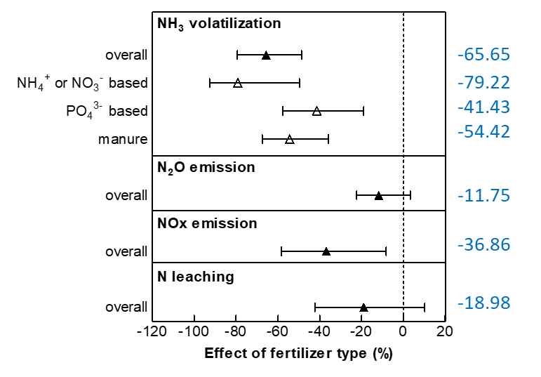
Fig. S1 | Effects of fertilizer type on Nr loss from croplands.

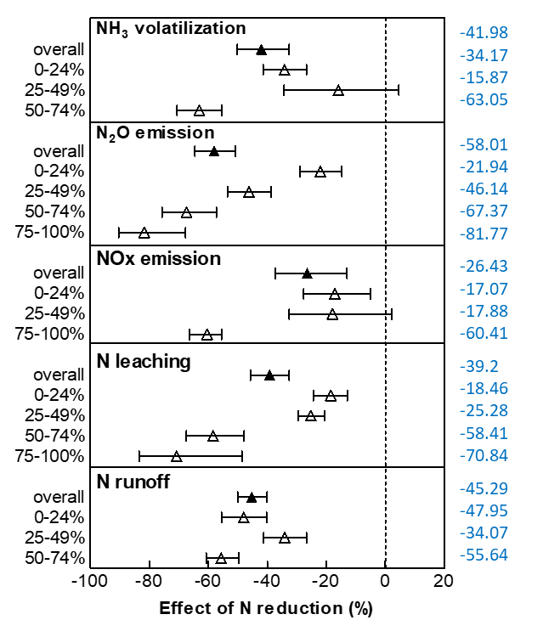
Fig. S2 | Effects of fertilizer reduction on Nr loss from croplands.
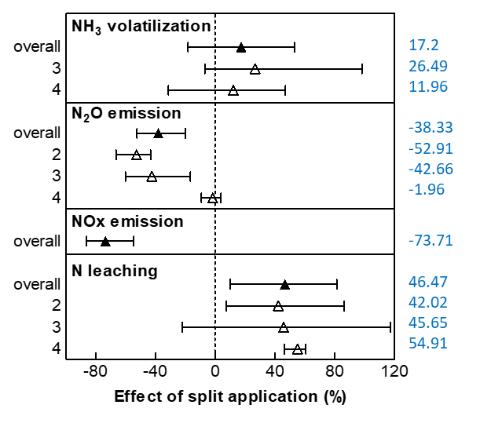
Fig. S3 | Effects of split application on Nr loss from croplands.

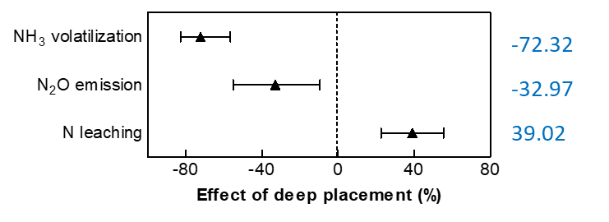
Fig. S4 | Effects of deep placement on Nr loss from croplands.

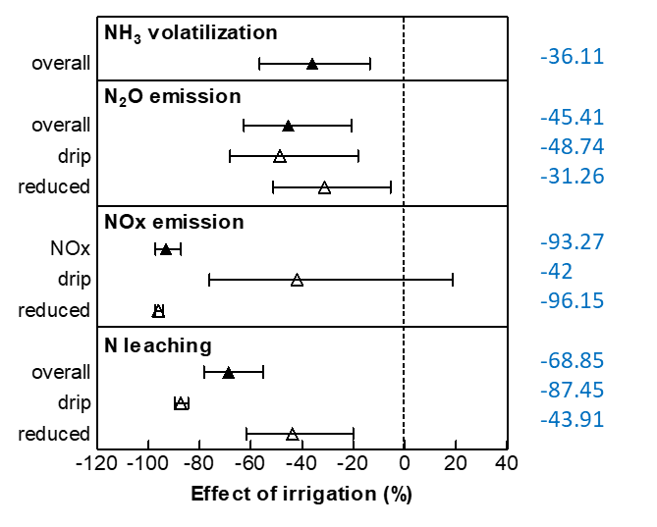
Fig. S5 | Effects of irrigation on Nr loss from croplands.

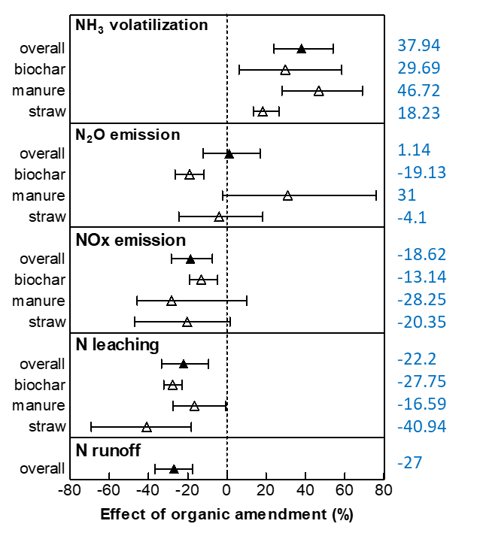
Fig. S6 | Effects of organic amendment on Nr loss from croplands.

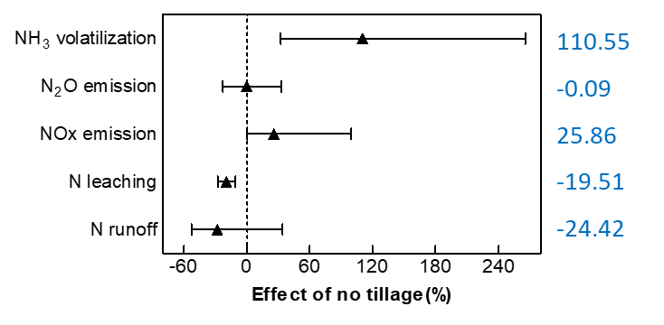
Fig. S7 | Effects of no tillage on Nr loss from croplands.

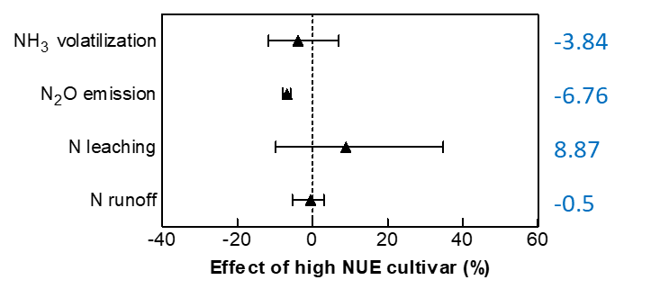
Fig. S8 | Effects of high NUE cultivar on Nr loss from croplands.

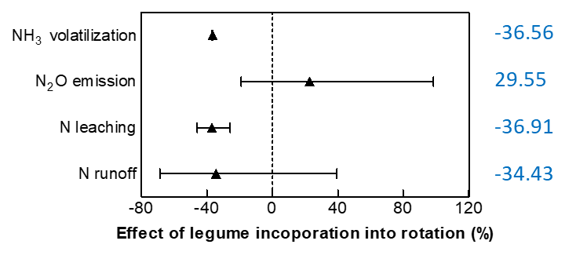
Fig. S9 | Effects of legume rotation on Nr loss from croplands.

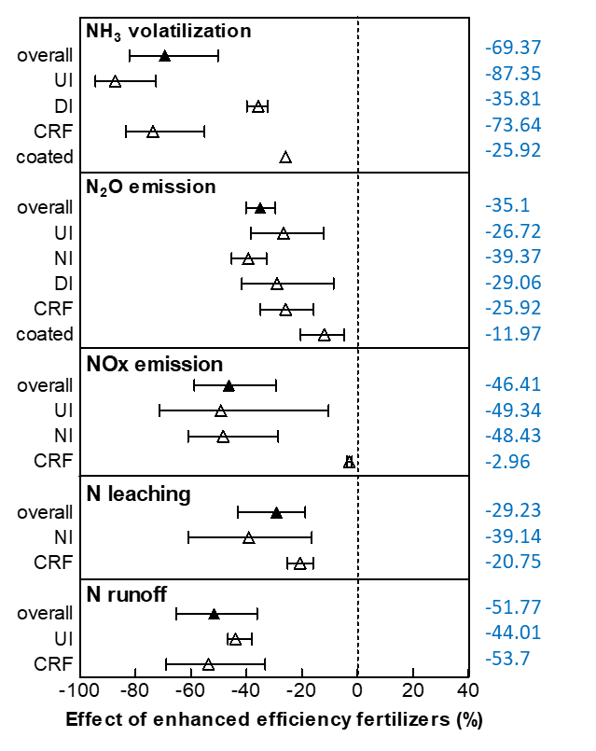
Fig. S10 | Effects of enhanced efficiency fertilizers on Nr loss from croplands. UI: urease inhibitor; NI: nitrification inhibitor; DI: dual inhibitor; CRF: controlled-release fertilizer; coated: coated fertilizer

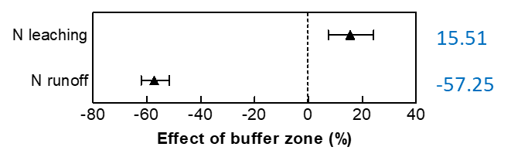
Fig. S11 | Effects of buffer zone on Nr loss from croplands.

