Additional file
Table S1. The monthly cases number of congenital syphilis in Guangdong province from 2005-2020

 | Year |  |  |  |  |  |  |  |  |  |  |  |  |  |  |  |  | Total
 | 2005 | 2006 | 2007 | 2008 | 2009 | 2010 | 2011 | 2012 | 2013 | 2014 | 2015 | 2016 | 2017 | 2018 | 2019 | 2020
Month
1 | 31 | 50 | 85 | 87 | 77 | 97 | 111 | 114 | 96 | 69 | 39 | 29 | 9 | 14 | 7 | 9 | 924
2 | 34 | 69 | 77 | 77 | 96 | 86 | 98 | 91 | 64 | 54 | 25 | 25 | 15 | 10 | 8 | 3 | 832
3 | 48 | 81 | 63 | 82 | 72 | 106 | 120 | 124 | 94 | 75 | 43 | 26 | 17 | 12 | 5 | 8 | 976
4 | 39 | 64 | 69 | 103 | 82 | 79 | 107 | 107 | 82 | 73 | 40 | 21 | 22 | 9 | 8 | 4 | 909
5 | 45 | 69 | 84 | 92 | 94 | 119 | 114 | 139 | 79 | 63 | 33 | 32 | 22 | 10 | 10 | 6 | 1011
6 | 46 | 60 | 107 | 67 | 94 | 111 | 119 | 120 | 87 | 69 | 45 | 31 | 16 | 6 | 7 | 8 | 993
7 | 37 | 70 | 108 | 97 | 115 | 97 | 148 | 156 | 97 | 69 | 48 | 30 | 22 | 15 | 6 | 4 | 1119
8 | 47 | 91 | 96 | 109 | 117 | 136 | 141 | 129 | 82 | 78 | 46 | 30 | 12 | 8 | 7 | 6 | 1135
9 | 59 | 90 | 110 | 126 | 112 | 100 | 163 | 116 | 100 | 65 | 53 | 20 | 20 | 12 | 15 | 6 | 1167
10 | 82 | 95 | 134 | 120 | 108 | 131 | 167 | 141 | 114 | 83 | 51 | 36 | 15 | 9 | 11 | 7 | 1304
11 | 61 | 116 | 111 | 109 | 108 | 135 | 154 | 116 | 97 | 71 | 65 | 20 | 17 | 20 | 6 | 7 | 1213
12 | 72 | 98 | 108 | 113 | 128 | 104 | 113 | 118 | 64 | 65 | 47 | 22 | 17 | 16 | 6 | 13 | 1104
Total | 601 | 953 | 1152 | 1182 | 1203 | 1301 | 1555 | 1471 | 1056 | 834 | 535 | 322 | 204 | 141 | 96 | 81 | 12687

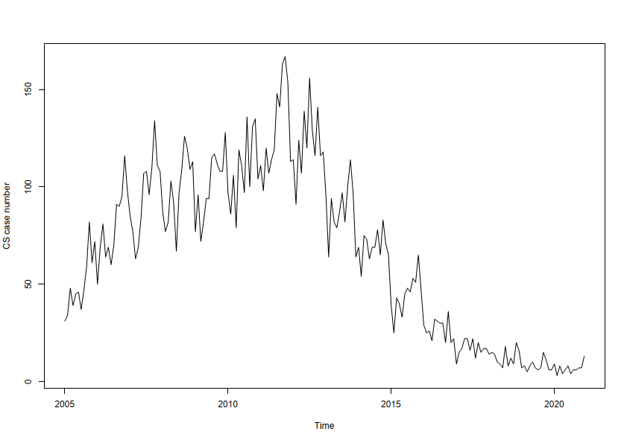
Figure S1. Time sequence diagram of monthly CS case during 2005-2020 in Guangdong Province

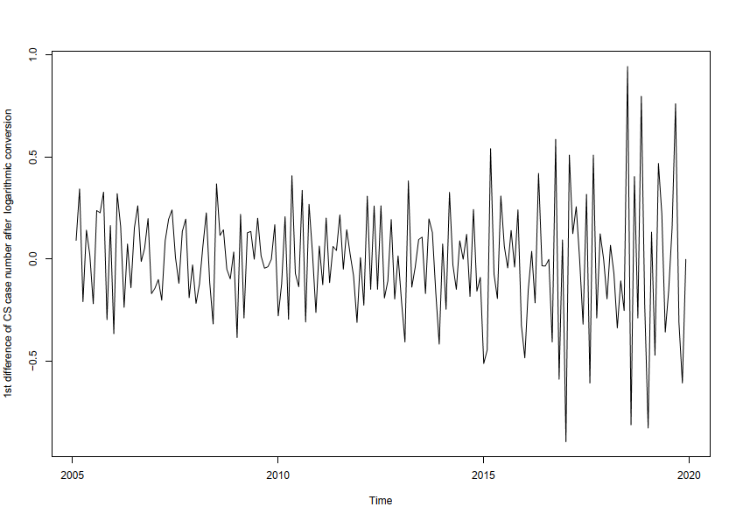
Figure S2. The time sequence diagram of CS case number from 2005-2020 in Guangdong Province after 1st order log differential
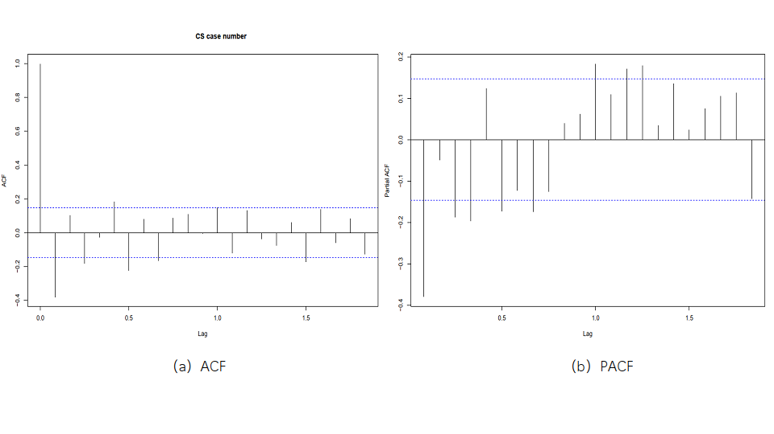

Figure S3. The correlogram graph for CS case number after logarithmic transformation and 1st difference, (a) presents ACF graph and (b) presents PACF graph.

Table S2. The forecasting result of CS case number in 2021 using ARIMA (0,1,1) (1,0,2) [12] model

Month | The year 2021
Month | Predicted incidence | Upper 95% CI | Lower 95% CI
1 | 4 | 1 | 10
2 | 4 | 1 | 10
3 | 4 | 1 | 10
4 | 4 | 1 | 11
5 | 4 | 2 | 13
6 | 3 | 1 | 10
7 | 4 | 1 | 12
8 | 3 | 1 | 11
9 | 5 | 2 | 16
10 | 4 | 1 | 14
11 | 4 | 1 | 14
12 | 4 | 1 | 13
Total | 48 | - | -

