Supporting Information

A 36 × 200 Gbps hybrid mode/wavelength division multiplexing transmitter using lithium niobate on insulator
Mingyu Zhu ^{a, ||}, Weihan Wang ^{a, ||}, Ruitao Ma ª, Aoyun Gao ª,Chun Gao ª, Zexu Wang ª, Fei Huang ª, Zhenyuan Bao ª, Dajian Liu ^{a, b}, Jiaxuan Gan ª, Zejie Yu ^{a, c}, Huan Li ^{a, c}, Weike Zhao ^{a,} *, and Daoxin Dai ^{a, c, d} *
ªState Key Laboratory of Extreme Photonics and Instrumentation, College of Optical Science and Engineering, International Research Center for Advanced Photonics, Ningbo Research Institute, Zhejiang University, Hangzhou 310058, China
^{b}ZJU-Hangzhou Global Scientific and Technological Innovation Center, Zhejiang University, Hangzhou 311215, China
^{c}Jiaxing Key Laboratory of Photonic Sensing & Intelligent Imaging, Intelligent Optics & Photonics Research Center, Jiaxing Research Institute, Zhejiang University, Jiaxing 314000, China
^{d}China Jiliang University, Hangzhou 310018, China.
||These authors contributed equally to this work
*dxdai@zju.edu.cn, wkzhao@zju.edu.cn

S1. 8-channels wavelength multiplexer with 1.6 nm channel spacing
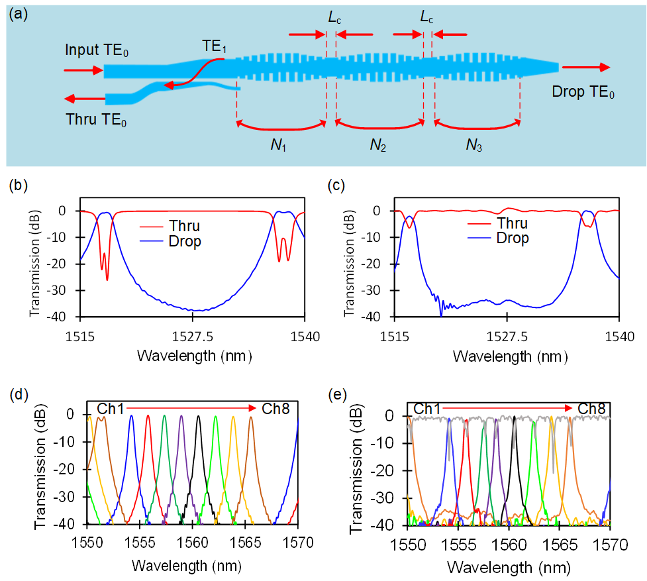
Figure S1. 8-channels wavelength multiplexer with 1.6 nm channel spacing, (a) a cascaded FP cavity based wavelength filter, (b) simulated optical transmission spectra of the cascaded FP cavity, (c) measured optical transmission spectra of the cascaded FP cavity, (d) simulated optical transmission spectra of the 8-channels wavelength multiplexer with 1.6 nm channel spacing, (e) measured optical transmission spectra of the 8-channels wavelength multiplexer with 1.6 nm channel spacing.

Figure S1(a) shows the detailed design of an a cascaded FP cavity based wavelength filter. The filter is designed according to the phase-matching condition between the forward TE₀ modes and the backward TE₁, and thus, one has
$$\begin{aligned}\left(Neff_{1}+Neff_{2}\right)Λ=λ_{B}\end{aligned}$$
where N_{eff1} and N_{eff2} are the effective refractive indices of the TE₀ and TE₁ modes in the AMWG, respectively, λ_{B} is the Bragg wavelength, and Λ is the grating period. The reflectivity and the reflective bandwidth of an AMWG can be flexibly designed simply by optimizing structural parameters of corrugation depth δ and teeth number N.
The simulated and measured optical transmission spectra of the cascaded FP cavity are shown in Fig. S1(b) and (c), respectively. It can be seen from the figures that the measured results are basically consistent with the simulated results, with the following parameters: δ = 850 nm, Λ = 440 nm, duty cycle η = 0.5, w = 2000 nm, b = 10, N₁ = N₃ = 60, and and N₂ = 90, L_{c} = 0.440 nm. Among them, the extinction ratio of the measured results is >35 dB, and the experimental loss is approximately 0.05-0.25 dB.
Fig. S1(d) and (e) compared the simulation and measurement spectra of the optimized 8-channel wavelength multiplexer with a channel spacing of 1.6 nm. The parameters used here are as follows: δ = 850 nm, Λ = 440 nm, duty cycle η = 0.5, w = 2000 nm, b = 10, N₁ = N₃ = 80, and N₂ = 150 . L_{c} = 0.440, 0.487, 0.534, 0.581, 0.628, 0.675, 0.722, 0.769 nm. With these parameters, the simulated minimum insertion loss of a single cascaded FP cavity is 0.11 dB, and the extinction ratio is >40 dB. Experimentally, this 8-channel wavelength multiplexer has an insertion loss of 0.1-0.9 dB, and an extinction ratio between different channels of > 40 dB.

S2. Design of EO modulators
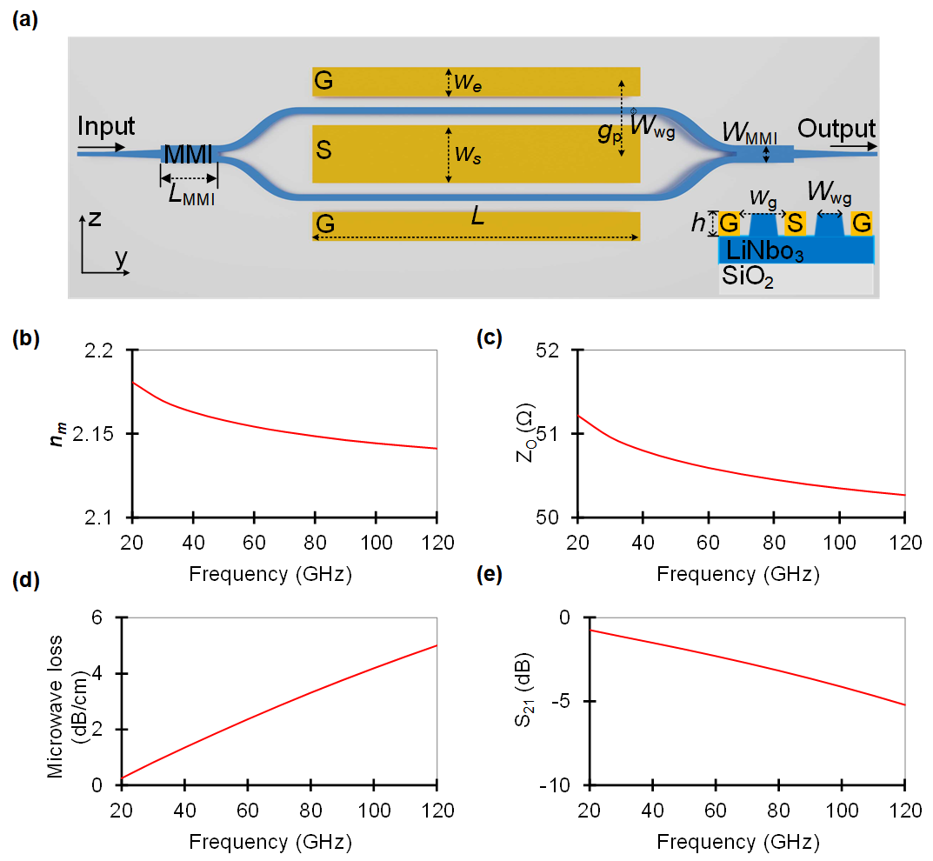

Figure S2. Simulated results of the MZM. (a) Schematic diagram of an MZM; (b) RF effective refractive index as a function of frequency; (c) RF impedance Re[Z₀] as a function of frequency; (d) RF attenuation 𝛼_{m} as a function of frequency; (e) calculated EO response.
Figure S2(a) shows the schematic illustration of the proposed MZM. The structural parameters are designed as Wwg = 1.5 μm, LMMI = 35.2 μm, WMMI = 7.5 μm, h = 600 nm, ws = 18 μm, gp =150 μm, L= 4500 μm, and Wg = 6.5 μm to realize group velocity and 50-Ω impedance matches according to the design rules. The calculated effective refractive index nm of the RF mode is shown in Figure S2(b), it is well matched with the group index of the optical mode no = 2.2201 at an RF bandwidth of 0–120 GHz. Figure S2(c) shows the calculated impedance Re[Z0] of the designed electrodes, indicating a good match with 50 Ω. The length of the modulation region is chosen to be L = 4500 μm. Figure S2(d) shows the calculated RF attenuation αm, which is less than 8.0 dB/cm in the RF range of <120 GHz. Figure S2(e) shows the calculated modulation response m[ω] of the designed modulator. It can be seen that the designed MZI EO modulator has a modulation damping of 1.6 dB at 40 GHz and features theoretical 3-dB EO bandwidth far exceeds 80 GHz.

S3. Effect of flat-top optical transmission spectra on high-speed signal transmission
Optical filters with flat-top optical transmission spectra are highly desired to reduce signal distortions, thus enhancing the spectral efficiency. Figure S3a shows the optical transmission spectra of filters based on single and coupled cavities. Figure S3b depicts the frequency spectra of 40 Gbaud, 80 Gbaud, 120 Gbaud, and 160 Gbaud signals, respectively, where the bandwidth increases almost linearly with the increase of data rate. An optical filter will cause signal distortions if its’ optical bandwidth is smaller than the bandwidth of the modulated signal. Wavelength multiplexer based on single-cavity filters must increase the 3-dB bandwidth to support high-speed signals, but the channel spacing must be increased at the same time to reduce the crosstalk between neighboring channels. As a result, the spectral efficiency is limited. In terms of wavelength multiplexer based on coupled-cavity filters with flat-top optical transmission spectra, the coupled-cavity filter has a broader 3-dB bandwidth and lower crosstalk at the same channel spacing as a single-cavity filter, thus supporting higher speed signals. Figure S3c show the simulated eye diagrams after transmitting through optical filters based on single and coupled cavities, respectively. Signal distortions can be clearly observed after transmitting through a single-cavity filter when the data rate is 120 GBaud OOK and 40 GBaud PAM4. As for a coupled-cavity filter, no signal distortion is found even when the data rate approaches 160 GBaud OOK and PAM4. All results simulated under 20 dB crosstalk.
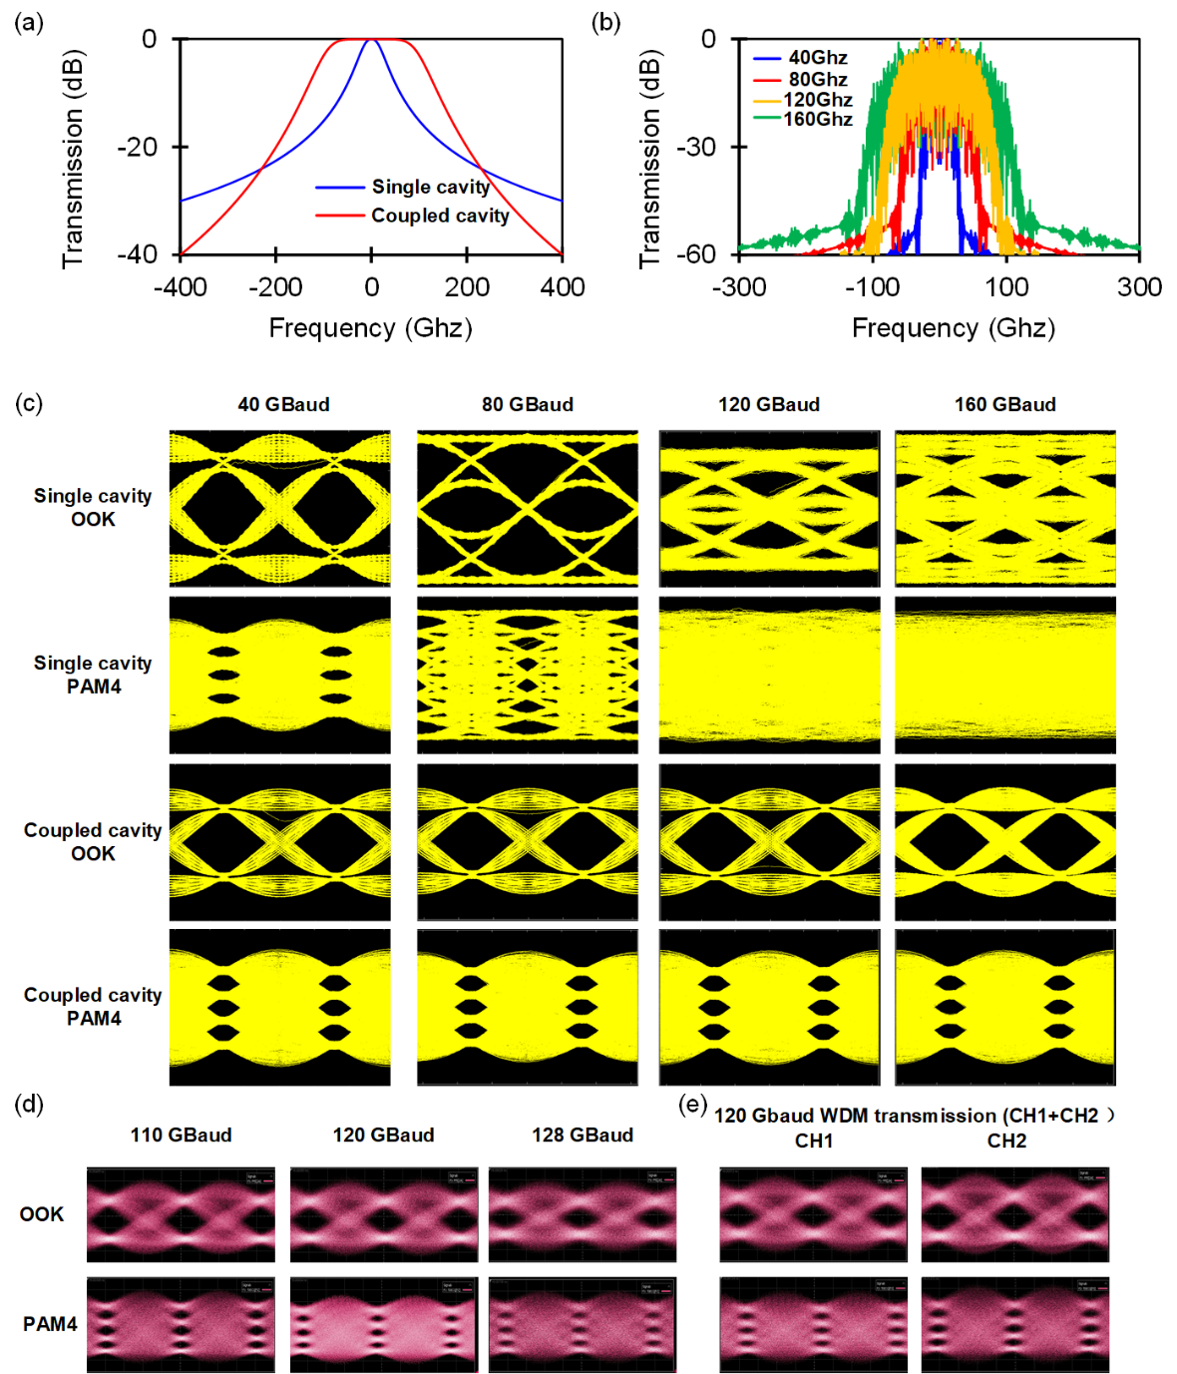
Figure S3. High-speed signal transmission comparison between filters with single and coupled cavities. (a) Optical transmission of filters with single (blue, 3-dB bandwidth = 50 GHz) and coupled (red, 3-dB bandwidth = 200 GHz) cavities. (b) Frequency spectra of 40 GBaud, 80 GBaud, 120 GBaud, and 160 GBaud signals. (c) Simulated eye diagrams of 40 GBaud, 80 GBaud, 120 GBaud, and 160 GBaud OOK and PAM4 signals after transmitting through a single-cavity filter. (d) Simulated eye diagrams of 40 GBaud, 80 GBaud, 120 GBaud, and 160 GBaud OOK and PAM4 signals after transmitting through a flat-top optical filter (under 20 dB crosstalk). (d) Measured eye diagrams of 100/110/120 GBaud OOK and 100/110/120 GBaud PAM4 in CH1 (TE₀ mode), (e) Measure the eye diagram signal of CH1 and CH2 while simultaneously applying a 120 GBaud signal to these two wavelength channels.

Figure S3(d) shows the test results of OOK and PAM4 signals under different rates for a single channel. The results indicate that, limited by the test equipment, the device can only achieve a maximum test rate of 128 GBaud, while it is theoretically capable of measuring higher-rate signals. Figure S3(e) displays the eye diagram when 120 GBaud microwave signals are simultaneously applied to CH1 and CH2 of the TE₀ mode. The eye diagram shows no significant degradation, which verifies that the device supports the simultaneous input and output of multi-channel signals.

