Spin-polarized light-emitting diodes based on CrI₃ operating without external spin injection
Chung-Chun Lu^{1, 5}, Li-Wei Chang^{1, 5}, Wei-Qing Li¹, Po-Liang Chen¹, Yen-Ju Lin^{1, 2}, Kun-Hung Pan¹, Ching Kuo¹, Chang-Hua Liu^{1, 3, 4*}
1. Institute of Photonics Technologies, National Tsing Hua University, Hsinchu 30013, Taiwan
2. Artilux Inc., Zhubei City, Hsinchu 30288, Taiwan
3. Department of Electrical Engineering, National Tsing Hua University, Hsinchu, 30013, Taiwan
4. College of Semiconductor Research, National Tsing Hua University, Hsinchu, 30013, Taiwan
5. These authors contributed equally to this work
Email: chliu@ee.nthu.edu.tw

Contents:
S1 PL DOCP as a function of magnetic field
S2 Spatially-resolved EL image of the graphene/hBN/CrI₃/hBN/graphene spin-LED
S3 Comparative performance of the graphene/hBN/CrI₃/hBN/graphene spin-LED
and traditional III–V/II–VI spin-LEDs
S4 Simulated temperature distribution and current-induced temperature rise in the biased
graphene/hBN/CrI₃/hBN/graphene spin-LED, obtained via finite-element analysis.
S5 Characterization of a spin-LED using bilayer CrI₃ as the emitting layer

Supplementary Section 1.
PL DOCP as a function of magnetic field
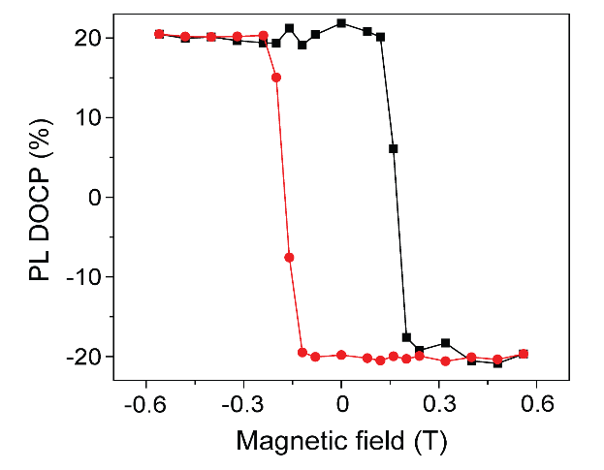
Figure S1 Change of the degree of PL polarization as a function of applied magnetic field. Red (black) data points denote the EL polarization measured when sweeping the magnetic field in the negative (positive) direction. The measurement was performed at 30 K using a linearly polarized He–Ne laser (λ = 633 nm) to excite the monolayer CrI₃ flake shown in Fig. 1b (main text).

Supplementary Section 2.
Spatially-resolved EL image of the graphene/hBN/CrI₃/hBN/graphene spin-LED
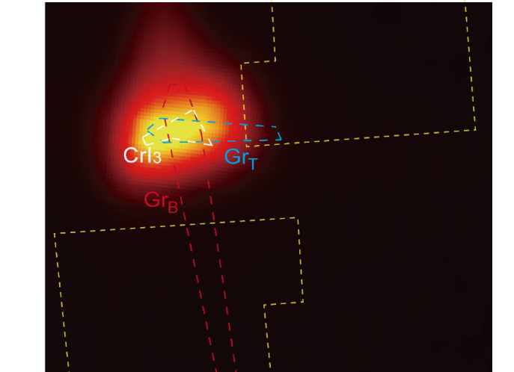

Figure S2 Spatially resolved EL image of the graphene/hBN/CrI₃/hBN/graphene spin-LED shown in Fig. 1a,b (main text), biased at 2.5 V and measured at 30 K. The top graphene (Gr_{T}), bottom graphene (Gr_{B}) and CrI₃ regions are outlined by blue, red and white dashed lines, respectively, and the EL emission is clearly localized at the graphene/CrI₃/graphene overlapping region. The image was acquired using an Andor Newton 920 CCD camera, capable of detecting light in the 300–1100 nm wavelength range.

Supplementary Section 3.
Comparative performance of the graphene/hBN/CrI₃/hBN/graphene spin-LED and traditional III–V/II–VI spin-LEDs
Spin injector |  | Emitting layer | DOCP | Temperature | Ref.
Diluted Magnetic Semiconductor  Ferromagnetic Metal | (Ga,Mn)As | InGaAs QW | 8% | 6K | [1]
Diluted Magnetic Semiconductor  Ferromagnetic Metal | (Ga,Mn)As | InAs QD | 1% | 4.5K | [2]
Diluted Magnetic Semiconductor  Ferromagnetic Metal | GaCrN | InGaN | 6% | 5K | [3]
Diluted Magnetic Semiconductor  Ferromagnetic Metal | Co_{2.4}Mn_{1.6}Ga | InGaAs QW | 13% | 5K | [4]
Diluted Magnetic Semiconductor  Ferromagnetic Metal | Co/Pt | AlGaAs/GaAs | 3% | 20K | [5]
Diluted Magnetic Semiconductor  Ferromagnetic Metal | CoFeB /MgO | InGaAs /GaAs QW | 20-22% | 25K | [6,7]
Diluted Magnetic Semiconductor  Ferromagnetic Metal | FeCo | GaN | 6% | 300K | [8]
Diluted Magnetic Semiconductor  Ferromagnetic Metal | CoFeB /MgO | InGaAs QD | 19% | 100K | [9]
 | Not required | CrI₃ monolayer | 20% | 30 K | This work

Table S1 Summary of key performance metrics and material compositions for the graphene/hBN/CrI₃/hBN/graphene spin-LED and representative III–V and II–VI spin-LEDs. The comparison includes representative material systems capable of reversing EL helicity within ±1 T and retaining helicity after the magnetic field is removed, without requiring a large external field to maintain spin injection efficiency and suppress spin decoherence. QW, quantum well; QD, quantum dot.

Supplementary Section 4.
Simulated temperature distribution and current-induced temperature rise in the biased graphene/hBN/CrI₃/hBN/graphene spin-LED, obtained via finite-element analysis.
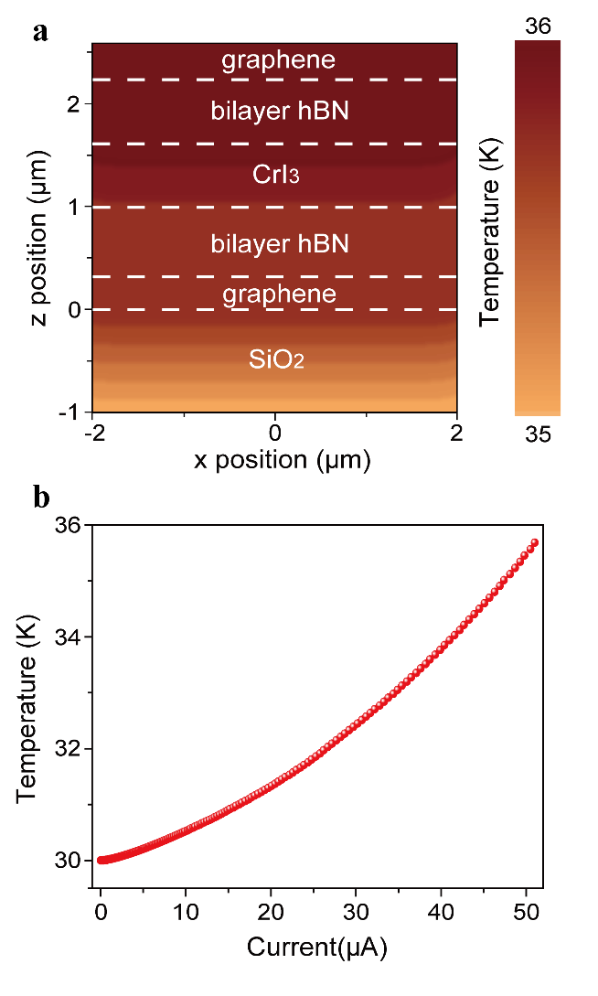
Figure S3 a. Simulated cross-sectional temperature distribution of the graphene/hBN/CrI₃/hBN/graphene spin-LED under an injected current of 50 µA. b. Simulated temperature of CrI₃ as a function of the input current injected into the graphene/hBN/CrI₃/hBN/graphene spin-LED. The power density applied to the device was calculated from the I–V characteristics shown in Fig. 3a (main text). In both panels, the LED was simulated on a cold finger at a base temperature of 30 K, and the material constants used, including thermal conductivity and specific heat, are listed in Table S2.

 | Density  (kg/m³) | Specific heat  $$(J/kg∙K)$$ | Thermal conductivity  $$(W/m∙K)$$
graphene | 2267 | 33 | 287
CrI₃ | 2419 | 92.44 | 1.355
hBN | 2100 | 122.1 | 227

Table S2 Materials constants used in the finite element simulations¹⁰⁻¹².

Supplementary Section 5.
Characterization of a spin-LED using bilayer CrI₃ as the emitting layer
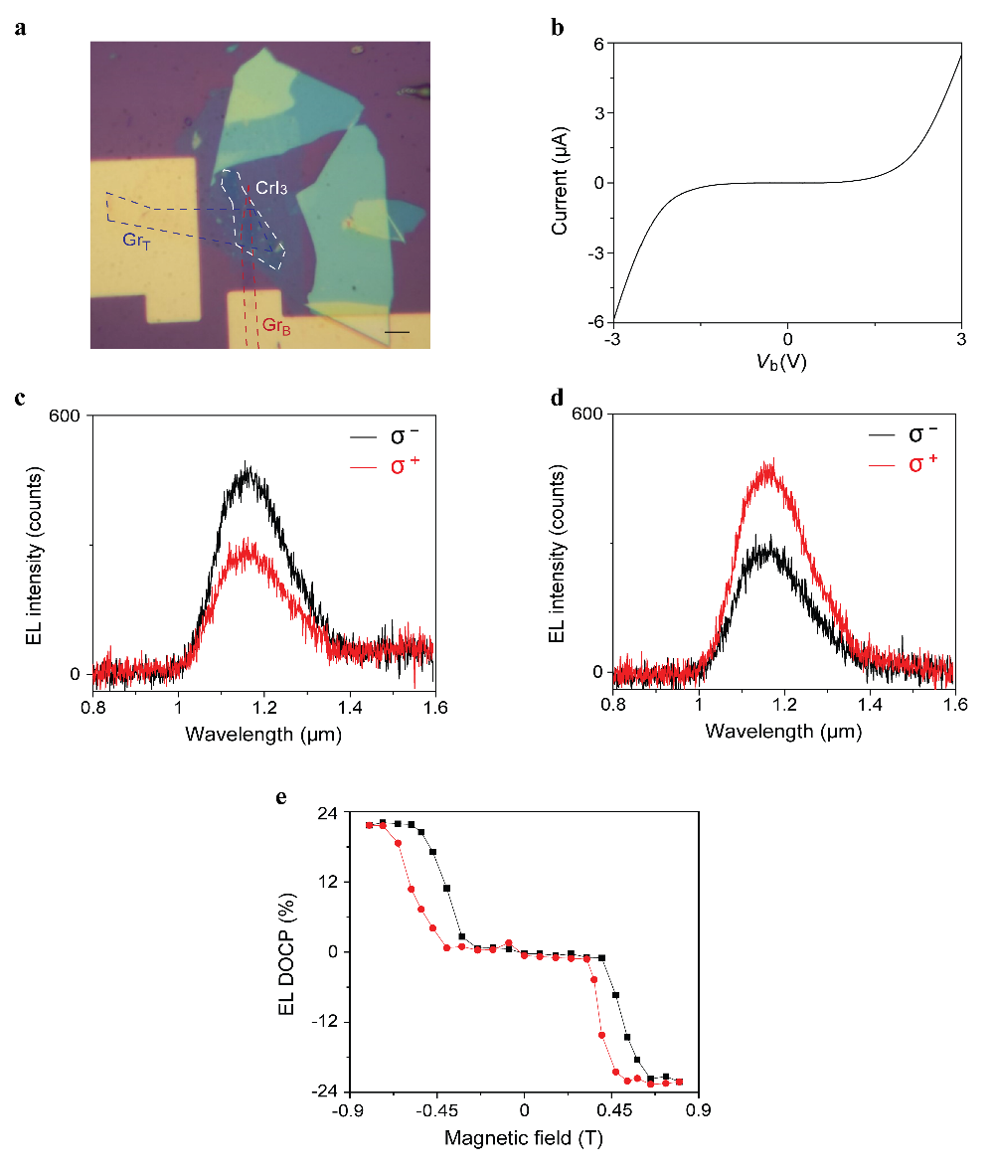
Figure S4 a. Optical microscope image of the vdW heterostructure spin-LED. The regions of top graphene (Gr_{T}), bottom graphene (Gr_{B}) and monolayer CrI₃ are defined by blue, red and white dashed lines, respectively. Scale bar, 10 µm. b. I–V_{b} characteristics of the light-emitting heterostructures measured under a bias applied across the graphene electrodes, with the bottom electrode grounded. c-d. Polarization-resolved EL spectra for σ⁻ (black) and σ⁺ (red) detection, with the magnetic field at (c) 0.8 T and (d) -0.8 T, respectively. e. Change of the degree of EL polarization as a function of applied magnetic field. Red (black) data points denote the EL polarization measured when sweeping the magnetic field in the negative (positive) direction. Panels (c–e) were measured under an injected current of 0.5 µA.

References:
1 Ohno, Y. et al. Electrical spin injection in a ferromagnetic semiconductor heterostructure. Nature 402, 790-792 (1999).
2 Chye, Y. et al. Spin injection from (Ga,Mn)As into InAs quantum dots. Phys. Rev. B 66, 201301 (2002).
3 Banerjee, D. et al. Electrical spin injection using GaCrN in a GaN based spin light emitting diode. Appl. Phys. Lett. 103, 242408 (2013).
4 Hickey, M. C. et al. Spin injection between epitaxial Co2.4Mn1.6Ga and an InGaAs quantum well. Appl. Phys. Lett. 86, 252106 (2005).
5 Zarpellon, J. et al. Spin injection at remanence into III-V spin light-emitting diodes using (Co/Pt) ferromagnetic injectors. Phys. Rev. B 86, 205314 (2012).
6 Liang, S. H. et al. Large and robust electrical spin injection into GaAs at zero magnetic field using an ultrathin CoFeB/MgO injector. Phys. Rev. B 90, 085310 (2014).
7 Barate, P. et al. Bias dependence of the electrical spin injection into GaAs from Co-Fe-B/MgO injectors with different MgO growth processes. Phys. Rev. Appl. 8, 054027 (2017).
8 Bhattacharya, A., Baten, M. Z., Frost, T. & Bhattacharya, P. Room temperature GaN-based edge-emitting spin-polarized light emitting diode. IEEE Photon. Technol. Lett. 29, 338–341 (2017).
9 Giba, A. E. et al. Spin injection and relaxation in p-doped (In, Ga)As/GaAs quantum-dot spin light-emitting diodes at zero magnetic field. Phys. Rev. Appl. 14, 034017 (2020).
10 Liu, J. et al. Temperature dependence of thermal conductivity of giant-scale supported monolayer graphene. Nanomaterials 12, 2799 (2022).
11 Sheng, H. H., Zhu, Y. J., Bai, D. M., Wu, X. S. & Wang, J. L. Thermoelectric properties of two-dimensional magnet CrI₃. Nanotechnology 31, 315713 (2020).
12 Zhou, H. Q. et al. High thermal conductivity of suspended few-layer hexagonal boron nitride sheets. Nano Res. 7, 1232-1240 (2014).

