Supplement: Appendix
Note: The following six papers reported that conventional long-axis in-plane ultrasound approach was used to guide the blood vessels for cannulation. This is obviously different from our modified long-axis in-plane (M-LAIP) approach.
1 DOI: 10.1213/ANE.0000000000000242
Quan Z, Takeshita J, Tian M, et al. Modified short-axis out-of-plane ultrasound versus conventional long-axis in-plane ultrasound to guide radial artery cannulation: a randomized controlled trial. Anesthesia and analgesia. 2014; 119(1): 163-169.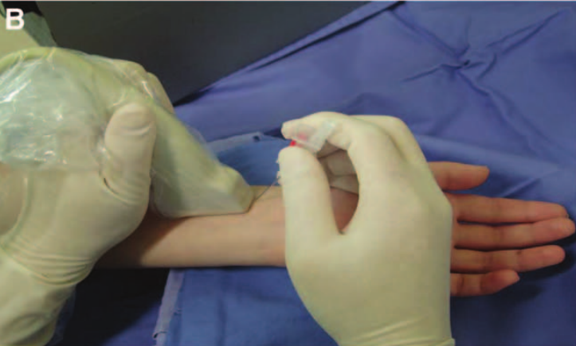
Figure. “The long-axis in-plane (LA-IP) approach. A, Ultrasonic image of the radial artery in the long-axis. B, The needle was inserted steeply downward at a 30° to 45° angle into the skin at the midpoint of the short-axis of the ultrasonic probe. C, The width of the ultrasound screen that was available for the needle was only 12 mm.”

2 DOI: 10.1007/s10877-013-9437-6
Berk D, Gurkan Y, Kus A, Ulugol H, Solak M, Toker K. Ultrasound-guided radial arterial cannulation: long axis/in-plane versus short axis/out-of-plane approaches? Journal of clinical monitoring and computing. 2013; 27(3): 319-324.
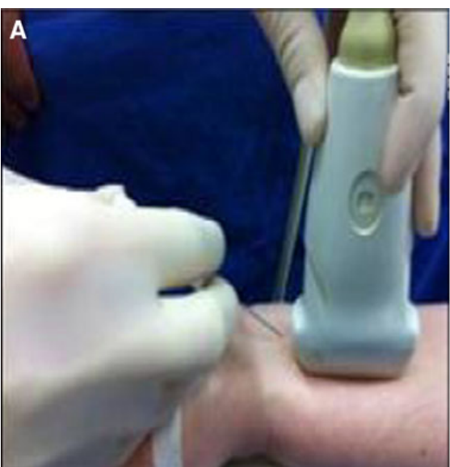
Fig. “The radial arterial image appears as a tubular anechoic structure in US image during long axis imaging. a Probe +needle position. b Doppler image of long axis view”.

3 DOI: 10.1007/s10877-014-9552-z
Kucuk A, Yuce HH, Yalcin F, Boyacı FN, Yıldız S, Yalcin S. Forty-five degree wrist angulation is optimal for ultrasound guided long axis radial artery cannulation in patients over 60 years old: a randomized study. J Clin Monit Comput. 2014; 28(6): 567-572.
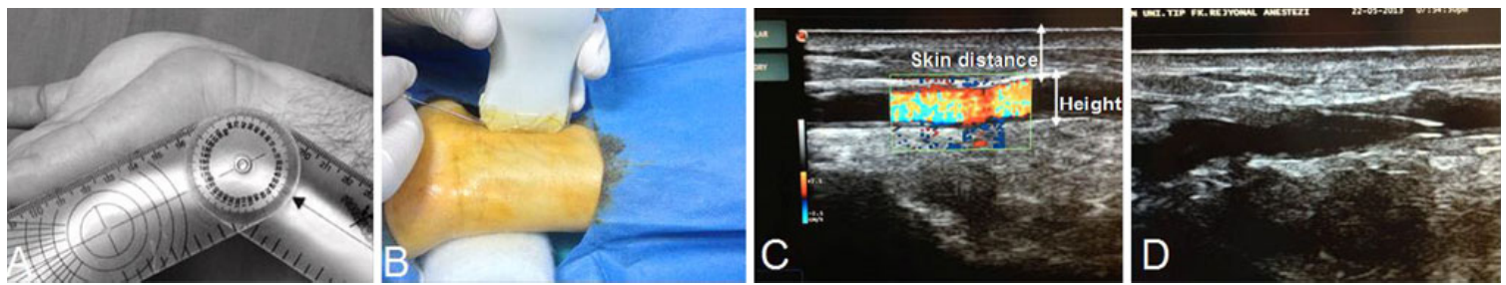
Fig “ The wrist board and arthrometer used in the study. b Probe and needle position during long axis imaging. c Doppler image of long axis in-plane view. d Radial artery long axis in-plane attempts and placement to intraarterial catheter.”

4 DOI: 10.1007/s00134-017-4756-6
Vezzani Antonella, Manca Tullio, Brusasco Claudia et al. A randomized clinical trial of ultrasound-guided infra-clavicular cannulation of the subclavian vein in cardiac surgical patients: short-axis versus long-axis approach. Intensive Care Med. 2017; 43: 1594-1601.
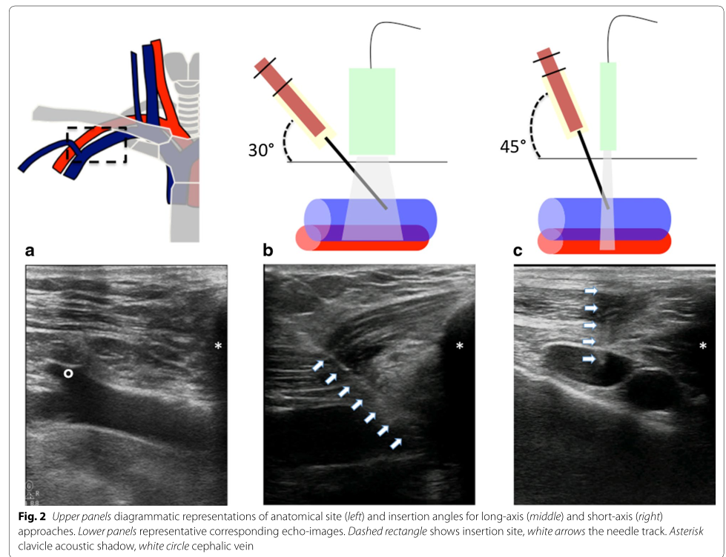
“With the long-axis approach, a short-axis view of the vein was first obtained and then the probe was rotated, maintaining the vessel in the middle of the screen, until the vein appeared in the longitudinal view. The probe was positioned almost parallel moving away from the clavicle, and the entry point of the needle was in-plane with the probe. With this approach, only the vein was visible on the screen. The needle was held at a 30° angle, oriented in-plane with the transducer, and the skin was punctured at the base of the transducer. The vessel alignment was maintained during the procedure and the entire length of the needle was visible during the progression through the tissues. Entry of the tip into the vessel was confirmed by blood aspiration (Fig. 2b).”

5 DOI: 10.1056/NEJMvcm1213181
Ailon J, Mourad O, Chien V, Saun T, Dev SP. Videos in clinical medicine. Ultrasound-guided insertion of a radial arterial catheter. N. Engl. J. Med. 2014; 371(15): e21.
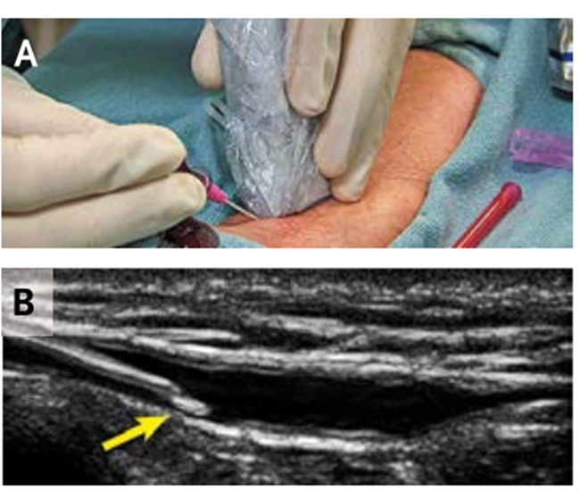
Figure. “Ultrasound-Guided Catheterization in the Longitudinal Orientation. The ultrasound probe is in the longitudinal orientation (Panel A) as the needle tip is inserted into the radial artery and visualized (Panel B, arrow).”

6 DOI: 10.1002/jum.14650
Davda D, Schrift D. Posterior Wall Punctures Between Long-and Short-Axis Techniques in a Phantom Intravenous Model. J Ultrasound Med. 2018; 37: 2891-2897.
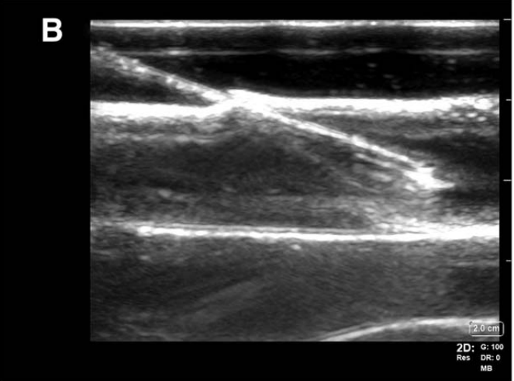
“The long-axis, in-plane approach provides excellent needle tip visualization because the needle tip and transducer are in plane; however, visualization of surrounding structures is limited. The target vessel and needle tip are imaged in a longitudinal orientation. The in-plane technique refers to the process by which the needle tip is inserted and advanced along the plane of the ultrasonic beam. This approach ensures that the needle tip and entire catheter are continuously viewed as they are advanced toward the target vessel. 2,3 For the remainder of this article, the long-axis, in-plane approach will be abbreviated as the long-axis approach.”

