Supplementary information
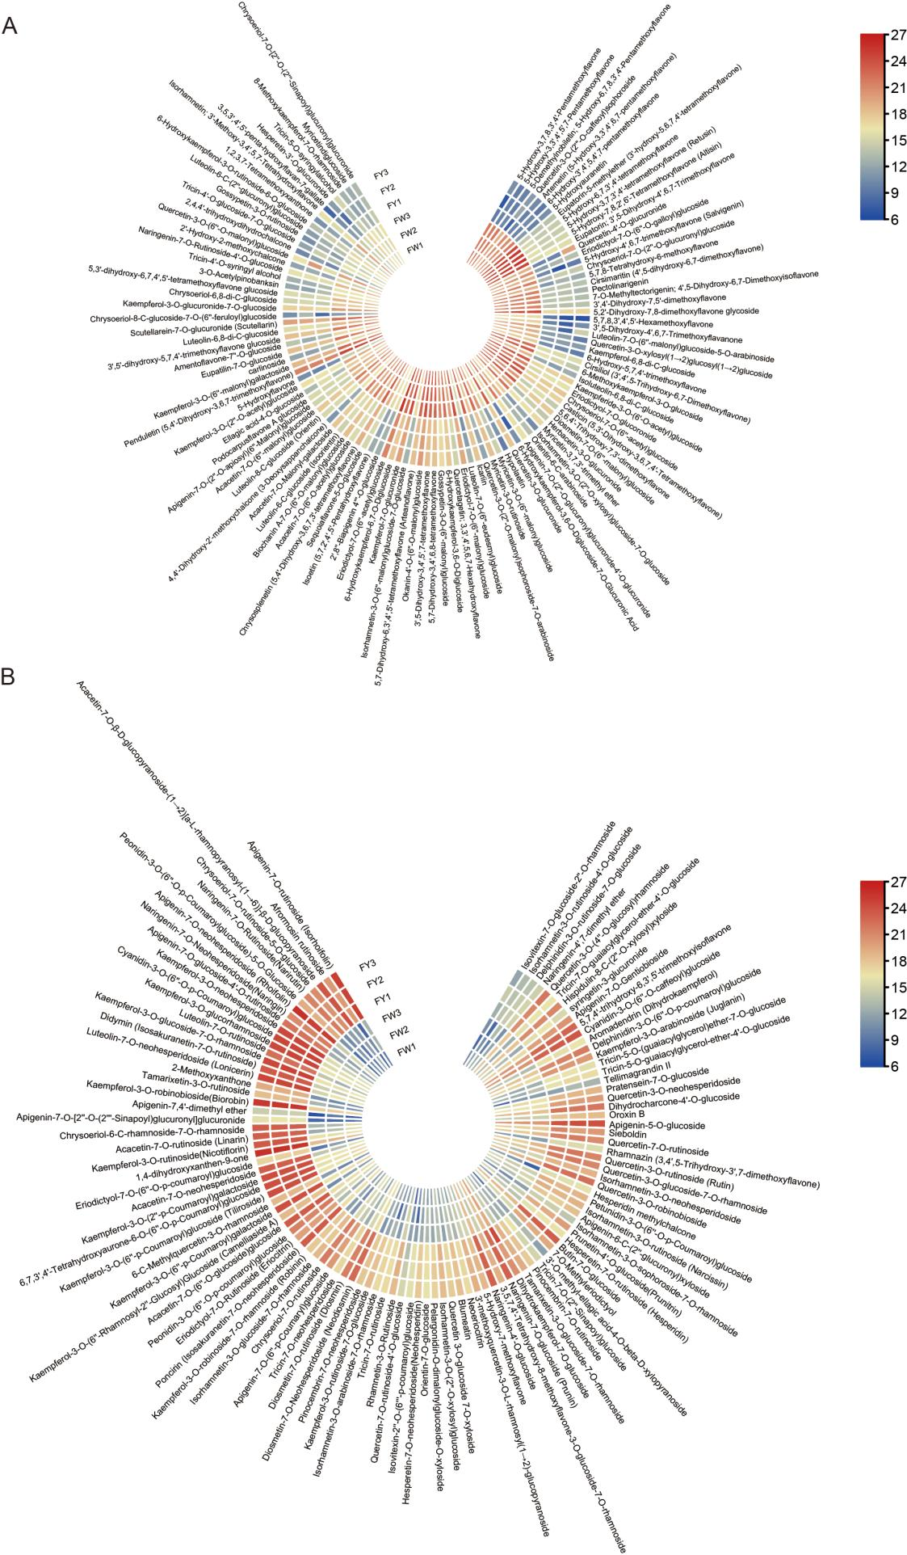
Fig. S1 Heat map of significantly different metabolites. The closer the color is red, the larger the value, and the closer the color is blue, the smaller the value.

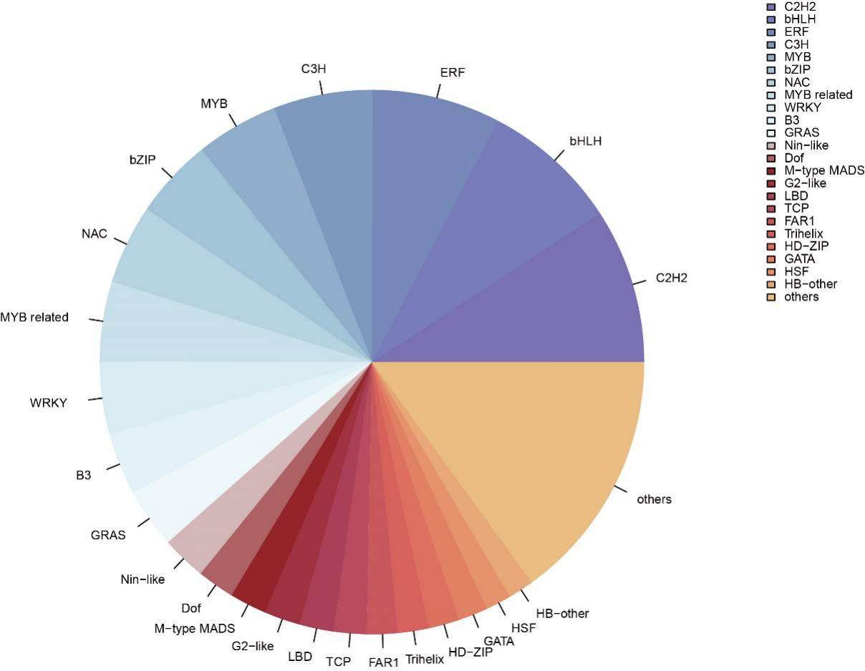
Fig. S2 TF classification and volume distribution of two flower-color C. indicum.

Table S1. The sequences of special primers used in this study.
Gene_ID | Unigene_ID | forward primer | reverse primer
PAL | Unigene8641 | CTCTTCGTACCTCGCCTCAATGG | CCACCGTGTAAAGCCTTGTTTCTC
FLS | Unigene1005 | AAGATGAAGTGAAGCAAGCGTTGG | GGCATGGACATGGTGGGTAGTAG
3AT | Unigene1414 | CGTTATGTGGAAGGTGATTCTGTGG | CATGTCCCAGAGGTGGTACAAGAG
3GT | Unigene11790 | GCCTAGATCCATTGCGTACATTTCC | CGGGGTTTTGGTTTCTTCGAGTG
bZIP | Unigene22143 | GCACCTGTCCTACCACTACTACTAC | ACAGCAGCCATGATTGGTTGTTG
DBB | Unigene15601 | CAAGTGATGGTAAAGTCGGCTGATC | CTGGACCCGTTGTTGTTTGTATCG
GRAS | Unigene6402 | GTGGCAGTGGTGGTGGTGAG | CCTCTCAACTCGGTCCATTCCTTC

Table S2. Metabolite composition in different tissues of two C. indicum varieties.
Class II | Count
Flavones | 241
Flavonols | 137
Flavanones | 51
Chalcones | 27
Isoflavones | 26
Other Flavonoids | 14
Anthocyanidins | 10
Biflavones | 12
Tannin | 8
Flavanols | 8
Flavanonols | 7
Aurones | 3

Table S3. Transcriptome sequencing data and quality statistics of two C. indicum varieties.
Sample | Raw reads | Raw bases | Clean reads | Clean bases | Q20_rate | Q30_rate | GC_content
FW1 | 43,345,832 | 6,501,874,800 | 43,330,026 | 6,127,049,456 | 99.08% | 97.49% | 41.99%
FW2 | 43,370,914 | 6,505,637,100 | 43,355,662 | 5,920,460,788 | 99.15% | 97.61% | 42.38%
FW3 | 43,384,132 | 6,507,619,800 | 43,368,686 | 5,965,502,650 | 99.13% | 97.61% | 42.35%
FY1 | 43,396,130 | 6,509,419,500 | 43,380,332 | 6,051,547,346 | 99.24% | 97.89% | 41.98%
FY2 | 43,335,358 | 6,500,303,700 | 43,319,822 | 5,978,276,226 | 99.13% | 97.62% | 42.21%
FY3 | 43,353,792 | 6,503,068,800 | 43,337,854 | 6,023,494,540 | 99.11% | 97.59% | 42.28%

