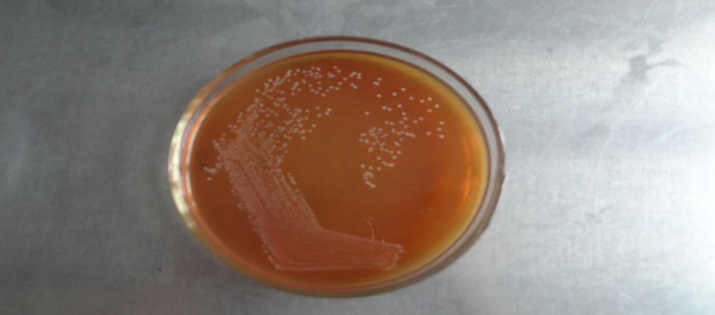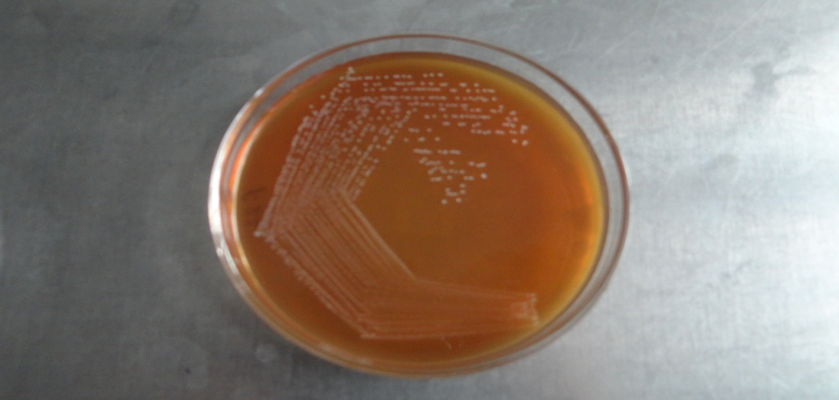
- Lactobacillus crustorum F11 b. Lactobacillus plantarum F22

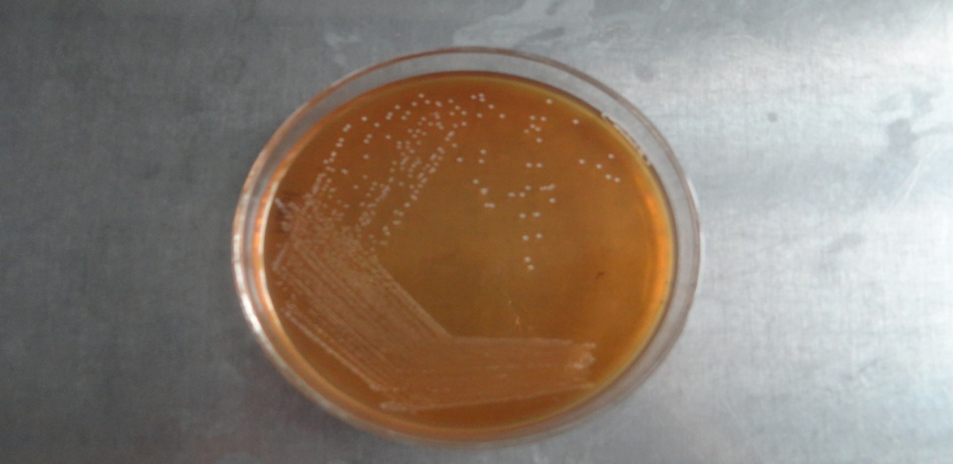
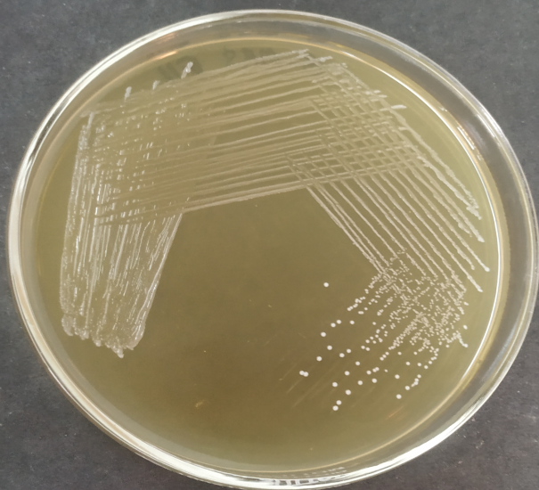

c. Lactobacillus pentosus S6 d. Lactobacillus paraplantarum KM1

Figure: Colony morphology of in-house probiotic cultures selected for synthesis of silver nanoparticles

