SUPPLEMENTAL MATERIAL 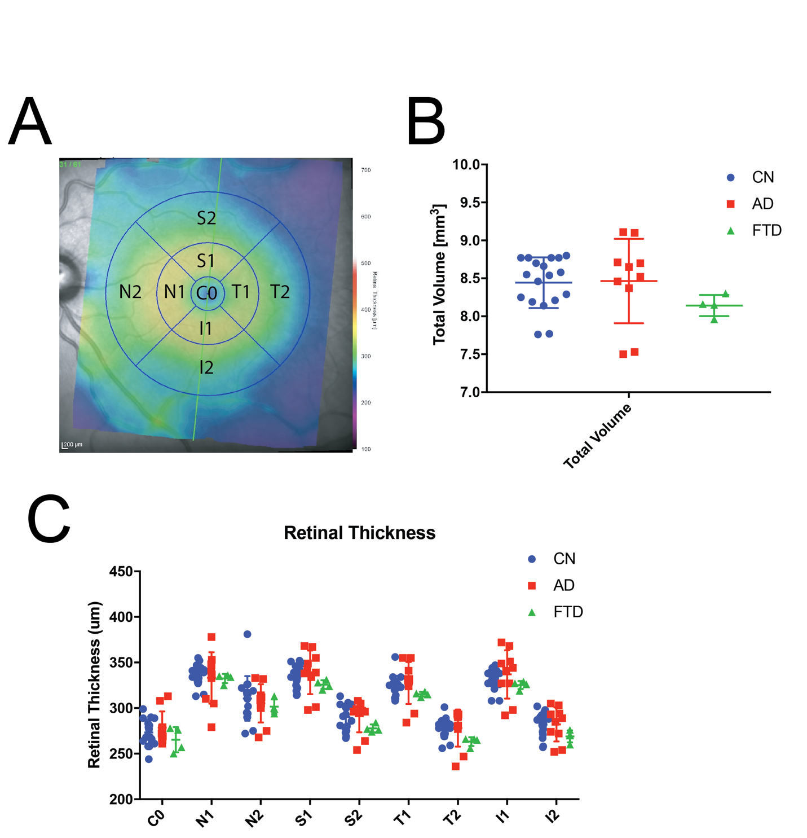
Figure S1. Comparison of total retinal thickness among dementia subtypes. A. Heat map of total retinal thickness divided into subsections centered around the macula B. Comparison of total retinal volume between internal limiting membrane and the basement membrane highlighting no significant differences among dementia subtypes. C. Analysis of total retinal thickness in various subsections centered around the fovea, with no differences found related to dementia subtype. Abbreviations: S, superior; T, temporal; I, inferior, N, nasal; 1, 3 mm from foveal center; 2, 6 mm from foveal center

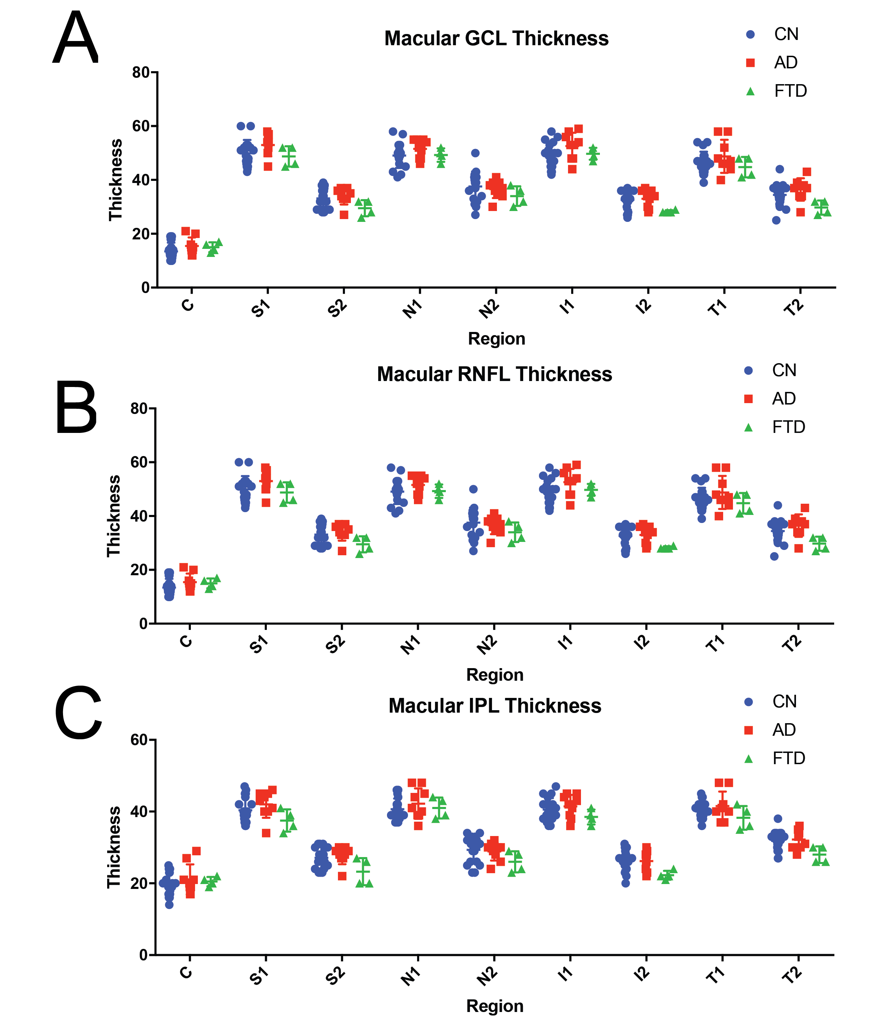
Figure S2. Comparison of macular retinal layer thickness in the ganglion cell layer, retinal nerve fiber layer, and inner plexiform layer. A. No differences in GCL thickness among dementia subtypes measured in anatomic regions centered on the macula. B. No differences were found in macular RNFL thickness among dementia subtypes. C. Analysis of IPL thickness among dementia subtypes measured in anatomic regions centered on the macula demonstrated no differences. Abbreviations: GCL, ganglion cell layer; RNFL, retinal nerve fiber layer; IPL, inner plexiform layer; C, center; S, superior; N, nasal; I, inferior; T, temporal; 1, 3 mm from macular center; 2, 6mm from macular center. One eye from one AD subject had uninterpretable scans due to motion and were thus excluded from the analysis.
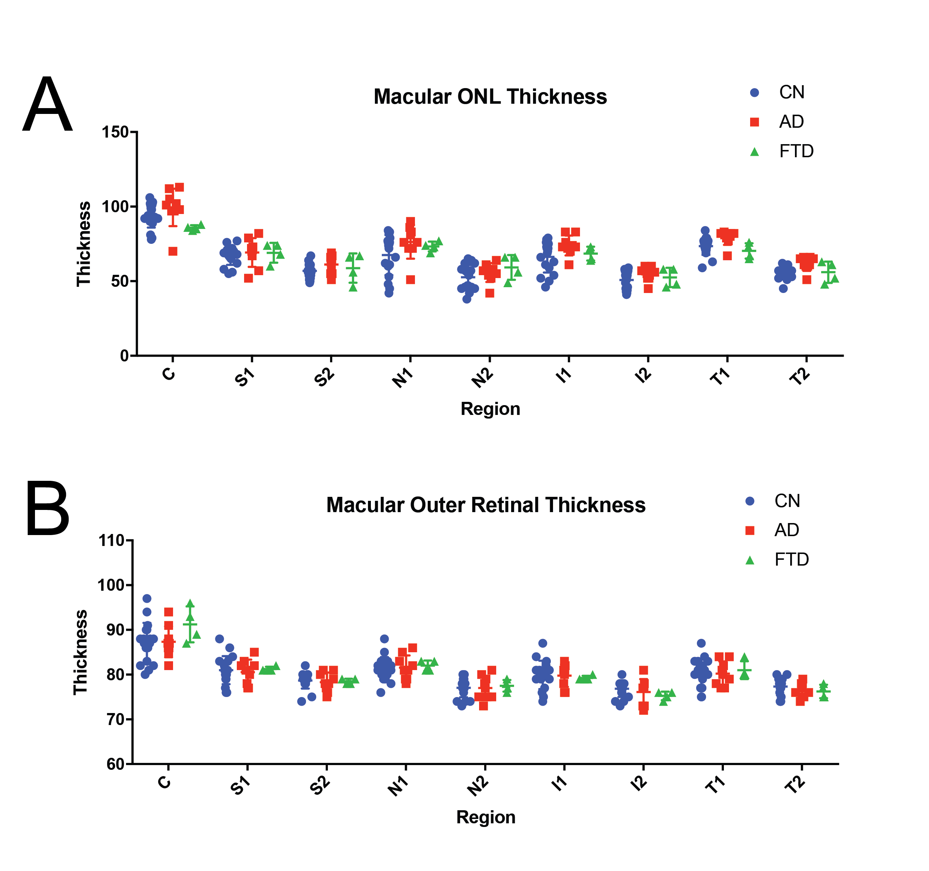
Figure S3. Analysis of macular retinal thickness in the ONL and the outer retinal layer. A. Measurements of macular ONL thickness show no significant differences among dementia subtypes in anatomic regions centered around the macula. B. Outer retinal thickness measurements show no significant difference among dementia subtypes in anatomic regions centered around the macula. Abbreviations: ONL, outer nuclear layer; C, center; S, superior; N, nasal; I, inferior; T, temporal; 1, 3 mm from macular center; 2, 6mm from macular center. One eye from one AD subject had uninterpretable scans due to motion and were thus excluded from the analysis.

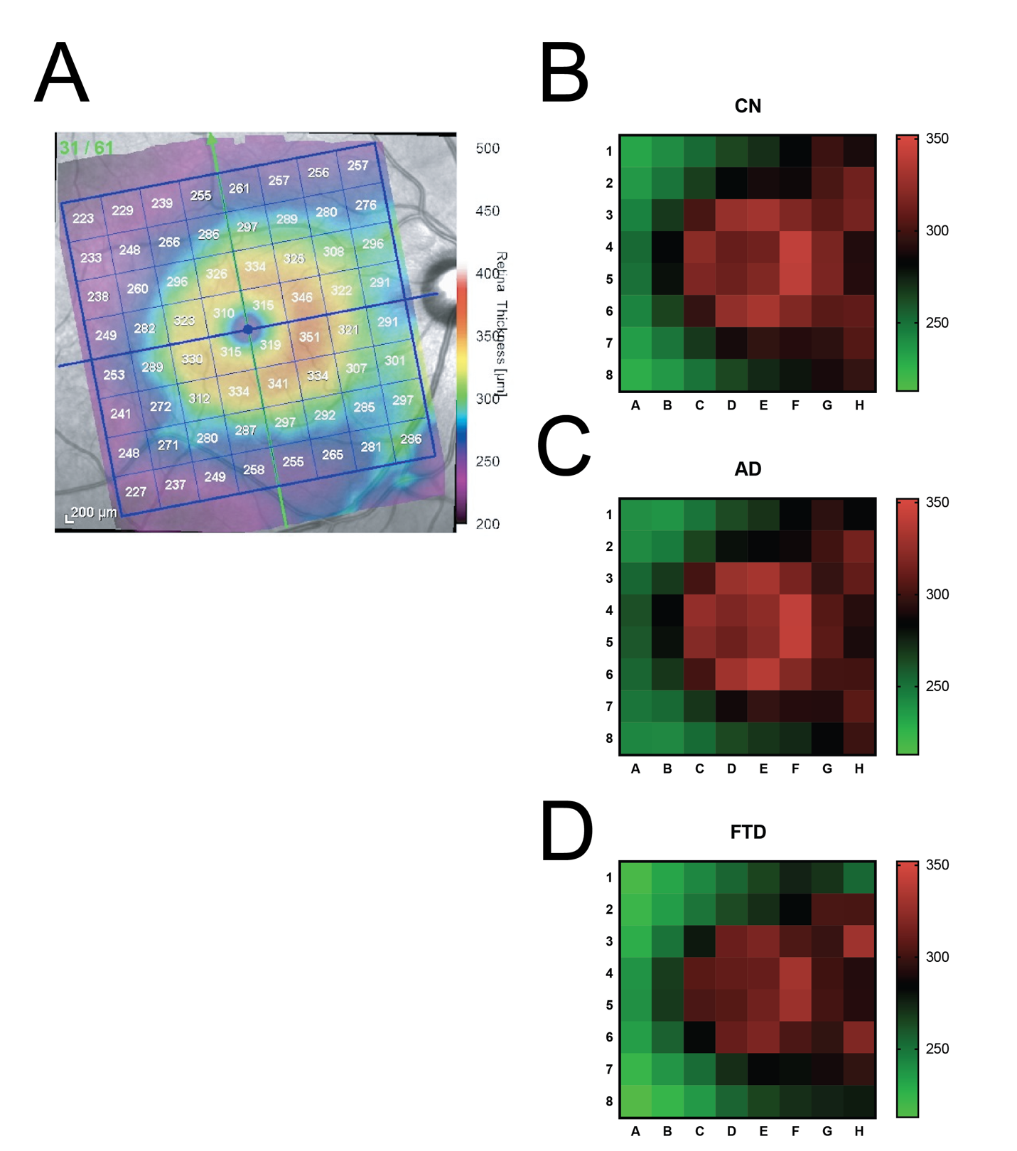
Figure S4. Posterior pole analysis among dementia subtypes. A. Mapped area of division of the posterior pole centered around the macula. B. Heat map comparison of posterior pole area among dementia subtypes. No significant difference was found among the three cohorts. Abbreviations: CN, cognitive normal; AD, Alzheimer’s disease; FTD, frontotemporal dementia

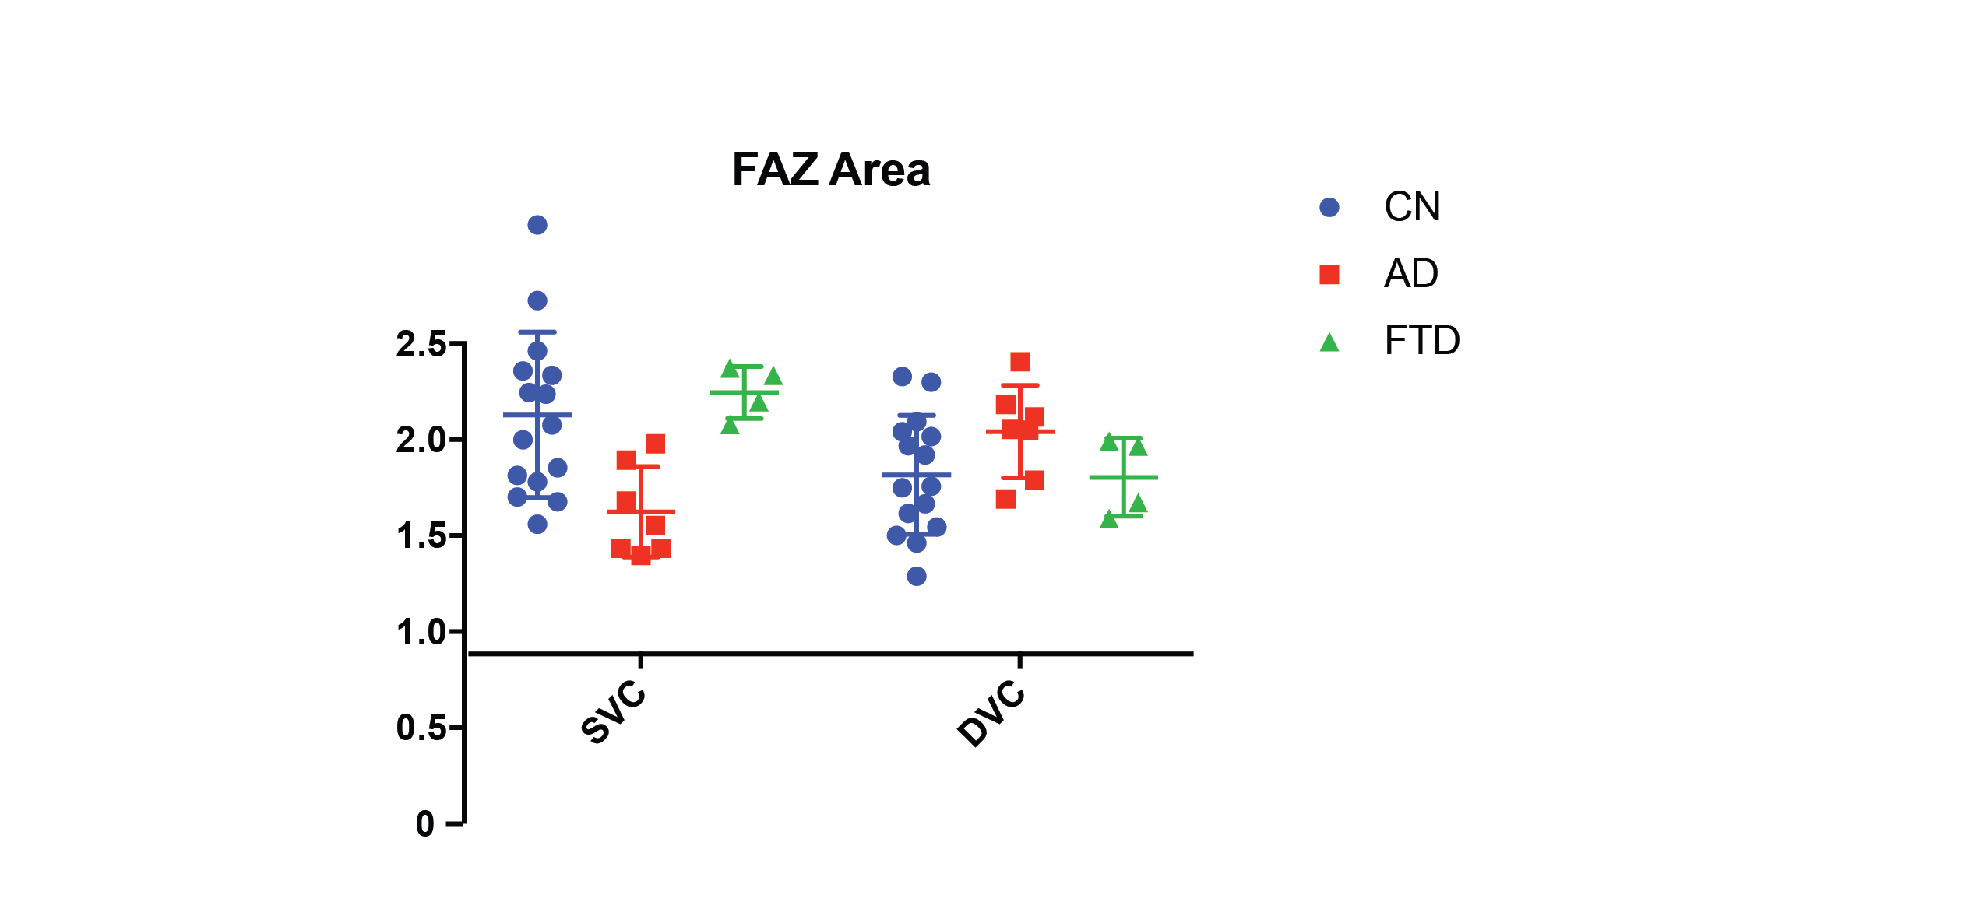
Figure S5. Analysis of choroidal and retinal flow on OCTA images among dementia subtypes. Measurement of foveal avascular zone area in the superior vascular complex and the deep vascular complex highlights no differences in FAZ area associated with dementia subtype. Abbreviations: abu, arbitrary unit; FAZ, foveal avascular zone; SVC, superficial vascular complex; DVC, deep vascular complex; CC, choriocapillaris

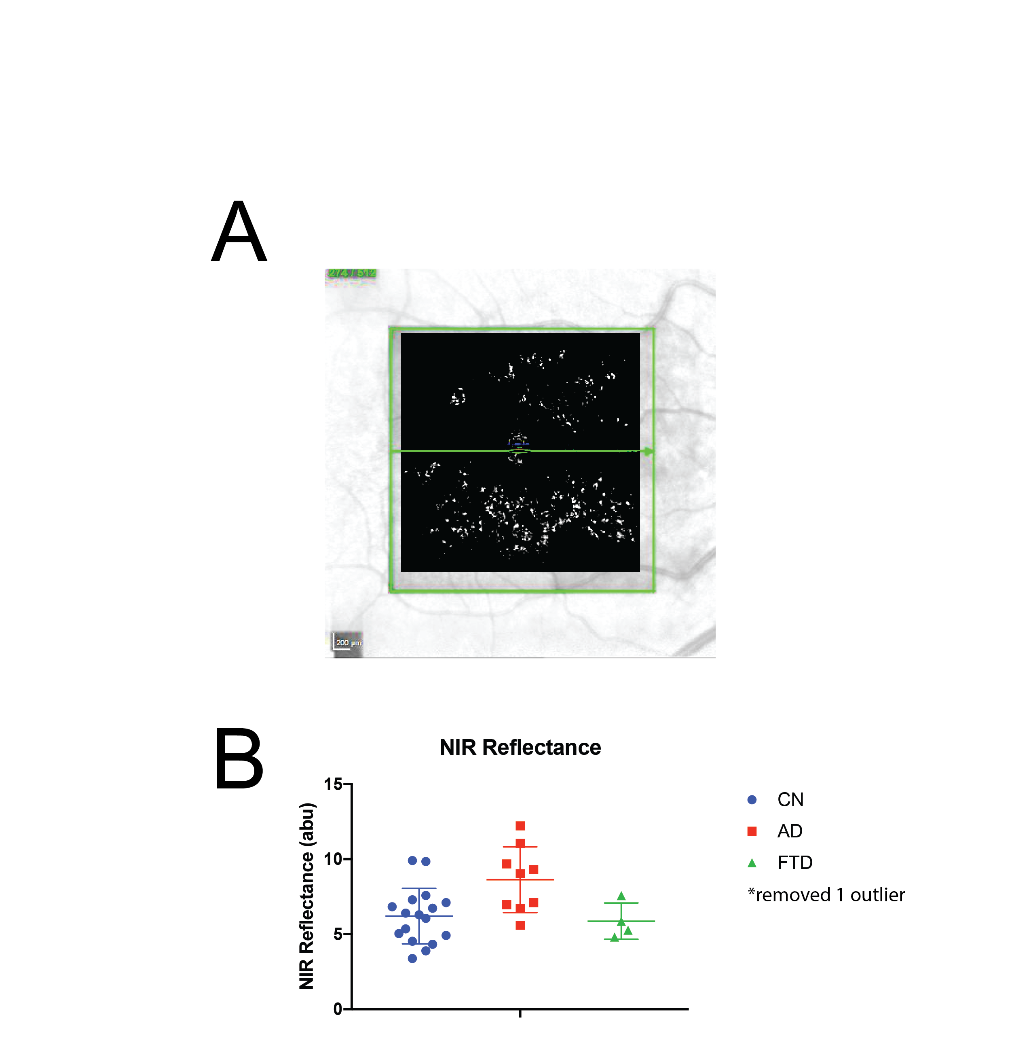
Figure S6. Comparison of Near-Infrared reflectance intensity signals between dementia subtypes A. Pictoral example of analysis completed using ImageJ software. A standardized area centered on the macula was chosen (green box) and each image was thresholded using identical parameters. Signal intensity was measured as a representation of retinal blood flow. B. Near-infrared reflectance measurements were not related to dementia subtype. Data from one FTD eye was removed due to blurriness of the image. Abbreviations: NIR, near-infrared

