Prevalence, antibiotic resistance, and virulence gene profiles of uropathogenic Escherichia coli (UPEC) isolated from raw milk: implications for public health

Aynur Akan¹, Seval Cing Yildirim^{2*} Cumhur Avsar³, Zeynep Yegin⁴

¹Department of Biology, Faculty of Arts & Sciences, Inonu University, Malatya, Turkey, https://orcid.org/0009-0000-6138-9257
²Department of Biology, Faculty of Arts & Sciences, Inonu University, Malatya, Turkey, https://orcid.org/0000-0001-7163-9512
³Department of Biology, Faculty of Arts & Sciences, Sinop University, Sinop, Turkey,
https://orcid.org/0000-0002-4095-0022
⁴Medical Laboratory Techniques Program, Vocational School of Health Services, Sinop University, Sinop, Turkey, https://orcid.org/0000-0003-4637-0253

*Corresponding author: Seval Cing Yildirim
Department of Biology, Faculty of Arts & Sciences, Inonu University, Malatya, Turkey
- mail: seval.cing@inonu.edu.tr; scingy@gmail.com

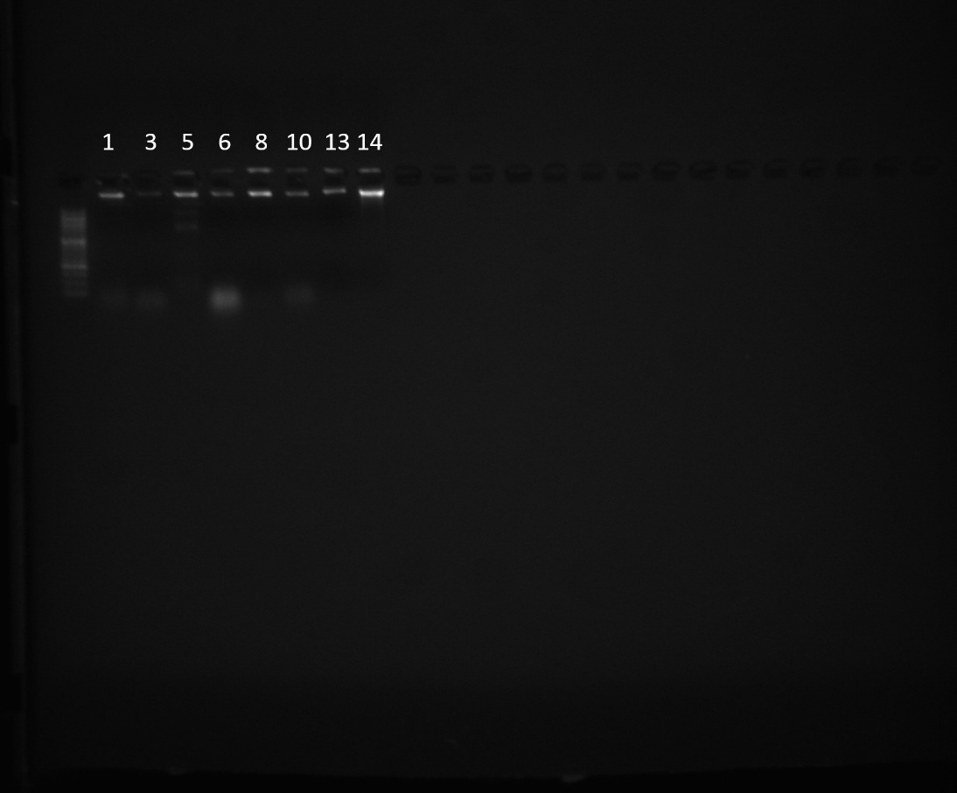
Supplementary Figure S1. Uncropped gel image showing genomic DNA integrity analysis of E. coli isolates.
(Gel image prepared by Cumhur Avşar, Zeynep Yegin, and Aynur Akan)

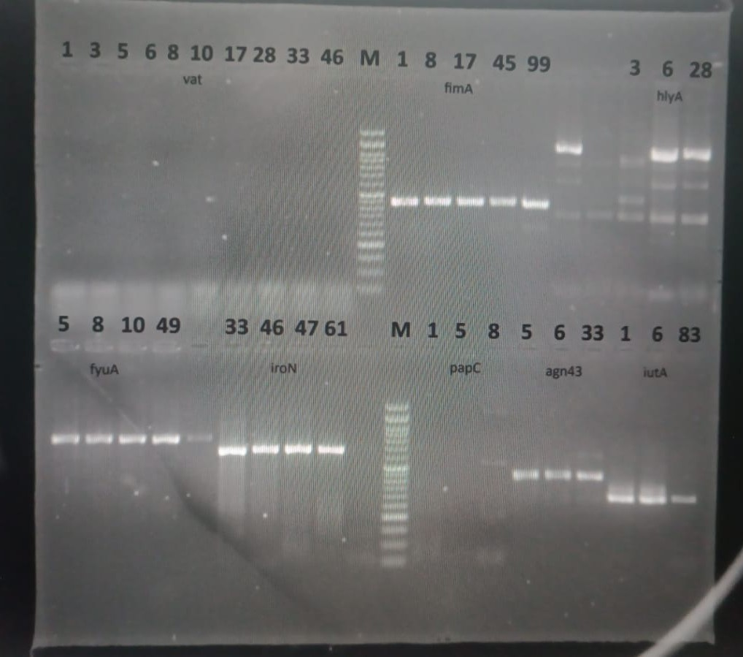
Supplementary Figure S2. PCR amplification patterns of virulence genes detected in potential UPEC strains.
(Gel image prepared by Cumhur Avşar, Zeynep Yegin, and Aynur Akan)

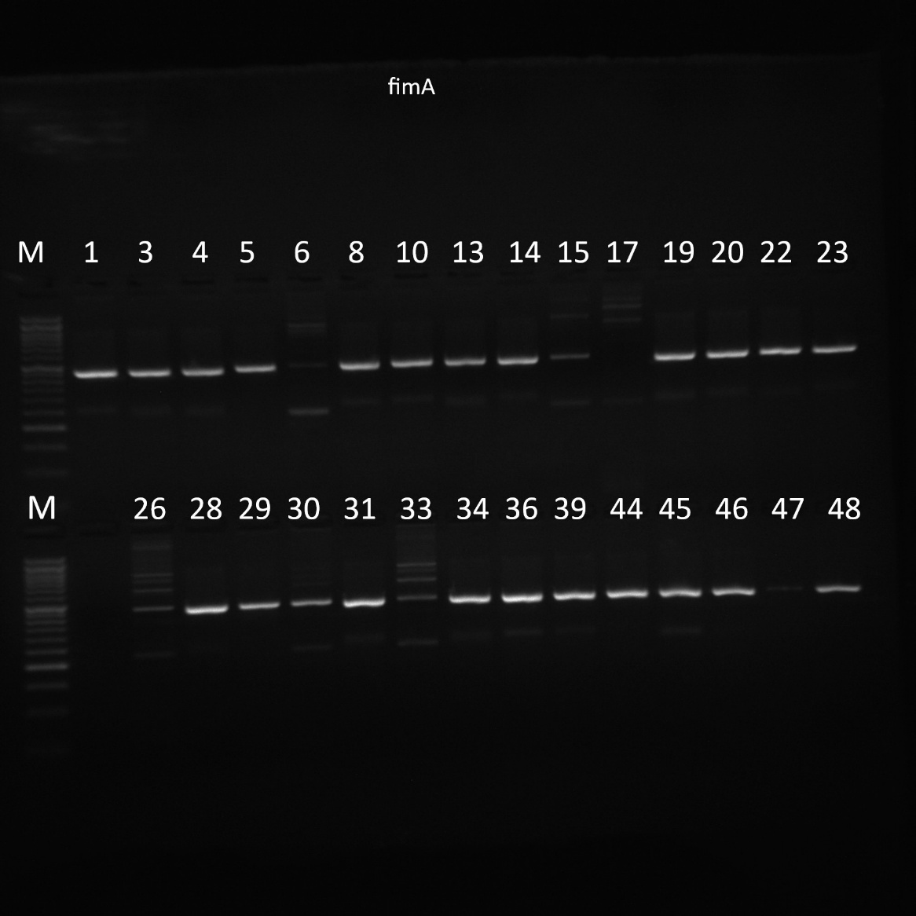
Supplementary Figure S3. PCR amplification pattern of the fimA virulence gene detected in potential UPEC strains. (Gel image prepared by Cumhur Avşar, Zeynep Yegin, and Aynur Akan)

