Methods
Preclinical Retinal Explant Assessment
KIO-301 was prepared as a concentrated 10 mM stock solution in DMSO and stored at -20ºC in darkness. A working solution of 100 µM KIO-301 was prepared by diluting the stock into physiological saline. Retinas obtained from P30-P60 rd1 mice were treated with the working solution for 30 min at 21ºC, followed by thorough washing with drug-free saline for 10 min. Retinas were mounted on a 60-electrode multi-electrode array (Multi Channel Systems, Holliston, MA, USA), inner retina side down, for simultaneous extracellular spike recording from many RGCs. Light responses were elicited with brief (1 s) flashes from a 455 nm LED light source at ~1.5 mW/cm² intensity, simulating photopic stimulation.
To quantify the strength of the light response in KIO-301-treated retinas, we measured the photoswitch index for each unit in the recording, defined as the mean frequency of spiking during the light flash minus the mean frequency in darkness, divided by the sum of the mean frequencies in light plus darkness. The photoswitch index provides a measure of the change in firing elicited by light, correcting for differences in background firing rate (i.e. in darkness) observed different retinal samples.
Inclusion/Exclusion Criteria
(1) aged between 18 to 80 years (unless otherwise approved by the principal investigator) and able to comply with the study protocol, attend all study visits and adequately perform all study assessments,

Key exclusion criteria were as follows: (1) evidence of material/substantial optic nerve disease, (2) history of retinal detachments, (3) other clinically significant ocular disease or opacities which might interfere with the study assessments, (4) high intraocular pressure (IOP) > 22 mmHg, (5) previous intraocular surgery (excluding phacoemulsification surgery with intraocular lens implant), (6) aphakia, (7) any psychiatric condition, medical condition or co-morbidities which in the view of the Investigator is likely to interfere with the study or put the participant at risk, (8) any routine contraindication to MRI, including MRI-incompatible metal containing implant or object such as pacemakers, intracranial aneurysm clips, cochlear implants, drug infusion devices, prosthetic devices, contraceptive devices, shrapnel, pins, screws or wire mesh.
Efficacy Assessments
Light Perception
This assessment involves showing the subject a series of videos and recording whether or not the subject perceived the visual stimulus, which was always an ‘X’ located at various locations on a screen. A strip of tape in front of the screen marked 60 cm where the center of the chair was placed and the patient seated. This assessment is meant to be performed as a monocular test and, therefore, an eyepatch was used to occlude the eye not being tested while assessing the contralateral eye. A unique video file driving the display of Xs on the screen was produced to correspond for each visit. There was also a setting for three different brightness levels (ranging from 3e14 photons/cm²/s (low), 1e15 photons/cm2/s (medium) and 5e15 photons/cm2/s (high), wavelength 400-800 nm). For each video, a series of six (6) images are displayed to the subject and the subject is instructed to verbally indicate if they perceive a particular shape or object and the responses are recorded as a success or failure.

Visual Acuity
Visual acuity (VA) was measured prior to pupillary dilation, both monocularly and then binocularly. and testing was performed under normal room illumination (between 250 and 1000 lux). VA assessment was performed using the Berkeley Rudimentary Vision Test (BRVT; Precision Vision, Woodstock, IL), as described by Bailey et al.¹³, which consists of presenting subjects three hinged card-pairs:
- Single Tumbling E Card-Pair (STE)
- Grating Acuity Card-Pair (GA)
- Basic Vision Card-Pair (BV)
A testing flow chart, based on the ability of subjects to perform the required task, converts responses to a logMAR score. If the BV card-pair was not seen by the participant, light perception was assessed at 25 cm using a pen torch, and the resultant VA was either LP if seen, or NLP if not seen.
Kinetic Visual Field
This assessment involves measuring the subject’s visual field using a traditional Goldmann kinetic perimeter outfitted with a custom light source. All perimetric assessments were performed by trained orthoptists and/or optometrists. The subject’s visual field was mapped in both in a horizontal and vertical meridian and measurements were taken in triplicate and averaged. The total change in degrees was obtained by summing the average horizontal and vertical field changes. This was performed as a monocular assessment.

Visual Function Tests
The Ora-MLOM™ (Multiluminance Orientation & Mobility) installation included a modular lighting system and a series of orientation and mobility test floor layouts of varying difficulty conducted at 3 ambient light levels (45 lux (low), 125 lux (mid), 350 lux (high)) monocularly (OD and OS) and binocularly (OU).
- The Window Location test is a stationary test that requires the study participant to locate a randomly placed (front, left, centre, right, no window) white “window” approximately three feet by two feet attached to a black opaque screen for contrast. Each test is a sequence of 8 trials conducted at each lux level.
- The Walking Direction test is a stationary test that requires the participant to identify the direction of motion (to the left, to the right, or no motion) of a person walking between 2 opaque screens located 10 feet in front of them. Each test is a sequence of 6 trials conducted at each lux level.
- The Door Location test is a straight-line mobility course that requires a participant to locate and navigate to a randomly located (left, right centre) high-contrast door-like object placed on a wall 12 feet in front of them. Each test is a sequence of 6 trials conducted at each lux level.
- The Exit Room Test is a straight-line mobility test that requires a participant to follow a pathway while avoiding three randomly placed high contrast 2 x 2 feet foam obstacles. Each test is a sequence of 6 trials conducted at each lux level. Success requires the participant to navigate the course from start to end without (i) hitting 2 or more obstacles during a single run, (ii) stepping completely off the white path with both feet or (iii) exceeding 3 minutes.
Functional MRI

Paradigms were presented to the participant using a NNL Aktiva fMRI interface (Nordic NeuroLab, Bergen, Norway). A series of three block design visual paradigms, each lasting approximately 5 minutes, was administered to each participant, testing each eye separately at baseline, and repeated at 2 days, 14 days and 28 days following treatment of each eye. A new baseline scan was established for the eye when treated with an increased dose approximately 3 months following the first treatment. Cohort 1 (NLP/BLP) paradigms consisted of: full visual field on/off, switching hemifield and flickering checkboard presentations. Cohort 2 (HM/CF) paradigms consisted of: E-down, moving line and flickering checkerboard presentations. Qualitative fMRI analysis was performed using Siemens Syngo Via workstation software (Erlangen, Germany) and post-processing using NNL with manual thresholding techniques, image interpretations by a single neuroradiologist.

Earplug protection was provided to each patient, and padded head clamps applied to limit head motion. T1-weighted anatomical images were acquired using three-dimensional magnetization-prepared rapid acquisition gradient echo sequence: 1 slab; 176 sagittal slices; FOV, 256 × 256 mm; slice thickness, 1 mm; isotropic voxel size, 1 × 1 × 1 mm; TR, 2300 ms; TE 2.98 ms; TI, 900 ms; and flip angle, 9°.

Blood-oxygenation-level-dependent (BOLD) fMRI data were acquired using a gradient-echo, simultaneous multi-slice, accelerated echo-planar imaging T2*-weighted sequence: 54 transversal slices angled to avoid the maxillary sinuses; in-plane resolution, 2 × 2 mm; slice thickness, 2.5 mm; field of view (FOV), 192 × 192 mm; repetition time (TR), 3000 ms; echo time (TE), 30 ms; flip angle, 90°; echo spacing, 0.65 ms; bandwidth, 1774 Hz/Px; and total acceleration factor of 4 (SMS 2, GRAPPA 2); 110 measurements were acquired for each paradigm, except for checkboard where 90 measurements were acquired.

The field map was acquired using a dual-echo gradient echo pulse sequence: 36 slices with the same position as fMRI; slice thickness, 3 mm without gap; voxel size, 3 × 3 × 3 mm; FOV, 192 × 192 mm; TR, 400 ms; TE1/TE2, 4.92/7.38 ms; and flip angle, 60°.

Supplementary Table 1. Demographics and baseline visual acuity of all study participants

Age (y) | Sex | Cohort | Baseline VA  OD | Baseline VA  OS
68 | M | Cohort 1 | NLP | BLP
72 | F | Cohort 1 | BLP | BLP
65 | M | Cohort 1 | NLP | NLP
70 | F | Cohort 2 | HM | HM
69 | M | Cohort 2 | CF | HM
67 | F | Cohort 2 | HM | CF
VA = visual acuity; OD = right eye; OS = left eye; BLP = bare light perception; NLP = no light perception; HM = hand movements; CF = count fingers.

Supplementary Figure 1

A

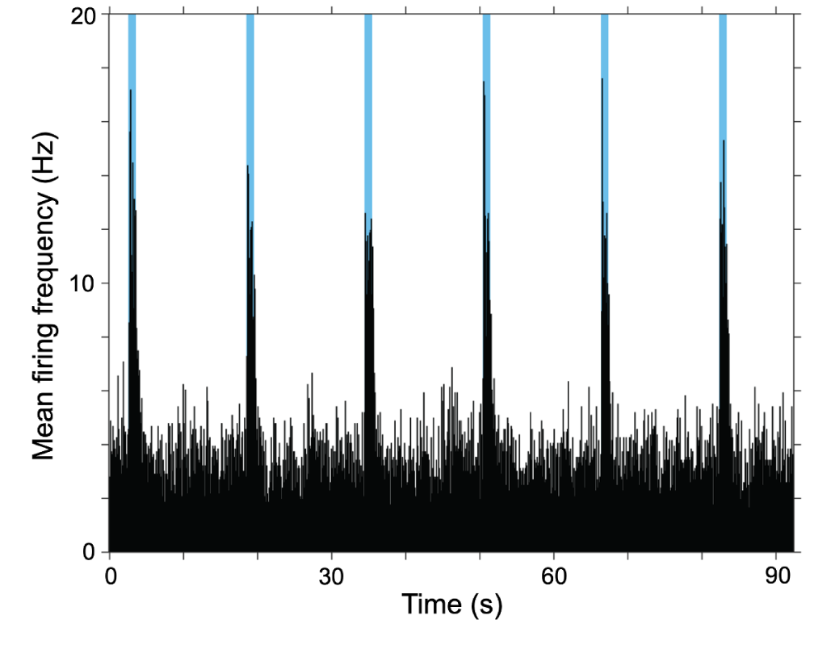

Supplementary Figure 1. Ex vivo demonstration of retinal ganglion cell (RGC) firing. (A) RGCs in BENAQ-treated retinas responded rapidly and reliably to light flashes (sky blue columns) with electrical spikes elicited within 100 ms after light onset and ceasing within 200 ms after light termination. Untreated retinas from rd1 mice showed no detectable light responses (not shown), consistent with loss of functional rods and cones and inability to trigger action potentials.

Supplementary Figure 2.

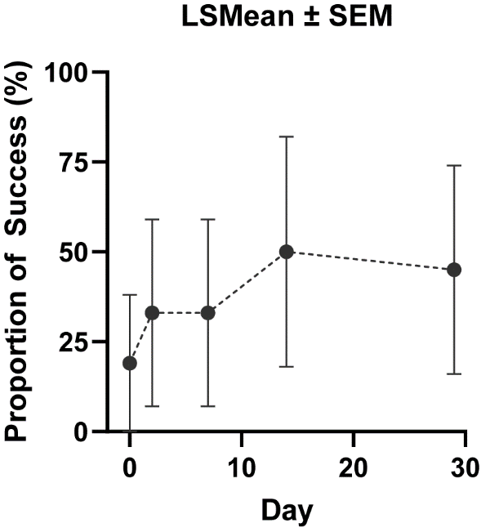

Supplementary Figure 2. Change in light perception after KIO-301 delivery. The mean correct responses of light perception with the treated eyes of all 3 participants in Cohort 1 at baseline was 19 +/- 19%, which increased to 50 +/- 32% by day 15 and then slightly declined to 45 +/- 29% at day 30 (Least Square (LS) means +/- SEM, 408 lux, n = 6 treated eyes, 3 eyes dosed at 7.5 µg OD and 3 eyes dosed at 25 µg OS).

Supplementary Figure 3

Figure S3. The mean VFQ-25 Composite Score improved by 4.2 points from baseline (38.2; SEM 3.26; n=12) to Day 29 (42.4; SEM 3.64; n=12) following administration of KIO-301.

