Appendix

Contents
1. T-test (wrong approach) iii
2. Autocorrelation Function Plots for Pre-intervention period iii
3. Total First Opioid iv
3.1. Pre-intervention ARIMA model iv
3.2. ARIMAX model for regressor effects iv
4. State Overall Opioids vi
4.1. Pre-intervention ARIMA model vi
4.2. ARIMAX model for regressor effects vi
5. State Average Day Supply viii
5.1. Pre-intervention ARIMA model viii
5.2. ARIMAX model for regressor effects viii
6. State Average Daily MME x
6.1. Pre-intervention ARIMA model x
6.2. ARIMAX model for regressor effects x
7. Benzo Control Series xii
7.1. State First Time Model xii
7.2. State Overall Model xii
7.3. State Average Day Supply Model xiii

Tables
Table 1- Two Sample t-test results ignoring pre-intervention trends and autocorrelations iii
Table 2- Total first opioid pre-intervention model iv
Table 3- Total first opioid model with policy implementation regressors iv
Table 4- Total first opioid model with policy implementation and announcement regressors v
Table 5- State overall opioids pre-intervention model vi
Table 6- Overall opioids model with policy implementation regressors vi
Table 7- Overall opioids model with policy implementation and announcement regressors vii
Table 8- State average day supply pre-intervention model viii
Table 9- Average day supply model with policy implementation regressors viii
Table 10- Average day supply model with policy implementation and announcement regressors ix
Table 11- Average daily MME pre-intervention model x
Table 12- Average daily MME model with policy implementation regressor x
Table 13- Average daily MME model with policy implementation and announcement regressors xi
Table 14- State first time Benzo model with policy implementation and announcement regressors xii
Table 15- State overall Benzo model with policy implementation and announcement regressors xii
Table 16- State average day supply Benzo model with policy implementation and announcement regressors xiii

Figures
Figure 1- Auto-correlation function, and Ljung-Box statistics of total first opioid pre-intervention model iv
Figure 2- Auto-correlation function, and Ljung-Box statistics of state overall opioids pre-intervention model vi
Figure 3- Auto-correlation function, and Ljung-Box statistics of state average day supply pre-intervention model viii
Figure 4 Auto-correlation function, and Ljung-Box statistics of average daily MME pre-intervention model x
Figure 5- First time Benzo prescriptions in the state of WV over time. The vertical lines indicate interventions. xii
Figure 6- Overall Benzo prescriptions in the state of WV over time. The vertical lines indicate interventions. xiii
Figure 7- Average days’ supply of Benzo prescriptions in the state of WV over time. The vertical lines indicate interventions. xiii

- T-test (wrong approach)
Table 1- Two Sample t-test results ignoring pre-intervention trends and autocorrelations
Time Series | T value | P-value | Conclusion | 95% Lower Bound (before-after) | 95% Upper Bound (before-after)
First Opioid | 13.895 | < 2e-16 | Reject Null | 1646.226 | 2197.555
Overall State | 16.165 | < 2e-16 | Reject Null | 4927.235 | 6303.234
Day Supply | 13.229 | < 2e-16 | Reject Null | 1.807 | 2.446
Daily MME | -1.205 | 0.230 | Fail to Reject Null | -0.500 | 0.122
Alternative hypothesis: before and after intervention difference in means is not equal to 0

- Autocorrelation Function Plots for Pre-intervention period
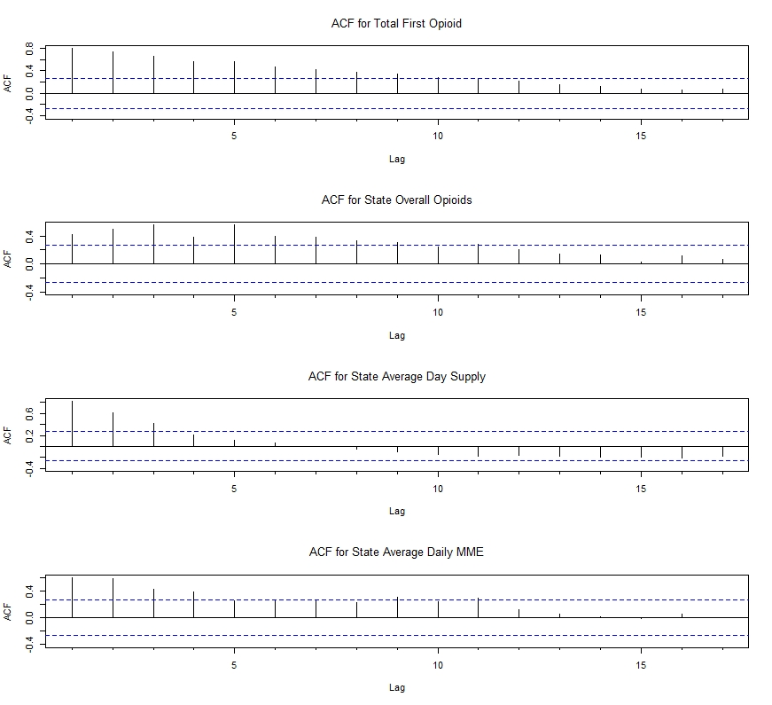

- Total First Opioid
  - Pre-intervention ARIMA model
Table 2- Total first opioid pre-intervention model
$$ARIMA\left(0,1,1\right)$$
Coefficients | Estimate | Std. Error | Z value | P-value
MA(1) | -0.532 | 0.098 | -5.381 | 7e-08 *
MAPE: 6.35
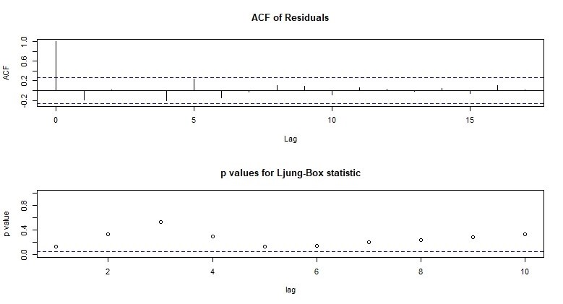

Figure 1- Auto-correlation function, and Ljung-Box statistics of total first opioid pre-intervention model

  - ARIMAX model for regressor effects
Table 3- Total first opioid model with policy implementation regressors
$$ARIMA\left(0,1,1\right) with pul{se}_{65}, step_{65}, ramp_{65} regressors$$
Coefficients | Estimate | Std. Error | Z value | P-value
MA(1) | -0.585 | 0.063 | -9.190 | 2e-16 *
Pulse 65 | 229.969 | 370.318 | 0.621 | 0.534
Step 65 | -184.153 | 343.659 | -0.535 | 0.592
Ramp 65 | -11.502 | 19.632 | -0.585 | 0.557

Table 4- Total first opioid model with policy implementation and announcement regressors
$$ARIMA\left(0,1,1\right) with pul{se}_{65}, step_{65}, ramp_{65},pul{se}_{55}, step_{55-65}, ramp_{55-65} regressors$$
Coefficients | Estimate | Std. Error | Z value | P-value
MA(1) | -0.590 | 0.063 | -9.301 | 2e-16 *
Pulse 65 | 230.809 | 369.161 | 0.625 | 0.531
Step 65 | -591.594 | 582.707 | -1.015 | 0.310
Ramp 65 | -11.450 | 19.337 | -0.592 | 0.553
Pulse 55 | -27.063 | 398.880 | -0.067 | 0.945
Step 55-65 | -128.844 | 400.046 | -0.322 | 0.747
Ramp 55-65 | -32.250 | 65.839 | -0.489 | 0.624

- State Overall Opioids
  - Pre-intervention ARIMA model
Table 5- State overall opioids pre-intervention model
$$ARIMA\left(5,0,0\right)$$
Coefficients | Estimate | Std. Error | Z value | P-value
AR(1) | 6.829e-03 | 1. 288e-01 | 0.053 | 0.957
AR(2) | 1.302e-01 | 1.271e-01 | 1.024 | 0.305
AR(3) | 3.208e-01 | 1.193e-01 | 2.930 | 0.007 *
AR(4) | 1.072e-01 | 1.311e-01 | 0.817 | 0.413
AR(5) | 3.353e-01 | 1.302e-01 | 2.574 | 0.010 *
Intercept | 3.0607e+04 | 1.3582e+03 | 22.535 | 2e-16 *
MAPE: 3.60
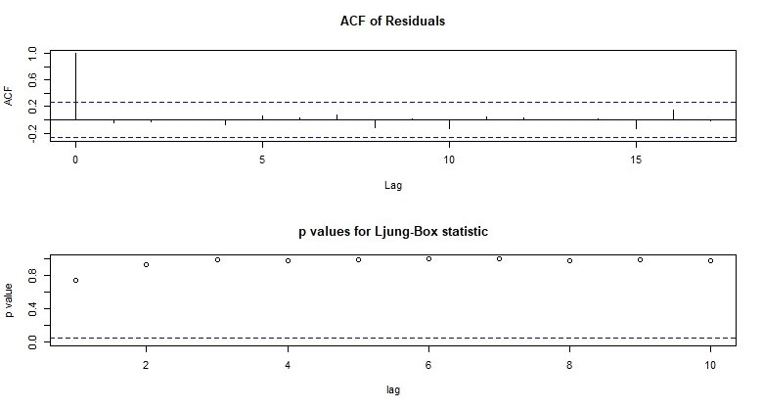
Figure 2- Auto-correlation function, and Ljung-Box statistics of state overall opioids pre-intervention model

  - ARIMAX model for regressor effects
Table 6- Overall opioids model with policy implementation regressors
$$ARIMA\left(5,0,0\right) with pul{se}_{65}, step_{65}, ramp_{65} regressors$$
Coefficients | Estimate | Std. Error | Z value | P_value
AR(1) | 9.111e-02 | 8.049e-02 | 1.132 | 0.257
AR(2) | 5.781e-02 | 7.966e-02 | 0.725 | 0.468
AR(3) | 2.819e-01 | 7.610e-02 | 3.704 | 0.0002 *
AR(4) | 8.615e-02 | 8.120e-02 | 1.060 | 0.288
AR(5) | 4.067e-01 | 8.091e-02 | 5.026 | 4.e-07 *
Intercept | 2.996e+04 | 1.422e+03 | 21.056 | 2e-16 *
Pulse 65 | 2.916e+02 | 1.307e+03 | 0.223 | 0.823
Step 65 | -8.858e+02 | 8.949e+02 | -0.989 | 0.322
Ramp 65 | -8.729e+01 | 3.643e+01 | -2.396 | 0.016 *

Table 7- Overall opioids model with policy implementation and announcement regressors
$$ARIMA\left(5,0,0\right) with pul{se}_{65}, step_{65}, ramp_{65},pul{se}_{55}, step_{55-65}, ramp_{55-65} regressors$$
Coefficients | Estimate | Std. Error | Z value | P_value
AR(1) | 6.511e-02 | 8.102e-02 | 0.803 | 0.421
AR(2) | 3.031e-02 | 8.041e-02 | 0.376 | 0.706
AR(3) | 2.708e-01 | 7.716e-02 | 3.510 | 0.0004*
AR(4) | 8.506e-02 | 8.252e-02 | 1.030 | 0.302
AR(5) | 3.974e-01 | 8.259e-02 | 4.812 | 1e-06 *
Intercept | 3.054e+04 | 8.889e+02 | 34.359 | 2e-16 *
Pulse 65 | 5.661e+02 | 1.297e+03 | 0.436 | 0.662
Step 65 | -2.987e+03 | 1.345e+03 | -2.221 | 0.026 *
Ramp 65 | -7.398e+01 | 2.837e+01 | -2.607 | 0.009 *
Pulse 55 | -1.910e+03 | 1.410e+03 | -1.354 | 0.175
Step 55-65 | -5.942e+01 | 1.031e+03 | -0.057 | 0.954
Ramp 55-65 | -2.358e+02 | 1.613e+02 | -1.461 | 0.143

- State Average Day Supply
  - Pre-intervention ARIMA model
Table 8- State average day supply pre-intervention model
$$ARIMA\left(0,1,3\right) with week 36 as outlier$$
Coefficients | Estimate | Std. Error | Z value | P_value
MA(1) | 0.136 | 0.138 | 0.98 | 0.327
MA(2) | 0.203 | 0.171 | 1.183 | 0.236
MA(3) | 0.461 | 0.250 | 1.839 | 0.065 *
AO (at36) | -0.743 | 0.444 | -1.672 | 0.094
IO (at36) | 3.403 | 0.596 | 5.707 | 1e-08 *
MAPE= 2.71

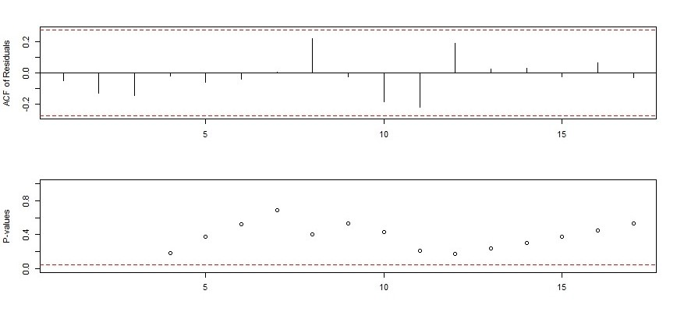
Figure 3- Auto-correlation function, and Ljung-Box statistics of state average day supply pre-intervention model
  - ARIMAX model for regressor effects
Table 9- Average day supply model with policy implementation regressors
$$ARIMA\left(0,1,3\right) with pul{se}_{65}, step_{65}, ramp_{65} and outlier regressors$$
Coefficients | Estimate | Std. Error | Z value | P_value
MA(1) | 0.194 | 0.095 | 2.034 | 0.041 *
MA(2) | 0.117 | 0.109 | 1.071 | 0.283
MA(3) | 0.240 | 0.109 | 2.198 | 0.027 *
AO (at36) | -0.501 | 0.363 | -1.379 | 0.167
IO (at36) | 3.152 | 0.549 | 5.734 | 9e-09 *
Pulse 65 | 0.350 | 0.348 | 1.004 | 0.315
Step 65 | 0.091 | 0.521 | 0.175 | 0.860
Ramp 65 | -0.010 | 0.066 | -0.153 | 0.878

Table 10- Average day supply model with policy implementation and announcement regressors
$$ARIMA\left(0,1,3\right) with pul{se}_{65}, step_{65}, ramp_{65},pul{se}_{55}, step_{55-65}, ramp_{55-65} and outlier regressors$$
Coefficients | Estimate | Std. Error | Z value | P_value
MA(1) | 0.199 | 0.095 | 2.082 | 0.037 *
MA (2) | 0.124 | 0.109 | 1.136 | 0.255
MA (3) | 0.251 | 0.111 | 2.260 | 0.023 *
AO (at36) | -0.505 | 0.363 | -1.391 | 0.164
IO (at36) | 3.147 | 0.549 | 5.724 | 1e-08 *
Pulse 65 | 0.373 | 0.350 | 1.066 | 0.286
Step 65 | -0.444 | 1.739 | -0.255 | 0.798
Ramp 65 | -0.007 | 0.067 | -0.116 | 0.907
Pulse 55 | -0.086 | 0.349 | -0.247 | 0.804
Step 55-65 | 0.337 | 0.567 | 0.594 | 0.552
Ramp 55-65 | -0.082 | 0.173 | -0.474 | 0.635

- State Average Daily MME
  - Pre-intervention ARIMA model
Table 11- Average daily MME pre-intervention model
$$ARIMA\left(2,0,0\right)$$
Coefficients | Estimate | Std. Error | Z value | P_value
AR(1) | 0.374 | 0.115 | 3.246 | 0.001 *
AR(2) | 0.534 | 0.122 | 4.374 | 1e-05 *
Intercept | 33.720 | 0.546 | 61.707 | 2e-16 *
MAPE= 1.12

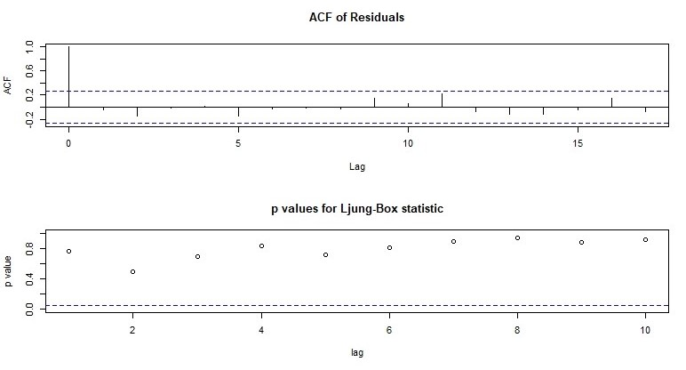
Figure 4 Auto-correlation function, and Ljung-Box statistics of average daily MME pre-intervention model

  - ARIMAX model for regressor effects
Table 12- Average daily MME model with policy implementation regressor
$$ARIMA\left(2,0,0\right) with pul{se}_{65}, step_{65}, ramp_{65} regressors$$
Coefficients | Estimate | Std. Error | Z value | P_value
AR(1) | 0.387 | 0.084 | 4.589 | 4e-06 *
AR(2) | 0.276 | 0.086 | 3.202 | 0.001 *
Intercept | 33.718 | 0.217 | 154.750 | 2e-16 *
Pulse 65 | 0.142 | 0.605 | 0.235 | 0.813
Step 65 | 1.216 | 0.444 | 2.739 | 0.006 *
Ramp 65 | -0.030 | 0.010 | -2.843 | 0.004 *

Table 13- Average daily MME model with policy implementation and announcement regressors
$$ARIMA\left(2,0,0\right) with pul{se}_{65}, step_{65}, ramp_{65},pul{se}_{55}, step_{55-65}, ramp_{55-65} regressors$$
Coefficients | Estimate | Std. Error | Z value | P_value
AR(1) | 0.389 | 0.085 | 4.577 | 4e-06 *
AR (2) | 0.277 | 0.087 | 3.177 | 0.001 *
Intercept | 33.693 | 0.238 | 141.031 | 2e-16 *
Pulse 65 | 0.232 | 0.630 | 0.369 | 0.711
Step 65 | 1.303 | 0.493 | 2.643 | 0.008 *
Ramp 65 | -0.031 | 0.011 | -2.880 | 0.003 *
Pulse 55 | 0.569 | 0.704 | 0.808 | 0.418
Step 55-65 | -0.459 | 0.797 | -0.576 | 0.564
Ramp 55-65 | 0.079 | 0.111 | 0.717 | 0.473

- Benzo Control Series
  - State First Time Model
Table 14- State first time Benzo model with policy implementation and announcement regressors
$$ARIMA\left(0,1,6\right) with pul{se}_{65}, step_{65}, ramp_{65},pul{se}_{55}, step_{55-65}, ramp_{55-65} regressors$$
Coefficients | Estimate | Std. Error | Z value | P-value
MA(1) | -0.233 | 0.085 | -2.719 | 0.006 *
MA(2) | -0.047 | 0.092 | -0.508 | 0.611
MA(3) | 0.018 | 0.086 | 0.210 | 0.833
MA(4) | -0.249 | 0.086 | -2.885 | 0.003 *
MA(5) | 0.366 | 0.093 | 3.906 | 9.e-05*
MA(6) | -0.180 | 0.088 | -2.045 | 0.040 *
Pulse 65 | 141.513 | 170.431 | 0.830 | 0.406
Step 65 | -238.1 | 455.863 | -0.522 | 0.601
Ramp 65 | -2.969 | 15.766 | -0.188 | 0.850
Pulse 55 | -81.694 | 192.276 | -0.424 | 0.670
Step 55-65 | -18.463 | 251.748 | -0.073 | 0.941
Ramp_55-65 | -22.014 | 48.373 | -0.455 | 0.649

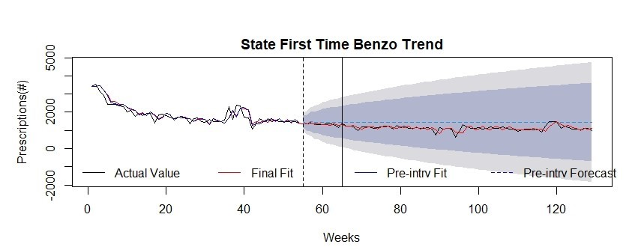
Figure 5- First time Benzo prescriptions in the state of WV over time. The vertical lines indicate interventions.
  - State Overall Model
Table 15- State overall Benzo model with policy implementation and announcement regressors
$$ARIMA\left(4,1,0\right) with pul{se}_{65}, step_{65}, ramp_{65},pul{se}_{55}, step_{55-65}, ramp_{55-65} regressors$$
Coefficients | Estimate | Std. Error | Z value | P-value
AR(1) | -0.965 | 0.078 | -12.222 | 2e-16 *
AR(2) | -0.948 | 0.100 | -9.441 | 2e-16 *
AR(3) | -0.655 | 0.099 | -6.583 | 4e-11 *
AR(4) | -0.445 | 0.078 | -5.652 | 1e-08 *
Pulse 65 | -147 | 804 | -0.182 | 0.854
Step 65 | -980 | 838 | -1.169 | 0.242
Ramp 65 | -27.1 | 27.6 | -0.980 | 0.326
Pulse 55 | -1480 | 873 | -1.690 | 0.090
Step 55-65 | 153 | 598 | 0.255 | 0.798
Ramp 55-65 | -126 | 97.3 | -1.298 | 0.194

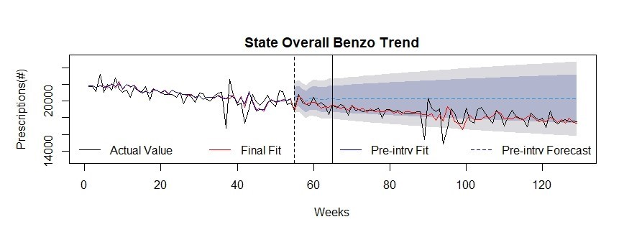
Figure 6- Overall Benzo prescriptions in the state of WV over time. The vertical lines indicate interventions.

  - State Average Day Supply Model
Table 16- State average day supply Benzo model with policy implementation and announcement regressors
$$ARIMA\left(0,1,2\right) with pul{se}_{65}, step_{65}, ramp_{65},pul{se}_{55}, step_{55-65}, ramp_{55-65} and outlier regressors$$
Coefficients | Estimate | Std. Error | Z value | P-value
MA(1) | -0.340 | 0.089 | -3.787 | 0.0001*
MA(2) | 0.289 | 0.112 | 2.563 | 0.010 *
AO (at36) | 0.159 | 0.814 | 0.195 | 0.844
IO (at36) | 3.003 | 1.001 | 2.998 | 0.002 *
Pulse 65 | 1.217 | 0.825 | 1.475 | 0.140
Step 65 | 0.125 | 2.737 | 0.045 | 0.963
Ramp 65 | -0.030 | 0.101 | -0.301 | 0.763
Pulse 55 | 0.098 | 0.871 | 0.112 | 0.910
Step 55-65 | -0.157 | 1.110 | -0.141 | 0.887
Ramp 55-65 | 0.043 | 0.277 | 0.158 | 0.874

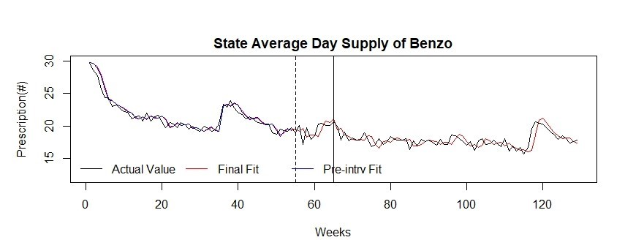
Figure 7- Average days’ supply of Benzo prescriptions in the state of WV over time. The vertical lines indicate interventions.

