Supplementary Table 1. Comparison of short-term recurrence rates (<6 and <12 months) among female patients with early-stage IDC receiving different treatments
Treatment | <6 months | <12 months | p-value
BCT | 0.05% | 0.07% | <0.001
MAS | 0.12% | 0.14% | <0.001
MAS+RT | 0.10% | 0.14% | <0.001
IDC, invasive ductal carcinoma; BCT, breast conservative treatment; MAS, mastectomy; RT, radiotherapy
Supplementary Table 2. Comparison of long-term recurrence rates among female patients with early-stage IDC receiving different treatments
Treatment | <1 year | <3 years | <5 years | <10 years | <15 years | p-value
BCT | 0.07% | 0.12% | 0.43% | 2.01% | 4.15% | <0.001
MAS | 0.14% | 0.20% | 0.24% | 0.55% | 0.81% | <0.001
MAS+RT | 0.14% | 0.24% | 0.43% | 0.68% | 0.97% | <0.001
IDC, invasive ductal carcinoma; BCT, breast conservative treatment; MAS, mastectomy; RT, radiotherapy
Supplementary Figure 1. Comparison of short-term recurrence rates among female patients with invasive ductal carcinoma receiving different treatments. BCT, breast conservative treatment; MAS, mastectomy; RT, radiotherapy
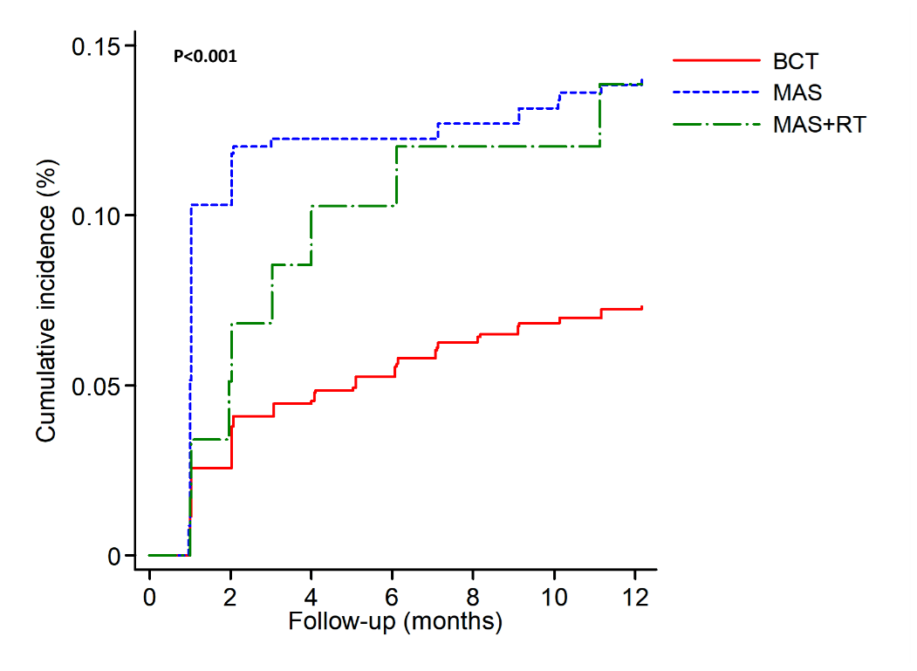
Supplementary Figure 2. Comparison of long-term recurrence rates among female patients with invasive ductal carcinoma receiving different treatments. BCT, breast conservative treatment; MAS, mastectomy; RT, radiotherapy
