Supplementary data
Additional Supporting Information may be found in the online version of this article at the publisher’s website:
Supplementary File 1
Table S1. Details regarding the bisulfite sequencing reads for the ‘Fuji’ and ‘Qinguan’ axillary buds.
Table S2. Bisulfite sequencing data of mapped reads for the ‘Fuji’ and ‘Qinguan’ axillary buds.
Table S3. The detail information of gene coverage for the ‘Fuji’ and ‘Qinguan’ axillary buds.
Table S4. Details regarding the RNA-sequencing data for the ‘Fuji’ and ‘Qinguan’ axillary buds.
Table S5. Details regarding the mapping of RNA-sequencing data for the ‘Fuji’ and ‘Qinguan’ axillary buds.
Table S1. Primers used in this study.
Figure S1. Detailed micrographs of longitudinal structural sections of ‘Fuji’ and ‘Qinguan’ axillary buds.
Figure S2. Additional details regarding of epigenome identification of ‘Qinguan’ and ‘Fuji’ axillary buds. (A) Circos plots of chromosomes. Track order: density plot of 5mC in the CG, CHG, and CHH contexts; density of TEs; and gene and RNA density of each chromosome in the FA. (B) Density plot of 5mC in the CG, CHG, and CHH contexts in the gene-bodies on each chromosome in the FA.
Figure S3. Bisulfite sequencing data for the mean depth and proportion of covered bases in each chromosome for the ‘Fuji’ and ‘Qinguan’ axillary buds.
Figure S4. Methylation densities (A) levels (B) and in the CG, CHG, and CHH contexts in the ‘Fuji’ and ‘Qinguan’ axillary buds.
Figure S5. DNA methylation patterns in various genomic regions in ‘Qinguan’ and ‘Nagafu No. 2’ axillary bud. (A) Heat map of the methylation levels involved in CG, CHG and CHH contexts in different regions. (B) Distribution of DNA methylation levels involved in CG, CHG and CHH contexts in different regions. (C) Methylation levels (%) involved in CG, CHG and CHH contexts in gene-bodies and their 2-kb upstream and downstream regions.
Figure S6. Additional details regarding of comparative analysis of DNA methylation levels in various genomic regions between ‘Qinguan’ and ‘Nagafu No. 2’ axillary bud. Circos plots comparing DNA methylation levels in all contexts between QA and FA.
Figure S7. Go enrichment terms analysis of the DMR_genes in the CG, CHG, and CHH contexts between ‘Qinguan’ and ‘Nagafu No. 2’ axillary bud. (A, C, E) Go enrichment terms for the DMR_genes hypermethylated in the CG, CHG, and CHH contexts. (B, D, F) Go enrichment terms for the DMR_genes hypomethylated in the CG, CHG, and CHH contexts.
Figure S8. Go enrichment terms analysis of the DMR_genes in the CG, CHG, and CHH contexts between ‘Qinguan’ and ‘Nagafu No. 2’ axillary bud. (A, C, E) Details regarding the pathway enrichment for the DMR_promoter_genes hypermethylated in the CG, CHG, and CHH contexts. (B, D, F) Go enrichment terms for the DMR_promoter_genes hypomethylated in the CG, CHG, and CHH contexts.
Figure S9. KEGG enrichment pathways of the DMR_genes in the CG, CHG, and CHH contexts between ‘Qinguan’ and ‘Nagafu No. 2’ axillary bud. (A–C) Details regarding the pathway enrichment for the DMR_genes hypermethylated in the CG, CHG, and CHH contexts. (D–F) Details regarding the pathway enrichment for the DMR_genes hypomethylated in the CG, CHG, and CHH contexts.
Figure S10. KEGG enrichment pathways of the DMR_promoter_genes in the CG, CHG, and CHH contexts between ‘Qinguan’ and ‘Nagafu No. 2’ axillary bud. (A–C) Details regarding the pathway enrichment for the DMR_promoter_genes hypermethylated in the CG, CHG, and CHH contexts. (D–F) Details regarding the pathway enrichment for the DMR_promoter_genes hypomethylated in the CG, CHG, and CHH contexts.
Figure S11. The gene expression distribution, as well as Pearson correlation among samples of ‘Fuji’ and ‘Qinguan’ axillary buds.
Figure S12. Phylogenetic analysis of Apple and Arabidopsis thaliana MADS-box genes. Protein designations: Arabidopsis (At, blue circle) and Apple (Md, red square).
Supplementary File 2
Additional file 1. Detailed information regarding the DEGs associated with MADS-box family genes between ‘Qinguan’ and ‘Nagafu No. 2’ axillary bud.
Additional file 2. Detailed information regarding the DEGs in multiple flowering pathways between ‘Qinguan’ and ‘Nagafu No. 2’ axillary bud.
Additional file 3. Detailed information regarding the DEGs in autonomous, vernalization pathways, as well as different composite components between ‘Qinguan’ and ‘Nagafu No. 2’ axillary bud.
Additional file 4. Detailed information regarding the DEGs in hormone pathways between ‘Qinguan’ and ‘Nagafu No. 2’ axillary bud.

Table S1. Details regarding the bisulfite sequencing reads for the ‘Fuji’ and ‘Qinguan’ axillary buds.
Sample name | Raw Reads | Raw Bases (G) | Clean Reads | Clean Bases (G) | Clean ratio  (%) | Q20  (%) | Q30  (%) | GC Content  (%) | BS Conversion Rate (%)
FA | 118363292 | 35.51 | 114420604 | 31.27 | 88.06 | 97.09 | 90.91 | 25.85 | 99.333
QA | 120354644 | 36.11 | 118150703 | 32.65 | 90.42 | 97.56 | 92.1 | 24.82 | 99.423

Table S2. Bisulfite sequencing data of mapped reads for the ‘Fuji’ and ‘Qinguan’ axillary buds.
Samples | Total reads | Mapped reads | Mapping rate (%) | Duplication rate (%)
FA | 114420604 | 62656722 | 54.76 | 16.93
QA | 118150703 | 73170730 | 61.93 | 17.24

Table S3. The detail information of gene coverage for the ‘Fuji’ and ‘Qinguan’ axillary buds.
Samples | C_covgMean | C  (Mb) | CG  (Mb) | CHG  (Mb) | CHH  (Mb) | Mean  C (%) | Mean  CG (%) | Mean  CHG (%) | Mean  CHH (%)
FA | 9.4 | 2230.4 | 283.2 | 280.5 | 1666.7 | 32.9 | 76.4 | 63.12 | 20.42
QA | 11.4 | 2708.6 | 334.8 | 334.1 | 2039.6 | 31.52 | 77.11 | 63.62 | 18.78

Table S4. Details regarding the RNA-sequencing data for the ‘Fuji’ and ‘Qinguan’ axillary buds.
Sample | Raw_reads | Clean_reads | Clean_bases | Error_rate | Q20 | Q30 | GC_pct
FA1 | 53889984 | 52462452 | 7.87G | 0.03 | 97.89 | 93.91 | 46.87
FA2 | 55005424 | 53875128 | 8.08G | 0.03 | 97.83 | 93.82 | 46.91
FA3 | 56463982 | 54297594 | 8.14G | 0.03 | 97.65 | 93.36 | 46.63
QA1 | 54744438 | 53467614 | 8.02G | 0.03 | 98 | 94.11 | 45.65
QA2 | 46463306 | 45592982 | 6.84G | 0.03 | 97.93 | 93.98 | 45.59
QA3 | 52300734 | 51266860 | 7.69G | 0.03 | 97.79 | 93.61 | 45.54

Table S5. Details regarding the mapping of RNA-sequencing data for the ‘Fuji’ and ‘Qinguan’ axillary buds.
Sample |  | Type | total_reads | total_map | unique_map | multi_map | splice_map | unsplice_map | proper_map
FA1 | Number |  | 52462452 | 46709082 | 45437585 | 1271497 | 15746124 | 29691461 | 43494698
FA1 | Rate |  | 100% | 89.03% | 86.61% | 2.42% | 30.01% | 56.6% | 82.91%
FA2 | Number |  | 53875128 | 48360376 | 47096602 | 1263774 | 16204272 | 30892330 | 45011908
FA2 | Rate |  | 100% | 89.76% | 87.42% | 2.35% | 30.08% | 57.34% | 83.55%
FA3 | Number |  | 54297594 | 48411248 | 47090288 | 1320960 | 16236295 | 30853993 | 45058906
FA3 | Rate |  | 100% | 89.16% | 86.73% | 2.43% | 29.9% | 56.82% | 82.99%
QA1 | Number |  | 53467614 | 48311365 | 46919438 | 1391927 | 14948996 | 31970442 | 44939676
QA1 | Rate |  | 100% | 90.36% | 87.75% | 2.6% | 27.96% | 59.79% | 84.05%
QA2 | Number |  | 45592982 | 41148699 | 39998455 | 1150244 | 12740891 | 27257564 | 38296090
QA2 | Rate |  | 100% | 90.25% | 87.73% | 2.52% | 27.94% | 59.78% | 84.0%
QA3 | Number |  | 51266860 | 46207295 | 44878550 | 1328745 | 14303464 | 30575086 | 42908156
QA3 | Rate |  | 100% | 90.13% | 87.54% | 2.59% | 27.9% | 59.64% | 83.7%

Table S6. Primers used in this study.
MD06G1204400 | AP1 | F | ACGTCAGGGCTGCTGAAGAAAG
MD06G1204400 | AP1 | R | TCCAGAGTCCAGTTCCCAGTGG
MD07G1123600 | SOC1 | F | GCACGCGAAAGGCAATCAAACC
MD07G1123600 | SOC1 | R | TCGGACGTTGTTCACGCTCTTC
MD12G1262000 | FT | F | TGTTGTTGGACGAGTGGTTGGT
MD12G1262000 | FT | R | TTGGGCTGGGTGCATCAGGAT
MD17G1236000 | SPL4 | F | TCTCCCACTCCTCCTGCTCCTT
MD17G1236000 | SPL4 | R | TCCTTCTTCACCACCACCACCA
MD09G1079200 | COL2 | F | GGCGGAGATGGAGGATGGGTTT
MD09G1079200 | COL2 | R | TGTTCCTGCTGCTGTTCTTGCT
MD04G1183900 | PHYA | F | TCCTGCTGCTGGGATTGGAGTC
MD04G1183900 | PHYA | R | ATTGCTGGACGAGTTGCTAGGC

Figure S1. Detailed micrographs of longitudinal structural sections of ‘Fuji’ and ‘Qinguan’ axillary buds.

Figure S2. Additional details regarding of epigenome identification of ‘Qinguan’ and ‘Fuji’ axillary buds. (A) Circos plots of chromosomes. Track order: density plot of 5mC in the CG, CHG, and CHH contexts; density of TEs; and gene and RNA density of each chromosome in the FA. (B) Density plot of 5mC in the CG, CHG, and CHH contexts in the gene-bodies on each chromosome in the FA.

Figure S3. Bisulfite sequencing data for the mean depth and proportion of covered bases in each chromosome for the ‘Fuji’ and ‘Qinguan’ axillary buds.
Figure S4. Methylation densities (A) and levels (B) in the CG, CHG, and CHH contexts in the ‘Fuji’ and ‘Qinguan’ axillary buds.
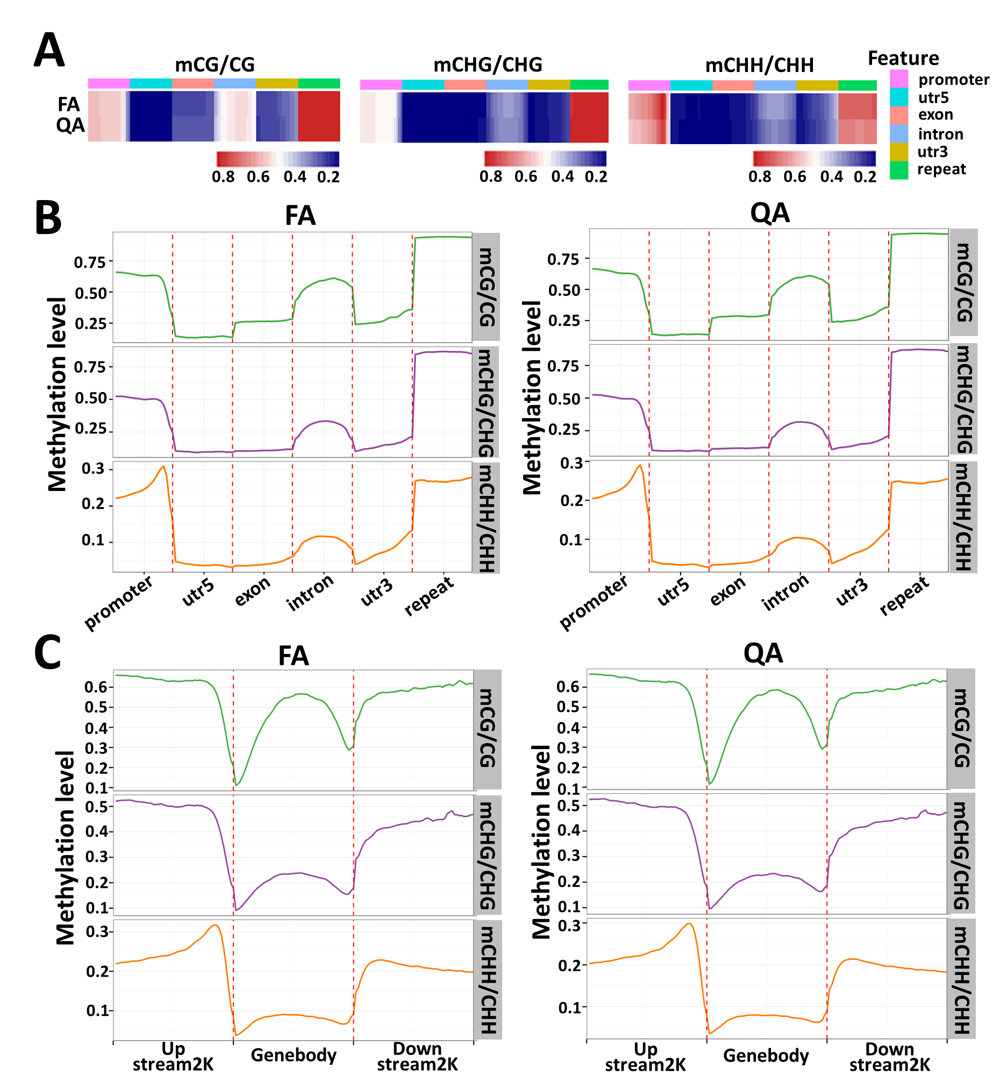
Figure S5. DNA methylation patterns in various genomic regions in ‘Qinguan’ and ‘Nagafu No. 2’ axillary bud. (A) Heat map of the methylation levels involved in CG, CHG and CHH contexts in different regions. (B) Distribution of DNA methylation levels involved in CG, CHG and CHH contexts in different regions. (C) Methylation levels (%) involved in CG, CHG and CHH contexts in gene-bodies and their 2-kb upstream and downstream regions.
Figure S6. Additional details regarding of comparative analysis of DNA methylation levels in various genomic regions between ‘Qinguan’ and ‘Nagafu No. 2’ axillary bud. Circos plots comparing DNA methylation levels in all contexts between QA and FA.
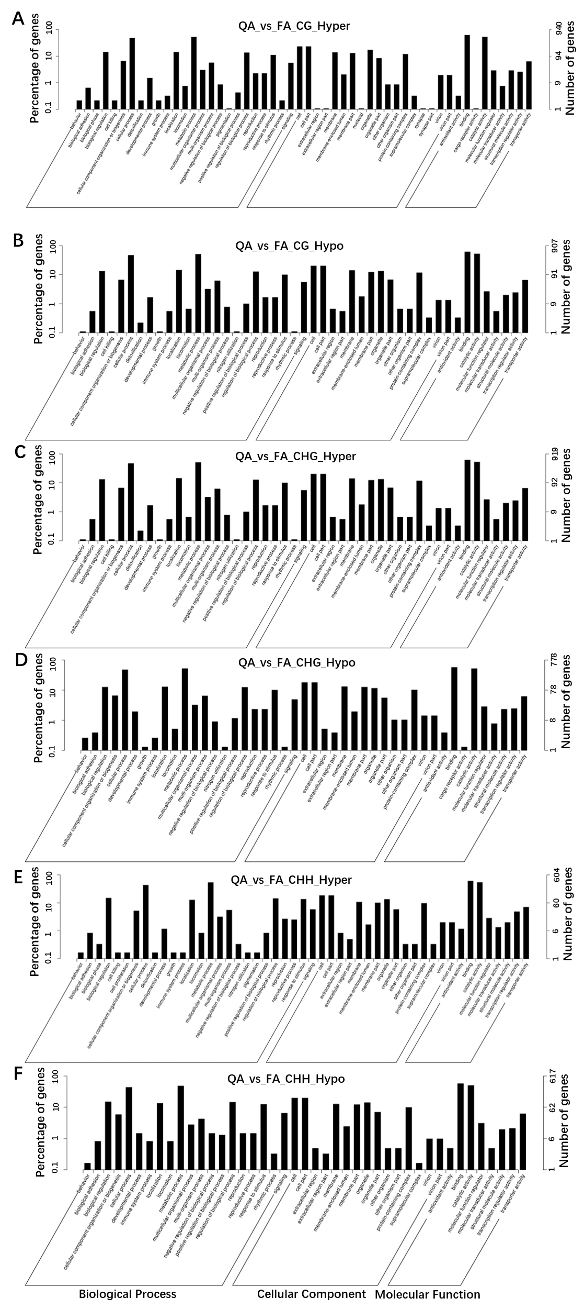
Figure S7. Go enrichment terms analysis of the DMR_genes in the CG, CHG, and CHH contexts between ‘Qinguan’ and ‘Nagafu No. 2’ axillary bud. (A, C, E) Go enrichment terms for the DMR_genes hypermethylated in the CG, CHG, and CHH contexts. (B, D, F) Go enrichment terms for the DMR_genes hypomethylated in the CG, CHG, and CHH contexts.

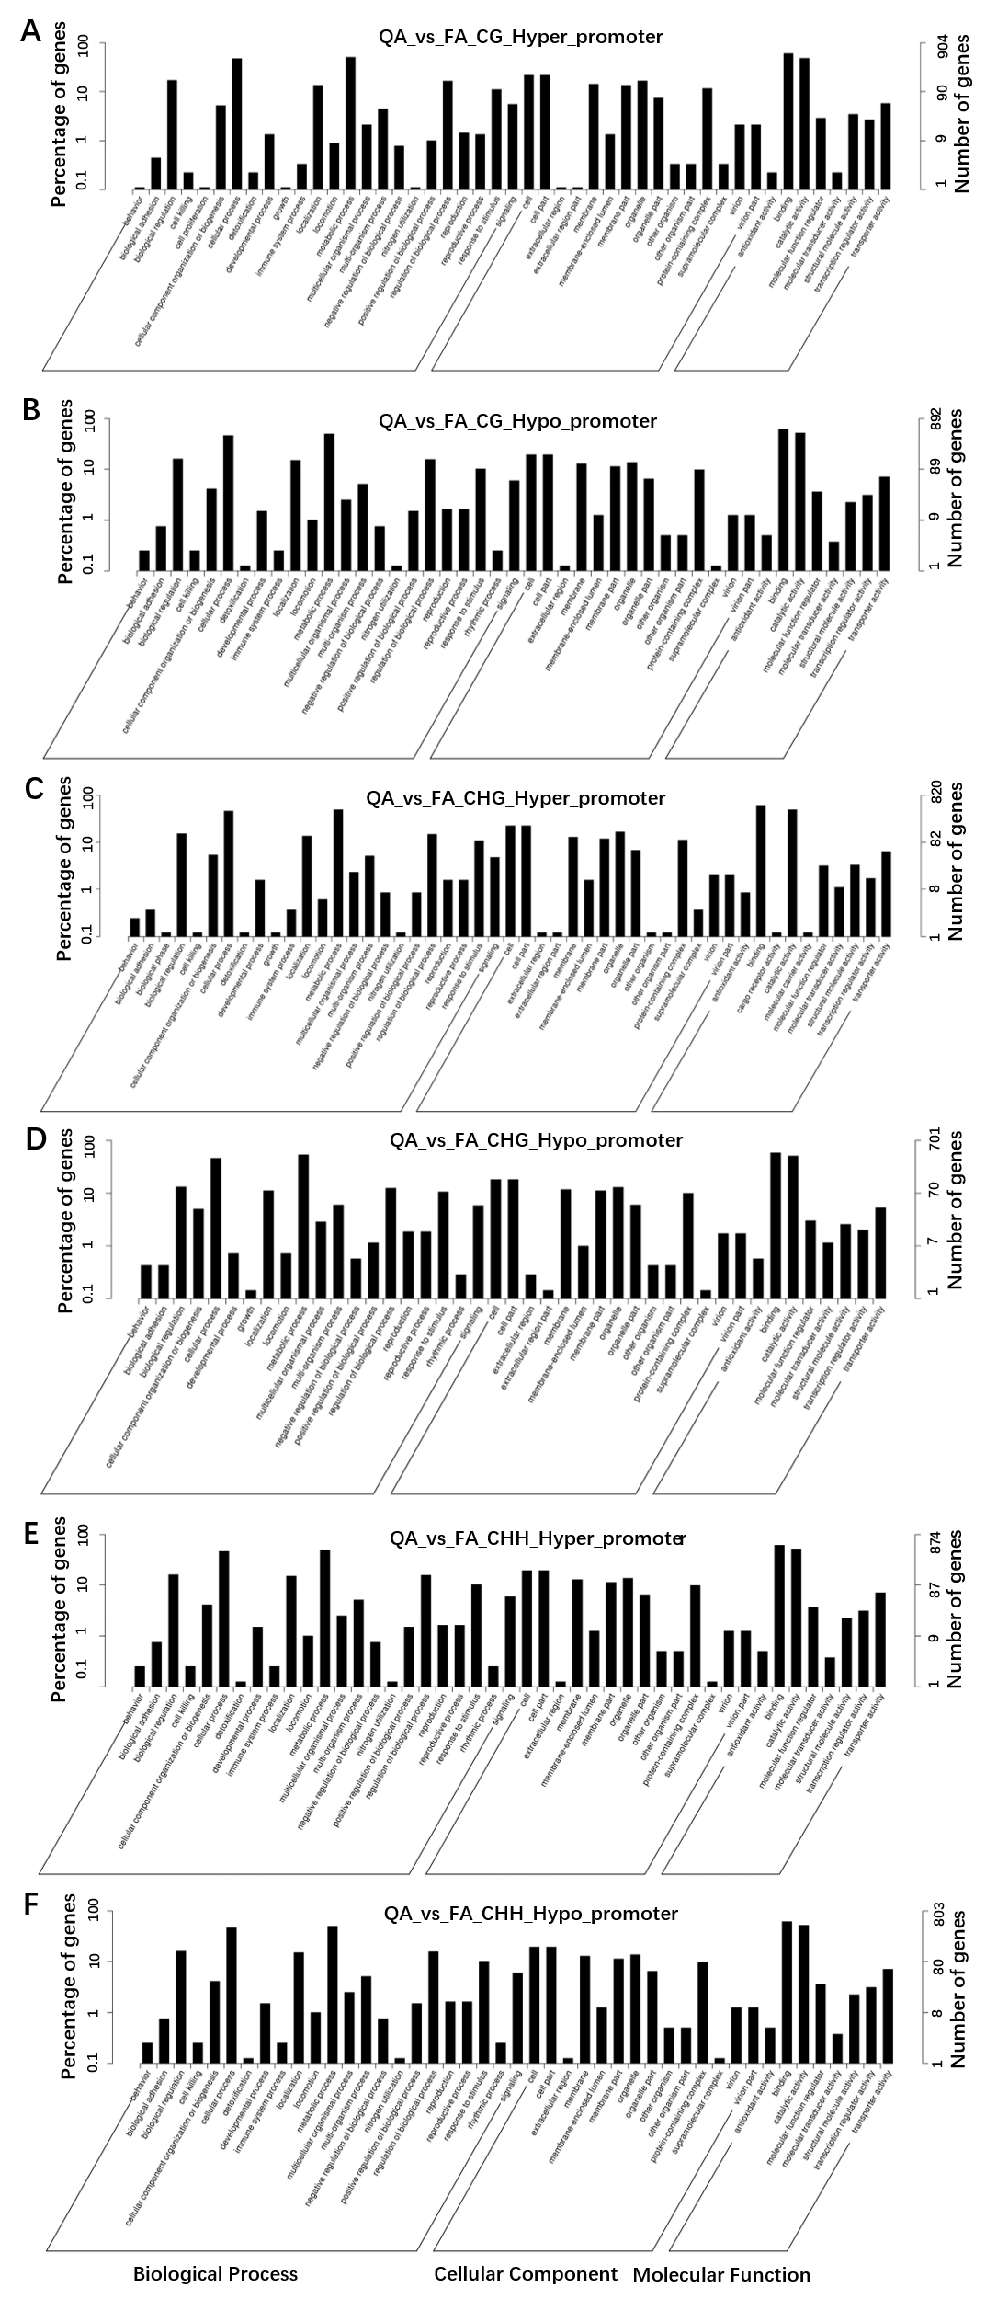
Figure S8. Go enrichment terms analysis of the DMR_genes in the CG, CHG, and CHH contexts between ‘Qinguan’ and ‘Nagafu No. 2’ axillary bud. (A, C, E) Details regarding the pathway enrichment for the DMR_promoter_genes hypermethylated in the CG, CHG, and CHH contexts. (B, D, F) Go enrichment terms for the DMR_promoter_genes hypomethylated in the CG, CHG, and CHH contexts.

Figure S9. KEGG enrichment pathways of the DMR_genes in the CG, CHG, and CHH contexts between ‘Qinguan’ and ‘Nagafu No. 2’ axillary bud. (A–C) Details regarding the pathway enrichment for the DMR_genes hypermethylated in the CG, CHG, and CHH contexts. (D–F) Details regarding the pathway enrichment for the DMR_genes hypomethylated in the CG, CHG, and CHH contexts.

Figure S10. KEGG enrichment pathways of the DMR_promoter_genes in the CG, CHG, and CHH contexts between ‘Qinguan’ and ‘Nagafu No. 2’ axillary bud. (A–C) Details regarding the pathway enrichment for the DMR_promoter_genes hypermethylated in the CG, CHG, and CHH contexts. (D–F) Details regarding the pathway enrichment for the DMR_promoter_genes hypomethylated in the CG, CHG, and CHH contexts.

Figure S11. The gene expression distribution, as well as Pearson correlation among samples of ‘Fuji’ and ‘Qinguan’ axillary buds.
Figure S12. Phylogenetic analysis of Apple and Arabidopsis thaliana MADS-box genes. Protein designations: Arabidopsis (At, blue circle) and Apple (Md, red square).

