Epidemiological and genomic characteristics of Acinetobacter baumannii from different infection sites using comparative genomics
Xingchen Bian^{1,2,3,4}, Xiaofen Liu^{2,3,4}, Xuefei Zhang², Xin Li^{2,3,4}, Jing Zhang^{2,3,4,5}, Huajun Zheng⁶, Sichao Song⁶, Xiang Li⁷, Meiqing Feng^{1,7*}
¹ Department of biological medicines & Shanghai Engineering Research Center of Immunotherapeutics, School of Pharmacy, Fudan University, Shanghai, 201203, China;
² Institute of Antibiotics, Huashan Hospital, Fudan University, Shanghai, 200040, China;
³ Key Laboratory of Clinical Pharmacology of Antibiotics, Shanghai, 200040, China;
⁴ National Health Commission & National Clinical Research Center for Aging and Medicine, Huashan Hospital, Fudan University, Shanghai, 200040, China;
⁵ Phase I Unit, Huashan Hospital, Fudan University, Shanghai, 200040, China;
⁶ Chinese National Human Genome Center, Shanghai, 201203, China;
⁷ Minhang Hospital, Fudan University, Shanghai, 201199, China

*Corresponding author: 825 Zhang Heng Rd, Shanghai, 201203, China;
Email: fmq@fudan.edu.cn ; Phone: +86-21-51980035

Running title: genomic characteristics of Acinetobacter baumannii
Key words: Acinetobacter baumannii, whole genome sequencing, epidemiological characteristics, multi-drug resistance, comparative genomics

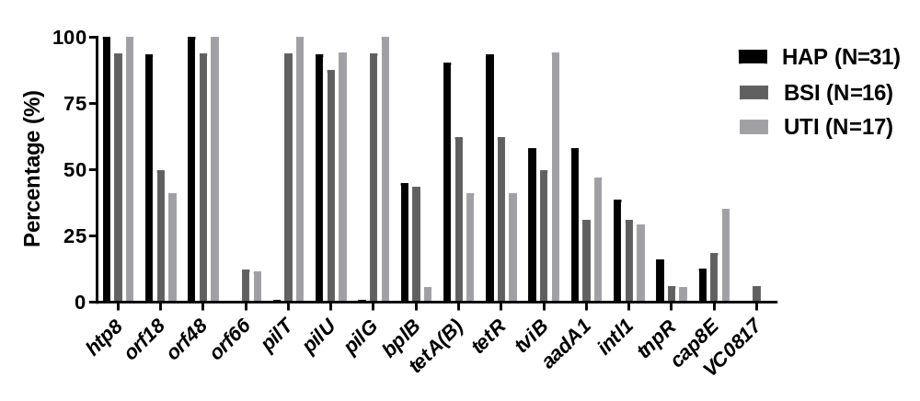
Figure S1. Virulence factors in 64 A. baumannii isolates. htp8, Hsp60, 60K heat shock protein HtpB; orf18, Unknown; orf48, orf66, hypothetical protein; pilT, pilU, pilG, twitching motility protein; bplB, probable acetyltransferase; tetA(B), tetracycline resistance protein TetA(B); tetR, tet repressor; tviB, Vi polysaccharide biosynthesis protein, UDP-glucose/GDP-mannose dehydrogenase; aadA1, streptomycin adenyltransferase AadA1; intl1, Tn21 integrase IntI1; tnpR, resolvase TnpR; cap8E, capsular polysaccharide synthesis enzyme Cap8E; VC0817, transposase, putative

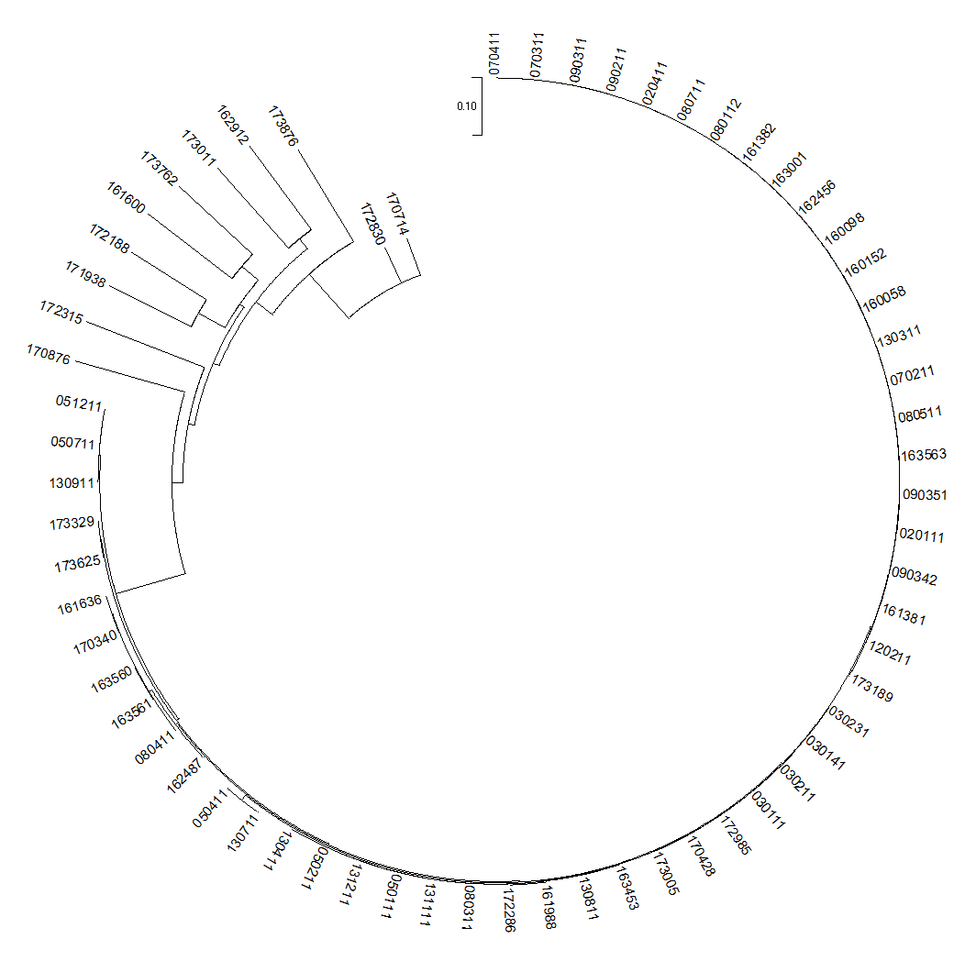
Figure S2. The circular phylogenetic tree of 64 A. baumannii isolates

Table S2. The full length and GC contents of intact AbGRI1 islands
Infection type | Strain | Total base (bp) | GC (%) | Infection type | Strain | Total base (bp) | GC (%)
HAP | 030111 | 30193 | 38.3 | HAP | 131211 | 17595 | 40.9
HAP | 030231 | 28537 | 39.4 | BSI | 160058 | 20701 | 39.0
HAP | 050111 | 17595 | 40.9 | BSI | 161381 | 16930 | 43.1
HAP | 050211 | 17595 | 40.9 | BSI | 161600 | 11963 | 36.1
HAP | 050411 | 20648 | 40.3 | BSI | 161636 | 16441 | 36.0
HAP | 050711 | 17595 | 40.9 | BSI | 162456 | 14527 | 43.3
HAP | 051211 | 17595 | 40.9 | BSI | 162487 | 12060 | 36.0
HAP | 080311 | 20445 | 40.3 | BSI | 163001 | 17389 | 42.3
HAP | 080411 | 9113 | 35.7 | BSI | 163561 | 18527 | 36.2
HAP | 090311 | 18496 | 41.1 | UTI | 170340 | 21930 | 36.0
HAP | 090342 | 22007 | 41.3 | UTI | 170428 | 17595 | 40.9
HAP | 090351 | 18614 | 41.1 | UTI | 170876 | 37800 | 37.0
HAP | 120211 | 17790 | 40.8 | UTI | 172286 | 20445 | 40.3
HAP | 130411 | 17595 | 40.9 | UTI | 172985 | 28616 | 39.4
HAP | 130711 | 31488 | 39.0 | UTI | 173329 | 17595 | 40.9
HAP | 130811 | 10544 | 46.8 | UTI | 173625 | 17595 | 40.9
HAP | 130911 | 17595 | 40.9 | UTI | 173762 | 19781 | 33.7
HAP | 131111 | 17595 | 40.9 |  | median | 17595 | 40.9

Table S5. Accession numbers of 64 A. baumannii isolates
Accession number | Sample Name | Accession number | Sample Name
SAMN14943599 | 020111 | SAMN14943631 | 160098
SAMN14943600 | 020411 | SAMN14943632 | 160152
SAMN14943601 | 030111 | SAMN14943633 | 161381
SAMN14943602 | 030141 | SAMN14943634 | 161382
SAMN14943603 | 030211 | SAMN14943635 | 161600
SAMN14943604 | 030231 | SAMN14943636 | 161636
SAMN14943605 | 050111 | SAMN14943637 | 161988
SAMN14943606 | 050211 | SAMN14943639 | 162456
SAMN14943607 | 050411 | SAMN14943640 | 162487
SAMN14943608 | 050711 | SAMN14943641 | 162912
SAMN14943609 | 051211 | SAMN14943642 | 163001
SAMN14943610 | 070211 | SAMN14943643 | 163453
SAMN14943611 | 070311 | SAMN14943644 | 163560
SAMN14943612 | 070411 | SAMN14943645 | 163561
SAMN14943613 | 080112 | SAMN14943646 | 163563
SAMN14943614 | 080311 | SAMN14943647 | 170340
SAMN14943615 | 080411 | SAMN14943648 | 170428
SAMN14943616 | 080511 | SAMN14943649 | 170714
SAMN14943617 | 080711 | SAMN14943650 | 170876
SAMN14943618 | 090211 | SAMN14943651 | 171938
SAMN14943619 | 090311 | SAMN14943652 | 172188
SAMN14943620 | 090342 | SAMN14943653 | 172286
SAMN14943621 | 090351 | SAMN14943654 | 172315
SAMN14943622 | 120211 | SAMN14943655 | 172830
SAMN14943623 | 130311 | SAMN14943656 | 172985
SAMN14943624 | 130411 | SAMN14943657 | 173005
SAMN14943625 | 130711 | SAMN14943658 | 173011
SAMN14943626 | 130811 | SAMN14943659 | 173189
SAMN14943627 | 130911 | SAMN14943660 | 173329
SAMN14943628 | 131111 | SAMN14943661 | 173625
SAMN14943629 | 131211 | SAMN14943662 | 173762
SAMN14943630 | 160058 | SAMN14943663 | 173876

