Supplementary information.
Table S1. SARS-CoV-2 IHC positive cases details

Case ID | Histology
6 | Diffuse alveolar damage
13 | Focal fibrin deposition
15 | Diffuse alveolar damage
17 | Diffuse alveolar damage
22 | Edema fluid accumulation and interalveolar capillaries dilatation
32 | Diffuse alveolar damage
34 | Diffuse alveolar damage
35 | Diffuse alveolar damage
38 | Diffuse alveolar damage
39 | Diffuse alveolar damage

Table S2. Control lung sample details
Sample type | Diagnosis | Average ACE2 intensity (SD)
Autopsy (n=6) | Road trauma accident | 1.06 (1.57)
Biopsy (n=2) | Interalveolar haemorrhage (n=1) and diffuse alveolar damage (n=1). | 9.75 (6.74)
Surgical resection (n=7) | Adjacent normal lung parenchyma in cases of squamous cell carcinoma (n=2), invasive mucinous adenocarcinoma (n=1), adenocarcinoma (n=2), typical carcinoid (n=2) | 2.51 (2.84)

Supplementary figure

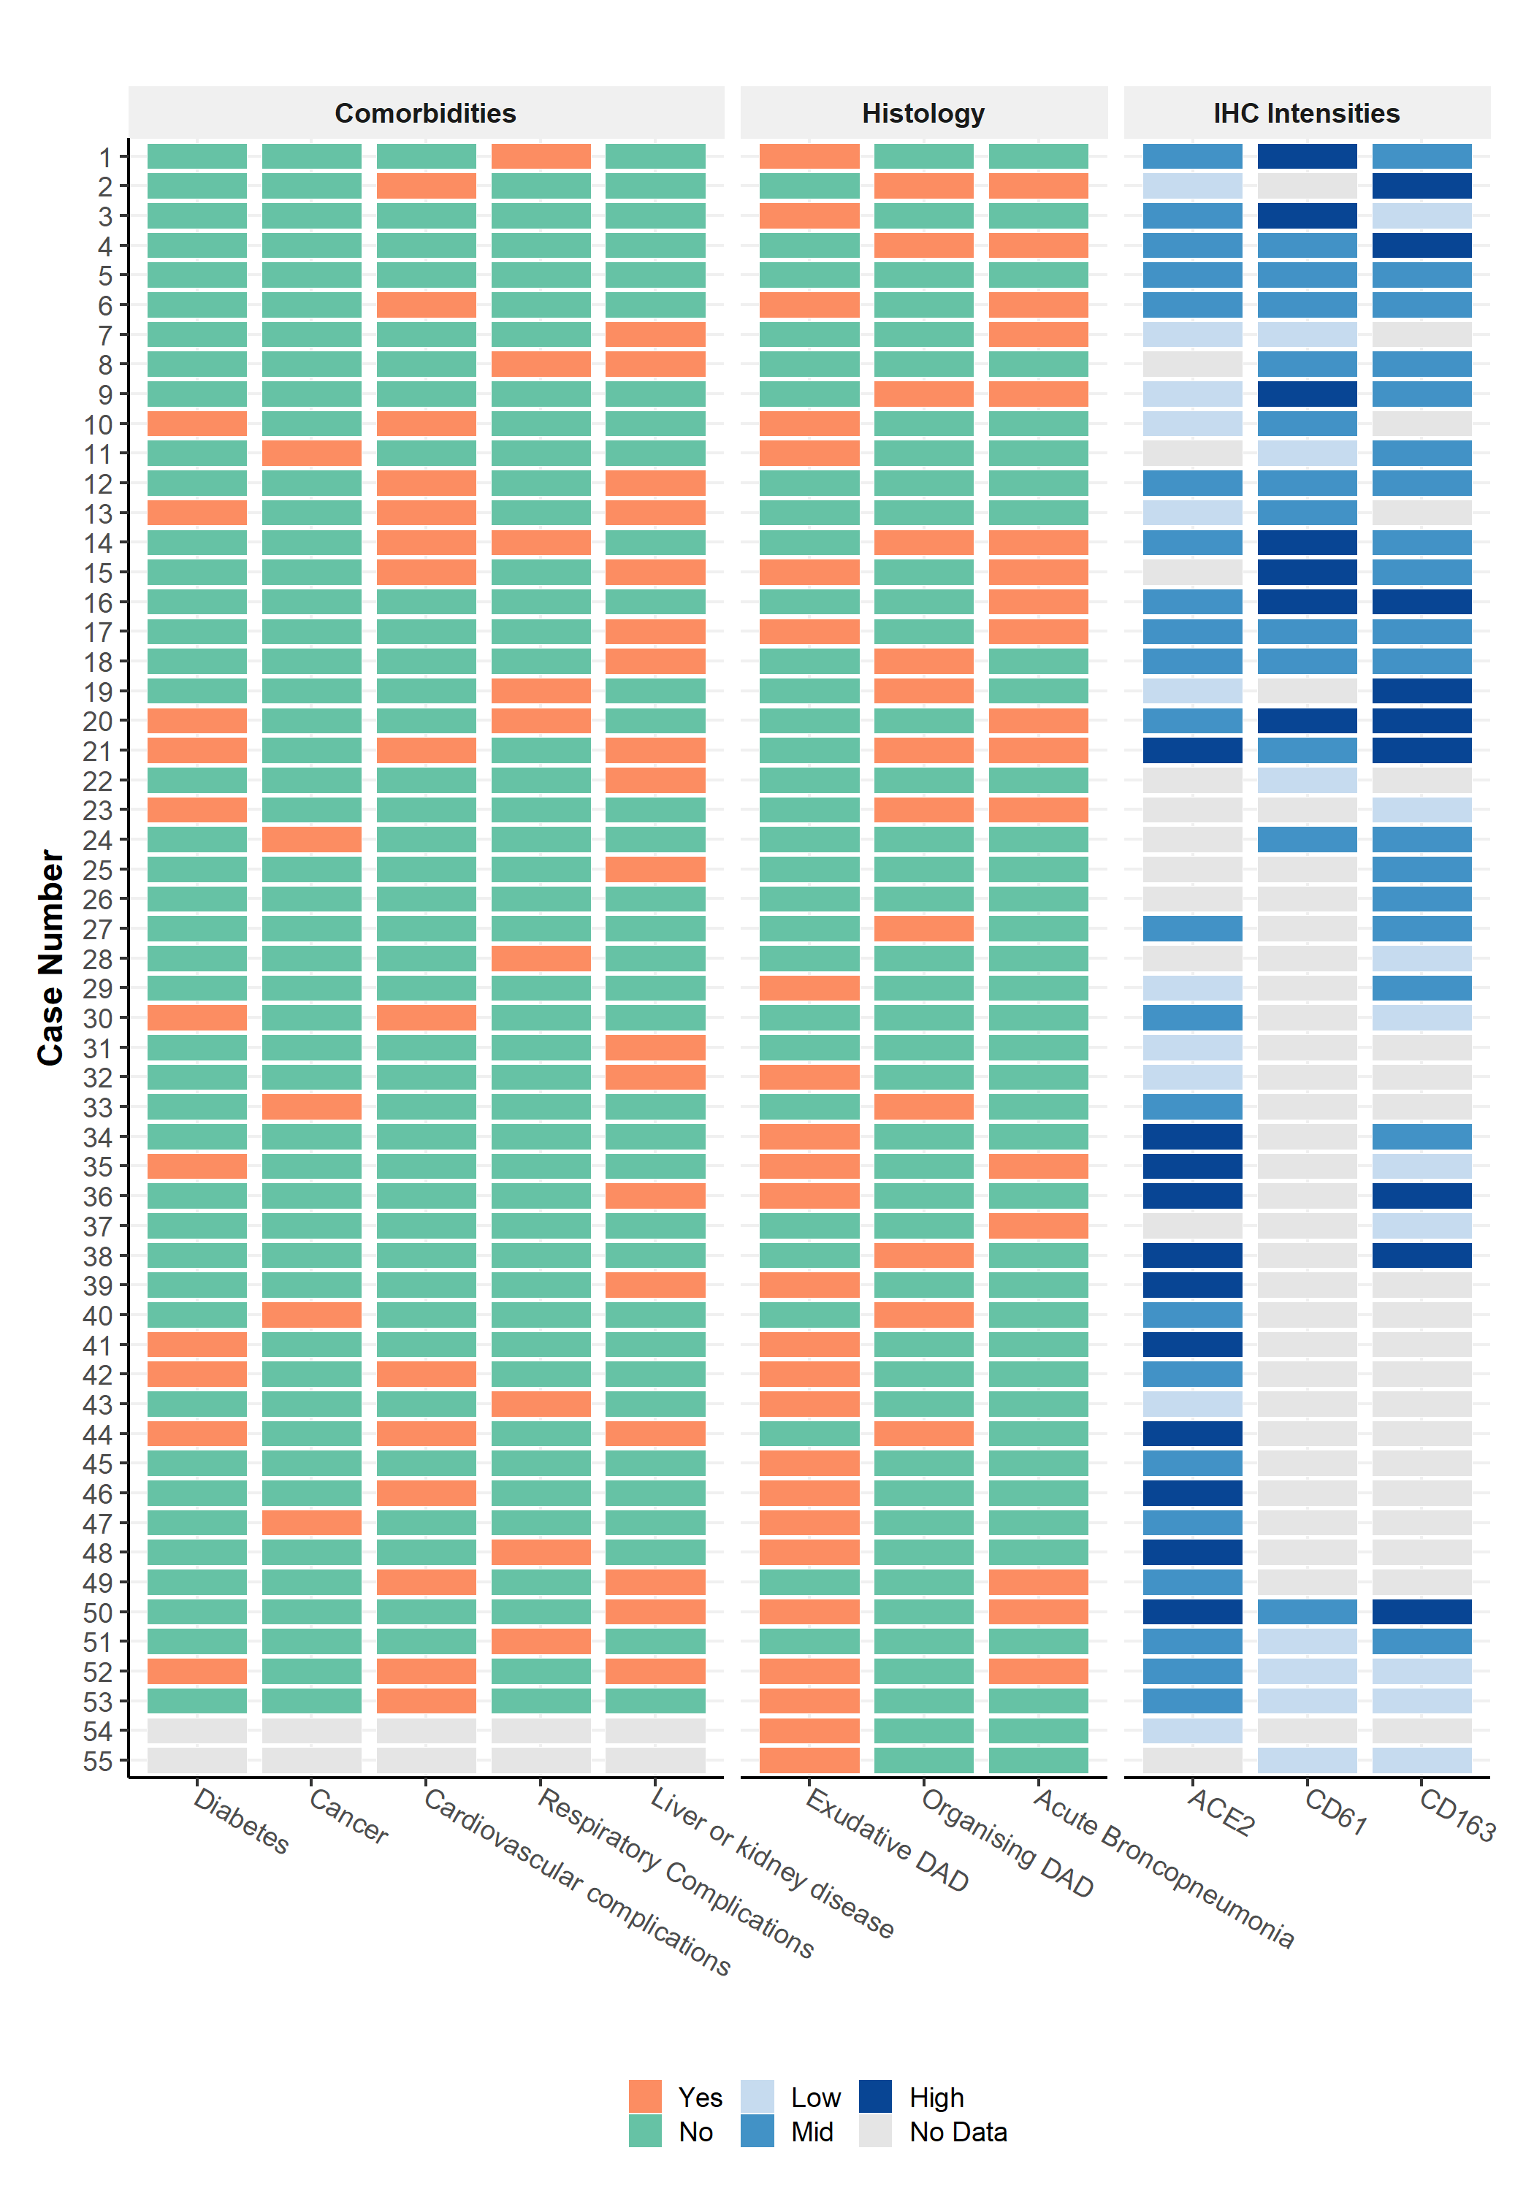
Figure S1. Summary of COVID-19 patients. Heatmap representing coexisting comorbidity, histopathological changes and IHC experimental details of COVID-19 patients.

