Supplemental Table 1. Demographic, laboratory, and clinical characteristics of train and test set population
Baseline Characteristics/Outcomes | Train set  (n= 1362) | Test set  (n= 584) | p-value
Demographic and laboratory Characteristics
Age | 73.4±7.12 | 73.14±6.67 | 0.303
Male | 916(67.2) | 409(70) | 0.248
Smoking | 465(34.1) | 197(33.7) | 0.902
Opium | 169(12.4) | 63(10.7) | 0.349
BMI | 27.45±4.59 | 27.35±4.31 | 0.64
Weight | 74.02±12.61 | 73.76±12.52 | 0.679
Total Cholesterol | 150.9±37.12 | 152.47±39.8 | 0.424
TG | 121.99±62.9 | 127.4±79.12 | 0.142
LDL | 96.16±32.52 | 96.52±33.83 | 0.827
HDL | 39.29±9.84 | 39.40±9.60 | 0.82
TG/HDL | 3.38±2.13 | 3.55±2.88 | 0.207
TyG.Index | 9026.5±8001 | 9540.7±8768.1 | 0.224
Creatinine | 1.04±0.39 | 1.06±0.48 | 0.334
FBS | 141.4±65.28 | 145.14±73.17 | 0.295
Hb | 14.44±1.96 | 14.45±1.88 | 0.94
Past medical history and comorbidities
Family History of CAD | 156(11.4) | 65(11.1) | 0.897
History of Hyperlipidemia | 678(49.7) | 301(51.5) | 0.507
History of Hypertension | 803(58.9) | 356(60.9) | 0.438
History of Diabetes | 646(47.4) | 276(47.2) | 0.984
History of VHD | 27(1.9) | 14(2.3) | 0.68
History of Chronic Lung Disease | 37(2.7) | 22(3.7) | 0.273
History of CVA | 79(5.8) | 28(4.7) | 0.433
History of Renal Failure | 38(2.7) | 19(3.2) | 0.682
History of CPR | 17(1.2) | 8(1.3) | 0.9
Atrial Fibrillation | 22(1.6) | 12(2) | 0.624
In-hospital and procedural characteristics and outcomes
Pain to Door Interval | 516.2±674.9 | 562.9±864.4 | 0.219
Pain to Needle Interval | 594.4±681.3 | 636.2±808.6 | 0.275
Door to Needle Interval | 79.6±66.17 | 72.4±57.39 | 0.015
Pre PCI TIMI Flow <2 | 879(64.53) | 377(68) | 0.658
Post PCI TIMI Flow <2 | 42(3) | 25(4.4) | 0.203
No Reflow during PCI | 33(2.4) | 14(2.3) | 0.9
Length of Lesion | 28.3±13.28 | 28.6±14.97 | 0.702
Length of Stent | 28.7±9.7 | 28.7±9.7 | 0.972
Diameter of Stent | 2.94±0.43 | 2.90±0.41 | 0.051
Previous Revascularization | 288(21) | 132(22.6) | 0.488
Previous MI | 221(16.2) | 104(17.8) | 0.428
Post PCI Shock | 35(2.5) | 10(1.7) | 0.322
LVEF | 40.65±7.93 | 40.28±7.93 | 0.112
MACE | 249(182) | 107(18.3) | 0.9
Values are reported as n (%) or mean ± SD.
TG, triglyceride; HDL, high-density lipoprotein cholesterol; LDL, low-density lipoprotein cholesterol; Tyg. index, Triglyceride-glucose index; FBS, fasting blood sugar; Hb, hemoglobin; CAD, coronary artery disease; VHD, Valvular heart disease; CVA, cerebrovascular accident; CPR, cardiopulmonary resuscitation; PCI, percutaneous coronary intervention; TIMI, Thrombolysis in Myocardial Infarction score; LVEF, Left ventricular ejection fraction; MACEs,major adverse cardiovascular events.
Bold values represent the p-value of <0.05 (statistical significance)

Supplemental Table 2. Univariate and multivariate regression analysis investigating probable predictive factors for MACE following PCI in elderly with STEMI
 |  |  |  |  | Univariate analysis |  |  |  | Multivariate analysis
Predictive factor |  |  |  |  | OR | 95%CI | p-value |  | OR | 95%CI | p-value
LVEF |  |  |  |  | 0.94 | 0.92-0.95 | <0.001 |  | 0.96 | 0.94-98 | <0.001
Age |  |  |  |  | 1.03 | 1.01-1.05 | <0.001 |  | 1 | 0.98-1.03 | 0.7
Male |  |  |  |  | 0.81 | 0.61-1.19 | 0.2
BMI |  |  |  |  | 0.99 | 0.96-1.02 | 0.6
Weight |  |  |  |  | 0.99 | 0.98-1 | 0.086
Total Cholesterol |  |  |  |  | 1 | 0.99-1 | 0.047 |  | 1 | 0.99-1.01 | 0.9
TG |  |  |  |  | 1 | 1--1 | 0.6
LDL |  |  |  |  | 1 | 0.99-1 | 0.11
HDL |  |  |  |  | 0.98 | 0.97-1 | 0.036 |  | 0.99 | 0.97-1 | 0.14
TG/HDL |  |  |  |  | 1.02 | 0.96-1.09 | 0.5
TyG.Index |  |  |  |  | 1 | 1--1 | 0.016 |  | 1 | 0.99-1.01 | 0.2
Creatinine |  |  |  |  | 2.59 | 1.88-3.6 | <0.001 |  | 1.41 | 1.23-2.33 | <0.001
FBS |  |  |  |  | 1.01 | 1-1.01 | <0.001 |  | 1.01 | 1-1.01 | 0.002
Hb |  |  |  |  | 0.83 | 0.77-0.89 | <0.001 |  | 0.88 | 0.81-0.95 | 0.001
Family History of CAD |  |  |  |  | 0.97 | 0.62-1.48 | 0.9
History of Hyperlipidemia |  |  |  |  | 0.86 | 0.65-1.13 | 0.3
History of Hypertension |  |  |  |  | 1 | 0.76-1.33 | 0.9
History of Diabetes |  |  |  |  | 1.85 | 1.4-2.45 | <0.001 |  | 1.23 | 0.85-1.80 | 0.3
Smoking |  |  |  |  | 0.94 | 0.7-1.25 | 0.7
Opium |  |  |  |  | 1.05 | 0.69-1.57 | 0.8
History of VHD |  |  |  |  | 3.71 | 1.68-8.01 | <0.001 |  | 2.39 | 1.24-5.87 | 0.038
History of Chronic Lung Disease |  |  |  |  | 1.24 | 0.52-2.62 | 0.6
History of CVA |  |  |  |  | 2.05 | 1.22-3.35 | 0.005 |  | 1.1 | 0.59-1.98 | 0.8
History of Renal Failure |  |  |  |  | 5.31 | 2.76-10.31 | <0.001 |  | 2.02 | 0.74-5.53 | 0.2
History of CPR |  |  |  |  | 4.07 | 1.51-10.8 | 0.004 |  | 2.23 | 0.64-7.07 | 0.2
Atrial Fibrillation |  |  |  |  | 2.61 | 1.03-6.15 | 0.03 |  | 1.58 | 0.55-4.16 | 0.4
Pain to Door Interval |  |  |  |  | 1 | 1--1 | 0.2
Pain to Needle Interval |  |  |  |  | 1 | 1--1 | 0.2
Door to Needle Interval |  |  |  |  | 1 | 1--1 | 0.3
Pre PCI TIMI Flow <2 |  |  |  |  | 0.9 | 0.79-1.01 | 0.072
Post PCI TIMI Flow <2 |  |  |  |  | 0.64 | 0.52-0.76 | <0.001 |  | 0.43 | 0.19-1 | 0.042
No Reflow during PCI |  |  |  |  | 1.21 | 0.48-2.67 | 0.7
Length of Lesion |  |  |  |  | 1.01 | 1-1.02 | 0.028 |  | 1.01 | 0.99-1.02 | 0.3
Length of Stent |  |  |  |  | 1.01 | 0.99-1.02 | 0.3
Diameter of Stent |  |  |  |  | 0.62 | 0.44-0.87 | 0.007 |  | 0.69 | 0.49-0.98 | 0.049
Previous Revascularization |  |  |  |  | 1.39 | 1-1.89 | 0.048 |  | 1.43 | 0.99-2.04 | 0.053
Previous MI |  |  |  |  | 1.26 | 0.87-1.78 | 0.2
Post PCI Shock |  |  |  |  | 54.6 | 19.3-228 | <0.001 |  | 28.4 | 9.45-123 | <0.001
Acronyms are explained In Table 1

Supplemental Table 3. Comparing the risk of MACE incidence between different risk groups
Comparison Groups | HR | Lower 95%-CI | Upper 95%-CI | P-value
>0.75 Vs. <0.75 | 13.12 | 7.09 | 24.25 | <0.001
>0.75 VS. 0.5-0.75 | 1.94 | 1.2 | 3.13 | <0.00L
>0.75 V5. 0.25-0.5 | 7.02 | 4.21 | 11.68 | <0.001
>0.75 Vs. <0.25 | 16.74 | 8.73 | 32.1 | <0.001
>0.5 Vs. <0.5 | 11.82 | 8.24 | 16.97 | <0.001
>0.5 V5. 0.25-0.5 | 5.32 | 3.75 | 7.54 | <0.001
>0.5 Vs. <0.25 | 13.87 | 9.5 | 20.25 | <0.001
>0.25 Vs. <0.25 | 4.43 | 3.53 | 5.56 | <0.001
0.25-0.5 Vs.<0.25 | 2.44 | 1.83 | 3.27 | <0.001

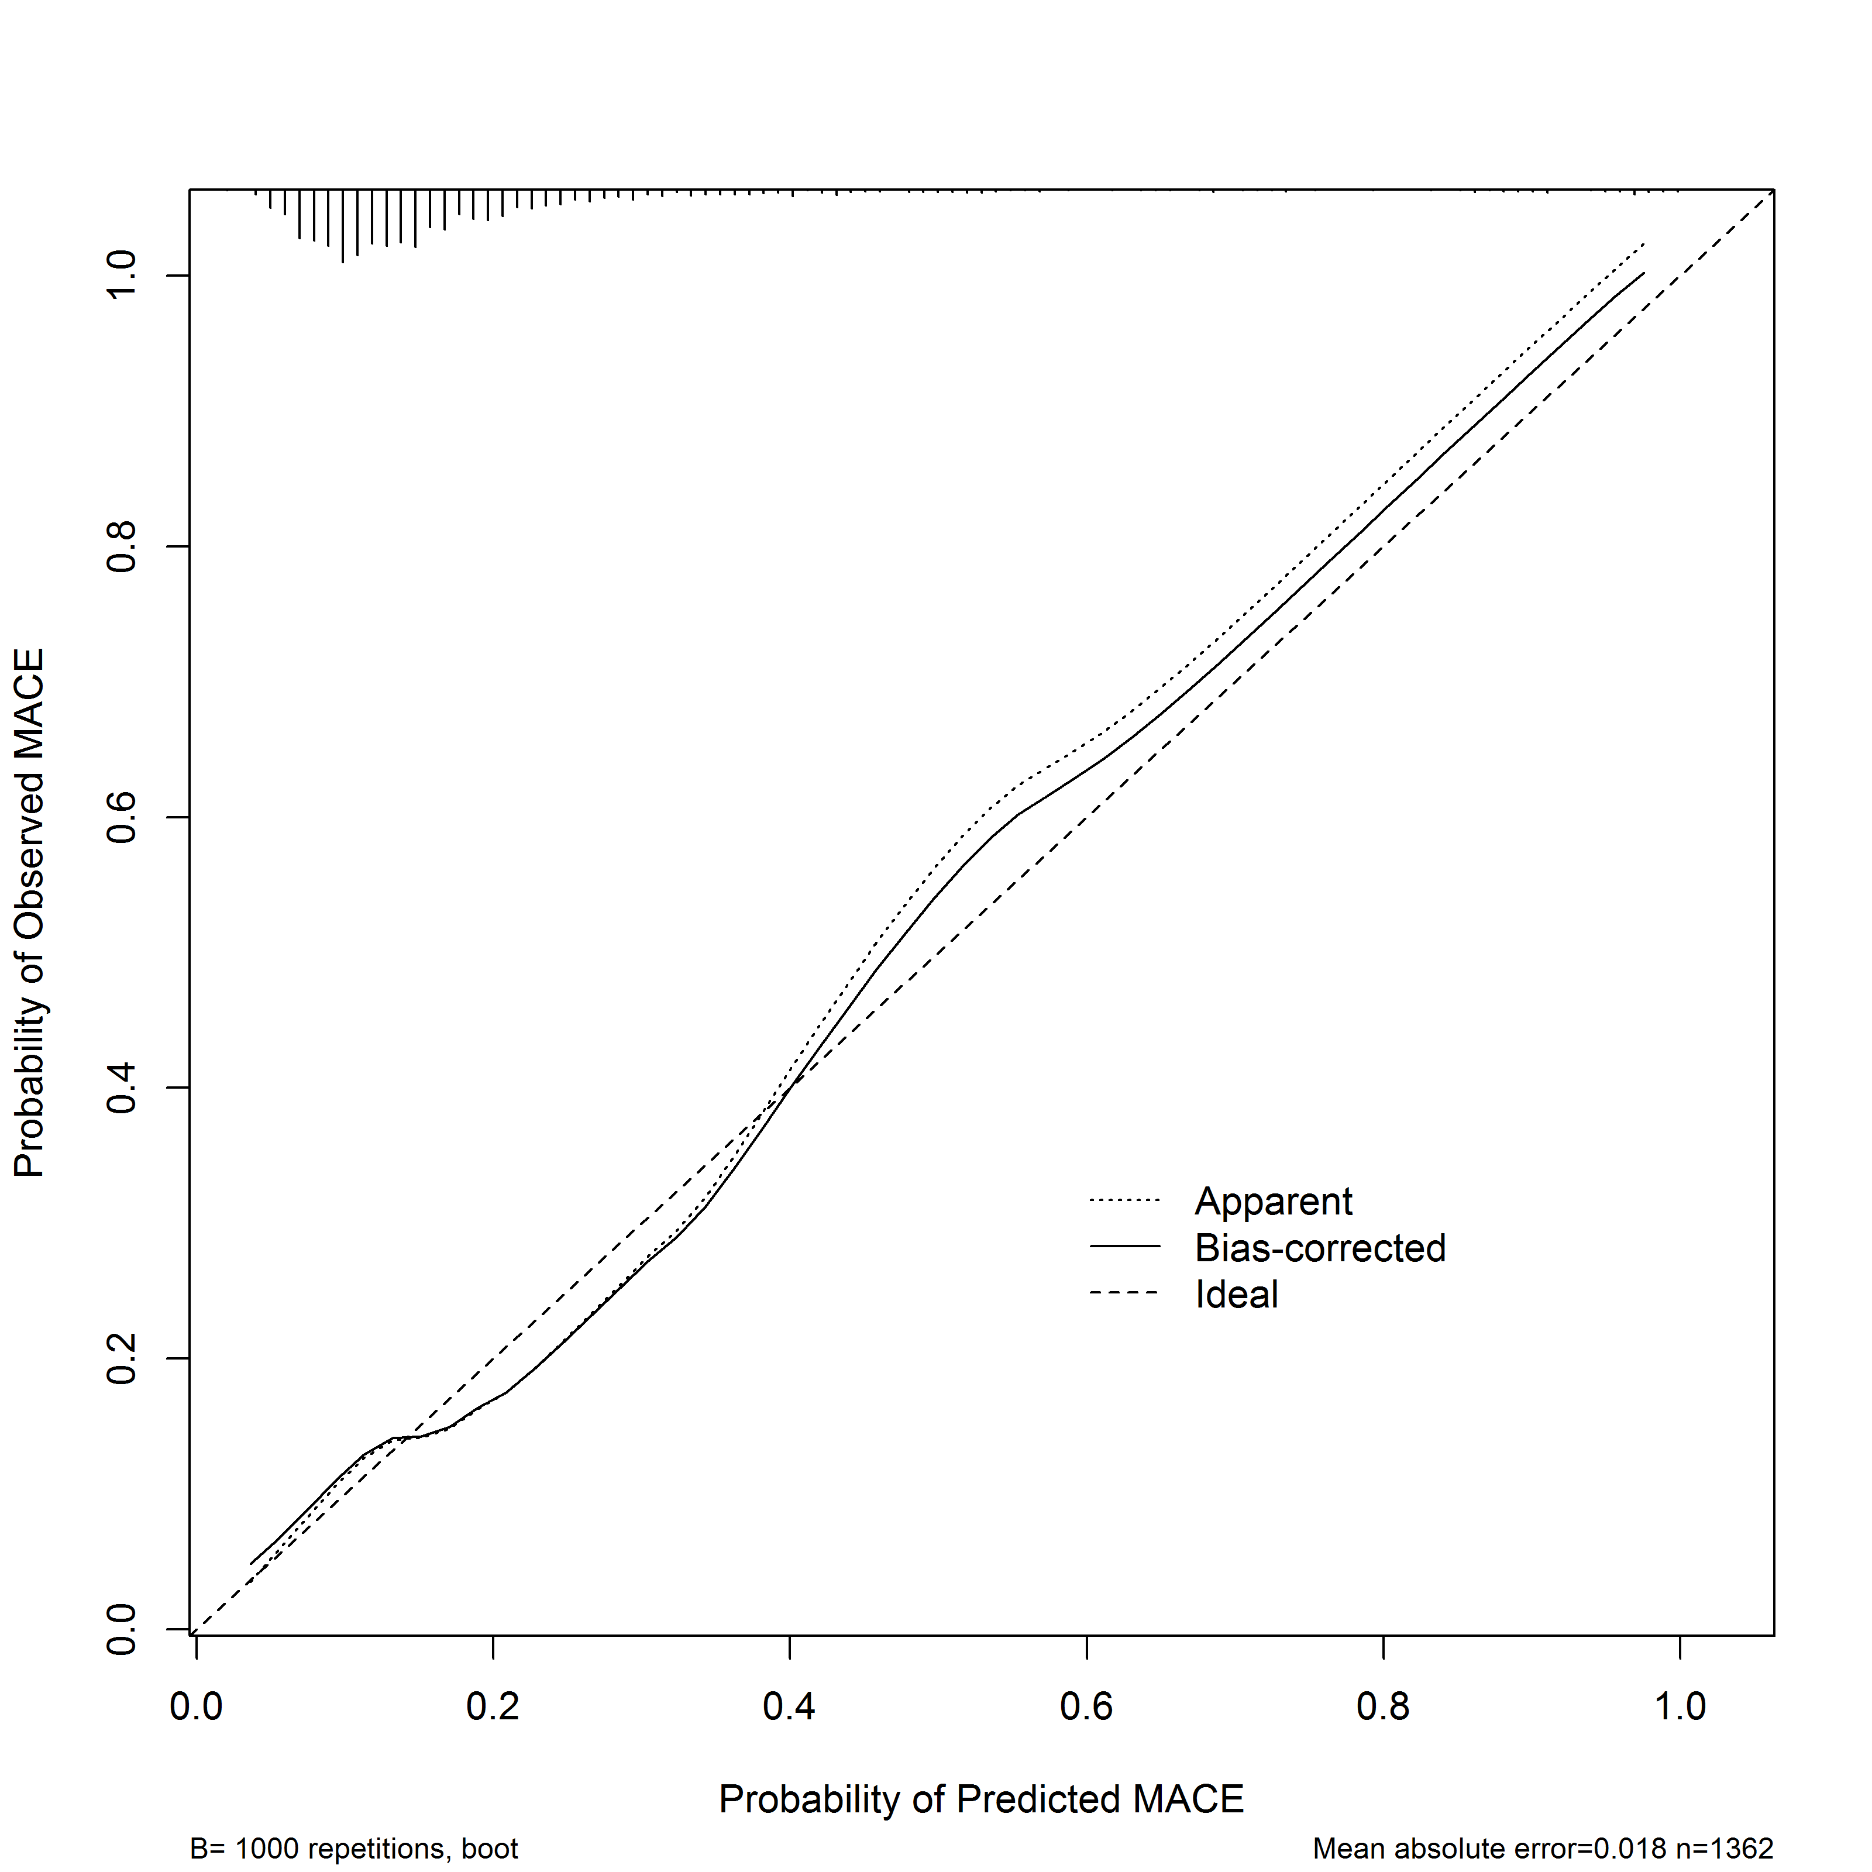
Supplemental Figure 1 Calibration plot of the model predicting MACE incidence.

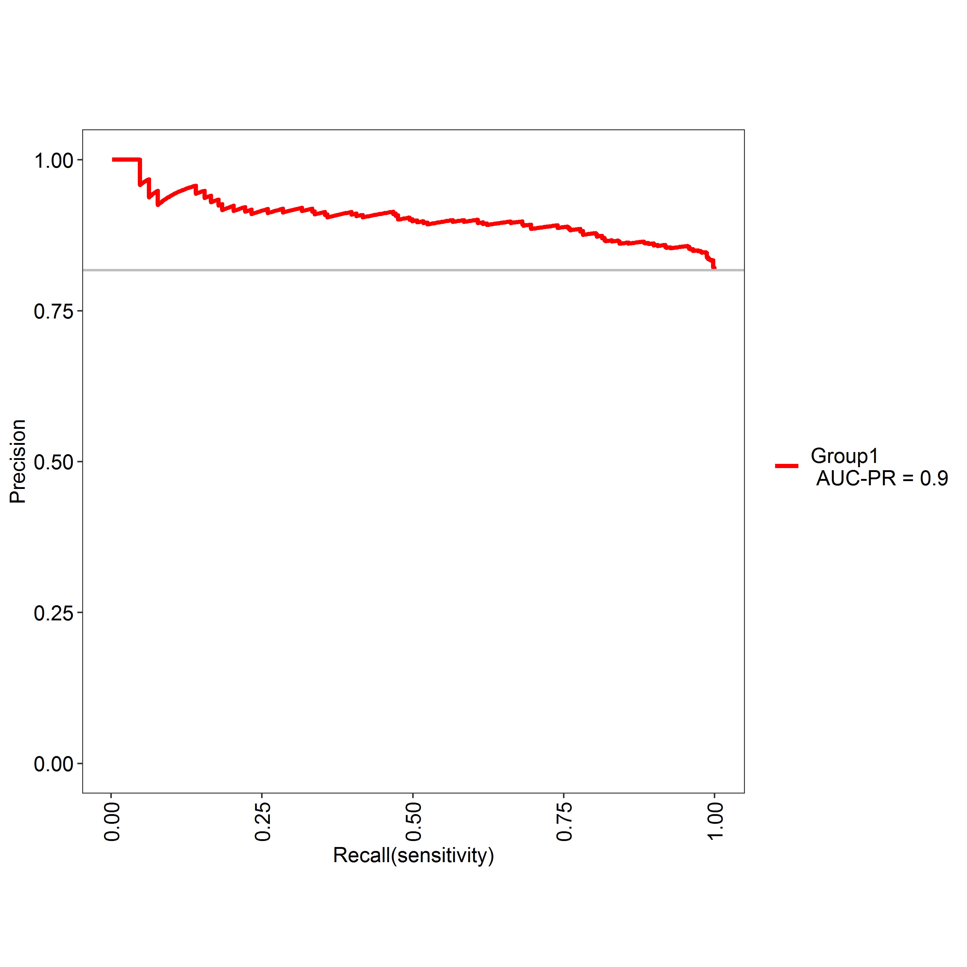
Supplemental Figure 2 Precision recall curve for MACE incidence prediction.

