Supplemental Information

A Data-Driven Framework for Evaluating EV Charging Station Permitting Processes Using Large Language Models
Ranjit R. Desai^{1,*}, Umapriya Renganathan1, Reid Olsen2, Erin Andrews-Sharer1, Noah Frey2, Alexandra Danner1 and Grant Buster²

¹Center for Integrated Mobility Sciences, National Renewable Energy Laboratory, 15013 Denver West Parkway, Golden, CO, USA
*Correspondence: Ranjit.Desai@nrel.gov
*Corresponding author
²Strategic Energy Analysis Center, National Renewable Energy Laboratory, 15013 Denver West Parkway, Golden, CO, USA

Methods

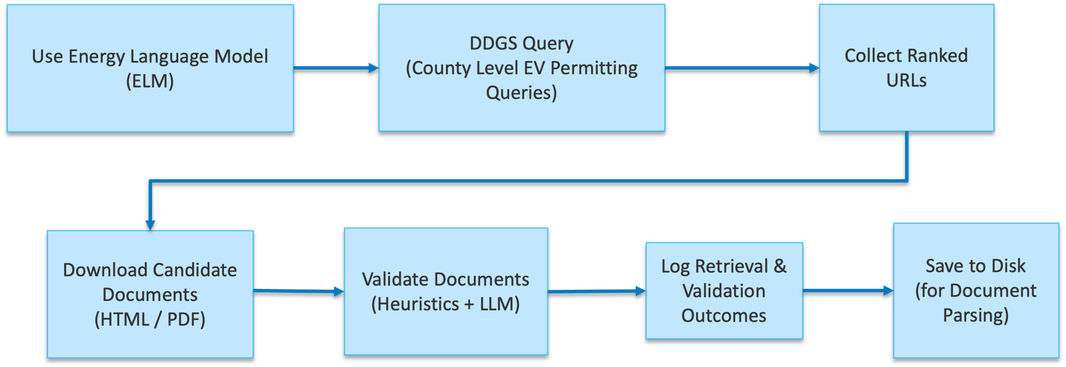
Figure S1. Flowchart of web scraping pipeline

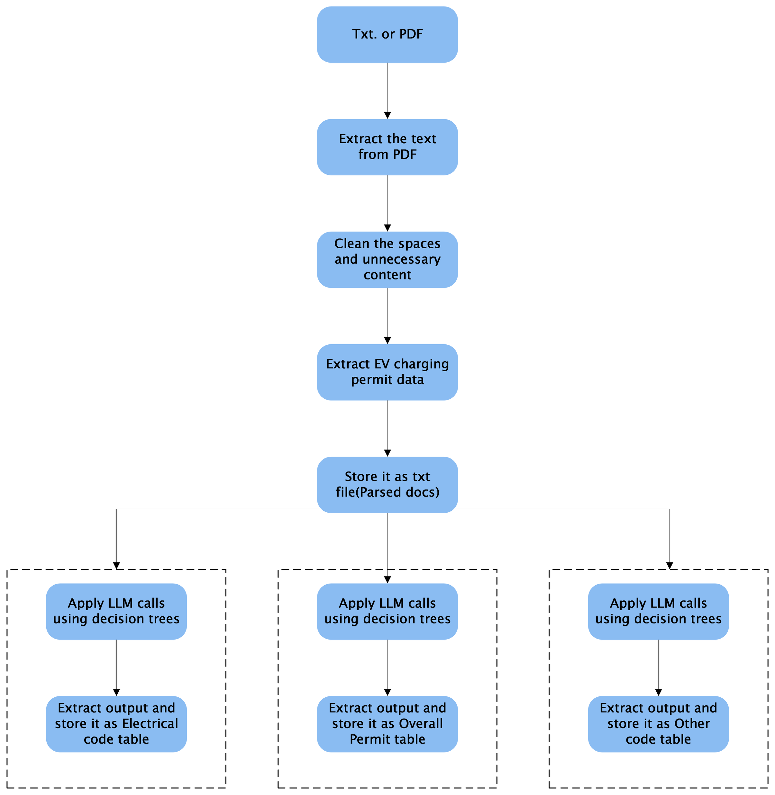
Figure S2. Flowchart of Permitting document parsing Pipeline

Scoring Method Application
This section presents an analysis and scoring of two example Authorities Having Jurisdictions (AHJs) to demonstrate the variability in permit application scores. The AHJs scored are the City of Southington, Connecticut and the City of San Diego, California ^{1,2}. The score ranges from 0 to 5, where a score of 5 reflects a comprehensive permitting application that outlines all relevant information for the EV charging permitting process, and a score of 0 indicates the total absence of specific information about EV charging permitting. The score is calculated based on five evaluation categories, each carrying a different weight: Process Description (40%), Requirement Explanations (35%), Technology and Tools (20%), and Communication and Support (5%). Within each category, criteria are assessed with a “Yes” or “No” response, where a “Yes” contributes 1 point to the total category score and a “No” contributes 0. The total scores across each category are weighed and rescaled so that a perfect score equates to 5. Southington received a score of 1.6 due to the lack of detailed descriptions and clarify within its permitting document ². San Diego earned a higher score of 3.5 for its application as it provided detailed guidance and documentation requirements with code references in addition to instructions for electronic submission. ¹.

Scoring for Southington, Connecticut
In the “Process Description” category, Southington received credit for having available a permitting document explicitly tailored to EV charging station installation projects and for outlining the process from application submission to final inspection. The AHJs also received points for outlining the different types of permits required for EV charging station installation projects and distinguishing between residential and commercial applications. As shown in Figure S3, the document states that residential applications require only an electrical permit, whereas commercial applications require both electrical and building permits. This differentiation adds clarity and thus saves applicants’ time. However, Southington’s process description lacked several important components which negatively impacted the total score. There were no clear, step-by-step instructions for completing the application, no checklist of permitting requirements, no explanation of process timelines, and no information about applicable fees. In addition, the documentation did not outline any exceptions or expedited review criteria, and did not define the applicant types eligible to submit applications. While the absence of these features does not necessarily reflect a poor permitting process, stating explicitly whether they are available could improve the clarity and helpfulness of the application process for users.

In the “Requirement Explanations” Category, Southington earned points for specifying the necessary documents to include with the permit application and for outlining which documents apply to residential versus commercial EV charging station installation projects, as illustrated in Figure S3. Although, the AHJ did not meet the remaining criteria within this category. Specifically, it did not reference the current model codes adopted by the AHJ, did not outline formatting requirements for the required documentation listed in the manuscript in Table 3, and failed to indicate which building code or electrical code applies to each listed requirement. Moreover, the AHJ did not address accessibility requirements, nor did it address requirements for different charger types (Level 1, Level 2, or DCFC). The absence of these details places a burden on the applicant to locate this information independently. Providing this information upfront would improve the efficiency of the permitting application process.
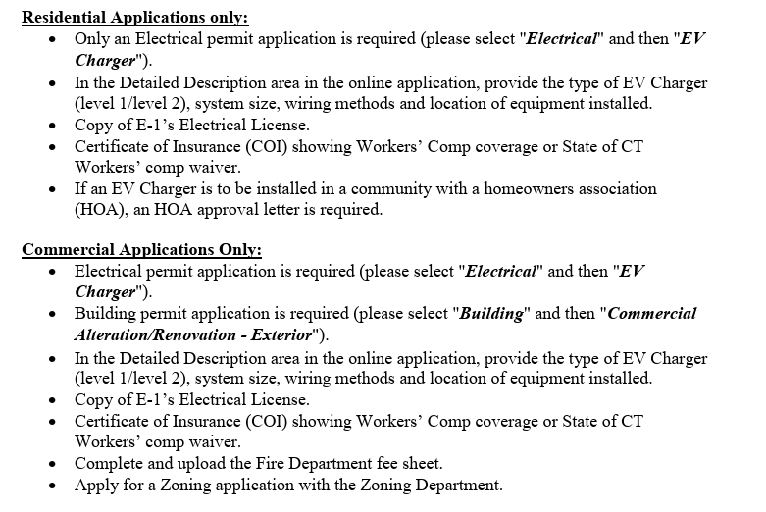
Figure S3. Section of Southington, Connecticut's EV Charger Permit Requirements document distinguishing requirements for residential versus commercial permit applications.
In the “Technology and Tools” section, Southington made a positive contribution to its overall score by noting that “All forms are to be uploaded to the online application.” The availability of an online submission process significantly improves the ease and convenience of the permitting submittal process. However, the AHJ did not provide instructions on how applicants can access the online application or outline the steps required to complete and submit it. Including this information would help streamline the process and reduce potential confusion for applicants. In addition, the AHJ did not clarify whether electronic signatures are accepted, which could further simplify submission processes.
Lastly, in the “Communication and Support” category, Southington earned points for including the contact information of permit reviewers within the permitting requirements document. The AHJ provided the name, email, and phone number of the building official, along with contact numbers for the building department, fire department, and zoning department. This availability of contact details eliminates the need for applicants to search for this information and prevents the situation of applicants contacting the wrong personnel, which saves time and improves the efficiency of the permitting process.

Scoring for San Diego, California
San Diego excelled in the “Process Description” category by meeting nearly all the criteria line items and earning points for each fulfilled requirement. The AHJ provides permitting application instructions on a dedicated webpage informational bulletin titled “How to Obtain a Permit for Electric Vehicle Charging Systems.” This webpage offers a comprehensive description of the EV charging permitting process from application submission to instructions. The information bulletin is well-structured, featuring a table of contents at the top of the webpage with reference links to the following sections: Permit Requirements, Submittal Requirements, Future Installations, What Permit Application Types to Select, Fees, Inspections, References, Checklist, and Previous Versions. The webpage also includes a detailed checklist of permitting requirements and specifies the documentation needed with content guidance. The bulletin further outlines district requirements for various site types, including single-family residential, multi-family residential, commercial, and other non-residential uses. It clearly identifies needed permits, required documentation, applicable fees, and any exemptions that apply to each site type. Overall, the process description stands out for its thoroughness and clarity. However, one drawback of this page is the lack of information regarding timelines for the various stages of the permitting process, which could help set clearer expectations for applicants.
San Diego also achieved a high score in the “Requirement Explanations” category due to the permitting webpage’s detailed outline of required documents, engineering drawing plans, and other documentation. The AHJ thoroughly explained the specific information each part of the engineering plans must include. For example, the requirements for the Site Plan document lists including details such as “existing building(s) and structure(s)”, “existing parking spaces and proposed location of EV charging station parking space(s)”, and “the dimensioned layout of existing accessible parking spaces, including access aisle,” among other clearly defined information criteria. Providing these explicit information requirements ensures applicants can submit compliant engineering plans, reducing rework caused by missing information. In addition, for every listed requirement, the AHJ included links to the referenced codes as well as the specific relevant electrical or building code article and section number for each listed requirement, facilitating greater compliance by removing ambiguity about applicable codes. The permitting document also addresses accessibility considerations, specifying which sites must include accessible EV charging stations and referencing the applicable code requirements for accessibility. One area for improvement would be offering visual illustrations of accessible EV parking spaces to clarify layout specifications according to code. In addition, the process description does not indicate whether requirements vary by charging type (Level 1, Level 2, and DCFC). While this omission may suggest that the requirements are the same across charging types, explicitly mentioning this would further improve clarity for applicants.
In the “Technology and Tools” category, San Diego performed exceptionally by meeting all criteria. As illustrated in Figure S4, the AHJ provides an explanation on how to use the online permit submission portal, complete with direct access links and clear instructions for its use across different site types such as single-family, multi-family, and non-residential. The inclusion of these resources simplifies the application process for users for various project types. Furthermore, the allowance of electronic signatures for permitting documents streamlines the process by reducing administrative hurdles and improving convenience for applicants.
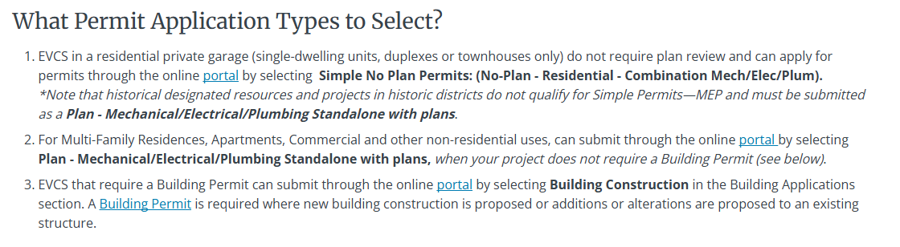
Figure S4. Section of San Diego, CA's permitting document on how to obtain a permit for electric vehicle charging systems. This section outlines which permit application types to select in the online submission portal according to site type.
Although San Diego performed well in other categories, it did not meet the criteria for the “Communication and Support” category. The webpage lacks clear contact information or guidance on how to reach relevant city officials for inquiries or updates regarding permit applications.

References
1. San Diego Development Services. How to Obtain a Permit for Electric Vehicle Charging Systems. https://www.sandiego.gov/sites/default/files/dsdib187.pdf (2025).
2. Weichsel, J. EV CHARGER PERMIT REQUIREMENTS. https://cms9files.revize.com/southingtonct/EV%20Charger%20Handout%2010.1.22.pdf (2022).

