Supporting Information
Plasmon Polarization Induced Multi-Field Coupling in Molybdenum-Oxide Based Heterojunctions to Efficiently Hydrolyze Ammonia Borane
Pengcheng Li^{ζ}, Nengrong Tu^{ζ}, Yang Yang*, Junxiang Li, Huilin Hou, Dongjiang Yang* and Weiyou Yang*
Institute of Micro/Nano Materials and Devices, Ningbo University of Technology, Ningbo City, 315211, P. R. China
^{ζ}Contribute equally to this work
*Corresponding Authors Emails: yangyangafterglow@yeah.net; d.yang@qdu.edu.cn; weiyouyang@tsinghua.org.cn

Contents
- Supplementary Figures, Corresponding Discussions.
- Supplementary References.

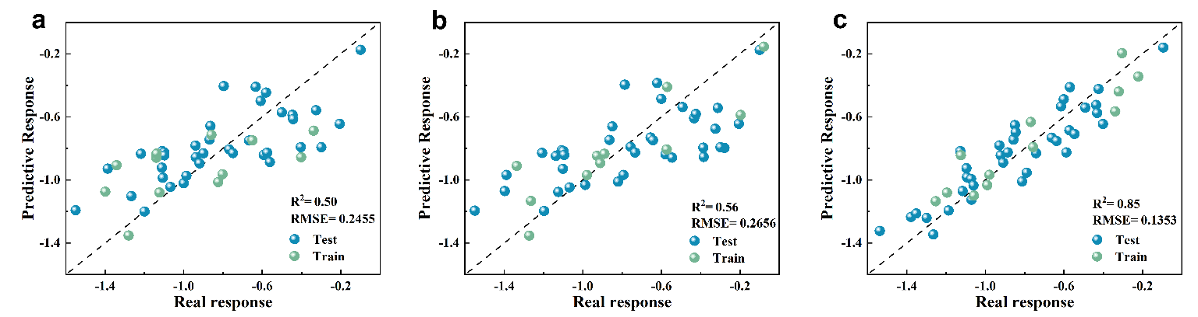
Supplementary Fig. 1 | Different algorithms based on machine learning. Root Mean Square Error (RMSE) and R² (coefficient of determination) for a Matern 5-2 GPR, b Second rational GPR and c Average index GPR.

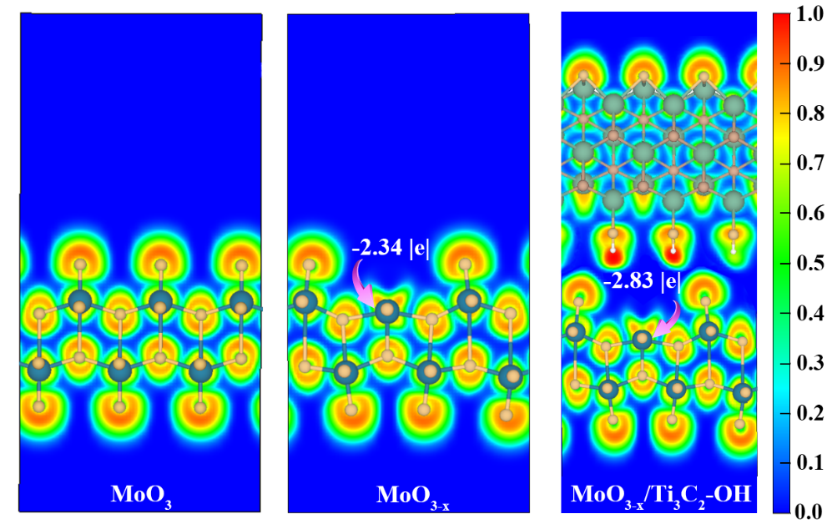
Supplementary Fig. 2 | The electrons spatial distribution and charge density analysis. ELF distribution map and Bader charge of MoO₃, MoO_{3-x} and MoO_{3-x}/Ti₃C₂-OH.
Theoretical calculations show that the elevated carrier concentration drives the formation of an electron delocalization network on the catalyst surface by lowering the electron localization barriers, that is intuitively verified by the electron localization function (ELF) analysis. More importantly, Bader charge results also confirm that this complex electronic effect induces a dual facilitation mechanism: optimization of Lewis acidity at the active site through local charge enrichment on the one hand, and enhancement of the dynamic regulation of reactant adsorption through the delocalization electron cloud on the other.

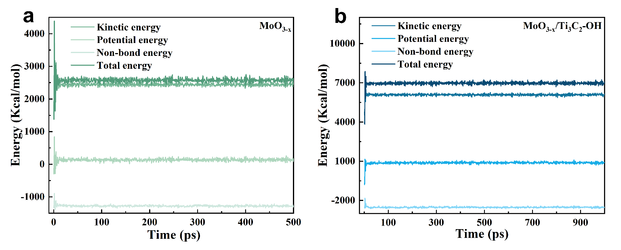
Supplementary Fig. 3 | Monitoring of the equilibrium state of the system. Plots of different energies over time in a MoO_{3-x} and b MoO_{3-x}/Ti₃C₂-OH systems.

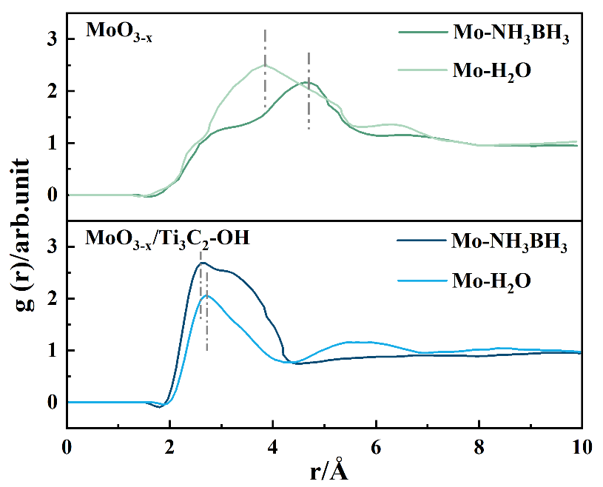
Supplementary Fig. 4 | Orderliness analysis of the solution structure. RDF curves of NH₃BH₃ and H₂O interactions with MoO_{3-x} and MoO_{3-x}/Ti₃C₂-OH.
The radial distribution function (RDF) after the reaction solution has reached stability indicates that a water crust is preferentially formed on the surface of MoO_{3-x}, occupying the active sites on the surface of the catalyst. The NH₃BH₃ curve around the active sites on the surface of MoO_{3-x}/Ti₃C₂-OH exhibits a stronger peak (gr= 2.88) at 2.52 Å, and corresponding water curve shows a weaker peak (gr= 2.08) at 2.68 Å. This suggests that the higher concentration of AB around MoO_{3-x}/Ti₃C₂-OH blocks the adsorption of H₂O, resulting in the aggregation of H₂O in the second shell layer.

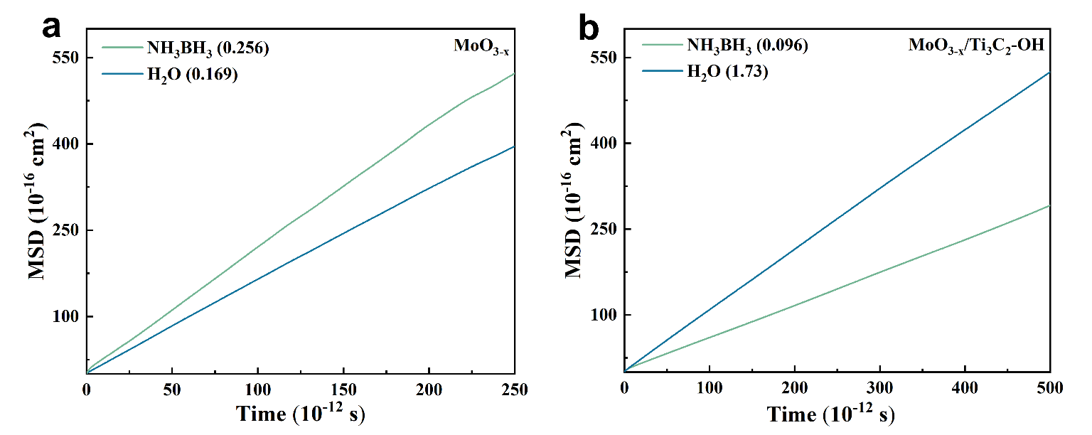
Supplementary Fig. 5 | Analysis of Molecular Diffusion Capacity. The mean square displacement (MSD) of NH₃BH₃ and H₂O in a MoO_{3-x} and b MoO_{3-x}/Ti₃C₂-OH.
The differences in molecular diffusion behaviors in the two systems are further revealed by mean-square displacement (MSD) analysis and quantitative comparison of diffusion coefficients. The lower diffusion coefficients of NH₃BH₃ in MoO_{3-x} compared with H₂O indicates that the strong adsorption of H₂O with the active sites weakens the free movement of H₂O molecules and creates a localized water enrichment effect. It means that NH₃BH₃ and H₂O are adsorbed on the surface of MoO_{3-x}, respectively, belonging to the Langmuir-Hinshelwood mechanism (Supplementary Fig. 5a). In the MoO_{3-x}/Ti₃C₂-OH system, the slope of the MSD curve for NH₃BH₃ is significantly lower than that of H₂O, indicating that the diffusion of NH₃BH₃ around the active site is inhibited due to the strong adsorption of AB on the substrate, which is consistent with the conclusion of the RDF results. This difference in dynamic behavior demonstrates that M^{δ+} active sites on the MoO_{3-x}/Ti₃C₂-OH surface are synergistically regulated by steric hindrance and hydrophobic effects, limiting the proximity of water molecules while facilitating the targeted adsorption of AB to the reconstructed Mo^{δ+} active site, attributed to the Eley-Rideal mechanism (Supplementary Fig. 5b).
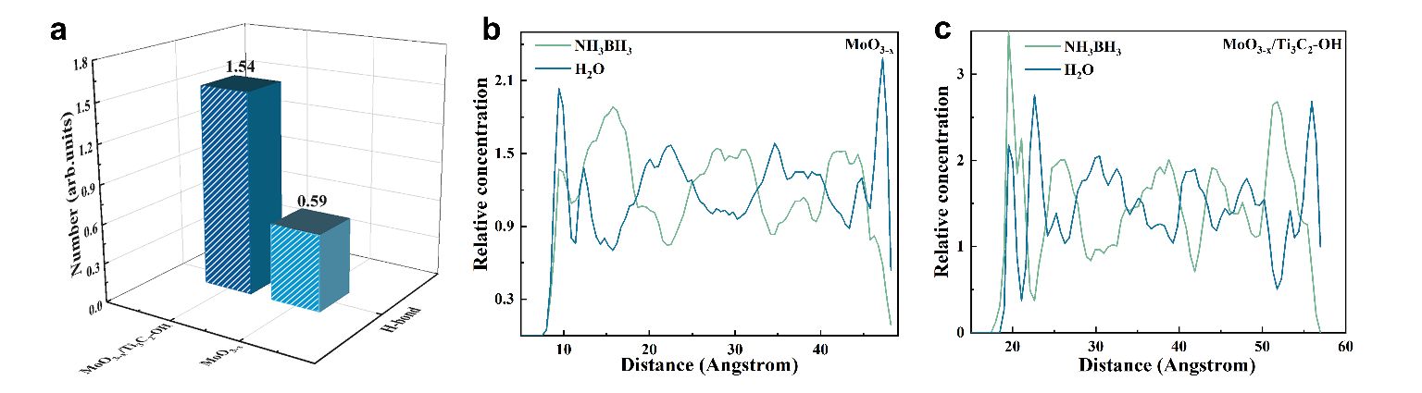
Supplementary Fig. 6 | Intermolecular interactions and spatial distribution structure. a Average number of hydrogen bonds per- interfacial water molecule and for different models. Concentration distribution of NH₃BH₃ and H₂O along the Z-axis in b MoO_{3-x} and c MoO_{3-x}/Ti₃C₂-OH systems.
The hydrogen bonding network statistics and z-axis distribution curves exhibit that the adsorbed configuration of AB is strongly immobilized and the disordered oscillations of the molecule are reduced.

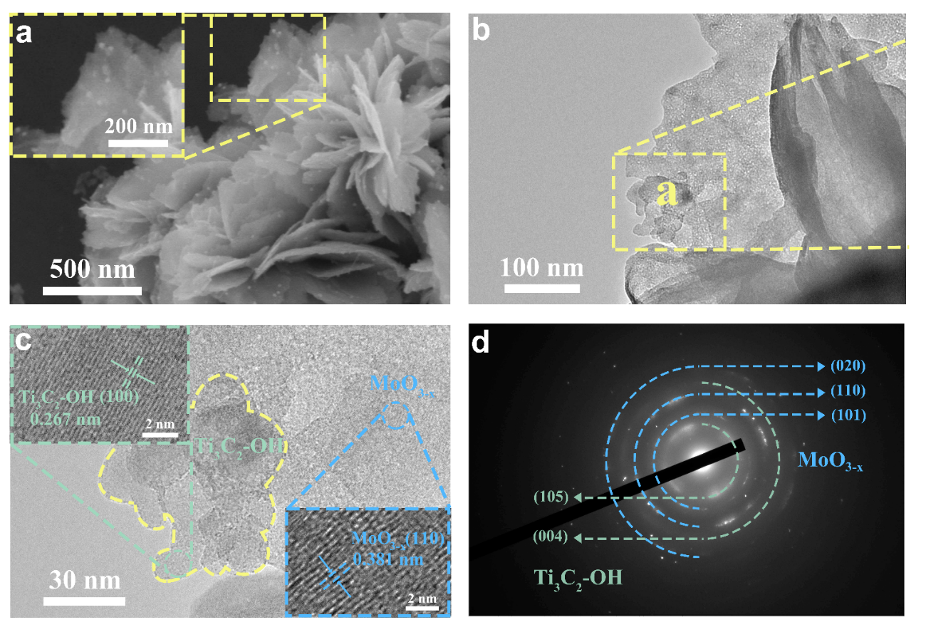
Supplementary Fig. 7 | Morphological and structural characterization. a SEM and b TEM images of as-obtained MoO_{3-x}/Ti₃C₂-OH sample. c HRTEM images of MoO_{3-x}/Ti₃C₂-OH recorded from the marked area in a. d SAED pattern of MoO_{3-x}/Ti₃C₂-OH recorded from the marked area in a.
Specifically, the synthesis and morphological structure of the MoO_{3-x}/Ti₃C₂-OH heterojunction are discussed. A simple synthesis route is implied to synthesize the heterostructure, Ti₃C₂-OH obtained by hydrothermal reaction in weak ammonia solution are subsequently adsorbed onto the surface of two-dimensional MoO_{3-x} nanosheets served as a support. Scanning electron microscope (SEM) and transmission electron microscopy (TEM) images of the MoO_{3-x}/Ti₃C₂-OH composite show that lots of 0D Ti₃C₂-OH are observed on a large piece of wrinkled ultrathin MoO_{3-x} nanosheets (Supplementary Fig. 7a, b). As shown in the high-resolution TEM (HRTEM) images, the supporters with a spacing of 0.381 nm are mainly composed by MoO_{3-x} as its characteristics (110) lattice fringes, and the modifiers with a spacing of 0.267 nm consist of Ti₃C₂-OH as its characteristics (100) lattice fringes. The lattice fringes of MoO_{3-x} and Ti₃C₂-OH are interwoven with each other, demonstrating the formation of the heterostructure with an intimate interface (Supplementary Fig. 7c). The coexistence of the two component crystalline phases is further evidenced by the selected area electron diffraction (SAED) pattern, here the diffraction rings point to the diffraction planes (110), (101) and (020) for MoO_{3-x}, as well as the (105) and (004) for Ti₃C₂-OH, respectively (Supplementary Fig. 7d).
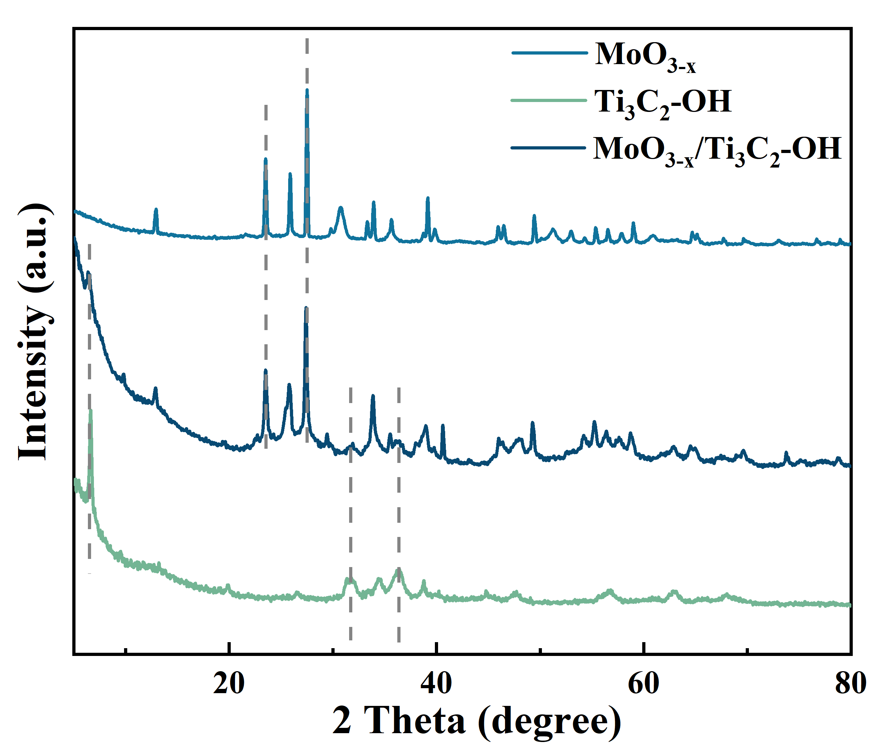
Supplementary Fig. 8 | XRD patterns of MoO_{3-x}, Ti₃C₂-OH and MoO_{3-x}/Ti₃C₂-OH samples.

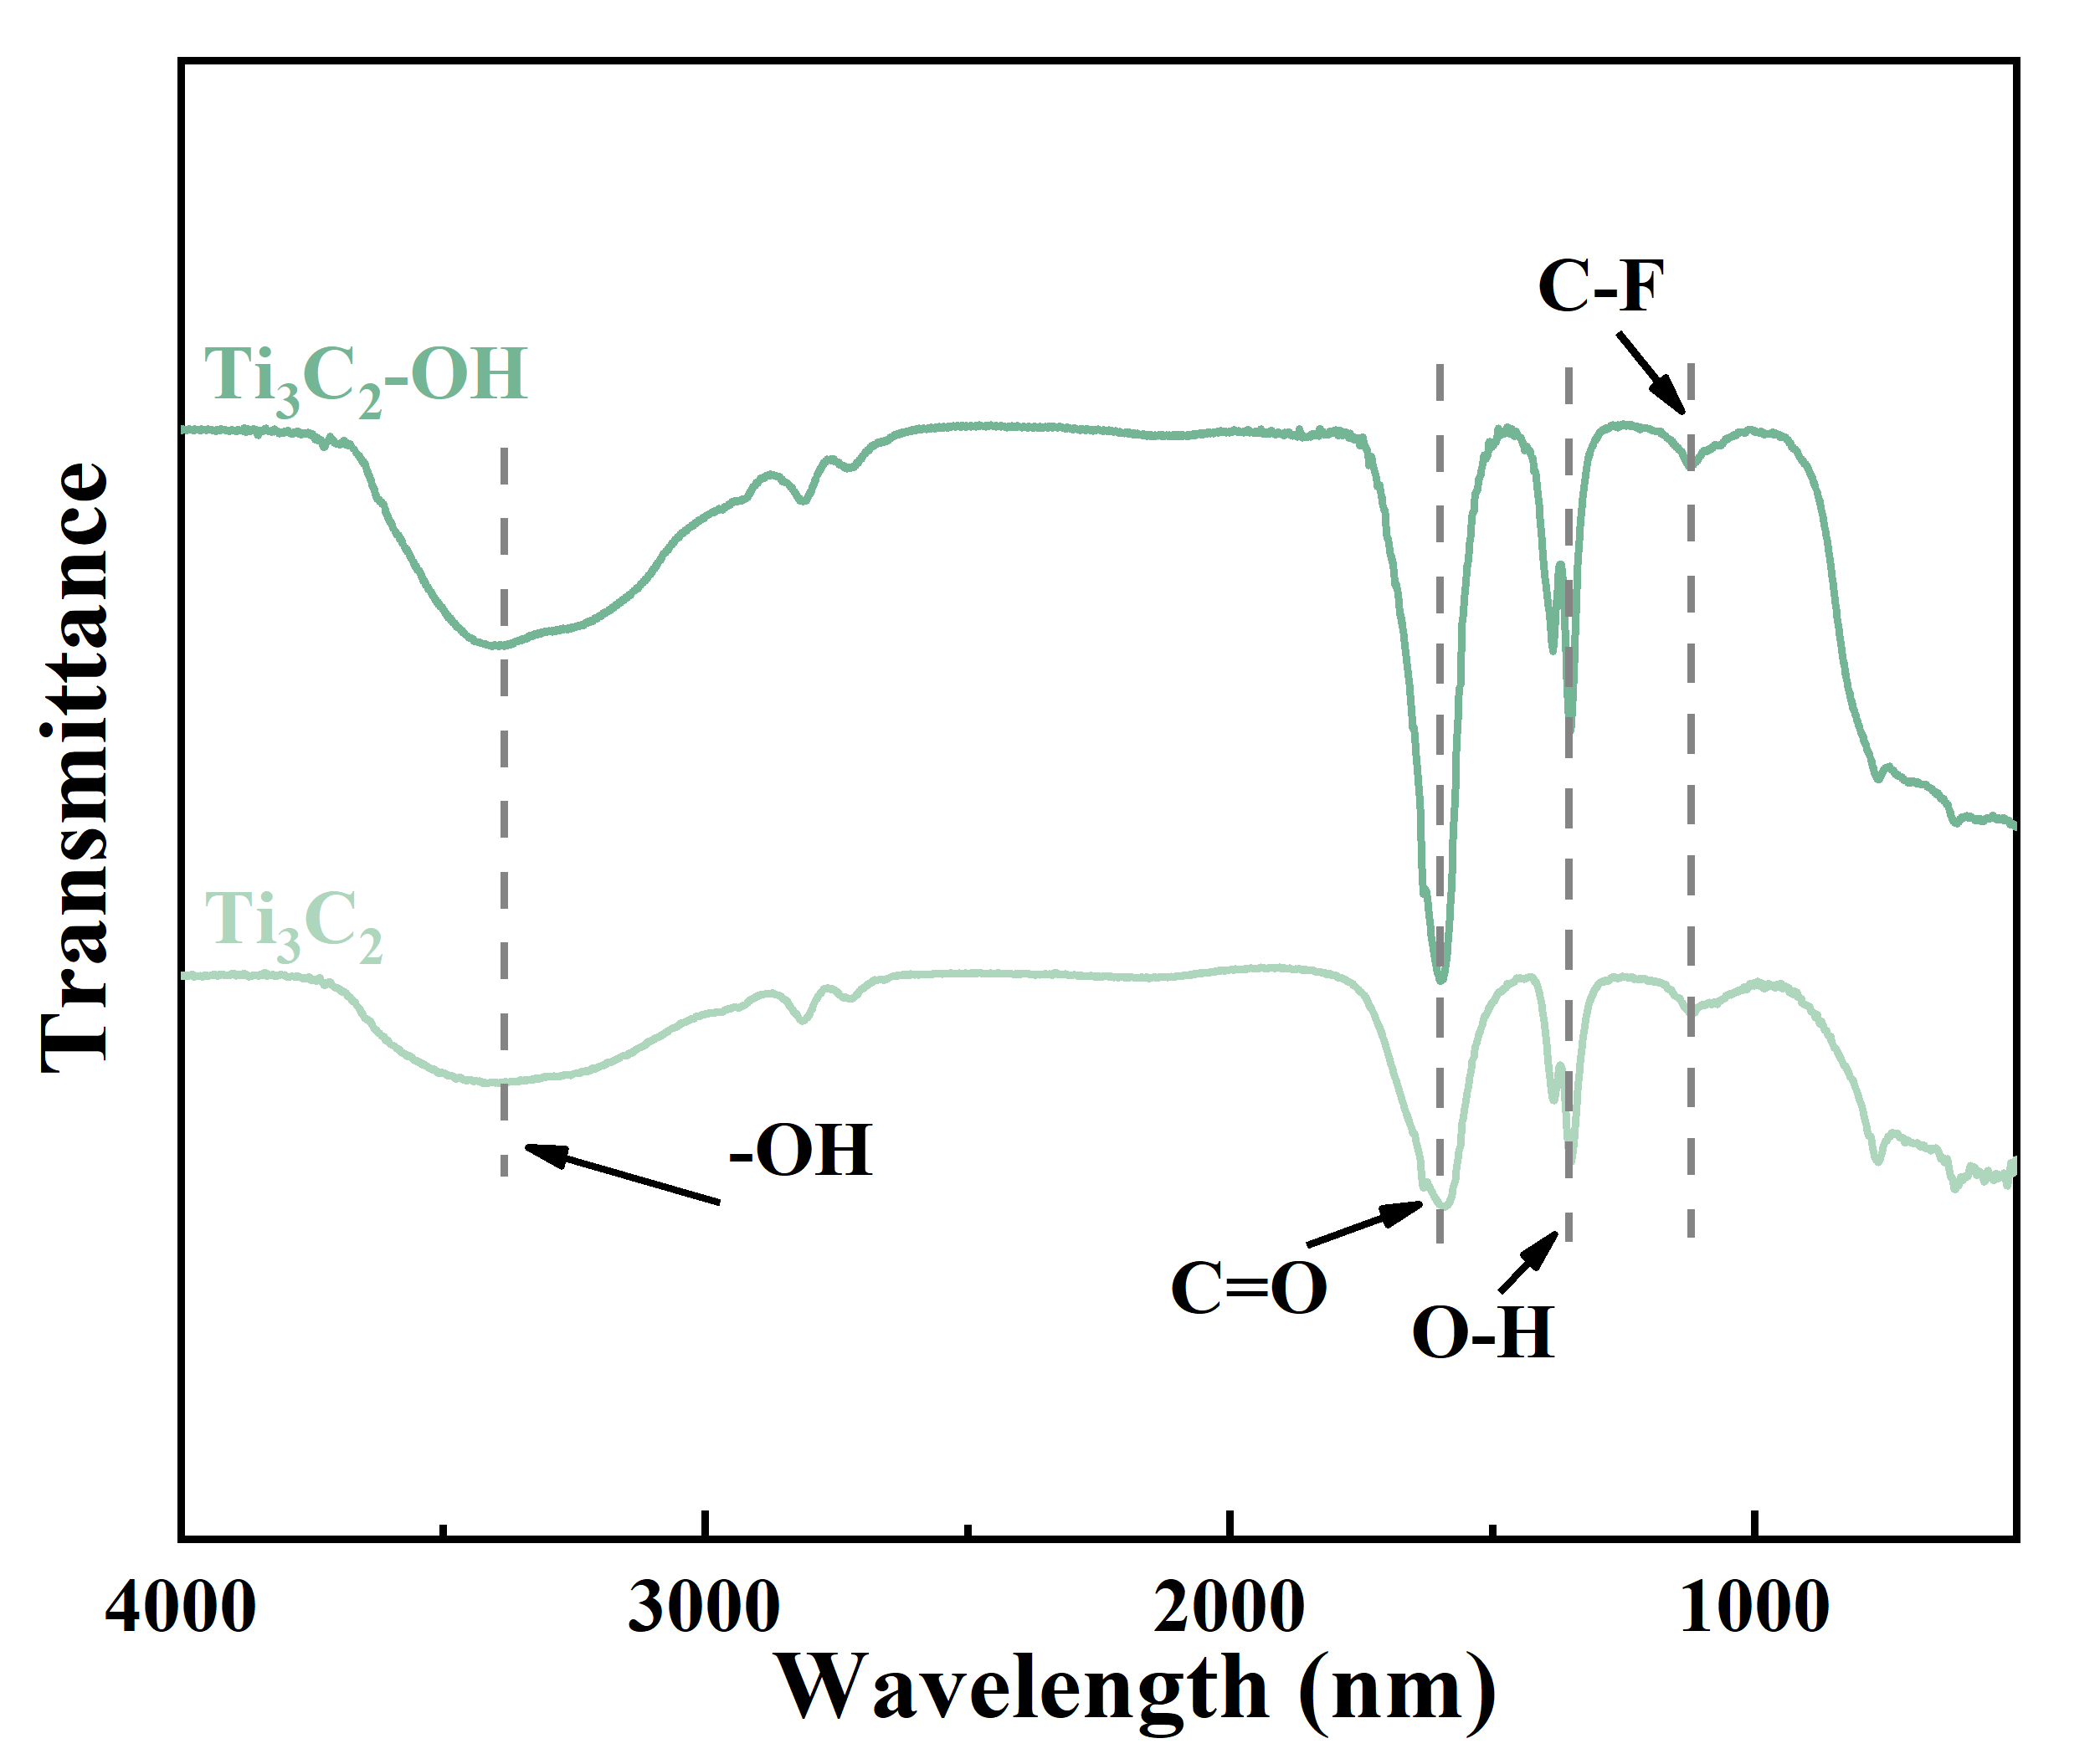
Supplementary Fig. 9 | FTIR spectra of Ti₃C₂ and Ti₃C₂-OH.
Under the thermal cutting effect of ammonia, the Ti₃C₂-OH with abundant -OH groups can be obtained by a facile hydrothermal reaction of precursor Ti₃C₂ nanosheets^{1,2}. Fourier transformed infrared (FTIR) spectra reveal the identical stretching vibrations at about 620, 1650, and 3420 cm⁻¹ in Ti₃C₂ nanosheets and Ti₃C₂-OH, corresponding to Ti-C, C=O, and -OH bonds deformation vibration, respectively. Significantly, the weakening of intensity ratio of C-F bond at 1100 cm⁻¹ to -OH bond at 1395 cm⁻¹ is observed in the Ti₃C₂-OH compared to Ti₃C₂^{3,4}. This result demonstrates that the -OH group can replace -F ones on the Ti₃C₂ surface in the ammonia solution.

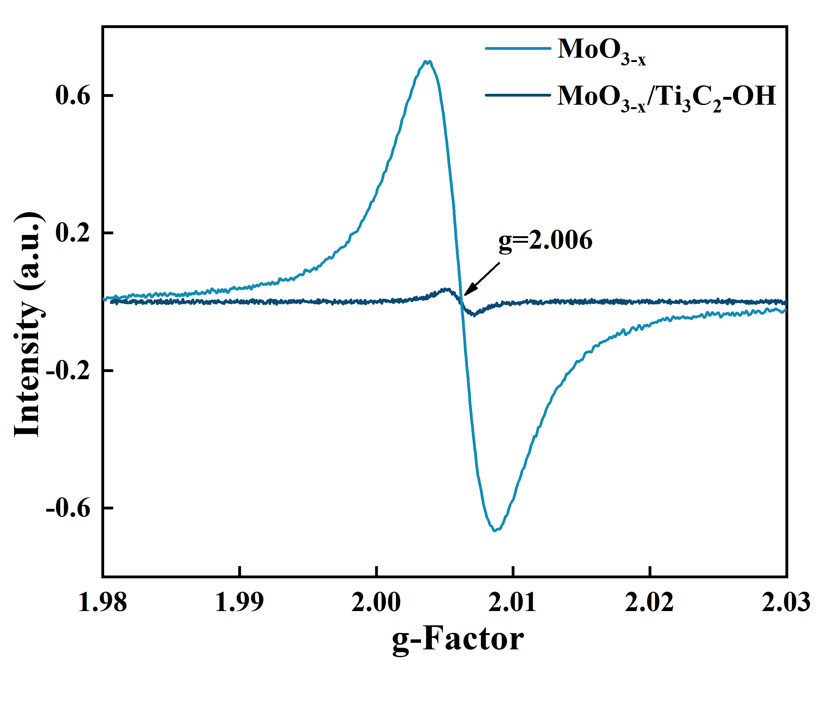
Supplementary Fig. 10 | EPR spectra of MoO_{3-x} and MoO_{3-x} /Ti₃C₂-OH.
MoO_{3-x} possess rich in a large number of oxygen defects illustrated through electron paramagnetic resonance (EPR) analysis. The significant reduction in oxygen vacancies observed in MoO_{3-x} when loaded with Ti₃C₂-OH is of particular interest.

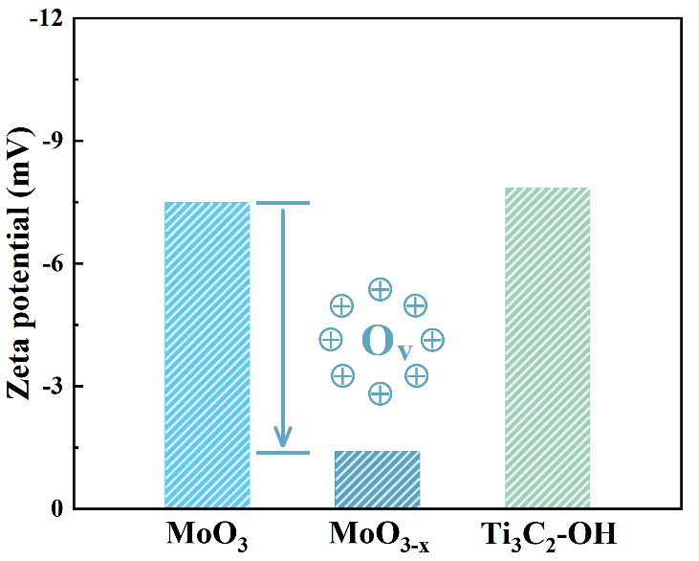
Supplementary Fig. 11 | Zeta potential distributions of MoO₃, MoO_{3-x} and Ti₃C₂-OH dispersions.
The Zeta potential of the prepared Ti₃C₂-OH nanosheets is -7.86 mV, which is attributed to the negatively charged -OH and -O at the end of the Ti₃C₂-OH surface. The zeta value of Mo^{δ+} in MoO_{3-x} shows a relatively positive potential compared to MoO₃, due to the presence of positively charged oxygen vacancies. The -F group on the surface of Ti₃C₂ are replaced by the -OH group under thermal cleavage of ammonia and the significant reduction in oxygen vacancies observed in positively charged MoO_{3-x} when loaded with hydroxyl-charged Ti₃C₂-OH is of particular interest (Supplementary Figs. 9-11).

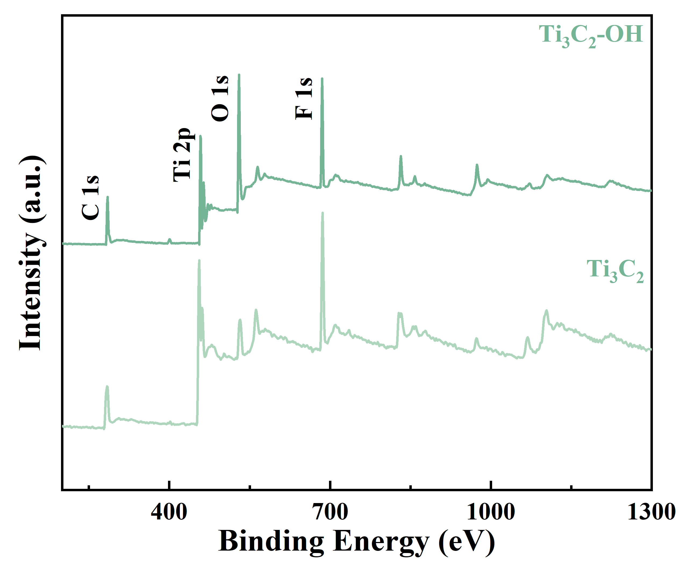
Supplementary Fig. 12 | XPS survey spectra of Ti₃C₂-OH and Ti₃C₂.
X-ray photoelectron spectroscopy (XPS) is employed to further illustrate the element composition of as-synthesized samples. The same elements peaks ascribed to Ti 2p, C 1s, O 1s and F 1s and the almost same surface functional bonds of Ti₃C₂ and Ti₃C₂-OH are observed in Supplementary Figs. 12, 13.

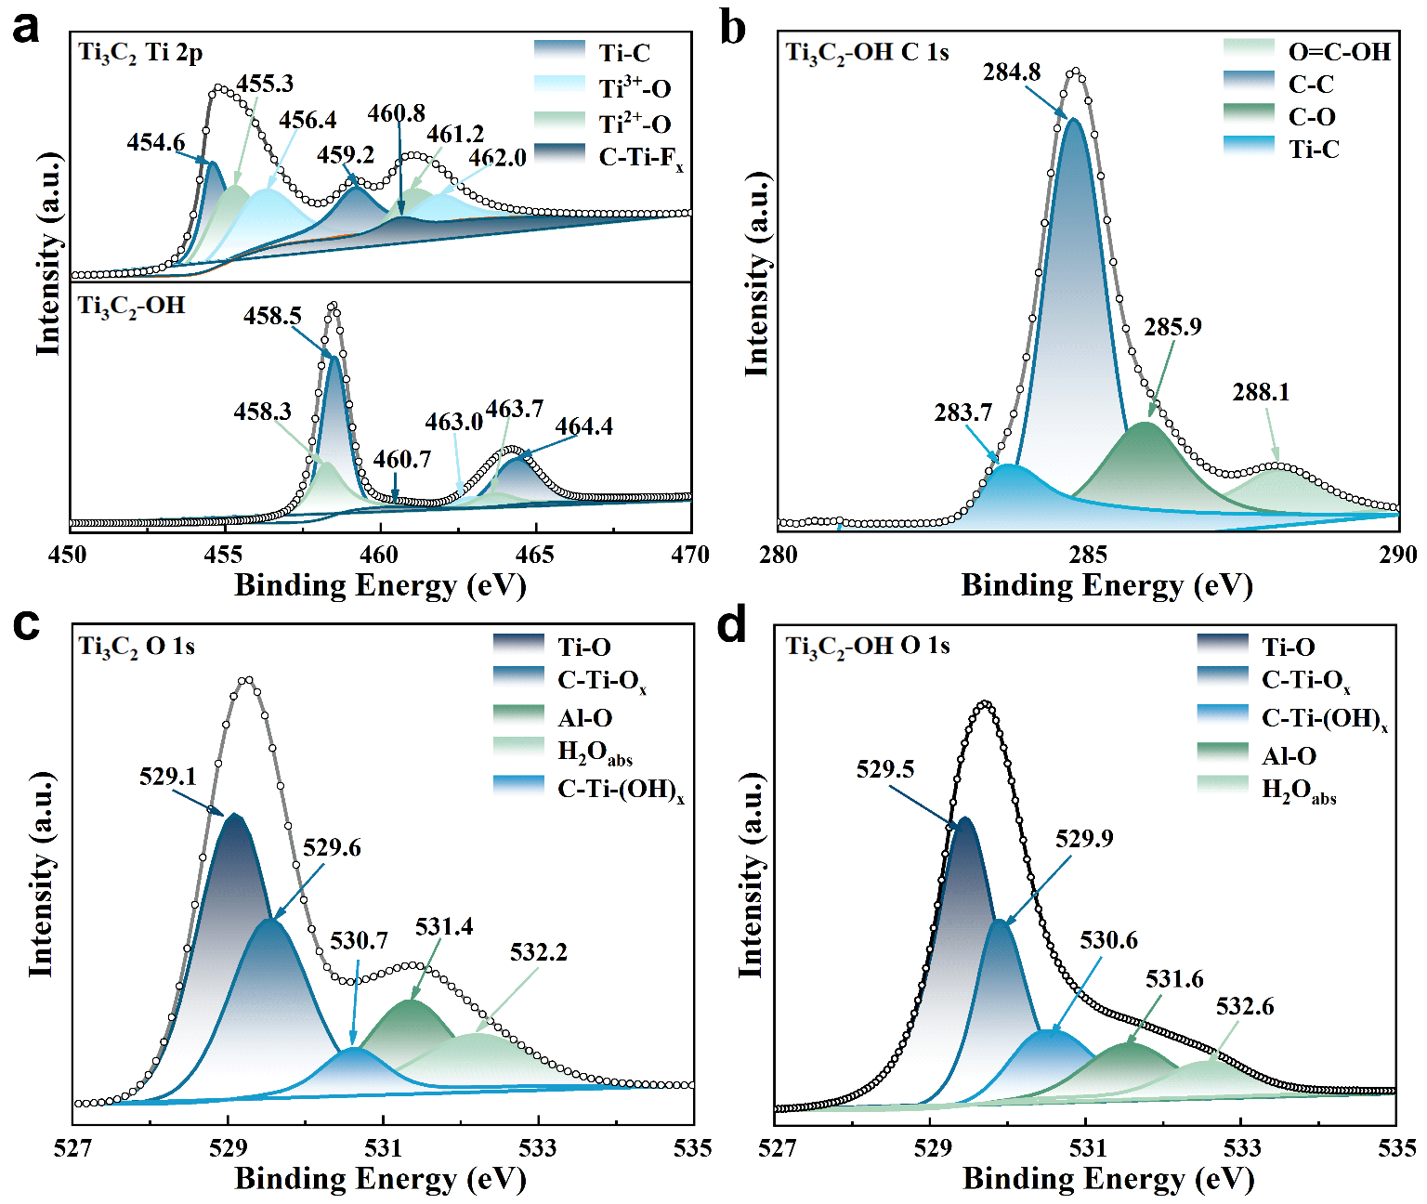
Supplementary Fig. 13 | XPS spectra of a Ti 2p of Ti₃C₂ and Ti₃C₂-OH, b C 1s of Ti₃C₂-OH, c-d O 1s of Ti₃C₂ and Ti₃C₂-OH.
As shown in Supplementary Fig. 13a, b, both exhibit Ti-C bonding in Ti₃C₂ and Ti₃C₂-OH, suggesting that the predominant configuration of Ti₃C₂ is maintained during the preparation of Ti₃C₂-OH. The XPS Ti 2p spectrum of Ti₃C₂-OH can be deconvoluted into Ti-C (2p_{3/2} at 458.5 eV and 2p_{1/2} at 464.4 eV), Ti²⁺-O (2p_{3/2} at 458.3 eV and 2p_{1/2} at 463.7 eV), Ti³⁺-O (2p₁ at 463.0 eV). The O 1s region for the Ti₃C₂ and Ti₃C₂-OH sample is fitted by components corresponding to Ti-O, C-Ti-O_{x}, C-Ti-(OH)_{x}, Al-O and H₂O_{ads}.
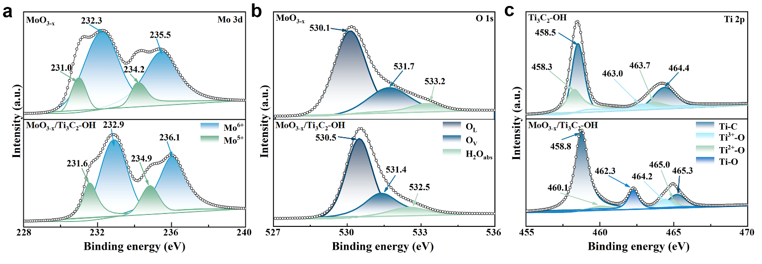
Supplementary Fig. 14 | XPS spectra of a Mo 3d, b O 1s and c Ti 2p of MoO_{3-x}, Ti₃C₂-OH and MoO_{3-x}/Ti₃C₂-OH.
As shown in Supplementary Fig. 14a, the Mo 3d spectrum of the MoO_{3-x} and MoO_{3-x}/Ti₃C₂-OH samples can be decomposed into four prominent peaks. Among these, two high-energy peaks are attributed to Mo⁶⁺, while the other two relatively weaker peaks correspond to the Mo⁵⁺ oxidation state caused by oxygen vacancies and unsaturated coordination. The core-level XPS spectra of the O 1s region exhibit a bifurcated profile, characterized by a predominant Mo-O lattice oxygen bonding (O_{L}) peak centered at ~530.3 eV and an accompanying shoulder feature (Supplementary Fig. 14b). This shoulder is attributed to a convolution of oxygen vacancy (O_{v}) defects and surface H₂O groups (H₂O_{ads}), the latter being a consequence of water molecule adsorption on the surface of the as-synthesized samples. Clearly seen that the -OH functional groups adsorb near the oxygen vacancies after complexation of Ti₃C₂-OH and MoO_{3-x}, resulting in an increase in Mo-O bonds as well as a decrease in oxygen vacancies, in agreement with the EPR results.
In addition, the Mo 3d peak of MoO_{3-x} /Ti₃C₂-OH shows a positive shift (≈0.6 eV, Supplementary Fig. 14a) compared to pure MoO_{3-x}, while the Ti 2p peak (≈0.3 eV, Supplementary Fig. 14c) shows a negative shift compared to Ti₃C₂-OH. Here, the F peak is significantly reduced and the C-Ti-(OH)_{x} peak is increased in Ti₃C₂-OH, confirming the desirable replacement of the -F group by the -O and -OH. The electron migration from MoO_{3-x} to Ti₃C₂-OH effectively promotes the separation of electron-hole pairs. This interfacial charge transfer directly affects the charge density and oxidation state of Mo^{δ+} sites, and reconstructs their electronic environment.
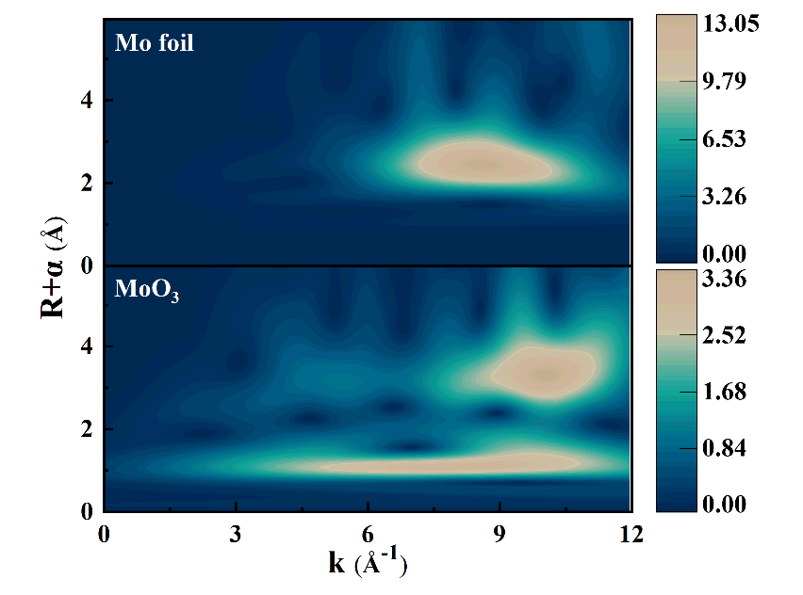
Supplementary Fig. 15 | WT k³-weighted χ(k)-function of the EXAFS spectra of Mo foil and MoO₃.

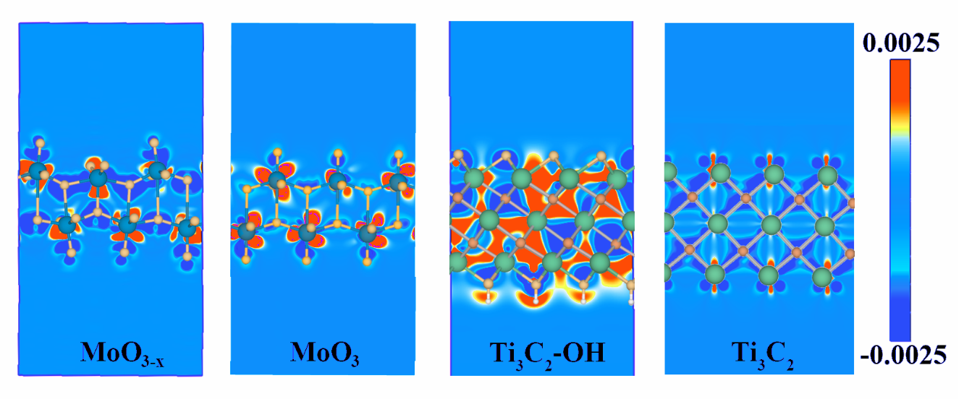
Supplementary Fig. 16 | 2D cross sectional view of differential charge density of MoO_{3-x}, Ti₃C₂-OH, MoO₃ and Ti₃C₂.
Red indicates electron accumulation and blue indicates electron depletion, respectively. The presence of oxygen vacancies and hydroxyl groups in Ti₃C₂-OH and MoO_{3-x} is seen to lead to localized breaking of the lattice symmetry compared to the internally symmetric MoO₃ and Ti₃C₂. Due to the different electronic properties (electron affinity and ionization energy and electronegativity) of the contact surfaces of the two subjects, the defects and functional groups lead to a local redistribution of charge at the MoO_{3-x}/Ti₃C₂-OH contact interface, forming an interfacial dipole layer and generating a strong interfacial electric field.

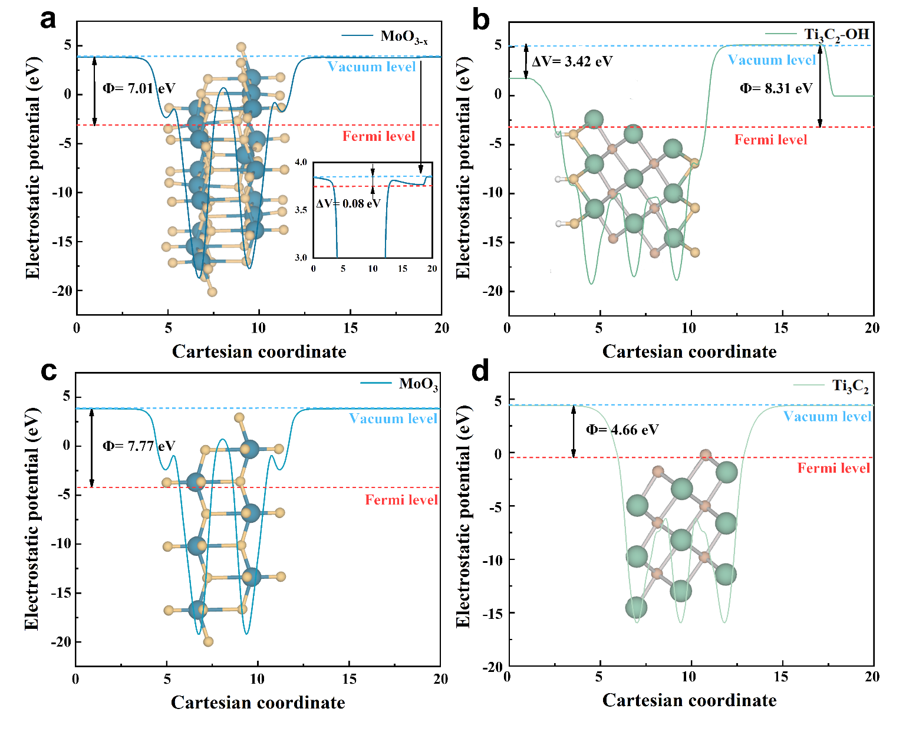
Supplementary Fig. 17 | Escape and transfer of electrons within the material. Average electrostatic potential distribution (V) of a MoO_{3-x}, b Ti₃C₂-OH, c MoO₃, d Ti₃C₂ along the out-of-plane direction.
The polarization-treated samples Ti₃C₂-OH and MoO_{3-x} (Supplementary Fig. 17a, b) both reveal asymmetric electrostatic potential distributions compared to Ti₃C₂ and MoO₃ (Supplementary Fig. 17c, d), where the hydroxyl surfaces and the oxygen-deficient surfaces show a lower vacuum. This leads to spontaneous polarization from the hydroxyl to the oxygen base layer and from the defective to the defect-free layer at the terminals of the two separate material surfaces, respectively.
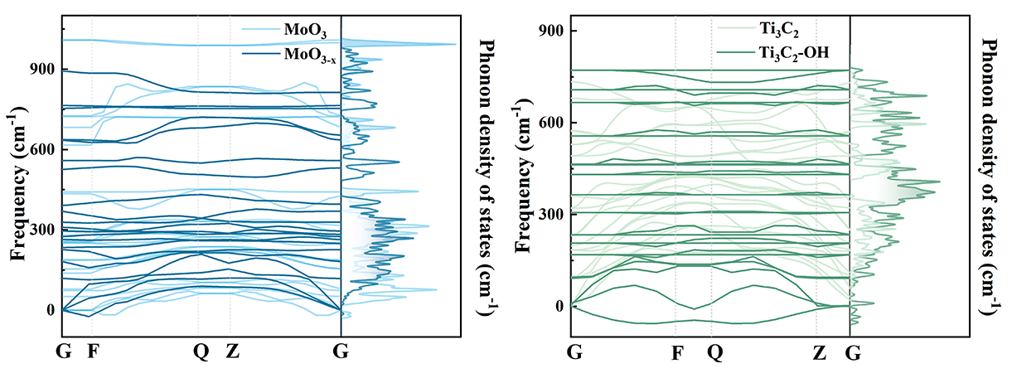
Supplementary Fig. 18 | The distribution of lattice vibration quanta. Calculated the phonon dispersions and phonon density of states.
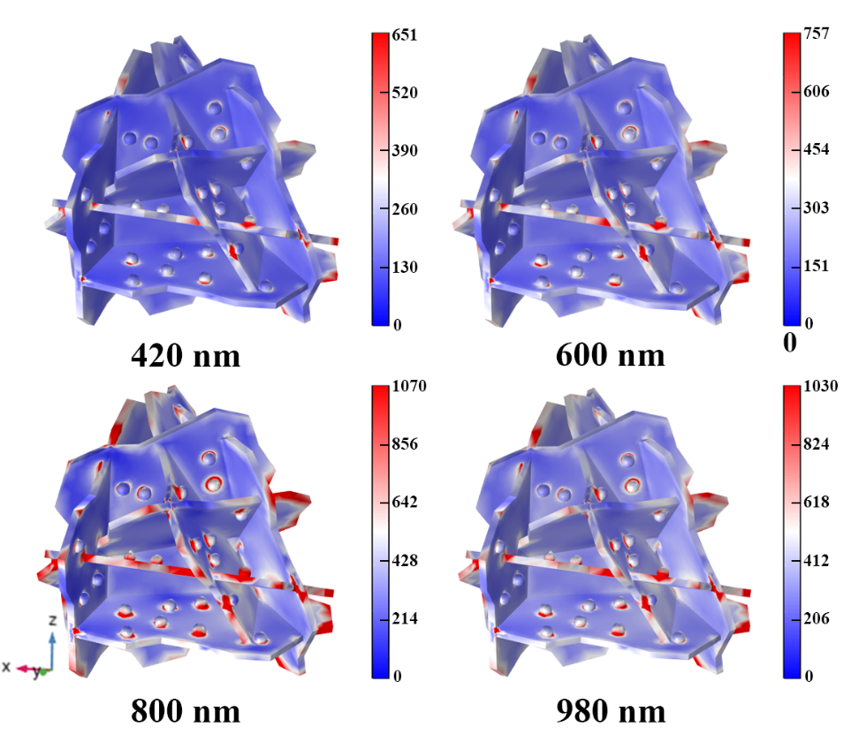
Supplementary Fig. 19 | COMSOL finite element method. Electric field distributions of MoO_{3-x}/Ti₃C₂-OH under 420 nm, 600 nm, 800nm and 980 nm excitation.
The sample model, placed in the X-Y plane, exhibits a significant local electromagnetic field enhancement under the excitation of the incident light (propagating along the Z direction and polarized by a voltage of 5V/m in the Y direction). Similar to the classical plasmonic metal-semiconductor system, the double plasmon can efficiently converge and amplify the incident light field, and the coupling-induced near-field effects are efficient at a distance of about 10 nm, which is great significant for the enhanced effects of 0D/2D high comparative area contact modes. In addition, 800 nm is identified as the irradiation source for driving the LSPR characteristics to probe the plasmon-induced photothermal effect.

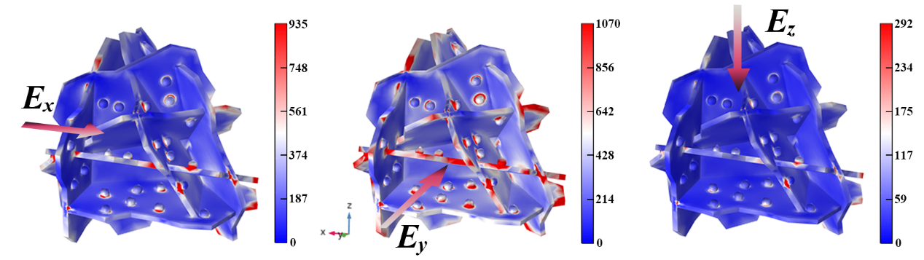
Supplementary Fig. 20 | COMSOL finite element method. Electric field distributions of MoO_{3-x}/Ti₃C₂-OH under different polarized directions at 800 nm.
Considering the plasmonic near-field resonance modes, the electric field intensity of the MoO_{3-x}/Ti₃C₂-OH model is compared under different polarized directions, revealing that the double plasmonic heterojunction system exhibits a strong near-field behavior oscillating along the polarized direction in the Y direction.
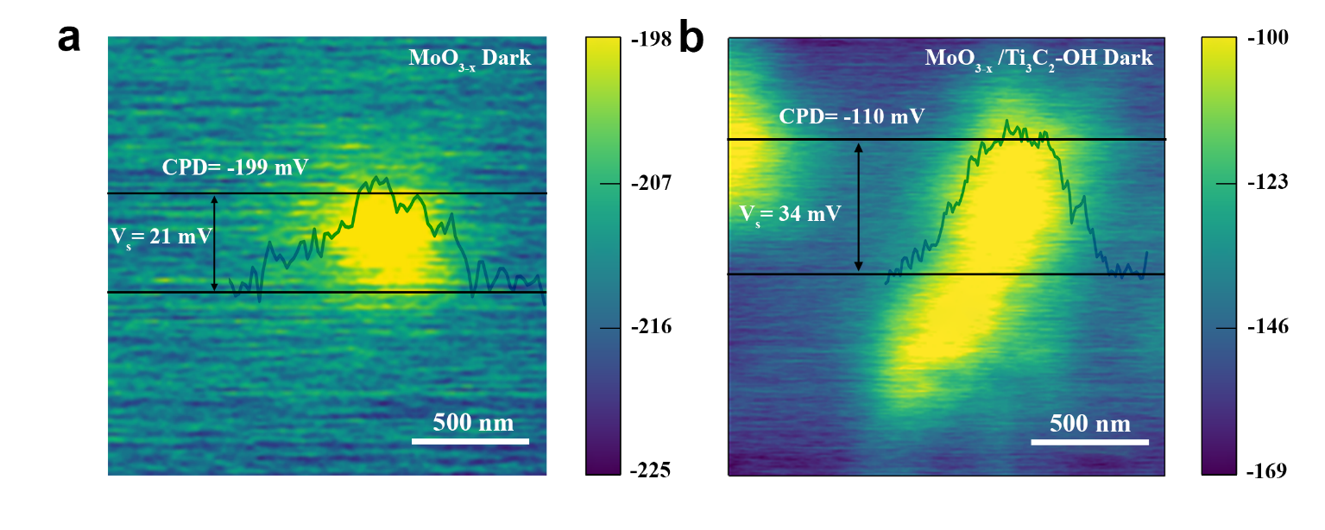
Supplementary Fig. 21 | KPFM measurement. Surface potentials of MoO_{3-x} and MoO_{3-x}/Ti₃C₂-OH under dark conditions.

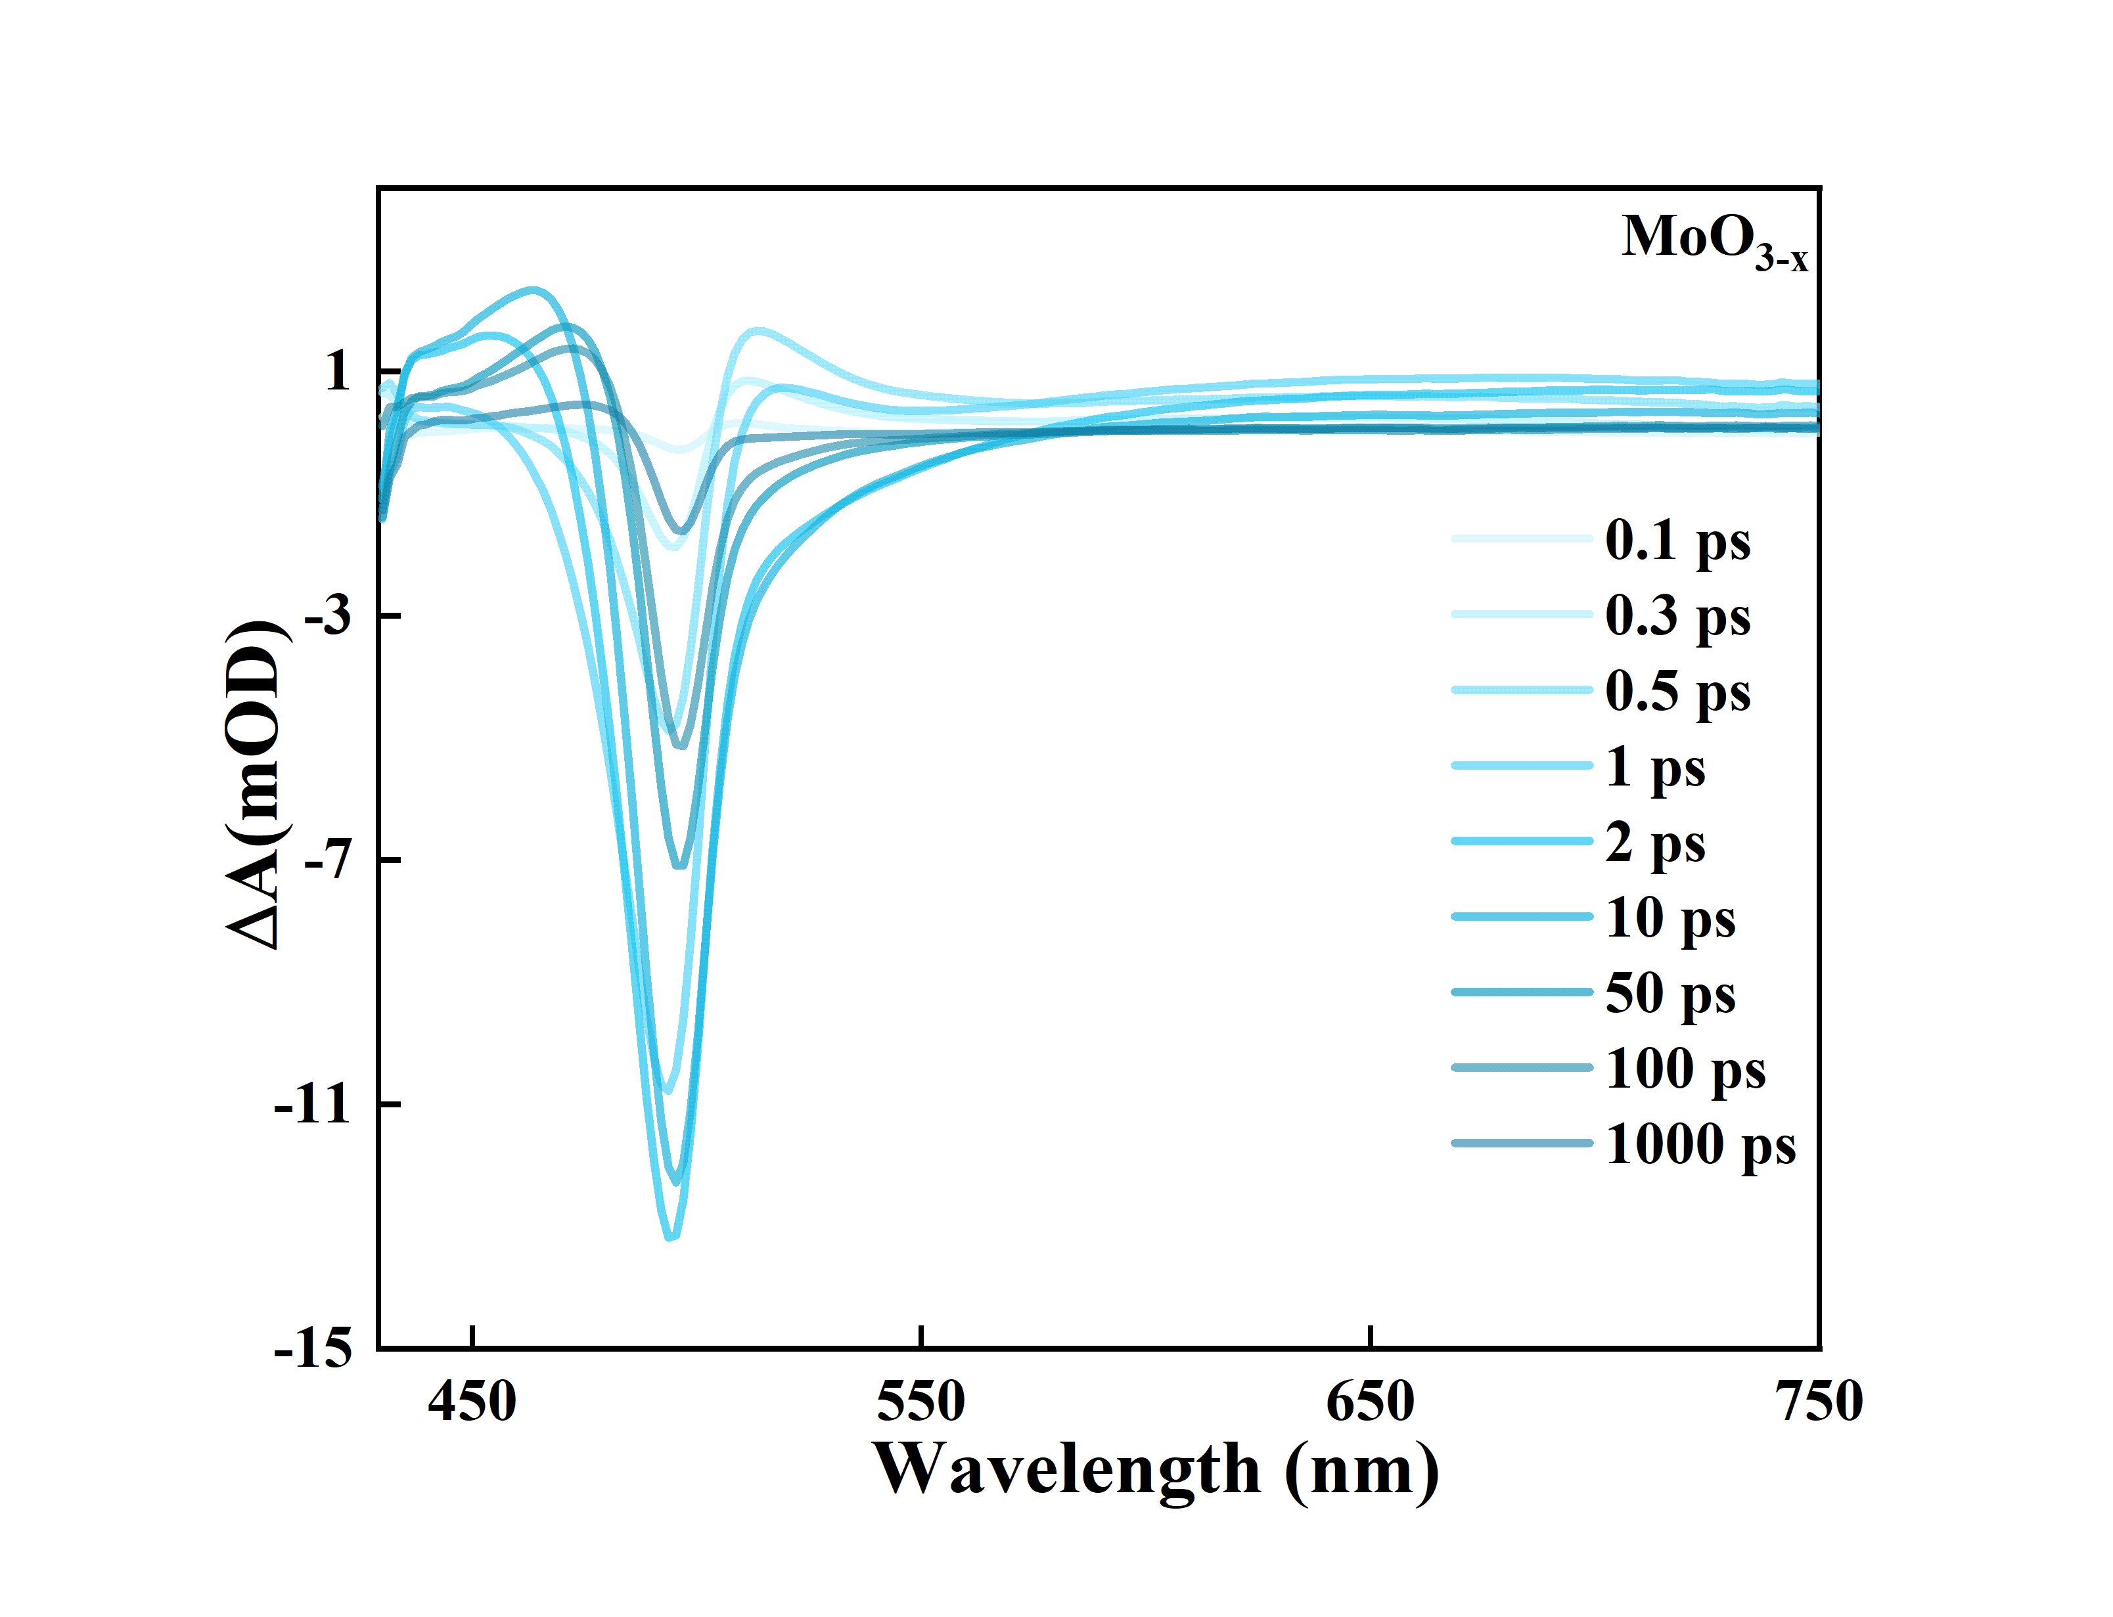
Supplementary Fig. 22 | Transient absorption characteristics. Representative spectra at different delay time for MoO_{3-x}.

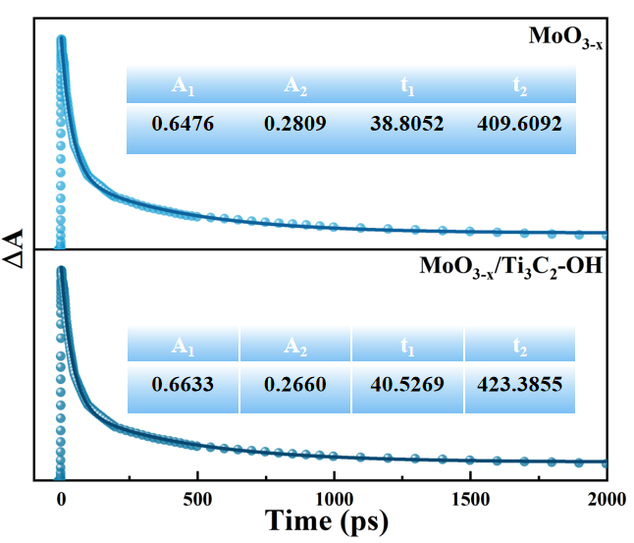
Supplementary Fig. 23 | Lifetime analysis. TA kinetics curves of MoO_{3-x} and MoO_{3-x}/Ti₃C₂-OH at with the probe wavelength at 494 nm.
Fitting the kinetic traces at the bleach center (494 nm), a biexponential decay curve can be obtained, corresponding to electron-phonon scattering (τ₁= 41 ps) and phonon-phonon scattering (τ₂= 423 ps) during the relaxation of plasmon-induced hot electrons, respectively. The hot electrons relax within a few picoseconds to vibrational modes via the electron-phonon coupling, and the longer τ₁ for the heterojunction compared to MoO_{3-x} implies a weakening of the electron-phonon coupling that favors the electron transport process. The longer time-scale decay arises from the phonon-phonon scattering of thermal charge carriers, which corresponds to the dissipation of thermal energy from the metal lattice to the surrounding medium, enhancing the reaction kinetics^{5,6}.

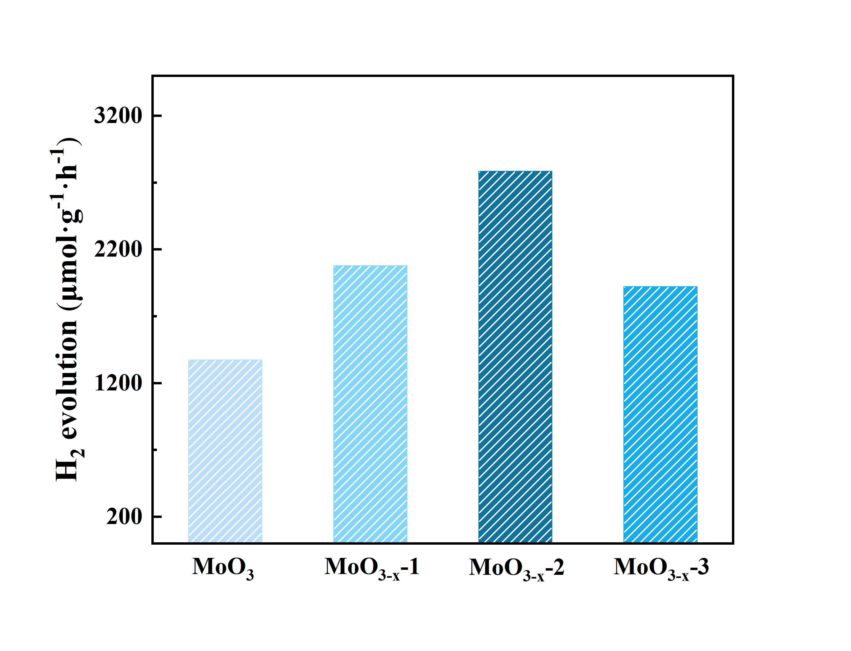
Supplementary Fig. 24 | AB hydrolysis performance. Hydrogen production of MoO_{3-x} at different oxygen defect concentrations (increasing oxygen defect concentrations from MoO_{3-x}-1 to MoO_{3-x}-3).

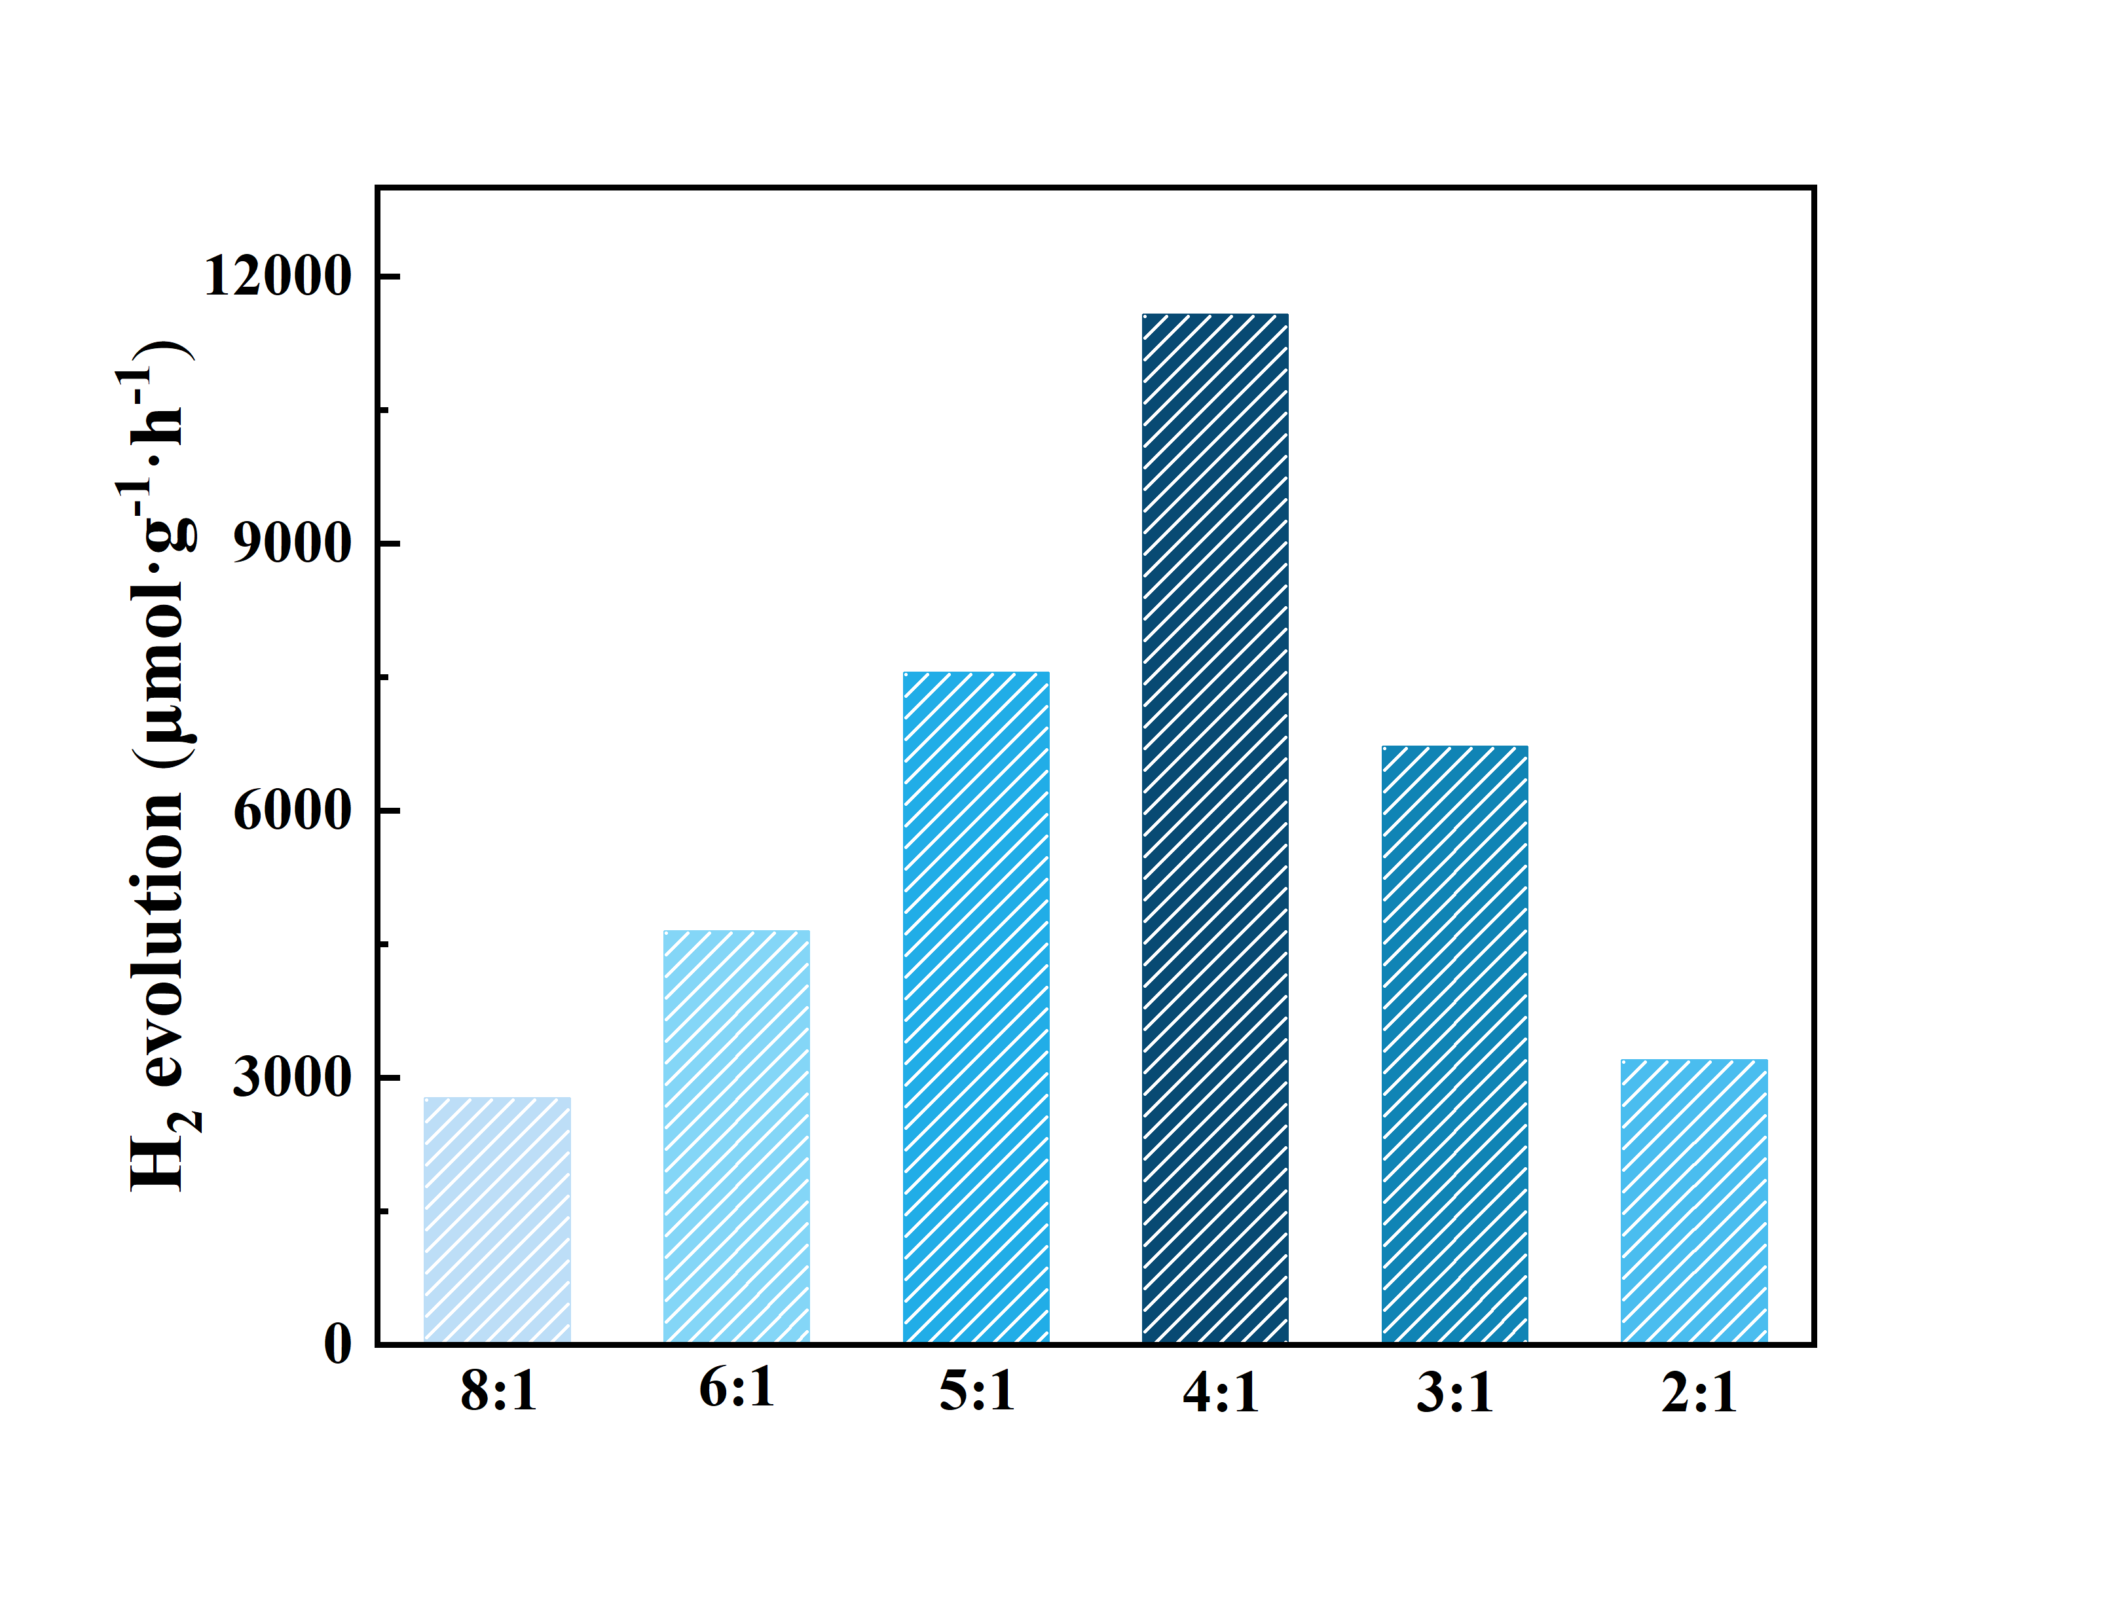
Supplementary Fig. 25 | AB hydrolysis performance. Hydrogen production of MoO_{3-x}/Ti₃C₂-OH with different proportions.

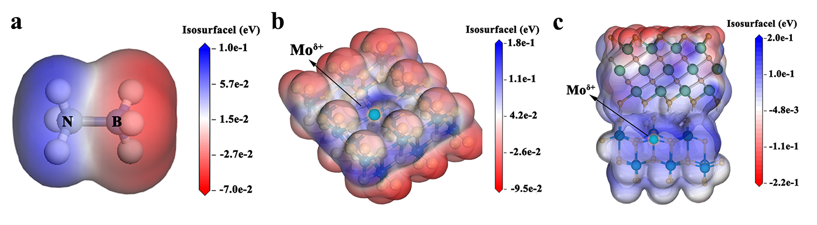
Supplementary Fig. 26 | Charge distribution of molecules. Electrostatic potential surface of a AB, b MoO_{3-x}, c MoO_{3-x}/Ti₃C₂-OH.
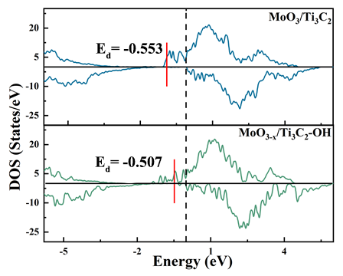
Supplementary Fig. 27 | D-band centers of MoO₃/Ti₃C₂ and MoO_{3-x}/Ti₃C₂-OH.

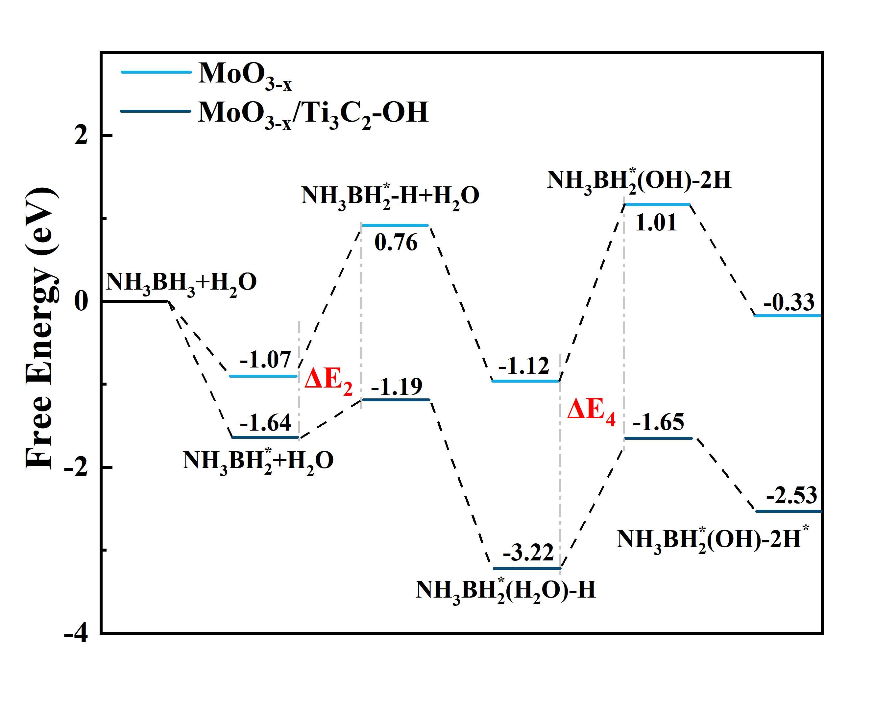
Supplementary Fig. 28 | The thermodynamic behavior of the reaction. Gibbs free energy of different intermediate states of MoO_{3-x} and MoO_{3-x}/Ti₃C₂-OH.
When the NH₃BH₃-H₂O system is adsorbed at the MoO_{3-x}/Ti₃C₂-OH interface, the energy required for B-H bond cleavage in NH₃BH₃ (ΔE₂= 0.45) is less than that in MoO_{3-x} (ΔE₂=1.83), and the energy required for O-H bond breaking in H₂O (ΔE₄ = 1.57) is less than that in MoO_{3-x} (ΔE₄ =2.13).

References
- Peng, Q. et al. Unique Lead Adsorption Behavior of Activated Hydroxyl Group in Two-Dimensional Titanium Carbide. J.Am.Chem.Soc. 136, 4113-4116 (2014).
- Li, H., Li, X., Liang, J. and Chen, Y. Hydrous RuO₂‐Decorated MXene Coordinating with Silver Nanowire Inks Enabling Fully Printed Micro‐Supercapacitors with Extraordinary Volumetric Performance. Adv. Energy Mater. 9, (2019).
- Wang, Z. et al. Highly stable lithium anodes from recycled hemp textile. Chem. Comm. 58, 1946-1949 (2022).
- Wang, X., Sun, G., Li, N. and Chen, P. Quantum dots derived from two-dimensional materials and their applications for catalysis and energy. Chem. Soc. Rev. 45, 2239-2262 (2016).
- Link, S. and El-Sayed, M. A. Optical Properties and Ultrafast Dynamics of Metallic Nanocrystals. Annu. Rev. Phys. Chem. 54, 331-366 (2003).
- Wang, J. et al. Strong vibrational coupling in room temperature plasmonic resonators. Nat. Commun. 10, (2019).

