Supplementary Figure Legends:
Fig. S1. Bioinformatics analysis of common differentially expressed genes (DEGs) under different Sb treatments.
Fig. S2. DEGs expression patterns of significantly enriched modules (p < 0.05).
Fig. S3. Enrichment analyses of DEGs in the significant correlation module (MM.pink, MM.blue, and MM.green modules).
Fig. S4. Metabolomic profiling under different Sb treatments.
Fig. S5. Nine-quadrant association analysis between DEGs and DAMs under different Sb treatments.
Fig. S6. Regulatory network analysis of isoquinoline alkaloid biosynthesis pathways.

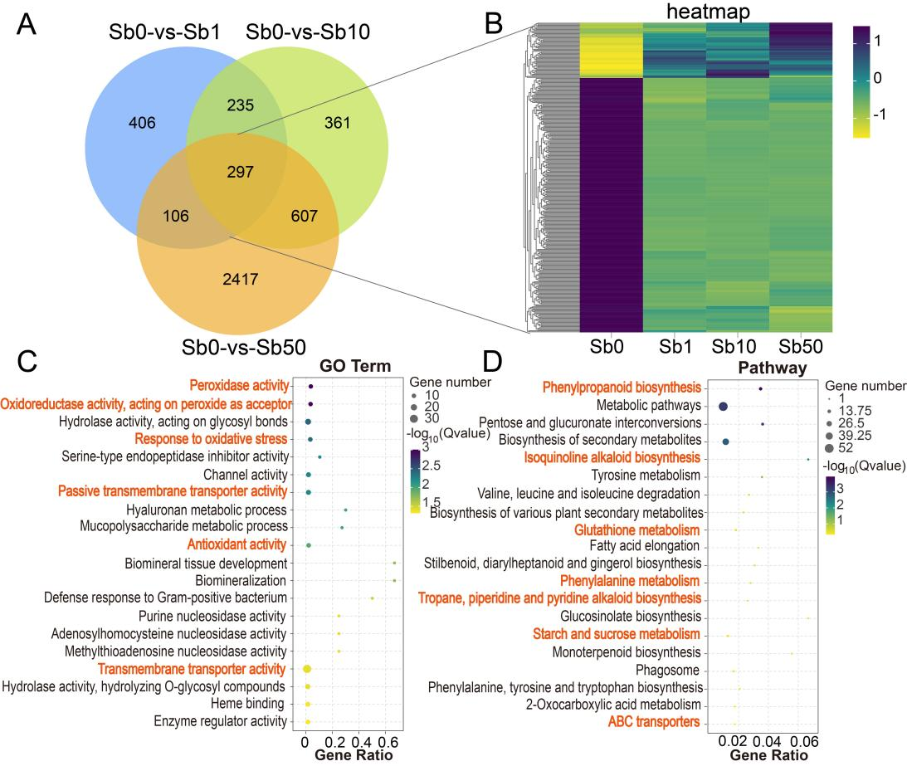
Figure S1. Bioinformatics analysis of common differentially expressed genes (DEGs) under different Sb treatments. A Venn diagram analysis. B Expression trend analysis of common DEGs. C GO enrichment analysis of common DEGs. D KEGG pathway enrichment analysis of common DEGs. Key GO terms and KEGG pathways are marked in orange font.

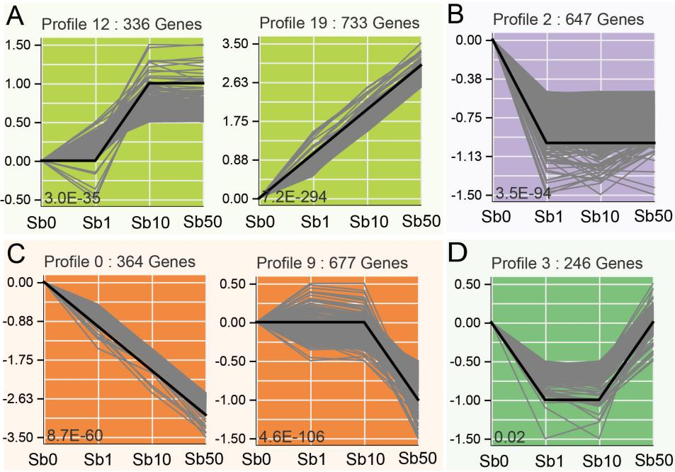
Figure S2. DEGs expression patterns of significantly enriched modules (p < 0.05). A bright green (Profile 12 and 19). B purple (Profile 2). C orange (Profile 0 and 9). D green (Profile 3). The gray lines represent the expression patterns of each DEG.

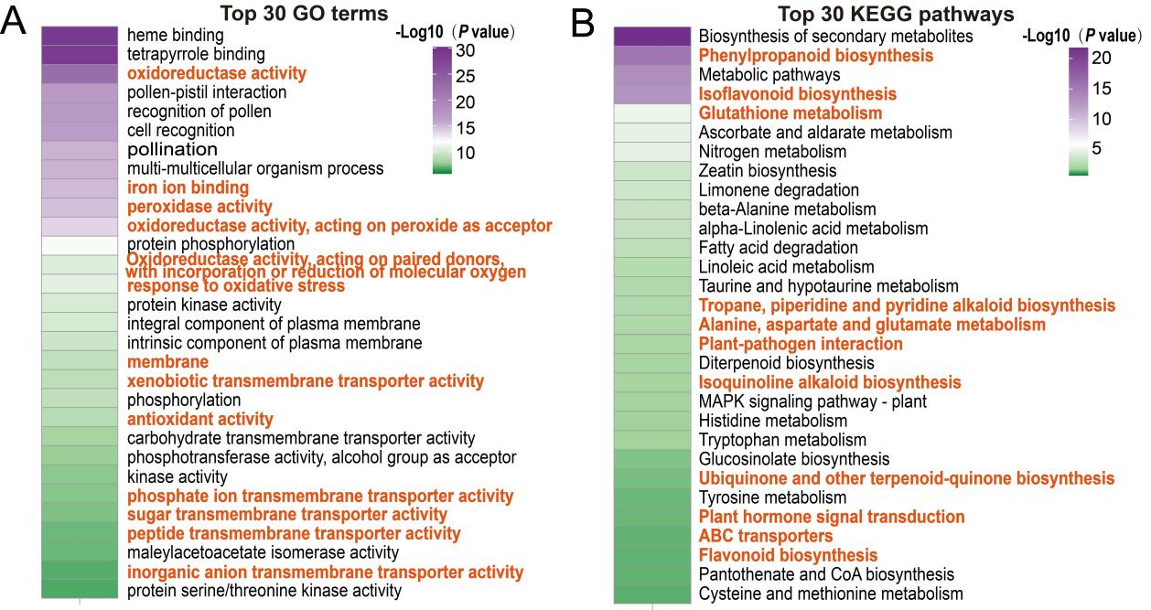
Figure S3. Enrichment analyses of DEGs in the significant correlation module (MM.pink, MM.blue, and MM.green modules). A GO enrichment analyses. B KEGG enrichment analyses. Key GO terms and KEGG pathways are marked in orange font.

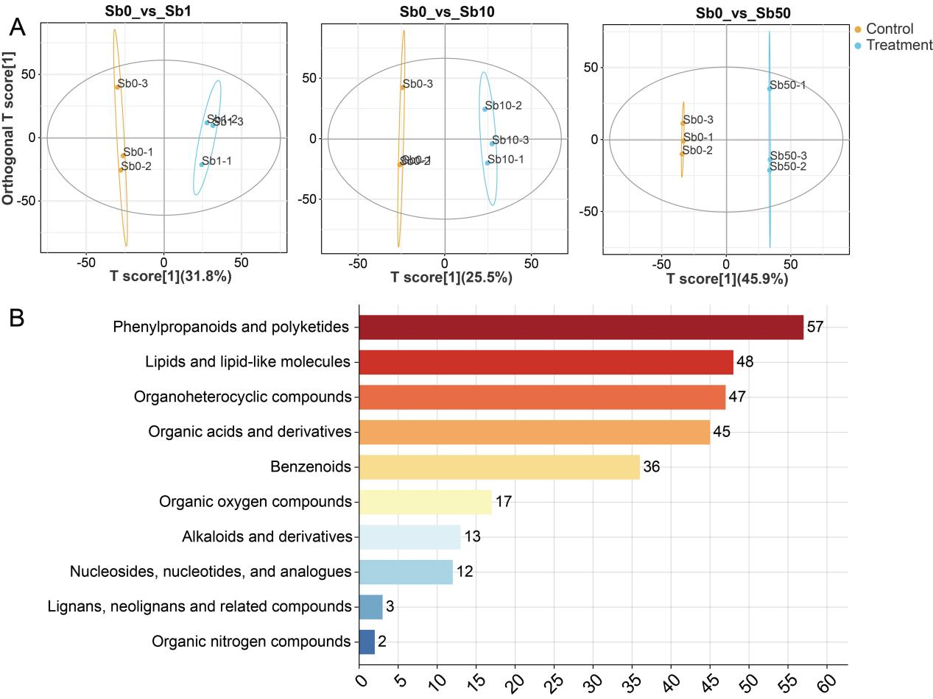
Figure S4. Metabolomic profiling under different Sb treatments. (A) OPLS-DA analysis; (B) Superclass classification of DAMs.

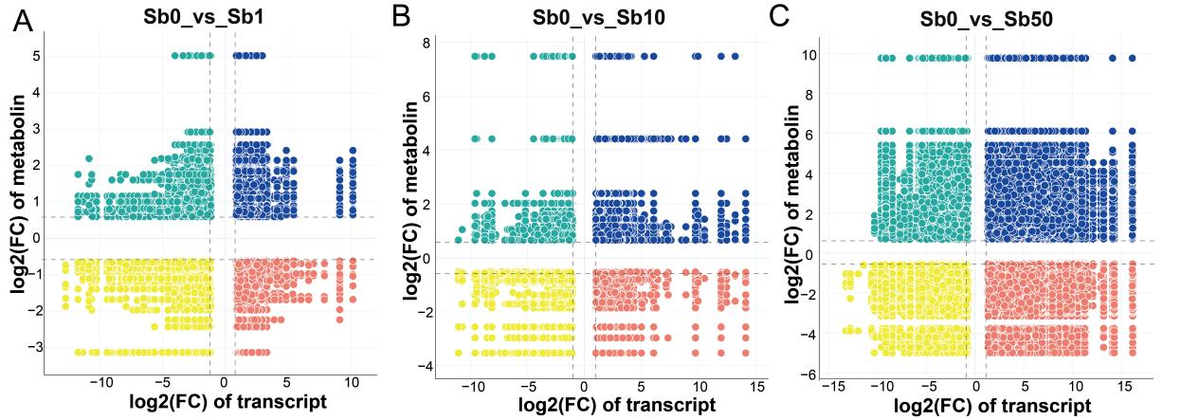
Figure S5. Nine-quadrant association analysis between DEGs and DAMs under Sb0_vs_Sb1 (A), Sb0_vs_Sb10 (B), Sb0_vs_Sb50 (C) comparisons.

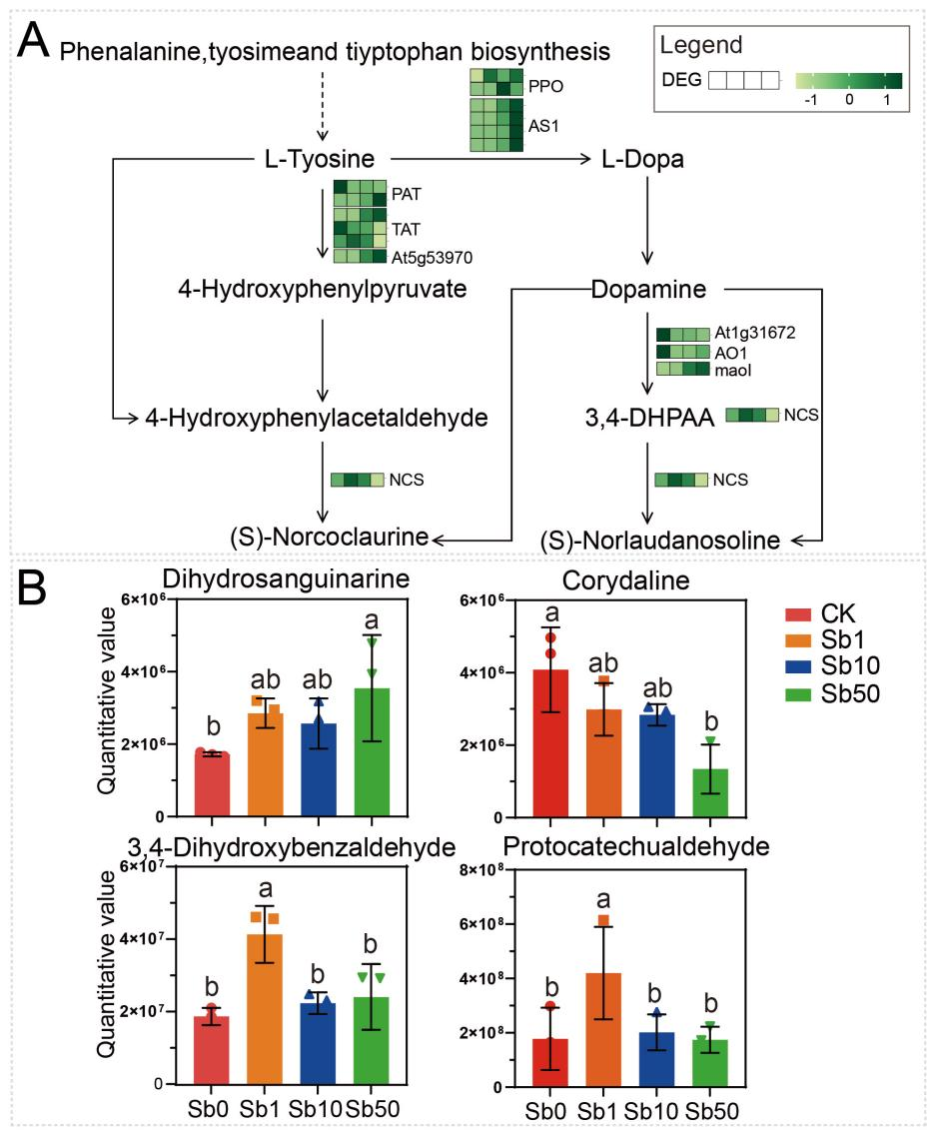
Fig. S6. Regulatory network analysis of isoquinoline alkaloid biosynthesis pathways. A DEGs distribution involved in isoquinoline alkaloid biosynthesis pathways following Sb exposure. Squares represent DEGs, with darker green indicating higher gene expression levels. Solid arrows and dashed arrows were used to indicate direct and indirect molecular interactions, respectively. KEGG pathways schematic derived from https://www.kegg.jp/. B Quantitative analysis of DAMs associated with isoquinoline alkaloid biosynthesis under Sb stress conditions, presented as bar plots.

