Appendix A

Item No | Questions | A | B | C | D
 | During virtual classes, what kind of body posture do you use? | Sitting   | Lying down   | Standing   | -
 | Please answer this question and select the appropriate image if you are in a sitting position during the virtual session. | Sitting on the ground   | Sitting at a desk and in a chair   | Sitting on a sofa or couch   | -
 | What is your position in this situation if you are more in a sitting position during the virtual class? | Leaning forward  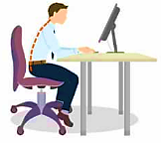 | Leaning Backwards  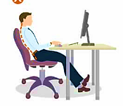 | Curved  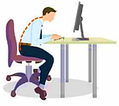 | Correctly  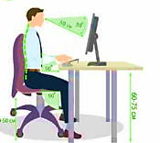
 | Please answer this question and select the appropriate image if you are more in a lying position during the virtual session. | Lying on your back (Supine)   | Lying on stomach (Prone)   | Side lying  
 | What is your preferred surface for lying down position? | Lying on the floor   | Lying on a sofa or couch  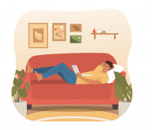 | Lying on the bed  
 | During the Covid-19 pandemic, did you feel joint or muscle pain while attending virtual classes? | Not at all | Very Little | Relatively High | Very Much
 | Which part of your body, based on the images, has the most joint or muscle pain? | Upper back pain  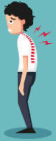 | Shoulder pain   | Neck Pain   | Low back pain  

