Gene editing-mediated enhancement of carotenoid compounds accumulation in common wheat grains

Yajie Guo, Mengtian Liu, Mengyao Li, Dan Wang, Huiyun Liu*
College of Agronomy and the State Key Laboratory of Wheat and Maize Crop Science, Henan Agricultural University, Zhengzhou 450002, Henan, China
*Corresponding author (liuhuiyun@henau.edu.cn).

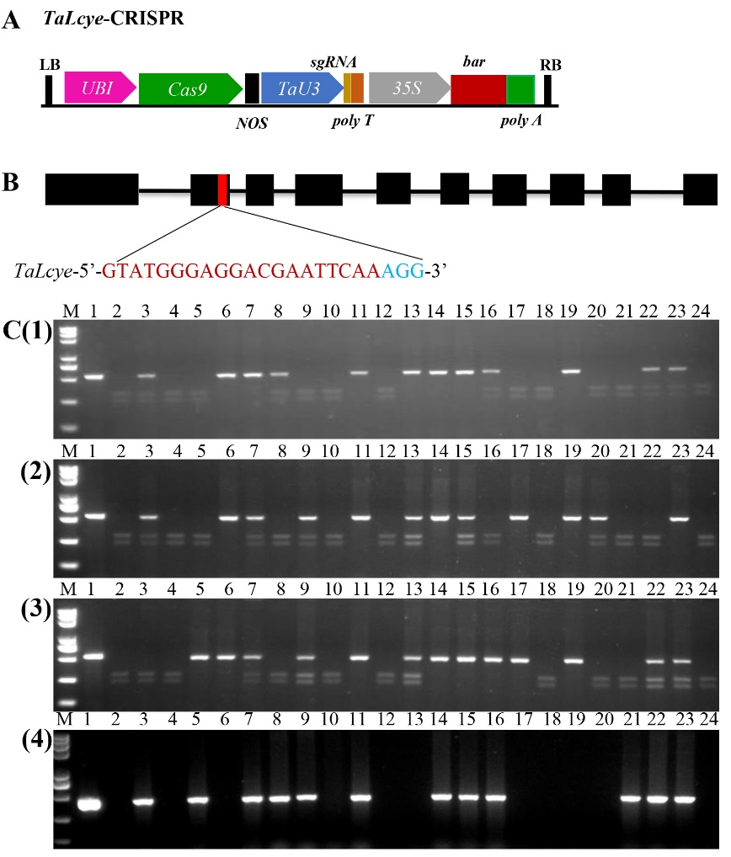
Fig. S1 Knockout of wheat homologues of TaLcye. A: Schematic representation of the TaLcye-CRISPR vector, the vector harbors the bar selectable marker under the control of the CaMV35S promoter, and the maize ubiquitin (ubi) promoter, a multiple cloning site (MCS), and the Agrobacterium nopaline synthase (NOS) terminator sequence for incorporating a target gene of interesting in the T-DNA region; B: gene structure of wheat TaLcye, exon in red is target region of guide RNA; C: detection the mutation of TaLcye; C(1): detection the mutation of TaLcye-3A; C(2): detection the mutation of TaLcye-3B; C(3): detection the mutation of TaLcye-3D; C(4): amplification the bar gene in the transgenic plants; lines 3-24: the PCR products from transgenic plants; A(1), B(1), and C(1), PCR products from wild-type Fielder undigested; A(2), B(2), and C(2), PCR products from wild-type Fielder digested; C(4)-line1: positive control; C(4)-line2: negative control; M: 5000 bp DNA marker, line 6, line 17, and line 19 are the homozygous transgene-free mutants of TaLcye.

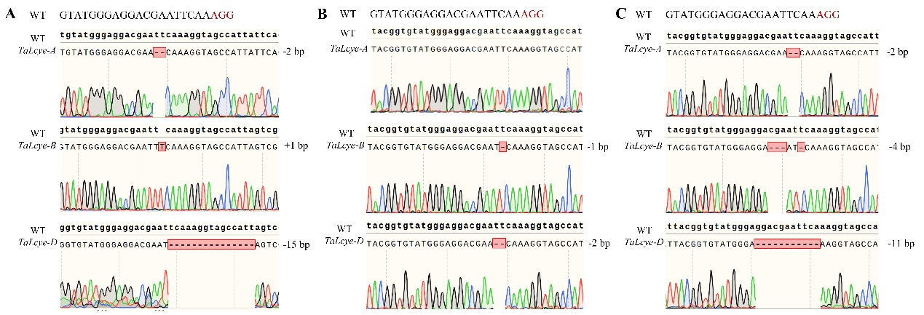
Fig. S2 Location of mutations within the TaLcye homologs in the wheat mutants. A: The homozygous transgene-free mutant 1-4; B: the homozygous transgene-free mutant 2-8; C: the homozygous transgene-free mutant 5-1; the mutated nucleotides are highlighted in red, deletions and insertion are shown by “-” and “+” on the left, respectively.

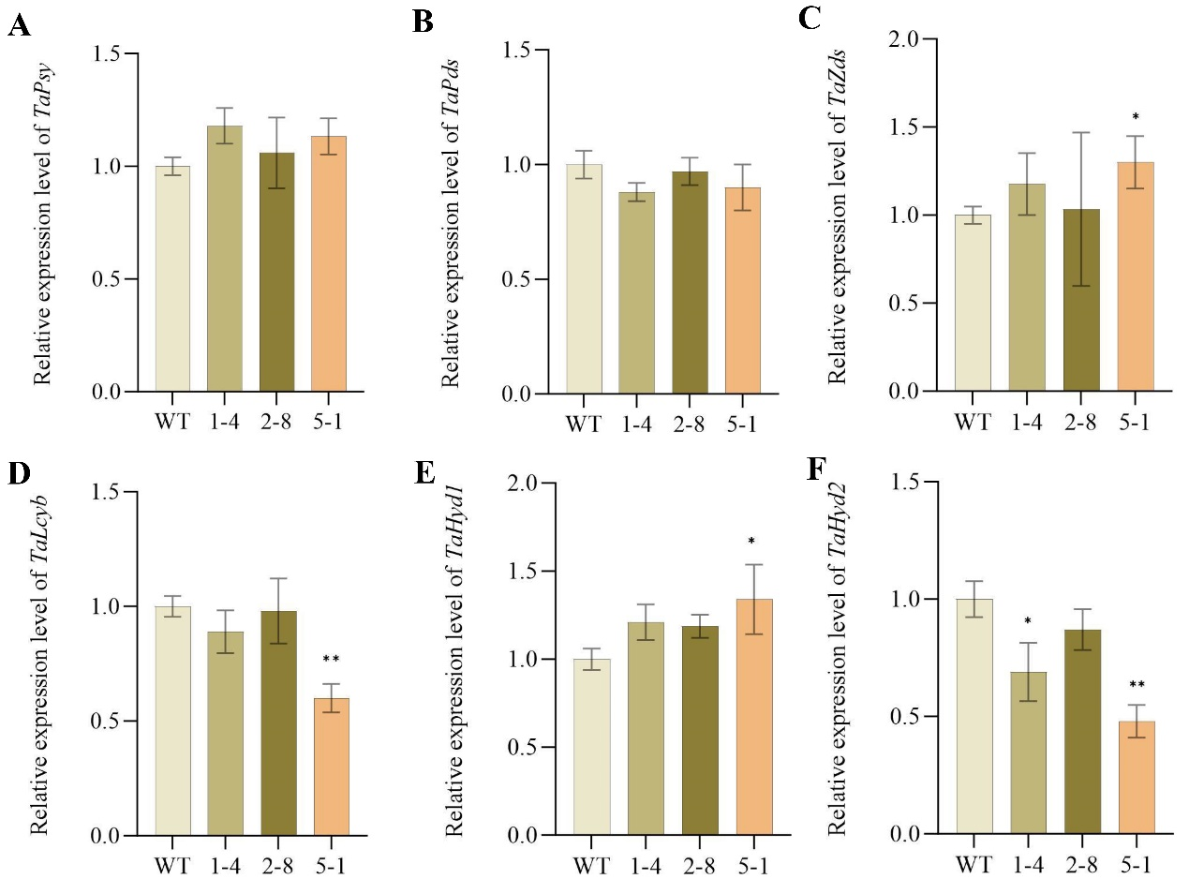
Fig. S3 Expression pattern of genes involved in the carotenoid biosynthesis in leaves. A: The expression level of TaPsy; C: the expression level of TaPds; D: the expression level of TaZds; E: the expression level of TaLcyb; F: the expression level of TaHyd1; G: the expression level of TaHyd2; the levels of gene expression are normalized using wheat TaActin gene; values are means ± sd of three biological replicates; standard error is indicated above each bar; two-tailed student’s t-tests showed relative expression values with significant (*p<0.05) and highly significant (**p<0.001) differences compared to the control are designated by the asterisk.

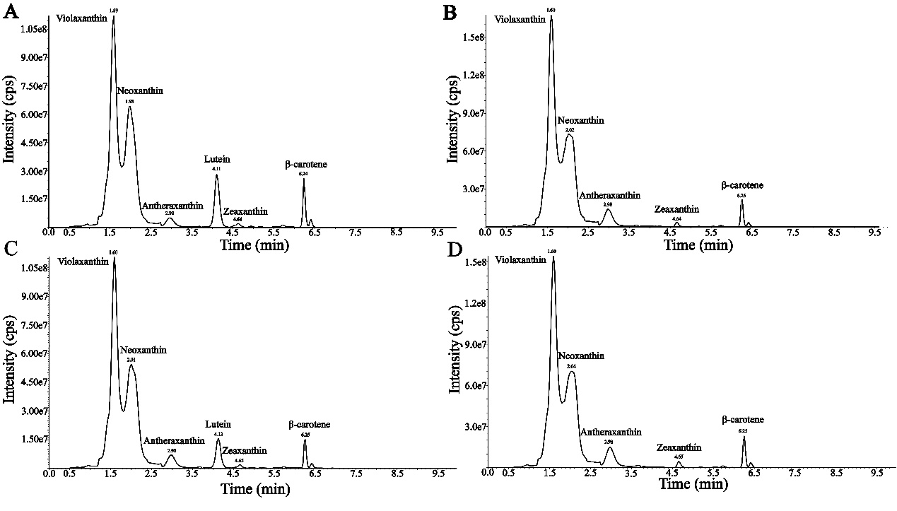
Fig. S4 UPLC-MS/MS chromatograms of carotenoids extracted from the leaves at 30 DPA. A: The wild-type Fielder; B: the mutant line 1-4; C: the mutant line 2-8; D: the mutant line 5-1.

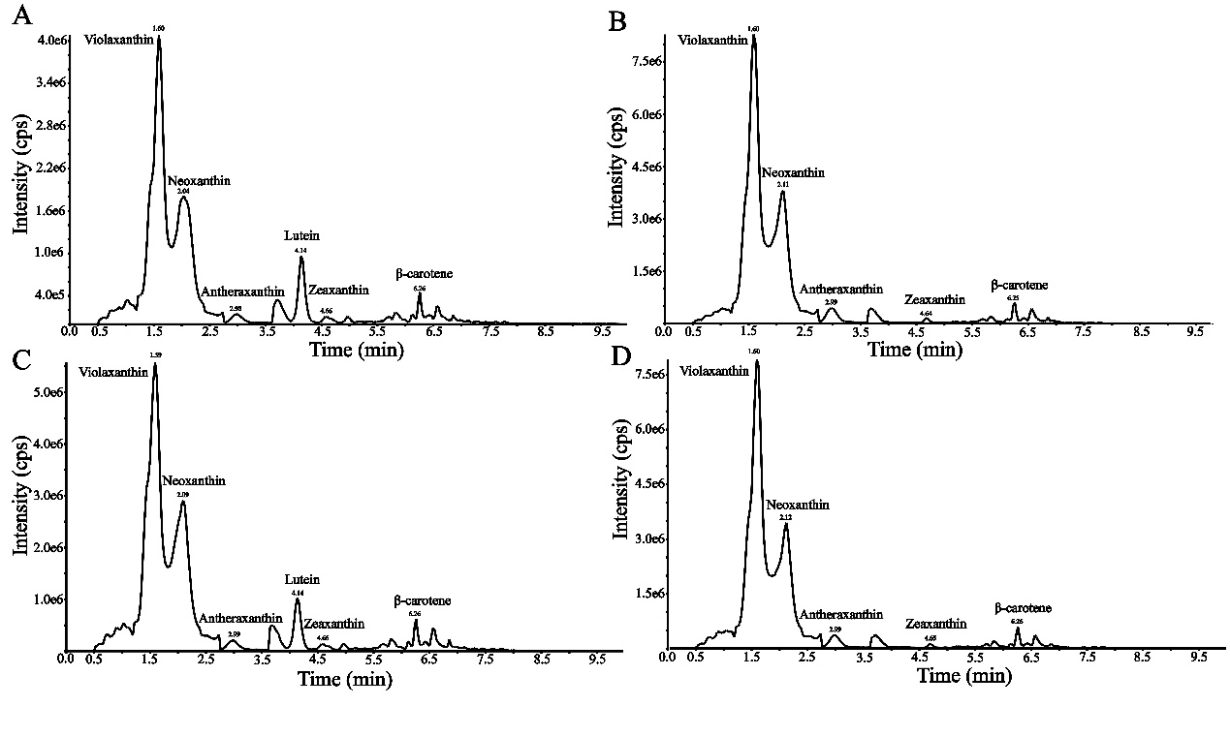
Fig. S5 UPLC-MS/MS chromatograms of carotenoids extracted from the grains at 30 DPA. A: The wild-type Fielder; B: the mutant line 1-4; C: the mutant line 2-8; D: the mutant line 5-1.

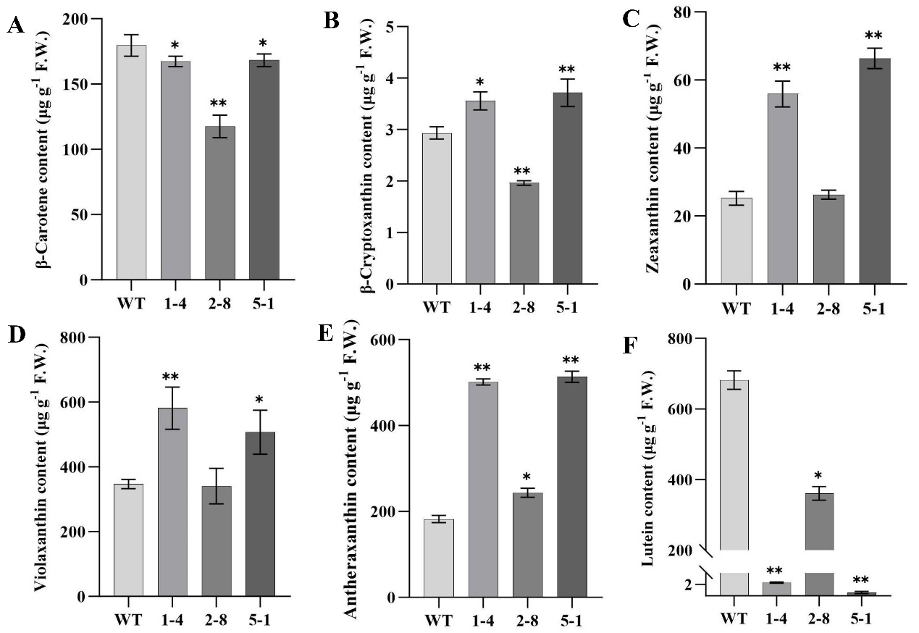
Fig. S6 Carotenoid content in the leaves of wild-type and TaLcye mutant lines. Values are reported as micrograms pergram of fresh weight (F.W.). Standard errors are shown above each bar, along with significant (*p<0.05) and highly significant (**p<0.001) differences compared to the control are designated by the asterisk.

