Supplemental materials
Title: Treatment of xerostomia with mesenchymal stem cells – a systematic review and meta-analysis of clinical trials
Authors:
¹Joachim Hansen, M.D., ¹Amanda-Louise Fenger Carlander M.D., PhD., ¹Kathrine Kronberg Jakobsen M.D., PhD,¹Josephine Skjoldbirk Andersen MSc, ¹Christian Grønhøj M.D., PhD., DMSc., ¹Christian von Buchwald M.D., DMSc., professor
1: Department of Otorhinolaryngology, Head and Neck Surgery and Audiology, Rigshospitalet, University of Copenhagen, Denmark
Corresponding author:
Joachim Hansen M.D., Email: Joachim.hansen.01@regionh.dk; ORCID: 0000-0001-8395-5037
Department of Otorhinolaryngology, Head and Neck Surgery and Audiology, Rigshospitalet, Inge Lehmanns Vej 7, section 7046, zipcode: 2100, City: Copenhagen Ø, Denmark

Search phrases

Cochrane

ID Search
#1 MeSH descriptor: [Stem Cells] explode all trees
#2 MeSH descriptor: [Stromal Cells] explode all trees
#3 MeSH descriptor: [Stem Cell Transplantation] explode all trees
#4 MeSH descriptor: [Cell- and Tissue-Based Therapy] explode all trees
#5 MeSH descriptor: [Secretome] explode all trees
#6 MeSH descriptor: [Exosomes] explode all trees
#7 MeSH descriptor: [Bone Marrow Transplantation] explode all trees
#8 (adipose tissue-derived mesenchymal stem cell*):ti,ab,kw
#9 (adipose derived mesenchymal stem cell*):ti,ab,kw
#10 (allogeneic mesenchymal stem cell*):ti,ab,kw
#11 (ASC):ti,ab,kw
#12 (ADSC):ti,ab,kw
#13 (BMSC):ti,ab,kw
#14 (MSC):ti,ab,kw
#15 ((bone or adipose) NEAR/5 (stem or stromal or cell*)):ti,ab,kw
#16 (bone-marrow stem cell*):ti,ab,kw
#17 (preadipocyte*):ti,ab,kw
#18 (Processed lipoaspirate cell*):ti,ab,kw
#19 (stromal vascular fraction*):ti,ab,kw
#20 #1 OR #2 or #3 or #4 or #5 or #6 or #7 or #8 or #9 or #10 or #11 or #12 or #13 or #14 or #15 or #16 or #17 or #18 or #19
#21 MeSH descriptor: [Saliva] explode all trees
#22 MeSH descriptor: [Salivation] explode all trees
#23 MeSH descriptor: [Salivary Glands] explode all trees
#24 MeSH descriptor: [Xerostomia] explode all trees
#25 MeSH descriptor: [Salivary Gland Diseases] explode all trees
#26 (saliva*):ti,ab,kw
#27 (saliva* NEAR/5 hypofunction*):ti,ab,kw
#28 ((oral or mouth) NEAR/3 dry*):ti,ab,kw
#29 (hyposalivation*):ti,ab,kw
#30 #21 or #22 or #23 or #24 or #25 or #26 or #27 or #28 or #29
#31 MeSH descriptor: [Radiotherapy] explode all trees
#32 MeSH descriptor: [Radiation] explode all trees
#33 MeSH descriptor: [Radiation Injuries] explode all trees
#34 MeSH descriptor: [Chemoradiotherapy] explode all trees
#35 (postradiation*):ti,ab,kw
#36 (radio-induced):ti,ab,kw
#37 (irradiation*):ti,ab,kw
#38 (radiotherap*):ti,ab,kw
#39 (radiation*):ti,ab,kw
#40 #31 or #32 or #33 or #34 or #35 or #36 or #37 or #38 or #39
#41 MeSH descriptor: [Sjogren's Syndrome] explode all trees
#42 (sjogren*):ti,ab,kw
#43 (sicca*):ti,ab,kw
#44 #41 or #42 or #43
#45 #30 and #40
#46 #30 and #44
#47 #45 or #46
#48 #47 and #20

EMBASE

1 exp saliva/
2 exp salivation/
3 exp salivary gland/
4 exp xerostomia/
5 exp salivary gland disease/
6 "saliva*".kf,tw.
7 (saliva* adj5 hypofunction*).kf,tw.
8 ((Oral or mouth) adj5 dry*).kf,tw.
9 hyposalivation*.kf,tw.
10 "Oral dry*".kf,tw.
11 "Xerostom*".kf,tw.
12 1 or 2 or 3 or 4 or 5 or 6 or 7 or 8 or 9 or 10 or 11
13 exp radiotherapy/
14 exp radiation/
15 exp radiation injury/
16 exp chemoradiotherapy/
17 postradiation.kf,tw.
18 radio-induced.kf,tw.
19 "irradiation*".kf,tw.
20 "radiation inju*".kf,tw.
21 "radiotherap*".kf,tw.
22 "radiation*".kf,tw.
23 13 or 14 or 15 or 16 or 17 or 18 or 19 or 20 or 21 or 22
24 exp Sjoegren syndrome/
25 morbus sjogren.kf,tw.
26 "sjogren*".kf,tw.
27 "sicca*".kf,tw.
28 24 or 25 or 26 or 27
29 12 and 28
30 12 and 23
31 29 or 30
32 exp stem cell/
33 exp stroma cell/
34 exp bone marrow transplantation/ or exp stem cell transplantation/
35 exp cell therapy/
36 secretome/
37 exosome/
38 "adipose tissue-derived mesenchymal stem cell*".kf,tw.
39 "adipose derived mesenchymal stem cell*".kf,tw.
40 "allogeneic mesenchymal stem cell*".kf,tw.
41 ASC.kf,tw.
42 ADSC.kf,tw.
43 MSC.kf,tw.
44 BMSC.kf,tw.
45 ((bone or adipose) adj5 (stem or stromal or cell*)).kf,tw.
46 "bone-marrow stem cell*".kf,tw.
47 "preadipocyte*".kf,tw.
48 "Processed lipoaspirate cell*".kf,tw.
49 "stromal vascular fraction*".kf,tw.
50 32 or 33 or 34 or 35 or 36 or 37 or 38 or 39 or 40 or 41 or 42 or 43 or 44 or 45 or 46 or 47 or 48 or 49
51 31 and 50

MEDLINE
1 exp Stem Cells/
2 exp Stromal Cells/
3 exp Stem Cell Transplantation/
4 exp "Cell- and Tissue-Based Therapy"/
5 Secretome/
6 Exosomes/
7 exp Bone Marrow Transplantation/
8 "adipose tissue-derived mesenchymal stem cell*".kf,tw.
9 "adipose derived mesenchymal stem cell*".kf,tw.
10 "allogeneic mesenchymal stem cell*".kf,tw.
11 ASC.kf,tw.
12 ADSC.kf,tw.
13 BMSC.kf,tw.
14 MSC.kf,tw.
15 ((bone or adipose) adj5 (stem or stromal or cell*)).kf,tw.
16 "bone-marrow stem cell*".kf,tw.
17 "preadipocyte*".kf,tw.
18 "Processed lipoaspirate cell*".kf,tw.
19 "stromal vascular fraction*".kf,tw.
20 1 or 2 or 3 or 4 or 5 or 6 or 7 or 8 or 9 or 10 or 11 or 12 or 13 or 14 or 15 or 16 or 17 or 18 or
21 Saliva/
22 Salivation/
23 exp Salivary Glands/
24 exp Xerostomia/
25 exp Salivary Gland Diseases/
26 "saliva*".kf,tw.
27 (saliva* adj5 hypofunction*).kf,tw.
28 ((oral or mouth) adj5 dry*).kf,tw.
29 "oral dry*".kf,tw.
30 hyposalivation.kf,tw.
31 21 or 22 or 23 or 24 or 25 or 26 or 27 or 28 or 30
32 exp Radiotherapy/
33 exp Radiation/
34 exp Radiation Injuries/
35 exp Chemoradiotherapy/
36 postradiat*.kf,tw.
37 radio-induced.kf,tw.
38 "irradiat*".kf,tw.
39 "radiation inju*".kf,tw.
40 "radiotherap*".kf,tw.
41 "radiat*".kf,tw.
42 32 or 33 or 34 or 35 or 36 or 37 or 38 or 39 or 40 or 41
43 exp Sjogren's Syndrome/
44 morbus sjogren.kf,tw.
45 "sjogren*".kf,tw.
46 "sicca*".kf,tw. 4191
47 43 or 44 or 45 or 46
48 31 and 42
49 31 and 47
50 48 or 49
51 20 and 50

Figures
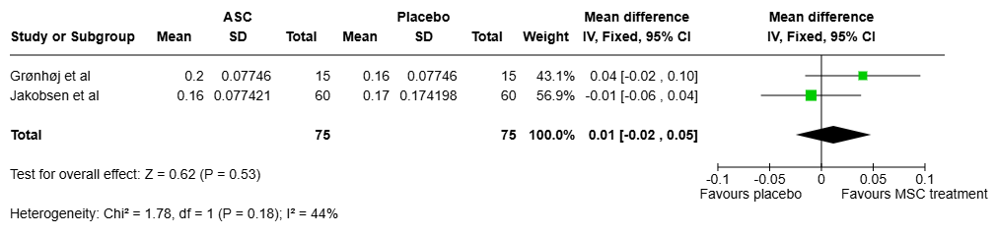
Figure 1 Forest plot for UWS long term effect
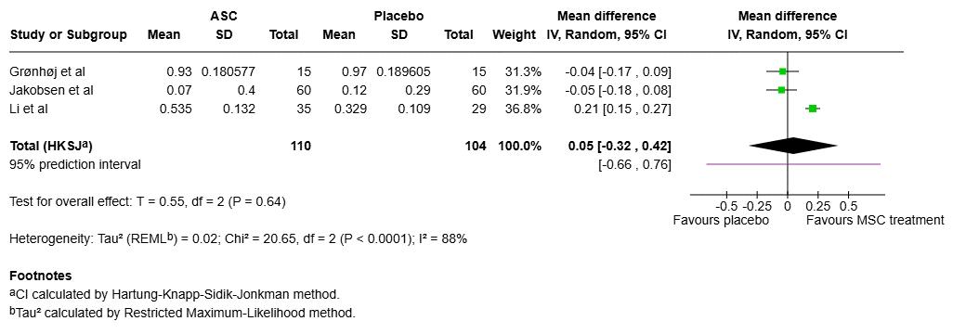
Figure 2 Forest plot for SWS short term effect
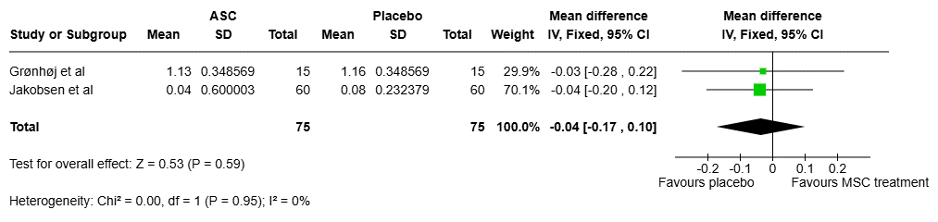
Figure 3 Forest plot for SWS long term effect

