Supplementary Information

Tropical cyclone climatology change greatly exacerbates US joint rainfall-surge hazard

Avantika Gori¹, Ning Lin*¹, Dazhi Xi¹, Kerry Emanuel²
¹Princeton University, Department of Civil & Environmental Engineering
²Massachussetts Institute of Technology, Department of Earth, Atmospheric and Planetary Sciences

*Corresponding Author, nlin@princeton.edu

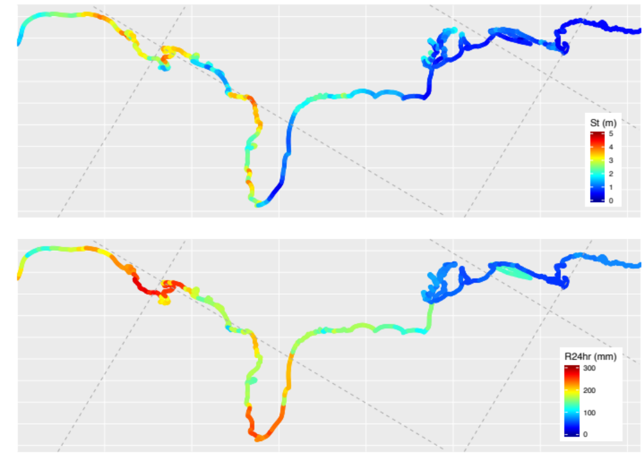
Figure S1: 100 year storm tide (St) relative to mean higher high water (MHHW) vertical datum (top) and 100 yr 24-hour maximum rainfall accumulation over the upstream HUC8 catchment (bottom) based on NCEP 1980-2005 storms

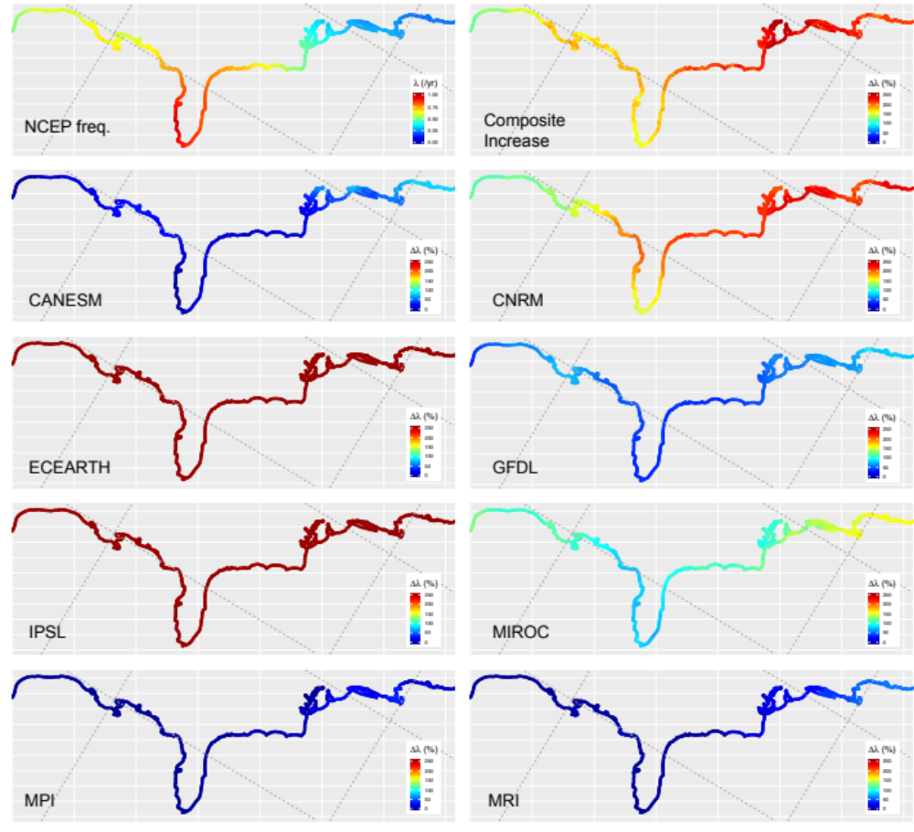
Figure S2: NCEP yearly TC frequency (top-left), composite percent increase in yearly frequency in future period 2070-2100 (top-right), and projected future increase for each GCM storm set

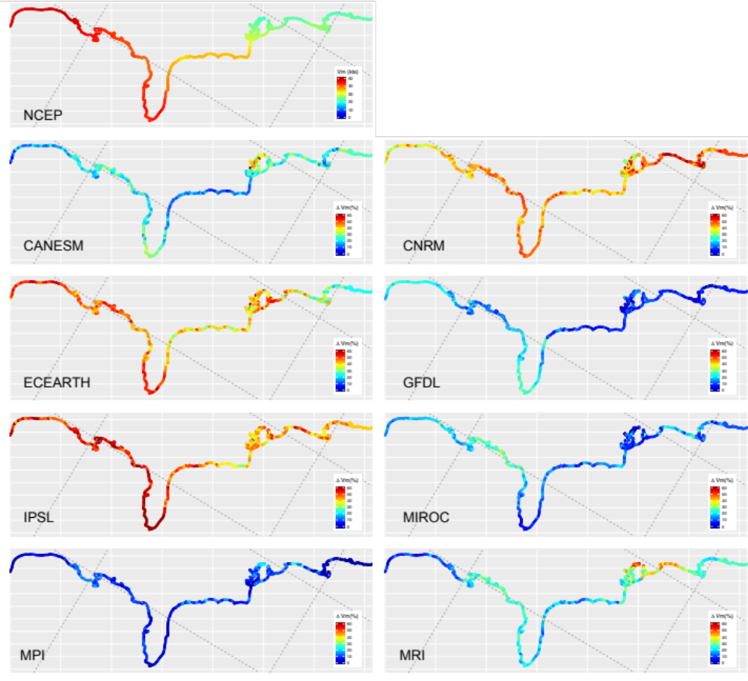
Figure S3: NCEP (1980-2005) 90th percentile Vmax, and percent change in 90th percentile Vmax projected by each GCM storm set for future period (2070-2100)

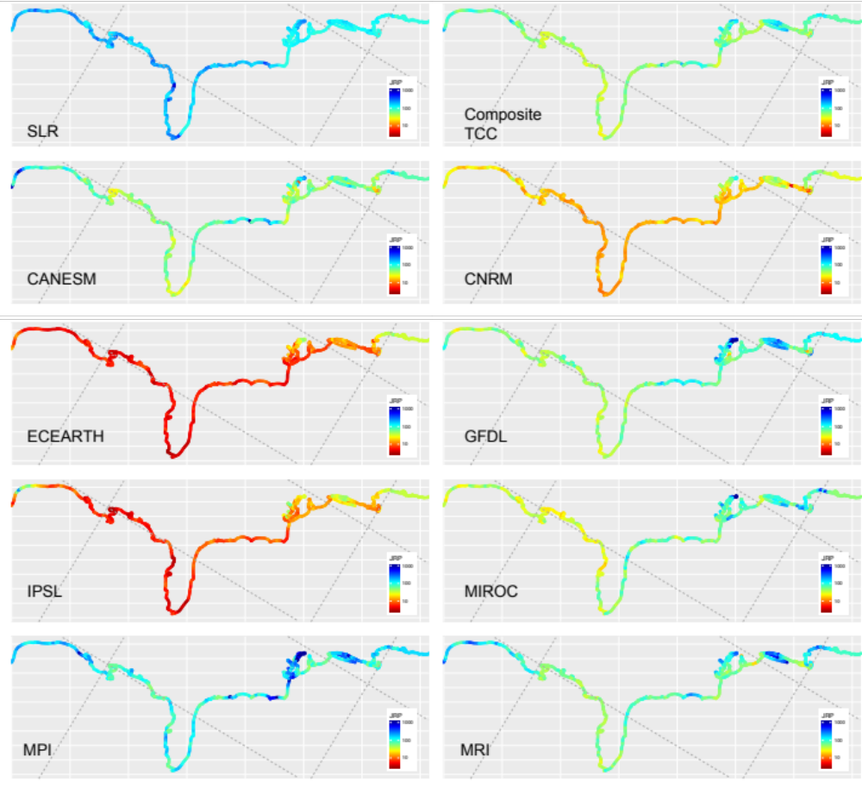
Figure S4: Joint 100 year return period under SLR (top-left), composite future storm climatology (TCC) (top-right), and joint 100 year return period due to future increases in TCC projected by each GCM storm set.

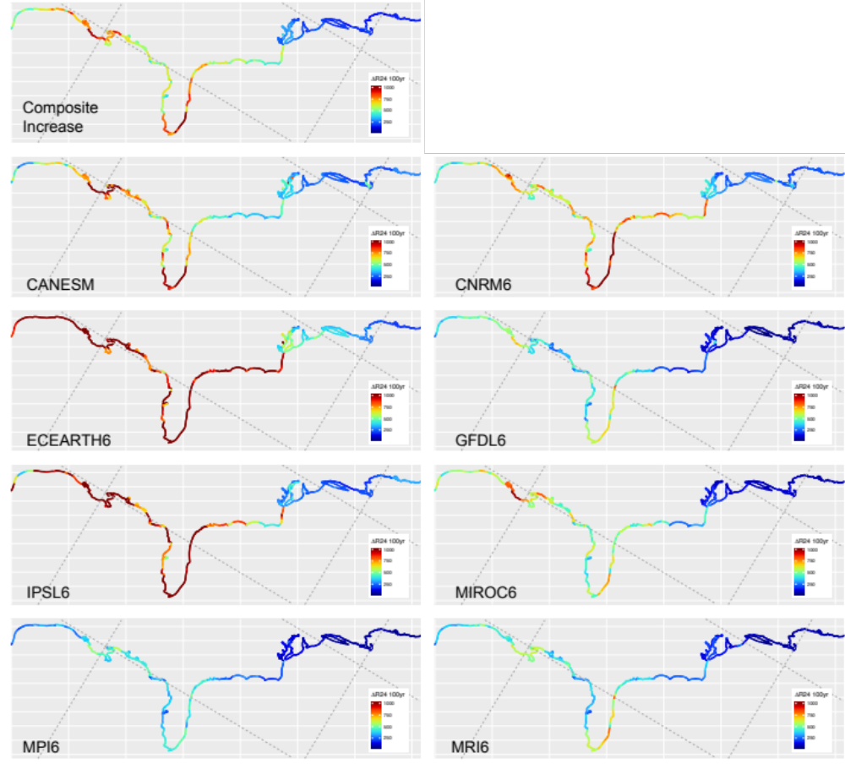
Figure S5: Increase in 100yr max 24hr rainfall (R24) from composite projection of future TC climatology (top-left), and from TC climatology changes projected by each GCM storm set.

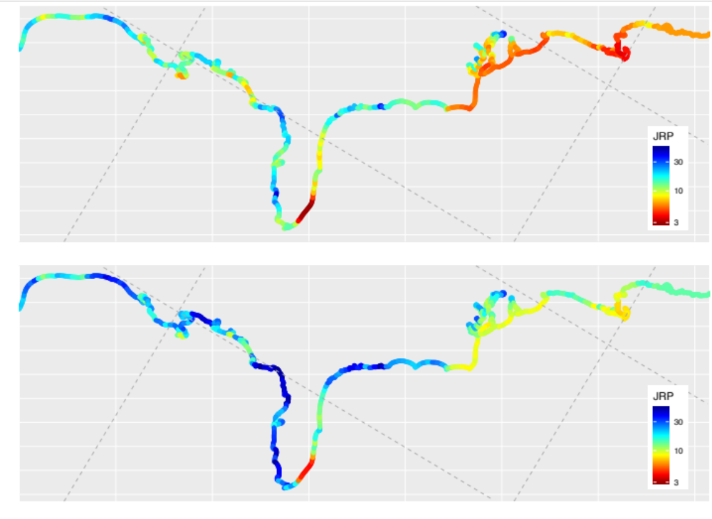
Figure S6: Future JRP considering SLR and storm climatology change (top), and future JRP considering SLR and storm climatology change but assuming constant historical storm frequency (bottom).

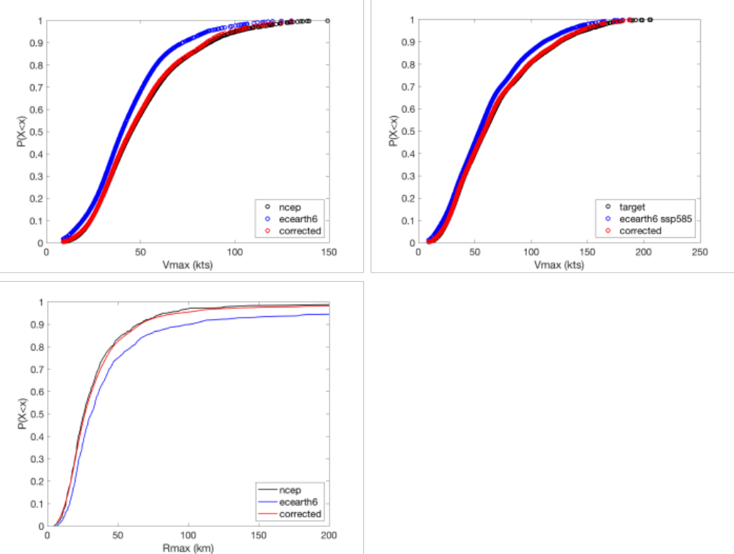
Figure S7: Illustration of bias correction procedure, showing correction of ecearth at New Orleans, LA. (a) Correction in historical period using quantile mapping approach with storm weighting and re-sampling, (b) correction in future period where black represents corrected Vmax distribution using quantile delta mapping (QDM) and red represents distribution of re-weighted storms, (c) comparison of ncep, ecearth, and corrected Rmax distribution using storm weights derived from Vmax. Plot shows that Vmax correction also corrects Rmax distribution.

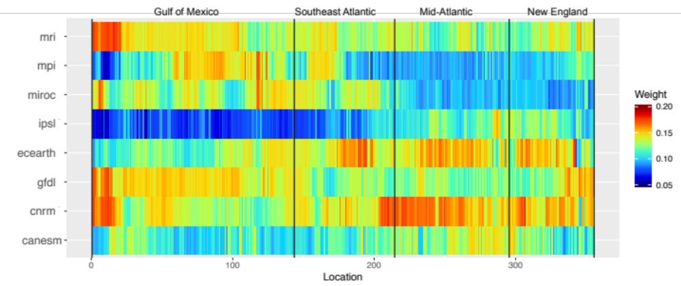
Figure S8: GCM model weights at each location along the coastline developed by comparing NCEP intensity return levels and modeled intensity return levels in the historical period (1980-2005).

