Influence of aging methods on the volatile aroma compounds of tobacco leaves and the structure of surface microbial communities

Xu Chunping¹, Sun Yizhe¹, Fan Yuntao², Qu Lili¹, Xiao Zhang³, Ding Meizhou^{4*}, Ma Rong^{2*}

1. College of Tobacco Science and Engineering, Zhengzhou University of Light Industry, Zhengzhou 450000, China;
2. Research Center, Hebei Tobacco Industry Co., Ltd., Shijiazhuang 052165, China;
3. Joint Innovation Laboratory for Natural Active Products, Henan Academy of Sciences, Zhengzhou 450046, China;
4. Research Center, Henan Tobacco Industry Co., Ltd., Zhengzhou, 450000, China;

Correspondence: Ma Rong (15286811817@163.com) and Ding Meizhou (dingmeizhou999@163.com)

Supplementary Materials
Figure S1. Rarefaction curves of bacterial communities in tobacco leaves with different aging treatments. The x-axis indicates the number of sequences sampled, and the y-axis represents the corresponding number of observed OTUs.
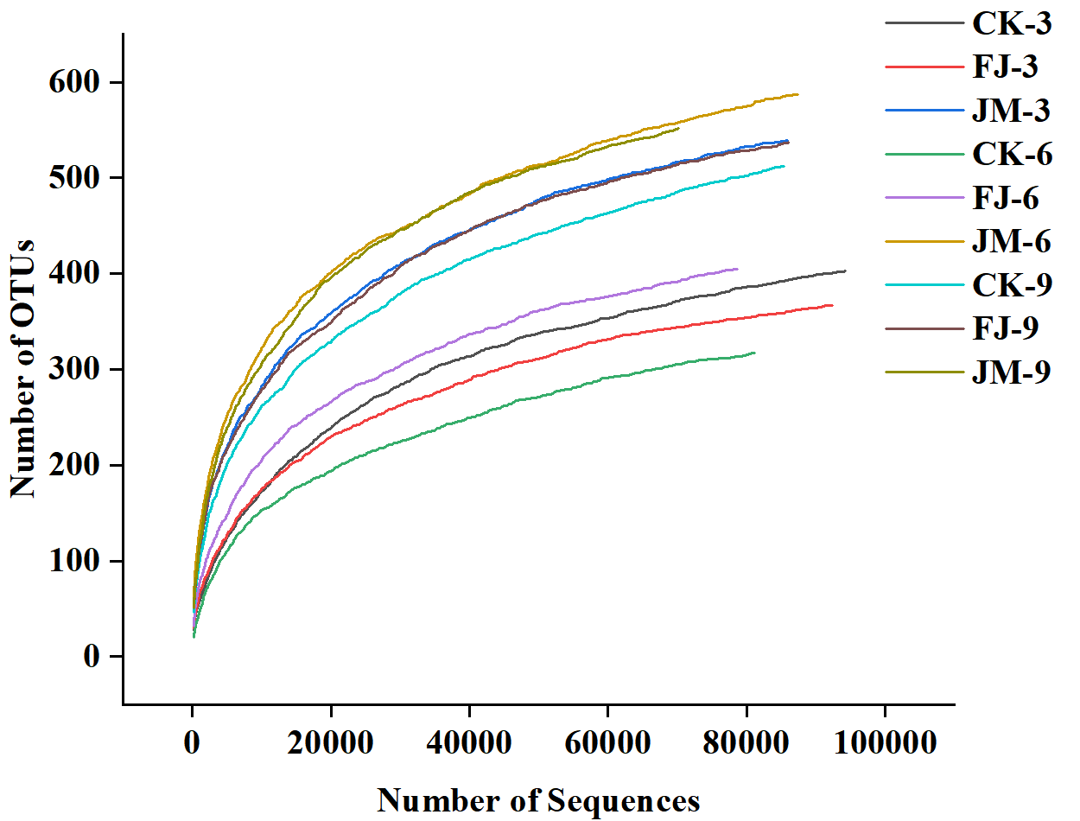

Figure S2. Linear discriminant analysis (LDA) score of LEfSe in tobacco leaves with different aging treatments. (A) CK; (B) FJ; (C) JM.
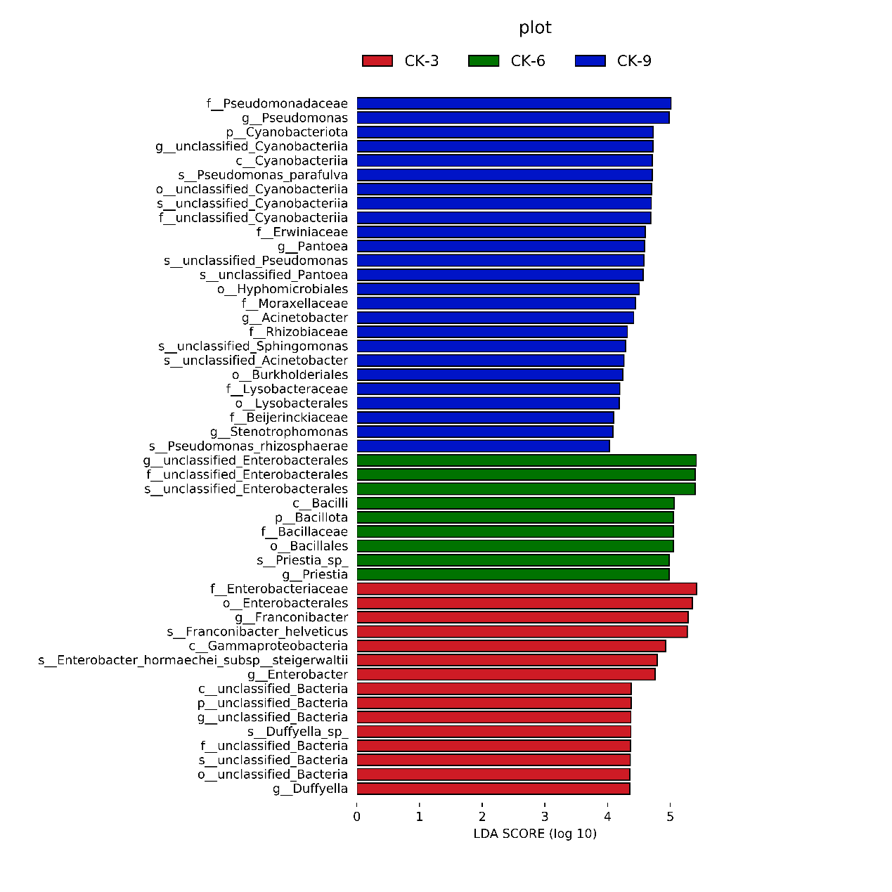
(B)
(B)
(A)
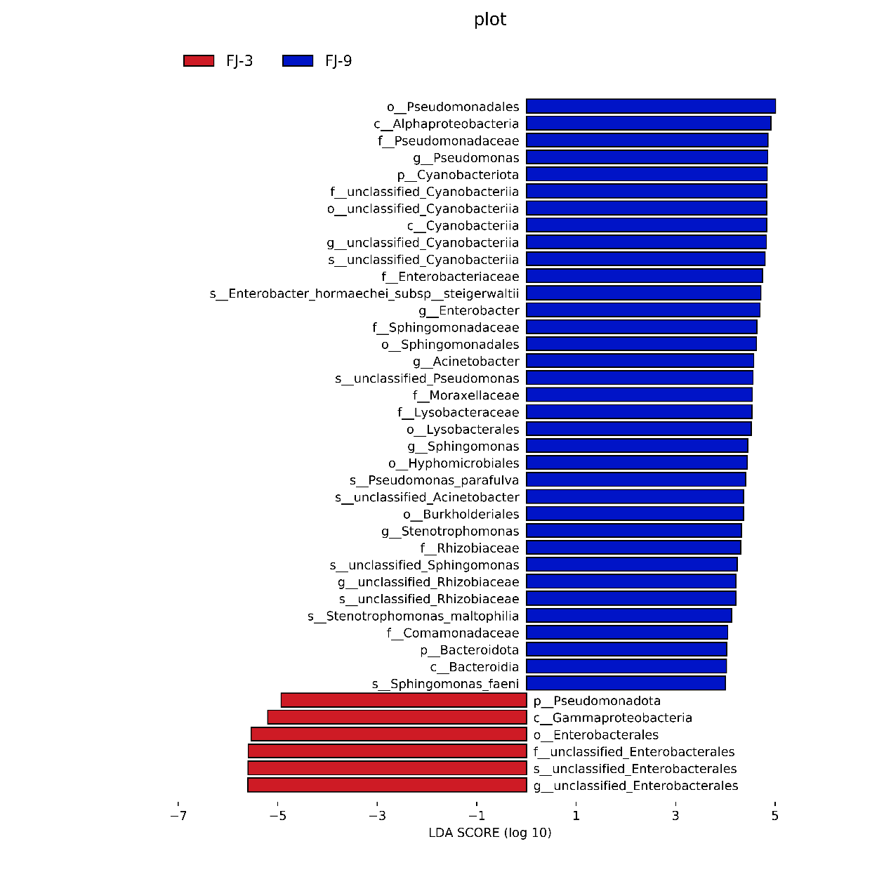
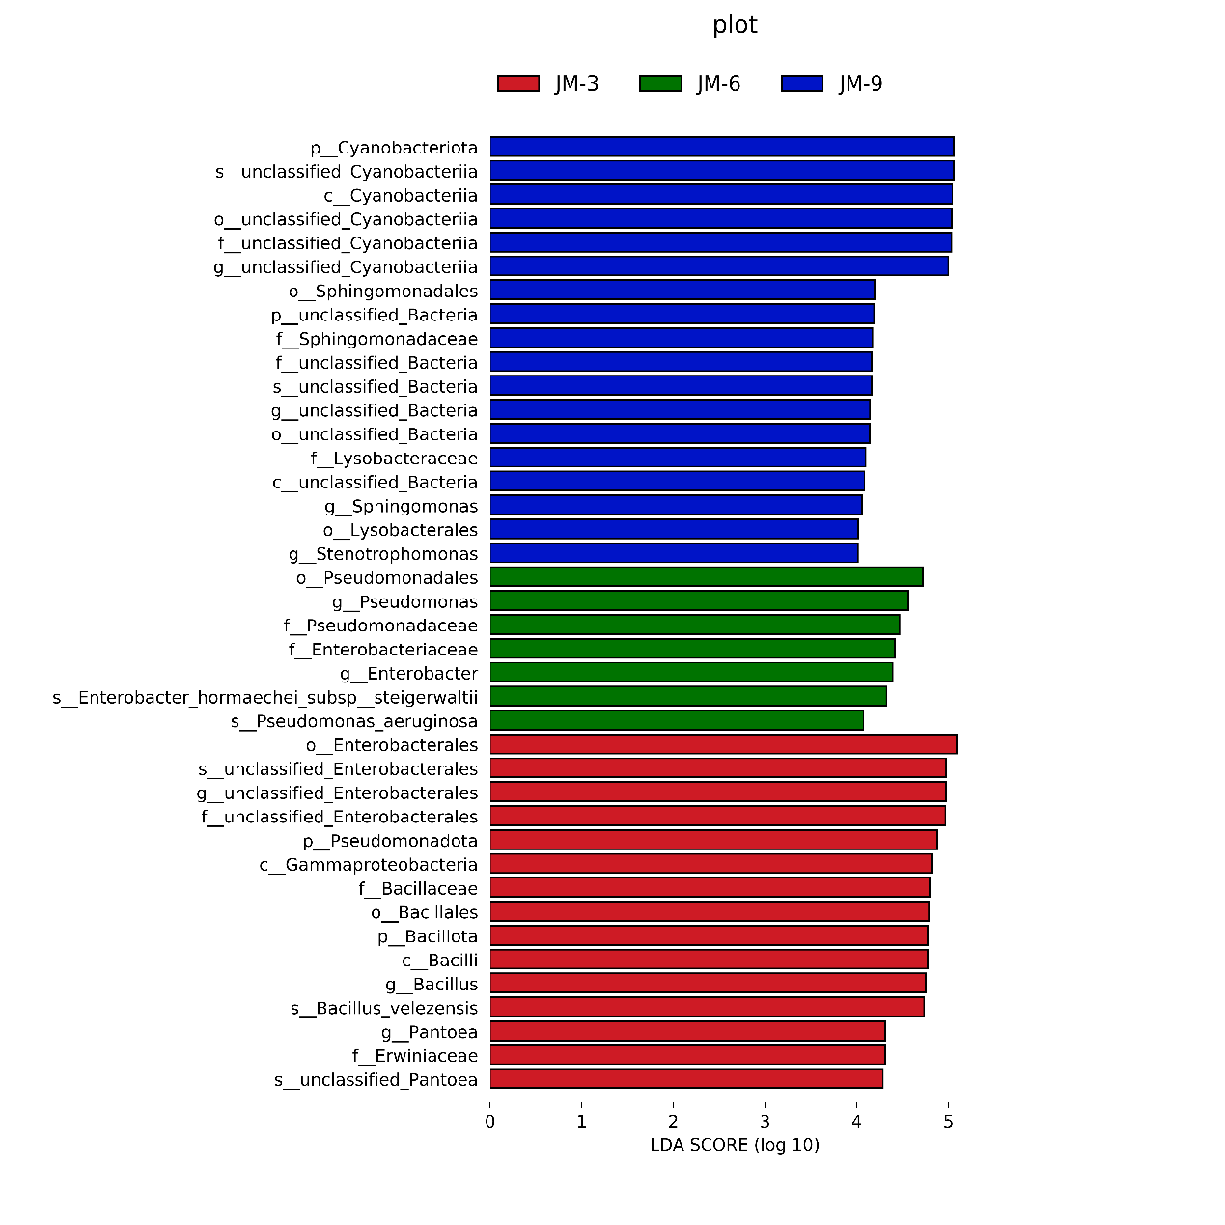
(C)

Table S1. Coverage of bacterial sequence reads after removing singletons in tobacco leaves with different aging treatments.
Sample ID | Number | OTUs | Coverage
CK-3 | 94247 | 403 | 0.999
FJ-3 | 92448 | 367 | 0.999
JM-3 | 85941 | 539 | 0.999
CK-6 | 81103 | 317 | 0.999
FJ-6 | 78697 | 405 | 0.999
JM-6 | 87463 | 587 | 0.999
CK-9 | 85348 | 512 | 0.999
FJ-9 | 86076 | 537 | 0.999
JM-9 | 70182 | 552 | 0.998

