Supplementary Information

Phage tail-like nanostructures affect microbial interactions between Streptomyces and fungi

Toshiki Nagakubo^{1,*}, Tatsuya Yamamoto², Shumpei Asamizu^{1,3}, Masanori Toyofuku^{2,4,5}, Nobuhiko Nomura^{2,4}, Hiroyasu Onaka^{1,3,*}

¹ Graduate School of Agricultural and Life Sciences, Department of Biotechnology, The University of Tokyo, Tokyo, Japan
² Department of Life and Environmental Sciences, University of Tsukuba, Tsukuba, Japan.
³ Collaborative Research Institute for Innovative Microbiology, The University of Tokyo, Tokyo, Japan
⁴ Microbiology Research Center for Sustainability (MiCS), University of Tsukuba, Tsukuba, Japan
⁵ Suntory Rising Stars Encouragement Program in Life Sciences (SunRiSE) Fellow

*Corresponding Authors: Toshiki Nagakubo and Hiroyasu Onaka
nagakubo@g.ecc.u-tokyo.ac.jp
aonaka@g.ecc.u-tokyo.ac.jp

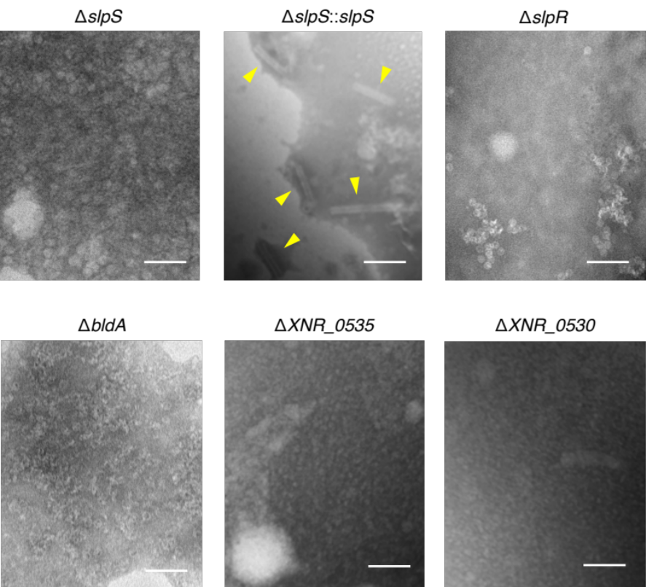

Supplementary Figure 1. Transmission electron microscopy analysis of the mycelial extracts of Streptomyces strains.
Deletion mutants for SLP-related genes do not produce phage tail-like particles. Each strain derived from S. lividans TK23 (ΔslpS, ΔslpR, ΔslpS::slpS and ΔbldA) and S. albus J1074 (ΔXNR_0535 and ΔXNR_0530) was grown on a solid medium and its mycelia were subjected to the extraction and microscopic analysis as described under Methods. Yellow arrowheads indicate SLP produced by slpS-complemented strain of S. lividans. Scale bars, 100 nm.

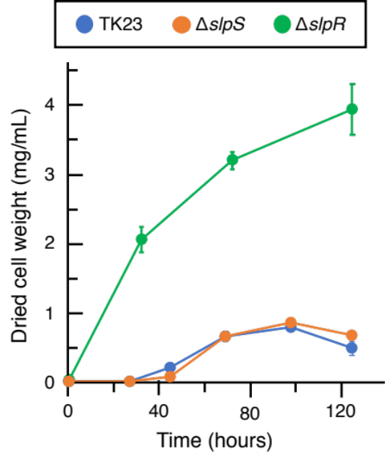

Supplementary Figure 2. Deletion of slpR affects the growth rate of Streptomyces lividans.
Growth curves of S. lividans strains are shown. In-frame deletion mutants for slpS (a SLP sheath protein) and slpR (a transcriptional regulator for structural genes of SLP) were constructed as described under Methods. These mutants and the parental type strain were grown in liquid BeG medium. At each time point, mycelia were harvested from 1 mL of culture and then dried cell weights were measured. All values and the bars represent the mean value ± S.D. for three independent cultures.

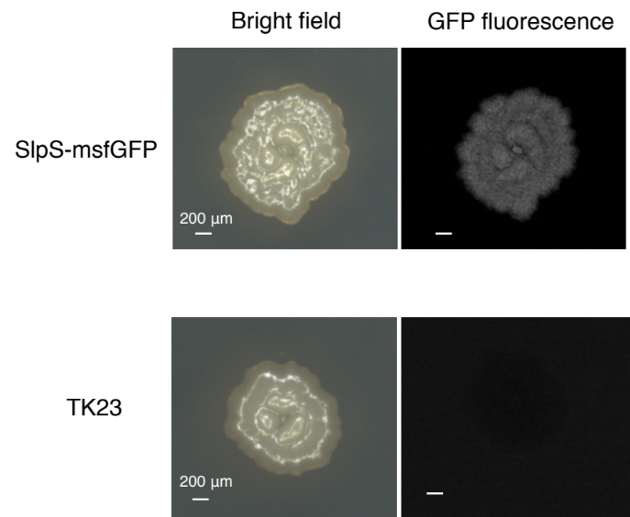

Supplementary Figure 3. SlpS-msfGFP expression in Streptomyces lividans grown on solid medium.
S. lividans strains were grown on solid BeG medium and observed. GFP fluorescence was displayed in gray-scale. Scale bars, 200 μm.

Supplementary Figure 4. Distribution of SlpS-mScarletI at the colony boundaries between Streptomyces lividans and fungi.
SlpS expression in S. lividans was observed under co-culture conditions. S. lividans mycelia and fungal cells were visualized by Syto59 dye (magenta) and GFP (green), respectively. Distribution of SlpS at the colony boundaries were visualized by detecting SlpS-mScarletI fluorescence (cyan).

Supplementary Table 1. Microorganisms used in this study.

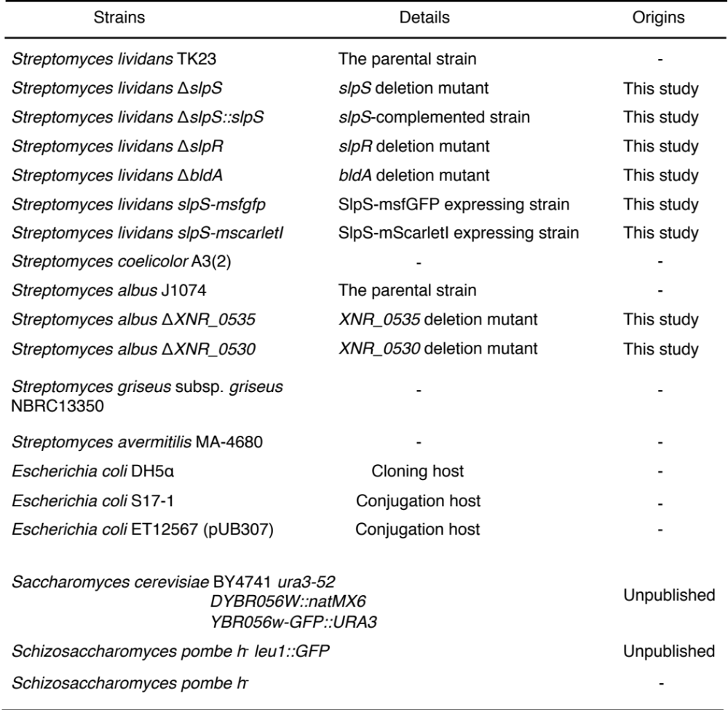

Supplementary Table 2. Primers and plasmids used in this study.

