Supplemental Material

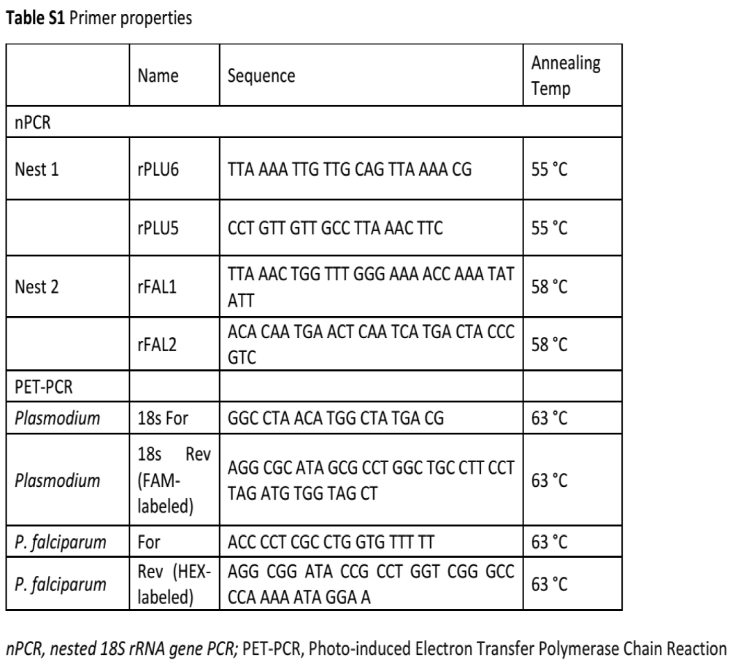

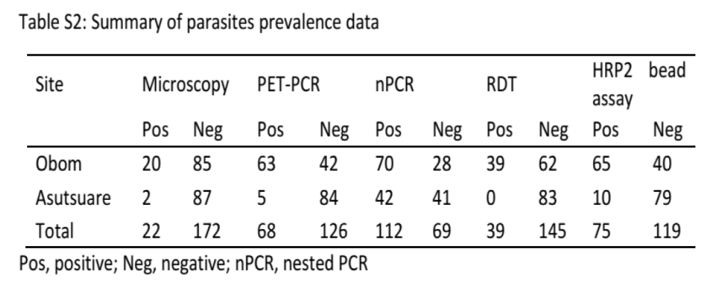

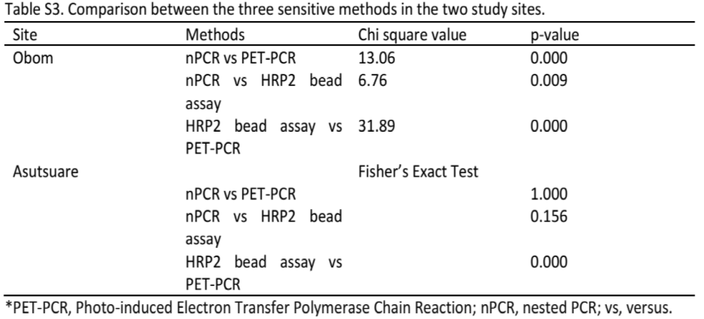

MIC, microscopy; nPCR, Nested PCR; pos, Positive
Figure S1. Flow chart illustrating sample processing. A flow chart showing the number of positive parasites by the five methods, in Obom, the five methods, microcopy, RDT, PET-PCR, bead assay and nPCR identified 20, 37, 63, 65, and 70 samples as parasite positive respectively. While in Asutsuare, the five methods microcopy, RDT, PET-PCR, bead assay and nPCR identified 2, 0, 5, 10, and 42 samples as parasite positive respectively. Overall, there were 8 from Obom and and 0 samples from Asutsuare that tested positive by all five methods.

