Supplementary figure 1.
Distribution of pathologic stage over time in robotic lung resection cases, stratified by surgeon. Stacked bar plots illustrate the proportional distribution of pathologic stage (I–IV) across sequential case groups, binned in increments of 10 cases. The x-axis represents the cumulative case count, while the y-axis denotes the proportion of each pathologic stage group. Panels are arranged from top to bottom as A (Surgeon A), B (Surgeon B), and C (Surgeon C). Color coding corresponds to each pathologic stage (PStage), as indicated in the legend on the right.
Surgeon A progressively focused on early-stage lung cancer cases over time. In contrast, Surgeon B consistently perform a substantial proportion of advanced-stage resections throughout the study period. Surgeon C initially selected predominantly early-stage cases but gradually expanded to include more advanced disease as experience accumulated.
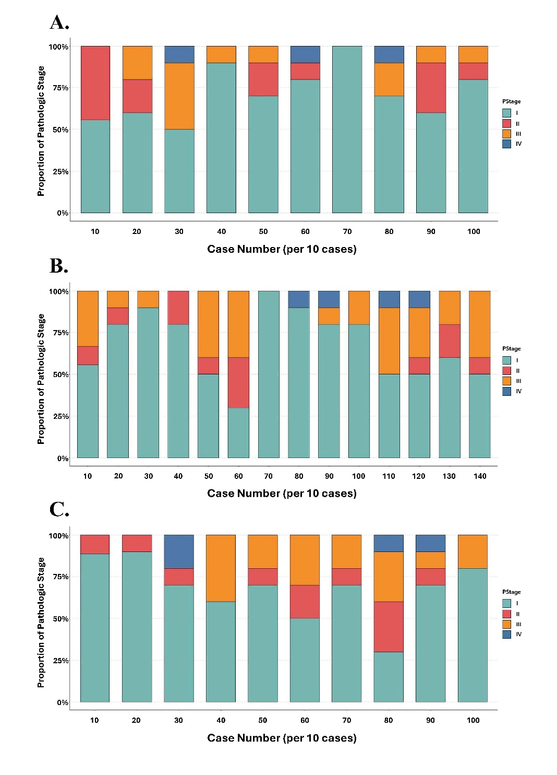

Supplementary figure 2.
Port configuration strategies utilized by Surgeon C for robotic lung resections. The x-axis denotes time, segmented into quarterly intervals by calendar year, and the y-axis represents the cumulative number of cases performed. The figure illustrates a sequential transition in port configuration, beginning with a conventional multiport setup, progressing to dual-port use, and eventually incorporating single-port (uniportal) techniques in selected cases.
