Silicon isotope fractionation modeling
We modeled the silicon isotope fractionation during the formation of Luxi granitoids using the P-T condition, residual mineral assemblages, and melt chemistry calculated by Sun et al., 2021. The modeling procedure is similar to that described in Deng et al. (2019). We start with the mass balance equation between the concentration of SiO2 between source, melt and residue. Under the assumption of closed system behavior for the melting process, the relationship between the concentrations of SiO2 in each phase can be written as
$${C^{SiO_{2}}}_{source}={C^{SiO_{2}}}_{melt}F+{C^{SiO_{2}}}_{residue}(1-F)$$
Where F is the degree of melting and C^{SiO2} represents the concentration of SiO₂. C^{SiO2}_{source} is derived from the measured average composition of 2.7Ga low-K tholeiitic rocks from the Eastern block, North China Craton, and C^{SiO2}_{melt} is derived from the calculated melt SiO₂. Because the C^{SiO2}_{source} and C^{SiO2}_{melt} are calculated with respect to different compositions (weight percent of water is calculated in melt composition, which is not measurable in actual rock samples. Similarly, LOI in whole rock data is not calculated in theoretical melt composition), both C^{SiO2}_{source} and C^{SiO2}_{melt} are renormalized so their abundances are reported with respect to the same composition. C^{SiO2}_{residue} can be calculated from the renormalized C^{SiO2}_{source} and C^{SiO2}_{melt}. Silicon isotopes between melt, residue, and source can then be related to each other by the equation
$${δ^{30}Si}_{source}{C^{SiO_{2}}}_{source}={δ^{30}Si}_{melt}{C^{SiO_{2}}}_{melt}F+{δ^{30}Si}_{residue}{C^{SiO_{2}}}_{residue}(1-F)$$
Where the δ³⁰Si_{residue} can be written as the fractionation between δ³⁰Si_{melt} and the fractionation between melt and residue.
$${δ^{30}Si}_{residue}={δ^{30}Si}_{melt}-Δ^{30}Si_{melt-residue}$$
For simplicity, we take the fractionation factors between silica melts and clinopyroxene, amphibole, garnet as 0.3‰, plagioclase as 0.03‰, quartz as -0.06‰ following Deng et al. (2019). Fractionation factor between melt and mica is taken as -0.14‰ based on the first principles calculation values in ². All other minerals in the residue should have negligible effect on silicon isotopes due to their trace abundance or lack of silicon as a major element in their crystal structure. The fractionation factor between the melt and residual phase can then be calculated as the sum of silicon isotope fractionation factors between each mineral phases.
$$Δ^{30}Si_{melt-residue}=Δ^{30}Si_{melt-garnet/amp/cpx}×\left(1-f_{plag}^{si02}-f_{mica}^{si02}-f_{qtz}^{si02}\right)+Δ^{30}Si_{melt-qtz}×f_{qtz}^{si02}+Δ^{30}Si_{melt-mica}×f_{mica}^{si02}+Δ^{30}Si_{melt-plag}×f_{plag}^{Si02}$$
Where $f_{mineral}^{si02}$ represents the fraction of SiO₂ in each mineral phases relative to the residue. The δ³⁰Si_{melt} can thus be calculated by substituting δ³⁰Si_{residue} via the third equation, and Δ³⁰Si_{melt-residue} via the fourth equation
$${δ^{30}Si}_{source}={δ^{30}Si}_{melt}\frac{{C^{SiO_{2}}}_{melt}}{{C^{SiO_{2}}}_{source}}F+\left({δ^{30}Si}_{melt}-Δ^{30}Si_{melt-residue}\right)\frac{{C^{SiO_{2}}}_{residue}}{{C^{SiO_{2}}}_{source}}\left(1-F\right)$$
The calculated δ³⁰Si_{melt} is plot again Sr/Sr*, where Sr* represents $\sqrt{Ce×Nd}$.

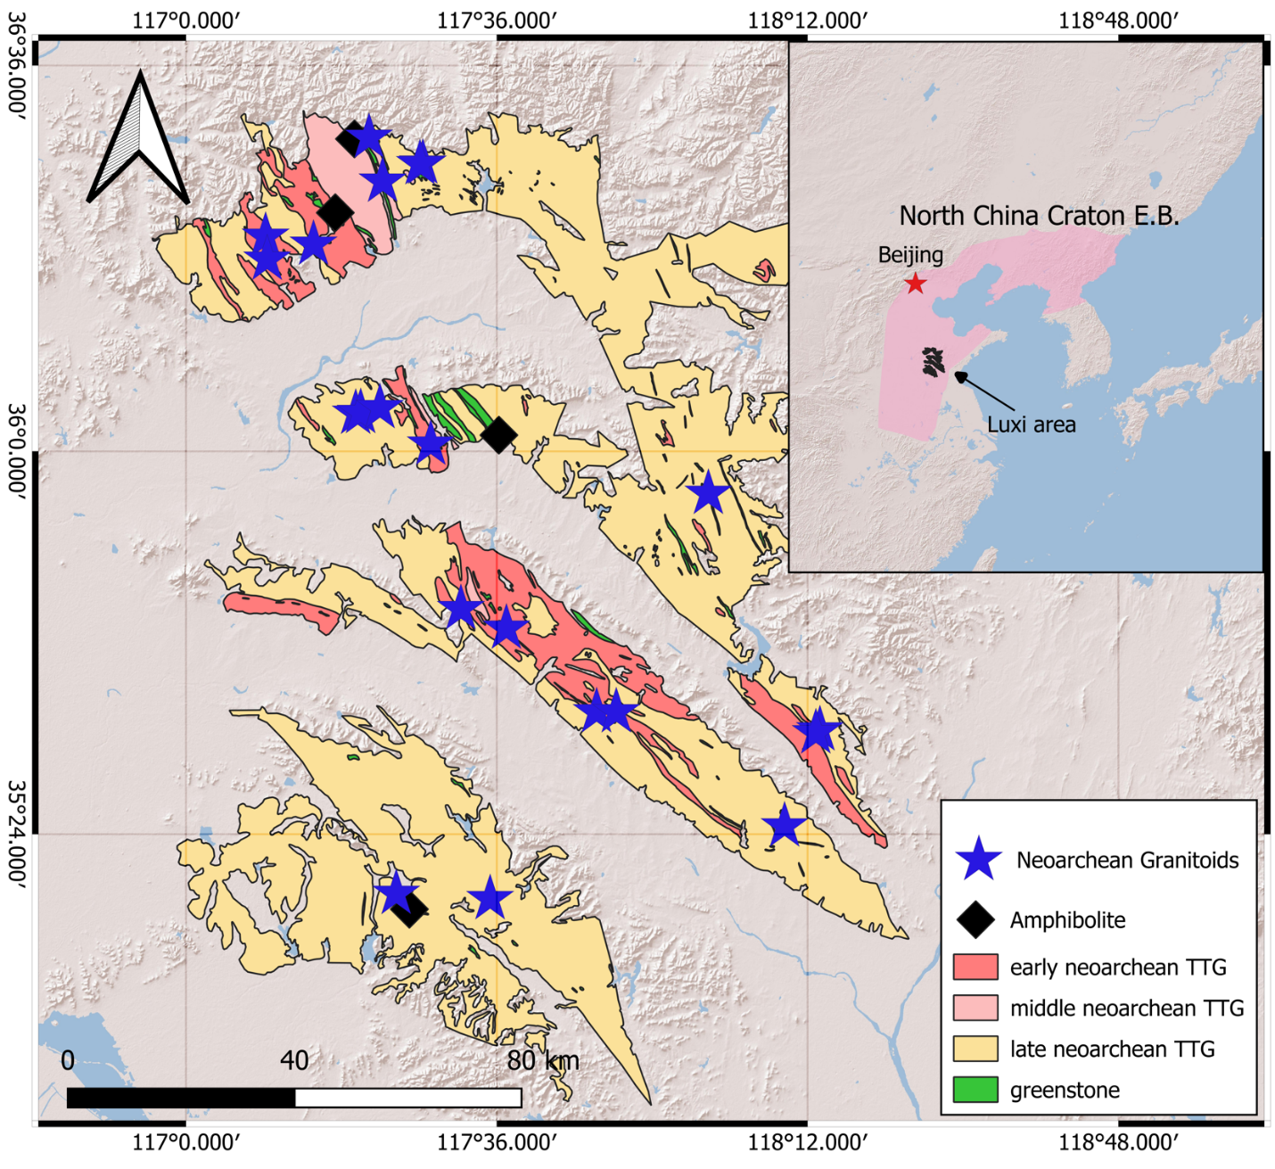
Figure S1: Geologic map of Luxi area, North China Craton and sampling locations.

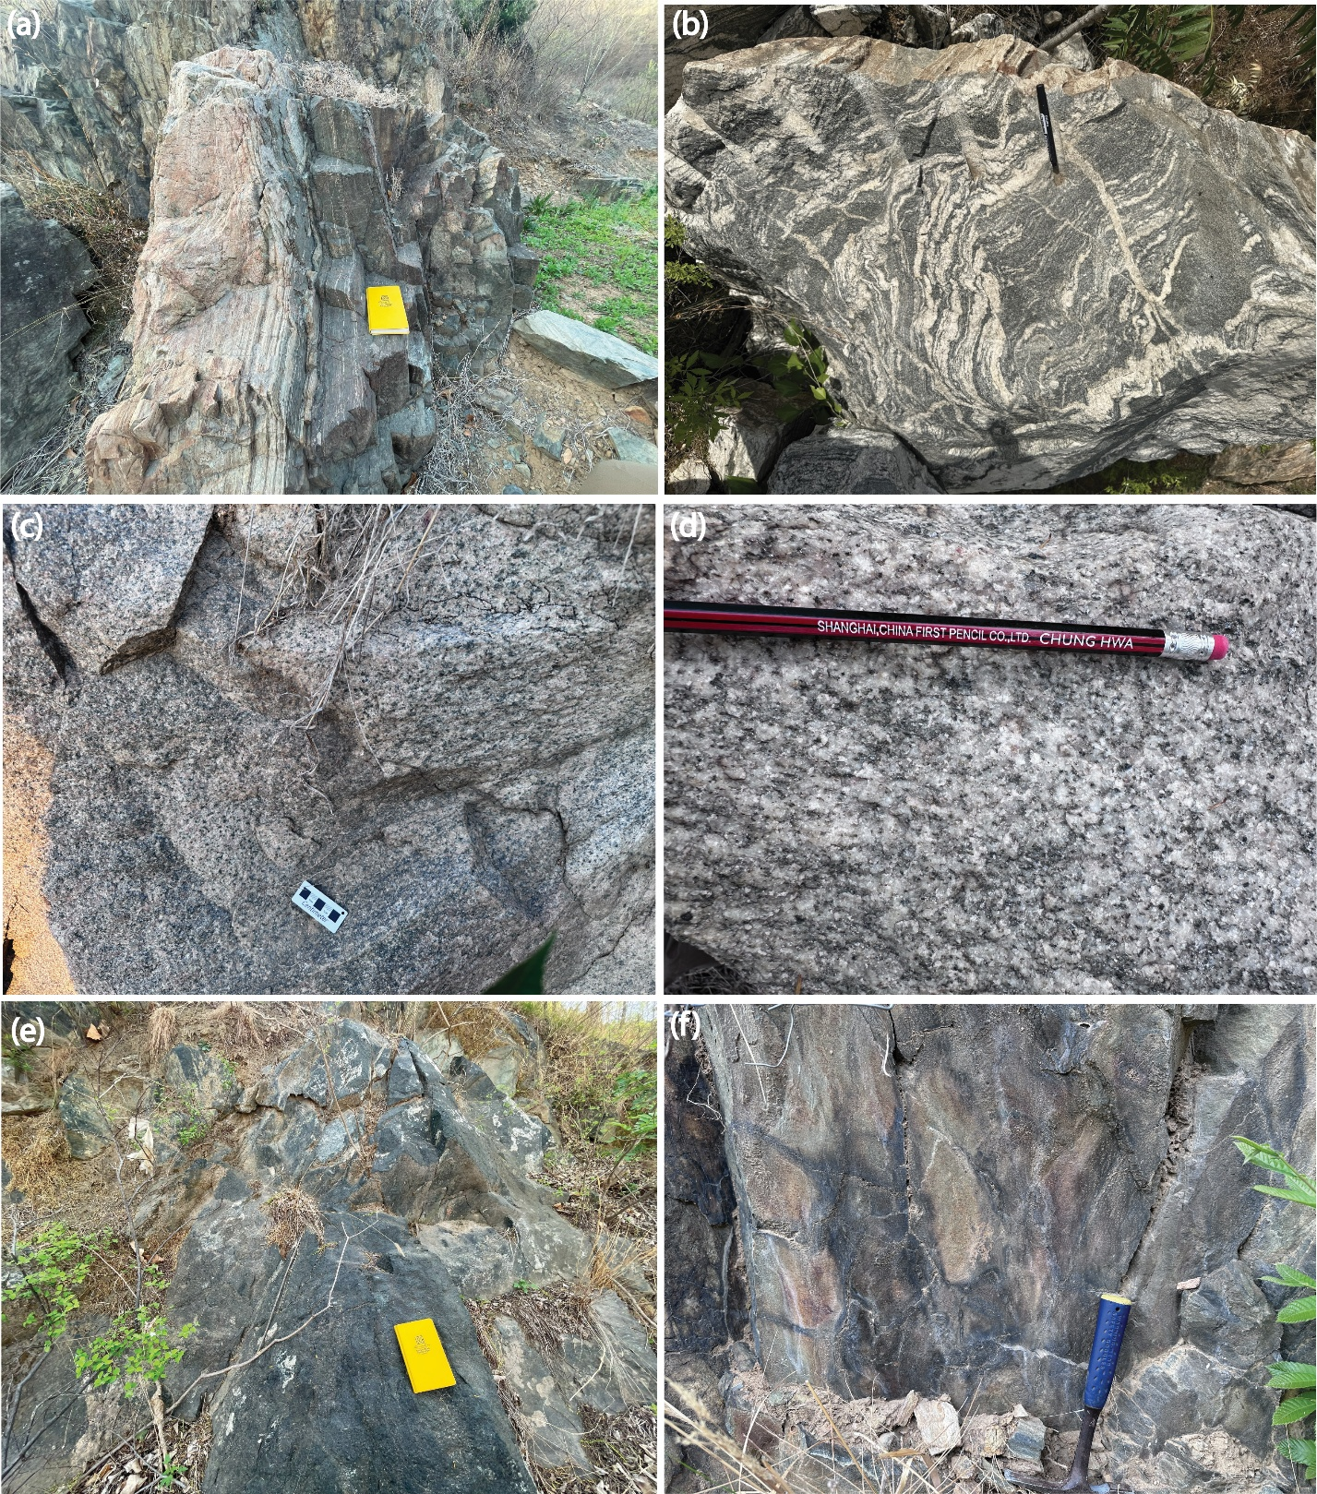Figure S2: field photo of outcrops in Luxi area. (a) mylonitized 2.7Ga granitoids (b) 2.7Ga granitoids showing strong anatexis (c,d) massive 2.5Ga granitoids (e) amphibolite (f) pillowed basalts
Figure S3: thin section images of sulfides in Luxi granitoids. Sulfides are found in various rock types and are included in different minerals.
Figure S4: Classification diagrams of granitoids from Luxi area. Red color points represent pre-2.6Ga granitoids, and black color points are post-2.6Ga granitoids. Compared with pre-2.6Ga granitoids, the post 2.6Ga granitoids are enriched in K₂O.
Figure S5: (a, b): Trace and REE elements spider plots of pre-2.6Ga granitoids. (c,d): Trace and REE elements spider plots of pose-2.6Ga granitoids

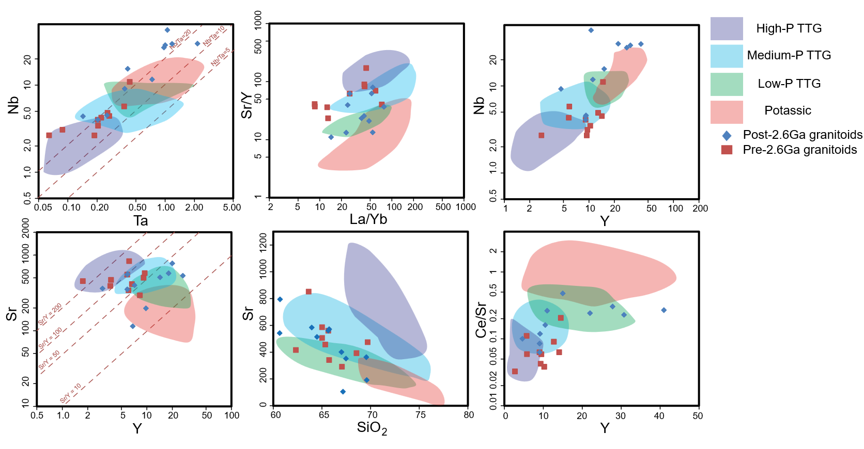
Figure S6: Depth of melting based on the classification diagrams in Moyen (2011). The pink, green, blue and purple color field represents potassic, low-pressure, medium-pressure, and high-pressure melting, respectively. Based on the diagrams, most 2.7Ga granitoids in Luxi formed at medium to high pressure condition, while post 2.7Ga granitoids were formed at medium to low pressure.
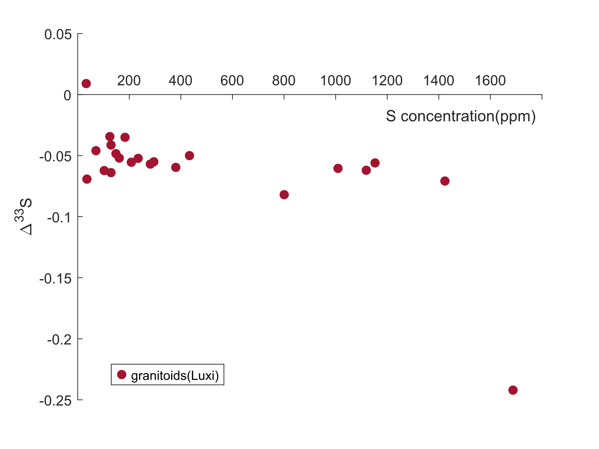
Figure S7: Δ³³S vs sulfur concentration of Luxi granitoids. There is no observable correlated existed between sulfur concentration and Δ³³S, indicating that the non-zero Δ³³S is unlikely to be incorporated into the granitoids via assimilating wall rocks.

Figure S8: sulfur concentration vs age. Increasingly higher sulfur concentration is observed in post 2.6Ga granitoids, while the pre-2.6Ga granitoids are characterized by low sulfur concentrations.

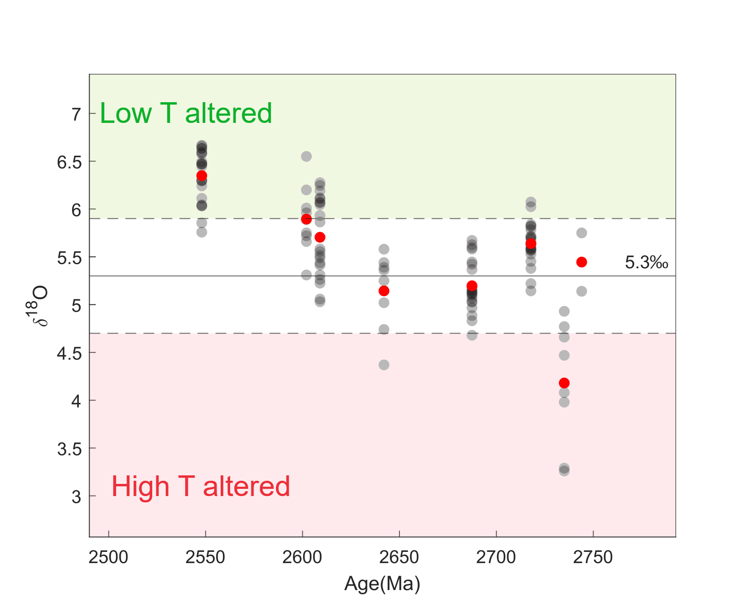
Figure S9: Magmatic zircon oxygen isotope data from granitoids in Luxi area (Chen et al., 2020; Ren et al., 2016). Solid and dashed lines represent the mantle value range of δ¹⁸O, which is 5.3 ± 0.06‰ (Valley et al., 1998). Grey data points represent the measured zircon data and red data points are average values. Granitoids formed at or before ~2650 Ma have near chondritic to slightly depleted δ¹⁸O. In contrast, post-2650 Ma granitoids show slight enrichment in δ¹⁸O, indicating addition of low temperature hydrothermally altered rocks.

