Title: Towards a genetic model organism: an efficient method for stable genetic transformation of Eschscholzia californica (Ranunculales)
Journal name: Plant Cell, Tissue and Organ Culture (PCTOC) Journal of Plant Biotechnology
Authors: Dominik Lotz¹, Jafargholi Imani², Katrin Ehlers¹, Annette Becker¹
Affiliations
¹ Institute of Botany, Plant Development Group, Justus-Liebig-University, Heinrich-Buff-Ring 38, 35392 Gießen, Germany
2. Institute of Phytopathology, Justus-Liebig-University, Heinrich-Buff-Ring 26-32, 35392 Gießen, Germany
* corresponding author: annette.becker@bot1.bio.uni-giessen.de

Supplemental Figures
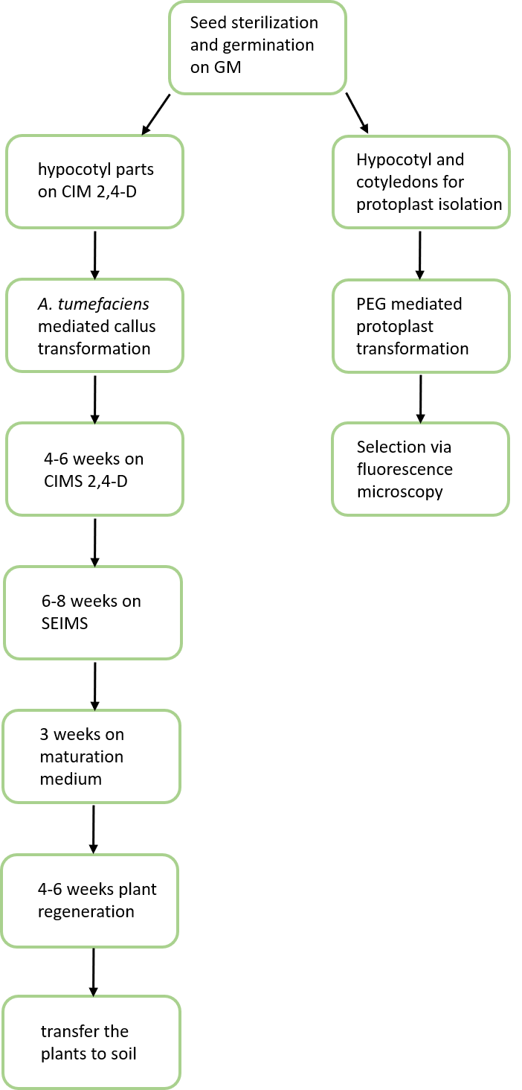
Supplemental Figure 1: schematic summary of methods developed

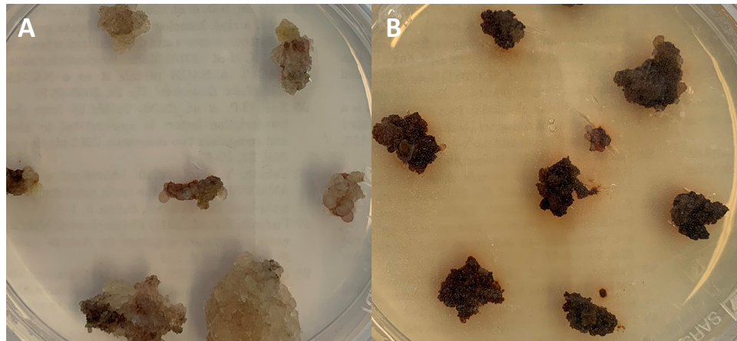
Supplemental Figure 2: Hygromycin B effect on E. californica wild type callus. E. californica wild type callus was cultivated for three weeks on CIM without selection (A) and with 40mg/l Hygromycin B as selection agent (B).
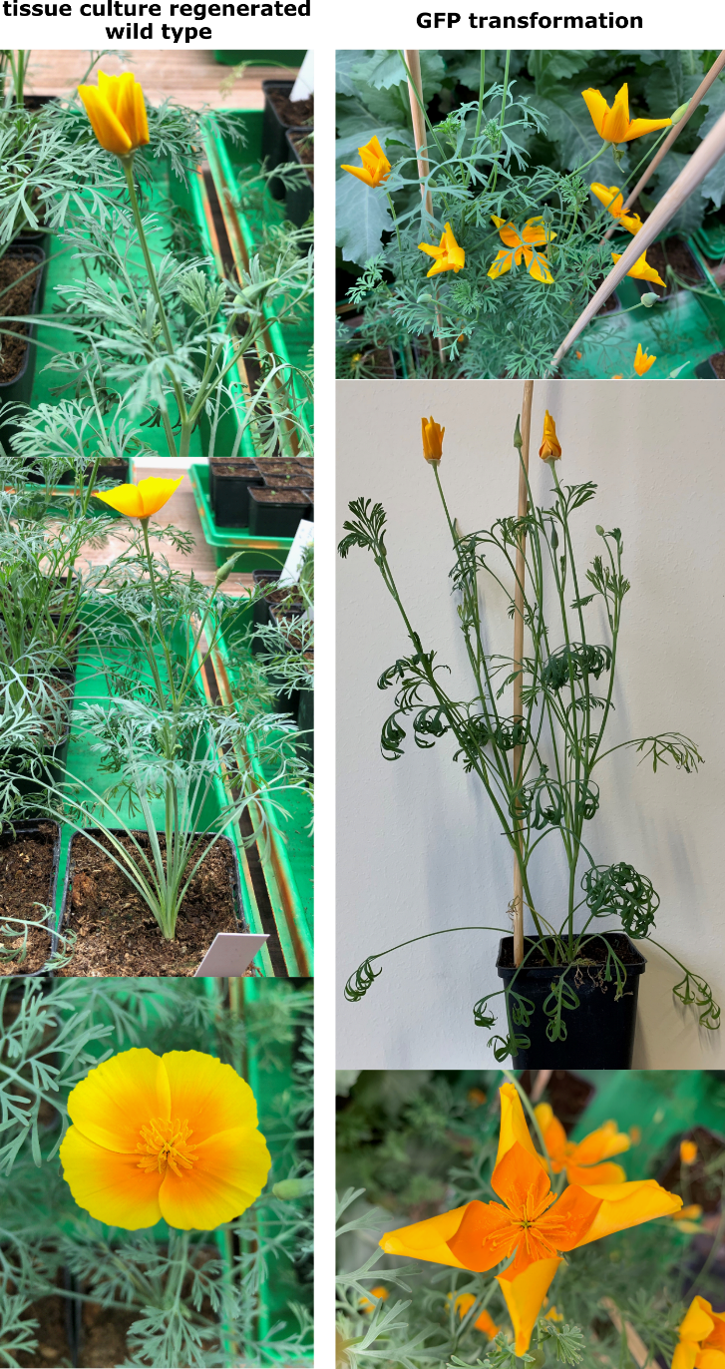
Supplemental Figure 3: comparison between tissue culture regenerated wild type and GFP transformation.

