Title: Masquerade of fruits to stones ensures reproductive success in Phyllolobium heydei

Authors: Feng Gao, Quan Yuan, Hong-Sen Hu, Hao-Ran Sun, Si-Chong Chen, and Yang Dong

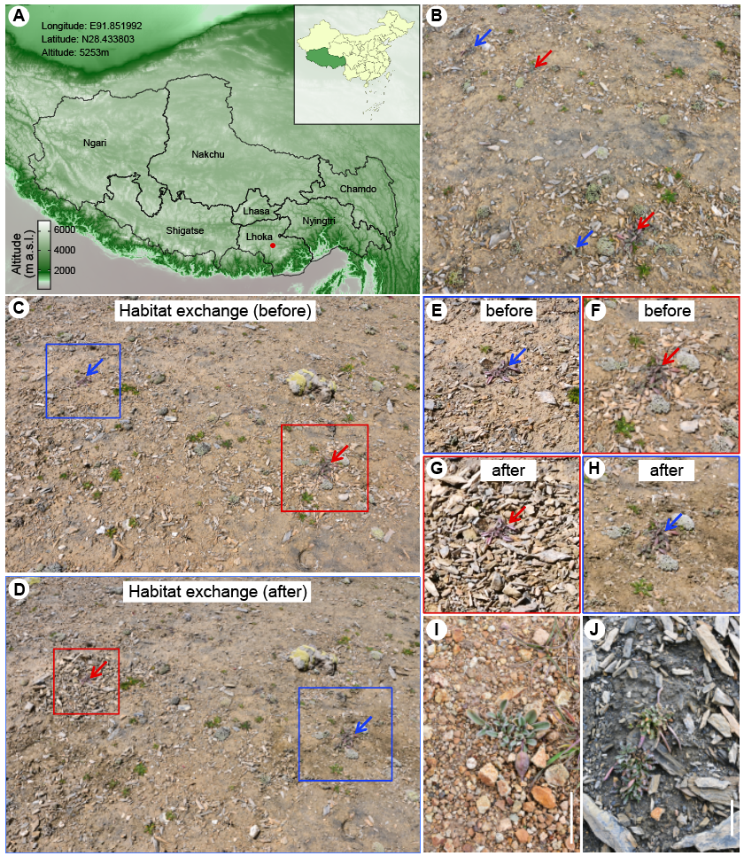
Supplemental Figure 1

Figure S1. Masquerading fruits as stones enhances reproductive success in Phyllolobium heydei, related to Figure 1.
(A) Map of Xizang Autonomous Region with altitude information showing the study location of Phyllolobium heydei (red dot).
(B) Typical habitats of P. heydei. The red and blue arrows mark individuals growing in scree and sandy habitats, respectively.
(C and D) Representative area showing the landscape before (C) and after (D) the habitat exchange experiment. The red and blue boxes indicate the individual in the scree and sandy habitats, respectively.
(E and F) Enlargement of the individuals grown in the sandy (E) and scree (F) habitats shown in C, before the habitat exchange experiment.
(G and H) Enlargement of the individuals grown in the scree (G) and sandy (H) habitats shown in D, after the habitat exchange experiment.
(I and J) Plants of Desideria pumila (I) and Leiospora sp. (J) showing the potential fruit masquerade in alpine tundra, scale bars in I and J represent 5 cm.

