Supporting Information
Interfacial coupling of pitch- and PAN-based carbon fibers with carbon nanotubes in polyethersulfone for electromagnetic interference shielding
Min Jeong Ko^{1,2}, Yoon Sang Kim¹, Sang Woo Kim^{1,3}, Jinsu Kim¹, Jihee Yoon¹, Byeongho Park¹ Dong Gi Seong^{2,*}, Jin Woo Yi^{1,*}
¹Composites & Convergence Materials Research Division, Korea Institute of Materials Science (KIMS), Changwon-daero 797, Seongsan-gu, Changwon, Gyeongsangnam-do, 51508, Republic of Korea
²Department of Polymer Science and Engineering, Pusan National University, 2 Busandaehak-ro 63beon-gil, Geumjeong-gu, Busan 46241, Republic of Korea
³School of Chemical and Biological Engineering and Institute of Chemical Processes, Seoul National University, 1, Gwanak-ro, Gwanak-gu, Seoul 08826, Republic of Korea
*Corresponding author: E-mail: Jin Woo Yi (yjw0628@kims.re.kr), Dong Gi Seong (dgseong@pusan.ac.kr)

Table S1 Ultrason® E 2010 NAT - PES characteristics and typical properties.
Property | Value
Melt volume-flow rate, MVR, cm³/10 min | 70
Tensile modulus, MPa | 2650
Yield stress, MPa | 85
Yield strain, % | 6.9
Glass transition temperature, 10 ℃/min, ℃ | 225
Temp. of deflection under load, 1.80 MPa, ℃ | 205
Temp. of deflection under load, 0.45 MPa, ℃ | 218
Coeff. of linear therm. expansion, parallel, E-6/K | 52
Water absorption, % | 2.2
Density, kg/m³ | 1370
Injection molding, melt temperature, ℃ | 360
Injection molding, mold temperature, ℃ | 160
Drying temperature (Pretreatment), ℃ | 130-150

Table S2 Physical and mechanical properties of pitch- and PAN-based short carbon fibers (XN-60C-03s and TR066A).
Property | Pitch | PAN
Tensile Strength, GPa | 3430 | 3730
Tensile Modulus, GPa | 620 | 224
Strain to failure, % | 0.6 | 1.5
Density, kg/m³ | 2.12 | 1.81
Thermal Conductivity, BTU/hr-ft-ºF (W/mK) | 180 | 120

Table S3 Thermal and physical properties of CNT masterbatch (matrix 808 beta, OCSiAl, Luxembourg).
Property | TEST METHOD | Value
Softening point, ℃ | ASTM D3461 | 65
Flash point, ℃ | ISO 2592 | 270
Thermal decomposition, ℃ | DSC | 300
Bulk density, g/cm³ | ISO 3923-1;2018 | 0.5

Table S4 Shielding effectiveness at 10 GHz (dB). V and H denote vertical and horizontal.
CF type | Composites | SE_{R_V} | SE_{A_V} | SE_{T_V} | SE_{R_H} | SE_{A_H} | SE_{T_H}
CNT-0.5 |  | 6.24 | 30.14 | 36.38 | 2.88 | 17.06 | 19.94
Pitch | CF-10 | 2.00 | 8.30 | 10.30 | 1.66 | 6.46 | 8.12
Pitch | CF-20 | 5.99 | 12.78 | 18.77 | 3.43 | 8.34 | 11.77
Pitch | CF-30 | 6.14 | 22.88 | 29.03 | 4.54 | 16.33 | 20.87
Pitch | CF-CNT | 6.34 | 32.45 | 38.79 | 3.23 | 19.82 | 23.05
Pitch | c-CF-CNT | 7.37 | 36.96 | 44.33 | 4.61 | 27.81 | 32.42
PAN | CF-10 | 6.01 | 18.04 | 24.05 | 5.29 | 13.08 | 18.36
PAN | CF-20 | 8.10 | 30.83 | 38.93 | 6.21 | 26.60 | 32.81
PAN | CF-30 | 8.25 | 39.21 | 47.46 | 6.57 | 31.90 | 38.47
PAN | CF-CNT | 6.68 | 35.72 | 42.40 | 5.66 | 27.13 | 32.79
PAN | c-CF-CNT | 7.90 | 46.72 | 54.61 | 6.36 | 33.60 | 39.96

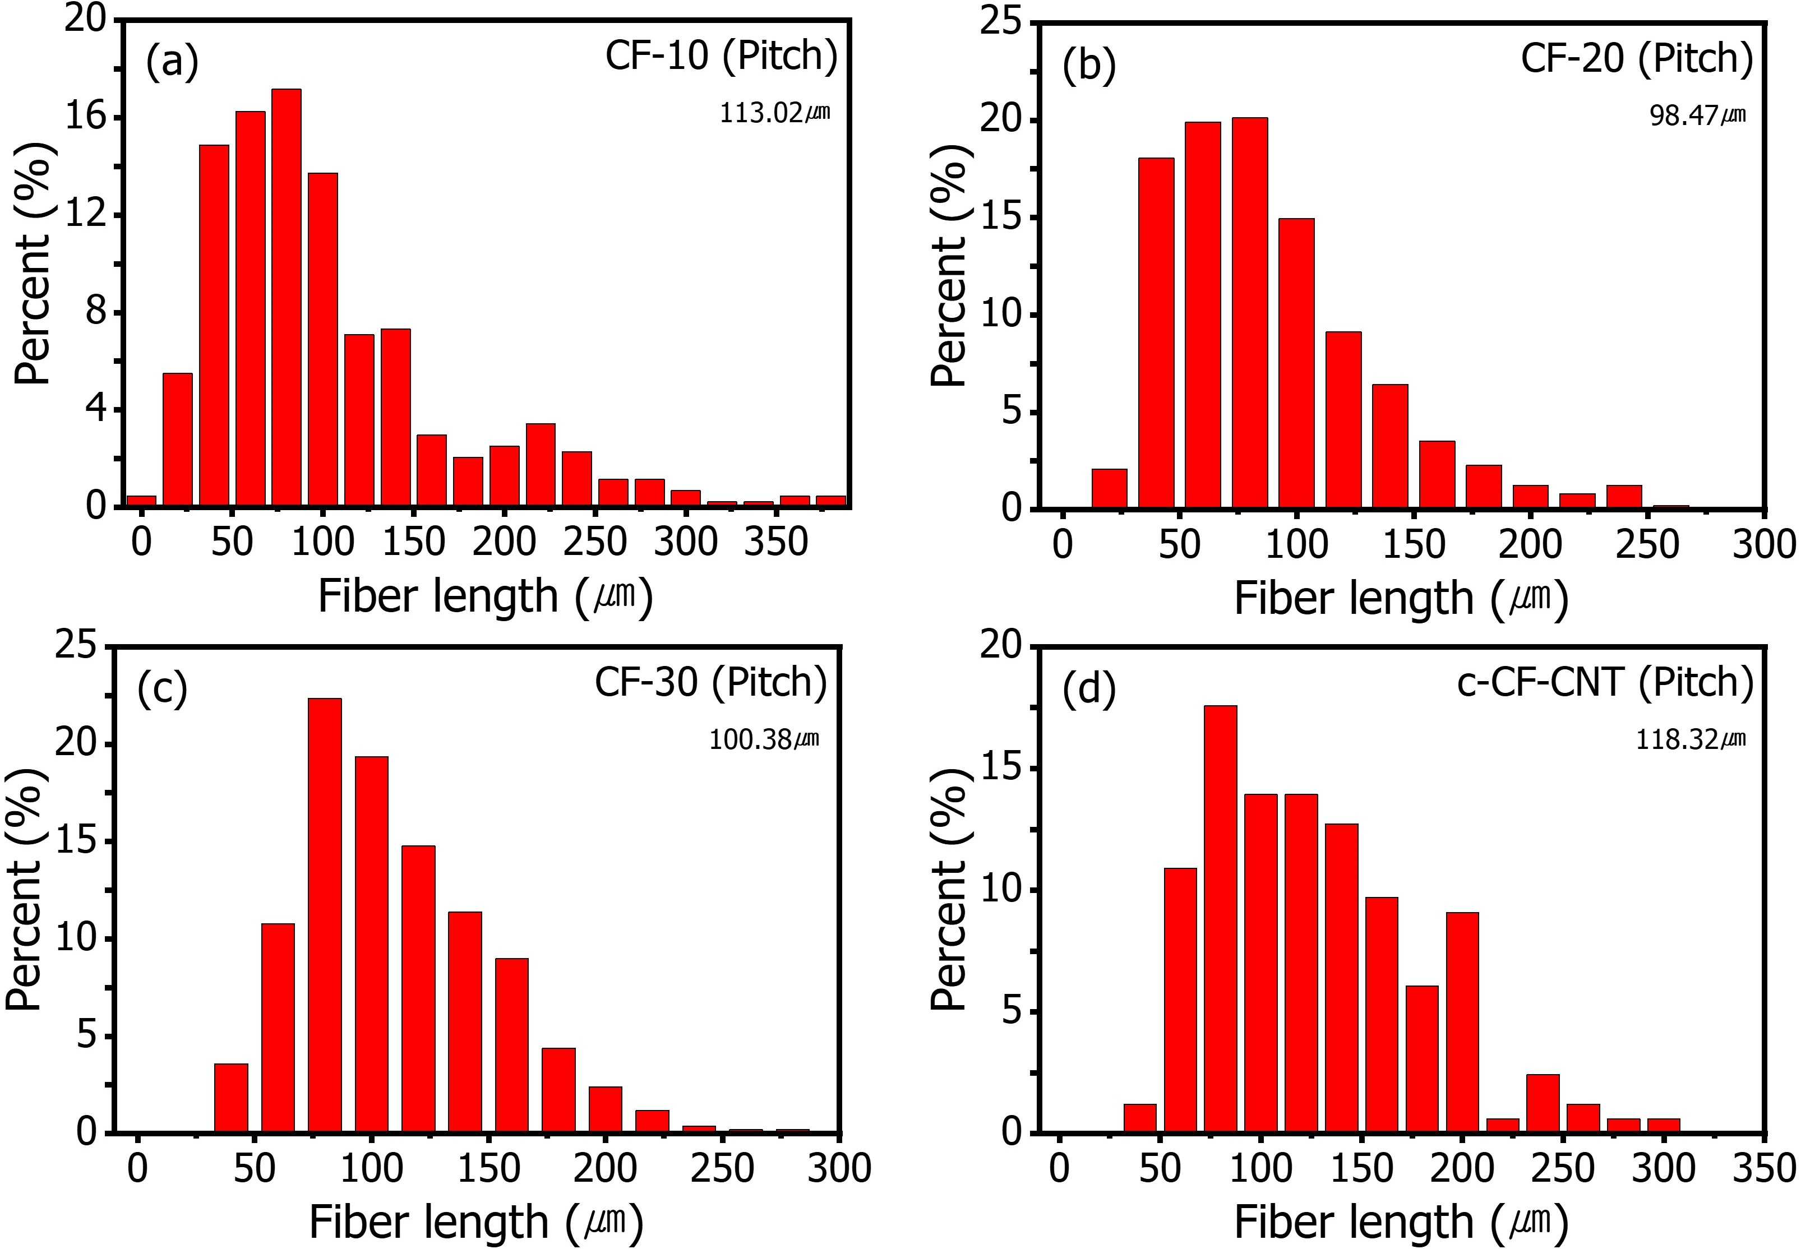
Fig. S1 Fiber length measured by optical microscopy for pitch composites, average length in parentheses. (a) CF-10, (b) CF-20, (c) CF-30, (d) c-CF-CNT.

Optical-microscopy histograms for the pitch matrix show unimodal fiber length distributions with long right tails that arise from a small number of extended fragments. The annotated means are approximately 100 to 120 μm for CF-10, CF-20, CF-30, and c-CF-CNT. These values define the pitch baseline used to compare retention across systems and are consistent with the processing history described in the main text.
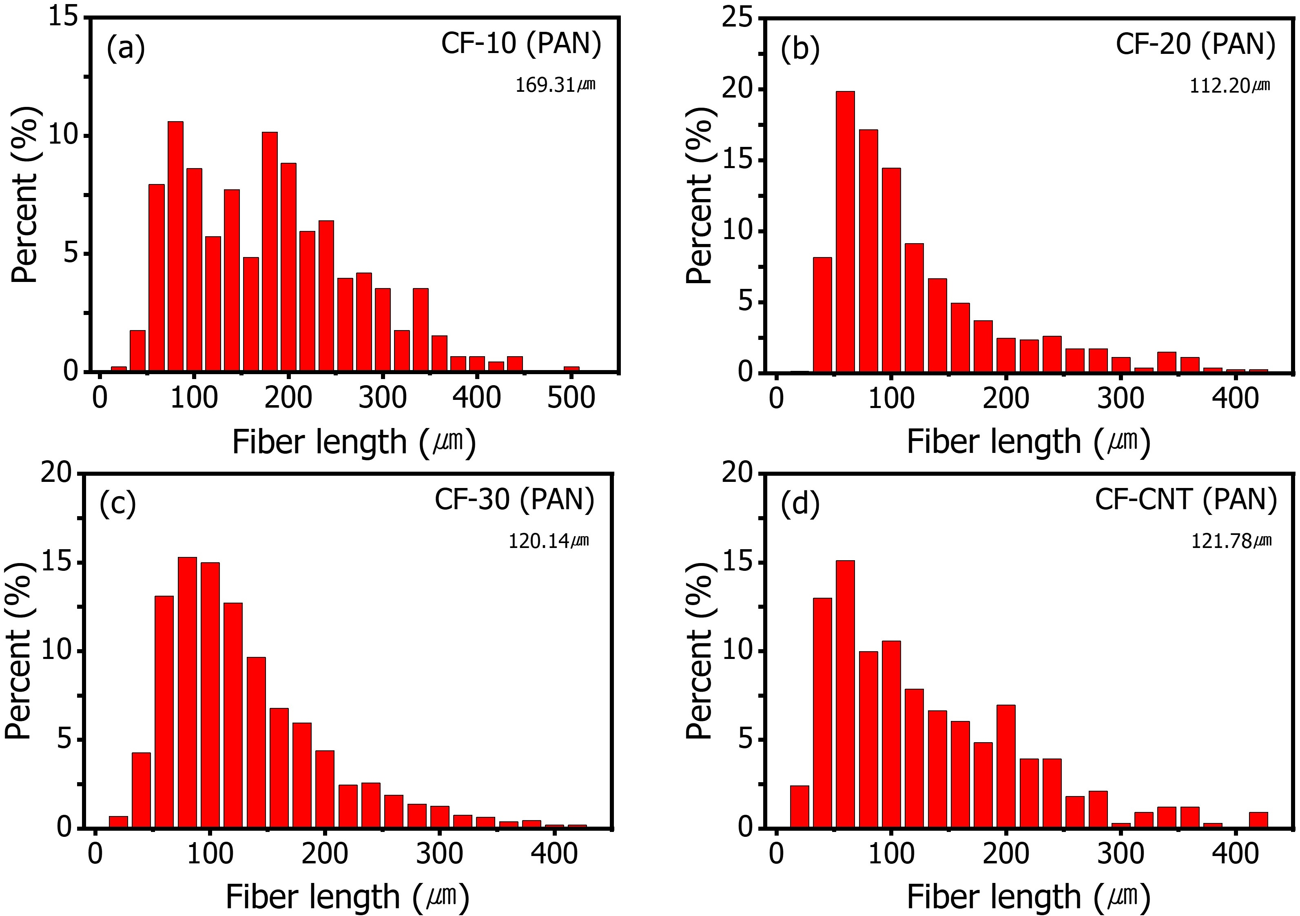
Fig. S2 Fiber length measured by optical microscopy for PAN composites, average length in parentheses. (a) CF-10, (b) CF-20, (c) CF-30, (d) c-CF-CNT.

The PAN matrix, evaluated with the same polishing and counting protocol, gives generally higher mean fiber lengths than pitch at the same CF level, most clearly at CF-10. At higher CF contents the averages move toward a similar range but still remain slightly greater than pitch. The distributions again display long tails, indicating that a minority of long fragments survive compounding and molding and can contribute to percolation.
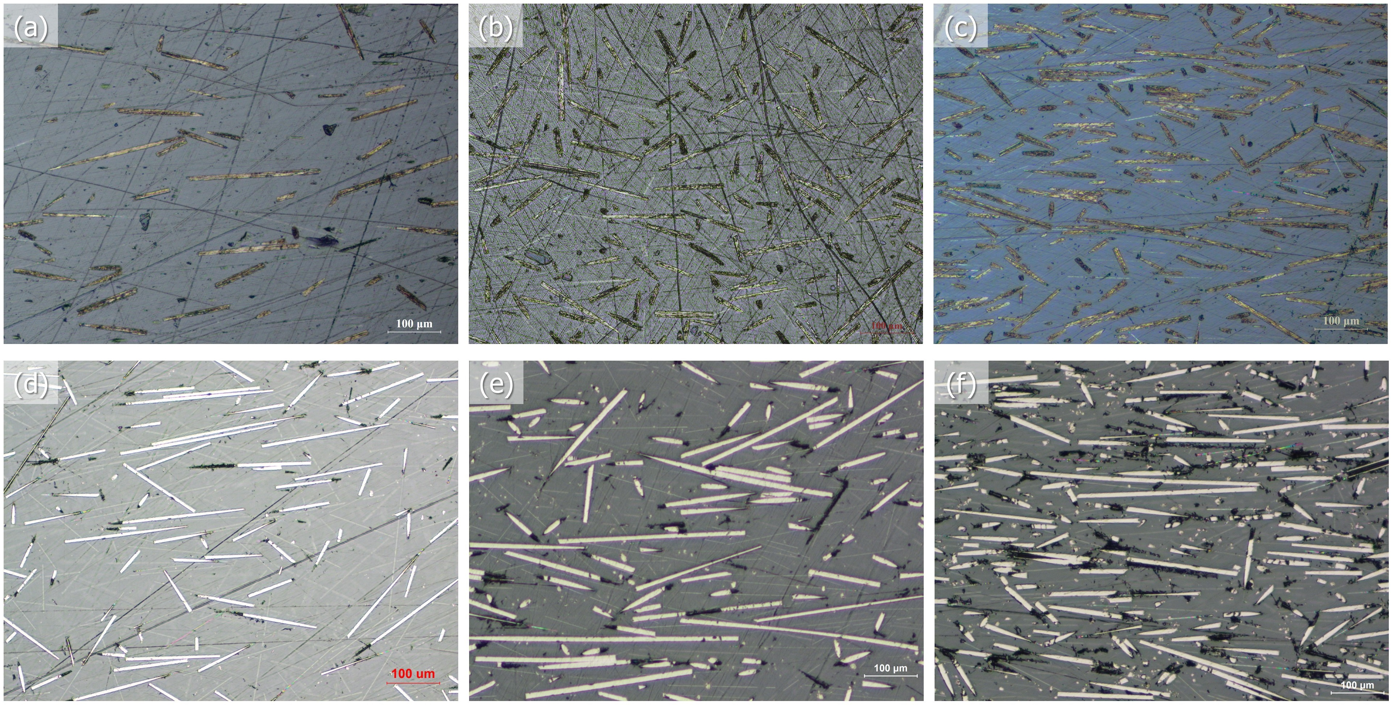
Fig. S3 Optical micrographs showing in-plane distribution and orientation with increasing CF loading. Pitch: (a) CF-10, (b) CF-20, (c) CF-30. PAN: (d) CF-10, (e) CF-20, (f) CF-30.

Plan-view optical micrographs illustrate in-plane CF distribution and alignment. Increasing CF loading leads to higher fragment areal density and reduced inter-fragment spacing, which supports the formation of conductive pathways under shear and fountain flow during molding. PAN samples appear more uniformly dispersed with fewer polishing artifacts, while pitch samples show more surface debris. These qualitative features are in line with the conductivity and shielding trends in the main text.

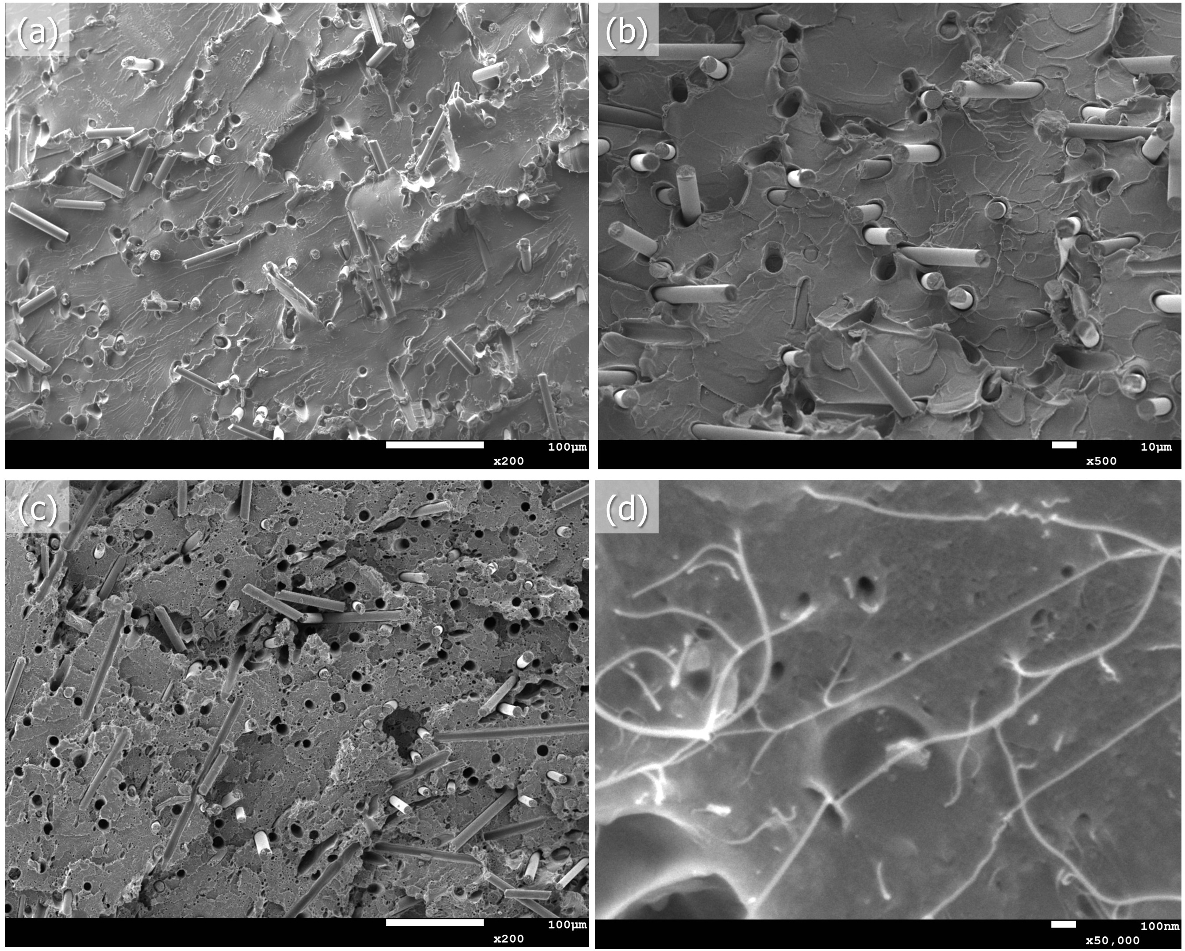
Fig. S4 Supplementary FE-SEM views of fractured fiber–matrix interphases. (a) CF-10 pitch, (b) CF-10 PAN, (c) c-CF-CNT pitch, (d) CNT-0.5. Scale bar 1 µm.

Fracture-surface SEM images resolve the interphase. Uncoupled interfaces show relatively smooth fiber imprints and clean pull-out cavities that suggest limited interfacial adhesion. Coupled specimens display rougher interphases with matrix residues and short micro-bridges attached to the fibers. High-magnification views reveal CNT filaments embedded in the matrix and locally wrapping the sized CFs, which supports the proposed CF–CNT interaction and accounts for improved load transfer and electrical connectivity.
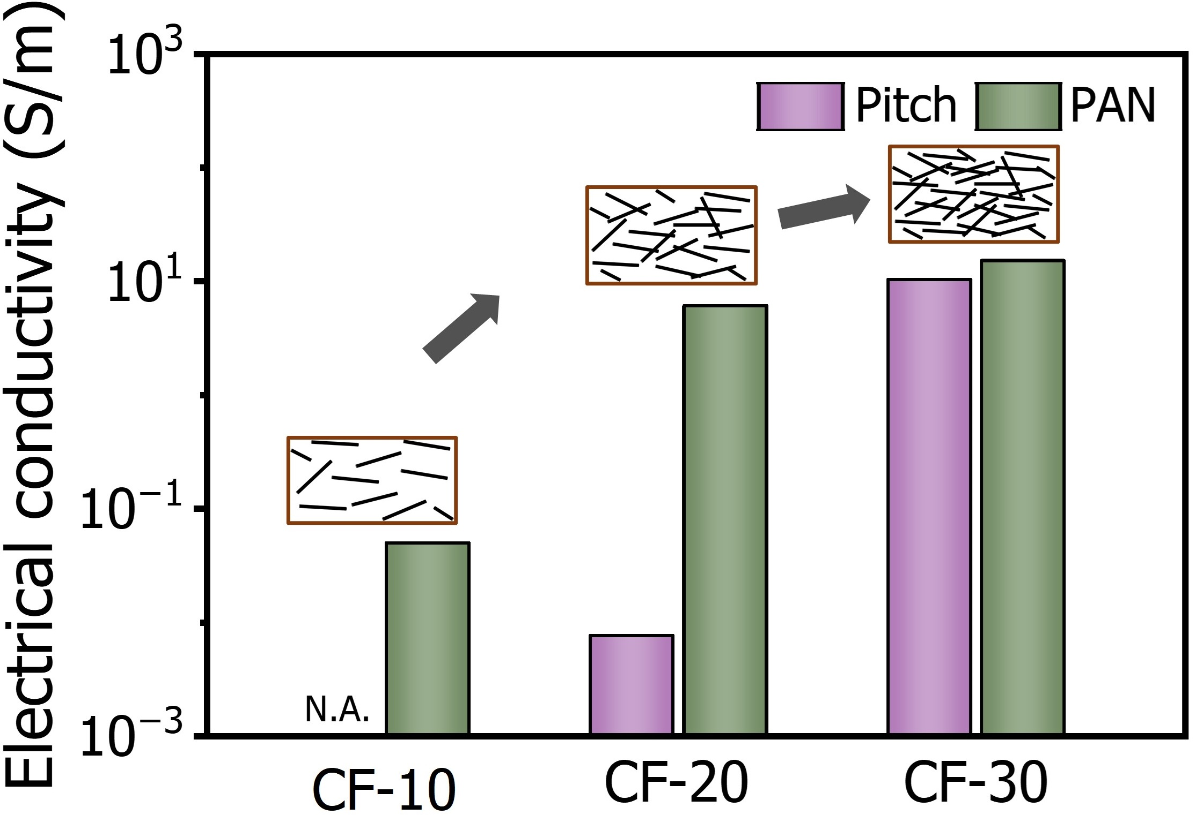
Fig. S5 Electrical conductivity versus CF loading for pitch and PAN at 0.5 wt% CNT, bars show the mean with error bars.
Electrical conductivity increases monotonically with CF content for both matrices as fragment density and orientation raise the probability of network formation. At the same CF loading the PAN matrix yields higher conductivity than the pitch matrix, consistent with its longer average fibers and cleaner dispersion. Pitch CF-10 falls below the instrument detection limit, which matches the threshold behavior discussed in the main text.

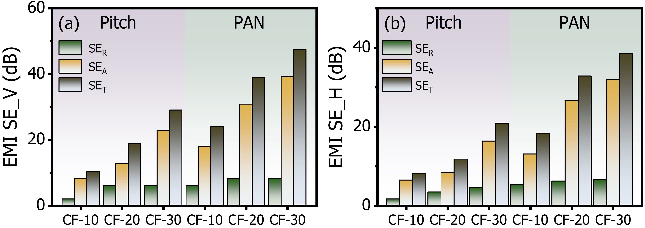
Fig. S6 Shielding effectiveness components at 10 GHz by geometry; (a) vertical and (b) horizontal. Stacked bars present SER, SEA, and SET for pitch and PAN across CF loadings.

Shielding component analysis at 10 GHz shows that total shielding effectiveness grows with CF content in both vertical and horizontal orientations. Across the series, absorption increases more than reflection in absolute terms, though reflection remains sizable. The vertical orientation shows a modest advantage consistent with flow induced alignment.

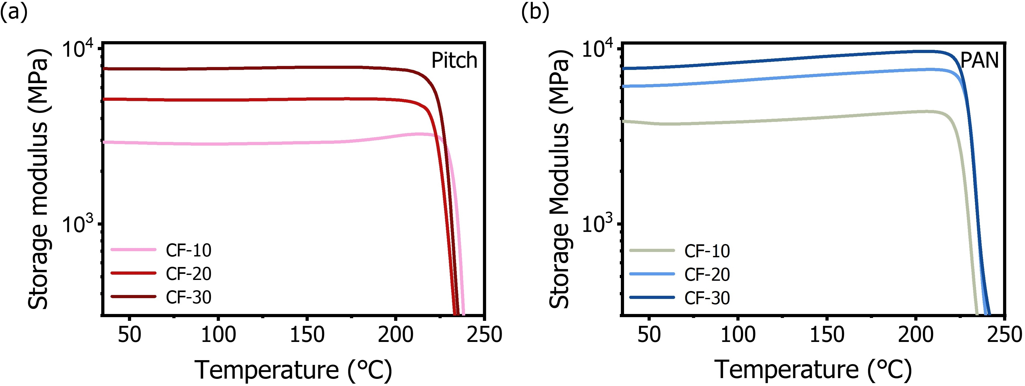
Fig. S7 Storage modulus versus temperature across CF contents for (a) pitch and (b) PAN.

DMA storage modulus curves increase with CF content through the measured temperature window, indicating effective reinforcement in both matrices. PAN composites maintain higher absolute moduli and a slightly delayed terminal softening relative to pitch at the same CF level. These thermal-mechanical responses are consistent with the tensile stiffness hierarchy and with the interphase roughening observed by SEM.

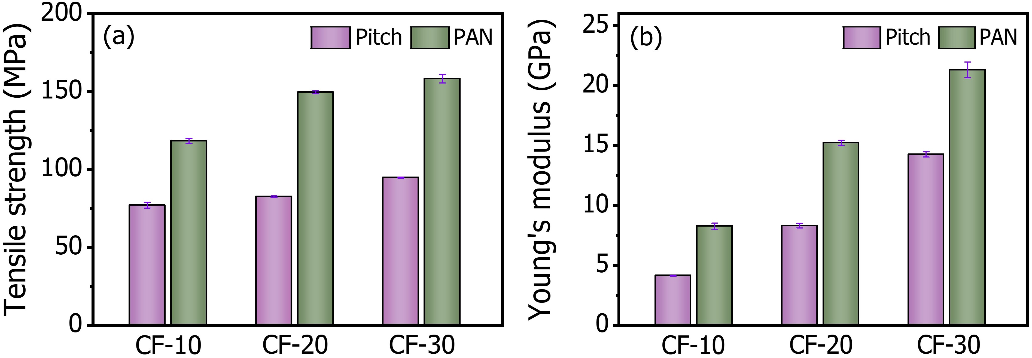
Fig. S8 Tensile properties across CF contents for pitch and PAN. (a) Tensile strength, (b) Young’s modulus. Error bars indicate sample-to-sample variability.

Tensile data follow the same trend. Strength and Young’s modulus rise with CF content for both pitch and PAN, and the PAN matrix outperforms pitch at matched loadings. The combination of longer average PAN fiber lengths, cleaner dispersion, and coupled interphase features explains the higher stiffness and strength and aligns with the DMA and shielding results.

