Substantial increases in the likelihood of extreme fire weather events for fire-prone ecosystems in Australia
Ryan McGloin¹*, Ralph Trancoso^{1,2}, Jozef Syktus^{1,2}, Rohan Eccles^{1,2}, Nathan Toombs¹, Andrew Dowdy³
¹Queensland Future Climate Science Program, Queensland Government, Brisbane, Australia
²School of The Environment, The University of Queensland, Brisbane, Australia
³School of Geography, Earth and Atmospheric Sciences, University of Melbourne, Melbourne, VIC, Australia

Supplementary Material
This supplementary material contains Figure S1 to Figure S23 and Table S1 to Table S4.

Bias correction: Calibration data
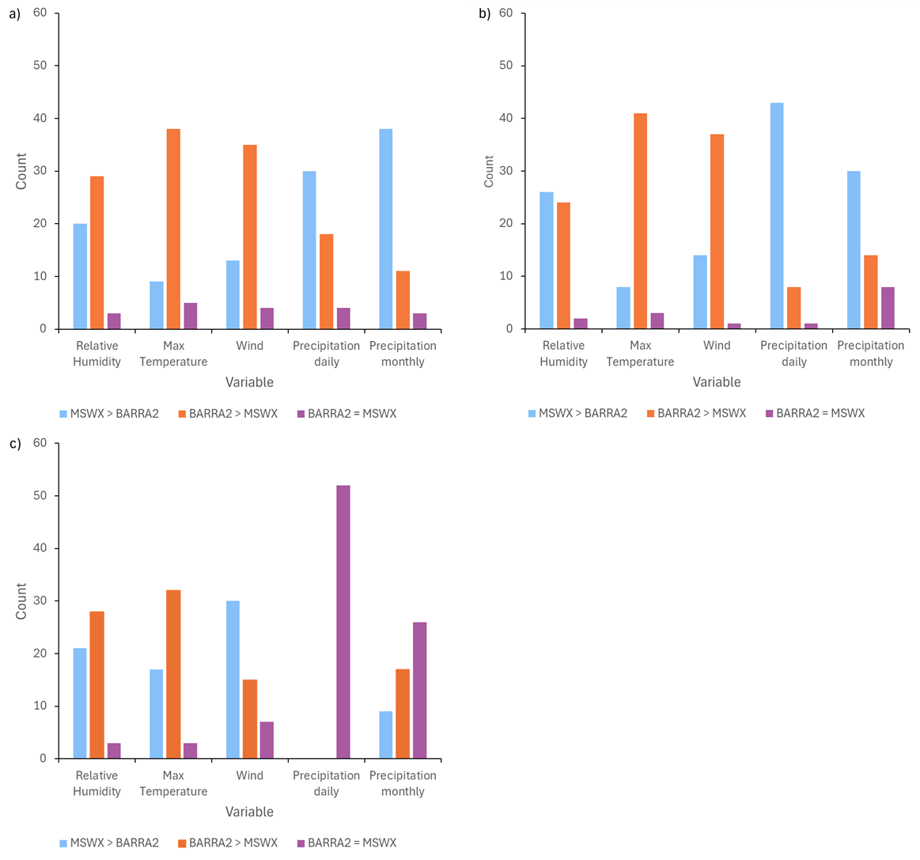
Figure S1. Counts of stations where the Perkins skill score was higher for either BARRA2 or MSWX-Past for relevant climate variables. Results are presented for a) Perkins skill scores calculated using the entire distributions as well calculated using just the b) upper (95–100th percentiles) and c) lower (0–5th percentiles) tails of the distributions.
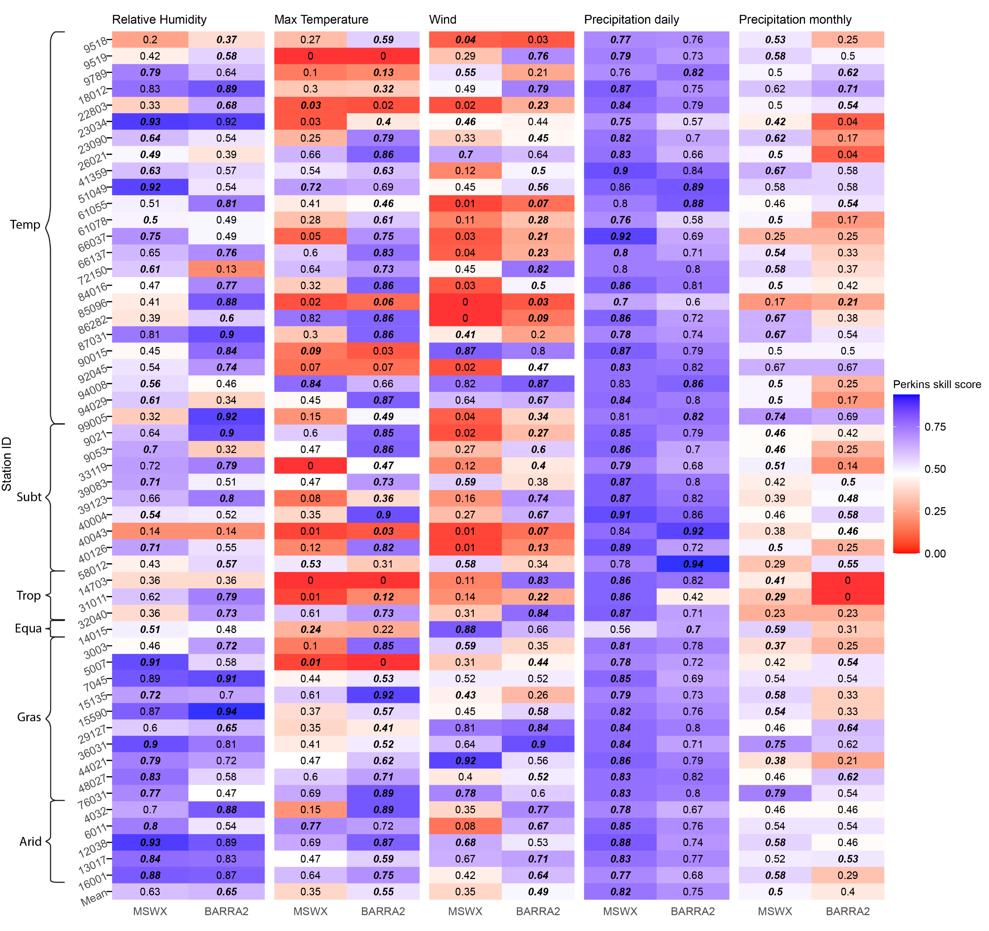
Figure S2. Heat map of Perkins skill scores calculated for the MSWX-Past and BARRA2 datasets using station observations for the 1980-2020 period. Perkins scores are provided for each station and variable (daily relative humidity, maximum air temperature and wind speed and daily and monthly precipitation). Only the upper tails of the distributions (95–100th percentiles) were used in these Perkins skill score calculations. The higher of the MSWX-Past and BARRA2 Perkins skill scores at each station is highlighted in bold italics. The climate regions where the stations are located are indicated on the lefthand side of the figure using the following abbreviations: Temp = Temperate, Subt = Subtropical, Trop = Tropical, Equa = Equatorial, and Gras = Grassland.

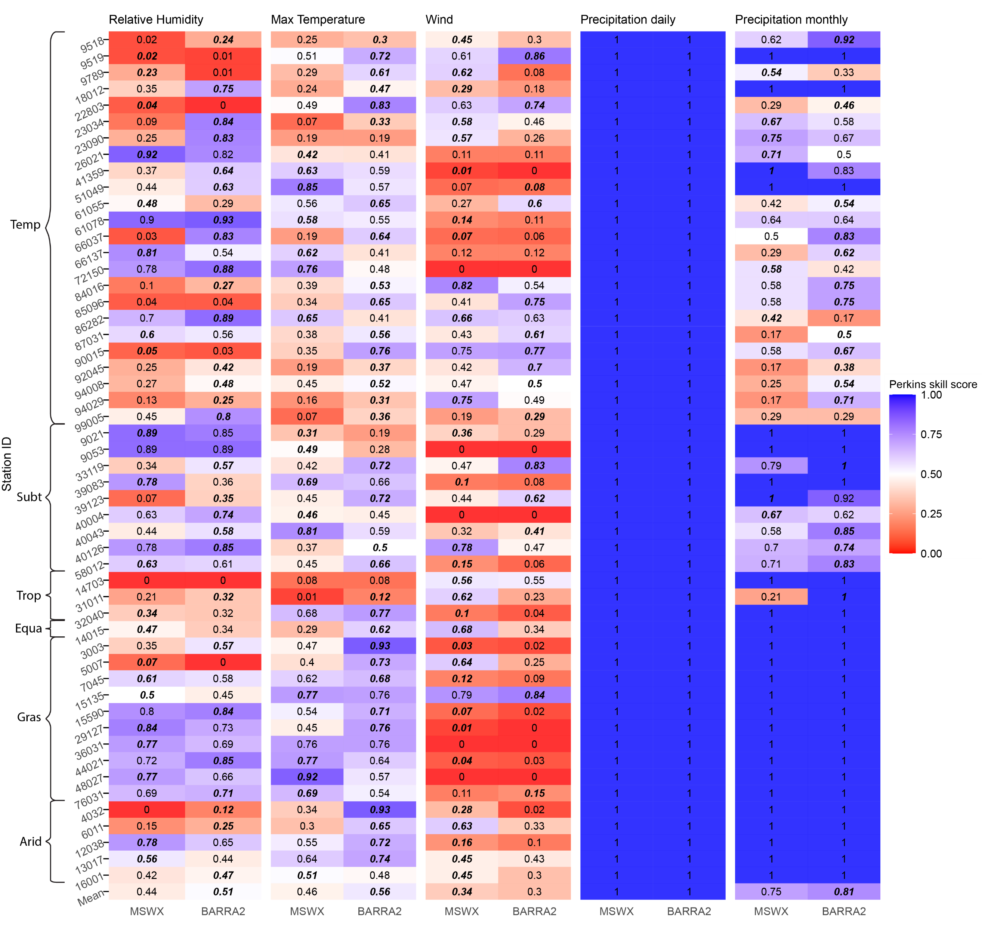
Figure S3. Heat map of Perkins skill scores calculated for the MSWX-Past and BARRA2 datasets using station observations for the 1980-2020 period. Perkins scores are provided for each station and variable (daily relative humidity, maximum air temperature and wind speed and daily and monthly precipitation). Only the lower tails of the distributions (0–5th percentiles) were used in these Perkins skill score calculations. The higher of the MSWX-Past and BARRA2 Perkins skill scores at each station is highlighted in bold italics.

Bias correction: Bias corrected data

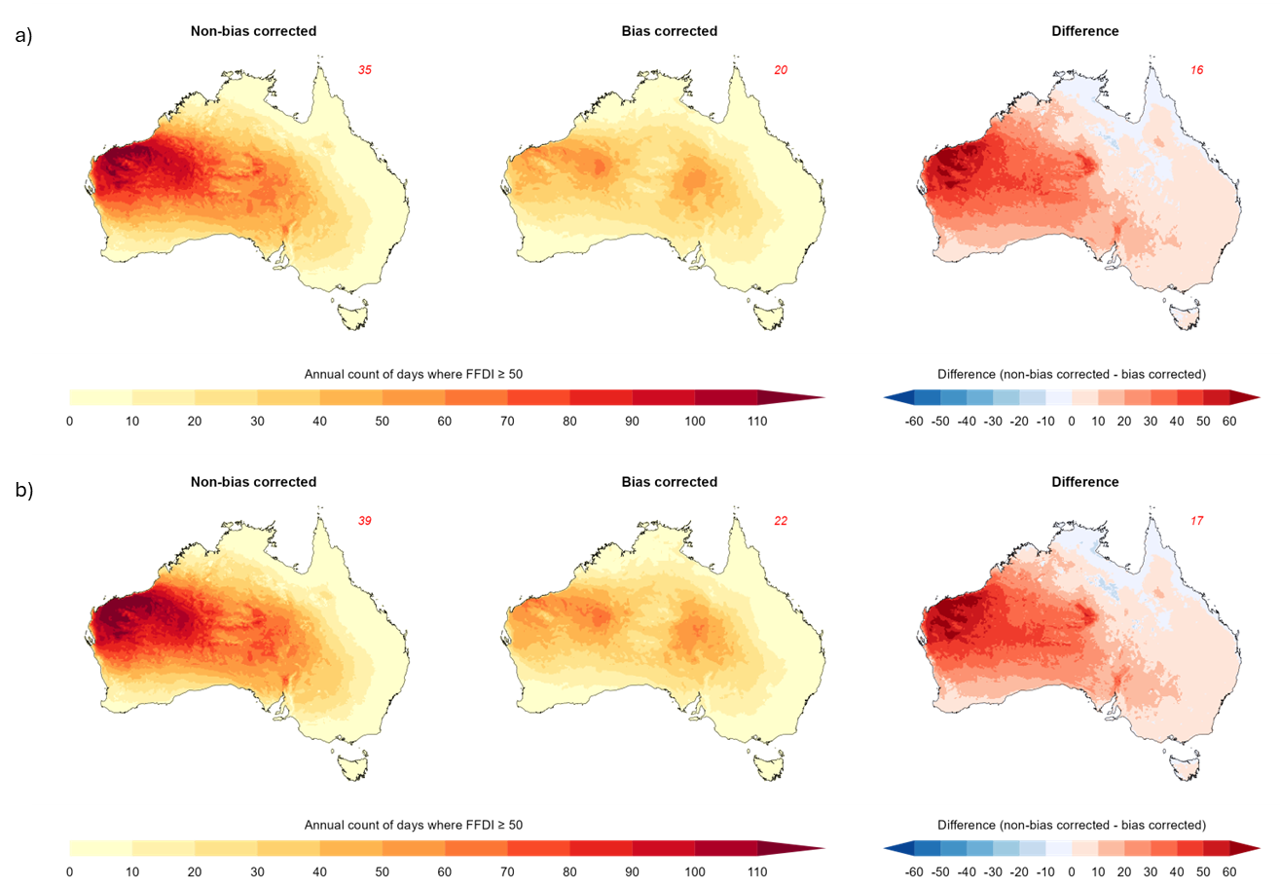
Figure S4. Ensemble average count of days with FFDI > 50 for the non-bias corrected and bias corrected downscaled model ensembles for a) 3 ◦C and b) 4 ◦C of global warming. The differences between the bias corrected and non-bias corrected ensembles are also shown.

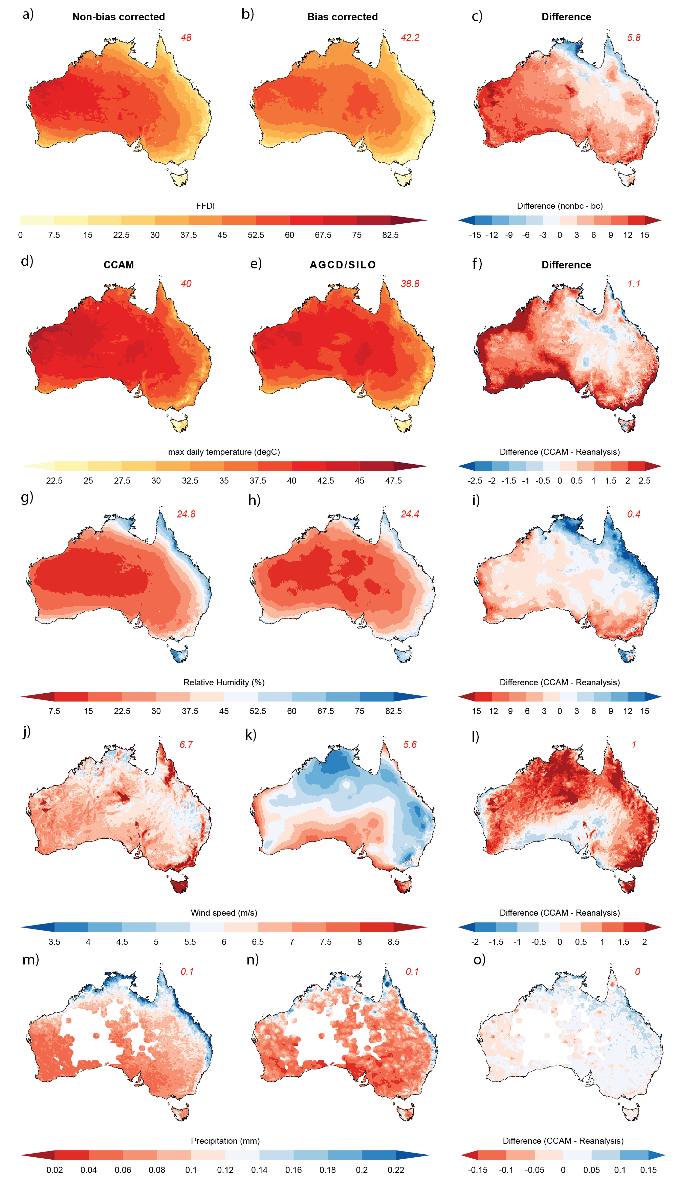
Figure S5. Comparison showing the ensemble average 95th percentile (a) bias corrected and (b) non-bias corrected FFDI and the ensemble average CCAM and AGCD (d and e) 95th percentile daily maximum temperature, (g and h) 5th percentile daily relative humidity, and (m and n) 5th percentile daily precipitation. Ensemble average CCAM and SILO (j and k) 95th percentile daily wind speed are also shown. Differences between the bias corrected and non-bias corrected FFDI, and CCAM and BARRA2 percentiles are also displayed (c, f, i, l and o). All percentiles were calculated for the 1981-2014 period. Red values in the top right corner show the average over Australia. Note that AGCD wind data was not available, hence the usage of SILO¹ wind speed data. Sub-daily AGCD/SILO data were also not available, hence the usage of daily data for wind speed and humidity. Areas where precipitation observations are poor are masked out.
FFDI categories
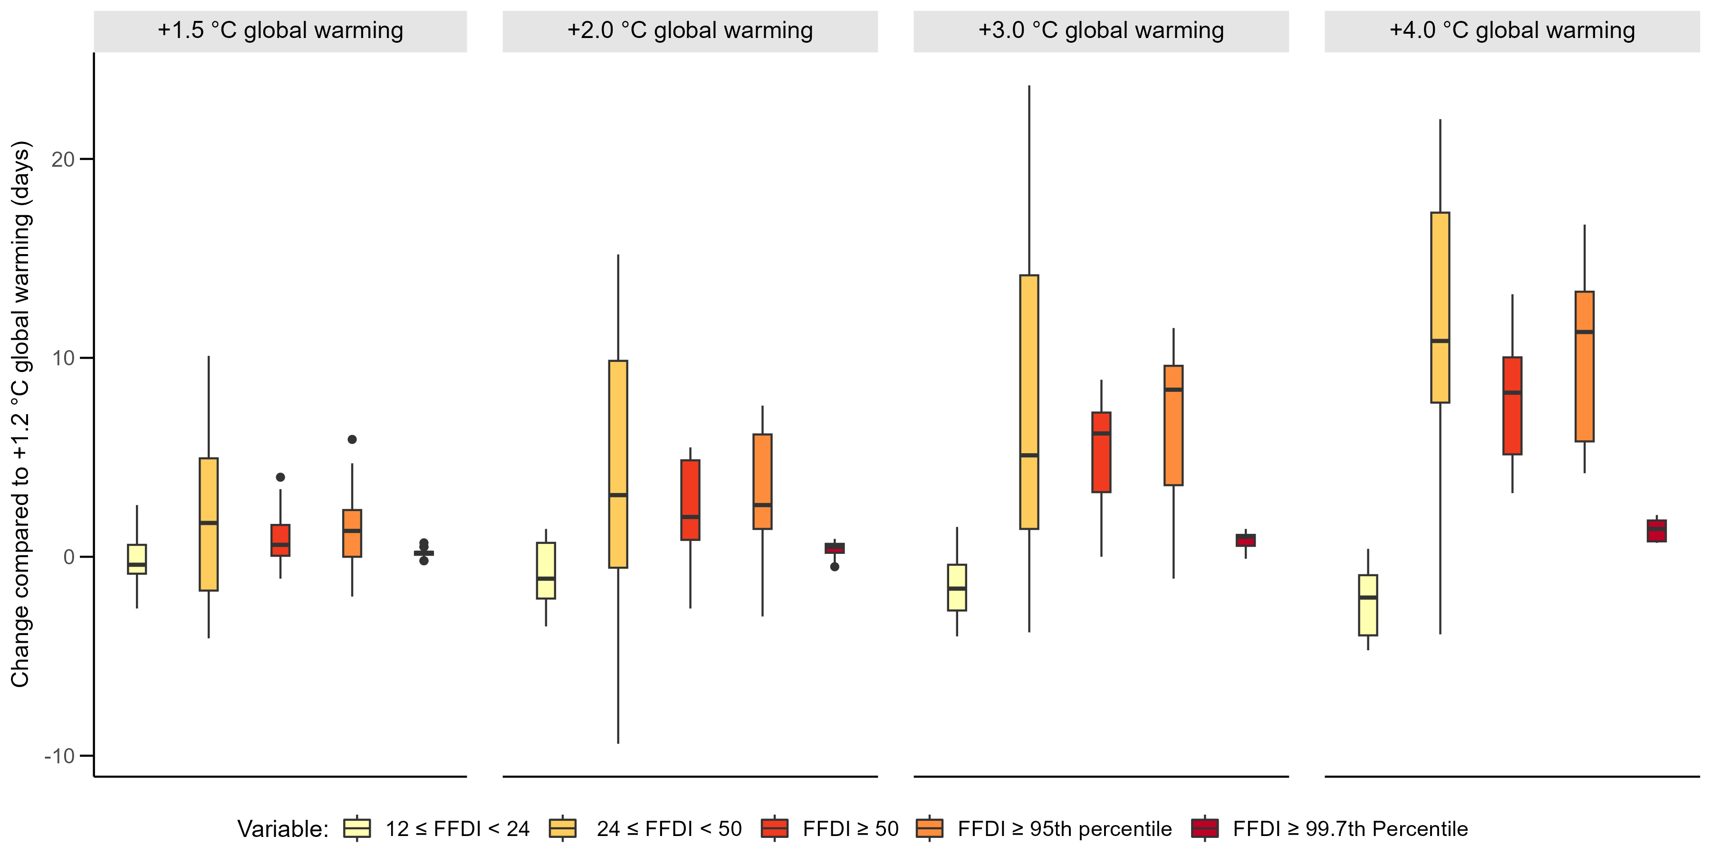
Figure S6. Changes in the mean annual count of days with high (12 ≤FFDI < 24), very high (24 ≤FFDI < 50) and severe (FFDI ≥ 50) fire weather conditions and when FFDI is greater than the 95th and 99.726th percentiles (as calculated for 1.2 ◦C of global warming) for different levels of global warming. Boxplots show variability in the mean change for Australia across the model ensemble.

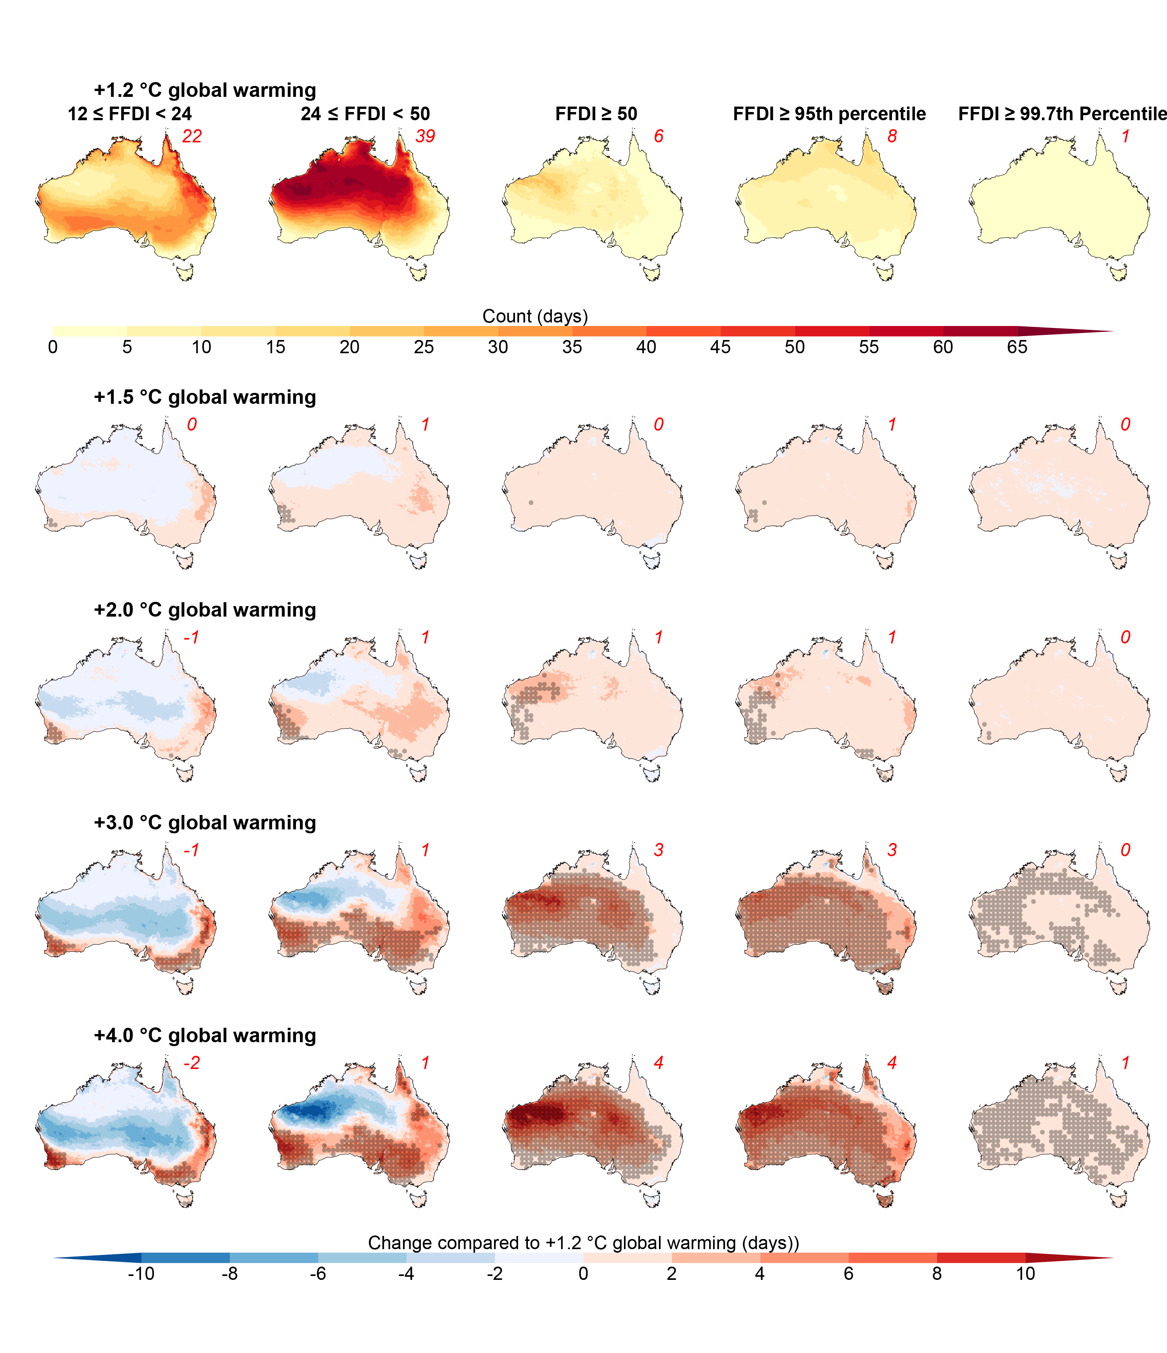
Figure S7. Comparison of ensemble mean change in the mean spring (September, October, November) count of days with high (12 ≤FFDI < 24), very high (24 ≤FFDI < 50) and severe (FFDI ≥ 50) fire weather conditions for different levels of global warming. Changes are calculated compared to the values under 1.2 ◦C of global warming (as shown in the top row). Changes in the counts of days with FFDI above the 95th and 99.726th percentiles calculated under 1.2 ◦C of global warming are also shown. Red values in the top right corner show the average changes over Australia while stippling shows where the signal to noise ratio > 1.0.
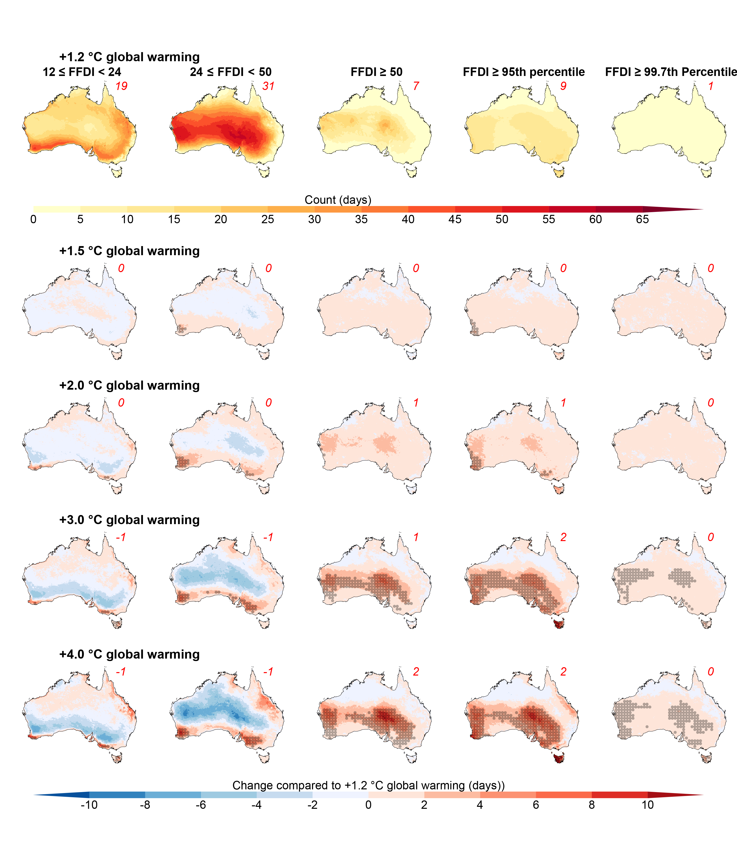
Figure S8. Comparison of ensemble mean change in the mean summer (December, January, February) count of days with high (12 ≤FFDI < 24), very high (24 ≤FFDI < 50) and severe (FFDI ≥ 50) fire weather conditions for different levels of global warming. Changes are calculated compared to the values under 1.2 ◦C of global warming (as shown in the top row). Changes in the counts of days with FFDI above the 95th and 99.726th percentiles calculated under 1.2 ◦C of global warming are also shown. Red values in the top right corner show the average changes over Australia while stippling shows where the signal to noise ratio > 1.0.

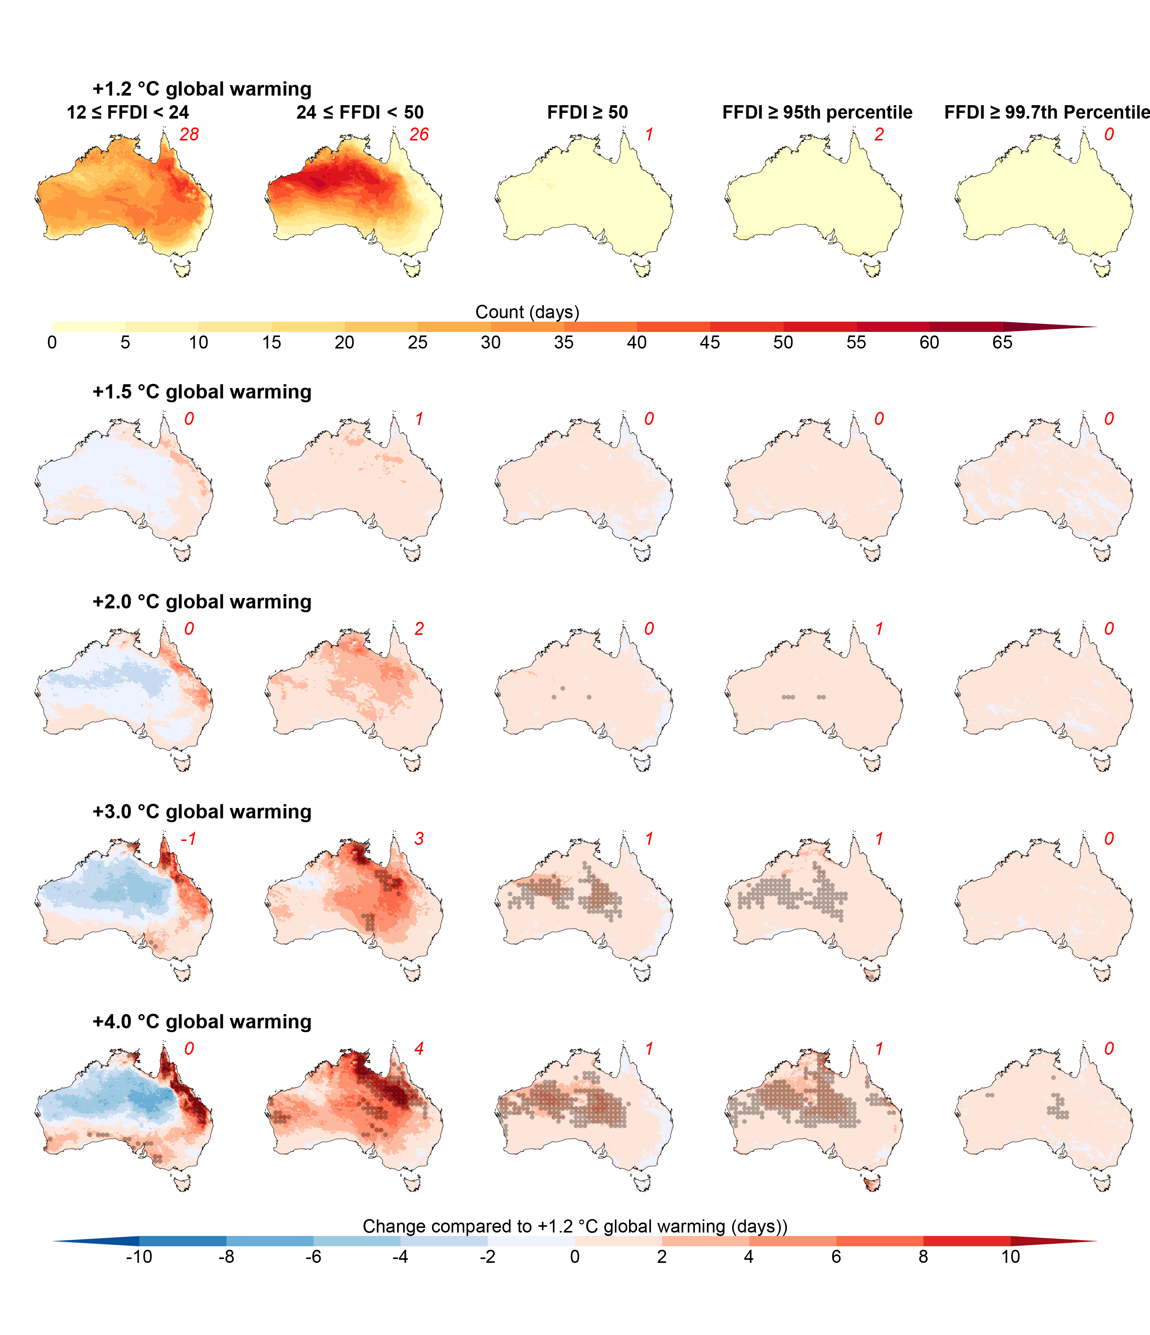
Figure S9. Comparison of ensemble mean change in the mean autumn (March, April, May) count of days with high (12 ≤FFDI < 24), very high (24 ≤FFDI < 50) and severe (FFDI ≥ 50) fire weather conditions for different levels of global warming. Changes are calculated compared to the values under 1.2 ◦C of global warming (as shown in the top row). Changes in the counts of days with FFDI above the 95th and 99.726th percentiles calculated under 1.2 ◦C of global warming are also shown. Red values in the top right corner show the average changes over Australia while stippling shows where the signal to noise ratio > 1.0.
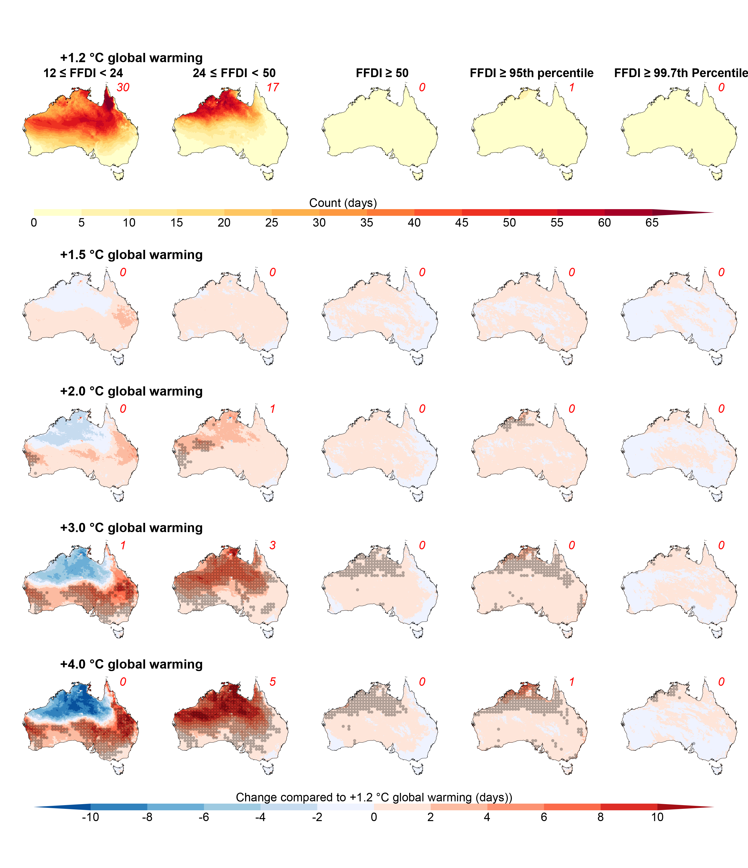
Figure S10. Comparison of ensemble mean change in the mean winter (June, July, August) count of days with high (12 ≤FFDI < 24), very high (24 ≤FFDI < 50) and severe (FFDI ≥ 50) fire weather conditions for different levels of global warming. Changes are calculated compared to the values under 1.2 ◦C of global warming (as shown in the top row). Changes in the counts of days with FFDI above the 95th and 99.726th percentiles calculated under 1.2 ◦C of global warming are also shown. Red values in the top right corner show the average changes over Australia while stippling shows where the signal to noise ratio > 1.0.

Extreme fire weather events in Australia: Magnitude
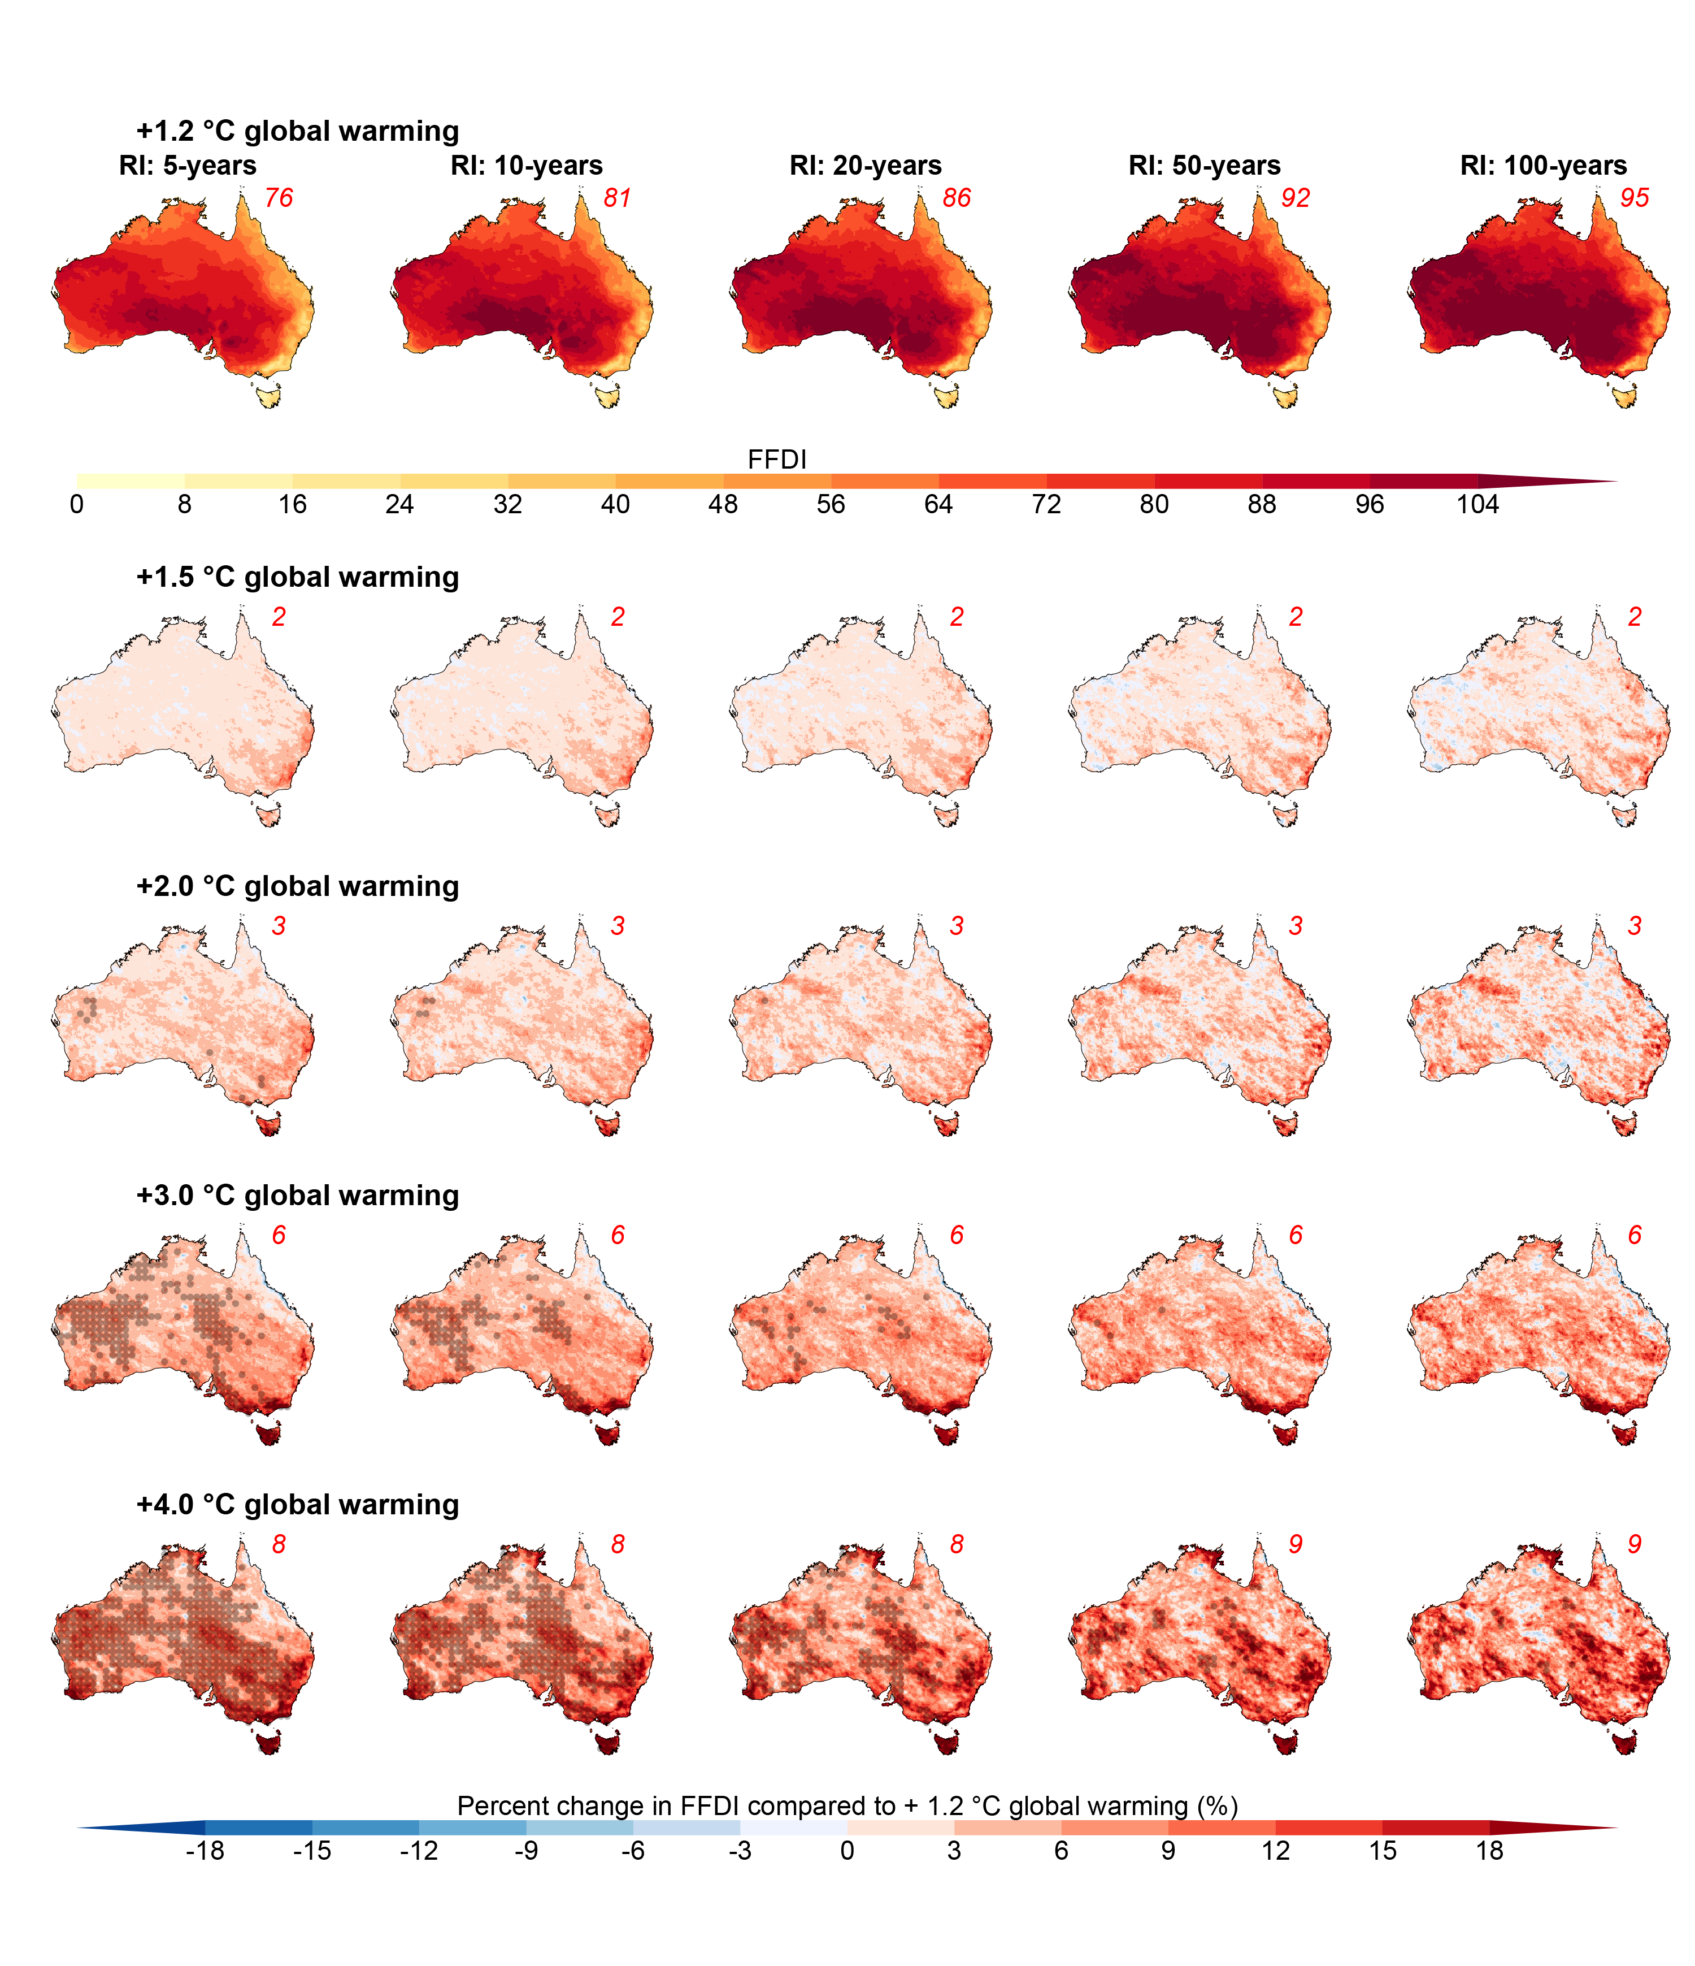
Figure S11. Comparison of ensemble median change in the magnitude of 5-, 10-, 20-, 50-, and 100-year return interval daily FFDI events for different levels of global warming. Changes are calculated as percentage change compared to the values under 1.2 ◦C of global warming (as shown in the top row). Red values in the top right corner show the average changes over Australia while stippling shows where the signal to noise ratio > 1.0. Boxplots showing the variations in mean changes over Australia across the model ensemble are provided in Supplementary Material Figure S13.

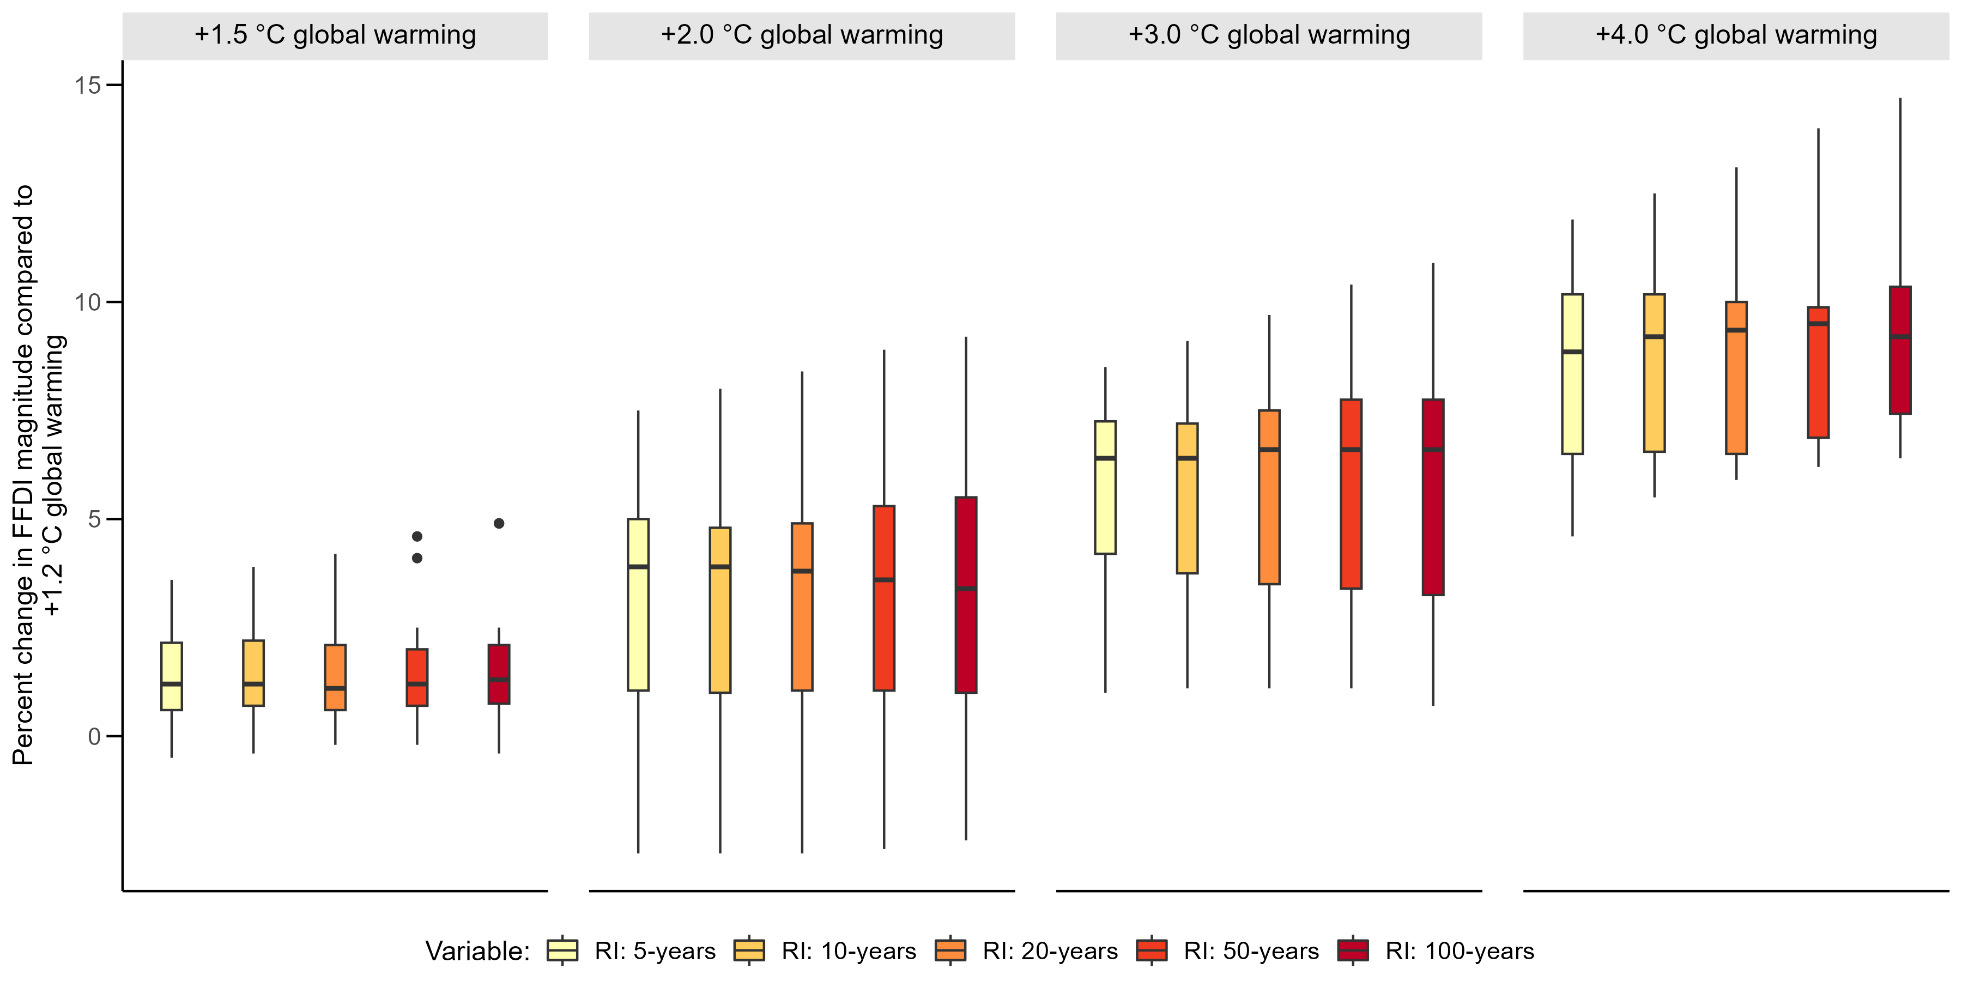
Figure S12. Changes in the magnitude of 5-, 10-, 20-, 50-, and 100-year return interval 7-day running mean FFDI events for different levels of global warming compared to +1.2 ◦C GWL. Boxplots show variability in the median change for Australia across the model ensemble.

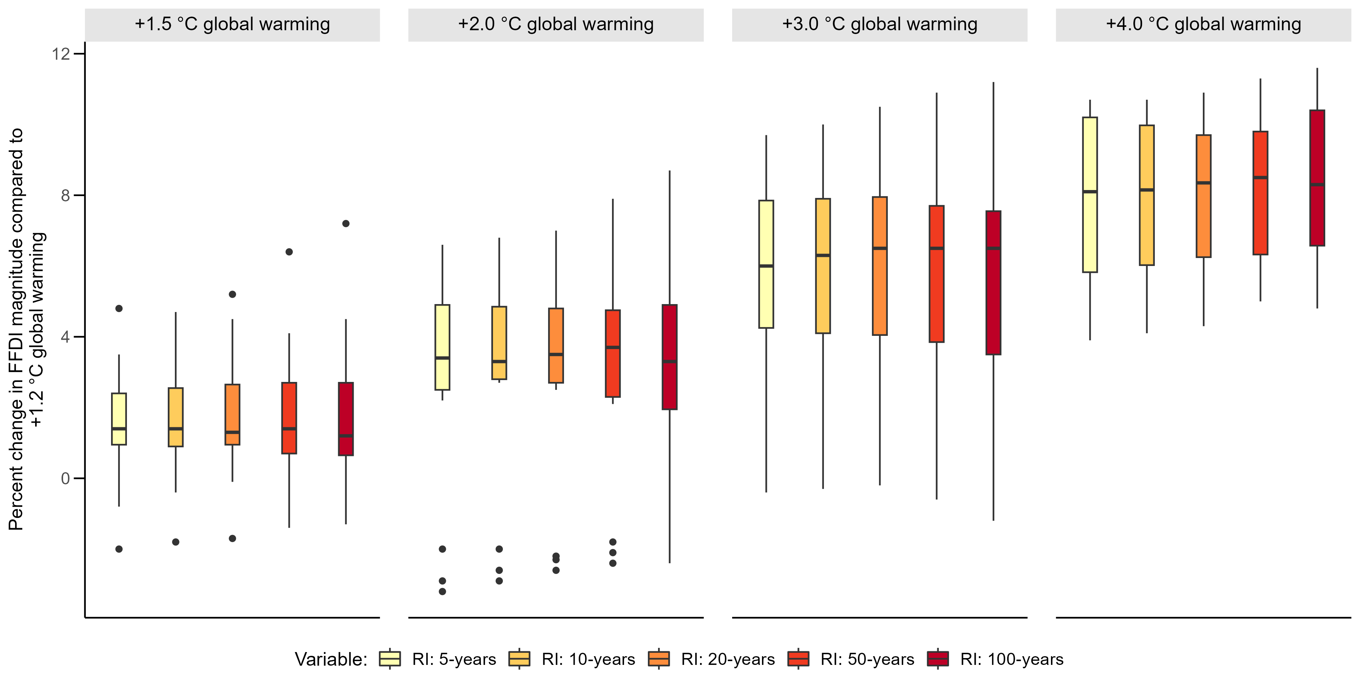
Figure S13. Changes in the magnitude of 5-, 10-, 20-, 50-, and 100-year return interval daily FFDI events for different levels of global warming compared to +1.2 ◦C GWL. Boxplots show variability in the median change for Australia across the model ensemble.

Extreme fire weather events in Australia: Frequency
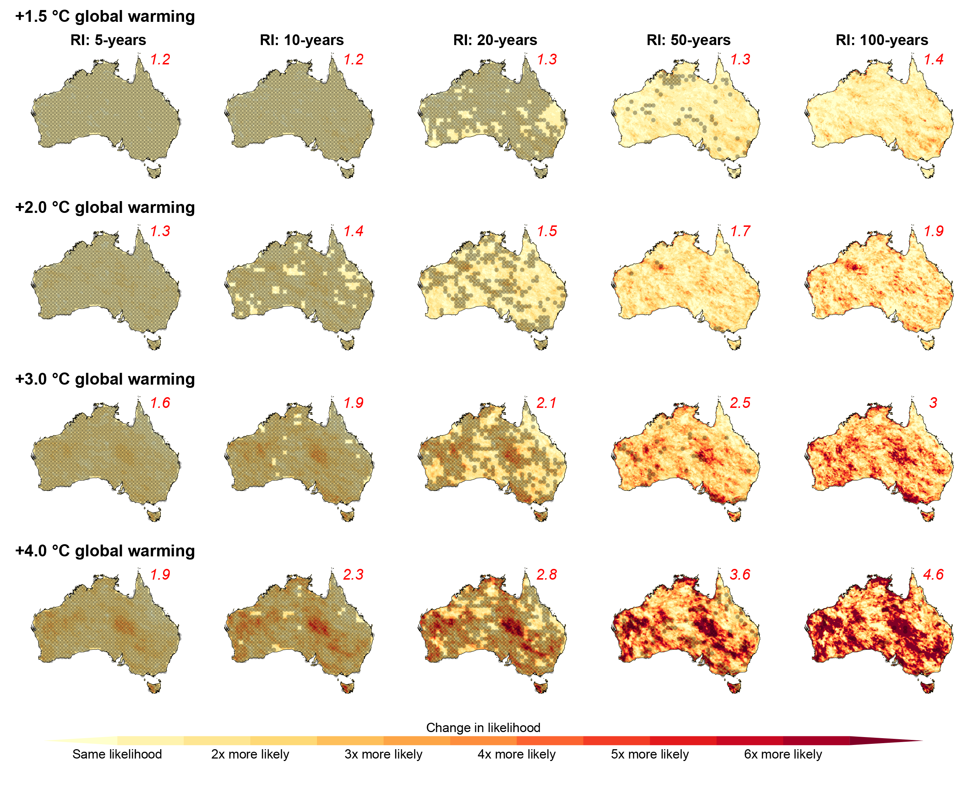
Figure S14. Comparison of ensemble median change in the likelihood of 5-, 10-, 20-, 50-, and 100-year return interval daily FFDI events for different levels of global warming. Changes are calculated as change in the likelihood of 7-day running mean FFDI events with magnitudes equal to those of 5-, 10-, 20-, 50-, and 100-year return interval events under +1.2 ◦C of global warming. Red values in the top right corner show the average changes over Australia while stippling shows where the signal to noise ratio > 1.0. Boxplots showing the variations in median changes over Australia across the model ensemble are provided in Supplementary Material Figure S15.

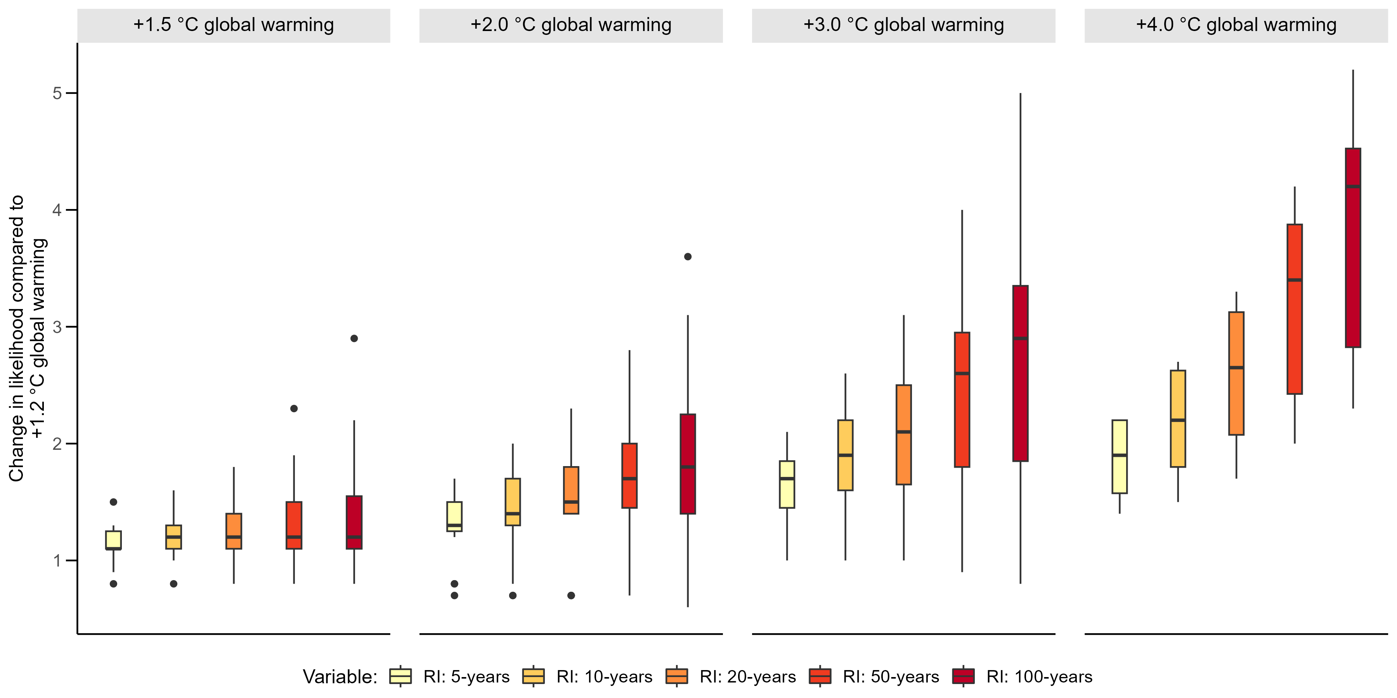
Figure S15. Changes in the likelihood of 5-, 10-, 20-, 50-, and 100-year return interval daily FFDI events for different levels of global warming compared to +1.2 ◦C GWL. Boxplots show variability in the median change for Australia across the model ensemble.
Extreme fire weather events in the eucalyptus forests of southeastern Australia

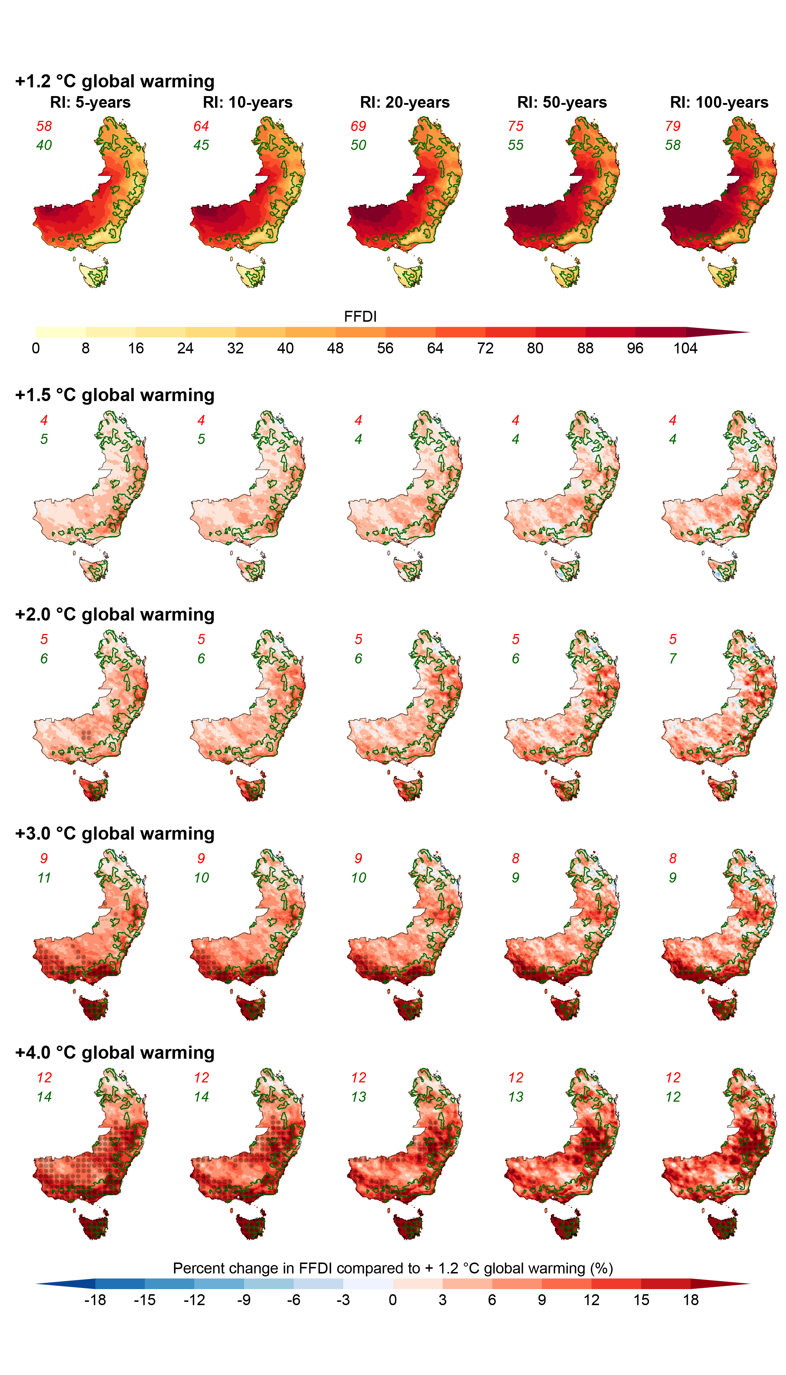
Figure S16. Comparison of ensemble median change to 5-, 10-, 20-, 50-, and 100-year return interval daily FFDI events for different levels of global warming. Changes are calculated as percentage change compared to the values under +1.2 ◦C of global warming (as shown in the top row). Data is displayed for southeastern Australia with the dense eucalyptus forests in the region outlined in green. Red values in the top left corner show the average changes for all southeastern Australia while the green values are the average for the eucalypt forests. Stippling shows where the signal to noise ratio > 1.0. Boxplots showing the variations in median changes across the model ensemble for southeast Australia’s Eucalypt forests are provided in Supplementary Material Figure S18.
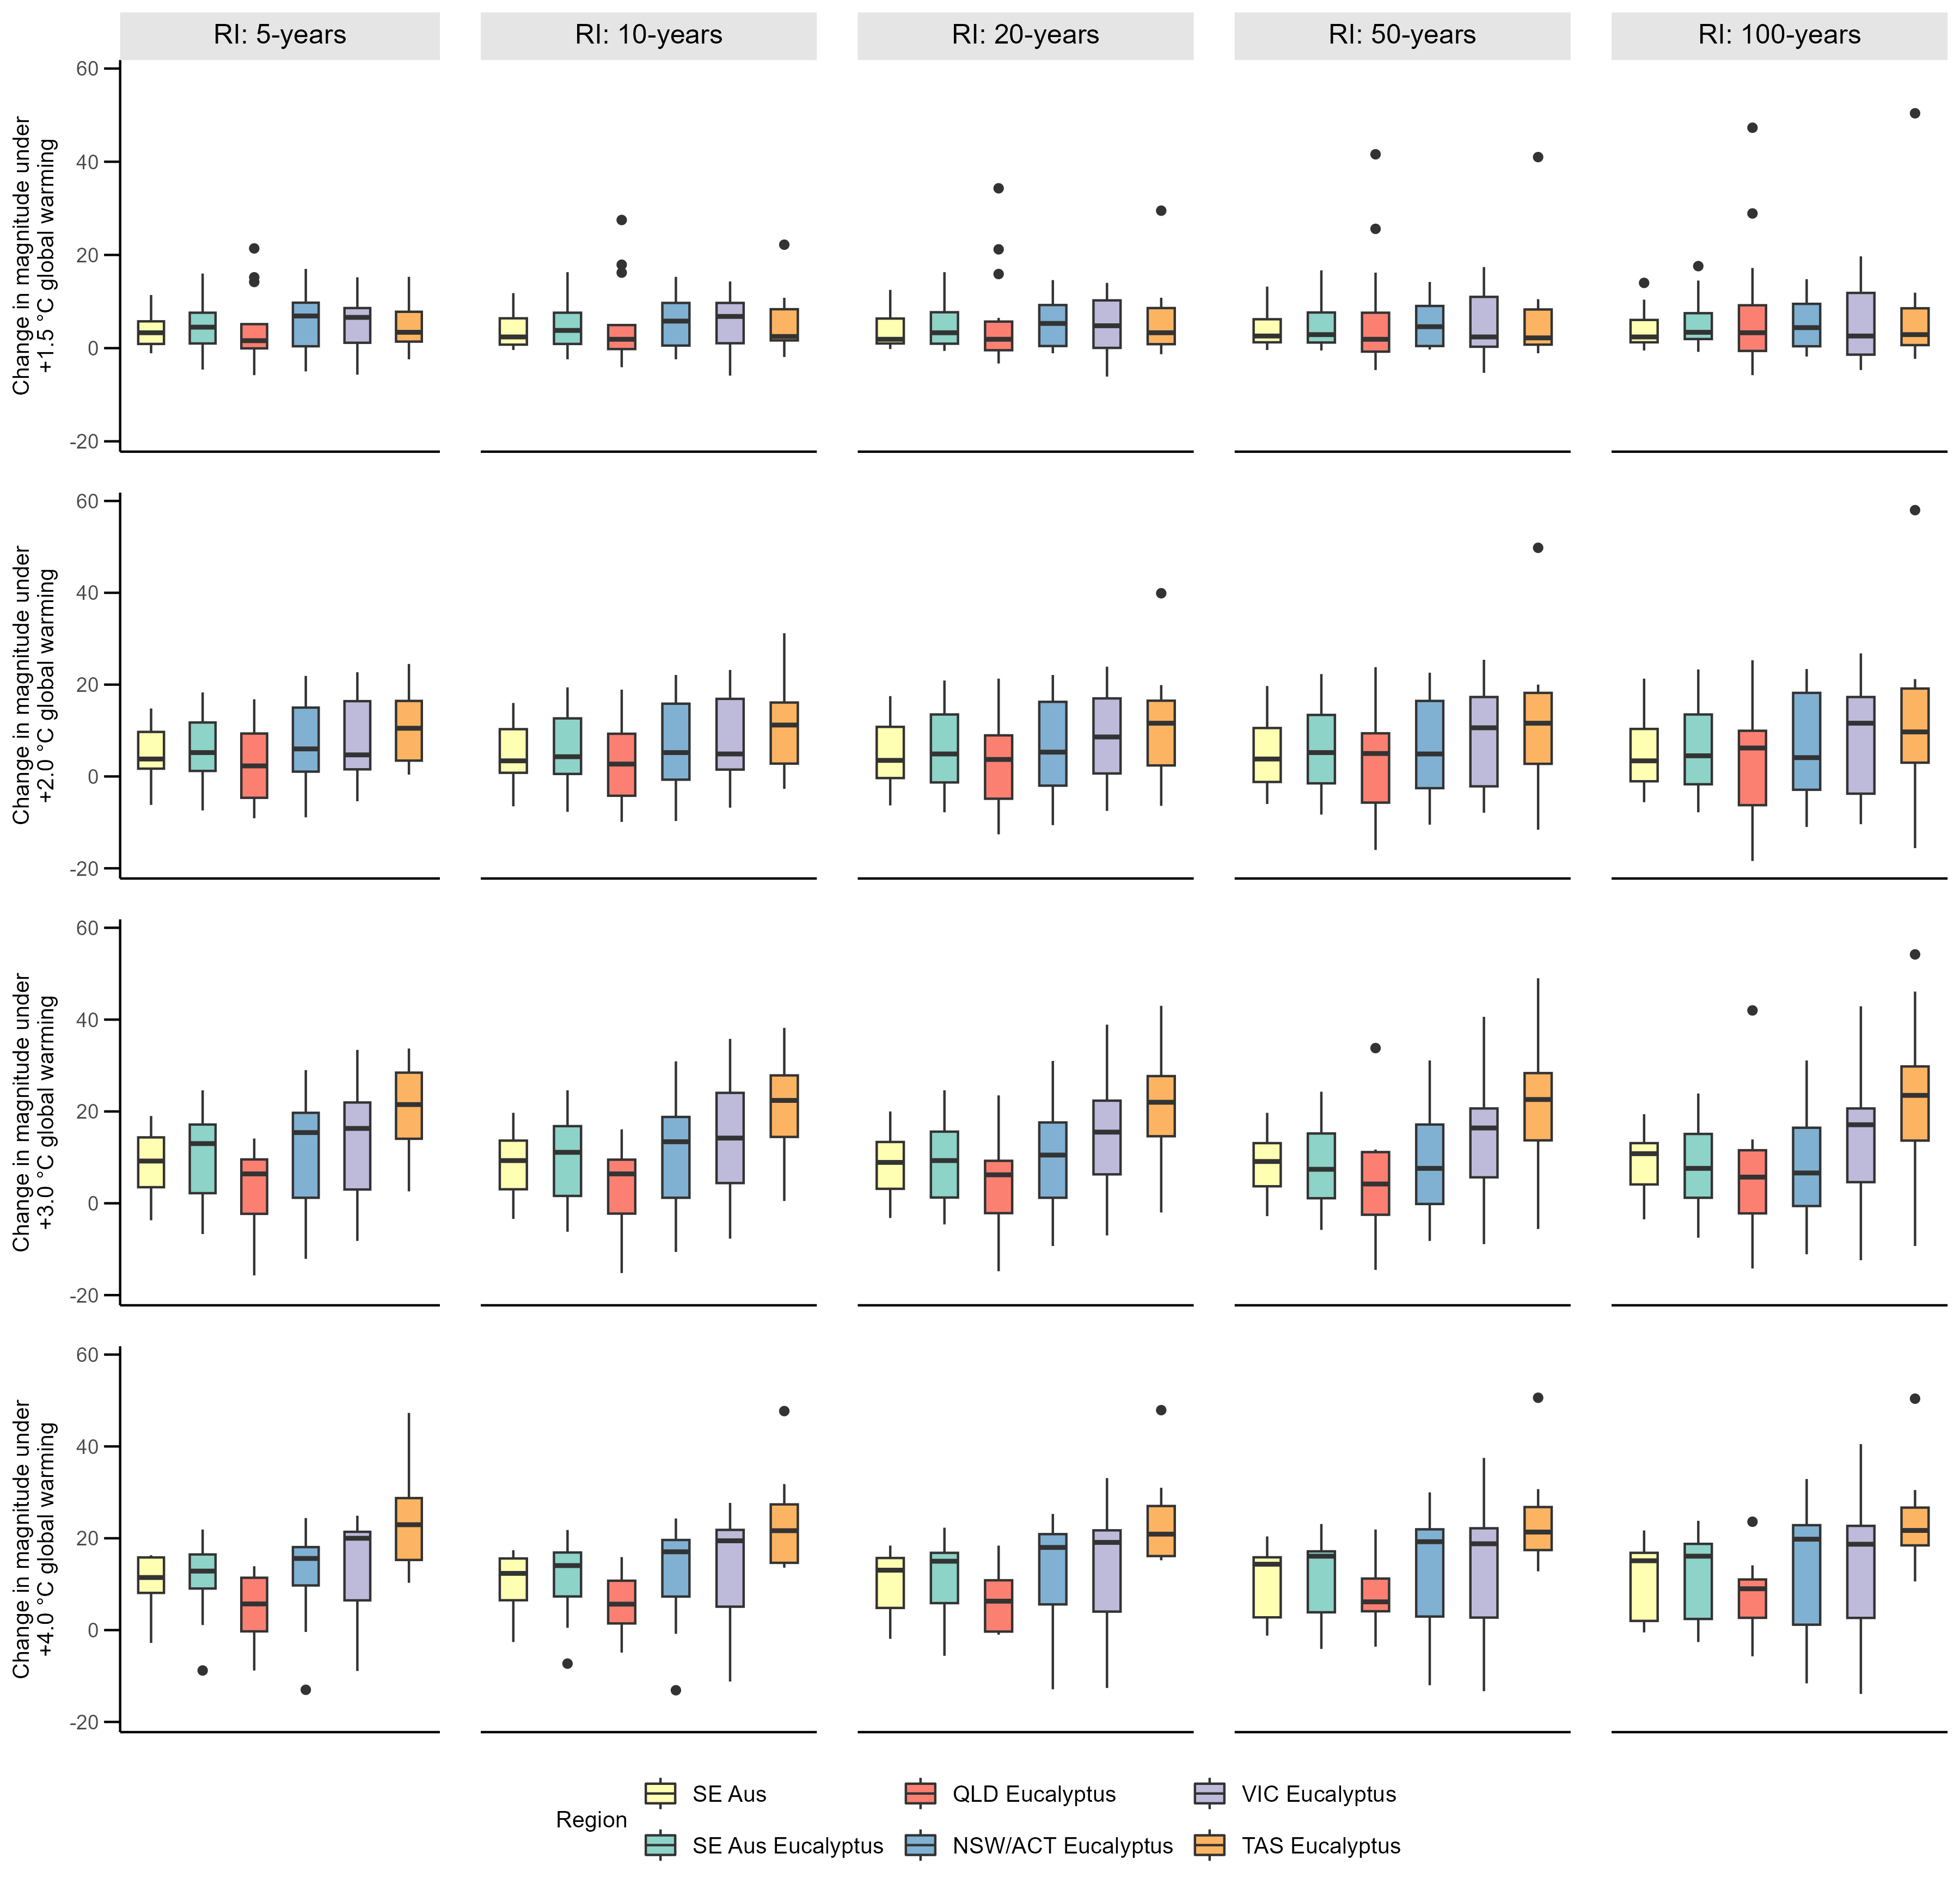
Figure S17. Changes in the magnitude of 5-, 10-, 20-, 50-, and 100-year return interval 7-day running mean FFDI events for southeast Australia’s eucalypt forests under different levels of global warming compared to +1.2 ◦C GWL. Boxplots show variability in the median change for the different regions across the model ensemble.

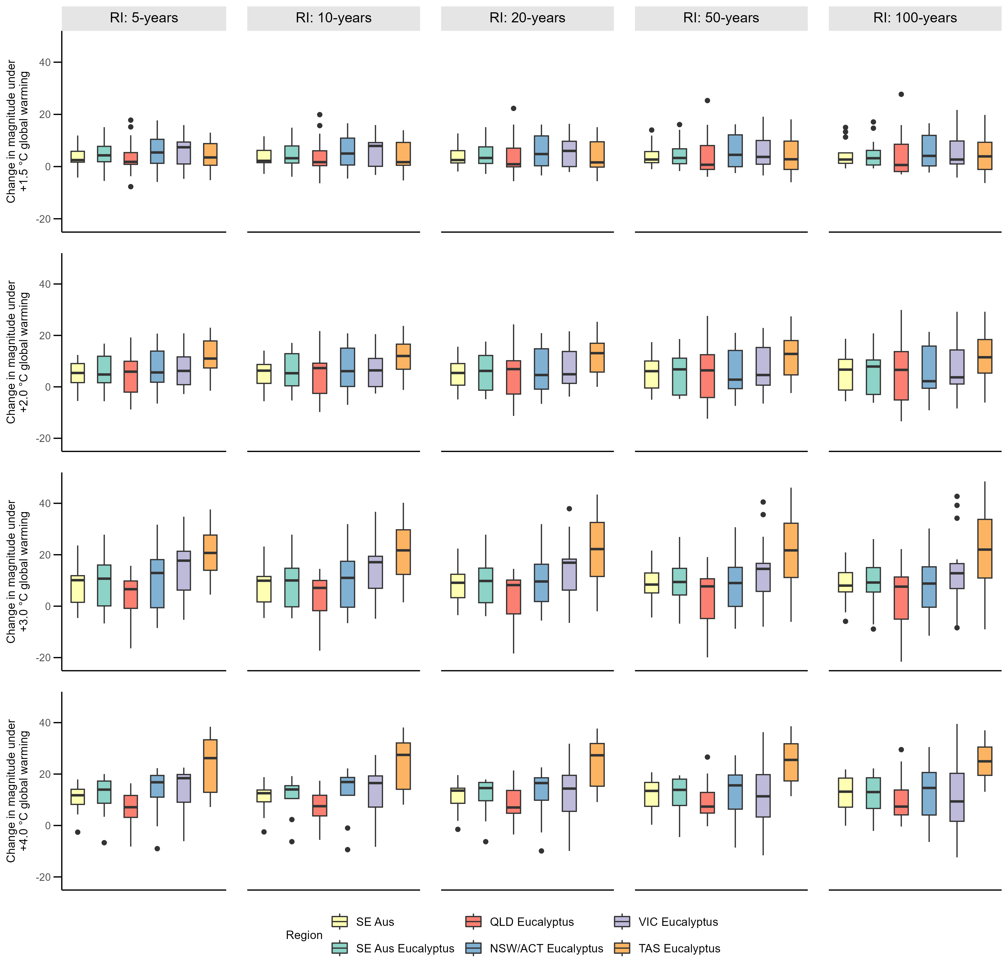
Figure S18. Changes in the magnitude of 5-, 10-, 20-, 50-, and 100-year return interval daily FFDI events for southeast Australia’s eucalypt forests under different levels of global warming compared to +1.2 ◦C GWL. Boxplots show variability in the median change for the different regions across the model ensemble.
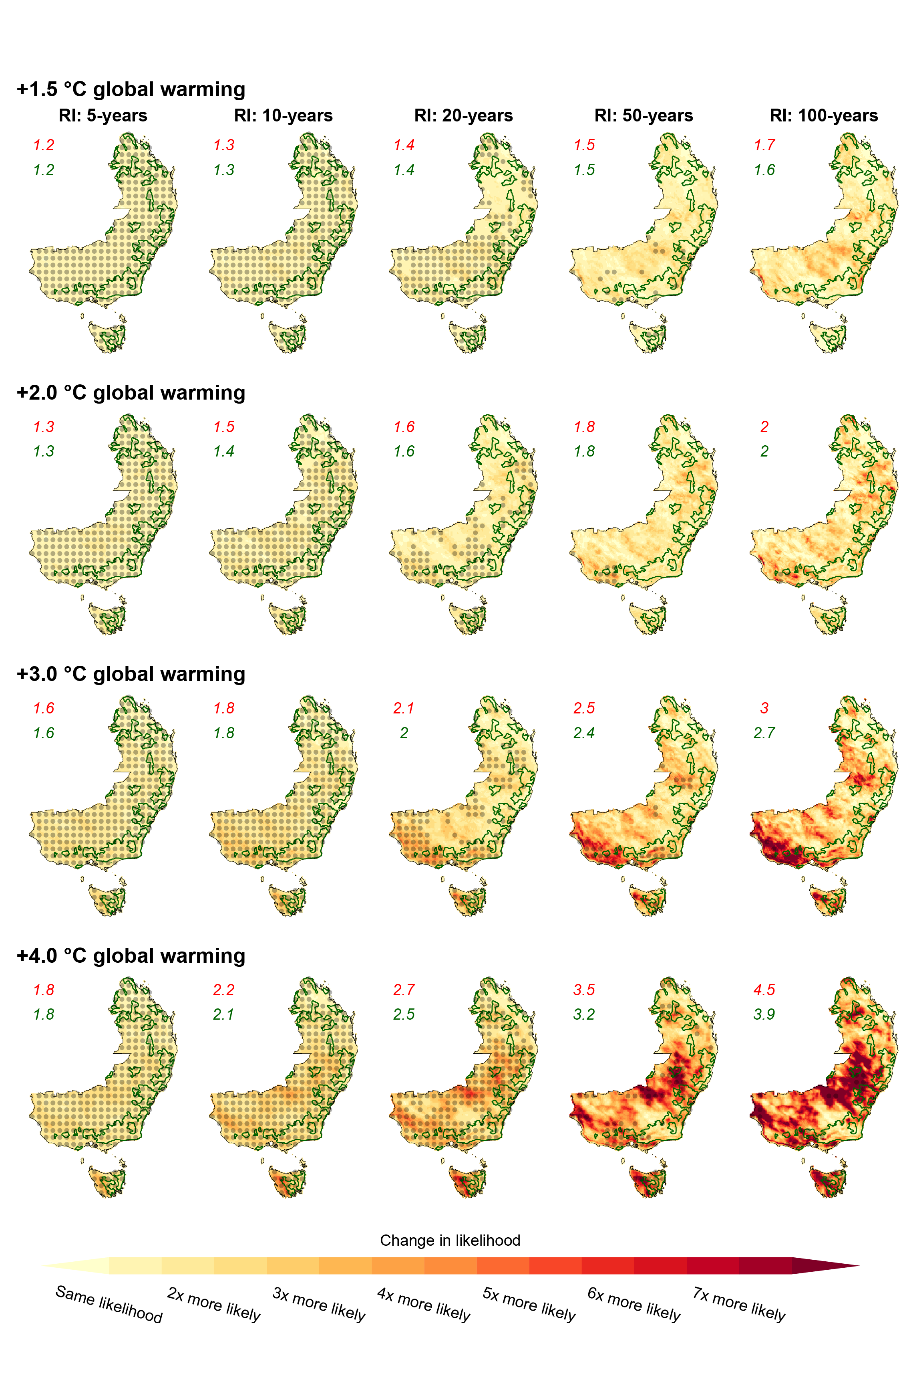
Figure S19. Comparison of ensemble median change in the likelihood of 5-, 10-, 20-, 50-, and 100-year return interval daily FFDI events for different levels of global warming. Changes are calculated as change in the likelihood of 7-day running mean FFDI events with magnitudes equal to those of 5-, 10-, 20-, 50-, and 100-year return interval events under +1.2 ◦C of global warming. Data is displayed for southeastern Australia, with the dense eucalyptus forests in the region outlined in green. Red values in the top left corner show the average changes for all southeastern Australia while the green values are the average for the eucalypt forests. Stippling shows where the signal to noise ratio > 1.0. Boxplots showing the variations in median changes across the model ensemble for southeast Australia’s eucalypt forests are provided in Supplementary Material Figure S20.
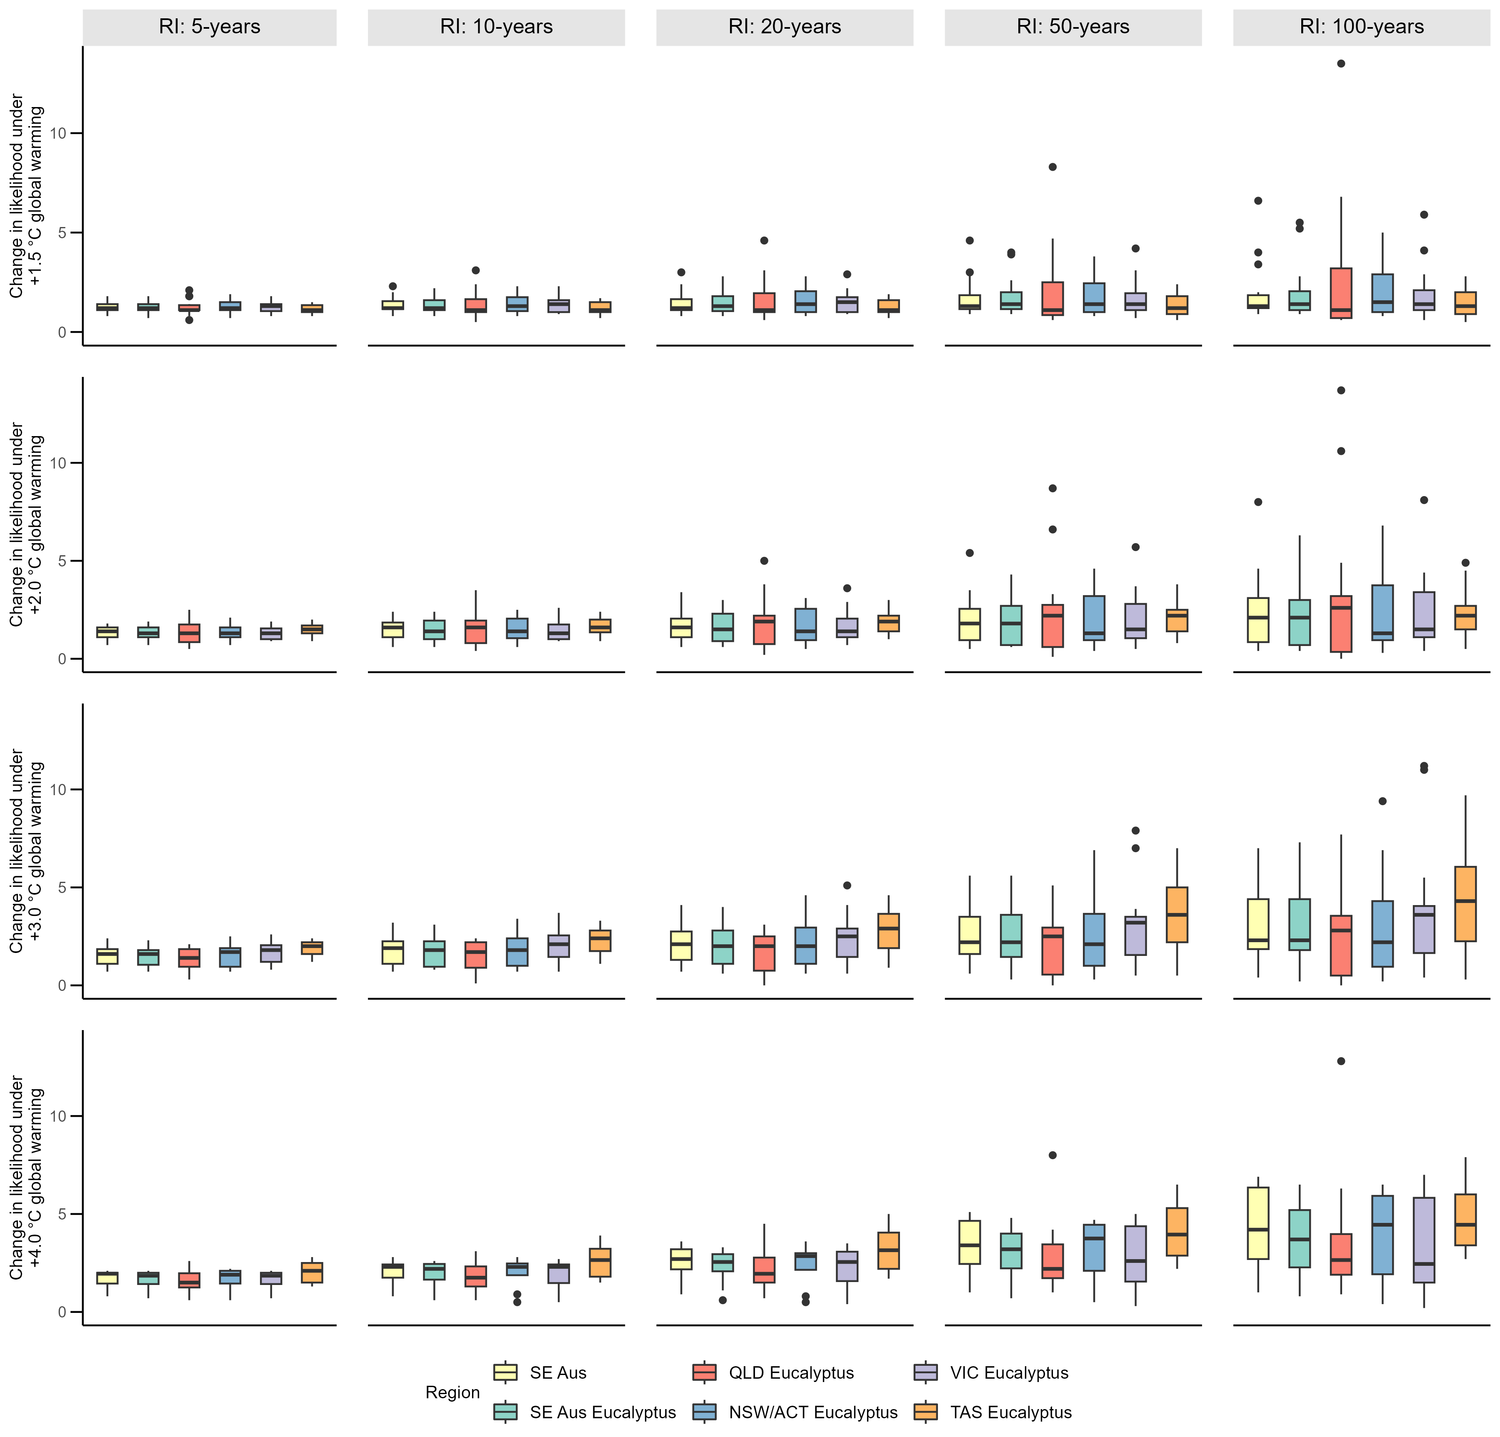
Figure S20. Changes in the likelihood of 5-, 10-, 20-, 50-, and 100-year return interval daily FFDI events for southeast Australia’s eucalypt forests under different levels of global warming compared to +1.2 ◦C GWL. Boxplots show variability in the median change for the different regions across the model ensemble.

Table S1. Summary of the ensemble median and range (10th to 90th percentile) of changes to the magnitude (as a percentage) of 5-, 10-, 20-, 50-, and 100-year return interval 7-day running mean FFDI events (compared to +1.2 ◦C of global warming) for the eucalypt forests of southeastern Australia and different levels of global warming.
Region | Global Warming Level | RI: 5-years | RI: 10-years | RI: 20-years | RI: 50-years | RI: 100-years
Eucalypt forests of southeast Australia | +1.5 ◦C of global warming | 4.5 (-3.1 - 15.4) | 4.2 (-2.6 - 16.9) | 3.9 (-2.9 - 18.9) | 3.9 (-4.2 - 22) | 4.1 (-5.6 - 24.6)
Eucalypt forests of southeast Australia | +2 ◦C of global warming | 6 (-6.3 - 19.9) | 6 (-7.3 - 20.5) | 6.4 (-8.7 - 21.9) | 6.6 (-11 - 24.8) | 6.7 (-13 - 27.7)
Eucalypt forests of southeast Australia | +2.5 ◦C of global warming | 9.3 (-8.1 - 21.7) | 8.4 (-8.1 - 21.9) | 7.9 (-8.7 - 22.8) | 7.3 (-10.4 - 25) | 6.8 (-12.4 - 27.1)
Eucalypt forests of southeast Australia | +3 ◦C of global warming | 11.5 (-4.9 - 24.6) | 10.8 (-5.9 - 25) | 10 (-7.2 - 26.5) | 9.4 (-9 - 29.6) | 9.2 (-10.4 - 32.7)
Eucalypt forests of southeast Australia | +4 ◦C of global warming | 13.8 (-3.1 - 24.2) | 13.7 (-3.4 - 24.5) | 13.6 (-3.5 - 25.9) | 13.7 (-3.9 - 28.9) | 13.9 (-4.8 - 31.9)
Eucalypt forests of Queensland | +1.5 ◦C of global warming | 3.1 (-4.3 - 16.3) | 3 (-3.5 - 18.9) | 2.7 (-3.3 - 22.1) | 2.9 (-4.2 - 26.5) | 3.4 (-5.5 - 29.8)
Eucalypt forests of Queensland | +2 ◦C of global warming | 3.9 (-9.5 - 16.4) | 3.9 (-10.2 - 16.8) | 4.2 (-11 - 18.2) | 4.5 (-12.7 - 20.8) | 4.7 (-14.5 - 22.9)
Eucalypt forests of Queensland | +2.5 ◦C of global warming | 7.1 (-11.1 - 16.5) | 6 (-11.1 - 16.7) | 5.3 (-11.5 - 17.7) | 4.5 (-12.9 - 20.2) | 3.8 (-14.8 - 22.7)
Eucalypt forests of Queensland | +3 ◦C of global warming | 6.6 (-8.7 - 17.6) | 5.7 (-9.2 - 18.4) | 5 (-10.3 - 20) | 4.3 (-11.8 - 23.4) | 4 (-13 - 26.5)
Eucalypt forests of Queensland | +4 ◦C of global warming | 8.3 (-5.8 - 19.3) | 8.2 (-4.6 - 18.7) | 8.8 (-3.2 - 19.4) | 10 (-2.3 - 22) | 11.1 (-2.9 - 25.4)
Eucalypt forests of New South Wales/ACT | +1.5 ◦C of global warming | 5.8 (-3 - 16.6) | 5.3 (-2.4 - 17.9) | 4.9 (-2.8 - 19.7) | 4.6 (-4.2 - 22.4) | 4.5 (-5.6 - 24.7)
Eucalypt forests of New South Wales/ACT | +2 ◦C of global warming | 6.9 (-6.6 - 22.2) | 6.7 (-7.6 - 22.4) | 7.2 (-9.2 - 23.5) | 7.2 (-11.6 - 26.3) | 7.1 (-13.6 - 29.2)
Eucalypt forests of New South Wales/ACT | +2.5 ◦C of global warming | 9.9 (-8.8 - 24.6) | 9 (-8.9 - 24.3) | 8.6 (-9.5 - 24.9) | 7.8 (-11.2 - 26.8) | 7.1 (-13.2 - 28.5)
Eucalypt forests of New South Wales/ACT | +3 ◦C of global warming | 12.8 (-5.5 - 27.8) | 11.7 (-6.5 - 27.7) | 10.5 (-7.8 - 28.8) | 9.6 (-9.7 - 31.3) | 9.3 (-11.2 - 33.8)
Eucalypt forests of New South Wales/ACT | +4 ◦C of global warming | 15.7 (-5 - 26.6) | 15.6 (-5.3 - 27.1) | 15.5 (-5.2 - 28.8) | 15.6 (-5.2 - 32.1) | 15.7 (-5.9 - 35.6)
Eucalypt forests of Victoria | +1.5 ◦C of global warming | 5.4 (-2.6 - 14.9) | 5.1 (-2.2 - 15.7) | 4.8 (-2.9 - 17) | 4.7 (-4.3 - 19.4) | 4.7 (-5.7 - 21.7)
Eucalypt forests of Victoria | +2 ◦C of global warming | 7.6 (-3 - 23.7) | 7.1 (-4 - 24.7) | 7.8 (-5.8 - 26.1) | 8.2 (-8.6 - 28.9) | 8.2 (-10.7 - 32.1)
Eucalypt forests of Victoria | +2.5 ◦C of global warming | 10.7 (-5.4 - 25.2) | 10.2 (-5.4 - 25.4) | 10.1 (-5.8 - 26.5) | 9.6 (-7.3 - 28.9) | 9.4 (-8.9 - 31.1)
Eucalypt forests of Victoria | +3 ◦C of global warming | 15.3 (-2.4 - 30.8) | 15.2 (-3.6 - 31) | 14.9 (-4.8 - 32.7) | 14.6 (-6.5 - 35.8) | 14.7 (-8.3 - 38.9)
Eucalypt forests of Victoria | +4 ◦C of global warming | 17.4 (-2.8 - 27.4) | 17.3 (-4.1 - 28.7) | 17 (-5.1 - 30.7) | 16.5 (-6.1 - 33.8) | 16.3 (-6.9 - 36.4)
Eucalypt forests of Tasmania | +1.5 ◦C of global warming | 3.8 (-1.9 - 13.1) | 3.8 (-1.9 - 13) | 3.6 (-2.2 - 13.7) | 3.9 (-3.3 - 16) | 4.1 (-4.6 - 18.1)
Eucalypt forests of Tasmania | +2 ◦C of global warming | 10.7 (0.5 - 22.4) | 11.6 (-0.6 - 23.3) | 12.1 (-2.7 - 24.7) | 11.7 (-6.2 - 27.9) | 11.5 (-9.1 - 31.6)
Eucalypt forests of Tasmania | +2.5 ◦C of global warming | 17.3 (1.1 - 30.5) | 16.8 (-0.5 - 31.6) | 16.3 (-2.2 - 32.4) | 16.2 (-4.7 - 34.3) | 16 (-7.2 - 36.3)
Eucalypt forests of Tasmania | +3 ◦C of global warming | 22.9 (8.1 - 37.5) | 22.8 (6.1 - 38.7) | 22.9 (4.2 - 41.1) | 22.9 (1.3 - 46) | 23.1 (-1.2 - 50.4)
Eucalypt forests of Tasmania | +4 ◦C of global warming | 28.7 (12.4 - 44) | 27.2 (12.1 - 43.1) | 26.3 (11.3 - 42.8) | 25.6 (9.3 - 43.4) | 25.1 (7.4 - 44.9)

Table S2. Summary of the ensemble median and range (10th to 90th percentile) of changes to the magnitude (as a percentage) of 5-, 10-, 20-, 50-, and 100-year return interval daily FFDI events (compared to +1.2 ◦C of global warming) for the eucalypt forests of southeastern Australia and different levels of global warming.
Region | Global Warming Level | RI: 5-years | RI: 10-years | RI: 20-years | RI: 50-years | RI: 100-years
Eucalypt forests of southeast Australia | +1.5 ◦C of global warming | 4.9 (-3.7 - 15.4) | 4.6 (-3.6 - 16.8) | 4.3 (-4.1 - 18.5) | 4.1 (-5.5 - 21.4) | 4.1 (-7 - 23.8)
Eucalypt forests of southeast Australia | +2 ◦C of global warming | 6.2 (-5.6 - 19.8) | 6.3 (-6.3 - 20.5) | 6.3 (-7.6 - 22.6) | 6.4 (-10 - 26.6) | 6.5 (-12 - 30.2)
Eucalypt forests of southeast Australia | +2.5 ◦C of global warming | 9.9 (-8.6 - 22.2) | 9.3 (-8.6 - 22.3) | 8.6 (-9.1 - 23.4) | 8 (-10.7 - 25.9) | 7.7 (-12.3 - 28.5)
Eucalypt forests of southeast Australia | +3 ◦C of global warming | 10.9 (-5.5 - 24.4) | 10.4 (-6.2 - 24.9) | 10 (-7.5 - 26.8) | 9.4 (-10.2 - 30.4) | 8.9 (-12.4 - 33.8)
Eucalypt forests of southeast Australia | +4 ◦C of global warming | 14.1 (-2.2 - 24.7) | 13.8 (-2.5 - 25.5) | 13.4 (-3.1 - 27.3) | 12.7 (-4.3 - 31.1) | 12.4 (-5.3 - 34.7)
Eucalypt forests of Queensland | +1.5 ◦C of global warming | 3.8 (-4 - 15.8) | 3.5 (-4.1 - 17.6) | 3.1 (-4.9 - 19.7) | 3.2 (-6.3 - 23) | 3.4 (-7.7 - 25.8)
Eucalypt forests of Queensland | +2 ◦C of global warming | 5.5 (-9.3 - 18) | 5.8 (-9.9 - 19.2) | 5.7 (-10.9 - 22.1) | 5.4 (-13 - 27.2) | 5.4 (-14.8 - 31.5)
Eucalypt forests of Queensland | +2.5 ◦C of global warming | 7.3 (-12 - 18.1) | 6.6 (-12.1 - 18) | 5.9 (-12.7 - 19) | 5.3 (-14.3 - 21.6) | 4.9 (-16.1 - 24.2)
Eucalypt forests of Queensland | +3 ◦C of global warming | 6.3 (-10.3 - 18.9) | 5.8 (-11.7 - 19.2) | 5.5 (-13.4 - 20.5) | 4.9 (-15.9 - 23.6) | 4.5 (-18 - 26.7)
Eucalypt forests of Queensland | +4 ◦C of global warming | 8.9 (-4.6 - 20.5) | 9 (-3.6 - 20.9) | 9.5 (-3.4 - 22.7) | 9.7 (-3.9 - 27.4) | 10.1 (-4.4 - 32.1)
Eucalypt forests of New South Wales/ACT | +1.5 ◦C of global warming | 6.1 (-3.7 - 17.2) | 5.7 (-3.5 - 18.4) | 5.1 (-3.9 - 20.2) | 4.7 (-5.5 - 23) | 4.7 (-7 - 25.4)
Eucalypt forests of New South Wales/ACT | +2 ◦C of global warming | 6.6 (-5.8 - 21.5) | 6.6 (-6.6 - 22) | 6.7 (-8 - 23.8) | 6.8 (-10.5 - 27.6) | 6.8 (-12.5 - 31.2)
Eucalypt forests of New South Wales/ACT | +2.5 ◦C of global warming | 10.7 (-9.6 - 24.4) | 9.9 (-9.4 - 23.9) | 9 (-9.9 - 24.5) | 8.1 (-11.5 - 26.3) | 7.7 (-13.2 - 28.6)
Eucalypt forests of New South Wales/ACT | +3 ◦C of global warming | 12 (-6.1 - 26.6) | 11.2 (-6.5 - 26.7) | 10.7 (-7.6 - 28.2) | 9.9 (-10.2 - 31.5) | 9.3 (-12.5 - 34.6)
Eucalypt forests of New South Wales/ACT | +4 ◦C of global warming | 15.2 (-4 - 27) | 14.8 (-4.7 - 27.6) | 14 (-5.3 - 29.4) | 12.6 (-6.2 - 33.3) | 11.9 (-6.9 - 37)
Eucalypt forests of Victoria | +1.5 ◦C of global warming | 6.3 (-4.1 - 15.6) | 5.8 (-3.7 - 16.6) | 5.2 (-3.7 - 18.1) | 4.7 (-5.1 - 20.8) | 4.6 (-6.8 - 23.2)
Eucalypt forests of Victoria | +2 ◦C of global warming | 6 (-2.9 - 21) | 6.1 (-3.8 - 21.4) | 6.6 (-5.4 - 22.9) | 7.3 (-8 - 26.5) | 7.6 (-10.1 - 30)
Eucalypt forests of Victoria | +2.5 ◦C of global warming | 12.7 (-6.4 - 24.9) | 12.2 (-5.8 - 25) | 11.5 (-5.4 - 26.1) | 10.9 (-6 - 28.6) | 10.6 (-7 - 31.5)
Eucalypt forests of Victoria | +3 ◦C of global warming | 15 (-2.4 - 29) | 14.4 (-2.1 - 29.1) | 14 (-2.5 - 31.3) | 13.3 (-4.5 - 35.6) | 12.6 (-6.4 - 39.5)
Eucalypt forests of Victoria | +4 ◦C of global warming | 16.9 (-3.7 - 25.9) | 15.9 (-5.5 - 27.1) | 14.3 (-7.1 - 29.3) | 12.1 (-9.1 - 33) | 10.7 (-10.6 - 36.1)
Eucalypt forests of Tasmania | +1.5 ◦C of global warming | 4.3 (-3.5 - 13) | 4.3 (-3.7 - 13.9) | 4.4 (-4.5 - 15.4) | 4.2 (-5.9 - 18.1) | 3.8 (-7.5 - 20.6)
Eucalypt forests of Tasmania | +2 ◦C of global warming | 12.5 (1.6 - 24.4) | 12.5 (1 - 25.6) | 12.1 (-0.3 - 27.8) | 11.4 (-2.9 - 31.9) | 11.2 (-5.3 - 35.4)
Eucalypt forests of Tasmania | +2.5 ◦C of global warming | 17 (1.9 - 31.1) | 16 (0.2 - 32.9) | 15.4 (-2.2 - 35.1) | 14.5 (-6 - 38.6) | 13.8 (-9.1 - 42)
Eucalypt forests of Tasmania | +3 ◦C of global warming | 22.5 (9.5 - 41.1) | 22.8 (6.5 - 43.2) | 22.6 (3 - 46.4) | 22 (-1.8 - 51.8) | 21.3 (-5.5 - 56.8)
Eucalypt forests of Tasmania | +4 ◦C of global warming | 29.7 (11.9 - 44.3) | 29 (12.5 - 43.6) | 28.5 (12.5 - 43.3) | 28.5 (11.3 - 44.5) | 28.5 (9.7 - 46.4)

Table S3. Summary of the ensemble median and range (10th to 90th percentile) of changes to the likelihood of 5-, 10-, 20-, 50-, and 100-year return interval 7-day running mean FFDI events (compared to +1.2 ◦C of global warming) for the eucalypt forests of southeastern Australia and different levels of global warming.
Region | Global Warming Level | RI: 5-years | RI: 10-years | RI: 20-years | RI: 50-years | RI: 100-years
Eucalypt forests of southeast Australia | +1.5 ◦C of global warming | 1.2 (0.8 - 1.9) | 1.3 (0.8 - 2.4) | 1.4 (0.7 - 3.2) | 1.5 (0.6 - 5.2) | 1.7 (0.4 - 8)
Eucalypt forests of southeast Australia | +2 ◦C of global warming | 1.3 (0.7 – 2.1) | 1.4 (0.5 – 2.8) | 1.6 (0.4 – 3.8) | 2 (0.2 – 6.2) | 2.3 (0.1 – 9.4)
Eucalypt forests of southeast Australia | +2.5 ◦C of global warming | 1.5 (0.6 - 2.3) | 1.7 (0.5 - 3.1) | 1.8 (0.4 - 4.2) | 2.1 (0.3 - 6.7) | 2.4 (0.2 - 10)
Eucalypt forests of southeast Australia | +3 ◦C of global warming | 1.6 (0.7 – 2.4) | 1.9 (0.6 – 3.2) | 2.1 (0.5 – 4.5) | 2.5 (0.4 – 7.4) | 3 (0.3 – 11.3)
Eucalypt forests of southeast Australia | +4 ◦C of global warming | 1.8 (0.9 – 2.4) | 2.2 (0.8 – 3.3) | 2.6 (0.8 – 4.5) | 3.5 (0.8 – 7.2) | 4.4 (0.8 – 10.9)
Eucalypt forests of Queensland | +1.5 ◦C of global warming | 1.2 (0.7 - 2) | 1.2 (0.7 - 2.7) | 1.3 (0.7 - 4) | 1.5 (0.5 - 7.1) | 1.8 (0.3 - 11.6)
Eucalypt forests of Queensland | +2 ◦C of global warming | 1.2 (0.4 – 2.2) | 1.3 (0.3 – 2.9) | 1.5 (0.2 – 4.1) | 1.8 (0.1 – 6.9) | 2.1 (0 – 11.1)
Eucalypt forests of Queensland | +2.5 ◦C of global warming | 1.5 (0.4 - 2.3) | 1.6 (0.3 - 3) | 1.7 (0.2 - 4.1) | 1.9 (0.1 - 6.8) | 2.1 (0 - 10.7)
Eucalypt forests of Queensland | +3 ◦C of global warming | 1.5 (0.5 – 2.2) | 1.6 (0.3 – 2.9) | 1.8 (0.2 – 4.1) | 2 (0.1 – 7) | 2.2 (0.1 – 11.1)
Eucalypt forests of Queensland | +4 ◦C of global warming | 1.5 (0.7 – 2.4) | 1.8 (0.7 – 3.2) | 2.1 (0.7 – 4.3) | 2.8 (0.8 – 7.1) | 3.7 (0.8 – 10.8)
Eucalypt forests of New South Wales/ACT | +1.5 ◦C of global warming | 1.3 (0.9 - 1.9) | 1.4 (0.9 - 2.4) | 1.4 (0.8 - 3.1) | 1.6 (0.6 - 4.7) | 1.7 (0.4 - 6.8)
Eucalypt forests of New South Wales/ACT | +2 ◦C of global warming | 1.4 (0.7 – 2.2) | 1.5 (0.6 – 2.8) | 1.7 (0.4 – 3.8) | 2 (0.3 – 5.8) | 2.3 (0.2 – 8.6)
Eucalypt forests of New South Wales/ACT | +2.5 ◦C of global warming | 1.6 (0.6 - 2.4) | 1.7 (0.6 - 3.2) | 1.9 (0.5 - 4.4) | 2.1 (0.3 - 6.8) | 2.3 (0.2 - 9.8)
Eucalypt forests of New South Wales/ACT | +3 ◦C of global warming | 1.7 (0.8 – 2.5) | 1.9 (0.7 – 3.4) | 2.1 (0.5 – 4.7) | 2.5 (0.4 – 7.6) | 2.8 (0.3 – 11.3)
Eucalypt forests of New South Wales/ACT | +4 ◦C of global warming | 1.8 (0.8 – 2.5) | 2.3 (0.8 – 3.3) | 2.8 (0.7 – 4.6) | 3.7 (0.7 – 7.4) | 4.7 (0.7 – 11)
Eucalypt forests of Victoria | +1.5 ◦C of global warming | 1.2 (0.9 - 1.7) | 1.3 (0.9 - 2.1) | 1.4 (0.8 - 2.6) | 1.5 (0.6 - 3.8) | 1.7 (0.5 - 5.2)
Eucalypt forests of Victoria | +2 ◦C of global warming | 1.4 (0.9 – 2.1) | 1.5 (0.7 – 2.8) | 1.7 (0.6 – 3.7) | 2.1 (0.4 – 5.8) | 2.4 (0.2 – 8.5)
Eucalypt forests of Victoria | +2.5 ◦C of global warming | 1.5 (0.8 - 2.3) | 1.7 (0.7 - 3) | 2 (0.6 - 4.1) | 2.3 (0.5 - 6.4) | 2.6 (0.4 - 9.2)
Eucalypt forests of Victoria | +3 ◦C of global warming | 1.8 (0.9 – 2.5) | 2.1 (0.8 – 3.4) | 2.5 (0.7 – 4.7) | 3.2 (0.5 – 7.6) | 3.9 (0.4 – 11.4)
Eucalypt forests of Victoria | +4 ◦C of global warming | 1.9 (0.9 – 2.4) | 2.4 (0.8 – 3.2) | 2.9 (0.7 – 4.4) | 3.8 (0.6 – 6.9) | 4.8 (0.6 – 10.1)
Eucalypt forests of Tasmania | +1.5 ◦C of global warming | 1.2 (0.9 - 1.6) | 1.2 (0.9 - 1.8) | 1.3 (0.9 - 2.1) | 1.3 (0.8 - 2.8) | 1.4 (0.6 - 3.6)
Eucalypt forests of Tasmania | +2 ◦C of global warming | 1.5 (1 – 2) | 1.7 (1 – 2.6) | 2 (0.8 – 3.3) | 2.3 (0.6 – 4.6) | 2.6 (0.4 – 6.3)
Eucalypt forests of Tasmania | +2.5 ◦C of global warming | 1.8 (1.1 - 2.3) | 2.1 (1 - 3.1) | 2.5 (0.9 - 4) | 3.1 (0.7 - 5.9) | 3.8 (0.5 - 8.2)
Eucalypt forests of Tasmania | +3 ◦C of global warming | 2 (1.4 – 2.6) | 2.6 (1.4 – 3.7) | 3.2 (1.4 – 5) | 4.1 (1.2 – 7.8) | 5.2 (1.1 – 11.2)
Eucalypt forests of Tasmania | +4 ◦C of global warming | 2.3 (1.5 – 3) | 3 (1.7 – 4.3) | 3.7 (1.9 – 6) | 4.8 (2 – 9.2) | 6 (2.1 – 12.9)

Table S4. Summary of the ensemble median and range (10th to 90th percentile) of changes to the likelihood of 5-, 10-, 20-, 50-, and 100-year return interval daily FFDI events (compared to +1.2 ◦C of global warming) for the eucalypt forests of southeastern Australia and different levels of global warming.
Region | Global Warming Level | RI: 5-years | RI: 10-years | RI: 20-years | RI: 50-years | RI: 100-years
Eucalypt forests of southeast Australia | +1.5 ◦C of global warming | 1.2 (0.8 - 1.8) | 1.3 (0.8 - 2.3) | 1.4 (0.7 - 3) | 1.5 (0.5 - 4.7) | 1.6 (0.4 - 6.8)
Eucalypt forests of southeast Australia | +2 ◦C of global warming | 1.3 (0.7 – 2) | 1.4 (0.6 – 2.7) | 1.6 (0.5 – 3.6) | 1.8 (0.3 – 5.6) | 2 (0.2 – 8.4)
Eucalypt forests of southeast Australia | +2.5 ◦C of global warming | 1.5 (0.6 - 2.2) | 1.7 (0.5 - 2.9) | 1.9 (0.4 - 3.8) | 2.1 (0.3 - 5.7) | 2.3 (0.3 - 8.3)
Eucalypt forests of southeast Australia | +3 ◦C of global warming | 1.6 (0.7 - 2.3) | 1.8 (0.6 - 3) | 2 (0.5 - 4.1) | 2.4 (0.4 - 6.6) | 2.7 (0.3 - 9.8)
Eucalypt forests of southeast Australia | +4 ◦C of global warming | 1.8 (0.9 - 2.4) | 2.1 (0.9 - 3.2) | 2.5 (0.9 - 4.3) | 3.2 (0.8 - 6.9) | 3.9 (0.8 - 10.5)
Eucalypt forests of Queensland | +1.5 ◦C of global warming | 1.2 (0.8 - 1.9) | 1.3 (0.7 - 2.5) | 1.3 (0.6 - 3.5) | 1.4 (0.4 - 5.8) | 1.5 (0.3 - 8.9)
Eucalypt forests of Queensland | +2 ◦C of global warming | 1.3 (0.5 – 2.1) | 1.5 (0.4 – 2.8) | 1.6 (0.3 – 3.9) | 1.8 (0.1 – 6.6) | 2 (0.1 – 10.5)
Eucalypt forests of Queensland | +2.5 ◦C of global warming | 1.5 (0.4 - 2.2) | 1.6 (0.3 - 2.9) | 1.7 (0.2 - 3.7) | 1.9 (0.1 - 5.7) | 2.1 (0 - 8.4)
Eucalypt forests of Queensland | +3 ◦C of global warming | 1.4 (0.4 - 2.2) | 1.5 (0.3 - 2.9) | 1.7 (0.2 - 3.9) | 1.9 (0.1 - 6.2) | 2.1 (0 - 9.4)
Eucalypt forests of Queensland | +4 ◦C of global warming | 1.6 (0.8 - 2.3) | 1.8 (0.8 - 3.1) | 2.2 (0.8 - 4.3) | 2.8 (0.7 - 6.9) | 3.4 (0.7 - 10.8)
Eucalypt forests of New South Wales/ACT | +1.5 ◦C of global warming | 1.3 (0.8 - 1.8) | 1.4 (0.8 - 2.3) | 1.5 (0.7 - 3) | 1.6 (0.5 - 4.4) | 1.7 (0.4 - 6.3)
Eucalypt forests of New South Wales/ACT | +2 ◦C of global warming | 1.3 (0.8 – 2) | 1.4 (0.6 – 2.7) | 1.6 (0.5 – 3.6) | 1.8 (0.3 – 5.4) | 2 (0.2 – 8)
Eucalypt forests of New South Wales/ACT | +2.5 ◦C of global warming | 1.5 (0.6 - 2.3) | 1.7 (0.5 - 3) | 1.9 (0.4 - 3.9) | 2.1 (0.3 - 5.8) | 2.3 (0.3 - 8.3)
Eucalypt forests of New South Wales/ACT | +3 ◦C of global warming | 1.6 (0.7 - 2.4) | 1.8 (0.7 - 3.1) | 2.1 (0.5 - 4.2) | 2.4 (0.4 - 6.6) | 2.7 (0.3 - 9.9)
Eucalypt forests of New South Wales/ACT | +4 ◦C of global warming | 1.8 (0.9 - 2.4) | 2.2 (0.8 - 3.2) | 2.6 (0.8 - 4.4) | 3.2 (0.7 - 7.1) | 3.9 (0.7 - 10.8)
Eucalypt forests of Victoria | +1.5 ◦C of global warming | 1.3 (0.8 - 1.7) | 1.4 (0.8 - 2) | 1.4 (0.7 - 2.6) | 1.6 (0.6 - 3.7) | 1.7 (0.4 - 5.1)
Eucalypt forests of Victoria | +2 ◦C of global warming | 1.3 (0.9 - 1.9) | 1.4 (0.8 - 2.5) | 1.5 (0.6 - 3.1) | 1.8 (0.4 - 4.4) | 2.1 (0.3 - 6.2)
Eucalypt forests of Victoria | +2.5 ◦C of global warming | 1.6 (0.8 - 2.2) | 1.8 (0.7 - 2.8) | 2 (0.7 - 3.6) | 2.3 (0.6 - 5.4) | 2.7 (0.6 - 7.6)
Eucalypt forests of Victoria | +3 ◦C of global warming | 1.7 (0.9 - 2.4) | 2 (0.9 - 3.2) | 2.4 (0.9 - 4.2) | 2.9 (0.7 - 6.8) | 3.2 (0.6 - 10.2)
Eucalypt forests of Victoria | +4 ◦C of global warming | 1.8 (0.9 - 2.2) | 2.2 (0.8 - 2.8) | 2.5 (0.6 - 3.8) | 2.8 (0.5 - 5.9) | 3.1 (0.4 - 8.6)
Eucalypt forests of Tasmania | +1.5 ◦C of global warming | 1.2 (0.9 - 1.5) | 1.2 (0.8 - 1.7) | 1.3 (0.7 - 2) | 1.3 (0.6 - 2.6) | 1.3 (0.5 - 3.2)
Eucalypt forests of Tasmania | +2 ◦C of global warming | 1.5 (1.1 - 2) | 1.7 (1.1 - 2.4) | 1.8 (1 - 3) | 2 (0.8 - 4.2) | 2.1 (0.7 - 5.6)
Eucalypt forests of Tasmania | +2.5 ◦C of global warming | 1.7 (1.1 - 2.2) | 1.9 (1 - 2.9) | 2.2 (0.9 - 3.8) | 2.4 (0.7 - 5.4) | 2.6 (0.5 - 7.4)
Eucalypt forests of Tasmania | +3 ◦C of global warming | 1.9 (1.4 - 2.5) | 2.3 (1.4 - 3.5) | 2.8 (1.3 - 4.8) | 3.5 (0.9 - 7.4) | 4.1 (0.7 - 10.6)
Eucalypt forests of Tasmania | +4 ◦C of global warming | 2.2 (1.5 - 2.8) | 2.8 (1.7 - 3.8) | 3.4 (1.9 - 5.2) | 4.4 (2.2 - 7.6) | 5.4 (2.3 - 10.2)

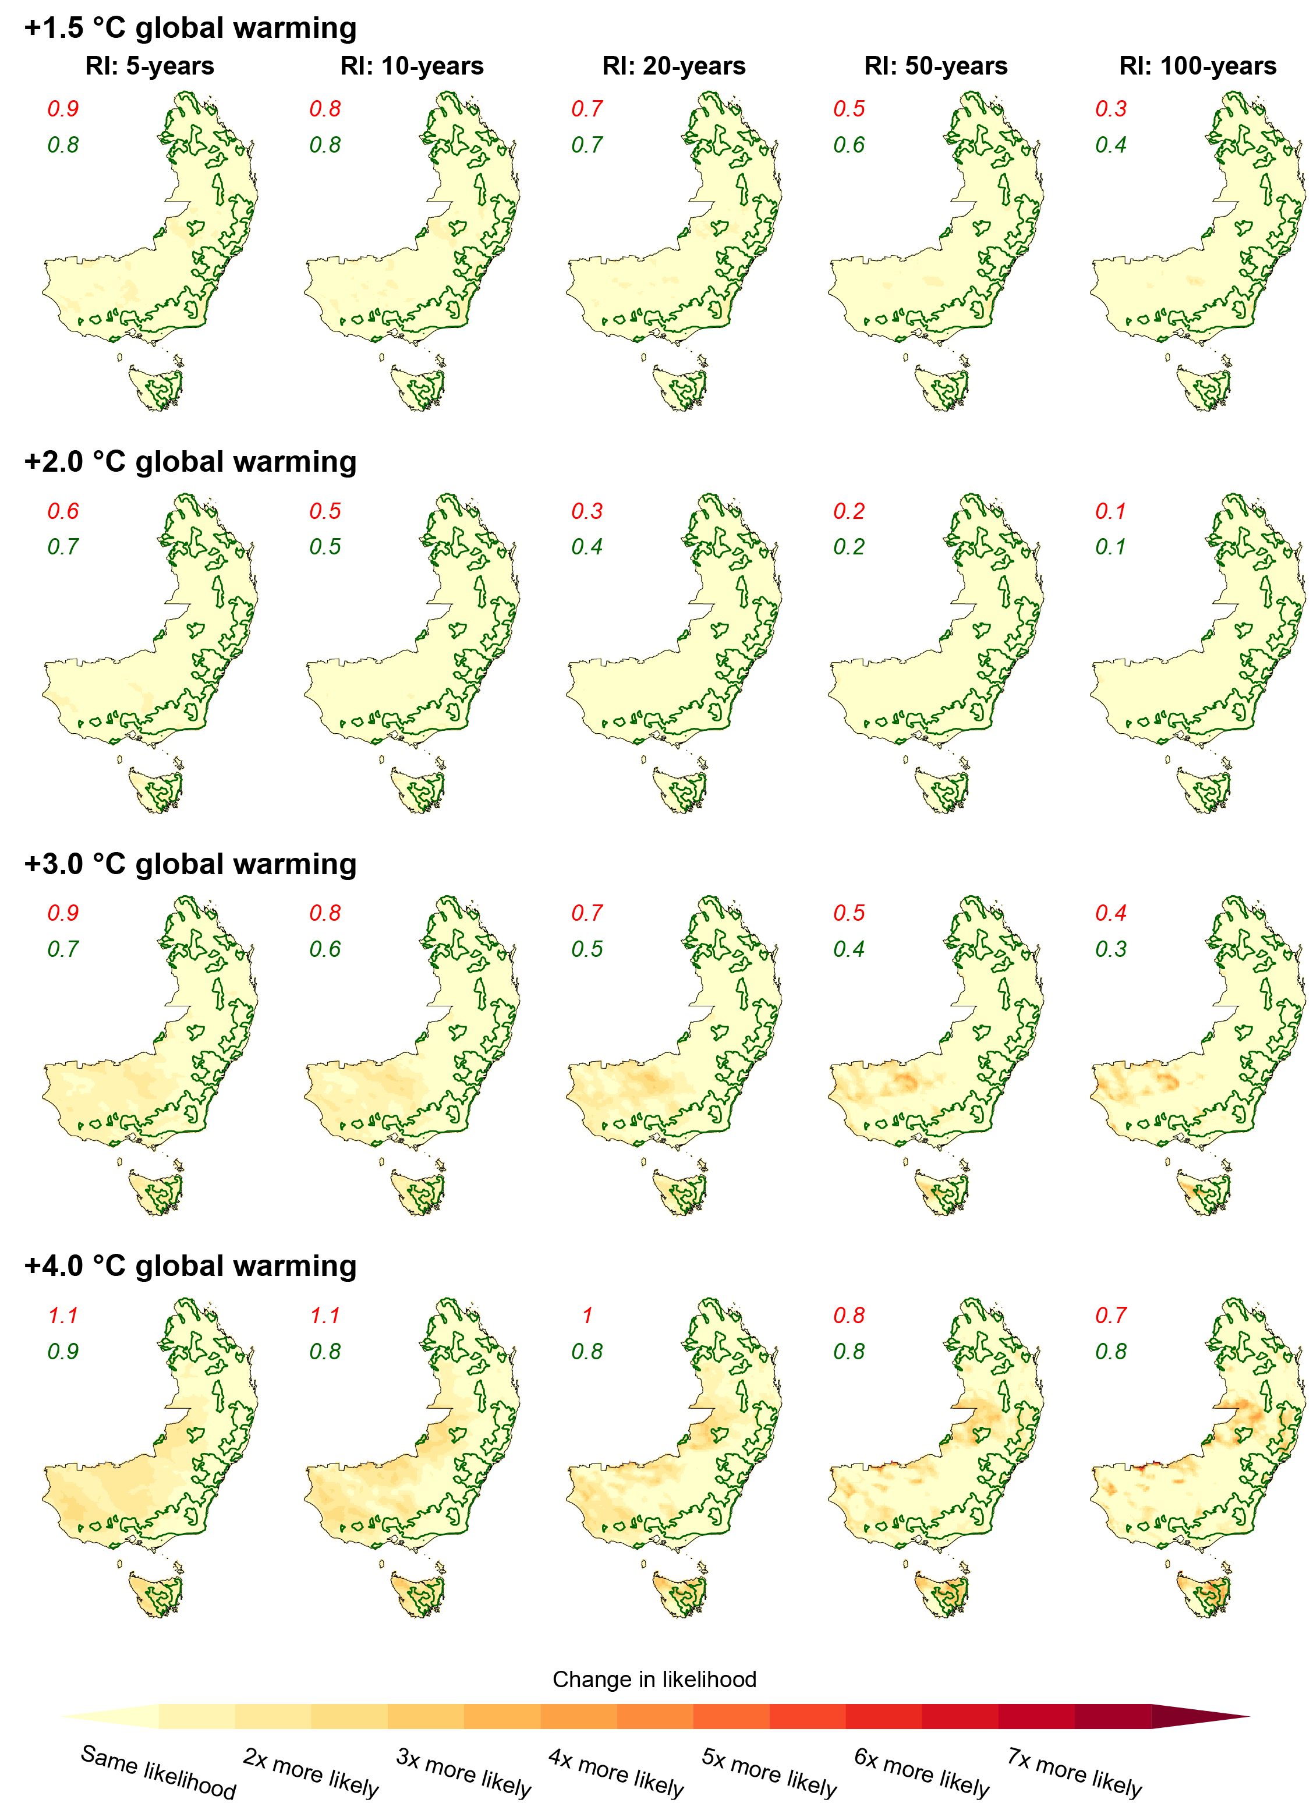
Figure S21. Comparison of ensemble 10th percentile change in the likelihood of 5-, 10-, 20-, 50-, and 100-year return interval daily FFDI events for different levels of global warming. Changes are calculated as change in the likelihood of 7-day running mean FFDI events with magnitudes equal to those of 5-, 10-, 20-, 50-, and 100-year return interval events under +1.2 ◦C of global warming. Data is displayed for southeastern Australia, with the dense eucalyptus forests in the region outlined in green. Red values in the top left corner show the average changes for all southeastern Australia while the green values are the average for the eucalypt forests.
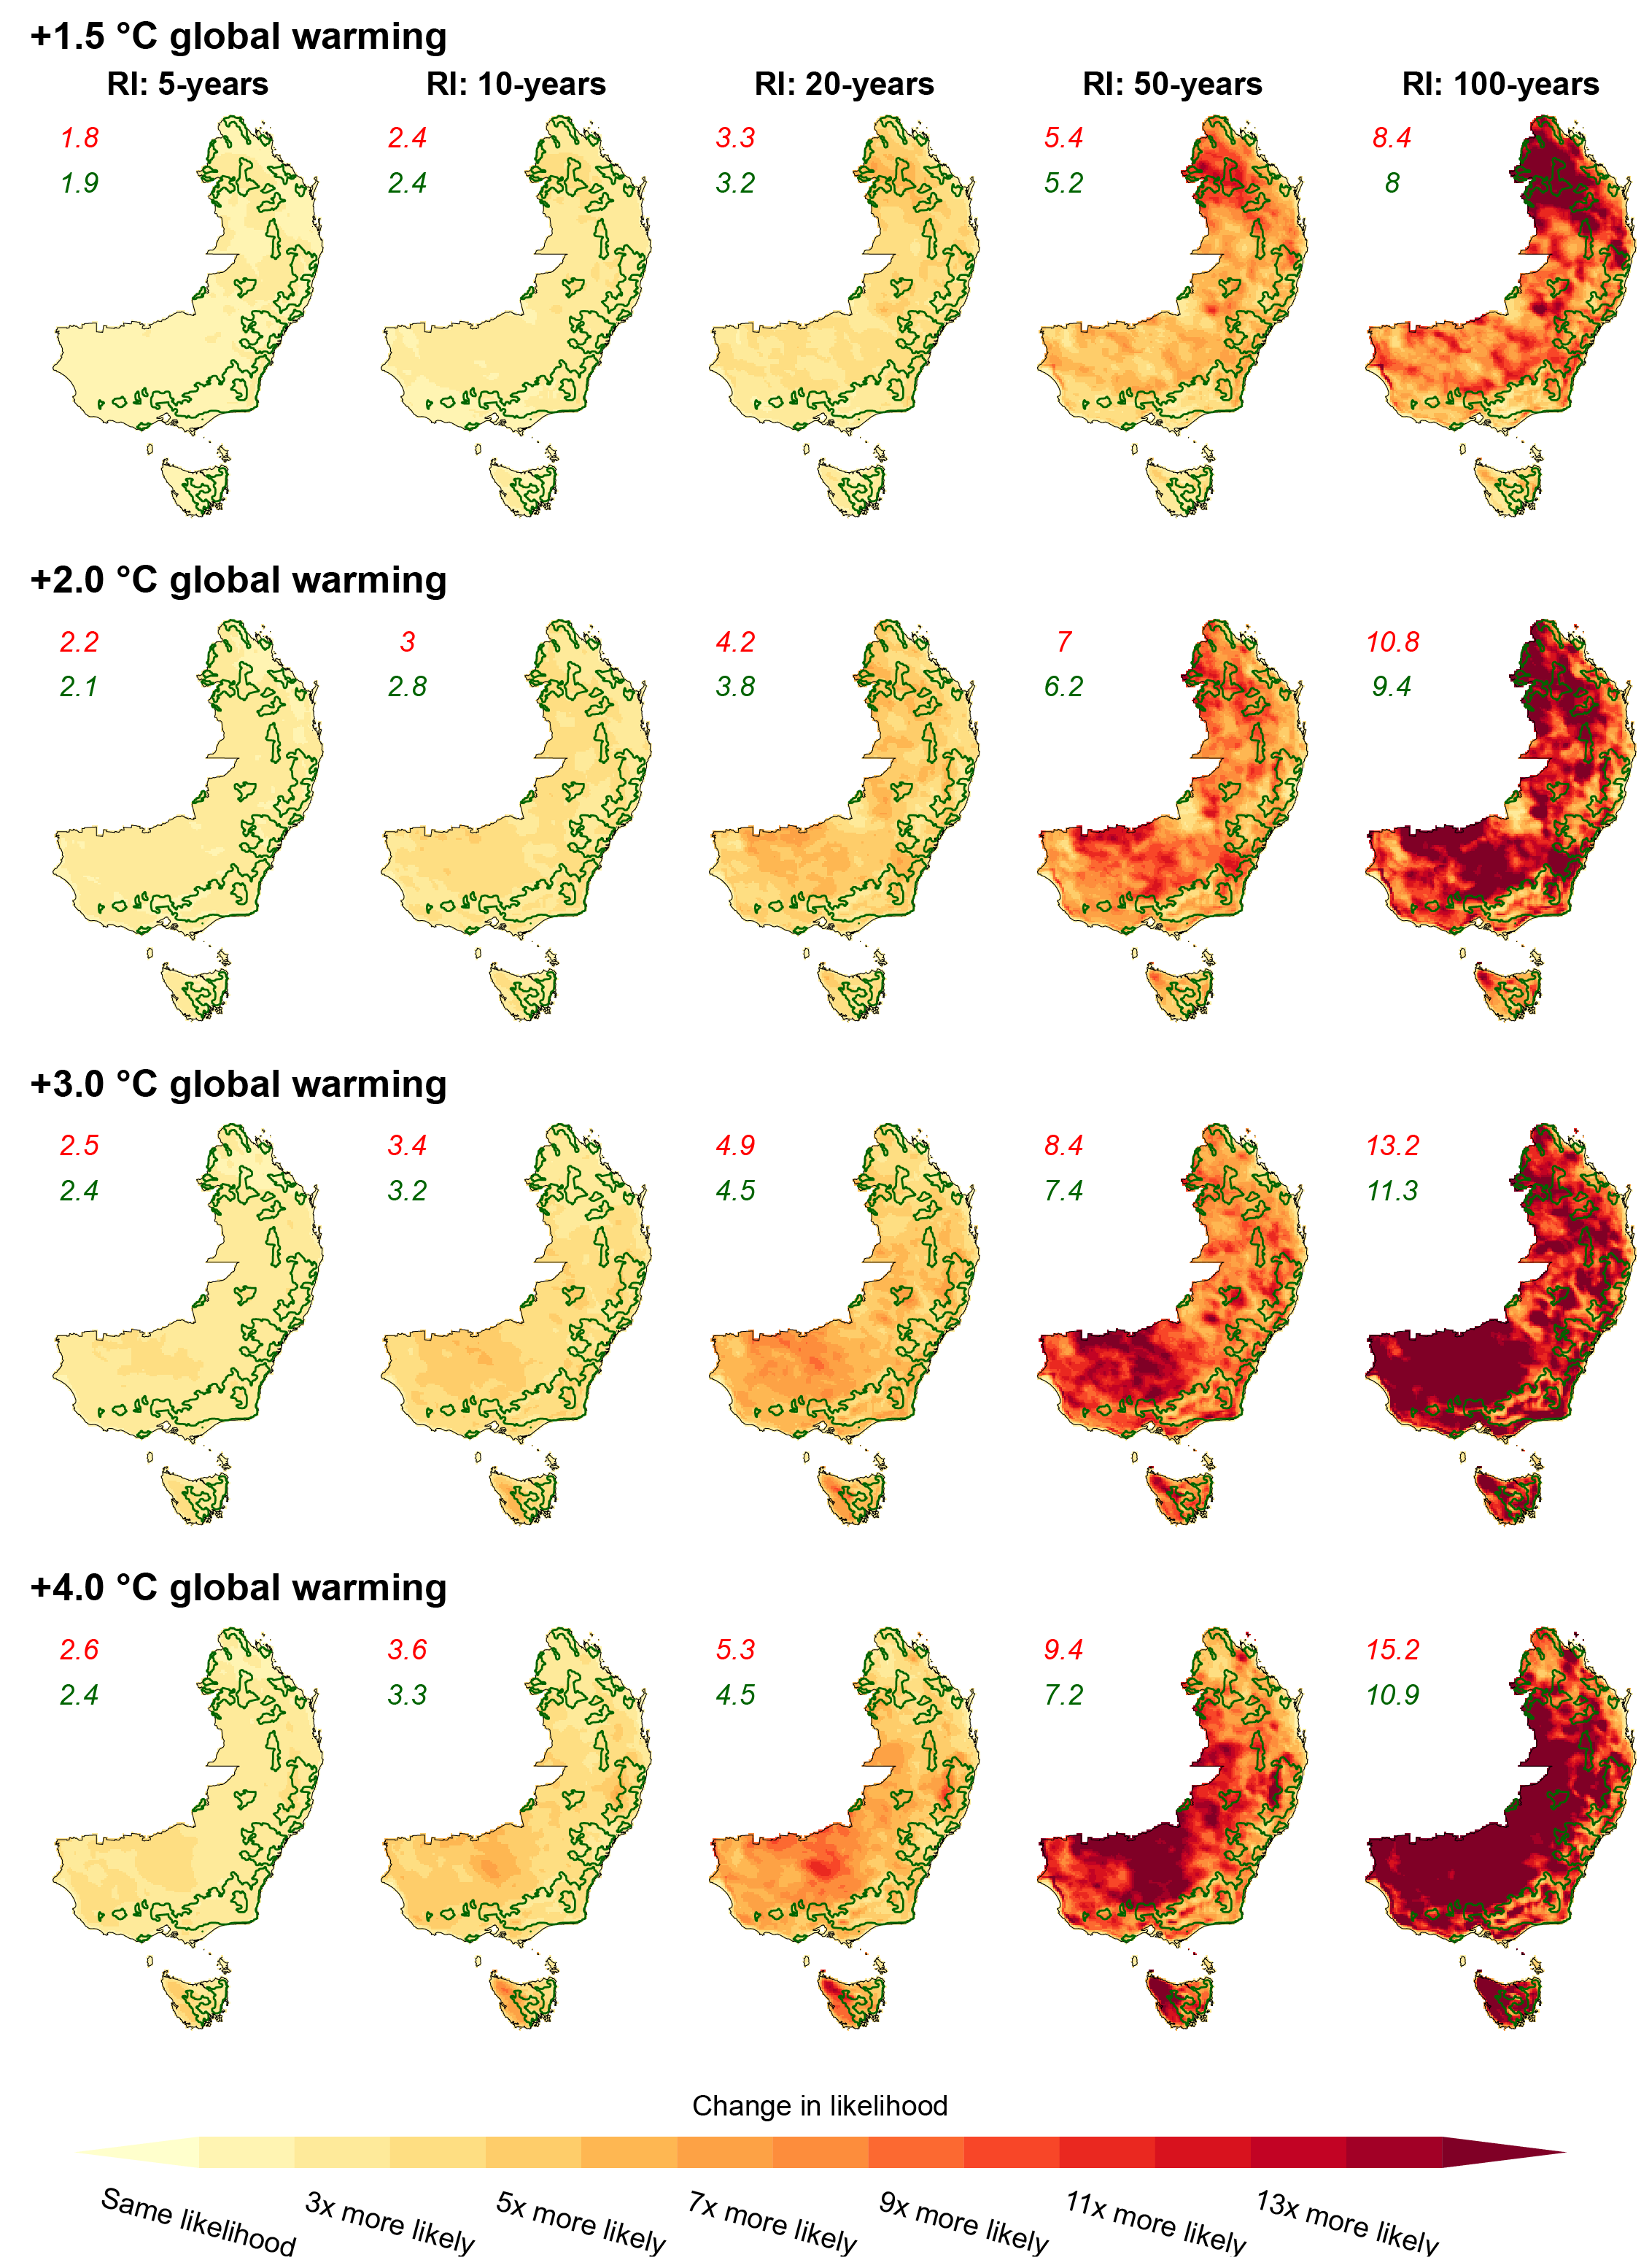
Figure S22. Comparison of ensemble 90th percentile change in the likelihood of 5-, 10-, 20-, 50-, and 100-year return interval daily FFDI events for different levels of global warming. Changes are calculated as change in the likelihood of 7-day running mean FFDI events with magnitudes equal to those of 5-, 10-, 20-, 50-, and 100-year return interval events under +1.2 ◦C of global warming. Data is displayed for southeastern Australia, with the dense eucalyptus forests in the region outlined in green. Red values in the top left corner show the average changes for all southeastern Australia while the green values are the average for the eucalypt forests.
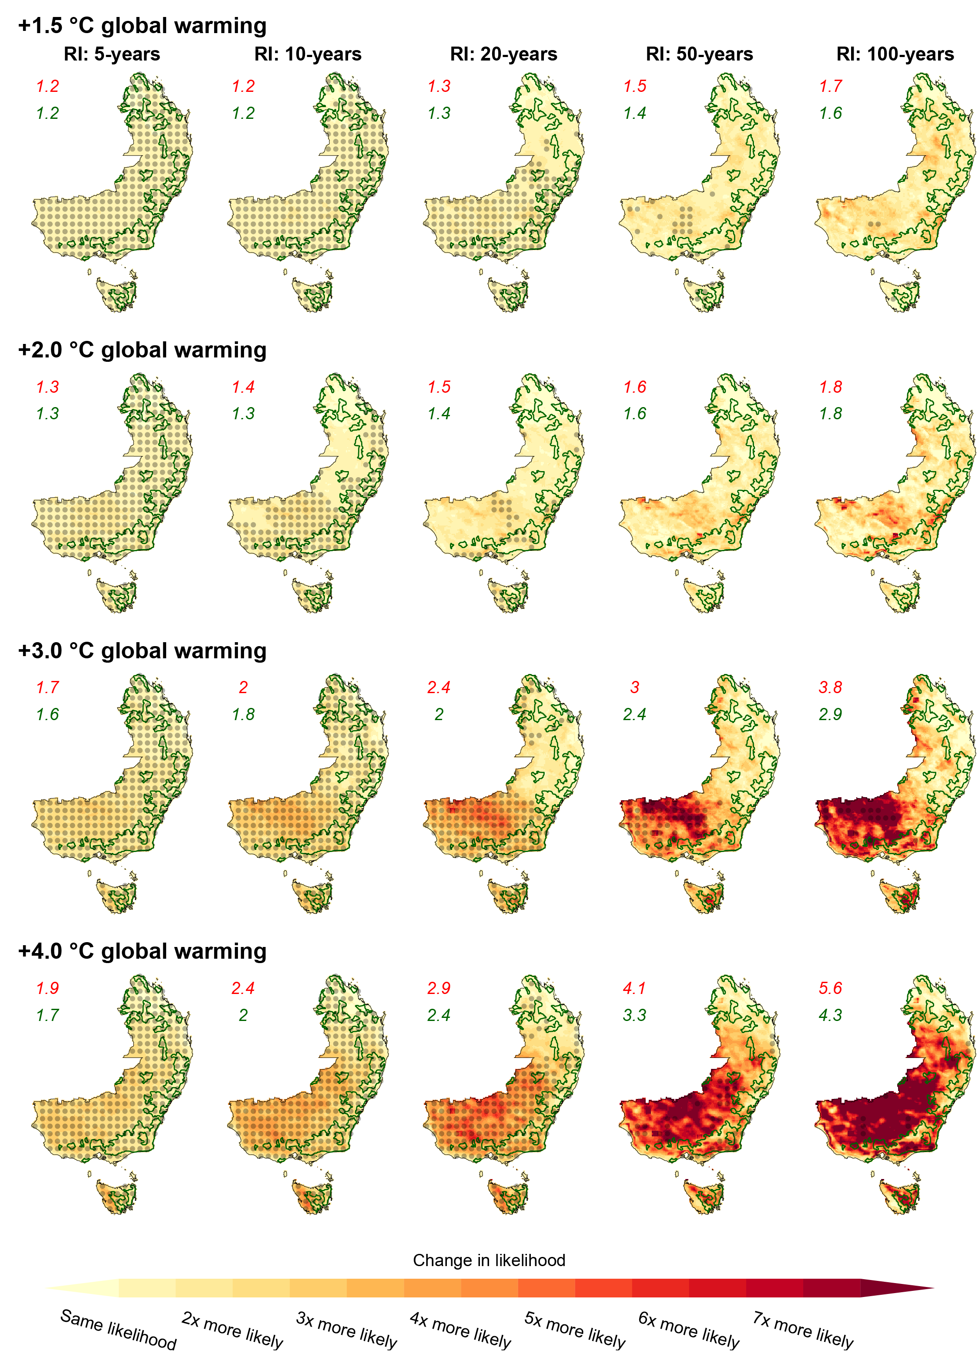
Figure S23. Comparison of ensemble median change in the likelihood of 5-, 10-, 20-, 50-, and 100-year return interval 7-day running mean FFDI events for different levels of global warming using non-bias corrected FFDI. Changes are calculated as change in the likelihood of 7-day running mean FFDI events with magnitudes equal to those of 5-, 10-, 20-, 50-, and 100-year return interval events under +1.2 ◦C of global warming. Data is displayed for SE Australia, with the dense eucalyptus forests in the region outlined in green. Red values in the top left corner show the average changes for all SE Australia while the green values are the average for the eucalypt forests. Stippling shows where the signal to noise ratio > 1.0.

References
1. Jeffrey, S. J., Carter, J. O., Moodie, K. B. & Beswick, A. R. Using spatial interpolation to construct a comprehensive archive of Australian climate data. Environmental Modelling & Software 16, 309–330 (2001).

