Supplementary Information
“Universal structural mechanism underlying collective order in active matter”
Ruizhi Jin and Kejun Dong

Derivation of $Φ_{max}$ at a given noise strength
In the considered Vicsek system at the maximum order state, particles are nearly all moving along the average direction $θ$. To simplify the calculation, we rotate the coordinate frame so that the average direction $θ$ aligns with x-axis. Note this will not affect the results. As at a time step, each particle’s moving direction $θ_{i}$ will be affected by a noise uniformly distributed between $[-η/2,η/2]$, the particles direction distribution is also uniformly distributed in this range.
The global order parameter is given by:
$Φ=\sqrt{{〈cosθ_{i}〉}^{2}+{〈sinθ_{i}〉}^{2}}$ (S1)
Since $θ_{i}$ is uniformly distributed in $[-η/2,η/2]$, we get:
$〈cosθ_{i}〉=\frac{1}{η}\int_{-η/2}^{η/2}{\cos{θ_{i}}}dθ_{i}=\frac{2}{η}\sin{\frac{η}{2}}$ (S2)
$〈sinθ_{i}〉=\frac{1}{η}\int_{-η/2}^{η/2}{\sin{θ_{i}}}dθ_{i}=0$ (S3)
Substituting Eqs. (S2) and (S3) into Eq. (S1), and consider this is the maximum order state:
$Φ_{max}=\frac{2}{η}\sin{\frac{η}{2}}$ (S4)
Table S1 shows that the maximum order parameter obtained from simulations closely approaches the theoretical upper limit and does not exceed it even at high densities.
Table S1. The comparison between theoretical prediction and numerical simulation
η | 0.2 | 0.5 | 0.75 | 1
Φ_{max}  (prediction) | 0.9983 | 0.9896 | 0.9767 | 0.9588
Φ_{max}  (simulation) | 0.9979 | 0.9887 | 0.9747 | 0.9552

Curvature method to detect the critical points in $Φ$/$Φ_{max}\sim 〈K〉$ curve
As given in the main text, the relationship between $Φ$ and $〈K〉$ is expressed by a sigmoid function:
$Φ(〈K〉)=Φ_{max}\frac{1}{1+e^{-0.3(〈K〉-13.5)}}$ (S5)
The curvature of the function is given by:
$κ(〈K〉)=\frac{Φ^{''}(〈K〉)}{{\left[1+{Φ^{'}(〈K〉)}^{2}\right]}^{1.5}}$ (S6)
where $Φ^{'}(〈K〉)$ is the first derivative of $Φ(〈K〉)$, given by:
$Φ^{'}\left(〈K〉\right)=0.3Φ(〈K〉)(1-Φ(〈K〉))$ (S7)
and $Φ^{''}\left(〈K〉\right)$ is the second derivative of $Φ(〈K〉)$, given by:
$Φ^{''}\left(〈K〉\right) =0.09Φ(〈K〉))(1-Φ(〈K〉))(1-2Φ(〈K〉))$ (S8)
The curvature as a function of $〈K〉$ is shown in FIG. S1a. It exhibits both a maximum and a minimum, which correspond to two distinct points of critical change in the Φ∼⟨K⟩ relationship. Figure S1b shows that the first derivative is smaller than 0.08. Therefore, the curvature factor ${\left[1+{Φ^{'}(〈K〉)}^{2}\right]}^{1.5}$ is close to 1, and the curvature function closely approximates the second derivative at those points. The two extreme points can be determined by solving the condition $Φ^{'''}\left(〈K〉\right)=0$, where $Φ^{'''}\left(〈K〉\right)$ is given by:
$Φ^{'''}\left(〈K〉\right)=\frac{0.027∙x(x^{2}-4x+1)}{{(x+1)}^{4}}$ (S9)
where $x=e^{-0.3(〈K〉-13.5)}$.
The two critical points can then be expressed by:
${〈K〉}_{crit}=13.5±\frac{1}{0.3}\ln{(2+\sqrt{3})≈13.5±4.4}$ (S10)
The first critical point, denoted as 〈K〉_{c}, corresponds to the disorder-order phase transition. The second critical point, defined as the onset saturation point and denoted as 〈K〉_{os}, marks the stage where Φ transits from rapid growth to slow growth. Furthermore, the saturation point 〈K〉_{s} is defined at the point where $Φ^{'}\left(〈K〉\right)<0.005$ , beyond which Φ remains essentially constant despite further increases in 〈K〉.
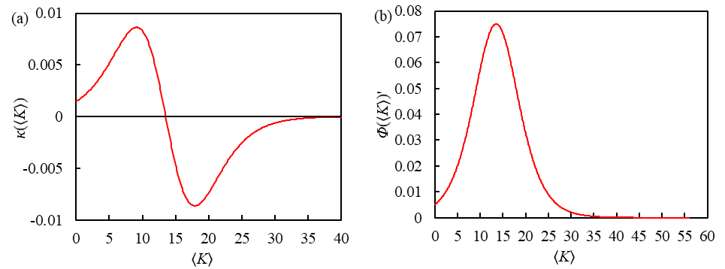
FIG. S1 (a) Curvature function as a function of 〈K〉. (b) First derivative function as a function of 〈K〉.

ρ^{0.5}/η vs Φ and 〈K〉
Previously, a general relationship between the composite controlling variable ρ^{0.5}/η and the order parameter Φ was proposed in [31]. Figure S2a shows this relationship also holds in our simulations. In addition, we find a universal correlation between ρ^{0.5}/η and the structural parameter 〈K〉, which provides the structure origin for the previous relationship. However, the 〈K〉~ρ^{0.5}/η relationship starts to diverge when ρ^{0.5}/η>1, as 〈K〉 is increasingly insensitive to noise at the high-density condition, as shown in FIG. 1b.
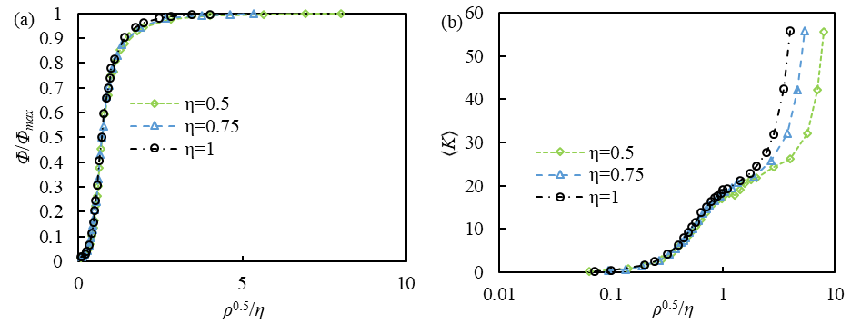
FIG. S2 (a) The normalized order parameter Φ/Φ_{max} and (b) the average interaction number 〈K〉 as a function of ρ^{0.5}/η.

Calculate the degree distribution of starling flocks based on nearest neighbor distance
In Refs [2] and [36], 500 independent flocking events were collected, and the coordinates of each bird in each flock at every time frame were measured. However, the interaction range R_{c} is unknown. To use a metric-based rule to determine alignment neighbors, it is essential to define the interaction range R_{c}. We adopt a nearest-neighbor-distance (NND) approach to derive R_{c} for the dataset from Ref [36] (event 28-10). Specifically, we calculate the median value of NND as shown in FIG. S3, and define the interaction range as twice the median value, given by:
$R_{c}=2×median\left(NND\right)$ (S11)
Figure S3 also shows that the derived value R_{c} ensures that almost every bird maintains at least one neighbor within the interaction range, resulting in a flock with negligible isolated members. The average interaction number 〈K〉 based on this method is 6.5, which is close to the empirically observed topological number [2], further supporting our assumption.

FIG. S3 Cumulative function distribution (CDF) of the nearest neighbor distance (NND) in the starling flock.

Closed form of order parameter vs cluster size distribution
In the main text, we show that in Stages I (Disorder) and II (Order growth), the order parameter Φ can be calculated by cluster size distribution P(S_{cl}) and the uniform correlation between the alignment of cluster and the cluster size (Eq. (5)). If we use some approximation, we can get the closed form of Φ vs P(S_{cl}).
In Stage I (Disorder), the cluster size distribution follows an exponential distribution. If we assume $P\left(S_{cl}\right)=C_{1}e^{-γS_{cl}}$, approximate Eq. (5) as $\cos\left(δθ_{cl}\right)=1-e^{-\left({0.0025S}_{cl}\right)}$, and change Eq. (6) into integral form, we can get a closed-form for the relationship between Φ and γ, given as:
$Φ=1-{\left(\frac{γ}{γ+0.0025}\right)}^{2}$ (S12)
From Eq. (S12), a decrease in γ leads to an increase in Φ, which is consistent with our results. Moreover, since γ is much larger than 0.0025, as shown in FIG. S4, Φ remains at a low level, corresponding to consistent low Φ in this stage.
In Stage II (Order growth), P(S_{cl}) turns into a power-law distribution: $P\left(S_{cl}\right)=C_{2}{S_{cl}}^{-α}$ with $α$ ranging around 2 [24]. If we set α=2, the integral form of Eq. (6) from the main article can be expressed as:
$Φ=1-\frac{E_{1}\left(0.0025\right)-E_{1}\left(0.0025S_{lim}\right)}{lnS_{lim}}$ (S13)
where $E_{1}\left(x\right)=\int_{x}^{∞}{\frac{e^{-t}}{t}}dt$ is the exponential integral and $S_{lim}$ denotes the upper limit of the integral for $S_{cl}$. For example, at the disorder-order transition point, $S_{lim}$ is around 1000. Substituting this into Eq. (S13), the value of Φ is 0.219, which is close to our numerical simulation results. It can be evident that Φ strongly depends on $S_{lim}$. In Stage II, $P\left(S_{cl}\right)$ develops a heavier tail and $S_{lim}$ increases, which gives large clusters greater weight and drives a rapid rise in Φ.
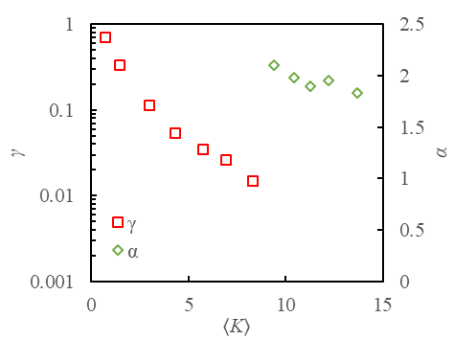
FIG. S4 Exponential coefficient γ (Stage I) and Power-law coefficient α (Stage II) as a function of 〈K〉.

Derivation of Φ as a function of 〈K〉 in Stage III (Order coherence)
In the considered Vicsek system, if the average velocity direction is $θ$, the deviation of particle i is :
$δθ_{i}=θ_{i}- θ$ (S14)
When the system is very ordered, $δθ_{i}≈0$, we can expand $cos\left(δθ_{i}\right)$ in a Taylor series with the higher-order items omitted, which yields:
$cos\left(δθ_{i}\right)=1-\frac{{\left(δθ_{i}\right)}^{2}}{2}$ (S15)
In the Vicsek model, the direction of particle i is updated according to:
$θ_{i,new}={\frac{1}{K+1}(θ}_{i}+ \sum_{j=1}^{K}{θ_{j})}+ε$ (S16)
When the system is very ordered, $θ_{new}$, $θ_{i}$, and $θ_{j}$ are all close to $θ$, then the deviation satisfies:
${δθ}_{i,new}=\frac{1}{K+1} ({δθ}_{i}+\sum_{j=1}^{K}{{δθ}_{j})}+ε$ (S17)
In the central limit theorem, if there are a large number of independent and identically distributed random variables X₁, X₂, …, X_{n}, their average
${\overline{X}}_{n}=\frac{1}{n}\sum_{i=1}^{n}{X_{i}}$ (S18)
tends to follow a normal distribution:
${\overline{X}}_{n}\sim N(μ,\frac{σ^{2}}{n})$ (S19)
At first, ${δθ}_{i}$ and all ${δθ}_{j}$ can be treated as random variables with a mean $μ=0$ and variance $σ_{θ}^{2}$. The angular noise $ε$ is uniformly distributed between $[-η/2,η/2]$, hence:
$Var\left(ε\right)=\frac{η^{2}}{12}$ (S20)
Therefore, the variance of $δθ_{i}$ at fixed K is:
${〈{(δθ_{i})}^{2}〉}_{K}=\frac{σ_{θ}^{2}}{K+1}+\frac{η^{2}}{12}$ (S21)
However, the real relationship may be more complicated as each neighbor j has its own degree K_{j} due to degree heterogeneity:
${〈{(δθ_{i})}^{2}〉}_{K}=\frac{σ^{2}+KA_{K}}{{\left(K+1\right)}^{2}}+\frac{η^{2}}{12}$ (S22)
where $A_{K}≈\sum_{j}{\frac{K_{j}P\left(K_{j}\right)}{〈K〉}}Var(δθ_{j}\left|K_{j}\right.)$. It can be seen that A_{K} decreases as 〈K〉 increases, because size-biased neighbors are, on average, of high degree, which leads to a stronger local averaging effect. Substituting Eq. (S22) into Eq. (S15), we obtain:
$cos\left(δθ_{K}\right)=1-\frac{a}{K+1}-b$ (S23)
where the parameters a and b are related to the interaction structure and the noise limit, respectively.

Finite-size effect on Φ~〈K〉 relationship
To examine the effect of system size, we perform two additional sets of simulations with different particle numbers (N=512 and 32768). As shown in FIG. S5, the Φ~〈K〉 relationships for different N show similar shapes but shift rightward with increasing N. Since the sigmoid function describing the Φ~〈K〉 relationships has two controlling parameters, i.e., in the general form $f(x)=\frac{1}{1+e^{a(x-b)}}$, a controls the shape and b controls the position, we focus on scaling b. Inspired by the finite-size scaling factor L^{0.275} proposed in a previous study [31] and noting that N~L² in 2D, we propose a similar factor N as N^{0.275/2}. Incorporating this scaling into b, Eq. (1) for Φ~〈K〉 relationship is modified as
$\frac{Φ(〈K〉)}{Φ_{max}}=\frac{1}{1+e^{-0.3\left[〈K〉-13.5*{\left(N/4000\right)}^{0.1375}\right]}}$ (S24)
As shown in FIG. S5, the predicted curves based on Eq. (S24) agree well with the simulation data for N=512 and 32768, which tentatively shows the universality across system sizes. Future work will study the detailed curve shape and perform a cluster-level analysis for different particle numbers.

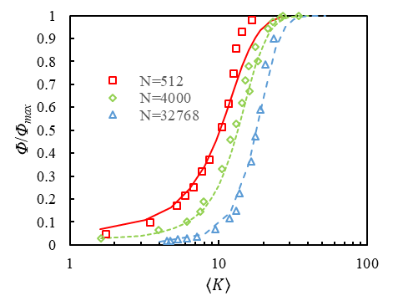
FIG. S5 The normalized order parameter Φ/Φ_{max} as a function of the average interaction number 〈K〉 for three different particle numbers (N=512, 4000 and 32768). Symbols are simulation results and lines are predicted by Eq. (S24) for different N.

