Pulsed Electrolysis for High Conversion Glycerol Electrooxidation on Platinum: Tuning Product Selectivity and Electrode Longevity

ª Mahdis Nankali, ª Shayan Angizi, ª Zahra Teimouri, ª Navid Noor, ª Hermione French, ª Reza Eslami, ª Rem Jalab, ª Inder sangha, Drew Higgins ^{a *}
ª Department of Chemical Engineering, McMaster University, Hamilton, ON, Canada.
* Corresponding author; higgid2@mcmaster.ca

Random Forest regression
The process of investigating the correlations between input experimental factors on the selectivity of different products produced in GOR using machine learning (ML) algorithms consists of several key stages, including data collection, pre–processing, hyperparameter tuning, model training, testing, and interpretation. Data collection is one of the fundamental steps in developing an effective ML algorithm in evaluating the significance of the input parameters on the target responses. Herein, the dataset was acquired from the experimental tests on the electrocatalytic oxidation of glycerol, using a pulsed electrolysis method (34 data points). Python 3 was used to build the model. To ensure that the input features are in the same scale and decrease overfitting; input data were first normalized by Min–Max algorithm using equation (1):
$$x_{iN}^{new}=\frac{x_{iN}^{old}-x_{i}^{min}}{x_{i}^{max}-x_{i}^{min}}$$ | (1)
Where $x_{iN}^{new}$and $x_{iN}^{old}$denotes the N^{th} sample of the scaled data and raw data for i^{th} feature, respectively. The minimum and maximum values for the input data (reduction potential, oxidation potential, reduction time, and oxidation time) were extracted from literature for GOR using the pulsed electrolysis. Specifically, random forest regression (RFR) was used in this work, which is an ensemble learning algorithm, that aggregates the predictions from several randomized decision trees[1]. The two most common hyperparameters for the RFR model, that can be tuned to improve its performance are: n_estimator, and max_depth. While n_estimator corresponds to the number of decision trees; max_depth stands for the maximum depth of each decision tree in the forest. Once the optimal hyperparameters were determined for RFR, the normalized dataset was randomly divided into training and testing data with a ratio of 75:25, respectively. The prediction accuracy of the model was evaluated based on the mean square error (MSE), mean absolute error (MAE), correlation coefficient (R²), and root mean square error (RMSE) descriptors by following equations:
$$MAE=\frac{1}{N}\sum_{i=1}^{N}{\left|Y_{i}^{actual}-Y_{i}^{pred}\right|}$$ | (2)
$$MSE=\frac{1}{N}\sum_{i=1}^{N}{{(Y_{i}^{actual}-Y_{i}^{pred})}^{2}}$$ | (3)
$$RMSE=\sqrt{\frac{\sum_{i=1}^{N}{{(Y_{i}^{actual}-Y_{i}^{pred})}^{2}}}{N}}$$ | (4)
$$R^{2}=1-\frac{\sum_{i=1}^{N}{{(Y_{i}^{actual}-Y_{i}^{pred})}^{2}}}{\sum_{i=1}^{N}{{(Y_{i}^{actual}-Y_{ave}^{actual})}^{2}}}$$ | (5)

In the last stage of the ML framework, model interpretation was carried out to investigate the nature of the dependence of the output responses on input variables. Herein, two–way PDPs were implemented using scikit–learn library of Python to study the possible dependencies between the catalyst performance descriptors (activity and selectivity) and a set of input features, while keeping other features at constant values.

Figure S1a–f presents SEM images of the Pt/Ni–foam electrode at progressively higher magnifications. Across the foam ligaments, galvanic displacement produces a conformal, nano dendritic Pt layer: micron–scale petal–like crystallites (a,b) give way to densely packed, sharp nanoplates and nano–buds down to ~100 nm (c–f). This hierarchical coating confirms uniform Pt deposition and endows the scaffold with an enlarged, high–surface–area architecture ideal for electrocatalysis [2].
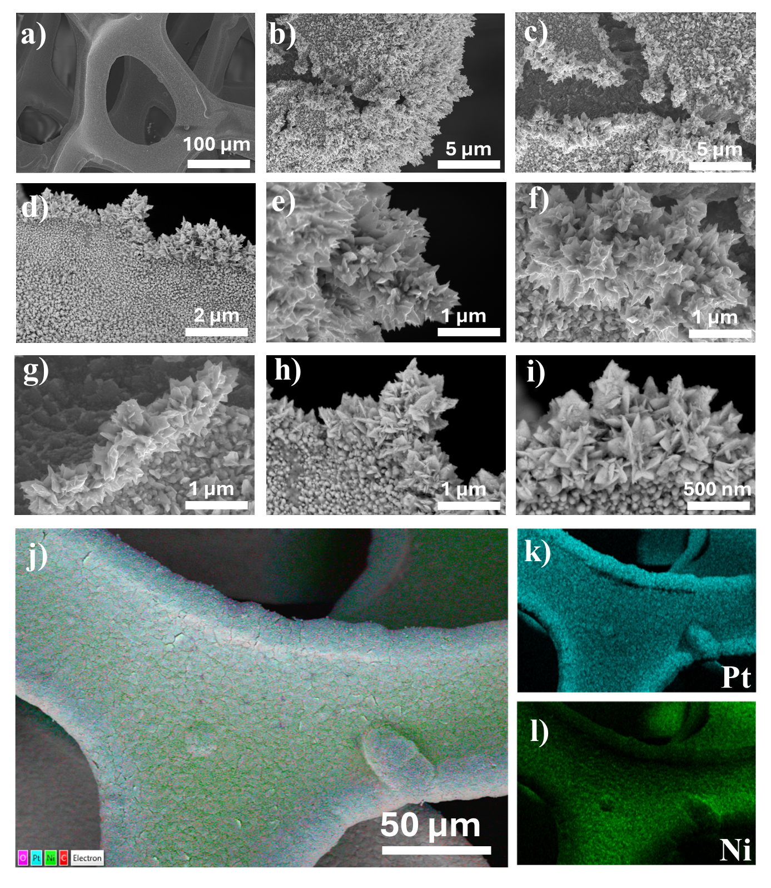
Figure S1. The SEM images (a-i) and EDX mapping (j-l) of Pt/NiF electrode.
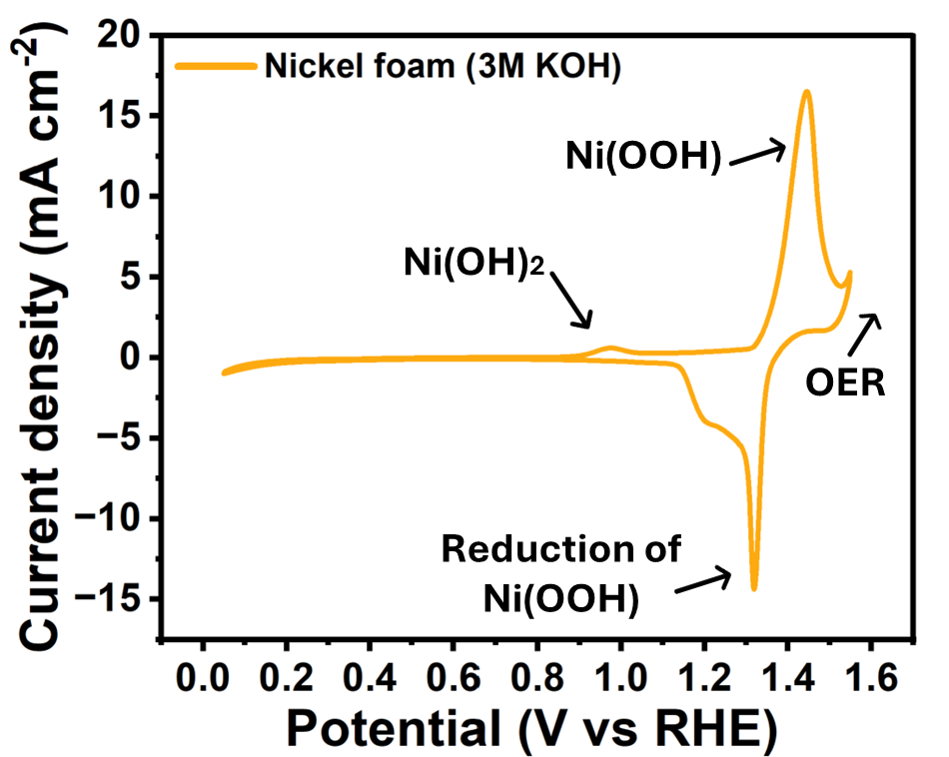
Figure S2. CV curves (at a scan rate of 20 mV s⁻¹) of NiF in a 3M KOH electrolyte.
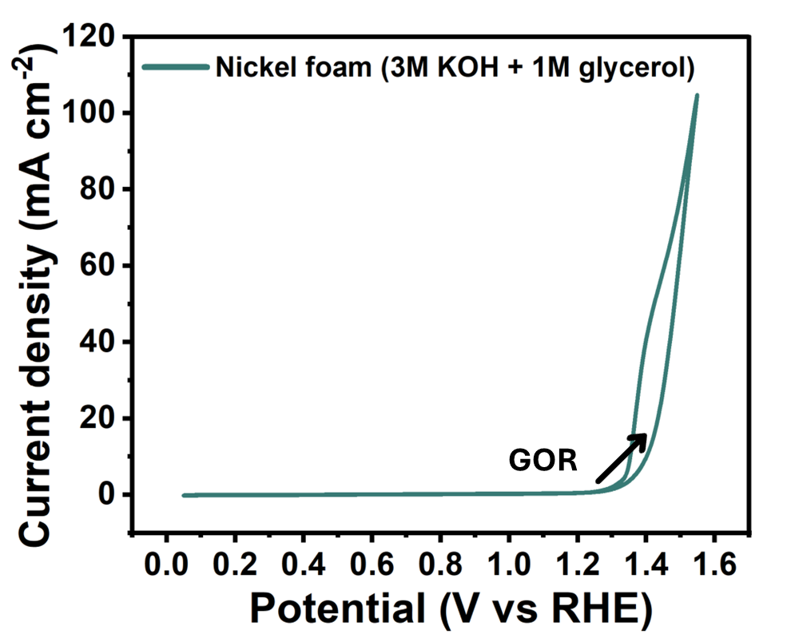
Figure S3. CV curves (at a scan rate of 20 mV s⁻¹) of NiF in a 3M KOH electrolyte containing 1M glycerol.

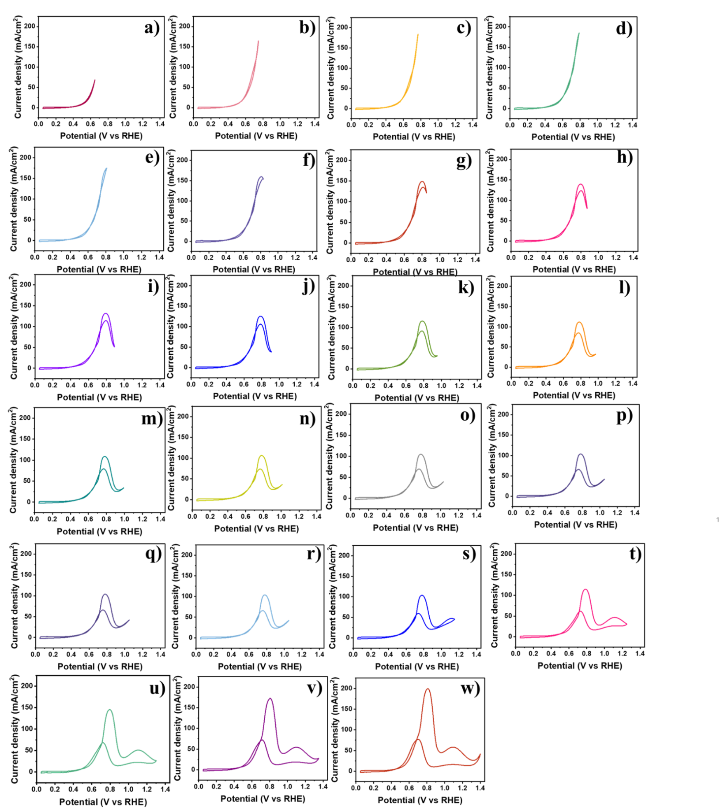
Figure S4. CV curves (at a scan rate of 20 mV/s) of NiF/Pt in the 3M KOH electrolyte and 1 M Glycerol at different upper potential limits.
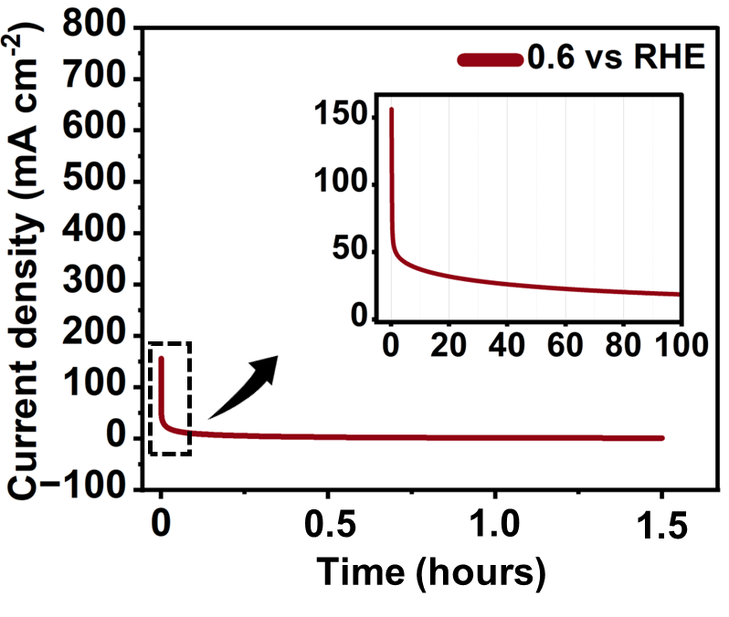
Figure S5. Constant electrolysis at 0.6 V vs RHE oxidation potentials for 1.5 h Chronoamperometry.
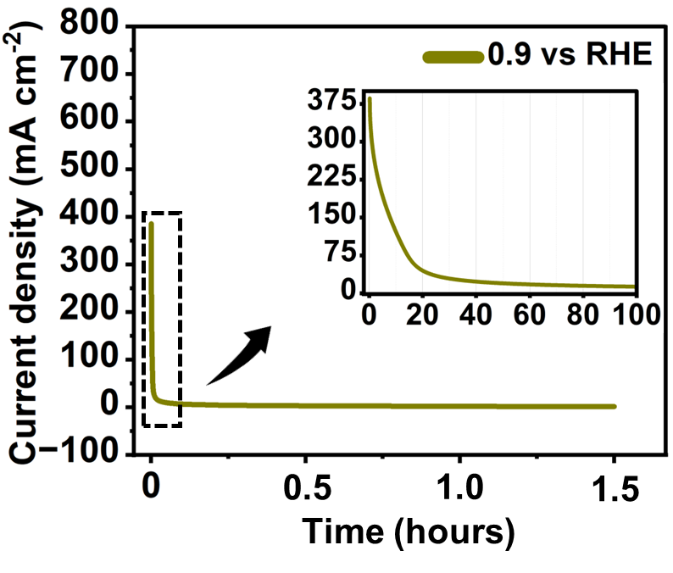
Figure S6. Constant electrolysis at 0.9 V vs RHE oxidation potentials for 1.5 h Chronoamperometry.
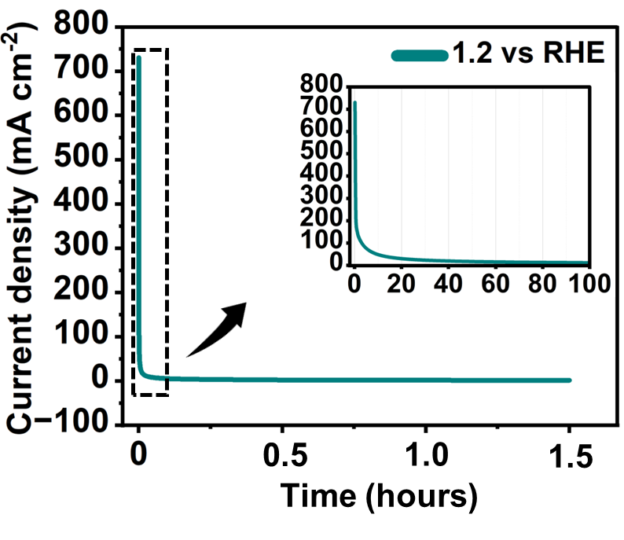
Figure S7. Constant electrolysis at 1.2 V vs RHE oxidation potentials for 1.5 h Chronoamperometry.

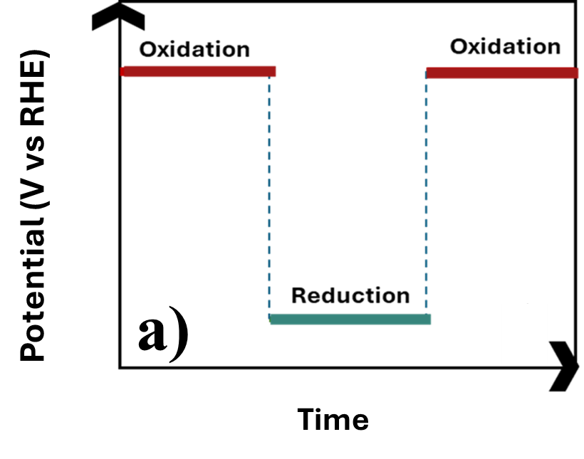
Figure S8. Schamatic illustration of pulsed electtrolysis.

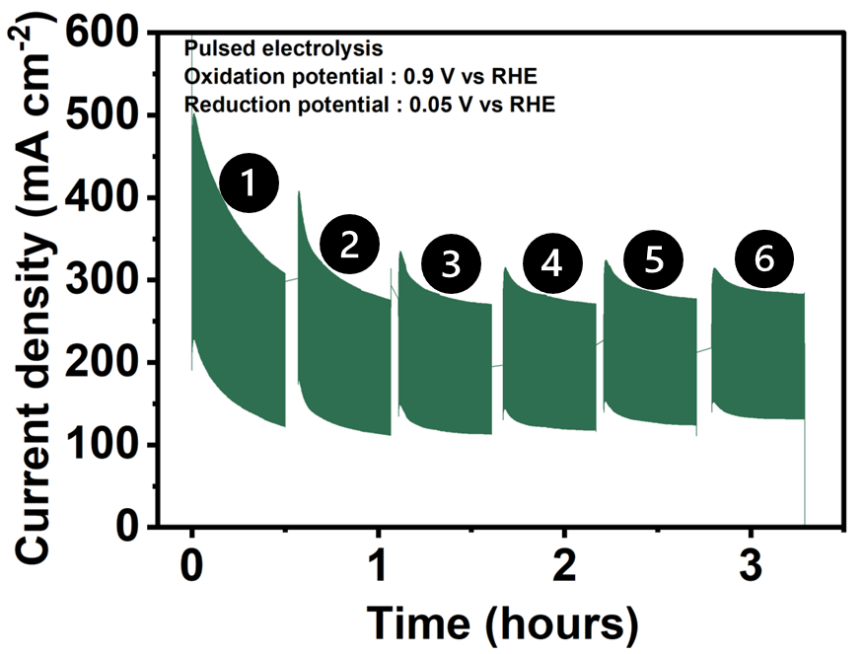
Figure S9. Chronoamperometry measurments of the Pt/NiF electrode during six sequential pulsed electrolysis periods at 0.9 V (oxidation potential) and 0.05 V (reduction potential) vs. RHE (the oxidation time = reduction time = 3 sec each) in 3 M KOH containing 1 M glycerol. After each 300-cycle of pulsed electrolysis (labeled 1–6), 0.2 mL of glycerol was added to the electrolyte to compensate for consumption and evaluate recovery behavior.

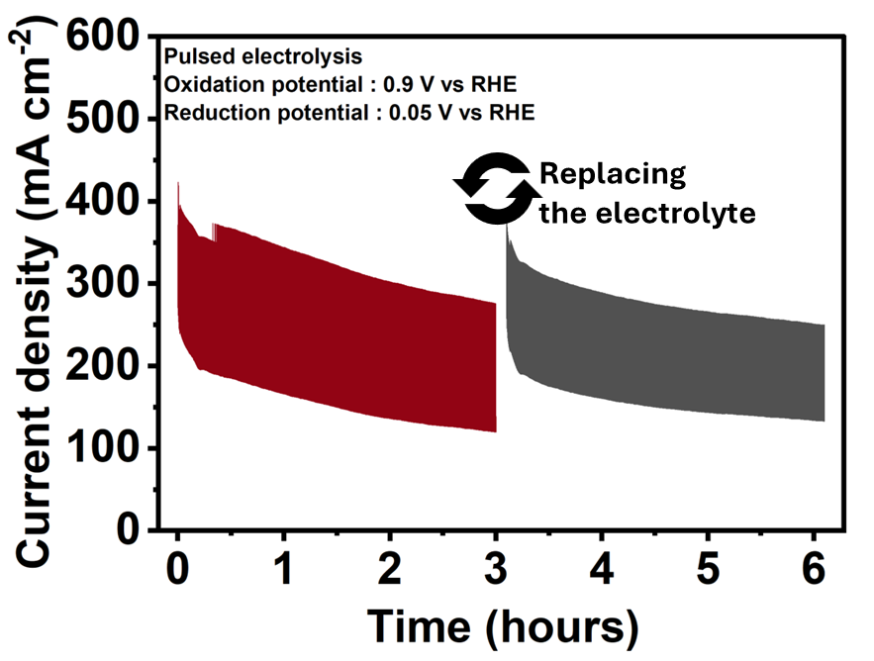
Figure S10. Chronoamperometry measurments of the Pt/NiF electrode during 6 hours of pulsed electrolysis at 0.9 V (oxidation potential) and 0.05 V (reduction potential) vs. RHE (the oxidation time = reduction time = 3 sec each) in 3 M KOH containing 1 M glycerol. After 3 h of the reaction, the electrolyte was completely refreshed while retaining the same electrode.

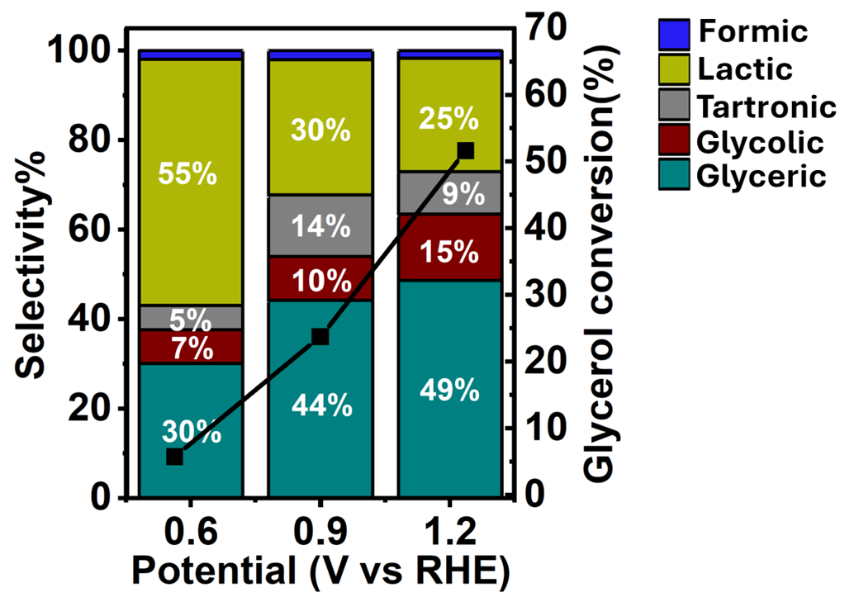
Figure S11. Product selectivity and glycerol conversion of the Pt/NiF electrode toward GOR products obtained from H–NMR analyses of pulsed electrolysis chronoamperometry tests in 3 M KOH containing 1 M glycerol at oxidation potential of 0.6 V vs RHE, 0.9 V and 1.2 V vs RHE with the reduction potential of 0.05 V vs RHE (the oxidation time = reduction time = 3 sec each) for 1.5 hours of oxidation.

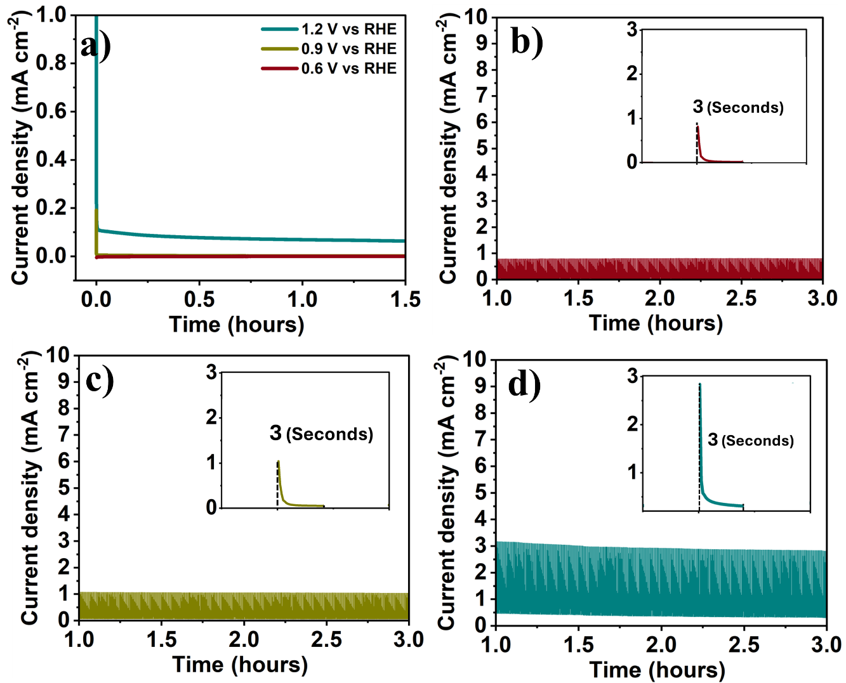
Figure S12.Cornoamperametry experiments for NiF a) Constant electrolysis at 0.6, 0.9 and 1.2 V vs RHE oxidation potentials for 1.5 hours Chronoamperometry, b) Pulsed electrolysis chronoamperometry tests at oxidation potential of b) 0.6 V vs RHE, c) 0.9 V and d) 1.2 V vs RHE with the reduction potential of 0.05 V vs RHE (the oxidation time = reduction time = 3 sec each) for 1.5 hours of oxidation.

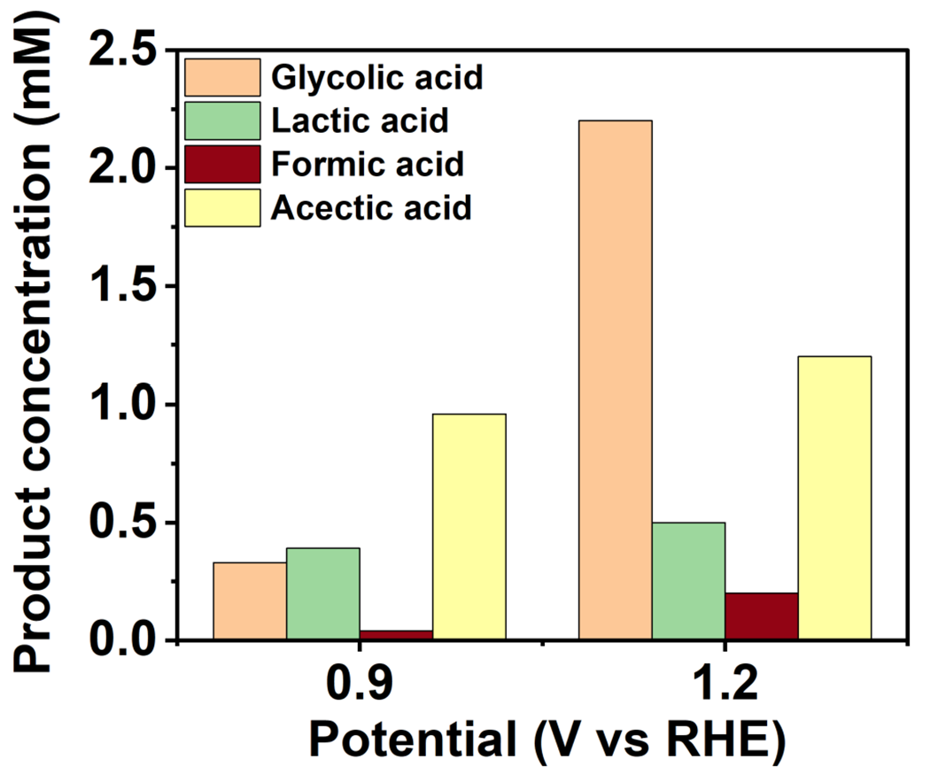
Figure S13. Concentration of products produced during pulsed electrolysis of NiF tests at oxidation potential of 0.9 V and 1.2 V vs RHE with the reduction potential of 0.05 V vs RHE (the oxidation time = reduction time = 3 sec each) for 1.5 hours of oxidation.
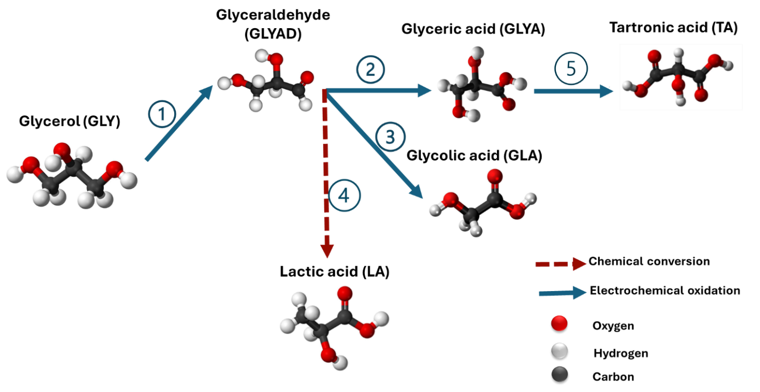

Figure S14. Proposed basic mechanism and pathway of glycerol electrooxidation for main products: glyceric acid, glycolic acid, lactic acid and tartronic acid.
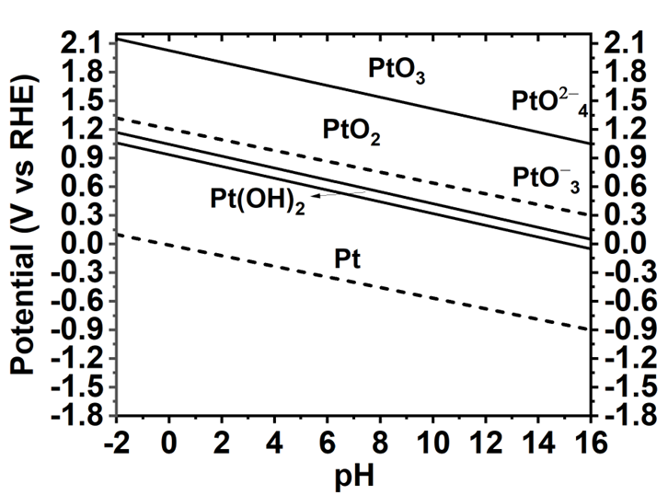
Figure S15. Pourbaix diagram of Platinum.

Mechanistic Interpretations of Pulsed Glycerol electrolysis
To achieve enhanced control over the glycerol electrooxidation outcomes, we employed a strategic approach to process design using RFR method. By carefully tuning its hyperparameters, specifically the number of trees (n_estimators) and the maximum depth, the predictive performance of the RFR model was enhanced. This approach enabled accurate prediction of the partial current densities of lactic acid, glyceric acid, glycolic acid, and tartronic acid under various operating conditions. Figure S4 illustrates the results of the hyperparameter tuning and the partial current density predictions achieved using the RFR model. For the partial current density of lactic acid, the minimum RMSE (2.23) was achieved using 1 tree with a maximum depth of 7 (Figure S4b). Optimization of the hyper–parameters of RFR for the partial current density of the glyceric acid led to a minimum RMSE of 2.79 using 1 tree and a maximum depth of 12 (Figure S4 d). For partial current densities of tartronic and glycolic acid, hyperparameters tunning resulted in 1 tree, maximum depth of 13, 1 tree, and maximum depth of 17, respectively (Figure S4 f, h).
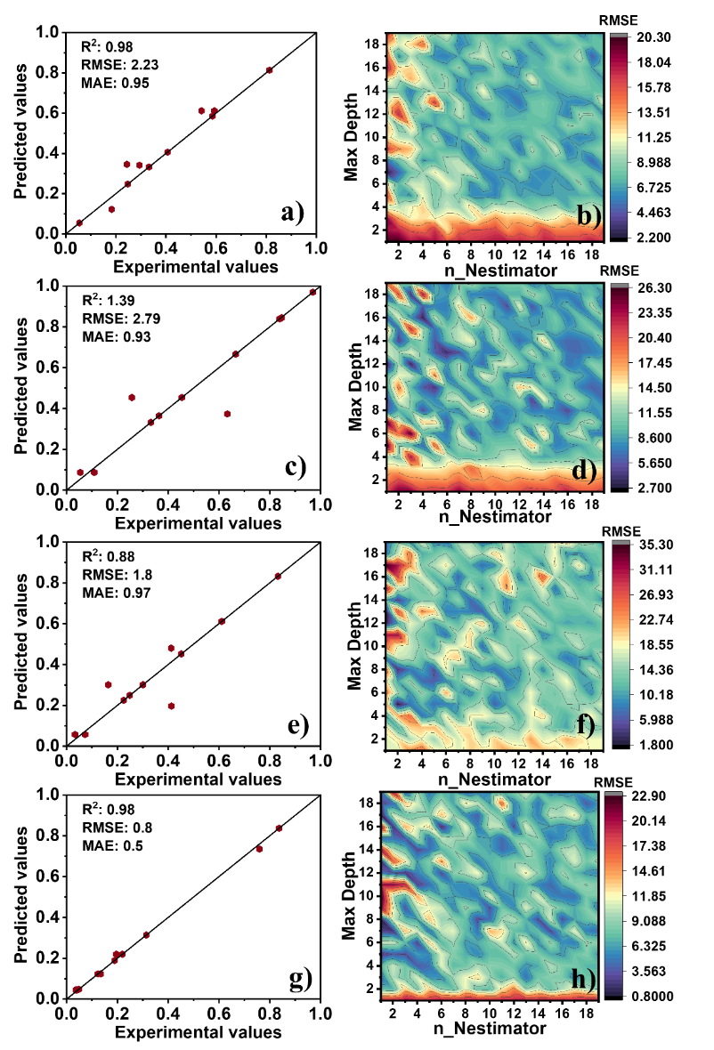
Figure S16. a) Predicted data vs experimental data for partial current density of Lactic acid using RFR for test data, b) Hyper–parameter tuning of RFR for partial current density of Lactic acid, c) Predicted data vs experimental data for partial current density of glyceric acid using RFR for test data, d) Hyper–parameter tuning of RFR for partial current density of glyceric acid, e) Predicted data vs experimental data for partial current density of Tartronic acid using RFR for test data, f) Hyper–parameter tuning of RFR for partial current density of Tartronic acid, g) Predicted data vs experimental data for a partial current density of glycolic acid using RFR for test data, and h) Hyper–parameter tuning of RFR for partial current density of glycolic acid. The predicted and experimental data shown in the graphs have been normalized.

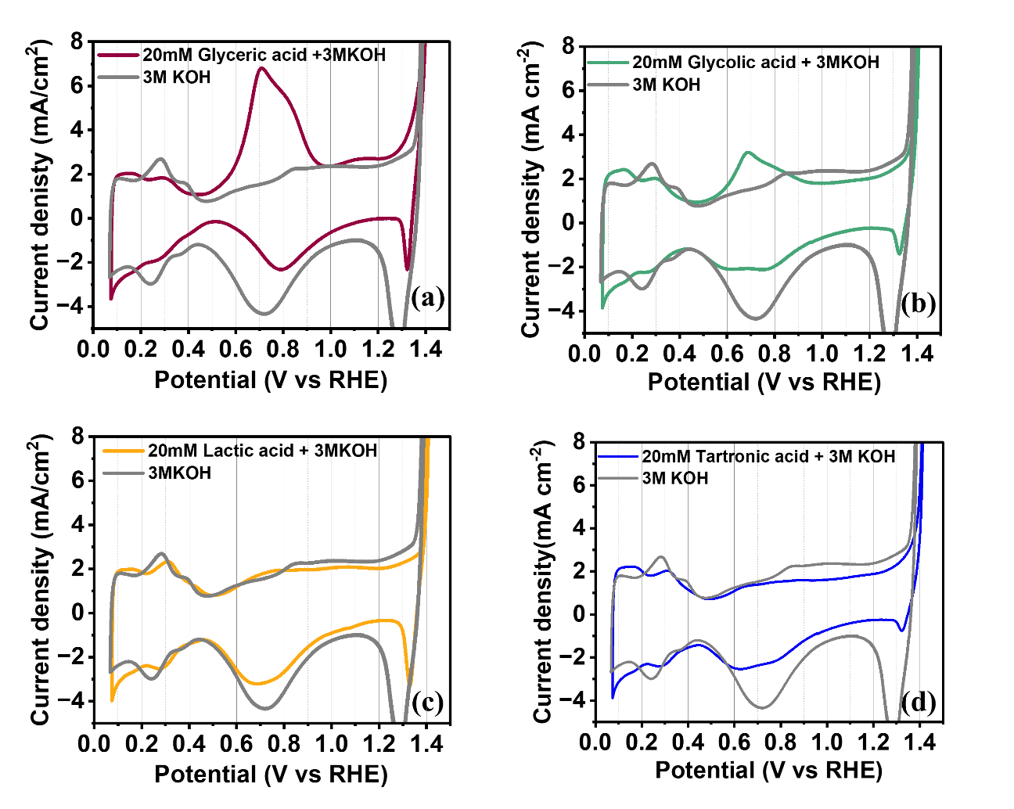
Figure S17. CV curves of Pt/NiF in a 3M KOH electrolyte in the absence (grey) and presence of 20mM of each product, at a scan rate of 20 mV/s, a) Glyceric acid, b) Glycolic acid, c) Lactic acid, and d) Tartronic acid.

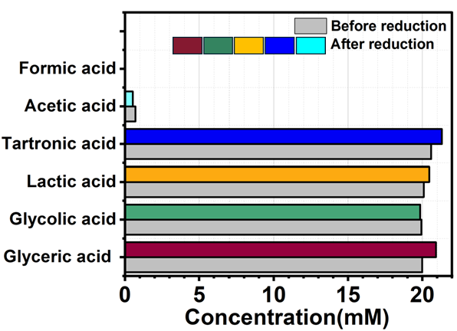
Figure S18. The results of reduction at 0.05 V vs RHE for 30 minutes in the solution containing mixture of 20 mM of glyceric acid, Glycolic acid, Lactic acid and glyceric acid.

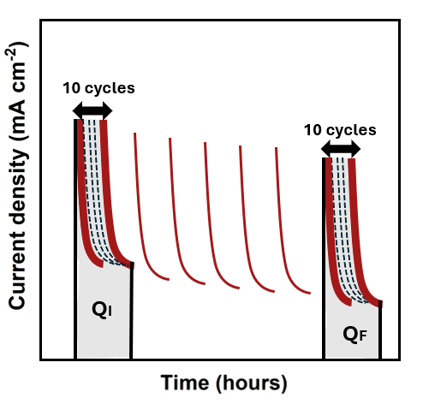
Figure S19. Schematic illustration of the method used to evaluate performance decay during pulsed electrolysis. The integrated area under the current density–time curves was calculated for the first 10 cycles (Q_{i}) and the last 10 cycles (Q_{F}) of the experiment.

Reference:
[1] W. Jiang, X. Xing, S. Li, X. Zhang, W. Wang, Synthesis, characterization and machine learning based performance prediction of straw activated carbon, Journal of Cleaner Production 212 (2019) 1210-1223.
[2] S. Angizi, M. Nankali, A. Foroozan, J. Park, E. Yelekli Kirici, N. Noor, M. Fefer, Y. Terazono, D. Higgins, 3D Bimetallic Platinum‐Nickel Electrodes for Electro‐Oxidation of Glycerol at Ambient Conditions, Advanced Functional Materials 35(14) (2025) 2420622.

