Fully parallel in-memory gradient descent on 1k graphene interfacial memristor crossbar array for edge fine-tuning

Supplementary information

Xudong Zhuang¹, Abdulkarim Alorf¹, Jiahui Yang¹, Tergel Molom-Ochir¹, MD Sazzadur Rahman¹, Brady G. Taylor¹, Isaiah K. Bernardino¹, Jiazheng Chen¹, Rafael B. Serpa¹, Victoria M. Ravel¹, Xianduo Jerry Zhao¹, Sanjeev J. Chauhan¹, Avantika Chopra^{1,5}, Yaqing Shen², Hintsa F. Hishe¹, Arijit Sarkar¹, Charles B. Parker¹, Mario Lanza³, Aaron D. Franklin^{1,4}, Jeffrey T. Glass¹, Hai (Helen) Li¹, Yiran Chen¹, Tania Roy¹⁺
¹Department of Electrical and Computer Engineering, Duke University, NC, USA
²Physical Science and Engineering Division, King Abdullah University of Science and Technology, Thuwal, Saudia Arabia
³Department of Materials Science and Engineering, National University of Singapore, Singapore
⁴Department of Chemistry, Duke University, NC, USA
⁵Department of Physics, Duke University, NC, USA
+Corresponding author: tania.roy@duke.edu

Table of content

S1. Device stack optimization 3
S2. Additional device properties 5
S3. Write noise analysis from endurance measurement 6
S4. Interfacial MIG Memristor benchmark 7
S5. X-ray Photoelectron Spectroscopy (XPS) during different steps of oxides deposition 8
S6. Conduction mechanism and compact modeling 9
S7. Schematic of testbenches in Cadence Virtuoso 14
S8. Conduction tuning curves produced from the compact model 15
S9. Linearity analysis of parallel programming with different BL/WL encoded numbers 16
S10. As-fabricated conductance map of functional devices inside the 32 × 32 crossbar array 18
S11. Independent programming inside the crossbar array 19
S12. Experimental setup for crossbar array measurement 20
S13. Experimental validation of outer product on crossbar array 21
S14. Macro and tile design for both inference and training 22
S15. Macro and tile design for both inference and training 23
S16. Dataflow comparison with and without outer product updates 25

S1. Device stack optimization
Systematic optimization of device stacks was conducted with different electrodes and different oxide stacks (Fig. S1). Particularly, we started from investigating a tri-layer oxide stack composed of 1 nm TiO_{x}/2 nm Al₂O₃/1 nm TiO_{x} sandwiched between bilayer graphene (BLGr) electrodes to form the graphene-insulator-graphene (GIG) stack (Fig. S1a). Unlike previous work of filamentary switching of similar stack, this device exhibited non-filamentary switching, as evidenced by the absence of abrupt current jumps in the I–V characteristics^{1, 2}. However, this stack suffers from ultra-low conductance (>1 GΩ), even in relatively large devices (10 μm × 10 μm), which could complicate peripheral circuitry, slow-down the readouts, and reduce the signal-to-noise ratio, especially with small crossbar array sizes and further-scaled devices³⁻⁵. Moreover, though the device can be deterministically potentiated upon the positive biasing region, the on/off ratio is only ~10 at a high read voltage of 1.5 V, and the hysteresis window under negative bias is negligible, which is likely due to the competition between the two TiO_{x} switching layers.
To address the above issues, we fabricated the metal-insulator-graphene1 (MIG1) stack, which comprises a single TiO_{x} switching layer with atomic layer deposition (ALD)-grown Al₂O₃ on the top, using BLGr as the top electrode and Au bottom electrode (Fig. S1b). Around 30% of the stack exhibits interfacial-switching characteristics, with conductance at MΩ range and an enlarged on/off ratio of over 10³, favorable for multiple-state storage with an improved signal-to-noise ratio (SNR). However, the remaining ~70% of MIG showed filamentary switching, with a lower on/off ratio of about 10 and higher conductance of over 100 MΩ to 1 kΩ, unsuitable for large crossbar array sizes due to high sneak path current⁶. This behavior originates from the porous nature and high oxygen-vacancy concentration of electron-beam–evaporated TiO_{x}, as well as the oxygen-vacancies-populated TiO_{x} /Al₂O₃ interface, both of which promote oxygen vacancies aggregation and filament formation⁷. We mitigate this effect through insertion of an ALD-grown TiO₂ layer between TiO_{x} and Al₂O₃, forming the MIG2 stack. It shows stable interfacial switching properties with suitable conductance region and large on/off ratio of around 5,000. Moreover, compared with its metal–insulator–metal (MIM) counterpart, MIG2 exhibits a larger on/off ratio at lower current levels, reflecting higher power efficiency (Fig. S1f).
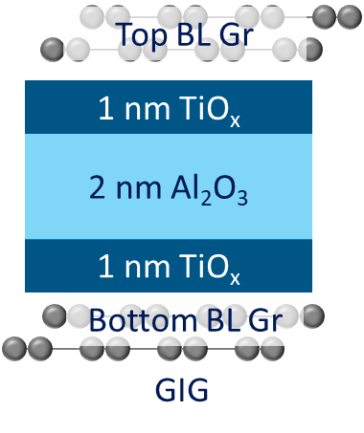
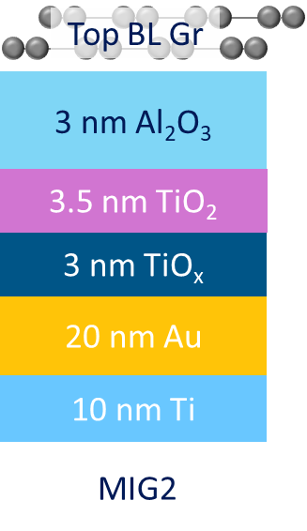
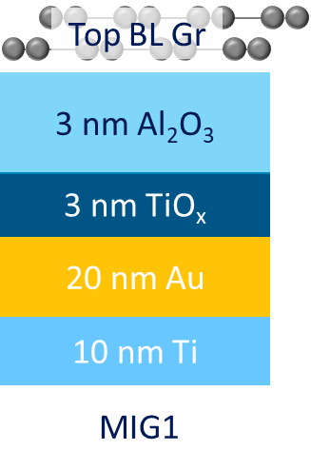
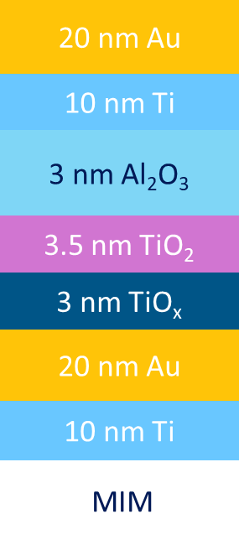
Fig. S1 Device optimization and the I-V characteristics of each stack. (a) graphene-insulator-graphene (GIG), (b) metal-insulator-graphene-1 (MIG1), (c) metal-insulator-graphene-2 (MIG2), and (d) metal-insulator-metal (MIM) memristors with all the device area of 10 um × 10 um. (e) I-V characteristics of different device stacks throughout the optimizations. (f) I-V characteristics of MIG2 device and its MIM counterpart as shown in d.
a
b
c
d
e
f

S2. Additional device properties
Conductance tuning curves with various pulse widths from 5 ms to 50 μs and fixed pulse height of 2.5 V for potentiation and -2.5 V for depression are measured with low initial conductance state. Across all the pulse widths, it shows abrupt depression upon the first depression pulse, which is due to the short lifetime of trap states of shallow traps^{8, 9}.
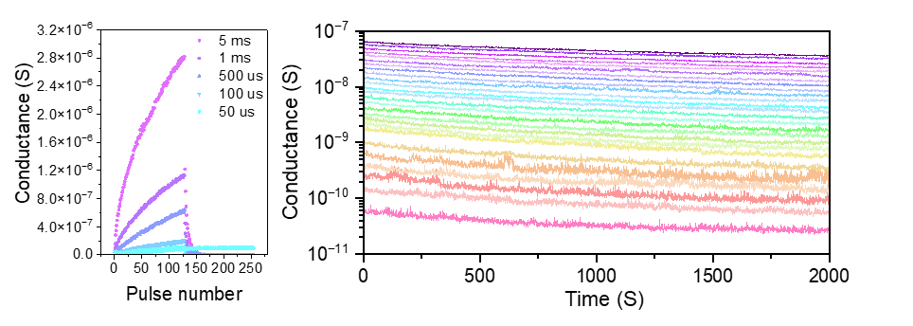
b
a
Fig. S2. Additional device properties. (a) Conductance tuning curve with low initial conductance and various pulse widths. (b) Retention at room temperature showing 26 distinctive states.

S3. Write noise analysis from endurance measurement
Write noise was extracted and analyzed based on endurance measurement (Fig. 1i). It can be observed that throughout the investigated conductance ranges, the device shows a close-to-constant conductance change regardless of initial conductance (Fig. S2a). Particularly, the mean value of absolute conductance change under one potentiation/depression pulse are the same, both are 2.2 ×10⁻⁹ S (Fig. S2b and Fig. S2c). This suggested that a good linearity and symmetry of the conductance tuning properties can be maintained throughout the 1,000 cycles of programming.

Fig. S3 Write noise extracted from endurance measurement. (a) Conductance change across different initial conductance. (b) Distribution of the potentiation upon one 100 μs/2.5 V pulse during the endurance measurement, showing the mean value of 2.2 nS upon one write pulse. (c) Distribution of the depression upon one 100 us/-2.5 V pulse during the endurance measurement, showing the mean value of -2.2 nS upon one write pulse.
Potentiation
Depression
a
b
c
2.2×10⁻⁹
-2.2×10⁻⁹

S4. Interfacial MIG Memristor benchmark
The proposed interfacial MIG memristors shows a good balance between pulse height, pulse width, on/off ratio, as well as retention and endurance as compared to other nonfilamentary memristor stack⁸⁻¹¹. Particularly, through using graphene as the top electrode, the device shows ultrahigh on/off ratio with moderate pulse height of 2.5 V, which is suitable for back-end-of-line (BEOL) integration on top of CMOS chip.
Table S1. Device characteristic benchmark against other non-filamentary memristors
Refereence | 10 | 11 | 12 | 13 | This work
Device stack | Au/Al₂O₃/TiO₂/TiO_{x}/Al/Ti | Pt/Ta₂O₅/Nb₂O_{5−x}/Al₂O_{3-y}/Ti | Au/O_{D}-IGZO/  O_{R}-IGZO/Pt | Pt/anodized TiO_{x}/Ti | Au/TiO_{x}/TiO₂/Al₂O₃/Graphene
Smallest device area | 300 nm × 300 nm | 5 μm × 5 μm | π × 50 μm  × 50 μm | 5 μm × 5 μm | 3 μm × 5 μm
Pulse height | -3.5 V/3 V | ±10 V | ±2 V | ±4.5 V | ±2.5 V
Pulse width | 5 ms | 1 ms | 25 ms | 100 us | 100 us
On/Off | 5 | > 8 × 10³ | < 3 | < 10 | 5 × 10³
Retention | >7.2 × 10³ s | 2 × 10⁵ s | 10⁴ s | 4 × 10⁻² s | > 4 × 10⁸ s
Endurance | >10⁸ | 10⁵ | 5 × 10³ | 5 × 10⁶ | > 1.2 × 10⁵

S5. X-ray Photoelectron Spectroscopy (XPS) during different steps of oxides deposition
The occurrence of Ti³⁺ peak in XPS measurement have been used as an indicator of the appearance of oxygen vacancies in TiO₂ and TiO_{x} as a memristive switching materials^{7, 12}. XPS was taken during the three steps of oxides deposition. The TiO_{x} layer, which was deposited through electron beam evaporation of 3 nm Ti and ambient oxidation for 36 hrs, shows Ti³⁺ peak, indicating the occurrence of oxygen vacancies in TiO_{x}. In contrast, when ALD TiO₂ was deposited on top of TiO_{x}, the Ti³⁺ peak almost completely diminished, indicates that the oxygen vacancies in TiO₂ is much less than that of TiO_{x}. Once ALD Al₂O₃ was deposited on top of TiO_{x}/TiO₂, the Ti³⁺ peak appears again, indicating the high oxygen vacancy concentration at the TiO₂/Al₂O₃ interface.

TiO_{x}
a
TiO_{x} /TiO₂
b
TiO_{x} /TiO₂/Al₂O₃
c
Fig. S4 XPS of oxides along fabrication process. (a) 3 nm Ti deposited by electron-beam evaporator and then oxidized in the air for 36 hrs to form TiO_{x}. (b) 3 nm ALD TiO₂ on top of the as-deposited TiO_{x}. (c) 3 nm ALD Al₂O₃ on top of the bilayer TiO_{x}/TiO₂. The value of Ti³⁺ and Ti⁴⁺ peaks are aligned with existed results from the literature^{7, 14}.

S6. Conduction mechanism and compact modeling
Fig. S5. Conduction mechanisms of different sweeping ranges and directions.
m = 1
m = 2-3
m = 2
2.5→0
m = 1
m = 3-5
0→-2.5
m = 1
m = 5-6
-2.5→0
a
b
c
Conduction mechanisms of three other segments are also investigated (Fig. S5). Two types of conduction mechanisms are included in this model. The first one is the power-law form of space-charge-limited current (SCLC), which describes the charge-trapping and detrapping dynamics, and is expressed generally as:

$I_{sclc }= m ⋅ V^{k}$ (1)

where $k$ and $m$ are fitted parameters. Due to the rich variations of trapping and detrapping mechanisms, multiple sets of $k$ and $m$ are required within each segment, so we need multiple $I_{sclc}$ to accurately depict the I-V characteristics of the MIG device. The second mechanism is Fowler–Nordheim tunneling (FNT), which dominates transport at higher biases across the Schottky barriers at the Au/TiO_{x} interface and the Al₂O₃ tunnel barrier, and is expressed generally as:

$\ln\left(\frac{I_{fnt}}{V^{2}}\right) = \frac{k}{V} + m$ (2)

where k and m are fitted parameters as well. While a theoretical work suggests that the exponent of V should be 3 for FNT across graphene/insulator junction due to linear dispersion relationship of graphene, we didn’t see a huge increase in the fitting accuracy, therefore we sticked to the usual case¹⁵.
Starting from fitting the consecutive I-V for four bias segments, we analyzed different conduction mechanisms in each bias range. We then used the max function to merge these segments into a complete I–V sweep to evaluate the overall fitting accuracy (Eq. 3). However, this relationship represents only the static current–voltage dependence, i.e., $I = I\left(V\right)$, and lacks a temporal component, making it insufficient to capture the evolution of the device state under different biasing schemes over time.

$I_{total}\left(V\right) = \max\left(I_{0}\left(V, P_{0}\right), …, I_{n}\left(V, P_{n}\right)\right)$ (3)

Where $I_{0}$ to $I_{n-1}$ are usually in the general form of SCLC (Eq. 1) and $I_{n}$ is in the form of $I_{fnt}$ (Eq. 2). The number $n$ depends on the variation in trapping and de-trapping dynamics in each bias segment.
To incorporate temporal dynamics into the model, we extracted the fitted parameters as functions of time during voltage sweeping. The parameter evolution was modeled separately for the forward and reverse sweeps to ensure higher fitting precision. This step is crucial because many parameters appear within exponential terms, where even minor distortions can lead to significant deviations in the modeled I–V characteristics. After establishing the time dependence of each parameter, we fitted their temporal evolution using a unified function for all parameters $P(t)$ (Eq. 4).

$P\left(t\right) = a⋅e^{bt} + c ⋅ t^{0.3} + d$ (4)

Accordingly, four fitted values, i.e., $a$, $b$, $c$, and $d$, were obtained for the slopes and intercepts of different conduction mechanisms in each bias segment. Consequently, the temporal evolution of the current can be expressed as:

$I_{total}\left(V\left(t\right)\right) = \max\left(I_{0}\left(V\left(t\right), P_{0}\left(t\right)\right), …, I_{n}\left(V\left(t\right), P_{n}\left(t\right)\right)\right)$ (5)

With this equation, we successfully integrated both time and voltage dependencies into the evolution of current, i.e., conductance, over time. We then employed the partial differential equation (PDE) framework from the Yakopcic model to describe the change in the device state, where the state variable is proportional to the fitted parameter evolution $P=P(t)$. In this formulation, t does not represent the physical time but rather a control parameter that ensures all model parameters evolve synchronously. This approach is feasible because the conductance change under both positive and negative biases in the consecutive I–V characteristics is monotonic, evolving from the minimum to the maximum conductance state.
The Yakopcic state function is depicted by two parts, one is $g(V(t))$, which depicts positive and negative thresholds with tunable exponentials¹⁶.
$g\left(V\left(t\right)\right)= \left\{\begin{aligned}A_{p}\left(e^{V\left(t\right)}-e^{V_{p}}\right), V\left(t\right)>V_{p} \\ {-A}_{n}\left(e^{-V\left(t\right)}-e^{V_{n}}\right), V\left(t\right)<{-V}_{n} \\ 0, -V_{n}≤V\left(t\right)≤V_{p}\end{aligned}\right.$ (6)
Another part of Yakopcic’s state function is $f(x(t))$, which is used to model the state evolution once the threshold is exceeded.

$$f\left(x\left(t\right)\right)= \left\{\begin{aligned}e^{-α_{p}\left(x-x_{p}\right)}w_{p}\left(x, x_{p}\right), x≥x_{p} \\ 1, x<x_{p}\end{aligned}\right.$$
(7)
$$f\left(x\left(t\right)\right)= \left\{\begin{aligned}e^{α_{n}\left(x+x_{n}-1\right)}w_{n}\left(x, x_{n}\right), x≤{1-x}_{n} \\ 1, x>1- x_{n}\end{aligned}\right.$$
(8)

$w_{p}\left(x, x_{p}\right)=\frac{x_{p}-x}{1-x_{p}}+1$ (9)
$w_{n}\left(x, x_{n}\right)=\frac{x}{1-x_{n}}$ (10)

The evolution of state function $x$ over time under different voltages is given by the product of $g$ and $f$ as follows:
$\frac{dx}{dt}=g(V(t))f(x(t))$ (11)

A full list of fitted parameters is listed in Table S2 and Table S3. For the fitted parameters evolution over state in Eq. 4 in different conduction mechanisms inside each segment.

Table S2. Change of slopes and intercepts inside conduction mechanisms function over state
Segment | Slopes  /intercepts | Para. | SCLC1 | SCLC2 | SCLC3 | FNT
0→2.5 V | k | a | 0.223 | 1.234 | 2.654 | -5.636
0→2.5 V | k | b | -2.853 | -0.065 | -0.032 | -13.196
0→2.5 V | k | c | 0.079 | 0.101 | 2.096 | 3.535
0→2.5 V | k | d | 0.650 | 1.388 | 12.553 | -20.770
0→2.5 V | m | a | -4.197 | -3.028 | -3.503 | 2.923
0→2.5 V | m | b | -0.073 | -0.095 | -0.053 | -0.211
0→2.5 V | m | c | 1.147 | 1.349 | 3.776 | -1.062
0→2.5 V | m | d | -4.229 | -3.754 | -17.737 | 10.172
2.5→0 V | k | a | 1.068 | 0.502 | 1.339 | -2.456
2.5→0 V | k | b | -0.181 | -0.080 | -0.126 | -0.075
2.5→0 V | k | c | -0.048 | -0.242 | -0.367 | 0.467
2.5→0 V | k | d | 1.255 | 3.345 | 3.693 | -4.382
2.5→0 V | m | a | -2.376 | -1.330 | -2.157 | 0.829
2.5→0 V | m | b | -0.031 | -0.057 | -0.079 | -0.128
2.5→0 V | m | c | -0.071 | 0.155 | 0.579 | -0.141
2.5→0 V | m | d | 1.675 | 2.716 | -1.085 | 5.085
0→-2.5 V | k | a | 2.634 | -1.690 | —— | -5.762
0→-2.5 V | k | b | -0.045 | -0.204 | —— | -0.021
0→-2.5 V | k | c | 0.935 | 0.290 | —— | 0.789
0→-2.5 V | k | d | 0.689 | 5.513 | —— | 3.272
0→-2.5 V | m | a | 3.964 | 1.804 | —— | 0.597
0→-2.5 V | m | b | -0.070 | -0.041 | —— | -3.319 × 10⁷
0→-2.5 V | m | c | -0.556 | -0.711 | —— | 0.695
0→-2.5 V | m | d | 2.172 | 5.023 | —— | 4.978
-2.5→0 V | k | a | -104.0 | 1.175 | —— | 2.806
-2.5→0 V | k | b | -0.022 | -0.016 | —— | -0.043
-2.5→0 V | k | c | -37.80 | 0.901 | —— | 1.816
-2.5→0 V | k | d | 161.0 | 1.538 | —— | -1.920
-2.5→0 V | m | a | 7.255 × 10⁴ | 0.790 | —— | 1.126
-2.5→0 V | m | b | 0 | -0.022 | —— | -0.046
-2.5→0 V | m | c | 15.99 | -0.819 | —— | 0.143
-2.5→0 V | m | d | -7.258 × 10⁴ | 6.330 | —— | 6.964

The fitted state function parameters inside the Yakopcic PDE are listed in Table 3.
Table S3. Fitted parameters in Yakopcic state function
Parameters | Value
$$A_{p}$$ | 30
$$A_{d}$$ | -4
$$x_{p}$$ | 0.83
$$x_{n}$$ | 0.98
$$α_{p}$$ | 10
$$α_{n}$$ | 0.1
$$V_{p}$$ | 2.3
$$V_{n}$$ | -2.3

S7. Schematic of testbenches in Cadence Virtuoso
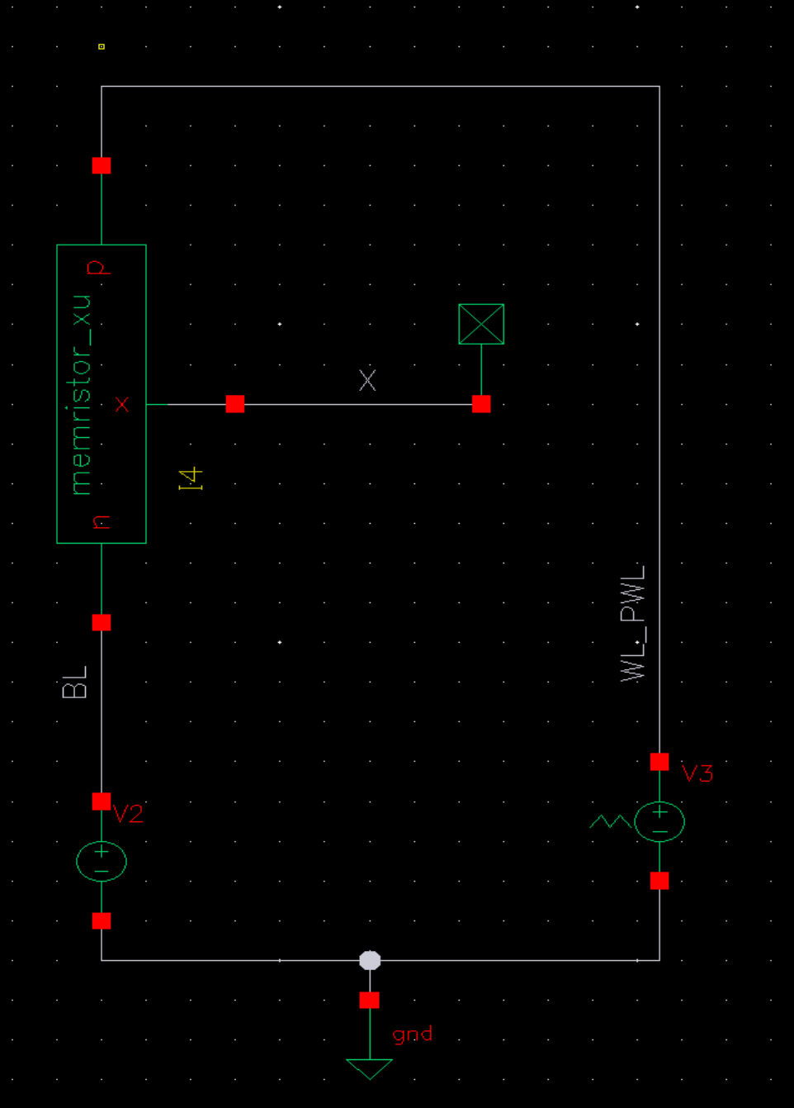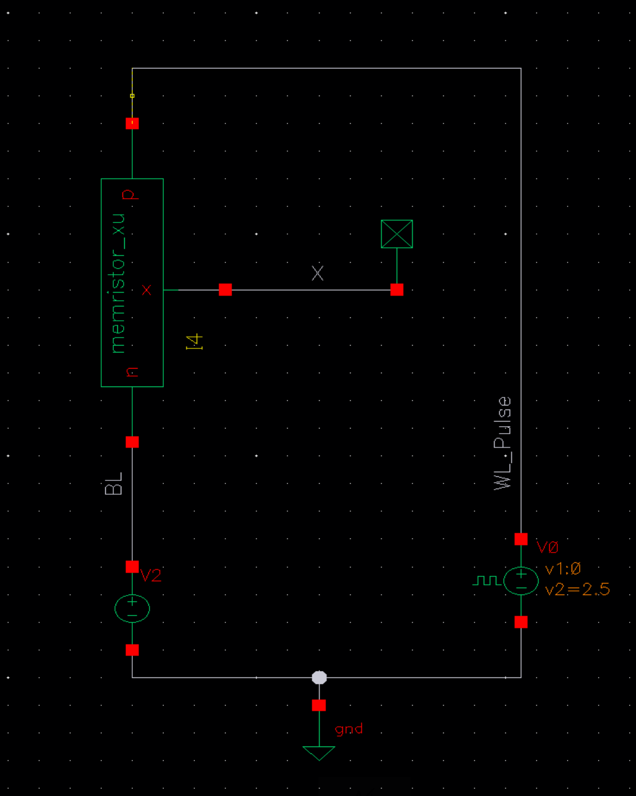
b
a

Fig. S6 (a) I-V characteristics simulation. The simulated result is shown in Fig. 2f. (b) Conductance tunning curve simulation. The simulated result is shown in Fig. S6. The input pulse voltage and pulse trains are the same as the experiments.

S8. Conduction tuning curves produced from the compact model
To ensure the accuracy of the compact model, we applied the same pulse train for experimental conductance tuning measurement to the model. The experimental data is with high initial conductance state of around 3.2 × 10⁻⁷ S. To match this high initial conductance state, we turned the initial state function value x in the compact model to be 87 (the highest value of x is 100) and managed to replicate the experimental data.
Fig. S7 Conductance tuning curve from experiment and compact model under 64 potentiation pulses (+2.5 V, 100 μs) and 64 depression pulses (-2.5 V, 100 μs) with high initial conductance state experimentally and high state function x in the model.

S9. Linearity analysis of parallel programming with different BL/WL encoded numbers
a
b

Fig. S8 Conductance change for 17 × 17 different combinations of input signals. (a) Varying WL spike rate leads to highly linear conductance tuning. (b) Varying BL duty cycle leads to less linear conductance tuning.

A total of 17 × 17 different combinations of BL/WL programming signals were applied to a MIG device and the conductance change before and after the programming are measured and linearity of different BL/WL numbers were analyzed. Interestingly, varying BL duty cycle leads to a slightly larger nonlinearity than varying WL spike rate (Table S5). The number encoding scheme of WL and BL signals is summarized in Table S4 and the nonlinearity of each condition is summarized in Table S5 except the WL/BL encoded number is 0.

Table S4. Number encoding schemes for WL and BL signals
Encoded number | WL spike rate (kHz) | BL duty cycle (%)
0 | 0 | 100
1 | 0.5 | 93.75
2 | 1 | 87.5
3 | 1.5 | 81.25
4 | 2 | 75
5 | 2.5 | 68.75
6 | 3 | 62.5
7 | 3.5 | 56.25
8 | 4 | 50
9 | 4.5 | 43.75
10 | 5 | 37.5
11 | 5.5 | 31.25
12 | 6 | 25
13 | 6.5 | 18.75
14 | 7 | 12.5
15 | 7.5 | 6.25
16 | 8 | 0

Table S5. Nonlinearity of fixed BL and varied WL signals/fixed WL and varied BL signals

BL number | Nonlinearity | WL number | Nonlinearity
1 | 0.00252 | 1 | 0.00874
2 | 0.00400 | 2 | 0.00671
3 | 0.00669 | 3 | 0.00533
4 | 0.00167 | 4 | 0.00841
5 | 0.00173 | 5 | 0.00942
6 | 0.00052 | 6 | 0.01028
7 | 0.00041 | 7 | 0.00891
8 | 0.00146 | 8 | 0.00862
9 | 0.00461 | 9 | 0.00870
10 | 0.00346 | 10 | 0.00942
11 | 0.00309 | 11 | 0.00999
12 | 0.00291 | 12 | 0.00716
13 | 0.00479 | 13 | 0.00814
14 | 0.00473 | 14 | 0.00828
15 | 0.00490 | 15 | 0.00673
16 | 0.00440 | 16 | 0.00736
Average | 0.00324 | Average | 0.00826

S10. As-fabricated conductance map of functional devices inside the 32 × 32 crossbar array
a
b
Fig. S9 (a) Spatial distribution of as-fabricated conductance map of functional devices across different wordlines (WLs) and bitlines (BLs) within the crossbar array at 2.5 V. (b) Distribution of as-fabricated conductance of the crossbar array. Inset is the zoom-in distribution from 0 to 20 nS. The mean conductance of the as-fabricated crossbar array is 26.6 nS at 2.5 V.

S11. Independent programming inside the crossbar array
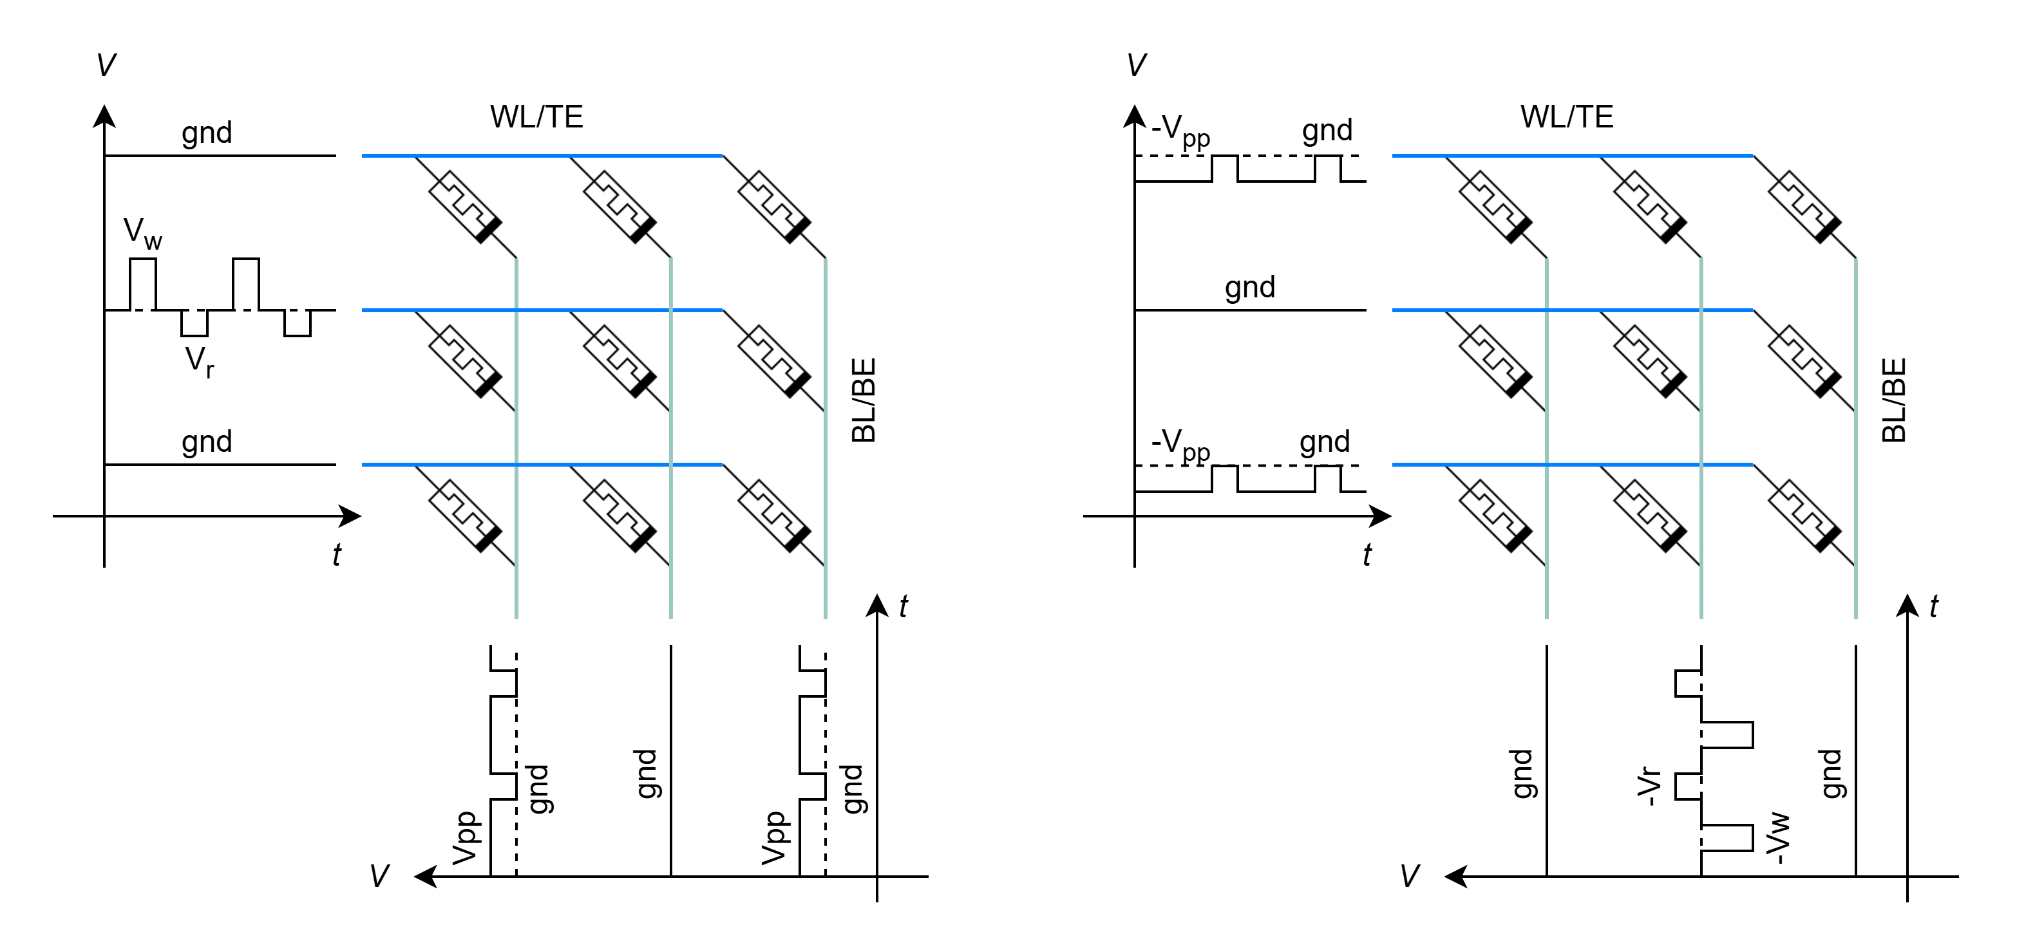
To enable accurate parallel programming of each cell, it is important to ensure that programming one cell won’t influence the neighboring cell¹⁷. To validate this property in the crossbar array, we conducted parallel programming on a targeted cell while measuring the two adjacent cells with shared WL and BL. The results show good independent programmability of the crossbar array under the proposed programming scheme.
c
d
a
b
Programmed device
Held device
Fig. S10 (a) Waveform applied to the crossbar for independent programming measurement for the case of shared WL. The device inside the red dashed rectangle is the device to be programmed while the two neighboring devices sharing the same WL is held. (b) Waveform applied to the crossbar for independent programming measurement for the case of shared BL. The device inside the red dashed rectangle is the device to be programmed while the two neighboring devices sharing the same WL is held. Note that all the voltages are reversed to ensure the same net voltage across top electrode and bottom electrode as in the case of shared WL. (c) Conductance measurement of three cells with shared WL. (d) Conductance measurement of three cells with shared BL.

S12. Experimental setup for crossbar array measurement
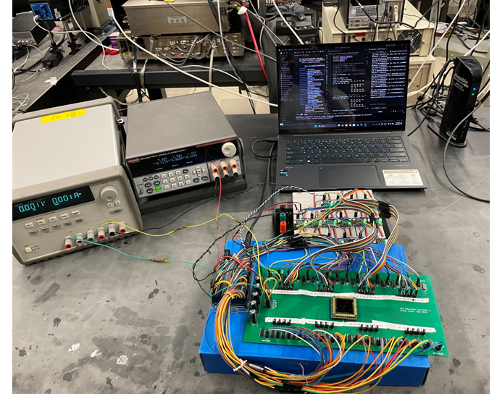
Fig. S11 Printed-circuit board (PCB) setup for crossbar array measurement. Specifically, two power supplies (in green box) are used to power the whole setup. The Arduino controller (in yellow box) and the computer were used for all the control. The crossbar array chip (in red box) was wire-bonded to a breakout board and then soldered onto the PCB. 16 INA228 chips were fixed to a breadboard and used to sense the current from the crossbar chip.

S13. Experimental validation of outer product on crossbar array
Table S6. Outer product benchmark table
Reference | 18 | 17 | 19 | 20 | This work
Device type | Filamentary memristor | ECRAM | MemCapacitor | Filamentary memristor | Interfacial memristor
Cell size in crossbar | - | >5 × 10⁴ μm² | 1.2 mm × 1.2 mm | 200 nm × 200 nm | 3 μm × 5 μm
Cell structure | 1R | 2T | 1C | 1R | 1R
Demonstrated crossbar size | 3 × 3 | 3 × 3 | 9 × 9 | 4 × 5 | 6 × 6

In this work, we conducted experimental validation of outer product update on a 6 × 6 subarray, which is the largest size in memristive crossbar array and the second largest size in all the crossbar array demonstrations, as well as the first demonstration of interfacial memristor for this functionality.

S14. Macro and tile design for both inference and training
Accuracies under three conditions: full-precision fine-tuning, quantized fine-tuning without device noise (ideal-quantized), and quantized fine-tuning with MIG device noise. The device noise is taken from the systematic parallel programming measurement (Fig. 3c). Though the accuracy of MIG training drops by 12% as compared to the case of full precision, it outperforms the ideal-quantized scheme without device noise by 10%. Thus, the reason for no increase in accuracy as the range of weight increase arises from the quantization scheme but not the device itself. The accuracy gap between the ideal-quantized case to standard DoReFa-Net is likely due to the difference in quantization scheme, as our simulation uses ADC-like quantization scheme for the whole activation in the simulation whereas DoReFa-Net employs a tanh weight quantization function²¹. Achieving full-precision fine-tuning on the edge using in-memory SGD require dedicated mix-signal hardware design and software–hardware co-design, which falls beyond the scope of this work^{22, 23}.
Fig. S12. Accuracy comparisons between full-precision fine-tuning, 4-bit weights during readout with weight ranges from -512 to 512 with, and without MIG device noise.

S15. Macro and tile design for both inference and training
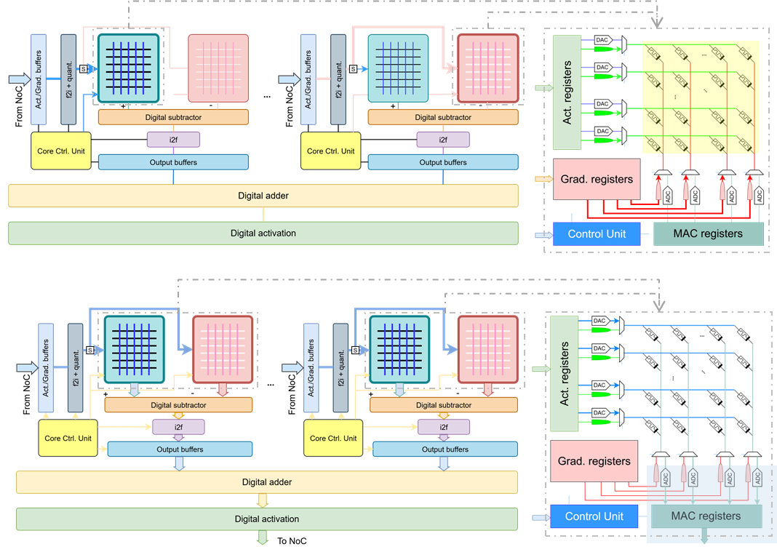
b
a
Fig. S13 Dataflow for (a) training and (b) inference on the designed macro and tile.

The proposed macro and tile support both fully-weight-stationary fine-tuning and inference (Fig. S13). At the macro level, activation registers store outputs from the previous layer. During inference, these values are decoded into voltages and applied to the WLs of the MIG crossbar array, while during fine-tuning they are converted into spike trains with variable spike rates by WL neurons and then applied on the WLs. Gradient registers store the gradient calculated from loss during backpropagation, which are decoded by BL neurons into long pulses raised from 0 to $V_{pp}$ with variable duty cycles for potentiation inside one programming cycle. Multiply-and-accumulation (MAC) registers store the macro’s vector-matrix multiplication (VMM) results during inference. For data converters, 5-bit digital-analog converters (DACs) are connected to WLs and 12-bit ADCs are connected to BLs in a crossbar array. The control unit reconfigures the macro according to the operation mode: in training mode, WL and BL neurons generate spike trains based on the values stored in the activation and gradient registers, whereas in inference mode, the ADCs and DACs are engaged to perform standard VMM operations. At the tile level, two macros are used to separately handle potentiation and depression. When multiplicand and multiplier share the same sign, the signals are routed to the potentiation macro, whereas if multiplicand and multiplier have opposite signs, the signals are directed to the depression macro to potentiate the MIG device. The digital outputs of two macros are then fed to the positive and negative inputs of a digital subtractor. Circuits for integer–floating-point conversion were simulated based on a previous design²⁴. At the bank level, multiple tiles are binding together to match the size of weights between adjacent layers. Digital adder and look-up-table (LUT)-based activation units are employed to mitigate the precision loss while improving the area efficiency.

S16. Dataflow comparison with and without outer product updates
The inference stages (T₀ – T₇) are identical for the hardware with and without outer product updates capability inside the crossbar (Fig. S14). The key difference lays on the training phase. For the case without outer product updates capability in memristive crossbar array, the amount of weight update needs to calculate explicitly on some digital cores, then update the weights encoded in the crossbar in a row-wise manner, creating a possible data transport bottleneck¹⁹. In contrast, with the outer product update capability, the amount of weight update doesn’t need to be calculated explicitly and can be directly realized through outer product based in-situ training. Moreover, the update speed for the whole crossbar array is much faster than the case of row-wise manner due to the O(1) time complexity, introducing further performance improvement.
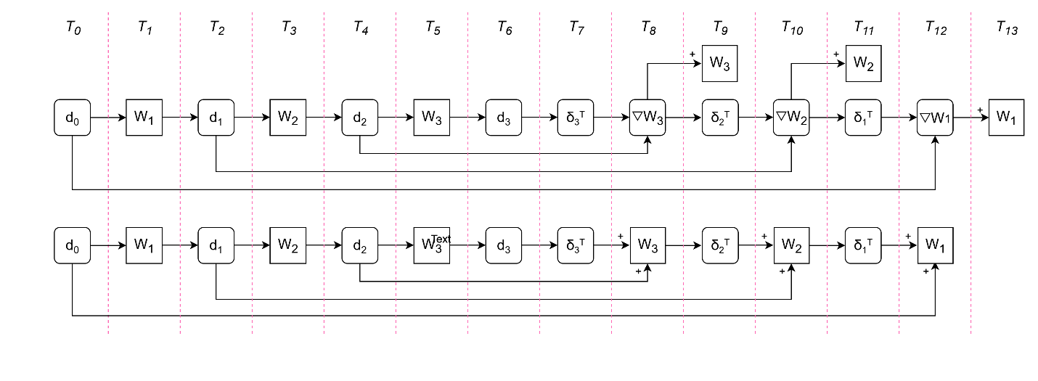
Fig. S14 Fine-tuning/training pipeline (a) with and (b) without outer-product capability in crossbar array. The case with outer product capability simplifies the training pipeline and saves one timestep²⁵.
b
a

Supplementary References
- Aussen, S. et al. Correlation between Electronic Structure, Microstructure, and Switching Mode in Valence Change Mechanism Al₂O₃/TiO_{x}-Based Memristive Devices. Adv. Electron. Mater. 9, 2300520 (2023).
- Chakrabarti, B. et al. Nonlinear Switching With Ultralow Reset Power in Graphene-Insulator-Graphene Forming-Free Resistive Memories. IEEE Electron Device Letters, 35, 7, 750-752 (2014).
- Chen, J. et al. Scaling Effects of Transistor Leakage Current and IR Drop on 1T1R Memory Arrays. https://arxiv.org/pdf/2410.20560v1 (2024).
- Athle, R. et al. Ferroelectric Tunnel Junction Memristors for In-Memory Computing Accelerators. Adv. Intell. Syst., 6: 2300554 (2024).
- Xie, L. et al. A Wide Dynamic Range Read-out System For Resistive Switching Technology. IEEE International Symposium on Circuits and Systems, 2003-2007 (2022).
- Shi, L. et al. Research progress on solutions to the sneak path issue in memristor crossbar arrays. Nanoscale Adv., 2, 1811-1827 (2020).
- Li, Y. et al. Scalable Al₂O₃–TiO₂ Conductive Oxide Interfaces as Defect Reservoirs for Resistive Switching Devices. Adv. Electron. Mater. 9, 2200800 (2023).
- Lee, J.-K. et al. Extraction of trap location and energy from random telegraph noise in amorphous TiO_{x} resistance random access memories. Appl. Phys. Lett. 98, 143502 (2011).
- Izmailov, R. et al. Electron emission from deep traps in HfO₂ under thermal and optical excitation. Phys. Rev. B 109, 134109 (2024).
- Kumar, A. et al. Filament-Free Bulk RRAM with High Endurance and Long Retention for Neuromorphic Few-Shot Learning On-Chip. IEEE International Electron Devices Meeting (IEDM), 1-4 (2024).
- Kim, G. et al. Retention Secured Nonlinear and Self-Rectifying Analog Charge Trap Memristor for Energy-Efficient Neuromorphic Hardware. Adv. Sci. 10, 2205654 (2023).
- Hu, L. et al. All-Optically Controlled Memristor for Optoelectronic Neuromorphic Computing. Adv. Funct. Mater. 31, 2005582 (2021).
- Jeon, K. et al. Purely self-rectifying memristor-based passive crossbar array for artificial neural network accelerators. Nat. Commun. 15, 129-142 (2024).
- Srivastava, S. et al. Induced Complementary Resistive Switching in Forming-Free TiOx/ TiO2/TiOx Memristors. ACS Appl. Mater. Interfaces 13, 43022−43029 (2021).
- Lee, J.-H. et al. Simulation of Figures of Merit for Barristor Based on Graphene/Insulator Junction. Nanomaterials, 12, 17, 3029 (2022).
- Yakopcic, C. et al. A memristor Device Model. IEEE Electron Device Letters, 32, 10, 1436-1438 (2011).
- Fuller, E. et al. Parallel programming of an ionic floating-gate memory array for scalable neuromorphic computing. Science 364, 570-574 (2019).
- Liao, Y. et al. Novel In-Memory Matrix-Matrix Multiplication with Resistive Cross-Point Arrays. IEEE Symposium on VLSI Technology (VLSI), 31-32, (2018).
- Kimura, M. et al. Neuromorphic System Using Memcapacitors and Autonomous Local Learning. IEEE Transactions on Neural Networks and Learning Systems, 34, 5, 2366-2373 (2023).
- Choi, W. et al. Update Disturbance-Resilient Analog ReRAM Crossbar Arrays for In-Memory Deep Learning Accelerators. Adv. Sci., e04578, 2025.
- Zhou, S. et al. DoReFa-Net: Training Low Bitwidth Convolutional Neural Networks with Low Bitwidth Gradients. https://arxiv.org/abs/1606.06160 (2016).
- Zheng, Q. et al. Hybrid Digital/Analog Memristor-based Computing Architecture for Sparse Deep Learning Acceleration. IEEE International Symposium on Circuits and Systems (ISCAS), 1-5 (2024).
- Rasch, M. et al. Fast and robust analog in-memory deep neural network training. Nat. Comm. 15, 7133 (2024).
- Ambrogio, S. et al. An analog-AI chip for energy-efficient speech recognition and transcription. Nature, 620, 768–775 (2023).
- Song, L. et al. PipeLayer: A Pipelined ReRAM-Based Accelerator for Deep Learning. IEEE International Symposium on High Performance Computer Architecture (HPCA), 541-552 (2017).

