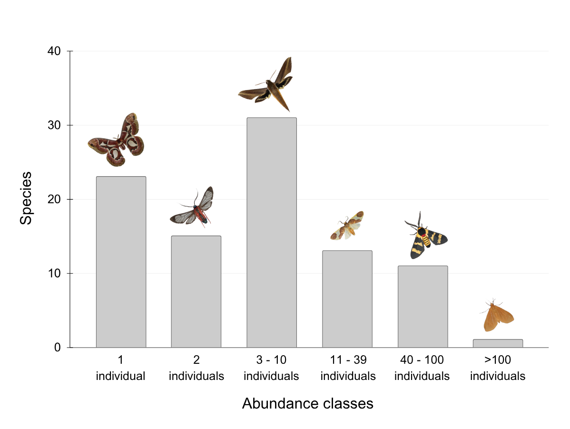
Fig. S. 1 Number of moth species that occurred in each abundance class. Images above the bars represent examples of species from each class: Rothschildia jacobaeae (1 individual); Cosmosoma auge (2 individuals); Xylophanes tersa (7 individuals); Trichromia cotes (18 individuals); Eurata hilaris (99 individuals); Heliactinidia nigrilinea (235 individuals). Species out of scale

