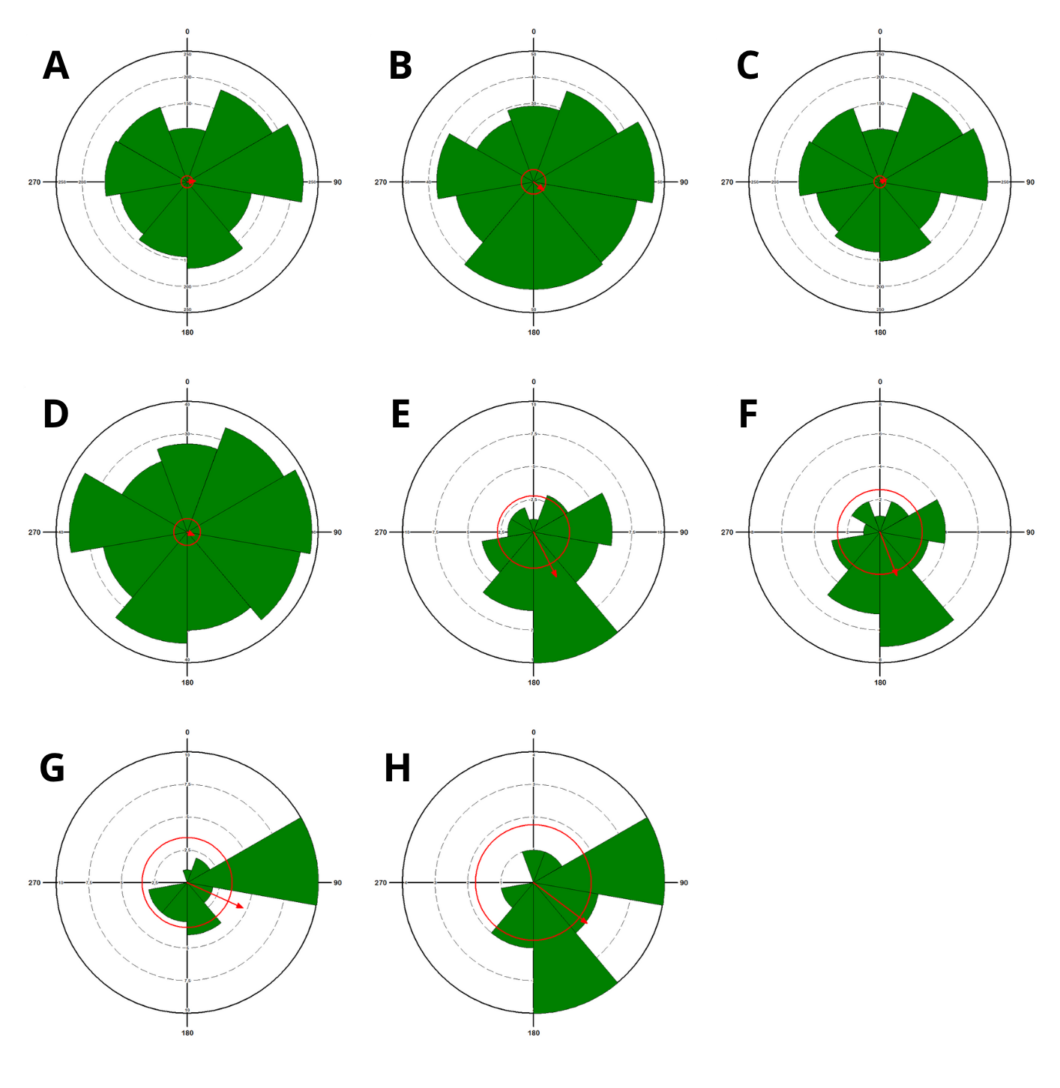Fig. S. 3 Concentration of abundance and richness of the studied taxa. The sector centered at 0 indicates the beginning of the night period (8:00 PM). The direction and length of the red arrow indicate the average angle of data distribution (α), as well as its intensity. The red circle indicates the critical Rayleigh value. Total Abundance (A); Total Richness (B); Arctiinae Abundance (C); Arctiinae Richness (D); Sphingidae Abundance (E); Sphingidae Richness (F); Saturniidae Abundance (G) and Saturniidae Richness (H)

