Supporting Information
Metal-Organic Frameworks with Linear and Branched Polyol Backbones for Dye Removal

Safoora Gazvineh , Mohsen Adeli*, Mohammad Nemati
Department of Organic Chemistry, Faculty of Chemistry, Lorestan University, Khorramabad 68141-54316, Iran
*Corresponding author: adeli.m@lu.ac.ir, m.aadeli@fu-berlin.de (M. Adeli)

Experimental…………………………………………………………….………….….……..4
Materials and methods……………………………………………………………...…..……..4
Synthesis of mesylated polyvinyl alcohol (PVA-OMs) ………………….…………..…....….4
Conjugation of 5-amino isophthalic acid (AIP) to polyvinyl alcohol (PVA-AIP)…….……...5
Synthesis of PVA-MOF ……………………………………..……………………………......5
Synthesis of mesylated hyperbranched polyglycerol (hPG-OMs)………………..…………...5
Conjugation of 5-Amino isophthalic acid (AIP) to mesylated hyperbranched Polyglycerol (hPG-AIP)…………………………………………………………………………...…………….…6
Synthesis of hPG-MOF…………………………………………………...……………….…..6
Dye removal………………………………………………………….......………………….…6

Results…………………………………………………………………...………………….…7
Table S1. Comparative elemental analysis of starting materials and synthesized MOF/polymer composites: (a) EDAX results and (b) CHNS analysis, presented for different stages of the synthesis process………………………………………………………………...….………….7
Figure S1. UV-Visible absorption spectra of (a) PVA and PVA-OMS, and (b) hPG and hPG-OMS............................................................................................................................................8
Table S2. The BET surface area, pore volume, and average pore diameter of the synthesized
PVA-MOF and hPG-MOF…………………………………………………………..………....8
Table S3. Adsorption capacities (mg·g⁻¹) of the synthesized PVA-MOF and hPG-MOF for the removal of Rhodamine B (Rh B), Methylene Blue (MB), and Fluorescein (FL), in comparison with analogous systems reported in the literature……………………………………………….8
Dye adsorption study…………………………………………………………………………..9
Investigation of adsorption kinetics……………………………………………………………..9
Figure S2. Kinetic models describing the adsorption mechanisms of MB, RhB, and FL dyes on PVA-MOF (a) and hPG-MOF (b) based on the pseudo-first-order kinetic model……... …….10
Pseudo-first-order kinetics………………………………...………………………...………….10
Pseudo-second-order kinetics…………………………………………………...…..………….10
Table S4. Kinetic parameters for the adsorption of various dyes onto PVA-MOF and hPG-MOF…………………………………………………………………………………………….11
Determination of adsorption isotherms……………………………………………..………..12
Langmuir isotherm study………………………………………...………………..……………12
Freundlich isotherm study……………………………………………………...……...………..12
Figure S3. (a) Langmuir isotherm plots for the adsorption of MB, Rh B, and FL onto PVA-MOF and hPG-MOF. (b) Freundlich isotherm plots describing the adsorption behavior of MB, Rh B, and FL on the same MOFs. (c) Experimental adsorption isotherms of MB, Rh B, and FL at various equilibrium concentrations……………………………………..………….……………13
Table S5. Isotherm parameters for Langmuir and Freundlich models describing the adsorption of MB, RhB, and FL dyes onto PVA-MOF and hPG-MOF……………………....………………14
Table S6. RL values for the adsorption of varying concentrations of MB, RhB, and FL dyes by PVA-MOF and hPG-MOF……………………………………………………….……………..14
Thermodynamic study of surface adsorption…………………………………..…………….15
Table S7. Various parameters including removal efficiency, adsorption capacity, and adsorption equilibrium constant for the adsorption of MB, RhB, and FL dyes by PVA-MOF and hPG-MOF at 25 °C………………………………….……………………….……………..………………..16
Figure S4. Plots of ln (K_{ad}) versus 1/T for the adsorption of MB (a), RhB (b), and FL (c) dyes on PVA-MOF and hPG-MOF at various temperatures……………………..……………………...17
Table S8. Thermodynamic parameters for the adsorption of MB, RhB, and FL dyes by PVA-MOF and hPG-MOF……………………………………………………..……………………..17
Table S9. Adsorption capacity and adsorption equilibrium constant parameters for MB, RhB, and FL dyes by PVA-MOF (a) and hPG-MOF (b) after 24 hours of shaking at 25 °C with dye solutions (5 mL,50 ppm)……………………………………………………….………………..18
References………………………………...………………………………….…………………19

Experimental
Materials and methods
N,N-Dimethylformamide (DMF), ethanol, acetonitrile, acetone, chloroform, polyvinyl alcohol (PVA, Mw = 72,000 g.mol⁻¹), and hyperbranched poly(glycerol) (hPG, Mw = 5,000 g.mol⁻¹) were purchased from Sigma-Aldrich. 5-Amino isophthalic acid (AIP, 95%), hydrochloric acid (HCl, 37%), sodium hydroxide (NaOH, 98%), iron(III) chloride hexahydrate (FeCl₃·6H₂O, 99%),Methylene Blue (C₁₆H₁₈ClN₃S, 99%), Rhodamine B (C₂₈H₃₁ClN₂O₃, 99%), and Fluorescein (C₂₀H₁₂O₅, 99%) were obtained from Merck. Triethylamine (Et₃N), methanesulfonyl chloride (MsCl), and potassium carbonate (K₂CO₃) were purchased from Sigma-Aldrich. All reagents were used directly without further purification. Dialysis bag (with molecular weight cut-off, MWCO: 2 kDa and 14 kDa) were provided by BioTechCell.
Fourier-transform infrared spectra (FTIR) of the synthesized materials were recorded in the range of 400 to 4000 cm⁻¹ using an FT-IR 8400 spectrometer (Shimadzu, Kyoto, Japan) employing the KBr pellet technique. Morphology of MOFs was investigated using a Field Emission Scanning Electron Microscope (FESEM) (CM120, Chk) equipped with Energy Dispersive X-ray Spectroscopy (EDS). X-ray diffraction (XRD) patterns of the synthesized materials were recorded using a StadiP STOE diffractometer (Germany) with Cu-Kα radiation, λ = 1.5406 Å. Elemental analysis (CHNS) was performed using a FlashEA 1112 Series analyzer (Thermo Finnigan) equipped with four columns and a detector for carbon, nitrogen, hydrogen, and sulfur. Ultraviolet-Visible (UV-Vis) absorption spectra were recorded using a Shimadzu UV-Vis 1650 PC spectrophotometer fitted with a quartz cell (path length 1.0 cm) at room temperature. Zeta potential measurements were conducted using a HORIBA SZ100 (Japan) laser Doppler electrophoresis instrument within the potential range of -200 mV to +200 mV. Porosity and surface properties were analyzed through Brunauer-Emmett-Teller (BET) surface area measurement and adsorption/desorption isotherm analysis using a BELSORP Mini II apparatus (Japan).¹H NMR and ¹³C NMR spectra were recorded at room temperature using Bruker DRX-500 Avance, Bruker DRX-400 Avance, and Bruker DRX-250 Avance spectrometers.

Synthesis of mesylated polyvinyl alcohol (PVA-OMs)
Initially, polyvinyl alcohol (PVA) (0.2 gr,0.0028 mmol) was added to a round-bottom flask along with the solvent dimethylformamide (DMF) (10 mL) and heated to 110 °C until fully dissolved. The solution was then cooled to room temperature, and trimethylamine (Et₃N) (1 mL) was added at room temperature and stirred for 2 hours. The resulting solution was placed in an ice bath, and methanesulfonyl chloride (MsCl) (1.78 mL,23mmol) was gradually added over the course of one hour. The mixture was then stirred at room temperature for 3 days. Product was crystalized in acetonitrile and used for further experiments The overall reaction yield was approximately 69.70%.

Conjugation of 5-amino isophthalic acid (AIP) to polyvinyl alcohol (PVA-AIP)
Mesylated polyvinyl alcohol (PVA-Oms) (0.1 gr, 0.000736 mmol) was dissolved in acetonitrile (25 ml), after which potassium carbonate (k₂CO₃) (0.1 gr ,0.724 mmol) and 5-amino isophthalic acid (AIP) (0.11 gr ,0.6 mmol) were added. The mixture was refluxed at 80 °C for 24 hours. The final product was purified using a dialysis bag in dimethylformamide (DMF), distilled water (D₂O), and ethanol (EtOH), and it was dried in a vacuum oven at 50 °C.The overall reaction yield was approximately 84.04%.

Synthesis of PVA-MOF
PVA-AIP and hexahydrate iron (III) chloride were mixed in a 2:1 ratio in a beaker, and the solvent dimethylformamide (DMF) (25 mL) was added. The resulting mixture was stirred for 2 hours and then placed in an autoclave, where it was heated to 110 °C for 20 hours. The final product was purified by washing with dimethylformamide (DMF) and ethanol and was then dried in a vacuum oven at 50 °C.The overall reaction yield was approximately 70.39%.

Synthesis of mesylated hyperbranched polyglycerol (hPG-OMs)
Hyperbranched polyglycerol (hPG) (Mn = 5000), (0.258 gr, 0.0516 mmol) was dissolved in a polymerization ampoule under an inert gas atmosphere (nitrogen) in dimethylformamide (DMF) (10 mL), and subsequently, triethylamine (Et₃N) (1 mL) was added while maintaining the temperature at 0 °C. Msyl chloride (MsCl) (1.74 mL, 22.47 mmol), was gradually added over the course of 1 hour. After the addition of mesyl chloride, the mixture was refluxed in a nitrogen atmosphere at room temperature for 24 hours. The crude product was purified using a dialysis bag in acetonitrile.The overall reaction yield was approximately 78.66%.

Conjugation of 5-Amino isophthalic acid (AIP) to mesylated hyperbranched Polyglycerol (hPG-AIP)
Mesylated hyperbranched polyglycerol (hPG-Oms) (0.1 gr, 0.0156 mmol) was dissolved in acetonitrile (25 mL), after which potassium carbonate (k₂CO₃) (0.1 gr, 0.724 mmol) and 5-amino isophthalic acid (AIP) (0.234 gr, 1.29 mmol) were added. The mixture was stirred at 80 °C for 24 hours. The final product was purified using a dialysis bag in dimethylformamide (DMF), distilled water (D₂O), and ethanol (EtOH), and it was dried in a vacuum oven at 50 °C.The overall reaction yield was approximately 83.66%.

Synthesis of hPG-MOF
The synthesis method for this compound is similar to that of PVA-MOF.

Dye removal
A stock solution of methylene blue, rhodamine B, and fluorescein was prepared by dissolving 100 mg.L⁻¹ of these dyes in water. Subsequently, standard solutions were prepared by diluting the stock solution for testing. For adsorption experiments, 3 mg of PVA-MOF and hPG-MOF was added to 5 mL of color solutions at concentrations of 20 ppm, 10 ppm, and 5 ppm (Rhodamine B, Methylene Blue, and Fluorescein) and incubated for 24 hours under ambient conditions (25 °C) without agitation.
After 24 hours, it was observed that the adsorbent could significantly absorb cationic dyes (Rhodamine B, Methylene Blue) and, to a lesser extent, the anionic dye (Fluorescein). Using a spectrophotometer, the absorbance of all samples at the corresponding λmax for each dye was obtained and compared with the standard curve. The dye adsorption capacity qt (mg. g⁻¹) and the percentage removal of dye (%R) by the adsorbent at each time point were calculated. Our aim was to investigate the adsorption of cationic and anionic dyes, which are among the most significant water pollutants.

Results
Table S1. Comparative elemental analysis of starting materials and synthesized MOF/polymer composites: (a) EDAX results and (b) CHNS analysis, presented for different stages of the synthesis process.
a

Element | %A  %W | %C | %O | %S | %N | %Fe
PVA |  | 65.42  58.68 | 34.58  41.32 | -  - | -  - | -  -
PVA-OMs |  | 65.93  55.37 | 28.81  32.23 | 5.26  12.40 | -  - | -  -
PVA-AIP |  | 58.09  51.85 | 30.55  36.32 | -  - | 11.36  11.83 | -  -
PVA-MOF |  | 57.95  47.20 | 27.09  35.64 | -  - | 11.50  11.39 | 3.46  5.77
hPG |  | 73.55  67.61 | 26.45  32.39 | -  - | -  - | -  -
hPG-OMs |  | 62.51  52.44 | 32.91  36.78 | 4.58  10.78 | -  - | -  -
hPG-AIP |  | 48.22  41.70 | 42.41  48.85 | -  - | 9.37  9.45 | -  -
hPG-MOF |  | 57.66  50.11 | 34.06  39.43 | -  - | 7.35  7.45 | 0.93  3.01
b

Element | %C | %H | %S | %N
PVA | 53.48 | 8.71 | - | -
PVA-OMs | 40.85 | 5.72 | 10.36 | -
PVA-AIP | 42.62 | 5.49 | 0.92 | 5.69
PVA-MOF | 49.26 | 6.21 | 0.38 | 5.53
hPG | 50.28 | 11.71 | - | -
hPG-OMs | 38.01 | 6.42 | 11.71 | -
hPG-AIP | 42.81 | 6.07 | 0.86 | 5.67
hPG-MOF | 46.52 | 6.18 | 0.48 | 5.30

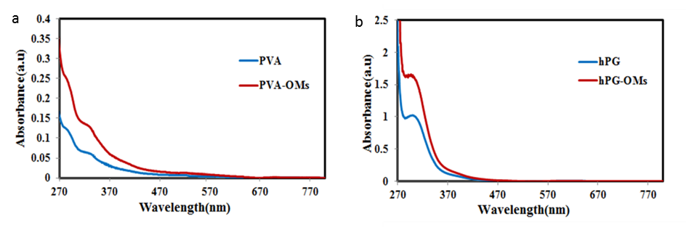
Figure S1. UV-Visible absorption spectra of (a) PVA and PVA-OMs, and (b) hPG and hPG-OMs.

Table S2. The BET surface area, pore volume, and average pore diameter of the synthesized
PVA-MOF and hPG-MOF.

Compound | BET Surface Area | BJH Adsorption cumulative volume of peres | Average pore diameter (4V/A by BET)
PVA-MOF | 15.509 m².g⁻¹ | 0.048105 cm³.g⁻¹ | 11.8 nm
hPG-MOF | 18.609 m².g⁻¹ | 0.051623 cm³.g⁻¹ | 11.12 nm

Table S3. Adsorption capacities (mg·g⁻¹) of the synthesized PVA-MOF and hPG-MOF for the removal of Rhodamine B (Rh B), Methylene Blue (MB), and Fluorescein (FL), in comparison with analogous systems reported in the literature.

Adsorbent | Rhodamine B (mg.g⁻¹) | Methylene Blue (mg.g⁻¹) | Fluorescein (mg.g⁻¹) | Reference
PVA-MOF (This Work) | 128.17 | 128.24 | 124.77 | This study
hPG-MOF (This Work) | 131.46 | 135.34 | 128.31 | This study
PNIPAM-Sponge | 245 | 98 | 231 | 1
UiO-66-NH2 | 104.20 | 106.80 | 95.10 | 2
ZIF-8 | 2500 | 40 | - | 3
silica microspheres (SM) with controlled hydrophobicity | 55-146 | - | 26-132 | 4
MOF-199/CCF | 659.6 | - | - | 5
Zn-MOF | 55.34 | - | - | 6
UiO-66-NO2 | 41.7 | - | - | 7
MOF-5/PANI | 135 | - | - | 8
MIL-100(Fe) | 763 | - | - | 9
MOF-235 | 252 | - | - | 10
Tweezers-LikeAdsorbent (CS-Ac-An) | - | - | 61.8 | 11
(MV)[BiI3Cl2] | - | - | 793 | 12

Dye adsorption study:
In this study, the adsorption of dyes from aqueous solutions was investigated using synthesized PVA-MOF and hPG-MOF as novel adsorbents. Three organic dyes including cationic Methylene Blue and Rhodamine B, and anionic Fluorescein were used in this study. To optimize the conditions for surface adsorption of these dyes, the effects of key parameters namely dye concentration, contact time, temperature, and pH on the adsorption process were thoroughly examined. The dye uptake was quantified spectrophotometrically by measuring the absorbance of all samples at their respective λ_{max}, and the results were calibrated against standard calibration curves. The dye adsorption capacity, (q_{t}) (mg.g⁻¹), and the dye removal efficiency, %R, were calculated at each time point using equations (1) and (2), respectively:
q_{t} = (C₀-C_{t}) V / m (1)

R%= (C₀-C_{t}) /C₀× 100 (2)
where ( C₀ ) and ( C_{t} ) represent the initial and time-dependent concentrations of the dye solution (mg.L⁻¹), respectively; ( v ) denotes the volume of the solution (L); and ( M ) corresponds to the mass of the adsorbent employed (g).¹³

Investigation of adsorption kinetics:
To elucidate the adsorption mechanism and assess the experimental data concerning the surface adsorption of pollutants onto the synthesized adsorbent, the adsorption rate constants were determined by fitting the data to commonly used kinetic models. Accordingly, this section focuses on examining the surface adsorption kinetics of the dyes Methylene Blue, Rhodamine B, and Fluorescein onto the prepared adsorbent, and their conformity to pseudo-first-order and pseudo-second-order kinetic models. The kinetic analysis utilized adsorption data collected at various initial concentrations of the dyes (Figures.7 and.S3).

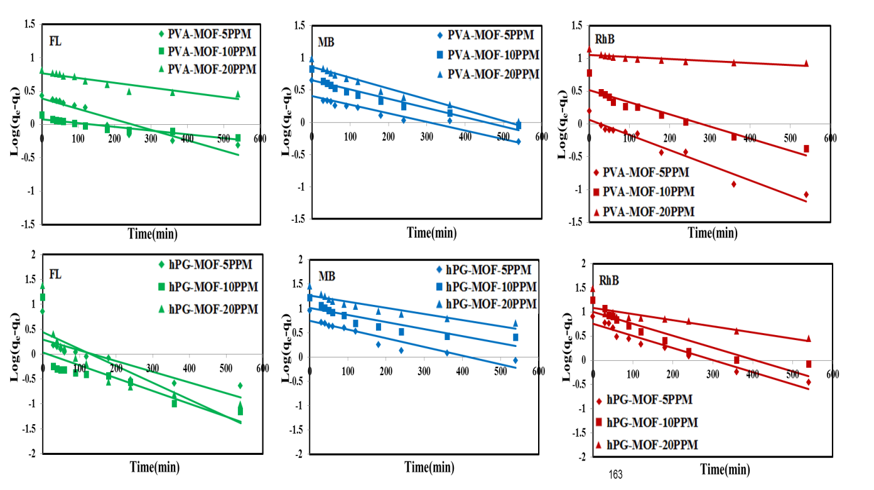
b
a
Figure S2. Kinetic models describing the adsorption mechanisms of MB, RhB, and FL dyes on PVA-MOF (a) and hPG-MOF (b) based on the pseudo-first-order kinetic model. Data fitting indicates that physisorption predominantly governs the dye adsorption process. All experiments were conducted under shaking conditions to evaluate the adsorption kinetics and the dye uptake capacity of MOFs for different dyes.

Pseudo-first-order kinetics:
In the pseudo-first-order kinetic model, as described by equation (3), the linearization involves plotting ln(q_{e} - q_{t}) versus time (t). Accordingly, such plots were constructed for each dye at different initial concentrations. From these linear plots, the correlation coefficients (R²) and the pseudo-first-order rate constants (k₁) were derived for each case.¹⁴
ln(q_{e} - q_{t}) = ln qe – k₁t (3)
Pseudo-second-order kinetics:
The pseudo-second-order kinetic model was examined using equation (4). Plots of ( t / q_{t} ) versus time (t) were constructed for the dyes methylene blue, rhodamine B, and fluorescein at different initial concentrations. From the linear regression of these plots, the correlation coefficients (R²) and the pseudo-second-order rate constants (k₂) were calculated. The kinetic parameters obtained are summarized in Table S4.
t/q_{t} = 1/(k₂q_{e}²) + t/q_{e} (4)
In equations (3) and (4), (k₁) and (k₂) denote the rate constants for the pseudo-first-order (min⁻¹) and pseudo-second-order (g·mg⁻¹·min⁻¹) kinetic models, respectively. The variable (t) represents the adsorption time in minutes (min). The derived kinetic parameters are summarized in Table S4.

Table S4. Kinetic parameters for the adsorption of various dyes onto PVA-MOF and hPG-MOF. The table summarizes the calculated values based on kinetic models, providing insights into the adsorption rates and mechanisms of dye uptake by both polymer-metal-organic frameworks.

Adsorbent | C(mg.L⁻¹) | First order kenetic |  |  | Second order kenetic
Adsorbent | C(mg.L⁻¹) | K₁ | q_{e} | R² | K₂ | q_{e} | R²
PVA-MOF MB | 5 | 0.0028 | 0.4380 | 0.962 | 0.0062 | 4.0519 | 0.9907
PVA-MOF MB | 10 | 0.0030 | 0.2438 | 0.9658 | 0.0027 | 6.2854 | 0.9977
PVA-MOF MB | 20 | 0.0037 | 0.1475 | 0.9794 | 0.0013 | 9.8912 | 0.9972
PVA-MOF Rh B | 5 | 0.0051 | 0.9221 | 0.9609 | 0.0084 | 1.6790 | 0.9846
PVA-MOF Rh B | 10 | 0.0039 | 0.3426 | 0.9736 | 0.0044 | 5.8720 | 0.9977
PVA-MOF Rh B | 20 | 0.005 | 0.0917 | 0.8441 | 0.0038 | 6.0680 | 0.9988
PVA-MOF FL | 5 | 0.0035 | 0.4160 | 0.8831 | 0.0009 | 3.6630 | 0.8905
PVA-MOF FL | 10 | 0.0012 | 0.8632 | 0.9305 | 0.0100 | 0.8587 | 0.9816
PVA-MOF FL | 20 | 0.0016 | 0.1742 | 0.8479 | 0.0007 | 5.6022 | 0.9247

Adsorbent | C(mg/l) | First order kenetic |  |  | Second order kenetic
Adsorbent | C(mg/l) | K₁ | q_{e} | R² | K₂ | q_{e} | R²
hPG-MOF MB | 5 | 0.0039 | 0.1990 | 0.8967 | 0.0027 | 8.9206 | 0.9958
hPG-MOF MB | 10 | 0.0030 | 0.1073 | 0.8131 | 0.0013 | 15.7978 | 0.998
hPG-MOF MB | 20 | 0.0025 | 0.0596 | 0.8941 | 0.0008 | 26.3852 | 0.9996
hPG-MOF Rh B | 5 | 0.0055 | 0.1884 | 0.9397 | 0.0014 | 9.0416 | 0.9849
hPG-MOF Rh B | 10 | 0.0053 | 0.1123 | 0.8807 | 0.0012 | 18.5874 | 0.9973
hPG-MOF Rh B | 20 | 0.0023 | 0.0996 | 0.9688 | 0.0007 | 30.3951 | 0.9995
hPG-MOF FL | 5 | 0.0042 | 0.6831 | 0.8703 | 0.0124 | 6.9881 | 0.9993
hPG-MOF FL | 10 | 0.0041 | 1.5911 | 0.959 | 0.0308 | 13.6799 | 1
hPG-MOF FL | 20 | 0.0062 | 0.5855 | 0.8586 | 0.0123 | 24.2718 | 1

Determination of adsorption isotherms:
To identify the adsorption isotherm governing the surface adsorption process, both Langmuir and Freundlich models were examined. The analysis utilized data derived from the dye concentration experiments detailed in the kinetic results section.
Langmuir isotherm study:
The Langmuir isotherm is described by equation (5). For this analysis, the reciprocal values (1/q_{e}) and (1/C_{e}) were calculated. Subsequently, a linear plot of (1/q_{e}) versus (1/C_{e}) was constructed to determine the isotherm parameters.
C_{e}/q_{e} = 1/K_{l}q_{m}+ C_{e}/q_{m} (5)

Based on the y intercept of the line, the value of q_{m} (maximum adsorption capacity) was calculated, and based on the slope of the line, the value of kl was calculated. The results are shown in Table S5.
Freundlich isotherm study:
The Freundlich isotherm is described by equation (6). For this analysis, the natural logarithms of (q_{e}) and (C_{e}), i.e., (ln q_{e}) and (ln C_{e}), were calculated. The results are provided in the table. Subsequently, a linear plot of (ln q_{e}) versus (ln C_{e}) was constructed to evaluate the isotherm parameters.
ln q_{e} = ln K_{f} + 1/n lnC_{e} (6)
Based on the y-intercept of the linear plot, the Freundlich constant (K_{f}) was determined, while the slope of the line was used to calculate the heterogeneity factor (1/n). The results are summarized in Table S5.

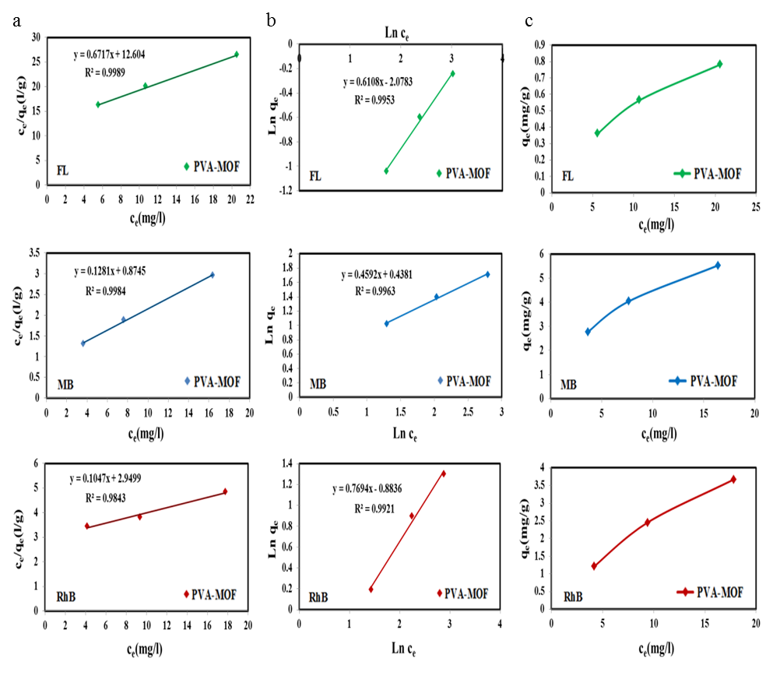

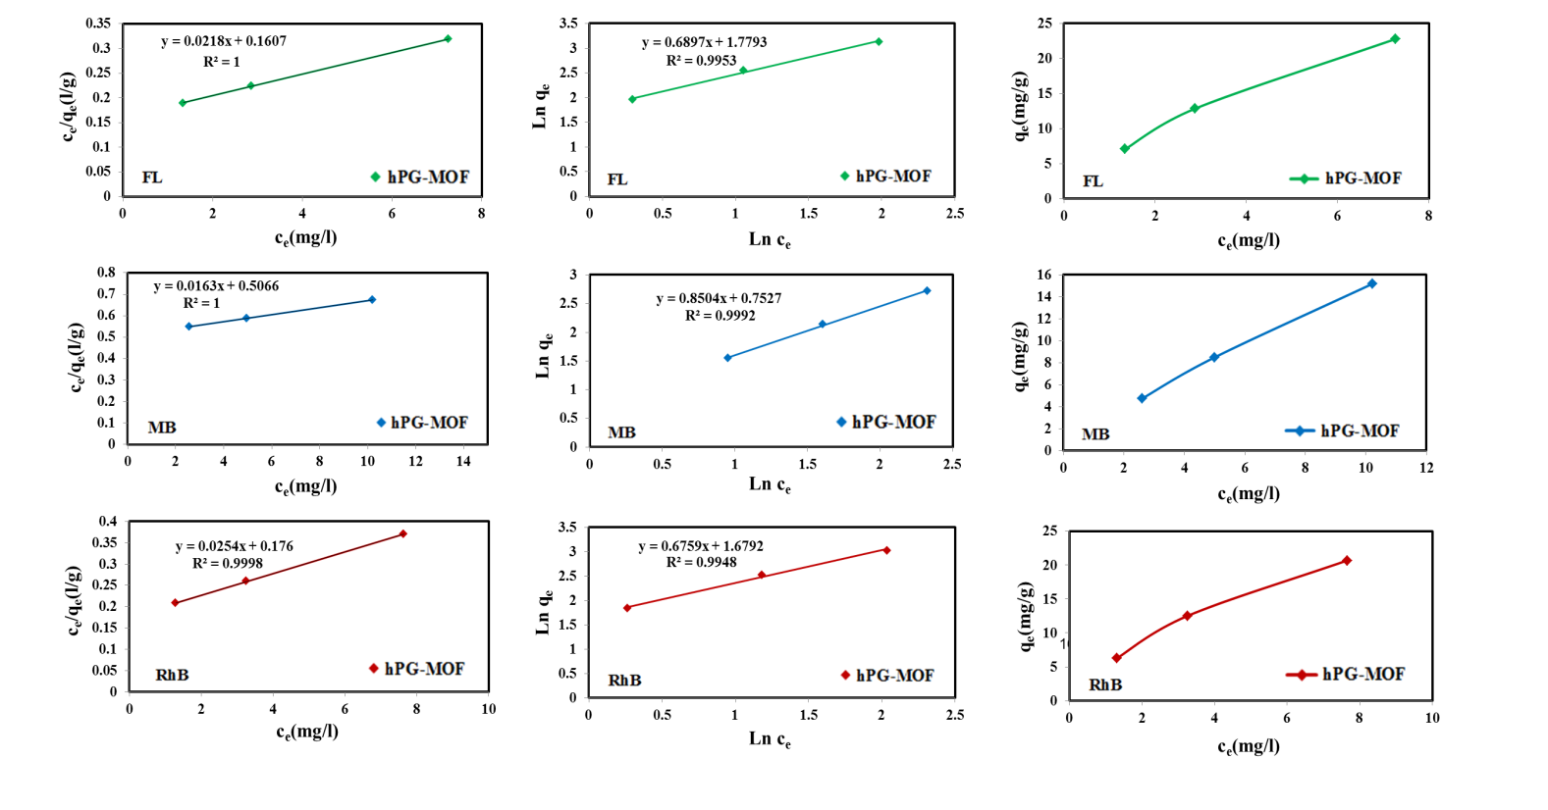

Figure S3. (a) Langmuir isotherm plots for the adsorption of MB, Rh B, and FL onto PVA-MOF and hPG-MOF. (b) Freundlich isotherm plots describing the adsorption behavior of MB, Rh B, and FL on the same MOFs. (c) Experimental adsorption isotherms of MB, Rh B, and FL at various equilibrium concentrations. All adsorption experiments were performed under continuous shaking to evaluate the affinity and adsorption capacity of the composites for each dye.

Table S5. Isotherm parameters for Langmuir and Freundlich models describing the adsorption of MB, RhB, and FL dyes onto PVA-MOF and hPG-MOF. This table presents the equilibrium constants and adsorption capacities, providing detailed insight into the adsorption behavior and affinity of MOFs toward different dyes.

Adsorbent | Langmuir Isotherm |  |  | Freundlich Isotherm
Adsorbent | q_{max} | k_{l} | R² | k_{f} | 1/n | n | R²
PVA-MOF MB | 7.8064 | 0.1465 | 0.9984 | 1.5498 | 0.4592 | 2.1777 | 0.9963
PVA-MOF RhB | 5.4318 | 0.0898 | 0.9989 | 0.6762 | 0.5615 | 1.2997 | 0.9960
PVA-MOF FL | 1.4888 | 0.0533 | 0.9989 | 7.9909 | 0.6108 | 1.6385 | 0.9953

Adsorbent | Langmuir Isotherm |  |  | Freundlich Isotherm
Adsorbent | q_{max} | k_{l} | R² | k_{f} | 1/n | n | R²
hPG-MOF MB | 61.3497 | 0.0322 | 1 | 2.1227 | 0.8504 | 1.1760 | 0.9992
hPG-MOF RhB | 39.3701 | 0.1443 | 0.9998 | 5.3613 | 0.6759 | 1.4795 | 0.9948
hPG-MOF FL | 45.8716 | 0.1357 | 1 | 5.9257 | 0.6897 | 1.4499 | 0.9953

Table S6. RL values for the adsorption of varying concentrations of MB, RhB, and FL dyes by PVA-MOF and hPG-MOF. The RL parameter evaluates the favorability of the adsorption process, reflecting the interaction affinity between dyes and MOFs at different initial dye concentrations.

Adsorbent | C(mg.L⁻¹) | R_{L}
PVA-MOF  MB | 5 | 0.5772
PVA-MOF  MB | 10 | 0.4057
PVA-MOF  MB | 20 | 0.2545
PVA-MOF  RhB | 5 | 0.6901
PVA-MOF  RhB | 10 | 0.5269
PVA-MOF  RhB | 20 | 0.3577
PVA-MOF  FL | 5 | 0.7896
PVA-MOF  FL | 10 | 0.6523
PVA-MOF  FL | 20 | 0.4840
Adsorbent | C(mg.L⁻¹) | R_{L}
hPG-MOF  MB | 5 | 0.8613
hPG-MOF  MB | 10 | 0.7564
hPG-MOF  MB | 20 | 0.6083
hPG-MOF  RhB | 5 | 0.5809
hPG-MOF  RhB | 10 | 0.4093
hPG-MOF  RhB | 20 | 0.2573
hPG-MOF  FL | 5 | 0.5958
hPG-MOF  FL | 10 | 0.4243
hPG-MOF  FL | 20 | 0.2693

Thermodynamic study of surface adsorption:
Determining the thermodynamic parameters is crucial for assessing the spontaneity and feasibility of the adsorption process. The key thermodynamic parameters namely, Gibbs free energy change (ΔG), enthalpy change (ΔH), and entropy change (ΔS) related to the adsorption equilibrium constants were calculated using equations (8) and (9). Initially, the equilibrium concentrations (C_{e}) were obtained from the adsorption data at equilibrium for various temperatures. Subsequently, the surface adsorption equilibrium constant was determined at each temperature using equation (7).
K_{ad}=C₀-C_{e}/C_{e} (7)
Based on equation (8), which describes the linear relationship between (ln K_{ad}) and (1/T), a plot of (ln K_{ad}) versus (1/T) was constructed. This plot yields a straight line with a y-intercept corresponding to (ΔS/R) and a slope corresponding to (ΔH/R). Using the gas constant (R = 0.008314, kJ/mol·K), the values of (ΔH) (kJ/mol) and (ΔS) (kJ/mol·K) for the surface adsorption of methylene blue, rhodamine B, and fluorescein onto the adsorbent were calculated from the slope and intercept, respectively.(Table S7 and Figure.S4)
(8) Ln k_{ad}=ΔS/R-ΔH/RT
To determine the changes in Gibbs free energy (ΔG) for the surface adsorption of methylene blue, rhodamine B, and fluorescein onto the adsorbent at various temperatures, equation (8) was used. The calculated (ΔG) values are summarized in Table S5.
ΔGᵒ=ΔHᵒ-TΔSᵒ (9)
Table S7. Various parameters including removal efficiency, adsorption capacity, and adsorption equilibrium constant for the adsorption of MB, RhB, and FL dyes by PVA-MOF and hPG-MOF at 25 °C. This table summarizes the performance metrics of MOFs under controlled temperature conditions.
q_{t}(mg.g⁻¹) | %R | Ln k_{ad} | k_{ad} | T(ᵒk) | Adsorbent
0.7565 | 4.5272 | -3.0487 | 0.0474 | 323 | PVA-MOF MB
1.0737 | 6.4257 | -2.6785 | 0.0687 | 333 | PVA-MOF MB
1.7814 | 10.6608 | -2.1259 | 0.1193 | 343 | PVA-MOF MB
1.9300 | 10.7513 | -2.1164 | 0.1205 | 323 | PVA-MOF Rh B
2.3231 | 12.9413 | -1.9061 | 0.1487 | 333 | PVA-MOF Rh B
3.0141 | 16.7906 | -1.6005 | 0.2018 | 343 | PVA-MOF Rh B
0.0742 | 0.4083 | -5.4968 | 0.0041 | 323 | PVA-MOF  FL
9.2428 | 50.8371 | 0.0335 | 1.0341 | 333 | PVA-MOF  FL
14.5137 | 79.8285 | 1.3756 | 3.9575 | 343 | PVA-MOF  FL

q_{t}(mg.g⁼¹) | %R | Ln k_{ad} | k_{ad} | T(ᵒk) | Adsorbent
1.2079 | 7.1506 | -2.5638 | 0.0770 | 323 | hPGMOF  MB
3.1479 | 18.6349 | -1.4739 | 0.2290 | 333 | hPGMOF  MB
4.3680 | 25.8577 | -1.0534 | 0.3488 | 343 | hPGMOF  MB
0.6433 | 3.6590 | -3.2707 | 0.0380 | 323 | hPG-MOF  Rh B
2.0372 | 11.5869 | -2.0321 | 0.1311 | 333 | hPG-MOF  Rh B
5.4920 | 31.2373 | -0.7891 | 0.4543 | 343 | hPG-MOF  Rh B
12.8805 | 73.5481 | 1.0226 | 2.7804 | 323 | hPG-MOF  FL
14.8478 | 84.7817 | 1.7176 | 5.5710 | 333 | hPG-MOF  FL
15.5902 | 89.0208 | 2.0929 | 8.1081 | 343 | hPG-MOF  FL

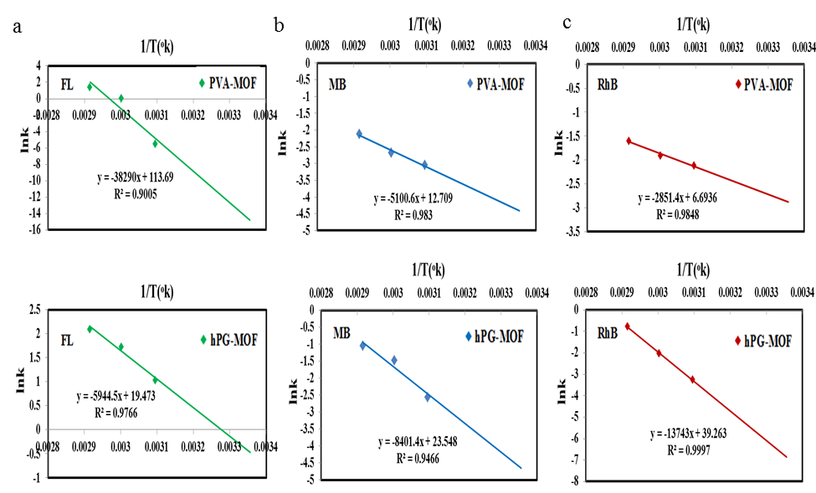
Figure S4. Plots of ln (K_{ad}) versus 1/T for the adsorption of MB (a), RhB (b), and FL (c) dyes on PVA-MOF and hPG-MOF at various temperatures. These graphs illustrate the temperature dependence of the adsorption equilibrium constant, providing insight into the thermodynamic behavior and adsorption affinity of MOFs.

Table S8. Thermodynamic parameters for the adsorption of MB, RhB, and FL dyes by PVA-MOF and hPG-MOF. The table includes values of enthalpy, entropy, and Gibbs free energy changes, providing insights into the spontaneity and nature of the adsorption processes.
R² | ΔGᵒ(kj.mol⁻¹) | T(ᵒk) | ΔSᵒ(j.mol⁻¹.k⁻¹) | ΔHᵒ(kj.mol⁻¹) | C(mg.L⁻¹) | Adsorbent
0.9830 | +10.9078 | 298 | +0.1057 | +42.4064 | 10 | PVA-MOF MB
0.9830 | +8.2653 | 323
0.9830 | +7.2083 | 333
0.9830 | +6.1513 | 343
0.9848 | +7.1079 | 298 | +0.0557 | +23.7065 | 10 | PVA-MOF Rh B
0.9848 | +5.7154 | 323
0.9848 | +5.1584 | 333
0.9848 | +4.6014 | 343
0.9005 | +36.6735 | 298 | +0.9452 | +318.3431 | 10 | PVA-MOF FL
0.9005 | +13.0435 | 323
0.9005 | +3.5915 | 333
0.9005 | -5.8605 | 343
R² | ΔGᵒ(kj.mol⁻¹) | T(ᵒk) | ΔSᵒ(j.mol⁻¹.k⁻¹) | ΔHᵒ(kj.mol⁻¹) | C(mg.L⁻¹) | Adsorbent
0.9466 | +11.5008 | 298 | +0.1958 | +69.8492 | 10 | hPG-MOF MB
0.9466 | +6.6058 | 323
0.9466 | +4.6478 | 333
0.9466 | +2.6898 | 343
0.9997 | +16.9921 | 298 | +0.3264 | +114.2593 | 10 | hPG-MOF Rh B
0.9997 | +8.8321 | 323
0.9997 | +5.5681 | 333
0.9997 | +2.3041 | 343
0.9766 | +1.1764 | 298 | +0.1619 | +49.4226 | 10 | hPG-MOF FL
0.9766 | -2.8711 | 323
0.9766 | -4.4901 | 333
0.9766 | -6.1091 | 343

Table S9. Adsorption capacity and adsorption equilibrium constant parameters for MB, RhB, and FL dyes by PVA-MOF (a) and PG-MOF (b) after 24 hours of shaking at 25 °C with dye solutions (5 mL, 50 ppm). This table summarizes the equilibrium adsorption performance of MOFs under controlled conditions.
a
Absorbent | Dyes (50 ppm) | Maximum dye adsorption (mg.g⁻¹)
H₂O-Gordab Sang khorramabad | RhB | 126.31
 | MB | 118.17
 | FL | 105.59
H₂O -Khorram Rud khorramabad | RhB | 125.63
 | MB | 120.08
 | FL | 110.16
H₂O- Drinking water Khorramabad | RhB | 127.78
 | MB | 120.21
 | FL | 121.74
D₂O | RhB | 128.17
 | MB | 128.24
 | FL | 124.77

b
Absorbent | Dyes (50 ppm) | Maximum dye adsorption (mg.g⁻¹)
H₂O-Gordab Sang khorramabad | MB | 129.01
 | RhB | 128.67
 | FL | 119.40
H₂O -Khorram Rud khorramabad | MB | 132.01
 | RhB | 128.88
 | FL | 123.85
H₂O- Drinking water Khorramabad | MB | 134.64
 | RhB | 131.14
 | FL | 125.19
D₂O | MB | 135.34
 | RhB | 131.46
 | FL | 128.31

References
1. Gazvineh, S.; Beyranvand, S.; Saki, S.; Nemati, M.; Ludwig, K.; Cheng, C.; Amsalem, P.; Schultz, T.; Adeli, M., Thermoresponsive Scaffolds Fabricated Using Covalent Organic Frameworks for the Selective Removal of Water Contaminants. Materials Advances 2024.
2. Fang, M.-D.; Drobek, M.; Cot, D.; Montoro, C.; Semsarilar, M., A Straightforward Method to Prepare MOF-Based Membranes via Direct Seeding of MOF-Polymer Hybrid Nanoparticles. Membranes 2023, 13.
3. Zhao, J.; Li, X.; Wang, Y.; Chen, L. Efficient removal of dyes by ErIII-based metal-organic frameworks. Journal of Molecular Structure 2024, 138345.
4. Melnyk, I. V.; Tomina, V. V.; Stolyarchuk, N. V.; Seisenbaeva, G. A.; Kessler, V. G., Organic dyes (acid red, fluorescein, methylene blue) and copper(II) adsorption on amino silica spherical particles with tailored surface hydrophobicity and porosity. Journal of Molecular Liquids 2021, 336, 116301.
5. Liang, Z.; Liang, Y.; Yu, P.; Wang, X., Ultrasonic-assisted in situ synthesis of MOF-199 on the surface of carboxylated cellulose fibers for efficient adsorption of methylene blue. RSC Advances 2024, 14, 15095 - 15105.
6. Elsherbiny, A. S.; Rady, A.; Abdelhameed, R. M.; Gemeay, A. H., Efficiency and selectivity of cost-effective Zn-MOF for dye removal, kinetic and thermodynamic approach. Environmental Science and Pollution Research International 2023, 30, 106860 - 106875.
7. Dinh, H. T.; Tran, N. T.; Trinh, D. X., Investigation into the Adsorption of Methylene Blue and Methyl Orange by UiO-66-NO2 Nanoparticles. Journal of Analytical Methods in Chemistry 2021, 2021.
8. Jevremović, A.; Savić, M.; Janošević Ležaić, A.; Krstić, J. B.; Gavrilov, N.; Bajuk-Bogdanović, D. V.; Milojević-Rakić, M.; Ćirić‐Marjanović, G., Environmental Potential of Carbonized MOF-5/PANI Composites for Pesticide, Dye, and Metal Cations—Can They Actually Retain Them All? Polymers 2023, 15.
9. Tan, Z., GO-MOF for organic dye adsorption. RSC Advances 2022, 12 (34), 21411-21420.
10. Li, X., UiO-66-NH2 MOFs for water purification. Materials Today Chemistry 2022, 23, 100624.
11. B. Vafakish and L. D. Wilson, Surfaces 2019, 2, 468-484.
12. J. Wang, J. Zheng, S. Wang, J. Sun, Y. Guo, H. Wang, S. Huang, Y. Li and C. Wang,
Materials Letters 2019, 254, 419-422.
13. Karami, K.; Beram, S. M.; Siadatnasab, F.; Bayat, P.; Ramezanpour, A., An investigation on MIL-101 Fe/PANI/Pd nanohybrid as a novel photocatalyst based on MIL-101(Fe) metal–organic frameworks removing methylene blue dye. Journal of Molecular Structure 2021, 1231, 130007.
14. Zhang, S.; Qiao, Q.; Wen, Y.; Ren, K.; Ma, X.; Tao, H., Synthesis of acetic acid-modulated NH2-MIL-101(Fe) for advanced oxidation of rhodamine B from aqueous solution. Colloids and Surfaces A: Physicochemical and Engineering Aspects 2023.

