Table S1. Species that were present in >1 warming experiment. The two B4WarmED experiments contain the same species by design and are therefore not shown in this table.
Species | Experiments present in
Achillea millefolium | Oklahoma, TeRaCON
Andropogon gerardii | Oklahoma, TeRaCON
Bouteloua gracilis | PHACE, TeRaCON
Plantago patagonica | PHACE, Oklahoma
Schizachyrium scoparium | Oklahoma, TeRaCON
Solidago rigida | Oklahoma, TeRaCON
Sorghastrum nutans | Oklahoma, TeRaCON

Table S2. Linear model output testing for an effect of year on ΔCTI for each experiment. The intercept represents the predicted ΔCTI in the first year of the experiment.
Experiment | Predictor | Estimate | Std. Error | T-Value | P-Value
JRGCE | Intercept  Year | -0.088  0.020 | 0.042  0.005 | -2.10  4.25 | 0.06  <0.001
PHACE | Intercept  Year | -0.104  0.057 | 0.071  0.020 | -1.46  2.91 | 0.20  0.033
TeRaCON | Intercept  Year | 0.114  -0.004 | 0.020  0.003 | 5.62  -1.20 | <0.001  0.26
Oklahoma | Intercept  Year | -0.063  0.013 | 0.085  0.011 | -0.74  1.12 | 0.48  0.29
B4WarmED CFC 3.1 | Intercept  Year | 0.027  0.022 | 0.062  0.009 | 0.444  2.49 | 0.67  0.030
B4WarmED CFC 1.6 | Intercept  Year | 0.055  0.004 | 0.044  0.006 | 1.24  0.71 | 0.24  0.49
B4WarmED HWRC 3.1 | Intercept  Year | -0.008  0.017 | 0.018  0.003 | -0.43  6.79 | 0.67  <0.001
B4WarmED HWRC 1.6 | Intercept  Year | -0.015  0.011 | 0.023  0.003 | -0.65  3.24 | 0.53  0.008

Table S3. All species contributions to the change in CTI in each experiment. Species contributions are ordered by the highest absolute species contribution to the lowest. The species temperature anomaly * the species abundance change = the species contribution. The slope of the warming effect on CTI over time is also given for each experiment (this slope matches those shown in Fig. 1g-l; for the B4WarmED experiments, the slope of the “warmed” treatment is given). The sum of all species contributions’ in each experiment equals the slope.
Experiment | Species | Species contribution | Species temperature anomaly | Species abundance change | Slope of warming effect on CTI
B4Warmed CFC | Pinus banksiana | 0.0041 | -2.0988 | -0.0020 | 0.0217
B4Warmed CFC | Picea glauca | 0.0040 | -1.9988 | -0.0020
B4Warmed CFC | Abies balsamea | 0.0037 | -1.9988 | -0.0019
B4Warmed CFC | Acer saccharum | 0.0028 | 1.5012 | 0.0019
B4Warmed CFC | Frangula alnus | 0.0023 | 2.0012 | 0.0012
B4Warmed CFC | Lonicera morrowii | 0.0014 | 2.1012 | 0.0007
B4Warmed CFC | Betula papyrifera | -0.0014 | -1.5988 | 0.0009
B4Warmed CFC | Rhamnus cathartica | 0.0013 | 1.3012 | 0.0010
B4Warmed CFC | Acer rubrum | 0.0012 | 1.0012 | 0.0012
B4Warmed CFC | Quercus rubra | 0.0011 | 1.3012 | 0.0009
B4Warmed CFC | Quercus macrocarpa | 0.0010 | 1.5012 | 0.0006
B4Warmed CFC | Pinus strobus | -0.0007 | 0.5012 | -0.0014
B4Warmed CFC | Populus tremouloides | 0.0007 | -0.6988 | -0.0010
B4Warmed CFC | Lonicera tatarica | 0.0001 | 1.2012 | 0.0001
B4Warmed CFC | Betula alleghaniensis | 0.0000 | -0.6988 | 0.0000
B4Warmed CFC | Pinus resinosa | 0.0000 | -1.0988 | 0.0000
B4Warmed CFC | Thuja occidentalis | 0.0000 | -0.7988 | 0.0000
B4Warmed HWRC | Pinus banksiana | 0.0053 | -2.0729 | -0.0026 | 0.0171
B4Warmed HWRC | Acer saccharum | 0.0042 | 1.1271 | 0.0037
B4Warmed HWRC | Picea glauca | 0.0040 | -1.7729 | -0.0023
B4Warmed HWRC | Quercus macrocarpa | 0.0030 | 1.2271 | 0.0024
B4Warmed HWRC | Frangula alnus | -0.0020 | 2.0271 | -0.0010
B4Warmed HWRC | Quercus rubra | 0.0013 | 1.1271 | 0.0011
B4Warmed HWRC | Abies balsamea | 0.0010 | -1.8729 | -0.0005
B4Warmed HWRC | Lonicera tatarica | 0.0008 | 1.2271 | 0.0006
B4Warmed HWRC | Pinus strobus | -0.0007 | 0.7271 | -0.0010
B4Warmed HWRC | Lonicera morrowii | -0.0005 | 2.1271 | -0.0002
B4Warmed HWRC | Betula papyrifera | 0.0004 | -1.4729 | -0.0003
B4Warmed HWRC | Acer rubrum | 0.0002 | 0.9271 | 0.0002
B4Warmed HWRC | Populus tremouloides | 0.0001 | -0.3729 | -0.0002
B4Warmed HWRC | Pinus resinosa | 0.0000 | -0.7729 | 0.0000
B4Warmed HWRC | Rhamnus cathartica | 0.0000 | 1.2271 | 0.0000
B4Warmed HWRC | Betula alleghaniensis | 0.0000 | -0.1729 | 0.0000
B4Warmed HWRC | Thuja occidentalis | 0.0000 | -0.4729 | 0.0000
JRGCE | Brachypodium distachyon | 0.0054 | 0.8099 | 0.0067 | 0.0204
JRGCE | Trifolium dubium | 0.0036 | -2.6901 | -0.0014
JRGCE | Geranium dissectum | 0.0034 | -1.2901 | -0.0027
JRGCE | Festuca bromoides | 0.0031 | -1.1901 | -0.0026
JRGCE | Bromus hordeaceus | 0.0029 | -0.4901 | -0.0059
JRGCE | Elymus glaucus | -0.0023 | -3.6901 | 0.0006
JRGCE | Danthonia californica | 0.0022 | -4.6901 | -0.0005
JRGCE | Rumex acetosella | -0.0021 | -3.9901 | 0.0005
JRGCE | Crepis vesicaria | 0.0013 | -1.7901 | -0.0007
JRGCE | Stipa pulchra | 0.0008 | 0.6099 | 0.0013
JRGCE | Dipsacus sativus | -0.0007 | -1.3901 | 0.0005
JRGCE | Torilis arvensis | 0.0006 | -1.1901 | -0.0005
JRGCE | Avena barbata | 0.0006 | 0.3099 | 0.0018
JRGCE | Gastridium phleoides | 0.0005 | 0.3099 | 0.0016
JRGCE | Convolvulus arvensis | 0.0005 | -1.8901 | -0.0003
JRGCE | Aira caryophyllea | 0.0003 | -2.2901 | -0.0001
JRGCE | Avena fatua | 0.0003 | 0.5099 | 0.0006
JRGCE | Sisyrinchium bellum | 0.0003 | -1.1901 | -0.0003
JRGCE | Briza maxima | 0.0003 | -2.2901 | -0.0001
JRGCE | Briza minor | 0.0003 | -1.2901 | -0.0002
JRGCE | Bromus diandrus | -0.0002 | 0.2099 | -0.0011
JRGCE | Vicia sativa | -0.0002 | -1.6901 | 0.0001
JRGCE | Epilobium brachycarpum | -0.0002 | -4.0901 | 0.0001
JRGCE | Lysimachia arvensis | -0.0002 | -0.1901 | 0.0010
JRGCE | Hemizonia congesta | 0.0002 | -1.3901 | -0.0001
JRGCE | Festuca perennis | -0.0002 | 0.7099 | -0.0003
JRGCE | Acmispon americanus | 0.0002 | -1.3901 | -0.0001
JRGCE | Taraxia ovata | -0.0002 | -2.0901 | 0.0001
JRGCE | Phalaris aquatica | 0.0001 | -1.0901 | -0.0001
JRGCE | Logfia gallica | 0.0001 | 0.4099 | 0.0003
JRGCE | Vicia tetrasperma | -0.0001 | -3.7901 | 0.0000
JRGCE | Rumex crispus | -0.0001 | -1.3901 | 0.0000
JRGCE | Carduus pycnocephalus | -0.0001 | -0.4901 | 0.0001
JRGCE | Zeltnera davyi | -0.0001 | -1.6901 | 0.0000
JRGCE | Trifolium hirtum | 0.0000 | -0.8901 | 0.0001
JRGCE | Lythrum hyssopifolia | 0.0000 | 0.1099 | 0.0004
JRGCE | Lactuca serriola | 0.0000 | -0.1901 | -0.0002
JRGCE | Juncus bufonius | 0.0000 | -1.1901 | 0.0000
JRGCE | Hypochaeris glabra | 0.0000 | 0.3099 | -0.0001
JRGCE | Centaurea solstitialis | 0.0000 | -1.1901 | 0.0000
JRGCE | Medicago polymorpha | 0.0000 | 0.6599 | 0.0000
JRGCE | Genista monspessulana | 0.0000 | -2.1901 | 0.0000
JRGCE | Baccharis pilularis | 0.0000 | -0.8901 | 0.0000
JRGCE | Kickxia spuria | 0.0000 | -0.5401 | 0.0000
JRGCE | Madia gracilis | 0.0000 | -2.6901 | 0.0000
JRGCE | Erigeron canadensis | 0.0000 | -0.6901 | 0.0000
JRGCE | Erodium botrys | 0.0000 | 0.0099 | 0.0009
JRGCE | Urospermum picroides | 0.0000 | -0.8401 | 0.0000
JRGCE | Pistacia atlantica | 0.0000 | 1.0099 | 0.0000
JRGCE | Sonchus asper | 0.0000 | 0.0099 | 0.0002
JRGCE | Quercus agrifolia | 0.0000 | -0.3901 | 0.0000
JRGCE | Erodium cicutarium | 0.0000 | -0.1901 | 0.0000
JRGCE | Toxicodendron diversilobum | 0.0000 | -1.2901 | 0.0000
JRGCE | Pseudognaphalium californicum | 0.0000 | 0.4099 | 0.0000
JRGCE | Helminthotheca echioides | 0.0000 | 0.0099 | 0.0000
JRGCE | Quercus lobata | 0.0000 | -0.1901 | 0.0000
Oklahoma | Bothriochloa ischaemum | 0.0327 | 2.9888 | 0.0109 | 0.0125
Oklahoma | Sorghastrum nutans | -0.0162 | -2.4112 | 0.0067
Oklahoma | Sporobolus compositus | 0.0160 | -2.2112 | -0.0073
Oklahoma | Solidago rigida | -0.0110 | -5.6112 | 0.0020
Oklahoma | Symphyotrichum ericoides | -0.0084 | -1.9112 | 0.0044
Oklahoma | Andropogon gerardii | 0.0054 | -3.2112 | -0.0017
Oklahoma | Schizachyrium scoparium | -0.0052 | 0.5888 | -0.0089
Oklahoma | Ambrosia psilostachya | -0.0050 | 2.7888 | -0.0018
Oklahoma | Carex brevior | 0.0044 | -3.8112 | -0.0012
Oklahoma | Dichanthelium oligosanthes | -0.0035 | 1.8888 | -0.0019
Oklahoma | Dactylis glomerata | 0.0031 | -5.8112 | -0.0005
Oklahoma | Dalea purpurea | -0.0026 | -5.4112 | 0.0005
Oklahoma | Psoralidium tenuiflorum | 0.0015 | -3.8112 | -0.0004
Oklahoma | Tridens flavus | -0.0015 | 0.7888 | -0.0018
Oklahoma | Solidago drummondii | -0.0012 | -2.3112 | 0.0005
Oklahoma | Sabatia campestris | -0.0011 | 3.3888 | -0.0003
Oklahoma | Lithospermum caroliniense | 0.0009 | -2.6112 | -0.0003
Oklahoma | Croton glandulosus | 0.0009 | 1.9888 | 0.0004
Oklahoma | Diodia virginiana | 0.0008 | 2.9888 | 0.0003
Oklahoma | Cornus drummondii | 0.0006 | 2.4888 | 0.0002
Oklahoma | Salvia azurea | -0.0006 | -0.8112 | 0.0007
Oklahoma | Panicum virgatum | 0.0006 | -1.3112 | -0.0004
Oklahoma | Elymus canadensis | 0.0005 | -3.9112 | -0.0001
Oklahoma | Sporobolus neglectus | 0.0005 | -2.7112 | -0.0002
Oklahoma | Achillea millefolium | 0.0005 | -5.9112 | -0.0001
Oklahoma | Solidago nemoralis | 0.0005 | -2.3112 | -0.0002
Oklahoma | Symphyotrichum ontarionsis | -0.0005 | -3.0112 | 0.0002
Oklahoma | Muhlenbergia capillaris | 0.0005 | 3.4888 | 0.0001
Oklahoma | Buglossoides arvensis | 0.0005 | 2.3888 | 0.0002
Oklahoma | Ratibida columnifera | 0.0004 | 2.4888 | 0.0002
Oklahoma | Dianthus armeria | -0.0004 | -3.4112 | 0.0001
Oklahoma | Solanum carolinense | 0.0004 | -1.6112 | -0.0003
Oklahoma | Dalea candida | 0.0004 | -4.0112 | -0.0001
Oklahoma | Lithospermum incisum | -0.0004 | -1.7112 | 0.0002
Oklahoma | Calylophus serrulatus | 0.0004 | -2.9112 | -0.0001
Oklahoma | Prunus angustifolia | -0.0004 | 2.1888 | -0.0002
Oklahoma | Galium virgatum | -0.0004 | 2.8888 | -0.0001
Oklahoma | Scutellaria parvula | 0.0004 | -1.9112 | -0.0002
Oklahoma | Aristida purpurascens | -0.0004 | 1.6388 | -0.0002
Oklahoma | Bothriochloa saccharoides | 0.0004 | 1.0888 | 0.0003
Oklahoma | Hedyotis nigricans | -0.0004 | 2.6888 | -0.0001
Oklahoma | Panicum capillare | 0.0004 | -3.0112 | -0.0001
Oklahoma | Amphiachyris dracunculoides | -0.0003 | 0.2888 | -0.0012
Oklahoma | Buchnera americana | -0.0003 | -1.3112 | 0.0003
Oklahoma | Diodia teres | -0.0003 | 1.4888 | -0.0002
Oklahoma | Croton punctatus | 0.0003 | 6.0388 | 0.0000
Oklahoma | Mimosa nuttallii | 0.0002 | 0.2888 | 0.0008
Oklahoma | Viola bicolor | -0.0002 | -2.7112 | 0.0001
Oklahoma | Mimosa rupertiana | -0.0002 | 1.2888 | -0.0002
Oklahoma | Antennaria neglecta | 0.0002 | -4.5112 | 0.0000
Oklahoma | Eragrostis curvula | 0.0002 | -0.5612 | -0.0004
Oklahoma | Aristida oligantha | -0.0002 | -1.2112 | 0.0002
Oklahoma | Coreopsis tinctoria | -0.0002 | 2.0888 | -0.0001
Oklahoma | Scleria ciliata | -0.0002 | 2.1888 | -0.0001
Oklahoma | Eragrostis trichodes | -0.0002 | -2.6112 | 0.0001
Oklahoma | Cirsium altissimum | 0.0002 | -2.2112 | -0.0001
Oklahoma | Linum sulcatum | 0.0002 | -2.7112 | -0.0001
Oklahoma | Ruellia humilis | -0.0002 | -1.2112 | 0.0001
Oklahoma | Euphorbia dentata | -0.0002 | 2.5888 | -0.0001
Oklahoma | Asclepias viridis | 0.0001 | 2.4888 | 0.0001
Oklahoma | Stenaria nigricans | 0.0001 | 2.5888 | 0.0001
Oklahoma | Stenosiphon linifolius | -0.0001 | -0.7112 | 0.0002
Oklahoma | Desmanthus illinoensis | -0.0001 | -0.1112 | 0.0012
Oklahoma | Hedeoma hispida | 0.0001 | -1.6112 | -0.0001
Oklahoma | Grindelia papposa | 0.0001 | 2.3888 | 0.0000
Oklahoma | Erigeron strigosus | -0.0001 | -0.3112 | 0.0004
Oklahoma | Haplopappus ciliatus | -0.0001 | 1.9888 | -0.0001
Oklahoma | Plantago patagonica | 0.0001 | -3.9112 | 0.0000
Oklahoma | Elymus elymoides | 0.0001 | -7.2612 | 0.0000
Oklahoma | Setaria parviflora | -0.0001 | 2.7888 | 0.0000
Oklahoma | Pyrrhopappus grandiflorus | -0.0001 | -0.6112 | 0.0002
Oklahoma | Diodia ocymifolia | -0.0001 | -4.4112 | 0.0000
Oklahoma | Andropogon ternarius | 0.0001 | 2.2888 | 0.0000
Oklahoma | Ruellia hirta | 0.0001 | -0.6112 | -0.0001
Oklahoma | Chamaecrista fasciculata | -0.0001 | 0.2888 | -0.0003
Oklahoma | Solidago canadensis | 0.0001 | -5.7112 | 0.0000
Oklahoma | Apocynum cannabinum | 0.0001 | -3.5112 | 0.0000
Oklahoma | Conyza canadensis | -0.0001 | -3.0112 | 0.0000
Oklahoma | Stipa tenuissima | -0.0001 | -0.6612 | 0.0001
Oklahoma | Croton monanthogynus | -0.0001 | 2.7888 | 0.0000
Oklahoma | Ulmus rubra | 0.0001 | -2.3112 | 0.0000
Oklahoma | Solidago ludiviciana | 0.0001 | 2.6388 | 0.0000
Oklahoma | Melilotus alba | 0.0001 | -7.1112 | 0.0000
Oklahoma | Solanum elaeagnifolium | 0.0001 | 2.7888 | 0.0000
Oklahoma | Erodium texanum | -0.0001 | 3.2888 | 0.0000
Oklahoma | Tragia betonicifolia | 0.0001 | -1.3112 | 0.0000
Oklahoma | Sideroxylon lanuginosum | 0.0001 | 3.0888 | 0.0000
Oklahoma | Chaerophyllum tainturieri | 0.0000 | 2.6888 | 0.0000
Oklahoma | Liatris squarrosa | 0.0000 | 1.0888 | 0.0000
Oklahoma | Gaura parviflora | 0.0000 | 0.8388 | 0.0000
Oklahoma | Grindelia ciliata | 0.0000 | 0.6388 | -0.0001
Oklahoma | Euphorbia hexagona | 0.0000 | -3.1112 | 0.0000
Oklahoma | Bouteloua curtipendula | 0.0000 | -1.2112 | 0.0000
Oklahoma | Anemone berlandieri | 0.0000 | 3.3888 | 0.0000
Oklahoma | Heterotheca latifolia | 0.0000 | 2.4888 | 0.0000
Oklahoma | Juncus marginatus | 0.0000 | 2.0888 | 0.0000
Oklahoma | Sorghum halepense | 0.0000 | 2.7888 | 0.0000
Oklahoma | Plantago virginica | 0.0000 | 0.8888 | 0.0000
Oklahoma | Gaillardia aestivalis | 0.0000 | 2.9888 | 0.0000
Oklahoma | Cyperus sp | 0.0000 | 0.9888 | 0.0000
Oklahoma | Setaria glauca | 0.0000 | -0.9612 | 0.0000
Oklahoma | Trifolium repens | 0.0000 | -0.9112 | 0.0000
Oklahoma | Bromus japonicus | 0.0000 | -1.5112 | 0.0000
Oklahoma | Lespedeza stuevei | 0.0000 | 1.4888 | 0.0000
Oklahoma | Polygala alba | 0.0000 | -1.5112 | 0.0000
Oklahoma | Coreopsis grandiflora | 0.0000 | 0.0888 | 0.0001
Oklahoma | Cercis canadensis | 0.0000 | 0.4888 | 0.0000
Oklahoma | Hieracium longipilum | 0.0000 | -2.8112 | 0.0000
Oklahoma | Euphorbia glyptosperma | 0.0000 | -4.1112 | 0.0000
Oklahoma | Celtis occidentalis | 0.0000 | -4.4112 | 0.0000
Oklahoma | Polygala incarnata | 0.0000 | -0.3612 | 0.0000
Oklahoma | Rosa spinosissima | 0.0000 | -3.0112 | 0.0000
Oklahoma | Lespedeza hirta | 0.0000 | -0.2112 | 0.0000
Oklahoma | Rhus copallina | 0.0000 | 0.7888 | 0.0000
Oklahoma | Cynodon dactylon | 0.0000 | 2.9888 | 0.0000
Oklahoma | Prunus gracilis | 0.0000 | 2.3888 | 0.0000
Oklahoma | Sisyrinchium angustifolium | 0.0000 | -0.2112 | 0.0000
Oklahoma | Eleocharis sp | 0.0000 | -0.8112 | 0.0000
Oklahoma | Desmodium paniculatum | 0.0000 | 0.3888 | 0.0000
Oklahoma | Oxalis stricta | 0.0000 | -2.9112 | 0.0000
Oklahoma | Oxalis corniculata | 0.0000 | 2.6888 | 0.0000
Oklahoma | Juniperus virginiana | 0.0000 | -0.0112 | 0.0000
Oklahoma | Ambrosia trida | 0.0000 | -0.0112 | 0.0000
PHACE | Artemisia frigida | 0.0317 | -2.3650 | -0.0134 | 0.0573
PHACE | Carex duriuscula | -0.0241 | -1.9650 | 0.0123
PHACE | Pascopyrum smithii | 0.0141 | 0.4350 | 0.0323
PHACE | Heterotheca villosa | 0.0113 | -1.7650 | -0.0064
PHACE | Koeleria macrantha | 0.0071 | -1.5650 | -0.0045
PHACE | Hesperostipa comata | 0.0064 | -0.4650 | -0.0137
PHACE | Vulpia octoflora | 0.0056 | 4.6350 | 0.0012
PHACE | Bouteloua gracilis | -0.0052 | 0.6350 | -0.0081
PHACE | Mertensia lanceolata | 0.0045 | -3.5650 | -0.0013
PHACE | Erigeron pumilus | 0.0044 | -1.0650 | -0.0041
PHACE | Plantago patagonica | 0.0043 | 3.8350 | 0.0011
PHACE | Oenothera coronopifolia | -0.0024 | -2.3650 | 0.0010
PHACE | Potentilla pensylvanica | 0.0020 | -3.5650 | -0.0006
PHACE | Sphaeralcea coccinea | 0.0019 | 0.5350 | 0.0035
PHACE | Astragalus sp | -0.0018 | 0.8350 | -0.0021
PHACE | Machaeranthera pinnatifida | 0.0017 | 4.5350 | 0.0004
PHACE | Cirsium undulatum | -0.0015 | 1.6350 | -0.0009
PHACE | Salsola tragus | -0.0014 | 3.6350 | -0.0004
PHACE | Linaria dalmatica | -0.0007 | -0.3650 | 0.0018
PHACE | Oenothera suffrutescens | -0.0005 | 1.8350 | -0.0003
PHACE | Lesquerella montana | -0.0005 | -2.0650 | 0.0002
PHACE | Lepidium densiflorum | 0.0004 | 0.8350 | 0.0004
PHACE | Grindelia squarrosa | -0.0003 | -0.3650 | 0.0009
PHACE | Lygodesmia juncea | -0.0003 | -1.4650 | 0.0002
PHACE | Tragopogon pratensis | 0.0001 | -1.4650 | -0.0001
PHACE | Mirabilis linearis | 0.0001 | 2.1350 | 0.0001
PHACE | Eriogonum effusum | 0.0001 | 0.5350 | 0.0002
PHACE | Escobaria vivipara | 0.0001 | 1.5350 | 0.0000
PHACE | Allium textile | 0.0001 | -1.2650 | -0.0001
PHACE | Centaurea diffusa | 0.0001 | -0.3650 | -0.0002
PHACE | Phlox hoodii | -0.0001 | -2.1650 | 0.0000
PHACE | Antennaria rosea | 0.0000 | -5.5650 | 0.0000
PHACE | Tetraneuris acaulis | 0.0000 | -0.5650 | 0.0001
PHACE | Lappula occidentalis | 0.0000 | 1.5350 | 0.0000
PHACE | Leucocrinum montanum | 0.0000 | -0.8650 | 0.0000
PHACE | Liatris punctata | 0.0000 | 0.3350 | -0.0001
PHACE | Penstemon albidus | 0.0000 | 0.3350 | 0.0001
PHACE | Musineon divaricatum | 0.0000 | -1.2650 | 0.0000
PHACE | Erysimum asperum | 0.0000 | -0.0650 | 0.0003
PHACE | Comandra umbellata | 0.0000 | -0.8650 | 0.0000
PHACE | Artemisia dracunculus | 0.0000 | 0.0350 | 0.0001
PHACE | Chenopodium leptophyllum | 0.0000 | 0.8350 | 0.0000
PHACE | Descurainia sophia | 0.0000 | 1.1350 | 0.0000
PHACE | Poa secunda | 0.0000 | -2.5650 | 0.0000
PHACE | Draba reptans | 0.0000 | -0.2650 | 0.0000
PHACE | Cryptantha thyrsiflora | 0.0000 | 0.2350 | 0.0000
PHACE | Sisymbrium altissimum | 0.0000 | 0.6350 | 0.0000
PHACE | Bouteloua dactyloides | 0.0000 | 4.8350 | 0.0000
PHACE | Cryptantha cinerea | 0.0000 | 2.1350 | 0.0000
PHACE | Delphinium geyeri | 0.0000 | -1.3650 | 0.0000
PHACE | Descurainia pinnata | 0.0000 | 5.3350 | 0.0000
PHACE | Eriogonum alatum | 0.0000 | 0.2350 | 0.0000
PHACE | Machaeranthera canescens | 0.0000 | -1.0650 | 0.0000
PHACE | Picradeniopsis oppositifolia | 0.0000 | 0.6350 | 0.0000
TeRaCON | Sorghastrum nutans | -0.0068 | 1.0405 | -0.0066 | -0.0037
TeRaCON | Asclepias tuberosa | 0.0041 | 1.3405 | 0.0030
TeRaCON | Andropogon gerardii | 0.0028 | 0.2405 | 0.0117
TeRaCON | Lespedeza capitata | -0.0018 | 0.6405 | -0.0028
TeRaCON | Bouteloua gracilis | -0.0014 | -0.4595 | 0.0030
TeRaCON | Poa pratensis | -0.0011 | -0.3595 | 0.0030
TeRaCON | Lupinus perennis | 0.0010 | -0.4595 | -0.0023
TeRaCON | Schizachyrium scoparium | -0.0008 | 0.1405 | -0.0056
TeRaCON | Achillea millefolium | 0.0006 | -0.8595 | -0.0007
TeRaCON | Petalostemum villosum | -0.0005 | -0.3595 | 0.0013
TeRaCON | Koeleria cristata | 0.0003 | -0.7595 | -0.0004
TeRaCON | Solidago rigida | -0.0002 | 0.0405 | -0.0042
TeRaCON | Agropyron repens | 0.0002 | 0.1405 | 0.0012
TeRaCON | Amorpha canescens | -0.0001 | 0.1405 | -0.0008
TeRaCON | Bromus inermis | -0.0001 | -0.5595 | 0.0002
TeRaCON | Anemone cylindrica | 0.0000 | -1.5595 | 0.0000

Table S4. Linear model outputs testing for a relationship between log(mean trait value) and species contributions, abundance shifts, and temperature anomalies for all plant traits. The adjusted p-value was calculated using BH correction.
Response | Trait | Estimate | Std. Error | T-Value | P-Value | P-Value (adj)
Species contribution to β CTI | Seed dry mass  Seed length  Seed number per plant  Seed germination rate  Seed longevity  SLA  LDMC  Leaf thickness  Stem diameter  Plant height vegetative  Specific root length  Specific fine root length  Fine root length | -5.32e-5  1.87e-4  -5.75e-4  -4.92e-4  -4.88e-4  3.99e-4  6.37e-4  -4.28e-4  4.59e-4  6.24e-5  -3.07e-4  8.10e-4  3.27e-4 | 1.18e-4  2.85e-4  3.25e-4  1.72e-3  3.43e-4  8.07e-4  9.80e-4  5.84e-4  2.33e-4  2.15e-4  7.02e-4  6.31e-4  2.40e-4 | -0.45  0.66  -1.77  -0.29  -1.42  0.49  0.65  -0.73  1.97  0.29  -0.44  1.28  1.37 | 0.65  0.51  0.08  0.78  0.16  0.62  0.52  0.47  0.07  0.77  0.66  0.21  0.19 | 0.78  0.78  0.54  0.78  0.54  0.78  0.78  0.78  0.54  0.78  0.54  0.78  0.54
Species β abundance | Seed dry mass  Seed length  Seed number per plant  Seed germination rate  Seed longevity  SLA  LDMC  Leaf thickness  Stem diameter  Plant height vegetative  Specific root length  Specific fine root length  Fine root length | 8.86e-5  -1.25e-4  -1.55e-4  7.82e-4  4.52e-4  5.17e-4  -1.44e-4  -7.82e-4  7.65e-5  4.94e-6  -7.38e-4  -3.24e-4  2.43e-4 | 6.67e-5  2.22e-4  1.50e-4  9.34e-4  2.10e-4  4.49e-4  5.47e-4  3.19e-4  1.78e-4  1.19e-4  6.00e-4  4.41e-4  2.05e-4 | 1.33  -0.56  -1.04  0.84  2.15  1.15  -0.26  -2.45  0.43  0.04  -1.23  -0.73  1.18 | 0.19  0.58  0.31  0.41  0.04  0.25  0.79  0.02  0.67  0.97  0.23  0.47  0.25 | 0.55  0.75  0.59  0.66  0.24  0.55  0.86  0.20  0.79  0.97  0.55  0.67  0.55
Species temperature anomaly (°C) | Seed dry mass  Seed length  Seed number per plant  Seed germination rate  Seed longevity  SLA  LDMC  Leaf thickness  Stem diameter  Plant height vegetative  Specific root length  Specific fine root length  Fine root length | 0.21  0.51  -0.10  -0.24  0.62  0.43  -0.23  -0.49  0.59  0.12  -0.20  -0.38  0.43 | 0.07  0.32  0.15  0.86  0.29  0.37  0.46  0.24  0.17  0.11  0.43  0.29  0.21 | 3.17  1.61  -0.68  -0.28  2.10  1.17  -0.50  -2.02  3.54  1.05  -0.47  -1.32  2.09 | 0.002  0.11  0.50  0.78  0.04  0.24  0.62  0.05  0.001  0.30  0.64  0.19  0.06 | 0.01  0.25  0.65  0.78  0.15  0.40  0.69  0.15  0.01  0.43  0.69  0.36  0.15

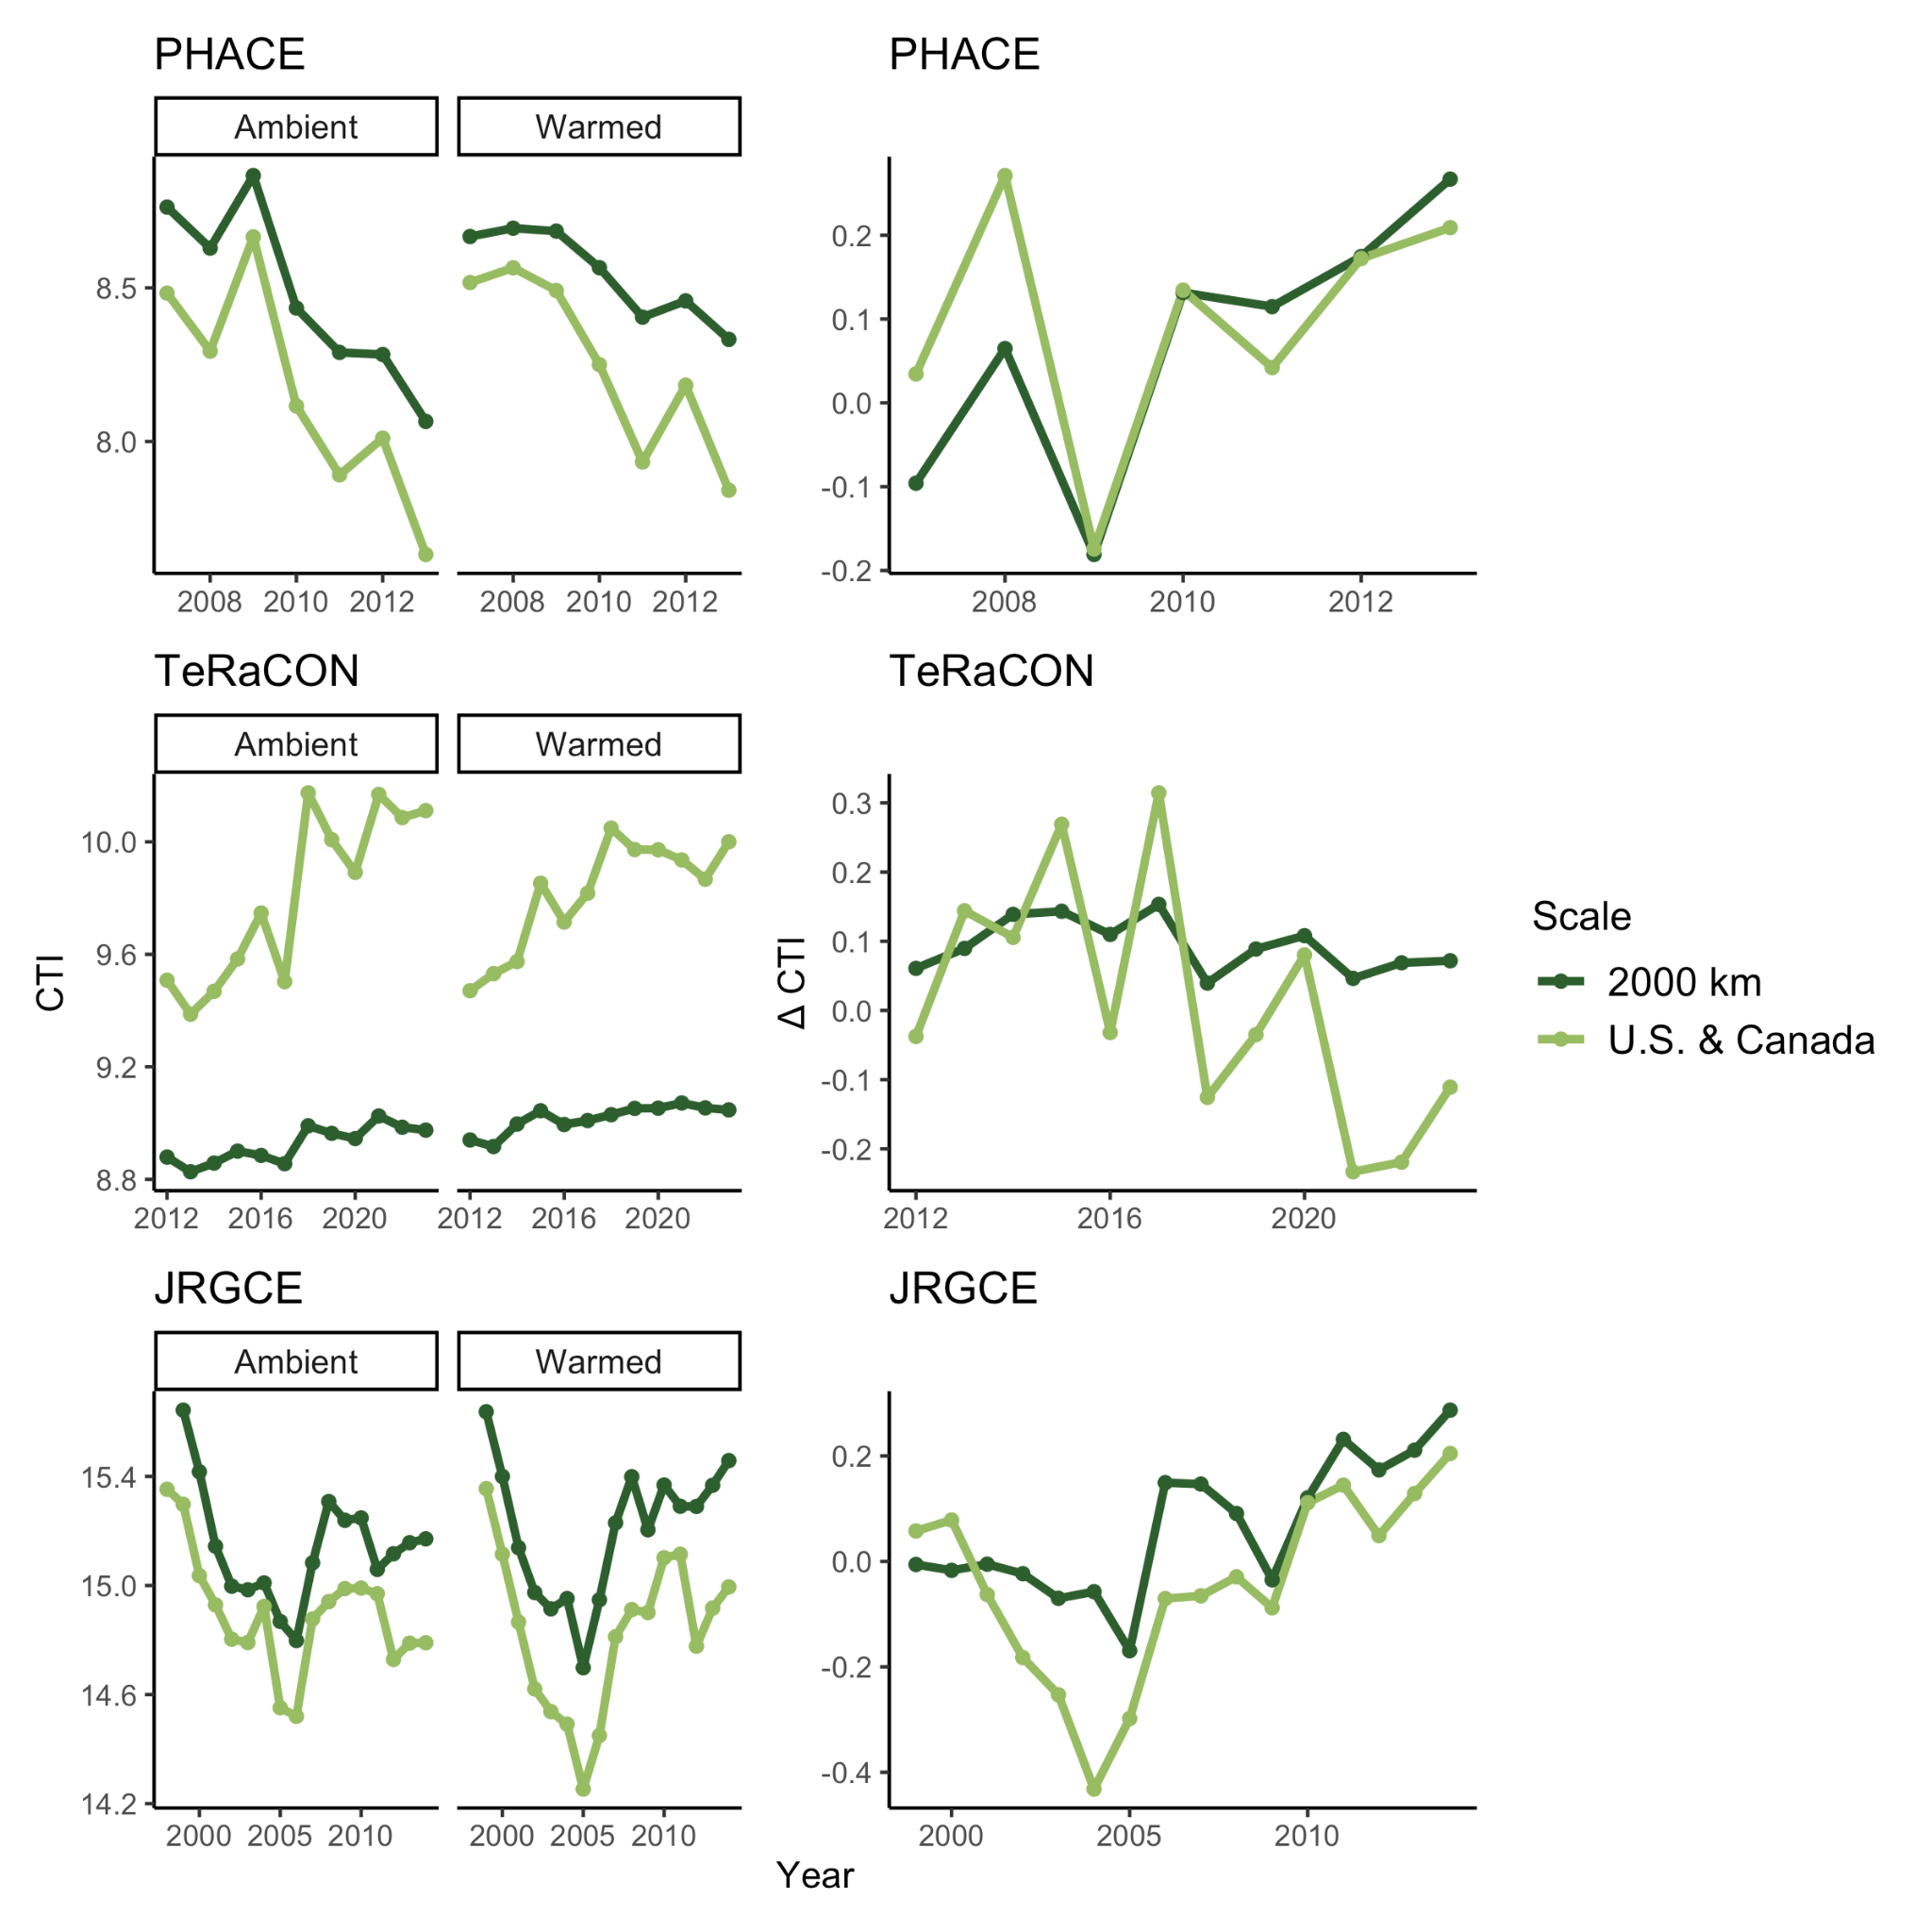
Figure S1. CTIs calculated using GBIF occurrence points in a 2,000 km x 2,000 km bounding box around each experiment’s location (dark green) and using all GBIF occurrence points in the U.S. and Canada (light green). The left column shows average CTI per scale, year, and treatment (ambient or warmed), and the right column shows the warming treatment effect on CTI each year (warmed CTI - ambient CTI).

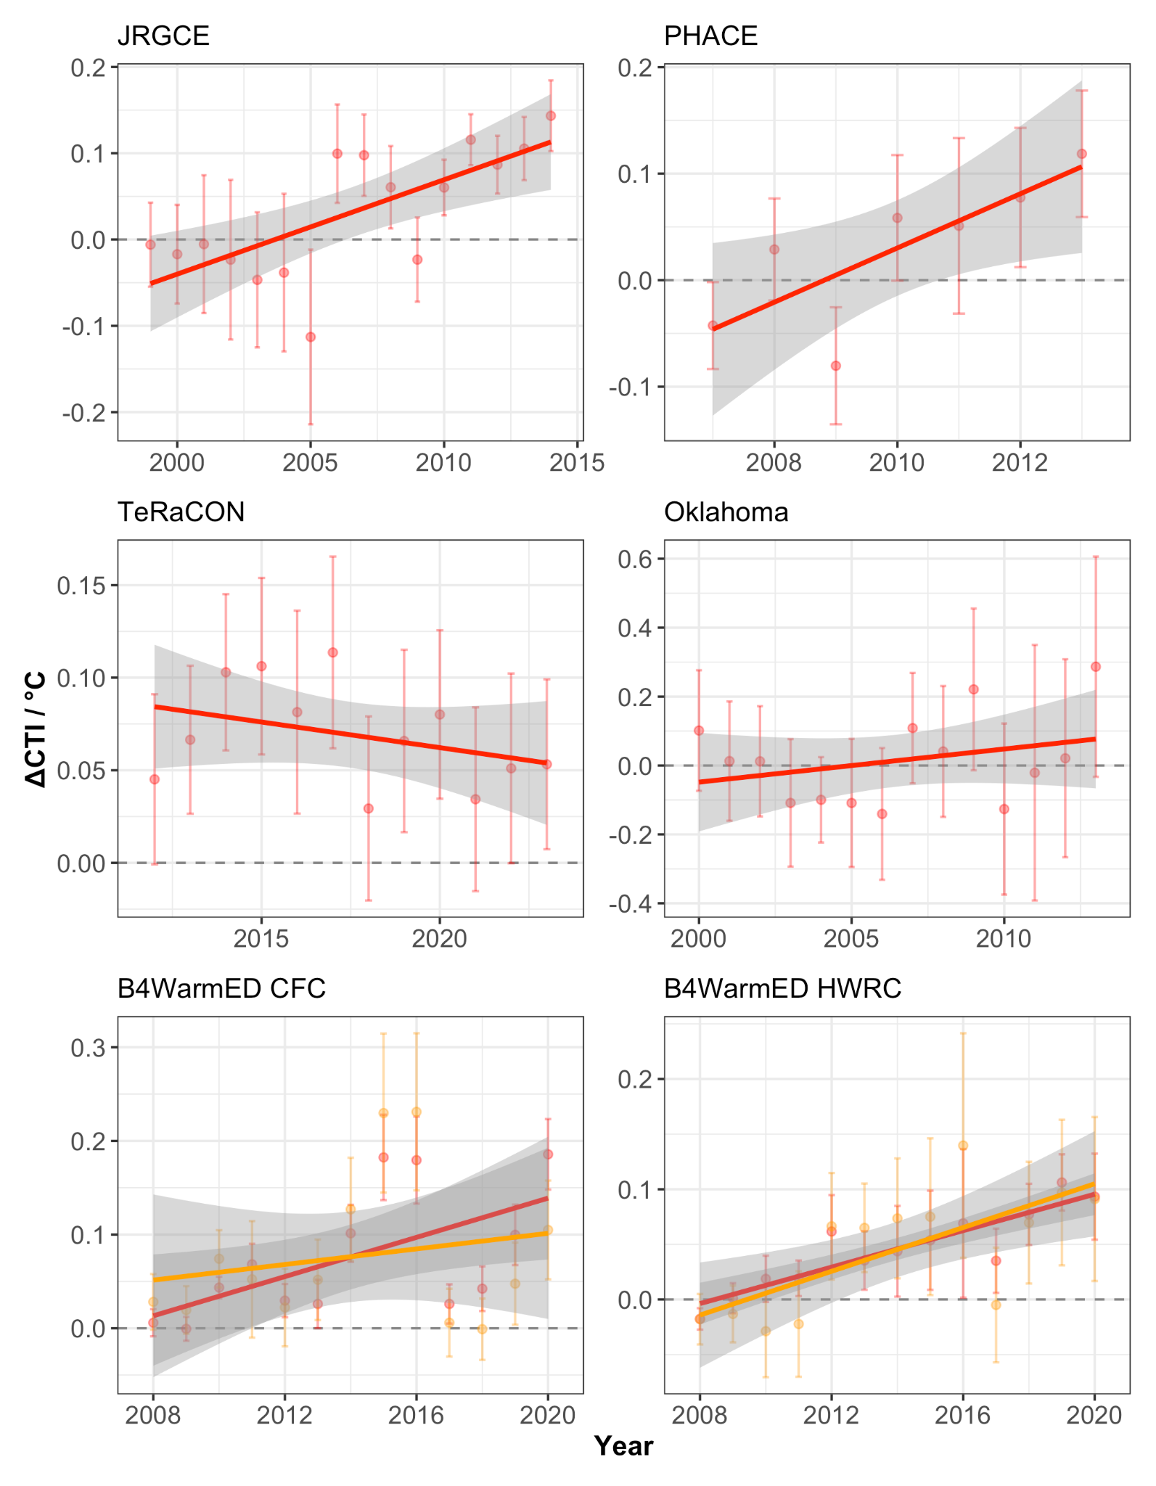
Figure S2. The effect of the warming treatment on CTI over time for each experiment, scaled by the amount warmed (ΔCTI / °C). Points represent the mean CTI in warmed (red) or intermediate warming (orange) minus the mean CTI in ambient for each year (ΔCTI) divided by the amount warmed in the experiment (°C) ± the standard error of the difference between means, and lines represent linear regressions with a 95% CI.

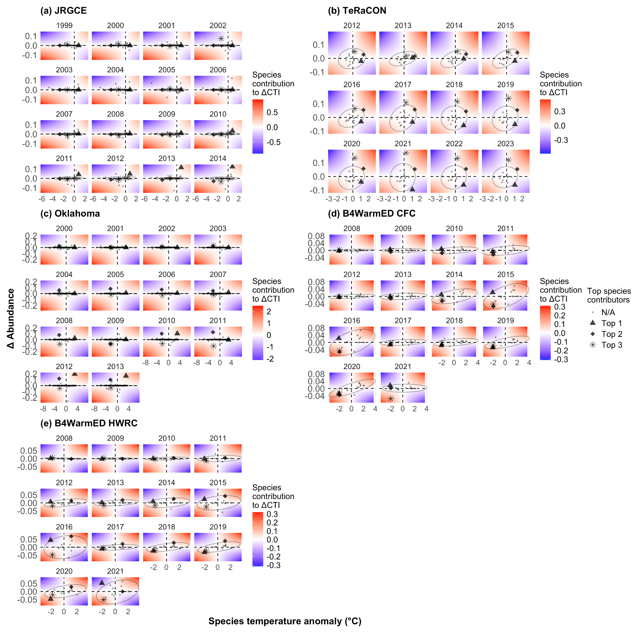
Figure S3. Species contributions to ΔCTI for each experiment, each year. Each point represents a single species’ contribution value, which is the product of a species’ temperature anomaly (°C) and the treatment effect of warming on its abundance (Δ abundance). The ellipses represent the 95% CI for all species points in each year. Only the warmed treatment is shown for the B4WarmED experiments (not the intermediate warming treatment).

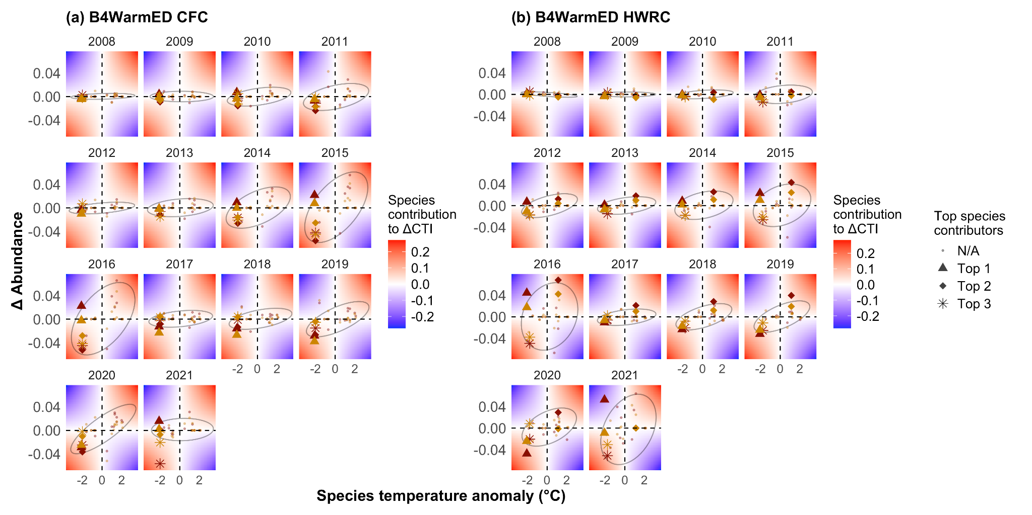
Figure S4. Species contributions to ΔCTI each year for B4WarmED CFC and HWRC. Species contributions are shown for both the intermediate (orange) and warmed (red) treatments. Each point represents a single species’ contribution value, which is the product of a species’ temperature anomaly (°C) and the treatment effect of warming on its abundance (Δ abundance). The ellipse represents the 95% CI for all species points.
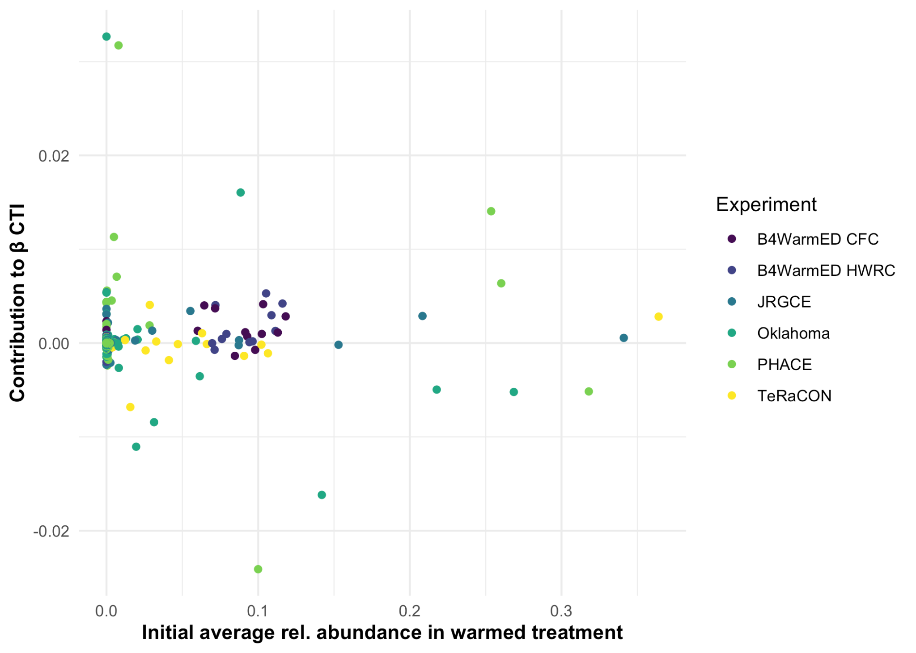
Figure S5. No relationship between species initial (year = 1) average relative abundance in the warmed treatment and their final contributions to thermophilization (β CTI) over time. Each point represents a single species, colored by which experiment it came from.

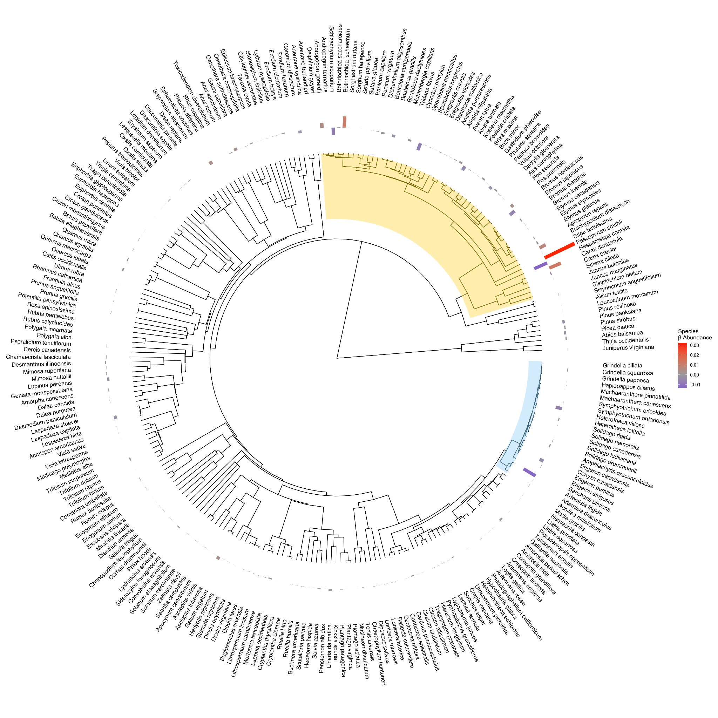
Figure S6. Phylogenetic tree of all species from all experiments. Bars represent the direction and magnitude of a species β_{ΔAbundance}. The yellow highlighted clade represents species from families Poaceae, Cyperaceae, and Juncaceae, whereas the blue highlighted clade represents species from the Astereae and Anthemideae tribes in the Asteraceae family.

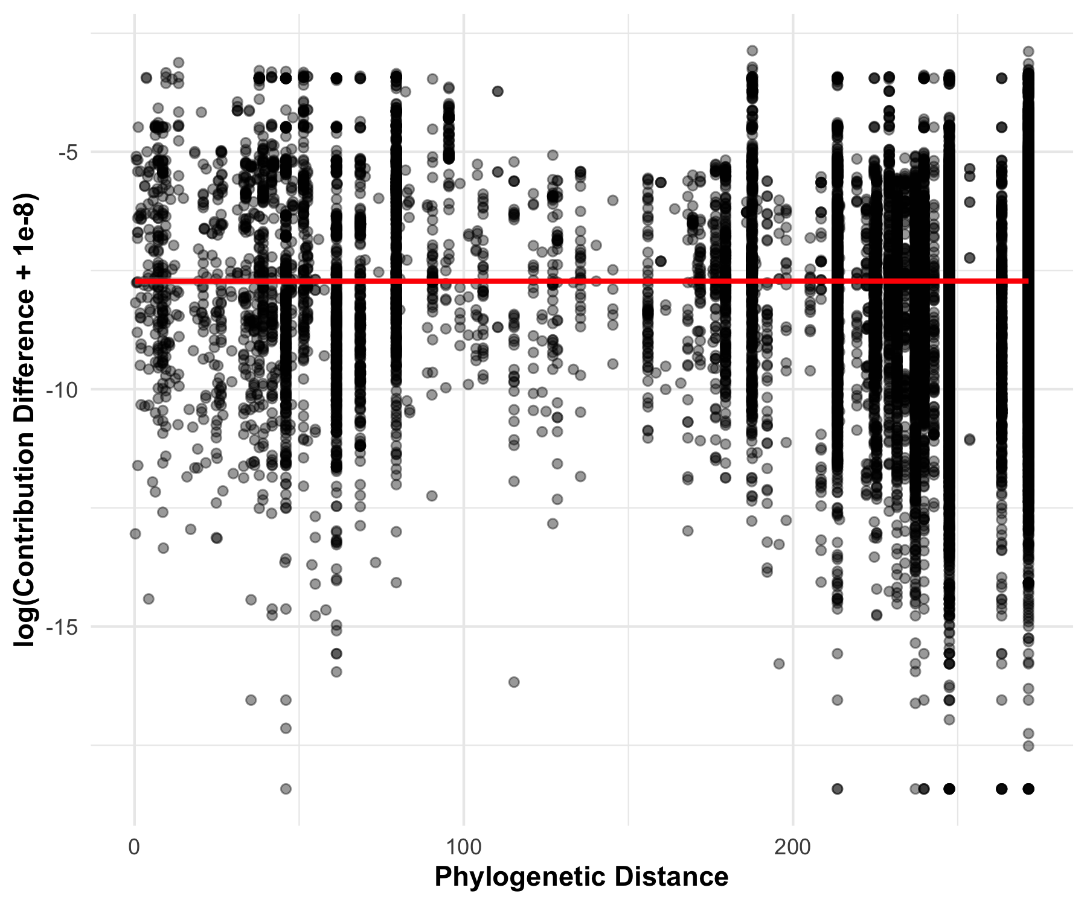
Figure S7. Species phylogenetic distance vs. contribution difference. Each point represents the phylogenetic distance between a species pair and the difference between their contribution values, and the red line is a fitted simple linear regression. There was no correlation between the distance and difference (p = 0.93).

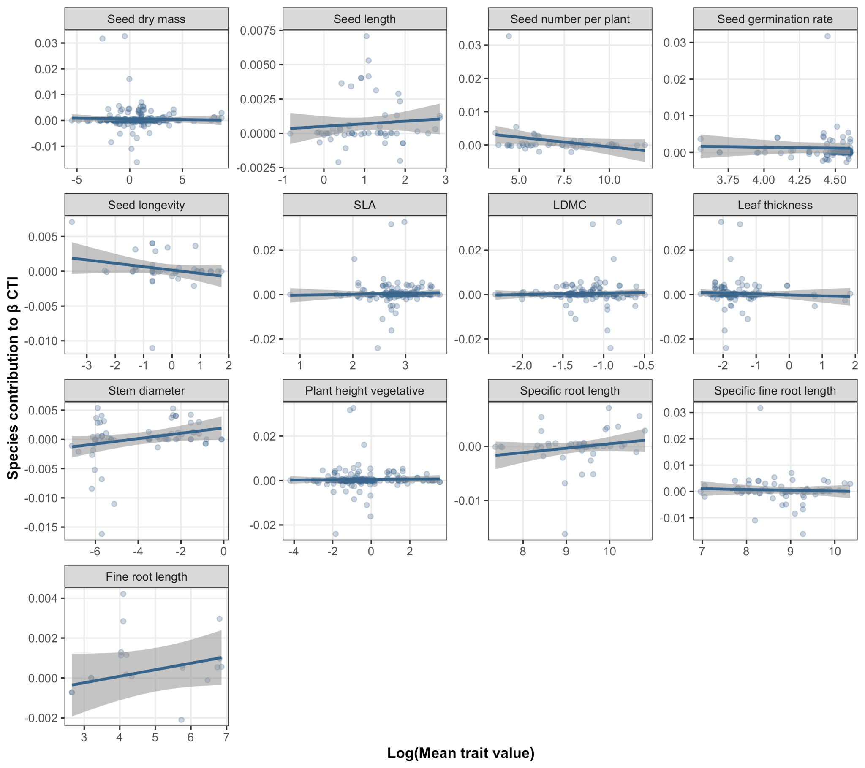
Figure S8. Relationships between mean plant trait values (log-transformed) and species contributions to β_{ΔCTI}. Each point in each plot represents a value for a single species, whereas the blue line and shaded region represents a fitted linear regression with a 95% confidence interval. No traits showed a significant relationship with species contributions.

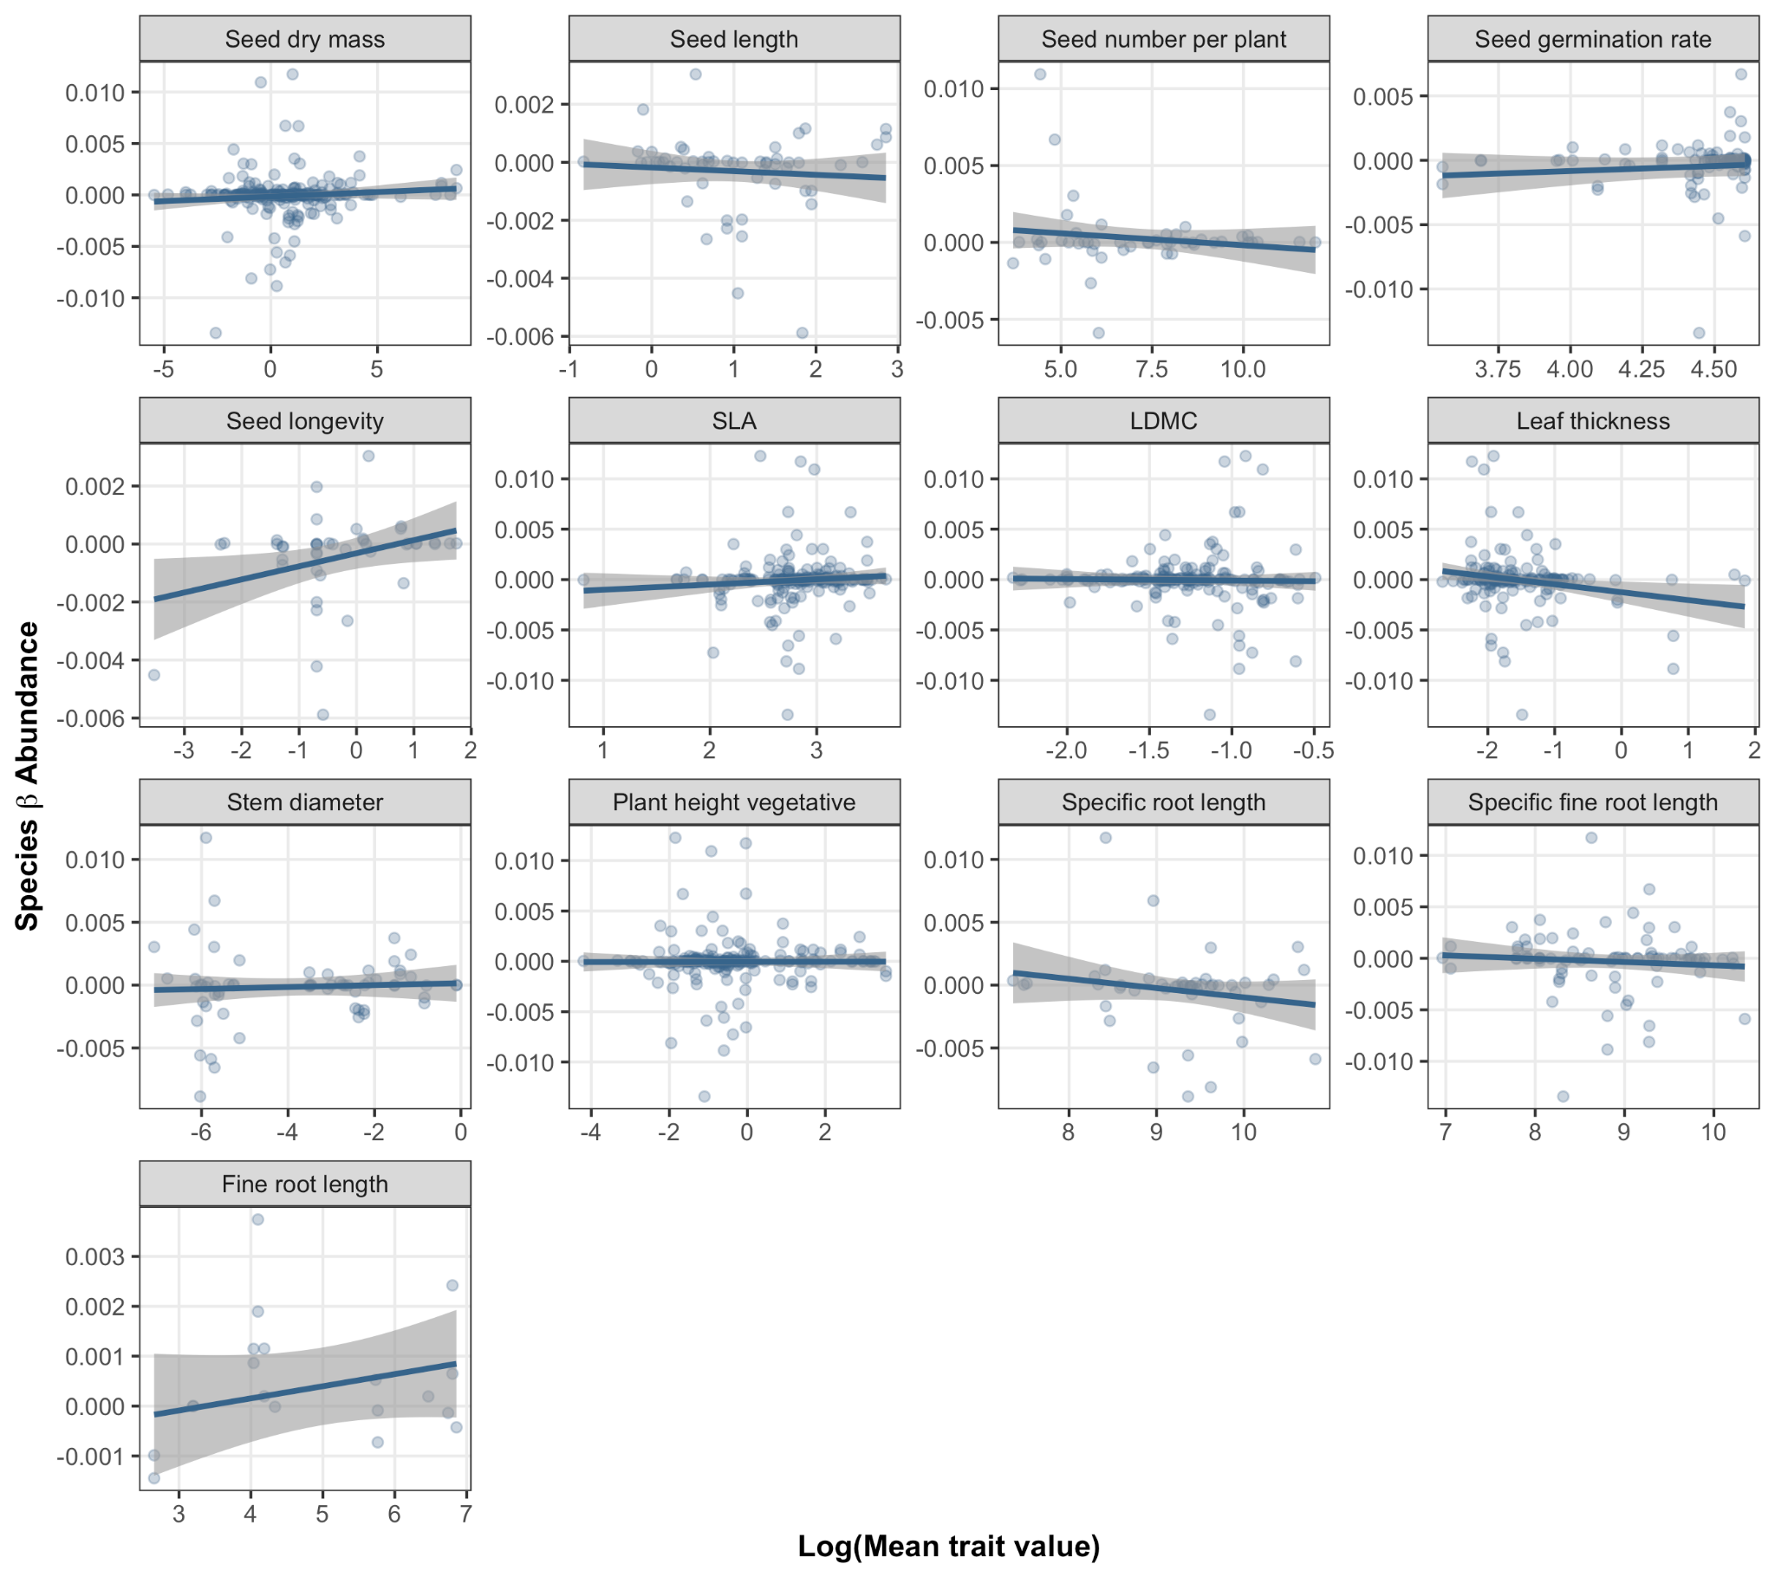
Figure S9. Relationships between mean plant trait values (log-transformed) and species changes in abundance due to warming (β_{ΔAbundance}). Each point in each plot represents a value for a single species, whereas the blue line and shaded region represents a fitted linear regression with a 95% confidence interval. No traits showed a significant relationship with species β abundance.

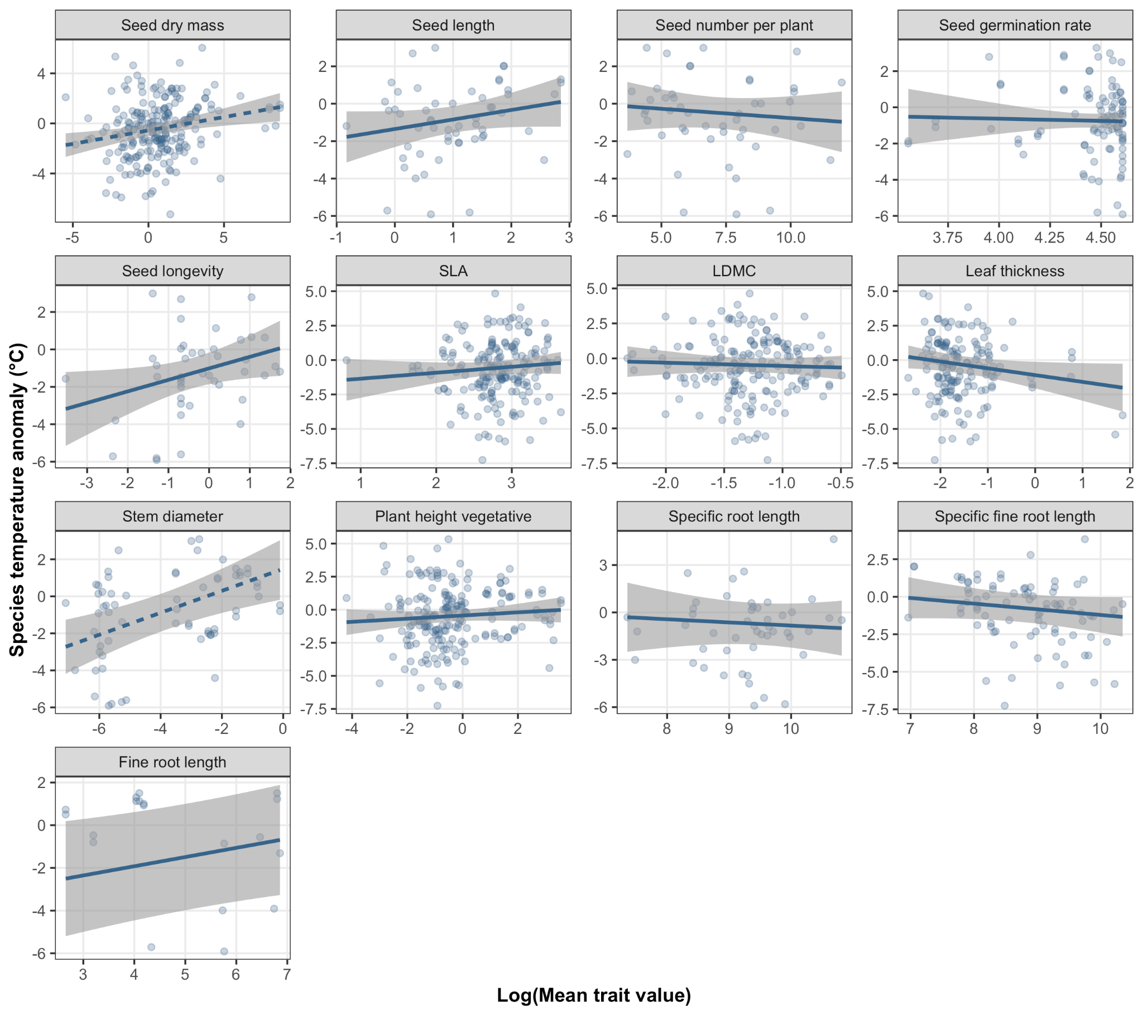
Figure S10. Relationships between mean plant trait values (log-transformed) and species temperature anomaly (°C). Each point in each plot represents a value for a single species, whereas the blue line and shaded region represents a fitted linear regression with a 95% confidence interval. Dashed lines represent a significant relationship; only seed dry mass (p = 0.01) and stem diameter (p = 0.01) demonstrated a significant relationship with species’ temperature anomalies.

